**Assignment No. 1**

**1. Creating and Renaming Files/Directories**

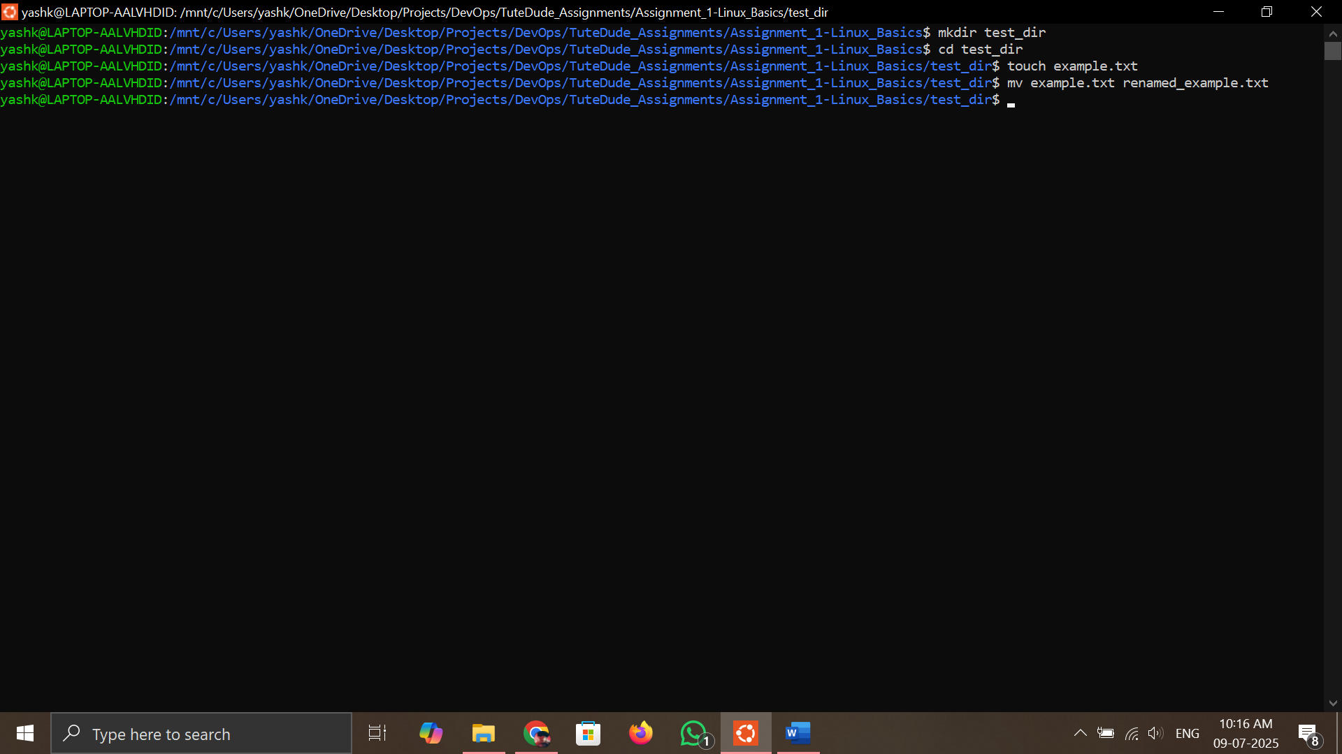

**Command:**

mkdir test_dir

cd test_dir

touch example.txt

mv example.txt renamed_example.txt

**Explanation:**

* mkdir test_dir – Creates a new directory called test_dir.
* cd test_dir – Enters the newly created directory.
* touch example.txt – Creates an empty file named example.txt.
* mv example.txt renamed_example.txt – Renames the file.

**2. Viewing File Contents**

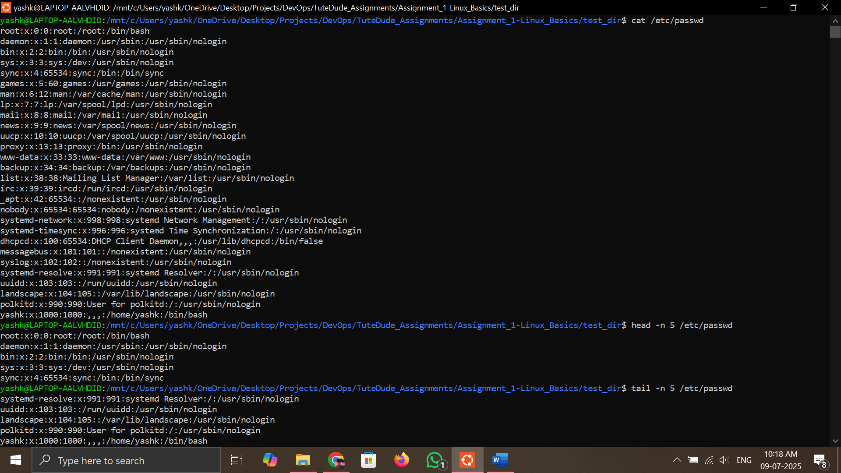

**Command:**

cat /etc/passwd

head -n 5 /etc/passwd

tail -n 5 /etc/passwd

**Explanation:**

* cat displays the entire contents of /etc/passwd.
* head -n 5 shows the first 5 lines.
* tail -n 5 shows the last 5 lines.

**3. Searching for Patterns**

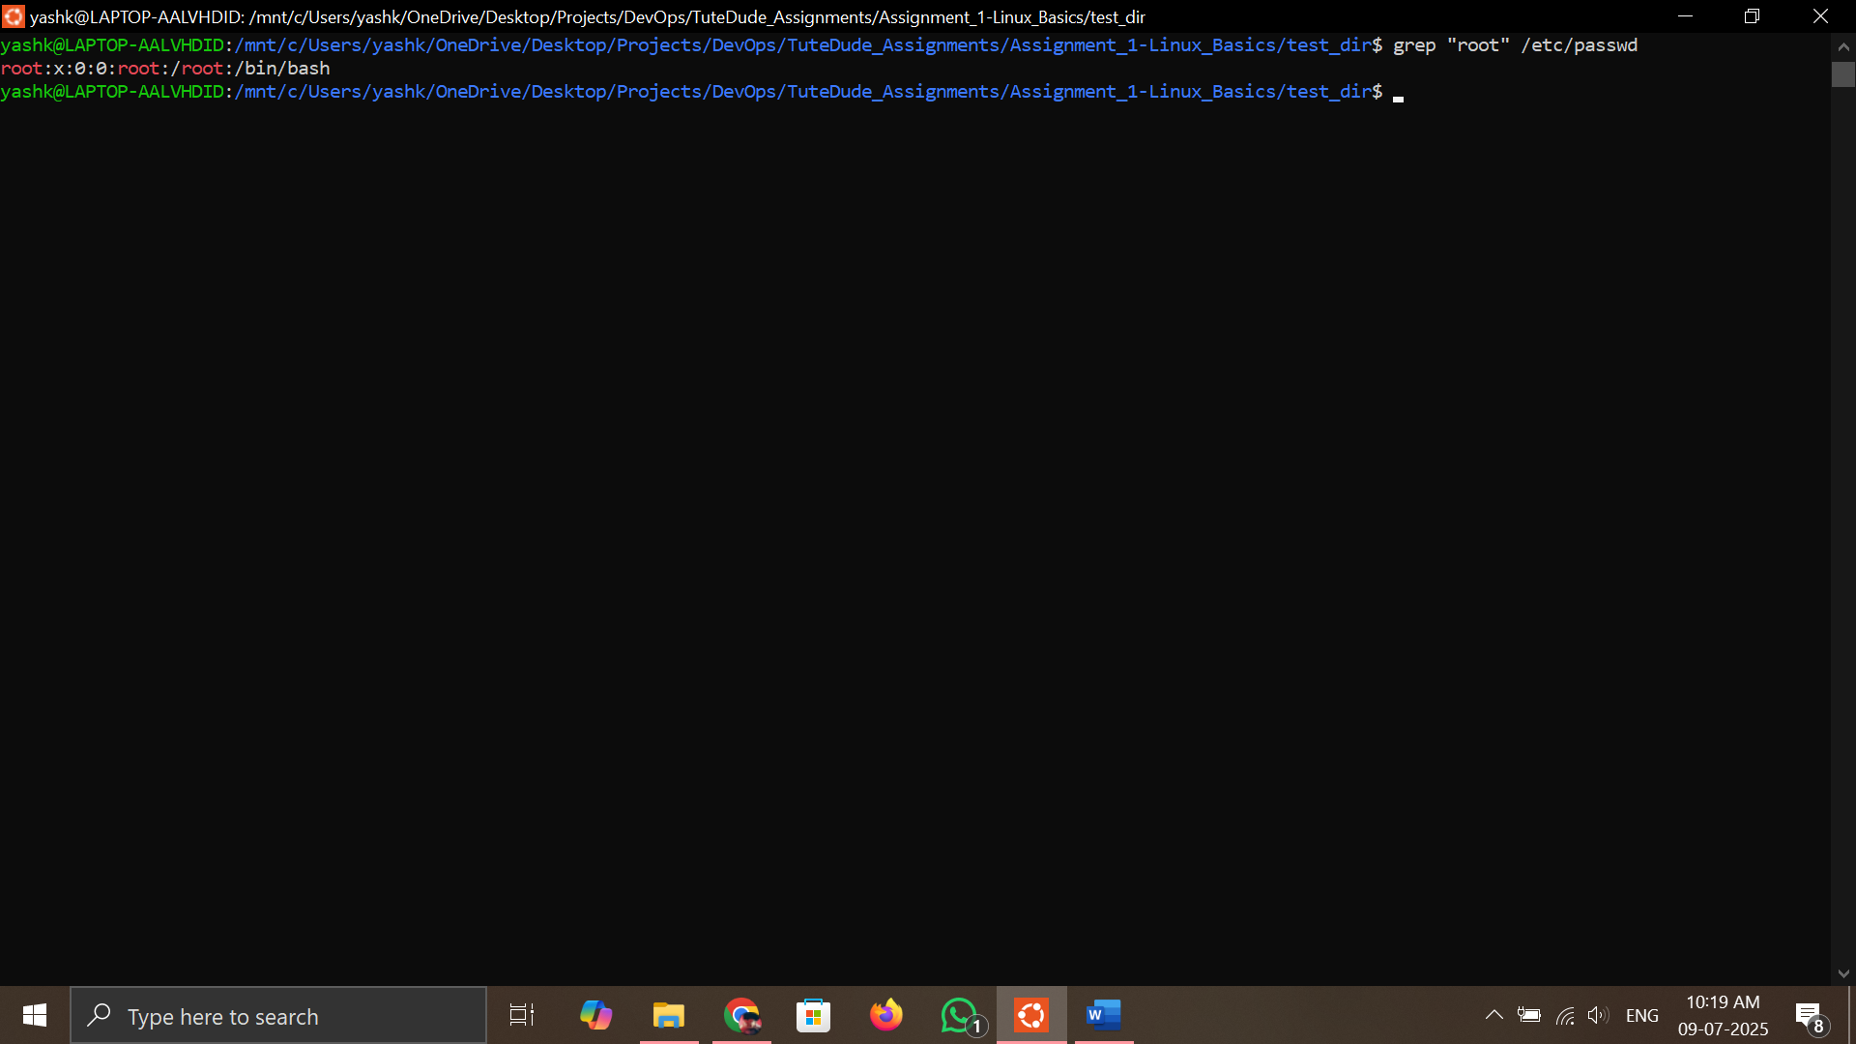

**Command:**

grep "root" /etc/passwd

**Explanation:**

* grep "root" searches for lines containing the word “root” in /etc/passwd.

**4. Zipping and Unzipping**

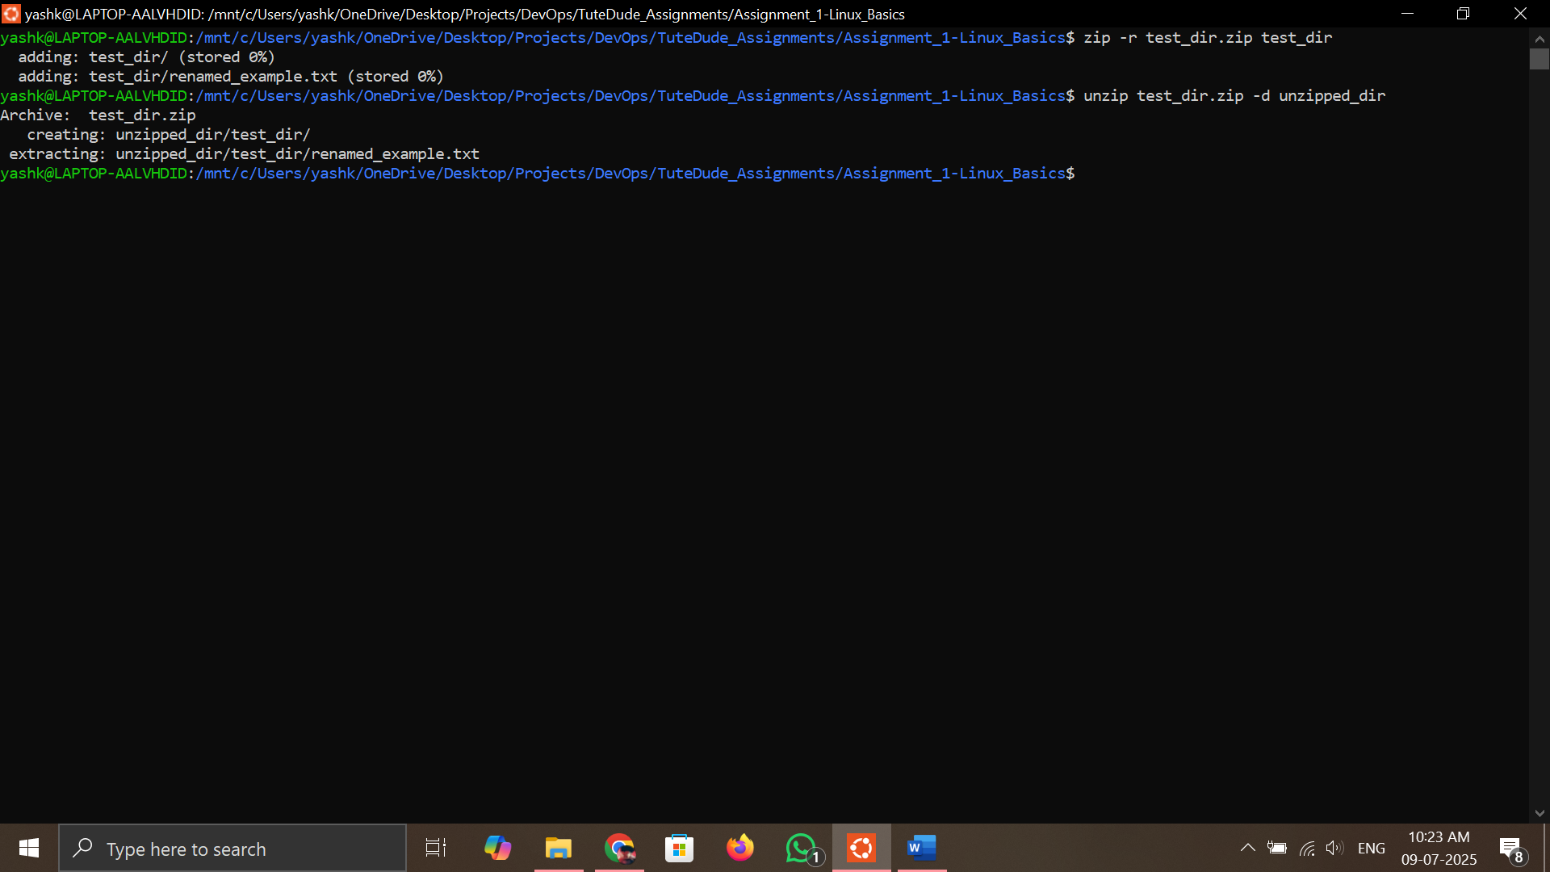

**Command:**

zip -r test_dir.zip test_dir

unzip test_dir.zip -d unzipped_dir

**Explanation:**

* zip -r compresses the test_dir into test_dir.zip.
* unzip -d extracts the contents into unzipped_dir.

**5. Downloading Files**

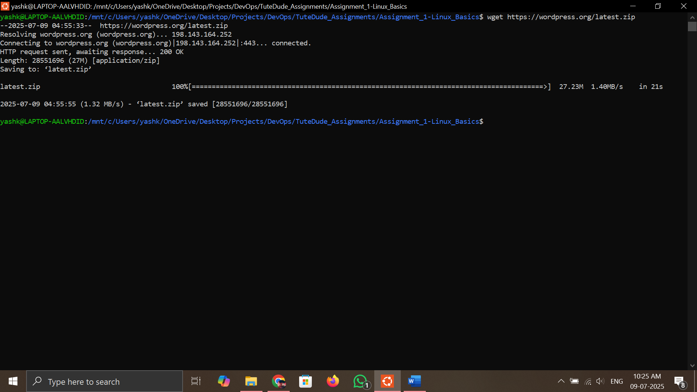

**Command:**

wget https://wordpress.org/latest.zip

**Explanation:**

* wget is used to download files from the internet.

**6. Changing Permissions**

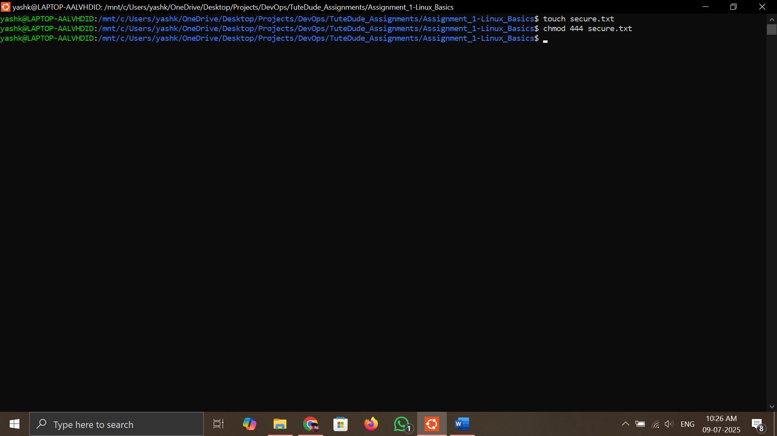

**Command:**

touch secure.txt

chmod 444 secure.txt

**Explanation:**

* touch secure.txt creates a new file.
* chmod 444 sets the file as read-only for all users.

**7. Working with Environment Variables**

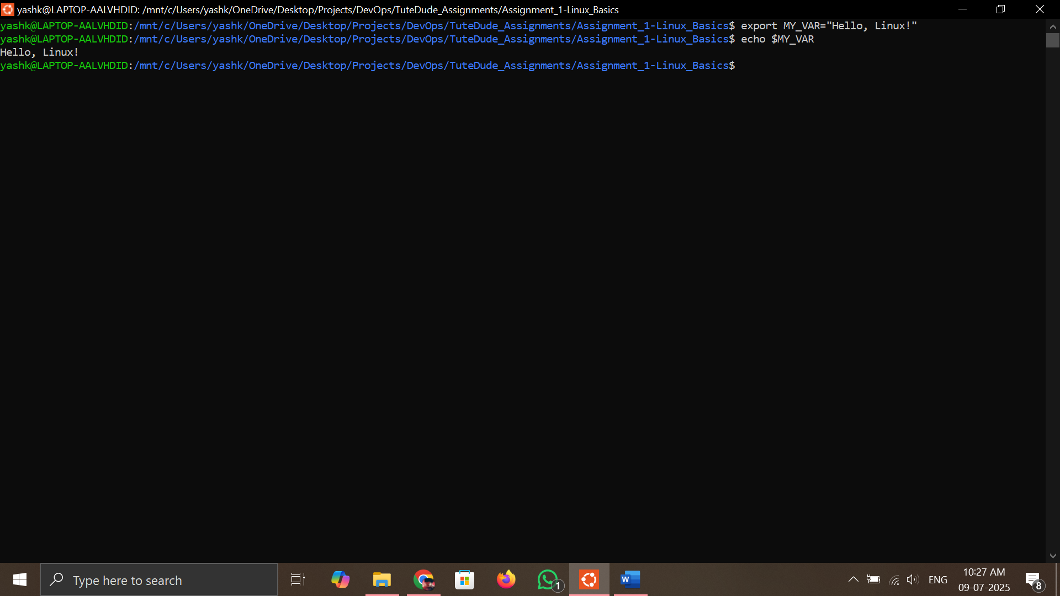

**Command:**

export MY_VAR="Hello, Linux!"

echo $MY_VAR

**Explanation:**

* export sets an environment variable.
* echo $MY_VAR confirms it was set correctly.