**ASSIGNMENT-2**

1. Grade Checker

Code:

score = int(input("Enter the score: "))

if score >= 90:

    grade = "A"

elif score >= 80:

    grade = "B"

elif score >= 70:

    grade = "C"

elif score >= 60:

    grade = "D"

else:

    grade = "F"

print(f"Grade: {grade}")

Output:

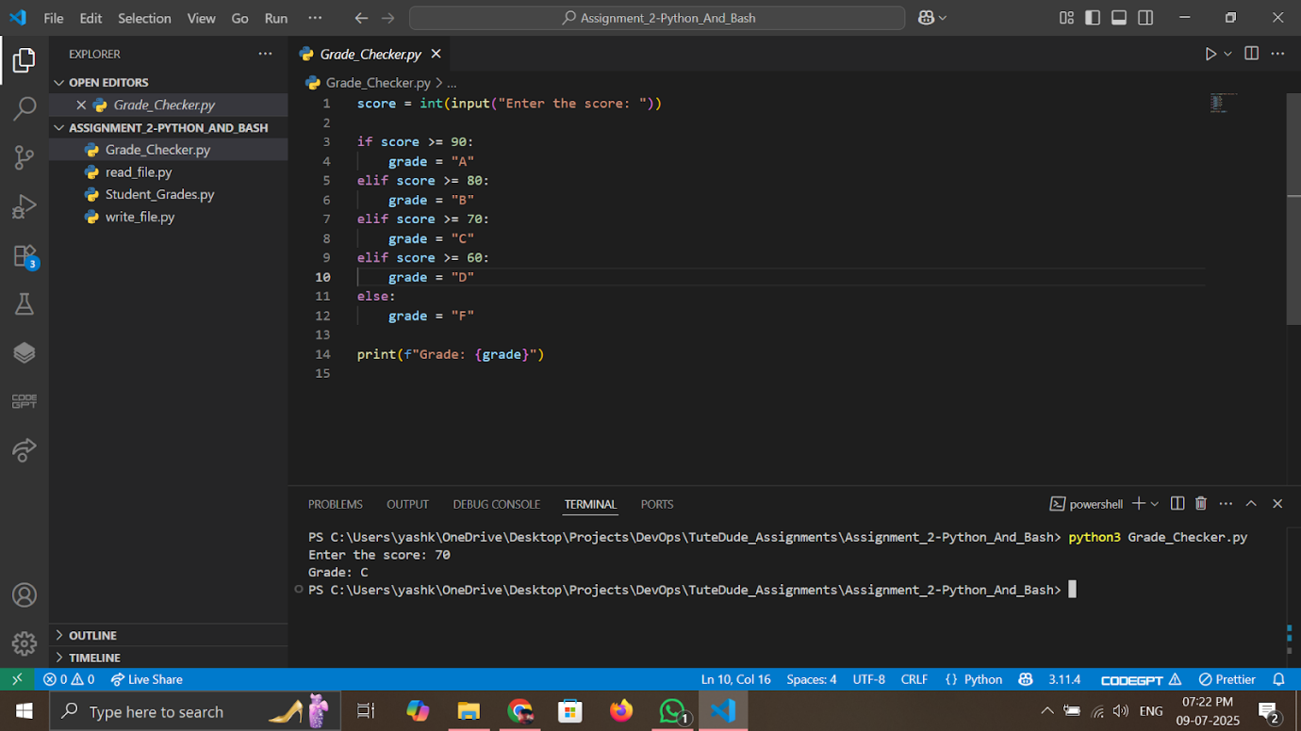

2 Student Grades

Code:

students = {}

while True:

    print("\nOptions:")

    print("1. Add a new student")

    print("2. Update student grade")

    print("3. Print all students and grades")

    print("4. Exit")

    choice = input("Enter your choice (1-4): ")

    if choice == "1":

        name = input("Enter student name: ")

        grade = input("Enter grade: ")

        students[name] = grade

        print(f"{name} added successfully.")

    elif choice == "2":

        name = input("Enter student name to update: ")

        if name in students:

            grade = input("Enter new grade: ")

            students[name] = grade

            print(f"{name}'s grade updated to {grade}.")

        else:

            print("Student not found.")

    elif choice == "3":

        print("\nStudent Grades:")

        for name, grade in students.items():

            print(f"{name}: {grade}")

    elif choice == "4":

        print("Exiting program.")

        break

    else:

        print("Invalid choice. Please try again.")

Output:

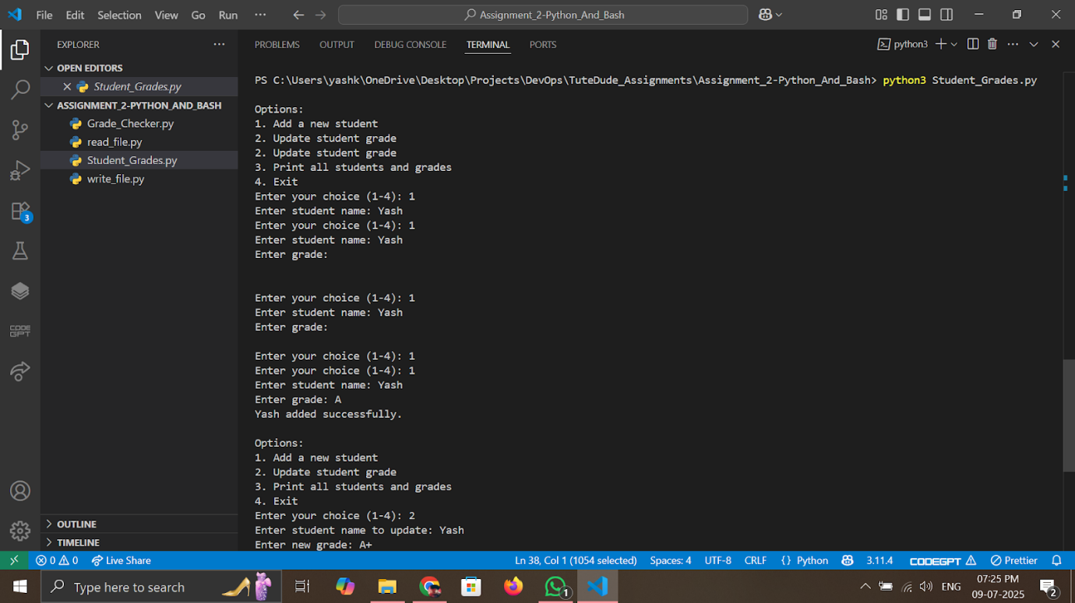

3.Write to a File

Code:

with open("sample.txt", "w") as file:

    file.write("This is a sample text file.\n")

    file.write("We are writing some content into this file.\n")

    file.write("Assignment: File handling in Python.\n")

print("Content written to sample.txt successfully.")

Output:

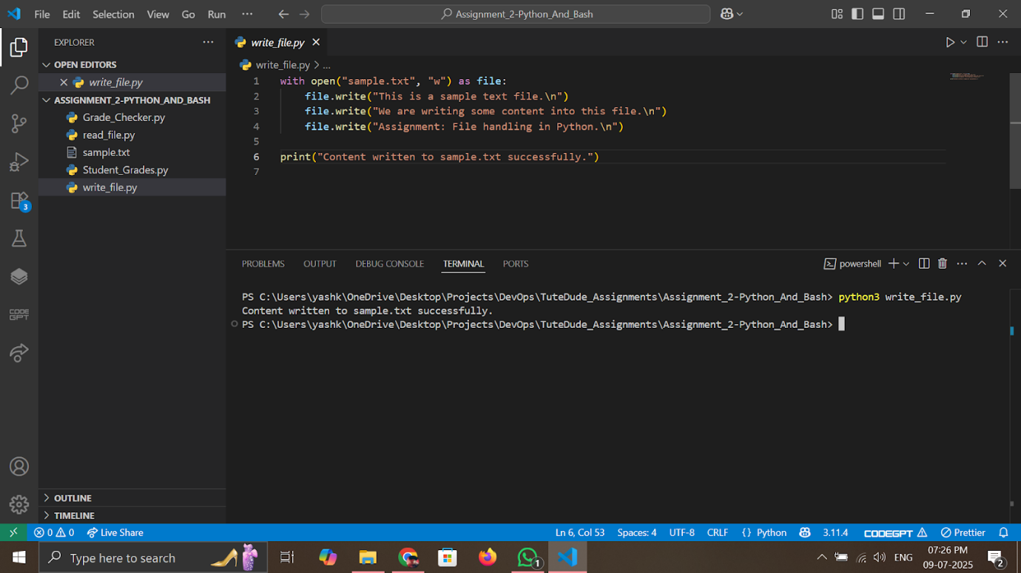

4. Read from a File

Code:

try:

    with open("sample.txt", "r") as file:

        content = file.read()

        print("File Content:")

        print(content)

except FileNotFoundError:

    print("sample.txt not found. Please run the write program first.")

Output:

