**Assignment No- 3**

1. Create a Flask application with an /api route. When this route is accessed, it should return a JSON list. The data should be stored in a backend file, read from it, and sent as a response.

App.py

from flask import Flask, jsonify

import json

import os

app = Flask(__name__)

def load_data():

    with open('data.json', 'r') as file:

        data = json.load(file)

    return data

@app.route('/api', methods=['GET'])

def get_data():

    try:

        data = load_data()

        return jsonify(data), 200

    except Exception as e:

        return jsonify({'error': str(e)}), 500

if __name__ == '__main__':

    app.run(debug=True)

Output:

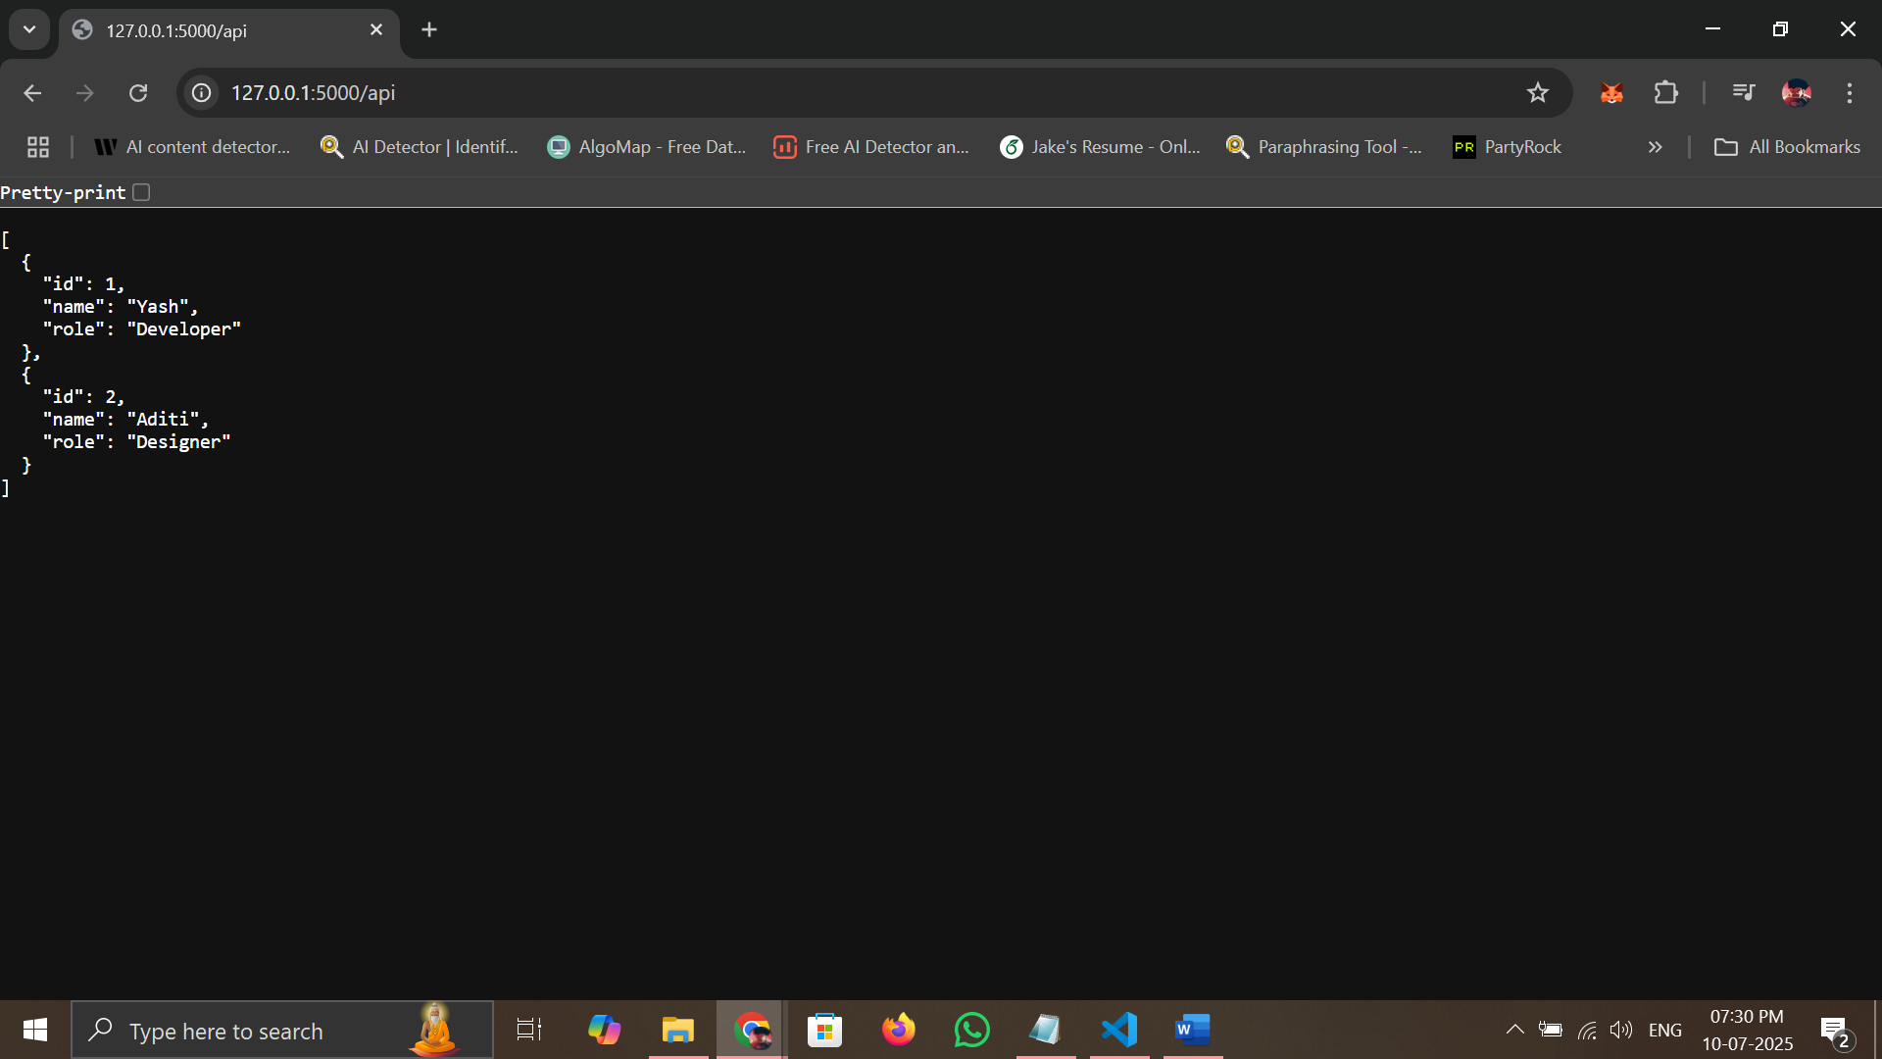

2. Create a form on the frontend that, when submitted, inserts data into MongoDB Atlas. Upon successful submission, the user should be redirected to another page displaying the message **"Data submitted successfully"**. If there's an error during submission, display the error on the same page without redirection.

Output:

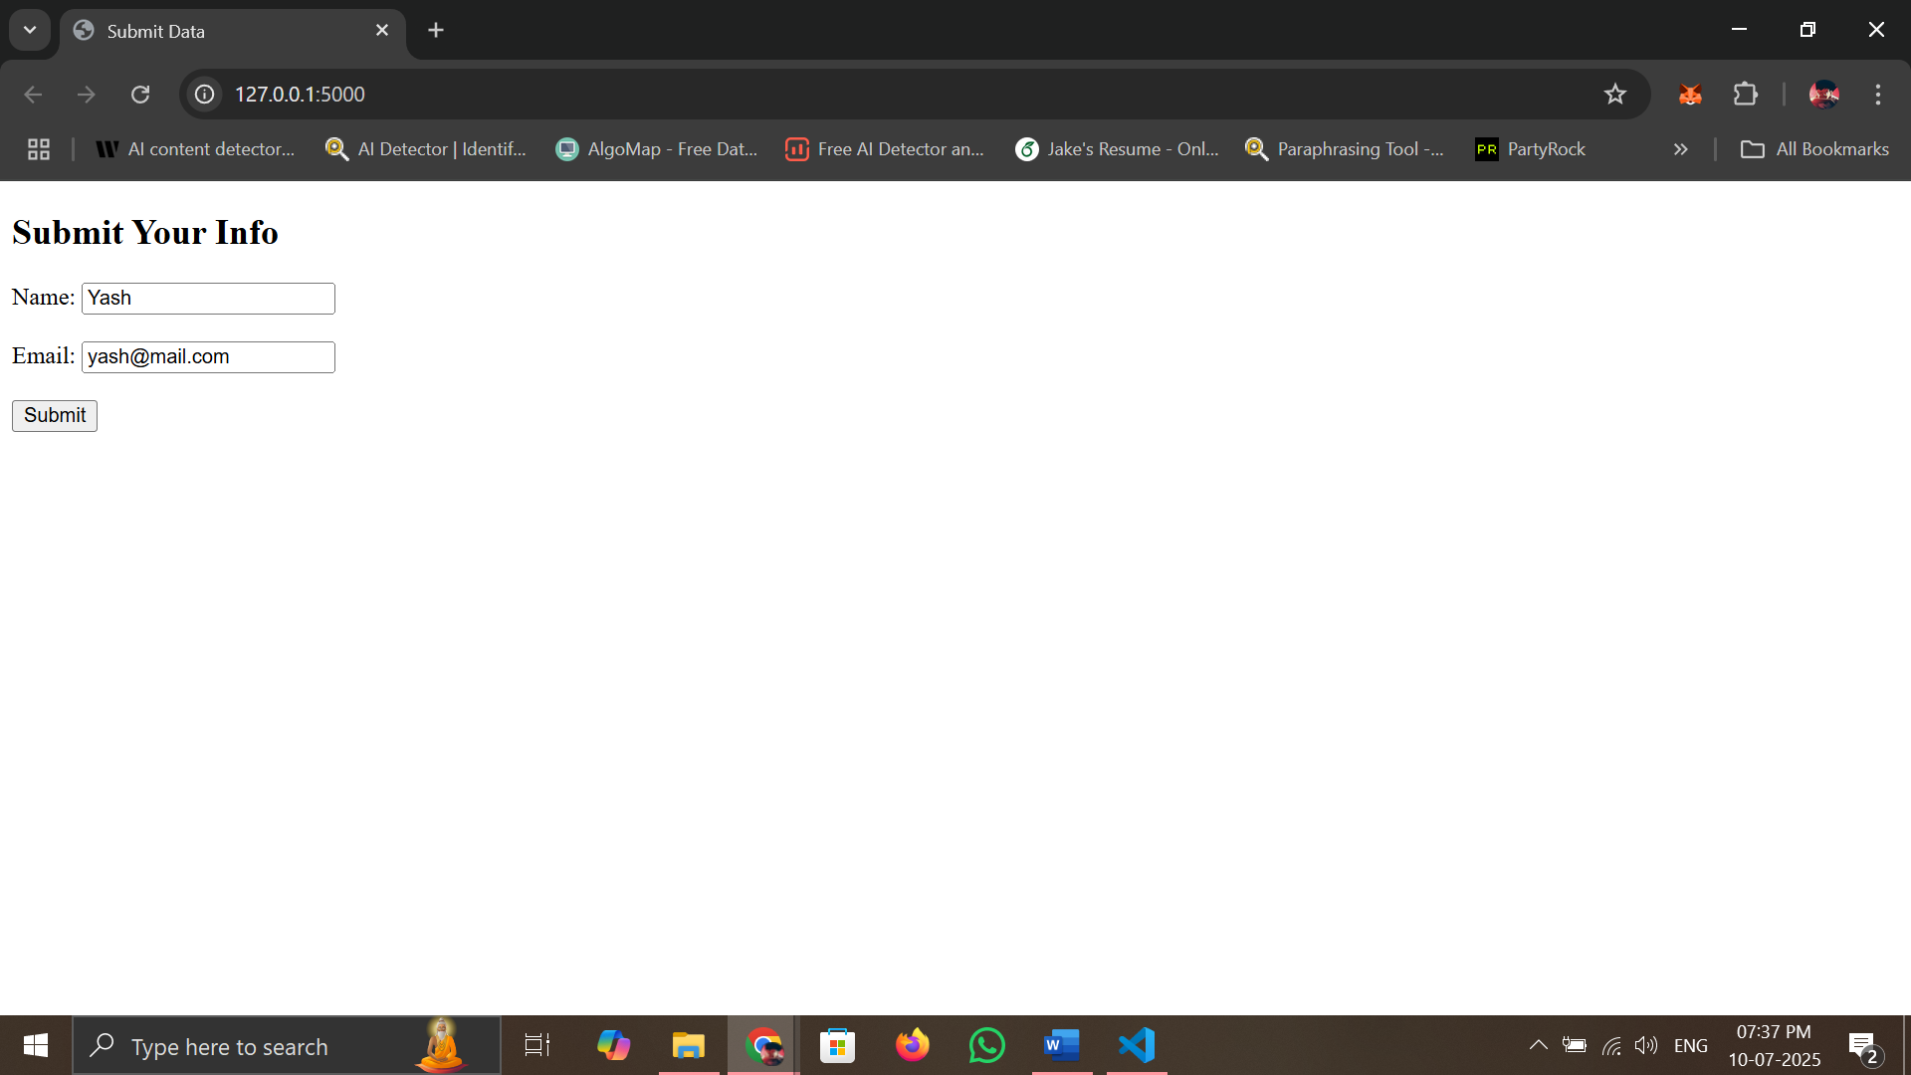

Error:

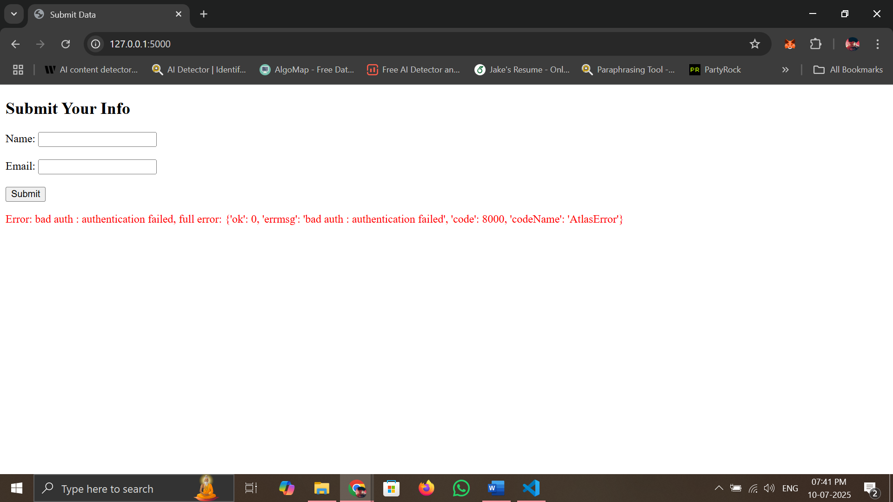

After Solving the Error:

