**Assignment-9**

**Part 1: Deploy Flask and Express on a Single EC2 Instance**

ssh -i your-key.pem ubuntu@<EC2_PUBLIC_IP>

sudo apt update && sudo apt upgrade -y

sudo apt install python3 python3-pip -y

curl -fsSL https://deb.nodesource.com/setup_16.x | sudo -E bash -

sudo apt install -y nodejs

sudo apt install git -y

sudo npm install -g pm2

Clone the Repos

cd backend-flask

pip3 install -r requirements.txt

pm2 start app.py --interpreter=python3 --name flask-app

cd ../frontend-express

npm install

pm2 start server.js --name express-app

Output:

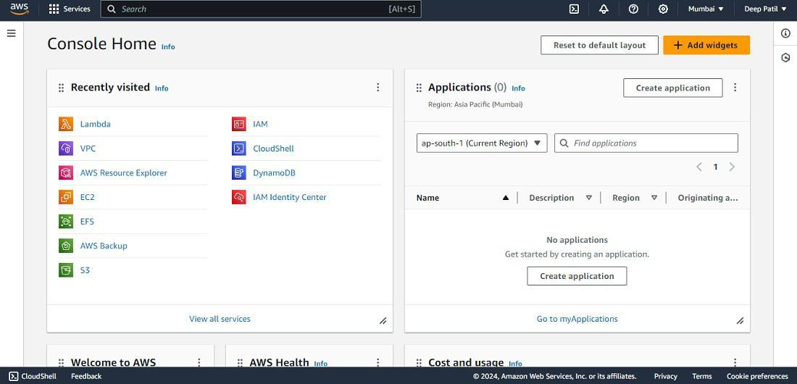

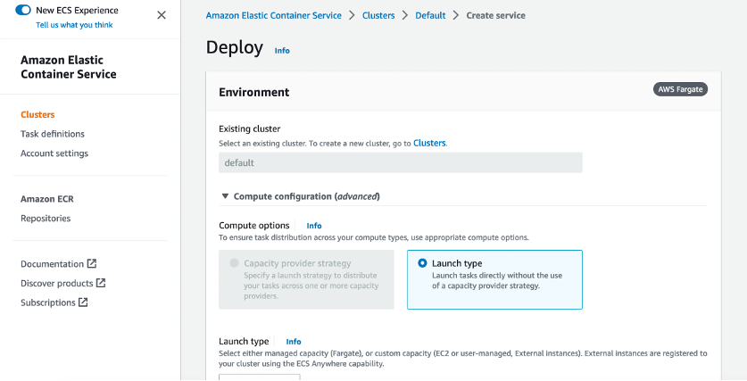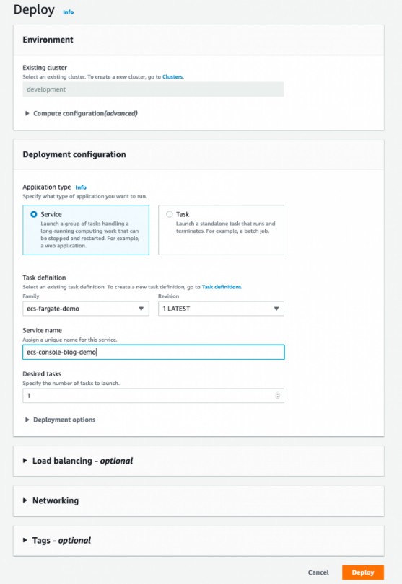

**Part 2: Implement CI/CD Pipeline Using Jenkins**

sudo apt install openjdk-11-jdk -y

wget -q -O - https://pkg.jenkins.io/debian-stable/jenkins.io.key | sudo apt-key add -

sudo sh -c 'echo deb http://pkg.jenkins.io/debian-stable binary/ > /etc/apt/sources.list.d/jenkins.list'

sudo apt update && sudo apt install jenkins -y

sudo systemctl start jenkins

sudo systemctl enable Jenkins

sudo ufw allow 8080

Output:

