Step 1: Clone the simple PKI example files from the bit bucket.

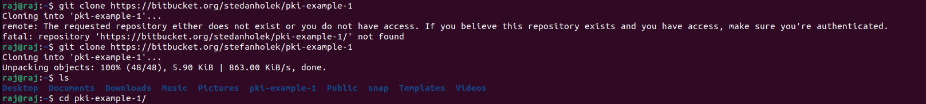

Step 2: Create Directories for CA resources, CRLS, and certificate.

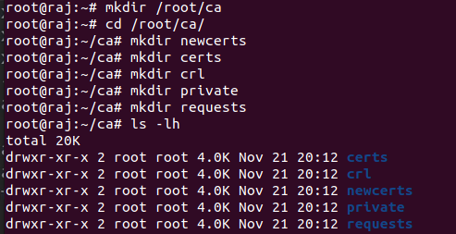

Step 3: Create Database

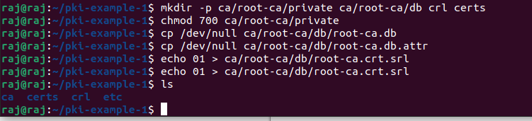

Step 4: Creating a private key file

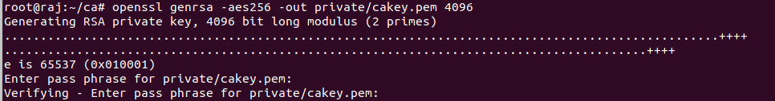

Step 5: Create new request certificates

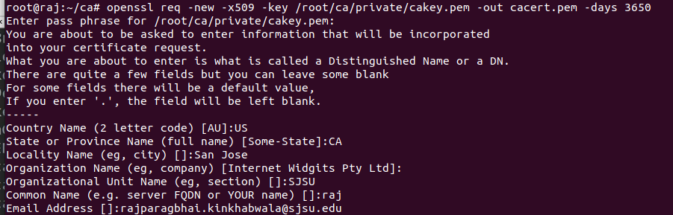

Step 6: Edit the /*usr/lib/ssl/openssl.cnf*

*edit the defualt CA location*

Step 7: Creating a private key and requesting a public key for a webserver

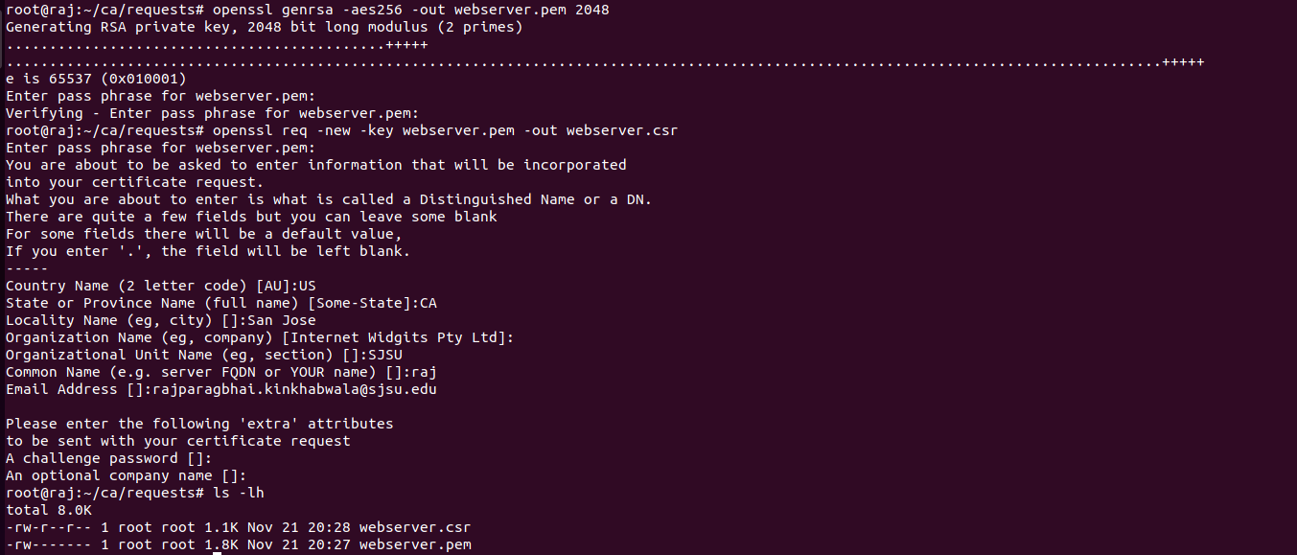

Step 8: Making a certificate

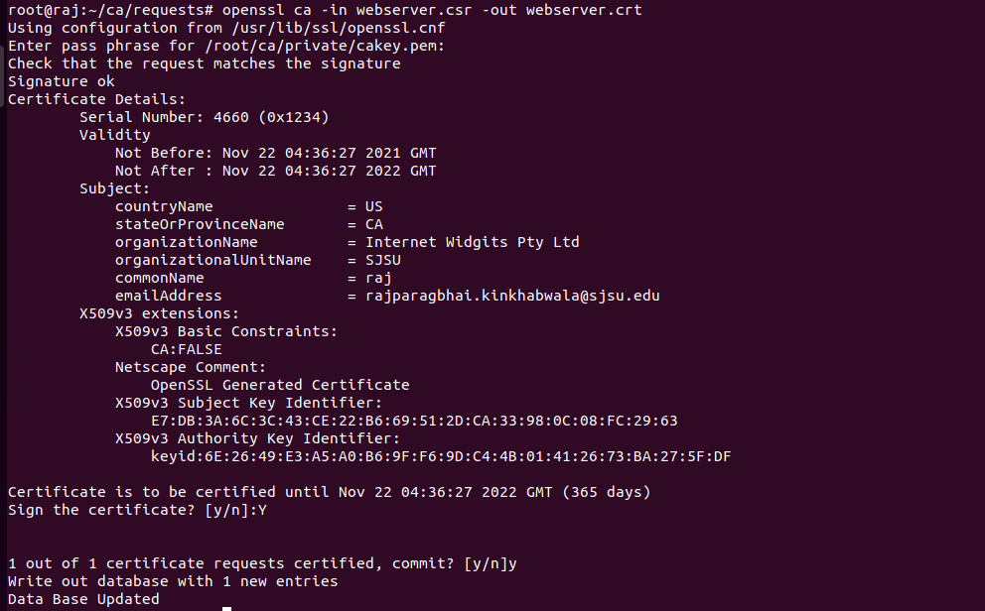

Step 9: Install Tomcat server

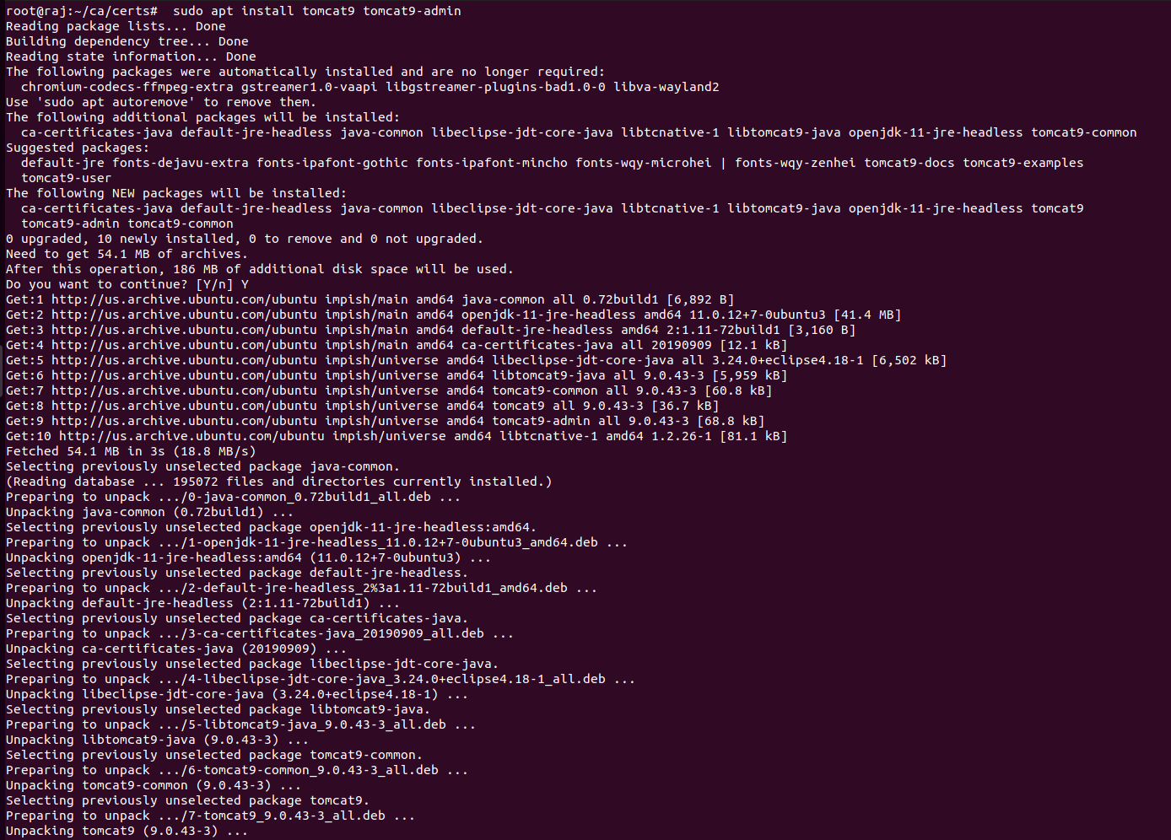

Step 10: Downloading the tomcat packages for running

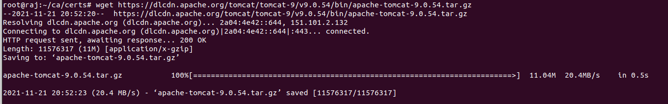

Step 11: Allowing ports



Steps 12: Creating keystore

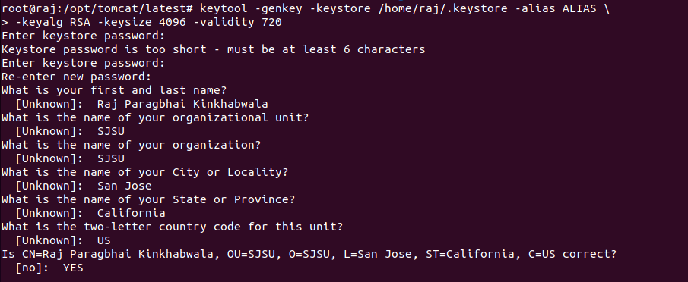

Steps 13: Create Tomcat service in systemd folder



Steps 14: Running tomcat on ssl

