Experiment Procedure Documentation

Introduction
This document captures the instructions to run the simulation.

Instructions
- To run the experiment, simply run the index.html file by clicking on it and the experiment will open in the browser.
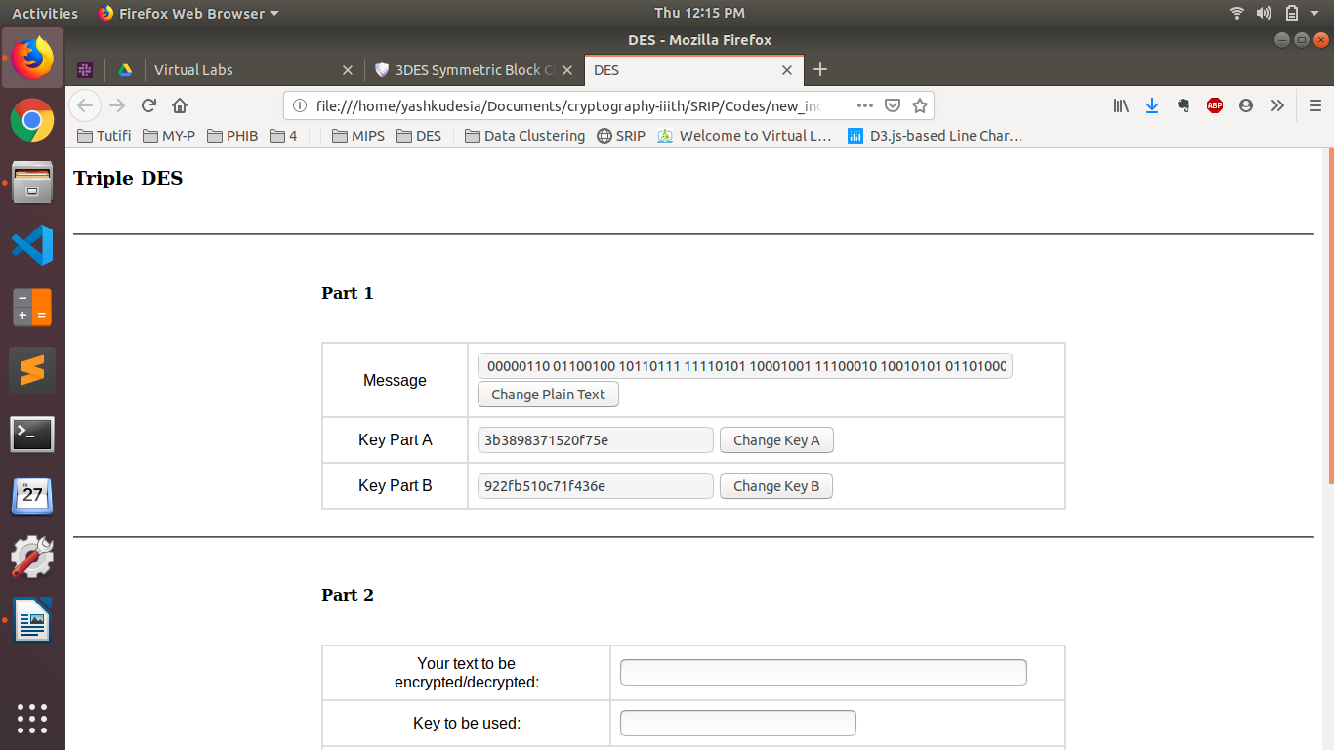

- To run the experiment, generate Plaintext m, keyA and keyB by clicking on rexpective buttons PART I of the simulation page (default are shown in above fig).

- Enter generated Plaintext m from PART I to PART II in "Your text to be encrypted/decrypted:" block.
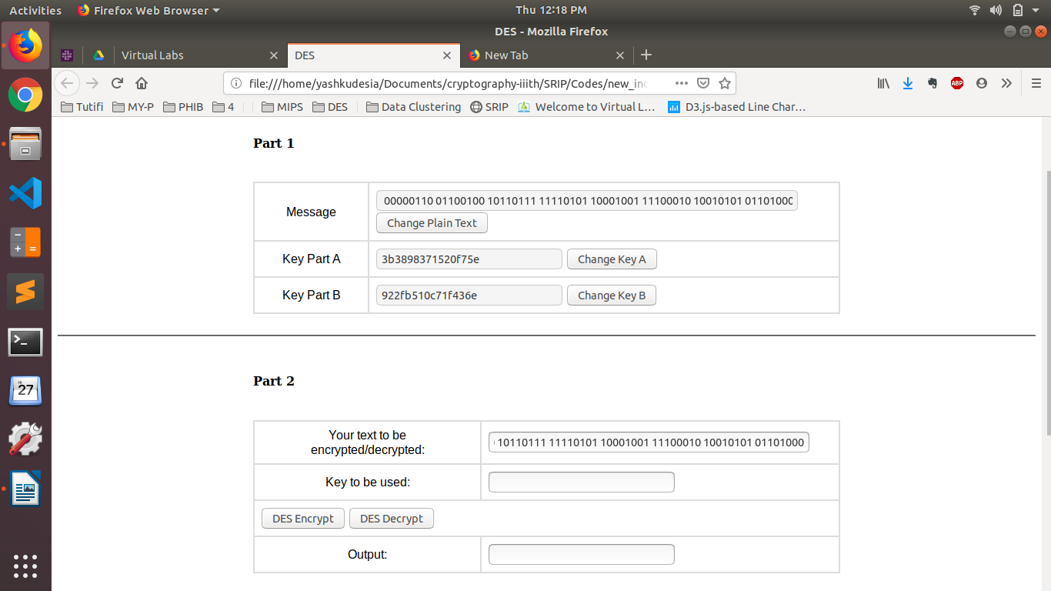

- Enter generated keyA from PART I to PART II "Key to be used:" block and click on DES encrpt button to output ciphertext c1.This is First Encryption.
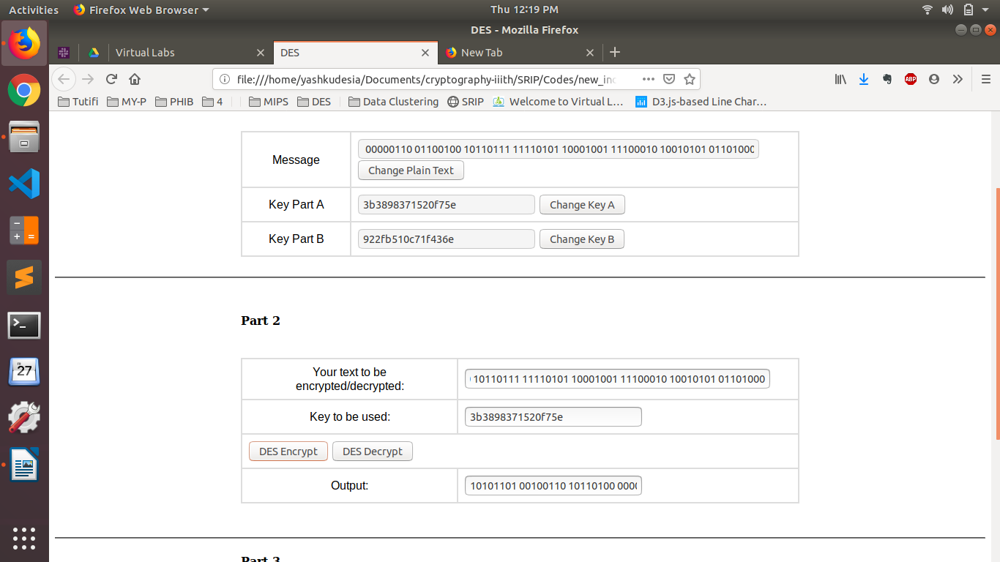
- Enter generated ciphertext c1 from PART II "Output:" Block to PART II in "Your text to be encrypted/decrypted:" block.

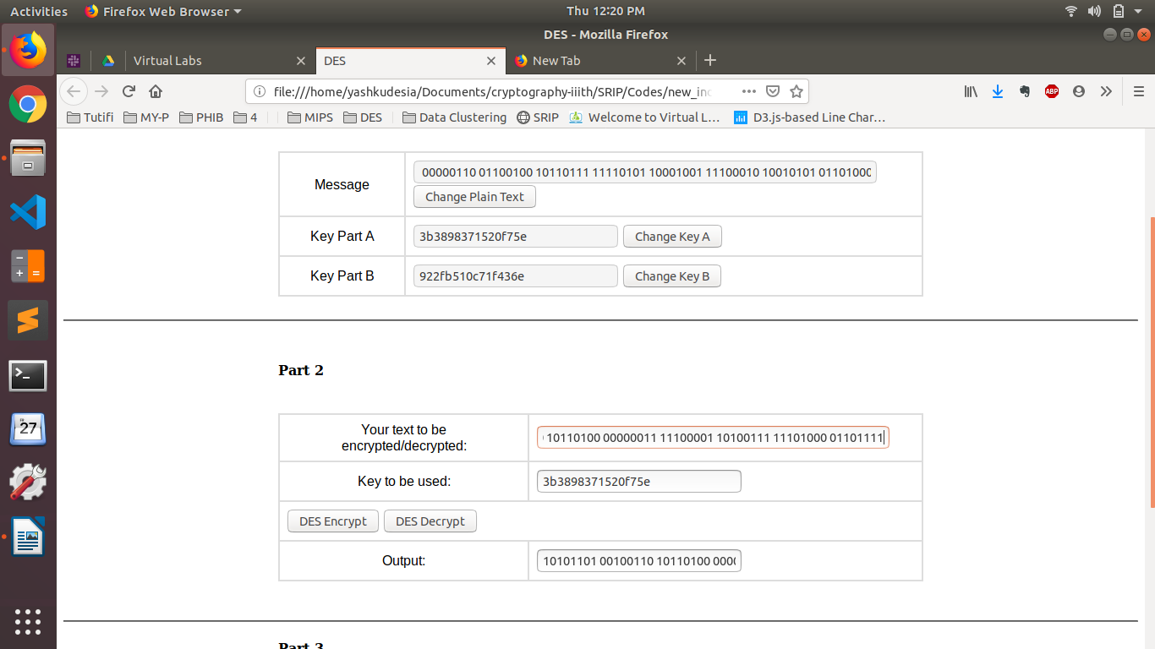

6. Enter generated keyB from PART I to PART II in "Key to be used:" block and click on DES decrypt button to output ciphertect c2.This is Second Encryption.
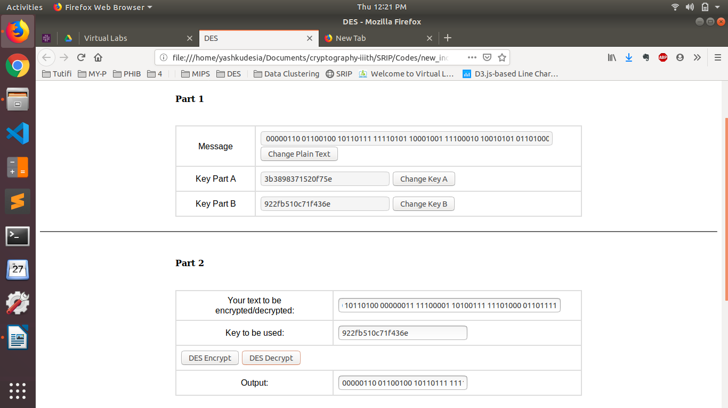
7. Enter generated ciphertext c2 from PART II "Output:" block to PART II in "Your text to be encrypted/decrypted:" block.
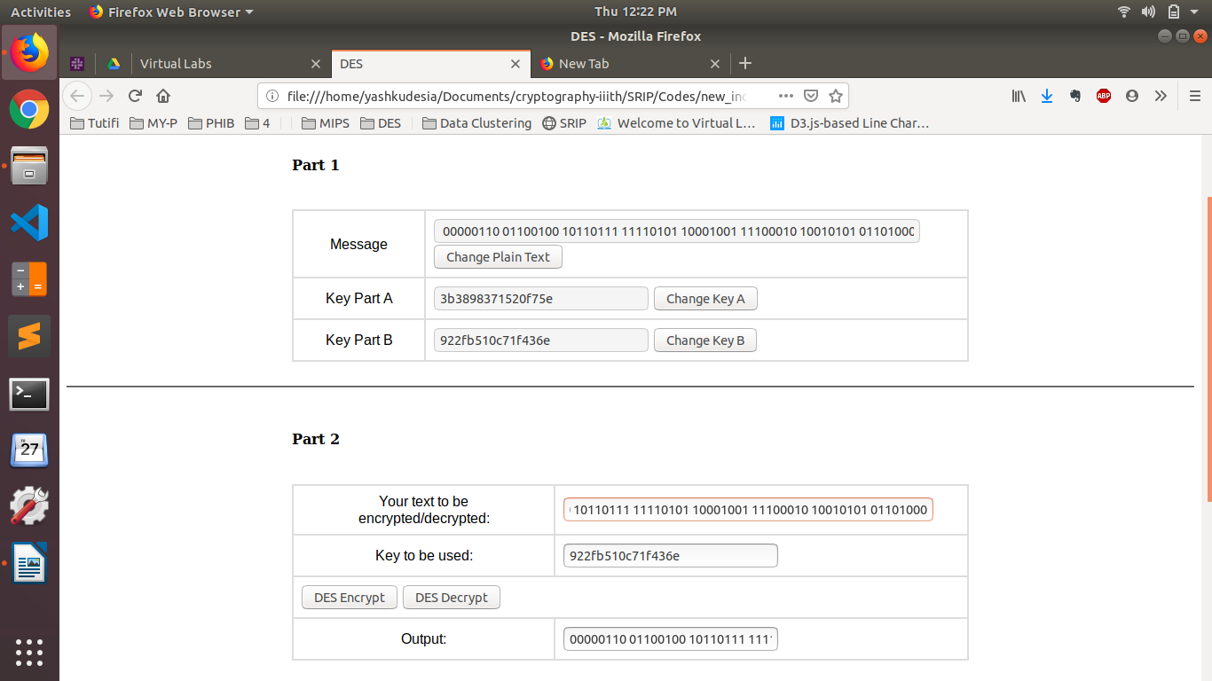
8. Enter generated keyA from PART I to PART II "Key to be used:" block and click on DES encrpt button to output ciphertext c3.This is Third Encryption. As Encryption is done thrice.This Scheme is called triple DES.
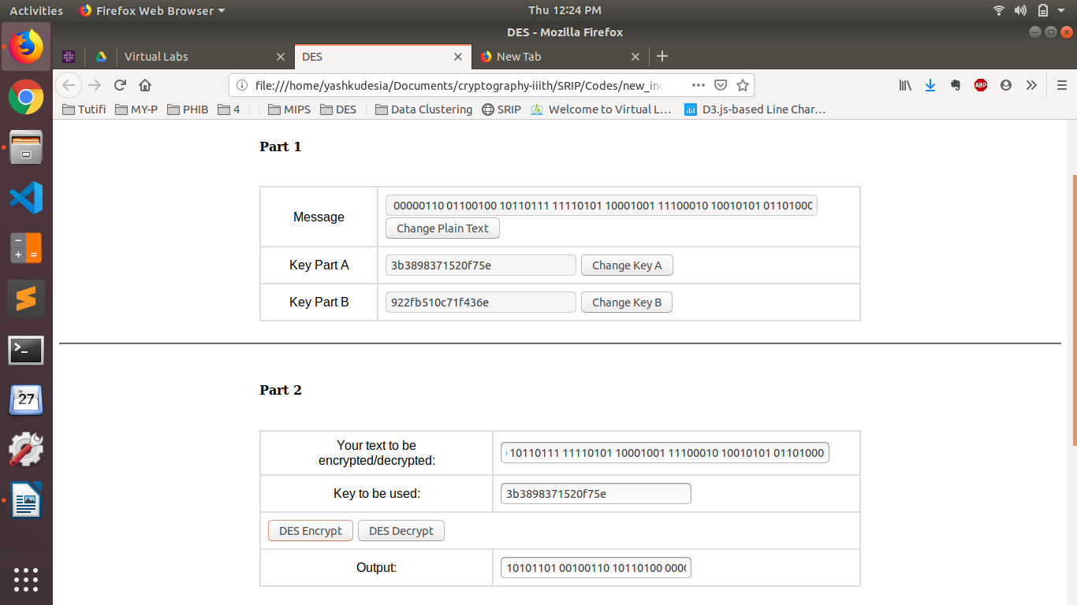
9. Enter generated ciphertext c3 from PART II "Output:" Block to PART III "Enter your answer here:" block inorder to verify your Triple DES.
