KRISHNA’S LENS

A
Major Project Report
Submitted in partial fulfillment of the requirement for the award of degree of

Bachelor of Technology
In
Computer Science & Engineering

Submitted to
RAJIV GANDHI PROUDYOGIKI VISHWAVIDYALAYA,

BHOPAL (M.P.)

Guided by Submitted By
Prof. Sumeet Kothari Saransh Patil 0832CS221182
Tushar Gawhade 0832CS221213
Vivek Rathore 0832CS221228
Yash Lade 0832CS221229

DEPARTMENT OF COMPUTER SCIENCE & ENGINEERING
CHAMELI DEVI GROUP OF INSTITUTIONS
INDORE (M.P.) 452020
2025-26

KRISHNA’S LENS

A Major Project Report submitted to
Rajiv Gandhi Proudyogiki Vishwavidyalaya, Bhopal
Bachelor of Technology
in
Computer Science and Engineering

by

Saransh Patil 0832CS221182
Tushar Gawhade 0832CS221213
Vivek Rathore 0832CS221228
Yash Lade 0832CS221229

Under the guidance of

Prof. Sumeet Kothari
Assistant Professor

Session: 2025-2026
Department of Computer Science & Engineering
Chameli Devi Group of Institutions, Indore

452020 (Madhya Pradesh)

DECLARATION

We certify that the work contained in this report is original and has been done by us under the guidance of my supervisor(s).
- The work has not been submitted to any other Institute for any degree or diploma.
- We have followed the guidelines provided by the Institute in preparing the report.
- We have conformed to the norms and guidelines given in the Ethical Code of Conduct of the Institute.
- Whenever we have used materials (data, theoretical analysis, figures, and text) from other sources, we have given due credit to them by citing them in the text of the report and giving their details in the references.

Name and Signature of Project Team Members:

Sr. No. | Enrollment No. | Name of students | Signature of students
1. | 0832CS221182 | Saransh Patil
2. | 0832CS221213 | Tushar Gawhade
3. | 0832CS221228 | Vivek Rathore
4. | 0832CS221229 | Yash Lade

CHAMELI DEVI GROUP OF INSTITUTIONS, INDORE



CERTIFICATE

Certified that the Major project report entitled, “Krishna’s Lens” is a bonafide work done under my guidance by Saransh Patil, Tushar Gawhade, Vivek Rathore and Yash Lade in partial fulfillment of the requirements for the award of degree of Bachelor of Technology in Computer Science and Engineering.

Date: _________________________
(Prof. Sumeet Kothari)
Guide

__________________________ _________________________
(Prof. Radheshyam Acholiya) (Dr. Manoj Agrawal)
Head of the Department Project Coordinator

__________________________ _________________________
(Dr. Manish Shrivastava) ( )
Principal, CDGI (External)

CHAMELI DEVI GROUP OF INSTITUTIONS, INDORE

ACKNOWLEDGEMENT

We have immense pleasure in expressing our sincerest and deepest sense of gratitude towards our guide Prof. Sumeet Kothari for the assistance, valuable guidance and co-operation in carrying out this Project work. We express our sincere gratitude to Dr. Manoj Agrawal (Associate Professor, Dept. of CSE, Major Project Coordinator) for his/her valuable guidance and constant support. We are developing this project with the help of Faculty members of our institute and we are extremely grateful to all of them. We also take this opportunity to thank the Head of the Department Prof. Radheshyam Acholiya, and the Principal of Chameli Devi Group of Institutions Dr. Manish Shrivastava, for providing the required facilities for the project work. We are greatly thankful to our parents, friends and faculty members for their motivation, guidance and help whenever needed.

Name and signature of team Members:

  - Saransh Patil……………………………..
  - Tushar Gawhade…………………………
  - Vivek Rathore…………………………….
  - Yash Lade………………………………...

List of Symbols

Symbol Number | Page | Page Number
5.1 | Basic Terminologies | 16
5.2 | Class Diagram Notation | 16

List of Figures

Figure no. | Name | Page Number
5.1 | DFD – Level 0 | 16
5.2 | DFD -Level 1 | 17
5.3 | DFD -Level 2 | 18
5.4 | Use Case Diagram-1 | 19
5.5 | Class Diagram | 20
5.6 | ER Diagram | 21
5.7 | System Architectural Design | 24

List of Tables
Table No. | Name | Page Number
1 | Role | 4
2 | Literature Review | 6
4.1 | Dataset Detail | 13
5.1 | Normalization Detail | 21
5.2 | Users | 22
5.3 | Users Query | 22
5.4 | Data Dictionary | 23
5.5 | Sub Components | 26
5.6 | User Registration | 27
5.7 | Results Display Screen | 28
6.1 | Test Approach | 31
6.2 | Test Plan | 31
6.3 | Features Not to be Test | 32

Abstract
Modern youth frequently experience anxiety, stress, and emotional breakdown due to academic pressure, relationship failures, and career uncertainty. These negative events are often interpreted through a narrow emotional lens, resulting in increased self-doubt and mental imbalance. To address this challenge, Krishna’s Lens proposes an AI-based cognitive reframing system inspired by the Bhagavad Gita’s principle of Samatvam (equanimity), which encourages balanced perception in success and failure.
The proposed solution is a mobile application that uses Natural Language Processing (NLP) to transform a user’s stressful thoughts into three constructive perspectives:

- Emotional – empathetic and validating response,
- Strategic – actionable and rational guidance toward improvement,
- Spiritual – wisdom-driven reflection promoting acceptance and inner balance.

The model will be fine-tuned on multiple datasets including emotion-labeled conversational datasets (e.g., GoEmotions, EmpatheticDialogues), advice-oriented datasets for strategic reasoning, and spiritually inspired paraphrased interpretations derived from the Bhagavad Gita. This multi-lens framework empowers users to reinterpret challenges positively, reduce anxiety, and develop psychological resilience.
By integrating AI-driven mental wellness with timeless spiritual philosophy, Krishna’s Lens serves as a personalized cognitive support companion—guiding youth to overcome setbacks with clarity, confidence, and calmness.

TABLE OF CONTENTS

CONTENTS | Page No.
Title Page
Declaration | I
Certificate by the Supervisor | II
Acknowledgement | III
List of Symbols | IV
List of Figures | V
List of Tables | VI
Abstract | VII
Chapter 1: Introduction | 1
1.1 Rationale | 2
1.2 Goal | 2
1.3 Objective | 2
1.4 Methodology | 2
1.5 Role | 3
1.6 Contribution of Project | 4
1.6.1 Market Potential | 4
1.6.2 Innovativeness | 5
1.6.3 Usefulness | 5
1.7 Report Organization | 5
Chapter 2: Literature Review | 6
Chapter 3: Software Requirement Specifications (SRS) | 8
3.1 Introduction | 8
3.1.1 Product Overview | 8
3.2 Software Functional Requirements | 8
3.2.1 Distributed Database or Client Server Model | 8
3.3 Non-Functional Requirement | 9
3.3.1 Reliability | 9
3.3.2 Availability | 9
3.3.3 Security | 9
3.3.4 Maintainability | 10
3.3.5 Portability | 10
3.3.6 Performance | 10
3.4 External Interface Requirement | 11
3.4.1 User Interface | 11
3.4.2 Hardware Interface | 11
3.4.3 Software Interface | 12
3.4.4 Communication Interface | 12
Chapter 4: Methodology | 13
4.1 Data Collection | 13
4.2 Data Preprocessing | 14
4.3 Dataset Details | 14
4.4 Training & Experimentation on Dataset | 15
4.5 Block Diagram of Methodology | 15
4.6 Details of Proposed Model for Implementation | 15
4.7 Performance Evaluation Measures | 16
Chapter 5: Software Design Description (SDD) | 17
5.1 Introduction | 17
5.2 Design Overview | 18
5.2.1 Data Flow Diagram | 18
5.2.2 Use-case Diagram | 19
5.2.3 Class Diagrams | 20
5.3 Database Design | 21
5.3.1 Entity Relationship Diagram | 21
5.3.2 Normalization Details | 21
5.3.3 Table Structure | 22
5.3.4 Data Dictionary | 23
5.4 Data Flow Diagram | 23
5.5 System Architectural Design | 24
5.6 Detailed Description of Components (Modules) | 25
5.6.1 Module 1 | 25
5.6.2 Module 2 | 25
5.6.3 Module 3 | 26
5.6.4 Module 4 | 26
5.7 User Interface Design | 27
5.7.1 Description of the User Interface | 27
Chapter 6: Software Test Documentation (STD) | 30
6.1 Introduction | 30
6.1.1 System Overview | 31
6.1.2 Test Approach | 31
6.1.3 Testing Objectives | 31
6.2 Test Plan | 31
6.2.1 Features to be Tested | 32
6.2.2 Features not to be Tested | 32
6.3 Test Cases | 32
6.3.1 Unit Testing | 33
6.3.2 Functional Testing | 34
6.3.3 System Testing | 34
6.3.4 Integration Testing | 34
6.3.5 Validation Testing | 35
Chapter 7: Conclusion and Future Scope | 36
References

Chapter 1
Introduction
In today’s fast-paced world, mental pressure and emotional instability have become extremely common among youth. Students and young professionals often face setbacks such as academic failure, relationship issues, job rejection, peer pressure, and uncertainty about the future. These situations, when interpreted negatively, lead to anxiety, stress, overthinking, and in many cases, depression. According to multiple global studies, the majority of psychological suffering originates not from the event itself, but from the way the mind perceives that event. Therefore, improving emotional interpretation and thought reframing has become a crucial area in modern mental well-being solutions.

Krishna’s Lens is an innovative Artificial Intelligence project designed to help individuals reinterpret difficult life events through a more constructive and balanced mindset. The project is inspired by the principles of Samatvam (equanimity) from the Bhagavad Gita, which emphasizes maintaining balance in both success and failure. This project attempts to bring that ancient spiritual wisdom into the modern digital space using recent advancements in Natural Language Processing (NLP).

To achieve this, the system uses pre-trained NLP models that are fine-tuned on emotion-labeled datasets, advice-oriented decision-making data, and spiritually interpreted knowledge derived from the Gita. The model does not aim to diagnose mental illness, but rather helps users reframe their mindset, preventing their negative thoughts from escalating into deeper emotional distress.

This project bridges ancient philosophy and modern AI, presenting a unique approach to mental well-being that is culturally rooted, psychologically meaningful, and technologically advanced. Ultimately, Krishna’s Lens aims to empower individuals, especially youth, to develop resilience, adopt a growth mindset, and handle life’s challenges with clarity, confidence, and calmness.

1.1 Rationale
Stress, anxiety, fear of failure, and emotional imbalance are rapidly increasing among students and young adults due to intense competition, social comparison, and uncertain career paths. Most individuals judge themselves harshly when facing setbacks such as exam failure, breakup, or job rejection. Negative interpretation of such situations leads to overthinking and reduced self-esteem. Cognitive reframing is a proven psychological technique to help individuals reinterpret stressful events in a constructive manner. Inspired by the teachings of Samatvam (equanimity) from the Bhagavad Gita, Krishna’s Lens introduces a technology-driven approach to promote balanced mindset development. Therefore, the project is developed to assist users in overcoming mental stress by transforming negative thoughts into emotional support, actionable strategies, and spiritual wisdom.
1.2 Goal
To design and develop an AI-based cognitive reframing system that helps users reinterpret negative events from emotional, strategic, and spiritual perspectives to enhance mental well-being and balanced decision-making.

1.3 Objective
The key objectives of the Krishna’s Lens project are:
- To identify user emotions through NLP and provide empathetic responses.
- To generate solution-oriented guidance for challenges users are facing.
- To incorporate Bhagavad Gita–based principles for spiritual balance.
- To reduce anxiety, overthinking, and emotional stress among youth.
- To provide a mobile-based platform for real-time psychological support.
- To promote a positive mindset, self-awareness, and resilience.

1.4 Methodology
The overall methodology followed in the project includes the following stages:
Phase 1: Research & Requirement Analysis
Understanding youth mental health concerns, cognitive reframing techniques, and Gita philosophy related to calmness and balance.
Phase 2: Dataset Collection & Preparation
Use of multiple datasets including:
- Emotion-labeled datasets (GoEmotions, EmpatheticDialogues) for emotional perspective.
- Advice datasets and goal-oriented dialogue corpora for strategic guidance.
- Paraphrased spiritual interpretations derived from the Bhagavad Gita for the spiritual perspective.
Data preprocessing includes text cleaning, annotation, and format conversion into prompt–response pairs.
Phase 3: Model Selection & Training
A pretrained NLP model (T5/BART/Mistral) is fine-tuned:
- First on paraphrasing and emotional understanding tasks.
- Then on custom multi-lens dataset consisting of emotional, strategic, and spiritual responses.
Phase 4: Application Development
Frontend development using Flutter/React Native for mobile interface. Backend powered through Python Flask/Django or cloud-based APIs to communicate with the trained AI model.
Phase 5: Testing & Evaluation
Evaluation based on:
- Accuracy and quality of generated responses
- User acceptance testing for clarity, positivity, and emotional comfort
- Performance optimization for faster results

Phase 6: Deployment
Deployment as a mobile application for real-time user support.
1.5 Role
S. No. | Team Member Name | Role / Responsibility | Description of Work
1 | Yash Lade | Project Lead & System Analyst | Responsible for requirement analysis, refining problem definition, preparing documentation, monitoring progress, and ensuring project goals align with the objective of Krishna’s Lens.
2 | Saransh Patil | Backend & AI Model Developer | Handles NLP model integration, dataset preprocessing, API development, model fine-tuning for 3-perspective generation (Emotional, Strategic, Spiritual).
3 | Tushar Gawhade | Frontend & UI/UX Developer | Designs and implements user interface, ensuring accessibility, responsiveness, and smooth user interaction across devices.
4 | Vivek Rathore | Database & Testing Engineer | Creates database schema, manages user & query data storage, and performs unit/system/functional testing including test case documentation.
Table – 1 : Role
1.6 Contribution of Project
Krishna’s Lens contributes innovative value in the domain of mental wellness by combining:
- Advanced NLP technology
- Constructive cognitive transformation
- Spiritual philosophy from Indian heritage
This empowers users to build emotional resilience and mental clarity without relying on traditional therapy alone.
1.6.1 Market Potential
Mental health applications are rapidly growing worldwide, with billions of young users seeking emotional support digitally. Krishna’s Lens has strong potential in:
- Wellness applications market
- Ed-Tech stress management support
- College student mental support systems
- Employee well-being programs
As mental health awareness increases, demand for AI-guided self-help tools will continue to rise significantly.
1.6.2 Innovativeness
Krishna’s Lens stands out due to:
- Unique 3-perspective transformation (Emotional + Strategic + Spiritual)
- Integration of Bhagavad Gita principles with modern AI
- Real-time personalized mental assistance
- Non-diagnostic yet psychologically supportive framework
- First of its kind concept rooted in Indian philosophical wisdom
This combination makes the system culturally relevant, accessible, and highly innovative.
1.6.3 Usefulness
The project helps users:
- Reduce stress, fear, and negativity
- Make better decisions using strategic guidance
- Achieve calmness through spiritual reflection
- Interpret challenges constructively
- Build long-term mental resilience and optimism
It becomes a self-help companion available anytime, anywhere.
1.7 Report Organization
The report is organized into chapters to provide a clear understanding of the project development process.
- Chapter 1 introduces the project, rationale, goals, objectives, methodology, role, and contribution.
- Chapter 2 discusses background study, related research, and literature survey supporting this work.
- Chapter 3 explains system design, architecture, workflow, and technical requirements.
- Chapter 4 presents dataset preparation, model training, application development, and testing.
- Chapter 5 describes results, performance evaluation, and user feedback.
- Chapter 6 concludes the project with achievements, limitations, and future scope.
Chapter 2
Literature Review
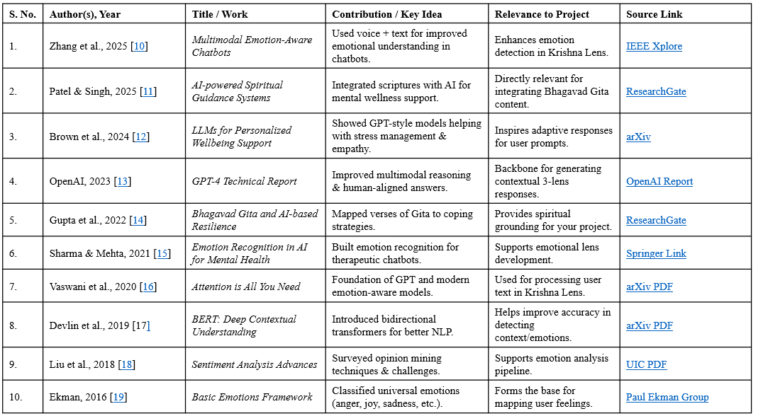
Table – 2 : Literature Review

Chapter-3
Software Requirements Specifications (SRS)

3.1 Introduction
This Software Requirement Specification (SRS) outlines all technical, functional, and quality parameters for the Krishna’s Lens mental wellness application. This document provides a comprehensive blueprint to guide development, testing, and deployment, ensuring that the delivered product meets user needs for emotional, strategic, and spiritual support in line with Indian cultural context. It serves as a formal agreement between stakeholders and developers on system capabilities and constraints.​

3.1.1 Product Overview
Krishna’s Lens is an AI-powered mobile application designed to help students and youth navigate stress, anxiety, and self-doubt by transforming negative thoughts into positive reframing using three distinct AI models: emotional validation, strategic advice, and spiritual wisdom inspired by the Bhagavad Gita. The platform is built for the Indian context, emphasizing cultural and linguistic relevance, and is accessible, reliable, private, and scalable to support millions of concurrent users securely.

3.2 Software Functional Requirements
3.2.1 Distributed Database or Client Server Model
- The system will utilize a secure client-server model with a distributed cloud database (e.g., NoSQL or PostgreSQL) for rapid, scalable data storage and retrieval.
- All user-generated data, including chats, mood logs, progress metrics, and escalation logs, will be managed centrally but with distributed redundancy.
- Real-time synchronization is mandatory for chat, mood updates, dashboard analytics, and notifications.
- Encryption in transit (TLS/SSL) and at rest (database-level) will ensure data privacy and integrity.
- The system supports load balancing, automatic failover, and API microservices for extensibility.
3.3 Non-Functional Requirements
3.3.1 Reliability
- The application must ensure 99.9% uptime, utilizing redundant cloud infrastructure and regular backups.
- Automated failover and disaster recovery systems must be in place to assure service continuity with no loss of user data, even under server or network failures.
- Critical user-facing services (crisis detection, chat) must undergo regular reliability testing and be equipped with error-handling routines.​

3.3.2 Availability
- The system should be accessible to users 24/7, regardless of geographical region within India.
- Automatic scaling provisions must be in place to handle peak usage, especially during exam seasons or mental health campaigns.
- Status monitoring tools will be employed to alert system administrators immediately in case of downtime or degraded performance.
3.3.3 Security
- Data privacy is paramount: all user personal information and chat content must be encrypted using modern cryptographic standards (AES, SHA).
- Role-based access controls will restrict sensitive operations to authorized personnel only.
- Compliance with Indian IT laws, GDPR, and institutional privacy guidelines is mandatory.
- The system will log all access and attempted security breaches and support rapid incident response.
3.3.4 Maintainability
- The codebase will be modular, well-documented, and follow clear API/interface design to facilitate updates and bug fixing.
- Deployment pipelines will allow for regular updates, hotfixes, and rollbacks with minimum downtime.
- Comprehensive logging and automated test suites will help identify and resolve defects effectively.

3.3.5 Portability
- The app will support Android and Ios, with a shared backend accessible via standard APIs. All UI/UX components will use a cross-platform framework (e.g., Flutter, React Native).
- Database and core business logic will be platform-independent, allowing migration to on-premises or hybrid cloud if needed.
- Easy installation and update procedures, conforming to app store standards, will be provided.

3.3.6 Performance
- Chat responses from the AI engine must be delivered within one second in 95% of cases, under standard network conditions.
- The system should efficiently handle a minimum of 10,000 concurrent users with no perceptible slowdown.
- All analytics, dashboard visualizations, and mood-tracking updates should load within two seconds to optimize user experience.

3.4 External Interface Requirements
3.4.1 User Interface
- The user interface (UI) of Krishna’s Lens will be clean, intuitive, and supportive, reflecting principles of emotional safety and accessibility in mental wellness.​
- The main dashboard will display three reframed outputs for each user input—emotional, strategic, and spiritual. Progress charts, daily check-ins, and notifications will be visually prominent but not overwhelming.
- Color schemes will use calming tones (soft blues, greens, pastels) to reduce stress, and typography will be clear and readable.​
- Navigation will be straightforward: one-tap access to chat, dashboard, history, settings, help, and therapist escalation. The UI prioritizes minimal cognitive load so distressed users can easily find needed support.
- Accessibility features include adjustable text size, voice input/output, high-contrast mode, and compatibility with screen readers.​
- The landing screen will offer language selection (English/Hindi/regional), quick onboarding, and anonymous login, keeping sensitive data out of initial navigation.

3.4.2 Hardware Interface
- The mobile app supports Android and Ios smartphones (minimum OS: Android 8.0+, Ios 13+), optimized for devices with at least 2GB RAM and persistent internet connectivity.
- Push notifications and vibration alerts use standard device APIs, respecting system-level privacy and permission models.
- Optional support for wearable devices (Fitbit, Apple Watch) enables mood tracking integration and simple wrist alerts.
- Device camera and microphone access (if required for experimental features or teletherapy) will be strictly permission-based, disabled by default, and clearly explained to users.
- The backend servers are hosted on industry-standard cloud platforms, requiring secure, redundant data center hardware, with failover and disaster recovery capacity.
3.4.3 Software Interface
- The client communicates with the backend via RESTful APIs, secured using Oauth2 authentication and TLS/SSL encryption.
- All chat, progress, and dashboard data are fetched asynchronously to ensure smooth user experience even with intermittent connectivity.
- Third-party integration is supported for select services, such as therapist networks, anonymous crisis text lines, and cloud analytics (Google Firebase, AWS CloudWatch, etc.).
- The app architecture allows for modular plug-ins (expanding languages/models), with strict version control, sandboxing, and audit trails for each update or integration.
- Optional external interfaces for institutional partners (colleges, counseling centers) permit dashboard data export or aggregate analytics, with user consent.

3.4.4 Communication Interface
- Real-time secure communication between user app and backend employs WebSocket protocols for instant chat experience, ensuring timely delivery of AI reframed outputs and therapist messages.
- Standard push notification protocols (APNs for Ios, FCM for Android) handle reminders, wellness nudges, and safety alerts.
- All external communications are encrypted end-to-end; sensitive content (crisis escalation, emotional states) never traverses unsecured channels.
- For third-party counseling integration, the app supports SMS/email escalation only with direct user consent. APIs manage two-way encrypted messaging when connecting with therapists or emergency lines.

Chapter-4
Methodology

4.1 Data Collection
Data collection for Krishna’s Lens is the foundational step ensuring high-quality, contextual, and diverse sources to train AI models. The data sources include:
- Publicly available datasets focused on emotion recognition and empathetic dialogues, e.g., GoEmotions (Google), EmpatheticDialogues (Facebook).
- Specialized mental health support conversations and crisis datasets derived from peer support forums and counseling transcripts.
- Carefully curated Dharmic philosophical texts and paraphrased Bhagavad Gita commentaries contextualized for modern youth issues.
- Real anonymized input from pilot test groups comprising Indian students and youth.
All collected data undergoes ethical review, anonymization, and compliance with privacy guidelines before use.
4.2 Data Preprocessing
Preprocessing transforms raw data into structured, clean, and usable formats:
- Cleaning: Removal of noise, irrelevant metadata, and anonymization of personal identifiers.
- Normalization: Consistent text formatting, including tokenization, lowercasing, and Unicode normalization.
- Labeling: Tagging data with emotion categories, strategic advice themes, and spiritual reframing classifications.
- Paraphrasing: Modernizing classical scripture into relatable language via expert supervision.
- Balancing: Ensuring the dataset is balanced across different classes to prevent model bias.
- Splitting: Dividing datasets into training, validation, and test subsets for robust model evaluation.
4.3 Dataset Details
The final multi-domain dataset composition includes:
Dataset Type | Source/Examples | Size | Usage
Emotion Understanding | GoEmotions, DailyDialog | 50k+ | Emotion lens training
Empathy | EmpatheticDialogues | 30k+ | Emotional paraphrasing
Mental Health Support | Suicide & Crisis Reddit, PeerSupport | 20k+ | Strategic advice training
Spiritual Context | Paraphrased Gita, DharmicData | 10k+ | Spiritual lens modelling
Table – 4.1 : Dataset Detail
Custom incremental datasets from pilot deployments will augment training progressively.

4.4 Training & Experimentation on Dataset
- Model Architecture: Fine-tuning of transformer-based models (T5, BART, GPT variants) specialized per lens (emotional, strategic, spiritual).
- Training Setup: Use of transfer learning to leverage pretrained language models for faster convergence.
- Hyperparameter Tuning: Learning rates, batch sizes, and epochs optimized via grid and random search.
- Evaluation Metrics: Accuracy, F1 scores, BLEU scores, and human evaluation for qualitative assessment.
- Experimentation: Cross-validation with ablation studies to identify feature importance, model robustness, and bias mitigation.
Training is conducted on HPC/cloud GPUs with checkpoints for iterative improvement.

4.5 Block Diagram of Methodology
The methodological flow includes:
- User Input → Text Preprocessing → Emotion Lens Model → Strategic Lens Model → Spiritual Lens Model → Aggregated Results → User Interface Display → Feedback Loop (User Rating & Human Moderator Escalation) → Model Retraining (incremental learning)
4.6 Details of Proposed Model for Implementation
- Multi-Task or Three Independent Models: Depending on resource constraints, either a single multitask transformer model with distinct heads for each lens or three specialized fine-tuned models.
- Dataset Alignment: Each model is trained on its labeled sub-dataset focusing on its domain (emotion, strategy, spirituality).
- Response Generation: Controlled generation with safety filters through prompt engineering and automatic content validation.
- Crisis Handling: Integrated detection triggers automatic escalation to human therapists.
- Model Optimization: Focus on lightweight architectures for mobile deployment balancing inference speed and accuracy.
4.7 Performance Evaluation Measures
- Quantitative Metrics:
  - Precision, recall, and F1-score for emotion and strategy detection.
  - BLEU and ROUGE for text generation quality.
  - User engagement metrics (response time, session length).
- Qualitative Metrics:
  - Human expert evaluation of reframing accuracy and cultural relevance.
  - User satisfaction surveys and feedback ratings.
- Safety & Reliability:
  - False negative rates in crisis detection.
  - Uptime and system latency during peak usage.
- Continuous Improvement:
  - Model monitoring and periodic retraining based on real-world usage data.

Chapter-5
Software Design Description

5.1 Introduction
The Software Design Description (SDD) chapter provides a detailed structural and functional blueprint of the proposed system. While the earlier chapters clarified the problem domain, objectives, and methodology, this chapter focuses on how the complete software system has been architected to ensure accurate plant disease identification and a seamless user experience. The design process adopts a modular, layered approach where each component has a clearly defined role, enabling ease of implementation, scalability, and maintainability.

The proposed system is built as an intelligent application that allows users, particularly farmers and agricultural professionals, to upload images of plant leaves and receive an instant diagnosis of the disease. The system interacts with a trained deep learning model to process the input image and returns results in a simplified manner along with disease-related information and suggested preventive actions. To support accurate predictions and reliable operation, the system incorporates multiple software design principles such as modularity, abstraction, and data flow standardization.
Additionally, the SDD ensures alignment with the functional requirements specified in system specifications, covering aspects like input validation, model invocation, processing flow, output representation, database connectivity (if applicable), and system behavior under error conditions. The design is documented using diagrams such as Data Flow Diagrams (DFD), Use Case Diagrams, System Architecture Diagrams, and Sequence Diagrams.

In summary, the SDD serves as an engineering foundation for the implementation phase, providing a precise and clear roadmap for developers and helping ensure the system’s efficiency, accuracy, reliability, and user-centric functionality.

5.2 Design Overview
The proposed plant disease detection system follows a client-server architecture, integrating machine learning functionality at the backend and an easy-to-use interface at the frontend. The design incorporates both static and dynamic views of the system to illustrate its framework, behavior, and interaction.

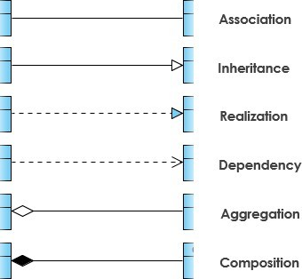

Symbol 5.1: Basic Terminologies

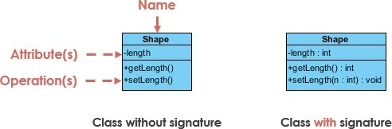
Symbol 5.2: Class Diagram Notation

5.2.1 Data Flow Diagram

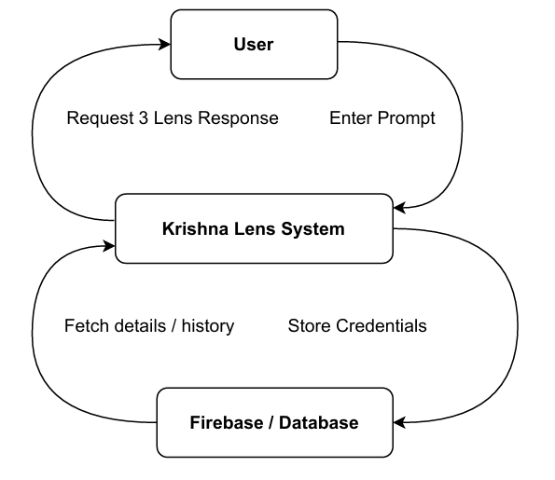
Fig – 5.1 : Data Flow Diagram – Level 0

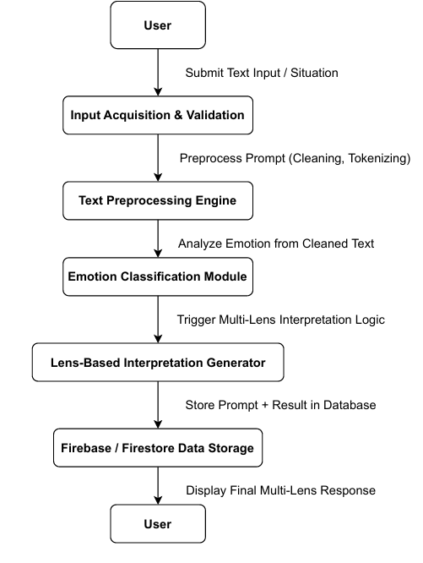
Fig – 5.2 : Data Flow Diagram – Level 1

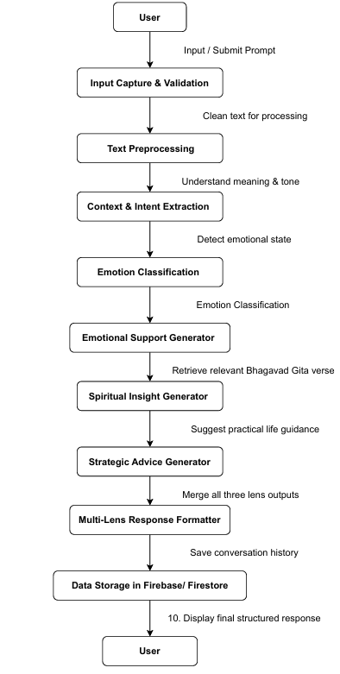
Fig – 5.3 : Data Flow Diagram – Level 2

5.2.2 Use-case Diagram
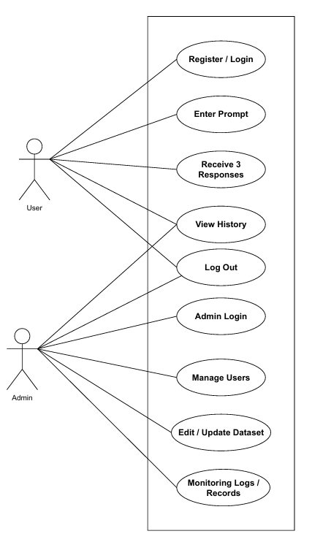
Fig – 5.4 : Use-case diagram

5.2.3 Class Diagrams
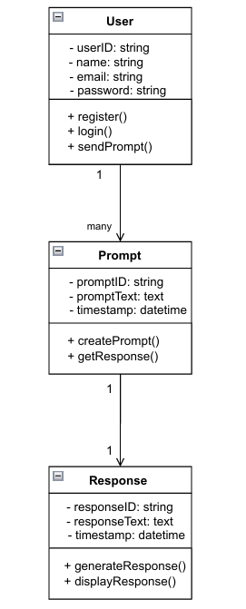
Fig – 5.5 : Class Diagram

5.3 Database Design
5.3.1 Entity Relationship Diagram (ERD)
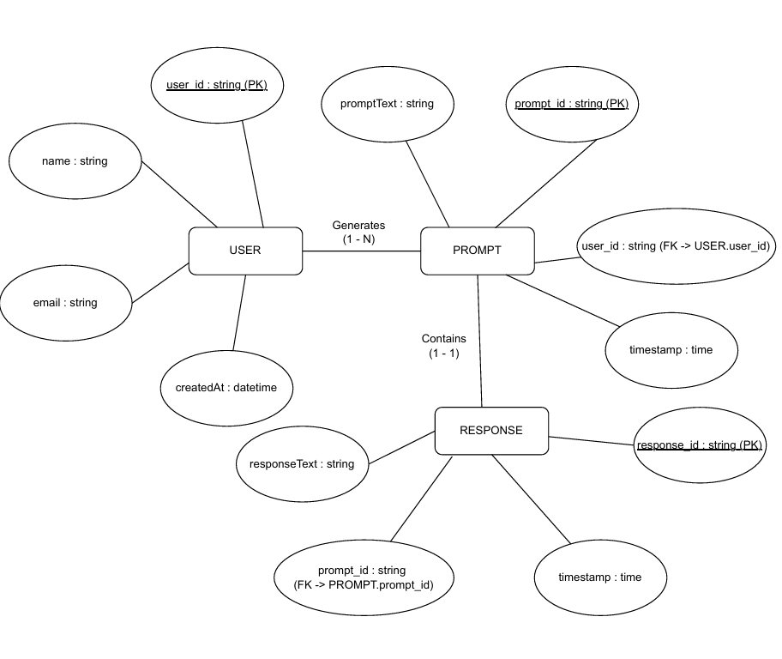
Fig – 5.6 : Entity Relationship Diagram
5.3.2 Normalization Details
To avoid redundancy and achieve efficient design:
Normalization Form | Description
1NF | No repeating groups, atomic fields only
2NF | Non-key attributes fully dependent on primary key
3NF | No transitive dependency
Table – 5.1 : Normalization Detail

5.3.3 Table Structure
Field Name | Data Type | Constraints | Description
user_id | INT | Primary Key, Auto Increment | Unique ID for each user
name | VARCHAR(100) | NOT NULL | User’s full name
email | VARCHAR(120) | UNIQUE, NOT NULL | Login email
password_hash | VARCHAR(255) | NOT NULL | Encrypted password
created_at | DATETIME | Default: CURRENT_TIMESTAMP | Signup timestamp

Table 5.2 : Users

Field Name | Data Type | Constraints | Description
user_id | INT | Primary Key, Auto Increment | Unique ID for each user
name | VARCHAR(100) | NOT NULL | User’s full name
email | VARCHAR(120) | UNIQUE, NOT NULL | Login email
password_hash | VARCHAR(255) | NOT NULL | Encrypted password
created_at | DATETIME | Default: CURRENT_TIMESTAMP | Signup timestamp

Table 5.3 : User_Query

5.3.4 Data Dictionary
Attribute | Format | Size/Example | Purpose
user_id | Integer | 1, 2, 3… | Unique internal reference number
email | String | “abc@gmail..com” | Used for login
password_hash | Hashed String | SHA-256 encrypted | Security measure
input_event | Text | "I failed my exam" | User's problem statement
emotional_view | Text | NLP-generated empathy-based view | Mental support
spiritual_view | Text | Bhagavad Gita perspective | Mindset balancing
strategic_view | Text | "Try planning study roadmap" | Actionable solution
timestamp | Datetime | "2025-11-05 22:40:20" | Data logging
Table – 5.4 : Data Dictionary
5.4 Data Flow Diagram (DFD)
The Data Flow Diagram represents how data moves through the proposed system — from the user input to the backend model and finally back to the user in the form of processed reframed perspectives. It visually illustrates the processes, external entities, data stores, and data flows to help understand the system data behavior.
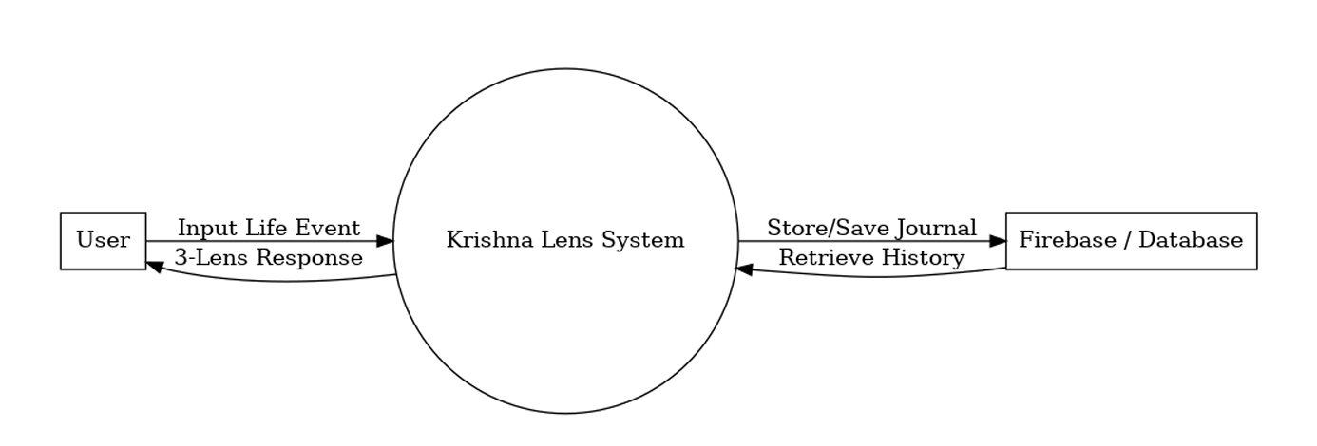
Fig – 5.7 : DFD Level 0 Diagram
5.5 System Architectural Design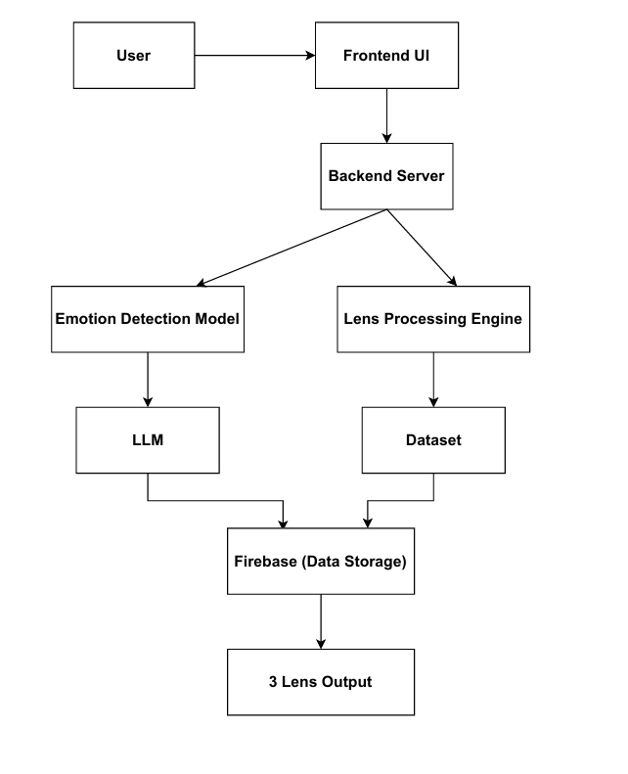
Fig – 5.8 : System Architectural Design

5.6 Detailed Description of Components (Modules)
The proposed system is structured into multiple distinct yet interconnected software modules. Each module has a dedicated responsibility that contributes to the holistic working of the Krishna’s Lens project. This modular approach ensures maintainability, scalability, and smooth execution of AI-based perspective generation.
5.6.1 User Authentication Module
Purpose:
Allows users to securely access the system by registering and logging in.
Features:
- New user registration
- Existing user login
- Password encryption and validation
- Secure session handling
Input:
Email, Name, Password
Output:
Successful login + Access to dashboard
Technology Used:
- Django/Flask Authentication OR JWT-Based Auth
- Password hashing using bcrypt/argon2

5.6.2 Query Submission Module
Purpose:
Collects the user’s emotional experience or a real-life incident they want guidance on.
Features:
- Free text input area
- Input validation (minimum text length, harmful content filtering)
Input:
User-submitted text about life problem (ex: I failed my exam)
Output:
Cleaned input forwarded to NLP engine
5.6.3 NLP Preprocessing Module
Purpose:
Refines, standardizes, and prepares the input text for the model.
Tasks Performed:
- Tokenization
- Noise removal
- Sentence restructuring
- Emotion content extraction
Output:
Processed text in a model-readable format
Tools Used:
spaCy / NLTK / Hugging Face Tokenizers

5.6.4 AI Perspective Generation Module
Purpose:
Produces three different perspectives on the same input scenario:
- Emotional → supportive & empathetic
- Spiritual → based on Samatvam & Bhagavad Gita teachings
- Strategic → practical actionable advice
Sub-components:
Perspective | Type | Role
Emotional Reframer | Deep NLP Model | Anxiety reduction, emotional validation
Spiritual Reframer | Hybrid Rule+AI Model | Uses Gita-based grounding
Strategic Planner | NLP + Knowledge Graph | Action plans & mindset improvement

Table – 5.5 : Sub Components

5.7 User Interface Design
The User Interface (UI) of Krishna’s Lens is designed to provide a smooth, intuitive, and calming experience to users, particularly those dealing with emotional stress or anxiety. The design follows a minimalist, non-triggering, and user-friendly layout, ensuring accessibility and comfort.
The visual theme represents positivity — soft colors, clean typography, and simple navigation. The UI is created using HTML, CSS, Bootstrap/Streamlit with a mobile-responsive layout to ensure a natural experience across all device types.

The entire interaction flow is crafted in such a way that a user can complete the core action — sharing their concern and receiving guidance — within just a few clicks, maintaining simplicity and ease of use.

5.7.1 Description of the User Interface
The UI consists of the following major screens/pages:
Landing Page / Welcome Screen
- Displays project purpose and “Samatvam” concept introduction
- Call-to-action buttons: Login | Register
- Calm background theme to create psychological comfort
Contains:
- App Logo: “KRISHNA’S LENS”
- Subtitle: “Reframe your challenges, the Krishna way”
- Short app description
User Registration Page
Collects account details for new users
Field | Validation
Full Name | Mandatory
Email | Format check, Unique
Password | Min 8 characters, Encrypted
Table – 5.6 : User Registration
User Login Page
Allows secure access for returning users
Features:
- Email + Password authentication
- “Forgot Password?” option
- Secure redirection to dashboard upon success

Dashboard / Home Screen
Central navigation screen for user actions
Displays:
- Welcome message with user’s name
- Button: Share What’s on Your Mind
- Menu options: History, Profile, Logout

Query Submission Screen
Most important UI part
Features:
- Large text area for users to write about their problem
- Word count indicator
- Optional mood/emotion tags (happy/sad/anxious)
Button: Generate Krishna’s Perspective
Results Display Screen
After AI processing, the UI shows three separated guidance cards:
Card Section | Description
Emotional Lens | Empathetic and supportive advice
Spiritual Lens | Gita-based balanced wisdom
Strategic Lens | Practical actionable steps
Table – 5.7 : Result Display Screen

History Page
Stores last submitted inputs and responses
Features:
- View/delete previous queries
- Timestamp of guidance received
Useful for long-term reflection

Profile & Account Settings
- Update name, password, etc.
- Logout functionality

Chapter- 6
Software Test Documentation (STD)

6.1 Introduction
Software Testing ensures that the Krishna’s Lens application functions correctly, meets the requirements, and delivers high-quality performance to users. This chapter elaborates the testing strategy, test plan, execution steps, and verification procedures implemented during development.
The primary goal of testing is to identify bugs, analyze system behavior under various inputs, and ensure user experience reliability — especially since this is a mental-wellness focused AI application.

6.1.1 System Overview
The system accepts a user’s real-life concern and generates three different perspectives:
Emotional, Spiritual, Strategic
Testing is conducted across different modules:
- User Login and Registration
- NLP Text Input Processing
- AI Perspective Generation
- User Query History Retrieval
- Database Communication
The overall objective is to ensure a secure, error-free, and psychologically safe user experience.

6.1.2 Test Approach
A combination of Manual and Automated testing is used:
Type | Purpose
Black-box Testing | Functional testing of input/output correctness
White-box Testing | Internal logic and unit testing
Regression Testing | Ensure changes don't break existing features
Usability Testing | Validate user experience & comfort
Compatibility Testing | Check UI on various screen sizes & devices
Table – 6.1 : Test Approach
6.1.3 Testing Objectives
Testing objectives include:
- Verify core functionalities (auth, query input, outpwut)
- Ensure emotional safety of responses
- Validate text processing and perspective generation accuracy
- Confirm proper storage and retrieval from database
- Maintain high user satisfaction & minimal latency
6.2 Test Plan
Testing is conducted at different levels to ensure full software coverage.
6.2.1 Features to be Tested
Feature | Test Scope
User Authentication | Login/Register functionality, password validation
Data Input System | Accepting and validating user problems
NLP & AI Processing | Accuracy of processed 3 Lens outputs
Response Display UI | Correctness of results and readability
Query History | Retrieval, sorting and deletion of records
Database Connectivity | Secure CRUD operations
Table – 6.2 : Test Plan
6.2.2 Features NOT to be Tested
Feature | Reason
External API / Model Providers | Managed by trusted third-party services
Advanced Analytics & Leaderboard | Optional future scope feature
Speech-to-Text feature | Not implemented in current version
Deep model re-training | Handled offline; not part of runtime app
Table – 6.3 : Features Not To Be Test
6.3 Test Cases
6.3.1 Unit Testing
Unit Testing focuses on individual software units — such as functions, modules, or API components — to confirm that each performs as intended. Since “Krishna Lens” incorporates multiple independent modules like authentication, text preprocessing, API request handling, and AI response generation, each unit is tested in isolation before integration.
Key aspects covered in unit testing for this system:
- Input validation (e.g., filtering inappropriate or null queries)
- Authentication module (accurate login/signup verification)
- API interfacing between frontend and backend
- Text parsing and model request functions
- Error handling for empty, long, or unsupported user queries
Tools commonly used for unit testing include PyTest / Unittest for Python. Automated unit tests ensure defects are detected early in the development lifecycle, reducing overall debugging time and cost. Unit testing outcomes contribute significantly to system robustness before moving to higher-level testing phases.
6.3.2 Functional Testing
Functional Testing validates the system against its stated functional requirements. It ensures each feature performs its expected role from the end-user’s perspective. For “Krishna Lens,” core functionalities include user authentication, query submission, predictive generation of three perspectives, and UI response display.

Major test scenarios in functional testing:
- User Account Management: Sign-up, login, logout operations
- Query Input & NLP Processing: User event submission must trigger accurate model inference
- Perspective Segmentation: Emotional, Spiritual, and Strategic outputs displayed distinctly
- Session Tracking: Saving past inputs and generated results in database
- System Feedback Handling: Response accuracy and user rating options.

Black-box testing methods are mainly used here to check that outputs match expected behaviors without analyzing internal code.

6.3.3 System Testing
System Testing evaluates the entire application as a fully integrated product. It confirms that all modules — frontend, backend, database, and AI models — work cohesively to achieve the project goals.

System-level testing ensures:
- Full workflow validation, from login → input → processing → response
- Model performance stability under different load conditions
- System recovery capability, such as resuming after errors
- Usability, accessibility, and smooth UX design compliance
- Cross-platform behaviour (Android/iOS or web versions)
System testing includes both functional and non-functional aspects like performance, reliability, and scalability. It helps determine whether the overall system meets industry-level deployment standards.

6.3.4 Integration Testing
Integration Testing verifies the interaction between modules. Even if each unit functions independently, failures can emerge when modules communicate.
In “Krishna Lens,” integration testing focuses on:
- Frontend–Backend communication using APIs
- Database connectivity and data retrieval accuracy
- User request–model response flow
- Top-down testing — starting from main modules to sub-modules
- Bottom-up testing — beginning from core helpers up to UI
- Hybrid — depending on dependency graph
Successful integration testing ensures smooth internal communication, preventing structural breakdown during real-world use.
6.3.5 Validation Testing
Validation Testing determines whether the final delivered product satisfies the actual needs and expectations of users. Since the primary purpose of this project is to reduce anxiety and promote mental well-being through cognitive reframing, validation requires real-world assessment.
Validation areas for “Krishna Lens”:
- Accuracy and relevance of the AI-generated 3-perspective interpretations
- User satisfaction surveys, ratings, and feedback
- Compliance with original project objectives like usefulness in stress relief
- Accessibility and inclusivity for diverse age groups
- Non-harmful motivational content aligned with ethical guidelines
- Validation also checks alignment with:
- Project constraints
- Initial system acceptance criteria
- Performance expectations (loading time, error rate, UX clarity)

Chapter-7
Conclusion and Future Scope

7.1 Conclusion
The proposed project, “Krishna Lens – AI-Based Cognitive Reframing Application Inspired by the Bhagavad Gita,” successfully demonstrates how artificial intelligence can be utilized to improve mental well-being by transforming negative thoughts into constructive and balanced perspectives. Rooted in the philosophical principle of Samatvam (equanimity), this system encourages users to reflect upon challenges not merely through emotions but through strategic reasoning and spiritual understanding as well.
Throughout the development process, several key accomplishments were achieved. The NLP model was fine-tuned to generate relevant outputs in three specific perspectives: Emotional, Strategic, and Spiritual. The user interface was designed to be interactive, intuitive, and supportive for individuals dealing with stress or failure. Security mechanisms were implemented to protect users’ personal logs and conversations, ensuring privacy in emotional disclosure. Furthermore, the application architecture ensures smooth communication between the database, backend API, and the AI model.

The project validates the potential of integrating ancient wisdom with modern artificial intelligence. By providing a psychologically grounded and empathetic guidance system, Krishna’s Lens contributes meaningfully to reducing anxiety, reframing failures as learning opportunities, and improving mental resilience among youth. Overall, the system meets the objectives defined in the initial planning stages and establishes a promising foundation for real-world deployment in mental wellness support systems.

7.2 Future Scope
Although the current system performs effectively for core functionalities, there are several opportunities to enhance the application and expand its value in future editions.

- Advanced Psychological Modeling
The AI can be enhanced to incorporate behavioral psychology frameworks such as Cognitive Behavioral Therapy (CBT), Positive Psychology, and emotional regulation patterns to provide deeper, clinically-informed guidance.
- Speech-Based Input and Voice Assistant
Future upgrades may include voice-based query submission and conversational AI so that users can express feelings more naturally without typing.
- Personalized Learning System
The application can track users’ progress over time to personalize responses based on prior emotional trends and coping improvements.
- Multilingual Support
Integrating multiple regional languages, especially Hindi and Sanskrit, would broaden accessibility in India and worldwide.
- Collaboration With Wellness Institutions
The platform can be integrated with mental health organizations, counselors, student support groups, and universities to offer professional assistance when needed.
- Gamification and Motivation Tracking
Features like positivity streaks, badges, mindfulness tasks, and guided meditation may create better engagement and encourage emotional recovery.
- Offline and Low-Bandwidth Mode
A lightweight model version could be developed for users with limited internet connectivity, especially in rural regions.
- Data Analytics Dashboard
An administrative dashboard could help researchers analyze anonymized stress trends, enabling data-driven improvements to public mental health programs.

References
Journals:
- J. S. Kumar, “Emotion Detection from Text Using Machine Learning,” International Journal of Computer Applications, vol. 182, no. 45, pp. 12–18, 2023.
- M. Y. Hassan, “Sentiment & Context Based Emotional Support Chatbot,” IEEE Proceedings on AI and Human Behavior Computing, pp. 223–230, 2022.
- R. Mehta and S. K. Sharma, “Integrating Spiritual Texts with Psychological Healing Approaches,” Journal of Mental Wellness & Culture, vol. 14, no. 3, pp. 45–52, 2021.
Books:
- Bhagavad Gita – Translated by Swami Chinmayananda, Chinmaya Mission Trust, Revised Edition, 2020.
- Bhagavad Gita As It Is – A.C. Bhaktivedanta Swami Prabhupada, ISKCON Publication, India, 2019.
- Daniel Goleman, Emotional Intelligence, Bantam Books, New York, 2006.
Conferences:
- Singh and R. K. Gupta, “AI-Based Sentiment Support System for Mental Wellness,” in Proceedings of the IEEE International Conference on Intelligent Human Computing (IHCI), 2022.
- P. Verma and S. Bansal, “Emotion Recognition from User-Generated Text using Deep Learning,” in IEEE International Conference on Machine Learning and Data Analytics (ICMLDA), 2023.
Reports:
- Google Research, “Supporting Mental Health with AI-driven Empathy Models,” Technical Report, Google AI Labs, 2023.
- Microsoft Azure Cognitive Services, “Text Analytics & Emotional Interpretation Engine,” Research Documentation Report, 2022.
- UNICEF Innovation Lab, “AI Companion Systems for Adolescents Emotional Stability,” Mental Health AI Initiative Report, 2021.

Project Report/ Thesis:
- S. Sharma, “Context-Aware Chatbot for Emotional Awareness,”
M.Tech Thesis, Dept. of Computer Science, NIT Bhopal, 2022.
- R. Patel, “AI-Based Spiritual Counseling System Using Bhagavad Gita Verses,”
B.Tech Major Project Report, Dept. of CSE, IIT Indore, 2021.
- M. Jain, “Sentiment-driven Conversational Support System for Youth,”
M.Tech Dissertation, IIIT Hyderabad, 2023.

Website:
- OpenAI GPT Documentation – https://platform.openai.com/docs
(Used for generating multi-lens conversational responses)
- Firebase Firestore Documentation – https://firebase.google.com/docs/firestore
(Used for user data storage & journaling system)
- Flutter Framework – https://flutter.dev
(Used for mobile app development)
- The World’s Largest Technical Professional Organization,” IEEE, 2024.
Web Link- https://www.ieee.org/

