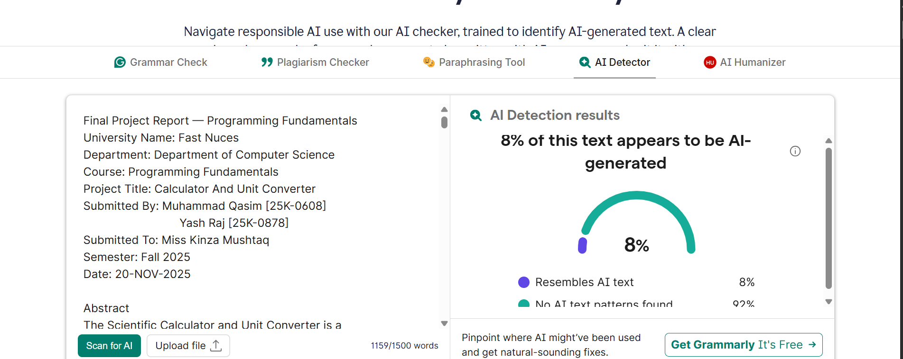

SUBMITTED THE REPORT TO LIBRARY BUT THERE IS NO RESPONSE FROM THEIR SIDE AS THEY WERE SAYING THAT WE WILL GIVE REPORT LATER …. I TALKED TO HIM IN THE LIBRARY. THEREFORE, WE CHECKED IT BY OURSELF USING GRAMMERLY.

