SOFTWARE REQUIREMENT SPECIFICATION
AND PROJECT REPORT
ON
HELPING HANDS

Submitted By
Sr. No. | Name | Enrolment Number | Class & Semester
1 | BHAVYA SOLANKI | 25CI2110109 | MCA Semester III Div.- B
2 | YASH SONI | 25CI2110112 | MCA Semester III Div.- B
3 | JAY VAGHELA | 25CI2110125 | MCA Semester III Div.- B

Submitted To
Faculty Guide: Prof. Unnati Parmar
Academic Year: 2026-2027

Shri Chimanbhai Patel Post Graduate Institute of Computer Applications
Master of Computer Applications (MCA) Programme
Chimanbhai Patel Institute Campus, Sarkhej - Gandhinagar Highway,
Ahmedabad.

Submitted in partial fulfilment of the requirements for the degree of Master of
Computer Applications as part of the Semester 3 part-time project.

COLLEGE CERTIFICATE

PROJECT DETAILS
Project Title | Helping Hands
Purpose | HelpingHands aims to provide a centralized platform connecting Volunteers, NGOs, and Corporate Organizations.  It ensures the verification of organizations before they canoperate on the platform.  The system validates volunteer attendance using GPS-based location evidence.  It also tracks participation hours and CSR funding to ensure transparency, accountability, and traceability
Technologies Used: | React.js, FastAPI, PostgreSQL, JWT Authentication
Front End | React.js, HTML, CSS, JavaScript, Bootstrap
Back End | FastAPI
Database | PostgreSQL
Other Tools | Visual Studio Code
Submitted To | Sardar Vallabhbhai Global University
Academic Term | Semester -3 (2026-2027)
Faculty Guide | Prof. Unnati Parmar
Submitted By | Bhavya Solanki–25CI2110109  Yash Soni–25CI2110112  Jay Vaghela–25CI2110125

ACKNOWLEDGEMENT

We would like to express our sincere gratitude to Sardar Vallabhbhai Global University for providing us with the opportunity and resources to work on the project “Helping Hands.”

We are thankful to our faculty guide, Prof. Unnati Parmar, for her valuable guidance, support, and feedback throughout the development of this project.

We would also like to thank our faculty members, friends, and everyone who supported us directly or indirectly during the completion of this project.

Finally, we thank all the team members for their cooperation, effort, and contribution towards successfully completing the Helping Hands project.

Thank You,
Bhavya Solanki–25CI2110109
Yash Soni–25CI2110112
Jay Vaghela–25CI2110125

TABLE OF CONTENTS
Section No. | Contents |  |  | Page No.
1 | Introduction
 | 1.1 Purpose
 | 1.2 Scope
2 | System Analysis
 | 2.1 Existing System
 | 2.2 Need for the New System
 | 2.3 Objective of the New System
 | 2.4 Problem Definition
 | 2.5 Core Components
3 | Advantages & Limitations  Proposed System | of | the
 | 3.1 Advantages
 | 3.2 Limitations
4 | Requirement Determination
 | 4.1 Functional Requirements
 | 4.2 Targeted Users
5 | System Design
 | 5.1 System Flow-Chart
 | 5.2 Use Case Diagram
 | 5.3 Activity Diagram
 | 5.4 System Architecture
 | 5.5 Sequence Diagram
 | 5.6 Class Diagram
 | 5.7 Data Dictionary
6 | Development
 | 6.1 Coding Standards
 | 6.2 Screenshots
7 | Agile Documentation
 | 7.1 Agile Project Charter
 | 7.2 Agile Read Map / Schedule
 | 7.3 Agile Project Plan
 | 7.4 Agile User Story
 | 7.5 Agile Release Plan
 | 7.6 Agile Sprint Backlog
 | 7.7 Agile Test Plan
8 | Proposed Enhancements
9 | Conclusion
10 | Bibliography

- INTRODUCTION

Helping Hands is a web-based platform designed to connect volunteers, NGOs, and corporate organizations on a common platform for volunteering and Corporate Social Responsibility (CSR) activities. The system provides a structured way for NGOs to publish volunteering opportunities, volunteers to discover and apply for activities, and corporate organizations to participate in or support social initiatives.

The platform also helps manage volunteer participation through features such as opportunity applications, GPS-based attendance, volunteering hours, activity records, and organization verification. NGOs and corporate organizations can submit their details for verification, which helps maintain reliable organization information on the platform.

To support platform-level management, the system includes a separate Platform Operator Panel through which the platform operators can perform operational and organization-verification activities.

The CSR funding functionality in the current system is implemented as simulated transactions for demonstration purposes. No actual money is transferred through the platform.

Overall, Helping Hands provides a centralized digital environment for coordinating volunteering activities, connecting different stakeholders, maintaining participation records, and supporting CSR-related collaboration.

  - Purpose

The purpose of the Helping Hands system is to provide a digital platform that connects volunteers, NGOs, and corporate organizations for volunteering and CSR activities. It simplifies the process of finding volunteering opportunities, managing participation, verifying organizations, tracking volunteering hours, and supporting CSR initiatives.

  - Scope

The scope of the Helping Hands system includes the following major functionalities:

  - Volunteer Management: Volunteers can register, maintain their profiles, browse available volunteering opportunities, and apply for suitable activities.

  - NGO Management: NGOs can register, provide organization details, create volunteering opportunities, and manage volunteer applications.

  - Corporate Organization Management: Corporate organizations can register, provide required organization details, participate in volunteering activities, and support CSR initiatives.

  - Opportunity Management: NGOs can create and manage volunteering opportunities with details such as activity information, requirements, location, and schedule.

  - Volunteer Participation: Volunteers can apply for opportunities and participate in approved activities.

  - GPS-Based Attendance: The system supports location-based check-in and check-out for volunteering activities and records participation time and volunteering hours.

  - Activity Records: The system maintains records related to volunteer participation, hours, certificates, and other relevant activities.

  - Organization Verification: NGO and corporate organization details can be reviewed and verified by platform operators.

  - CSR Support: Corporate organizations can support NGOs and volunteering opportunities through simulated CSR funding or sponsorship transactions for demonstration purposes. No real money is transferred through the system.

  - Platform Operator Panel: A separate Platform Operator Panel is provided for the platform operators to perform platform-level operational and verification-related activities.

- SYSTEM ANALYSIS

  - Existing System

Before platforms such as HelpingHands, volunteer coordination between individuals, NGOs, and corporate organizations happens through fragmented, manual channels — phone calls, WhatsApp groups, spreadsheets, and social media posts.

NGOs post volunteering opportunities without any centralized visibility or verification, and interested volunteers apply informally with no structured tracking of hours or participation.

Corporate organizations wishing to support CSR initiatives coordinate with NGOs through email exchanges and manually maintained spreadsheets, with no reliable way to confirm employee participation or verify that donated funds and volunteer hours were genuinely utilised.

Attendance at volunteering events is typically self-reported or tracked on paper, leaving it open to inflation or outright fabrication. There is no shared, trustworthy record of an individual's volunteering history, no standard way to verify an NGO's legitimacy before volunteers commit their time, and no transparent mechanism for corporates to confirm the real-world impact of their CSR contributions

  - Need for New System

A centralized platform is needed to bring Volunteers, NGOs, and Corporate Organizations onto one system where organizational legitimacy is verified before an NGO or Corporate can operate, volunteer attendance is confirmed through location-based evidence rather than self-reporting, and every hour of participation and every rupee of CSR funding is recorded transparently and traceably.

HelpingHands addresses this by combining verified onboarding, GPS-based attendance validation, and structured CSR collaboration in a single system.

  - Objective of the New System

The main objectives of the system are:
        - Provide a centralized platform connecting Volunteers, NGOs, and Corporate Organizations.
        - Allow only verified NGOs and Corporate Organizations to access organizational features.
        - Prevent fake volunteer attendance using GPS-based location verification.
        - Simplify volunteer application and event management.
        - Automatically calculate verified volunteer hours.
        - Generate participation certificates for eligible volunteers.
        - Improve NGO credibility through volunteer ratings and reviews.
        - Enable corporate organizations to financially support NGOs or sponsor specific volunteering opportunities.
        - Support employee volunteering through optional corporate affiliation.
        - Maintain transparent CSR participation records.
        - Design a scalable, layered architecture capable of supporting future enhancements without major redesign

  - Problem Definition

The volunteering and CSR ecosystem faces several challenges in managing activities and maintaining reliable records. Fake or inaccurate volunteer attendance can make it difficult to verify actual participation in volunteering activities. Unverified NGOs and organizations can create trust issues for volunteers and corporate organizations.

Manual calculation of volunteer hours can lead to errors and inconsistent records. CSR support activities may also lack clear and centralized records, making them difficult to track. There is limited collaboration between volunteers, NGOs, and corporate organizations when a common platform is not available. Additionally, the absence of centralized volunteer history and trust indicators makes it difficult to track participation and assess organizations effectively.

  - Core Components

The system consists of the following core components:

        - Volunteer Management – Handles volunteer registration, profiles, opportunity browsing, applications, and participation records.
        - NGO Management – Allows NGOs to register, provide organization details, create volunteering opportunities, and manage volunteer applications.
        - Corporate Management – Enables corporate organizations to register, participate in volunteering activities, and support CSR initiatives.
        - Volunteering Opportunity Management – Provides functionality for creating, viewing, and managing volunteering opportunities with details such as location, schedule, requirements, and activity information.
        - GPS-Based Attendance – Verifies volunteer attendance through location-based check-in and check-out and records the time spent in an activity.
        - Volunteer History and Hours Tracking – Maintains records of volunteer activities, participation hours, credits, and related achievements.
        - Organization Verification – Allows platform operators to review and verify NGO and corporate organization details.
        - CSR Support and Simulated Transactions – Enables corporate organizations to support NGOs or volunteering activities through simulated CSR funding or sponsorship transactions for demonstration purposes.
        - Platform Operator Panel – Provides a separate interface for platform operators to manage platform-level operational and verification activities.

- Advantages and Limitations of the Proposed System

  - Advantages

The main advantages of the system are:

          - Establishes a verified and trustworthy ecosystem for volunteering and CSR collaboration between volunteers, NGOs, and corporate organizations.

          - GPS-based Haversine distance verification makes fraudulent attendance significantly harder by verifying the volunteer's location during check-in and check-out.

          - Volunteer hours and participation records are maintained systematically, reducing the need for manual calculation and record keeping.

          - CSR activities and simulated transactions are tracked within the system, providing structured records for demonstration and reporting purposes.

          - Organization verification improves accountability by allowing NGO and corporate organization details to be reviewed through the Platform Operator Panel.

          - Centralized volunteer history helps maintain records of activities, participation hours, credits, and related achievements in one place.

          - Separate Platform Operator Panel provides a dedicated interface for platform-level operational and organization-verification activities.

          - Modular architecture allows the system to be extended with additional features and integrations in the future.

  - Limitations

The main limitations of the system are:

        - Organization verification requires platform operator involvement, which may introduce some delay in the verification process.

        - GPS accuracy depends on the volunteer's device and surrounding environment, and indoor locations or weak GPS signals may affect attendance verification.

        - CSR transactions are simulated and do not involve real financial transactions or transfer of money.

        - No native mobile application is available, so the platform is currently accessed through a web browser.

        - Internet connectivity is required for users to access the platform and perform activities such as opportunity browsing, applications, attendance, and record updates.

- Requirement Determination

  - Requirements

- Functional Requirements:

              - User Registration and Login – The system shall allow volunteers, NGOs, and corporate organizations to register and access the platform according to their respective user type.

              - Profile Management – Users shall be able to view and manage their profile and organization-related information.

              - Volunteering Opportunity Management – NGOs shall be able to create and manage volunteering opportunities by providing details such as activity description, location, schedule, requirements, and other relevant information.

              - Opportunity Browsing and Application – Volunteers shall be able to view available opportunities and apply for activities that match their interests.

              - Application Management – NGOs shall be able to view and manage applications submitted by volunteers for their opportunities.

              - GPS-Based Attendance – The system shall support location-based check-in and check-out for volunteering activities and verify the volunteer's location using GPS and distance calculation.

              - Volunteer Hours Tracking – The system shall record attendance duration and maintain volunteering-hour records for participating volunteers.

              - Volunteer History and Credits – The system shall maintain records of volunteer activities, participation hours, credits, and related achievements.

              - Certificate Generation – The system shall generate participation certificates in PDF format based on eligible volunteering activity records.
              - NGO and Corporate Verification – NGO and corporate organization details shall be submitted for verification and reviewed by platform operators through the separate Platform Operator Panel.

              - CSR Support – Corporate organizations shall be able to support NGOs or volunteering initiatives through CSR-related activities.

              - Simulated CSR Transactions – The system shall provide simulated CSR funding or sponsorship transactions for demonstration purposes without transferring real money.

              - Platform Operator Panel – The system shall provide a separate panel for platform operators to perform platform-level operational and organization-verification activities.

- Non-Functional Requirements
Non-functional requirements describe the quality, performance, security, and usability of the system.

            - Usability – The platform should provide a simple and understandable interface so that volunteers, NGOs, corporate organizations, and platform operators can use the system easily.

            - Performance – The system should respond to user requests within a reasonable time during normal usage.

            - Security – User and organization information should be protected through appropriate authentication, authorization, and secure handling of data.

            - Reliability – The system should maintain accurate records of user profiles, applications, attendance, volunteering hours, and other activities.

            - Maintainability – The system should have a modular structure so that individual features can be maintained or extended without significantly affecting other components.

            - Scalability – The system architecture should allow additional users, volunteering opportunities, organizations, and future features to be added as the platform grows.

            - Availability – The system should be accessible through a web browser whenever the application and required services are running and network connectivity is available.

            - Compatibility – The web application should work with commonly used modern web browsers and devices.

  - Targeted Users:

The Helping Hands is intended for the following categories of users:

        - NGOs: Organizations that conduct social and community activities. They can create volunteering opportunities, manage volunteer applications, and coordinate activities.

        - Volunteers: Individuals who want to discover and participate in volunteering activities. They can apply for opportunities, record their attendance and volunteering hours, and receive participation certificates

        - Corporate Organizations:Organizations that participate in volunteering activities and support social initiatives through CSR activities and simulated CSR transactions

        - Platform Operator:Platform operators who manage platform-level activities through the separate Platform Operator Panel, including NGO and corporate organization verification.

- SYSTEM DESIGN:

System Design describes the structure, behaviour, interactions, and data organization of the proposed Helping Hands. UML diagrams are used to represent different aspects of the system, while the Data Dictionary describes the data stored in the system.

  - System Flow-Chart:
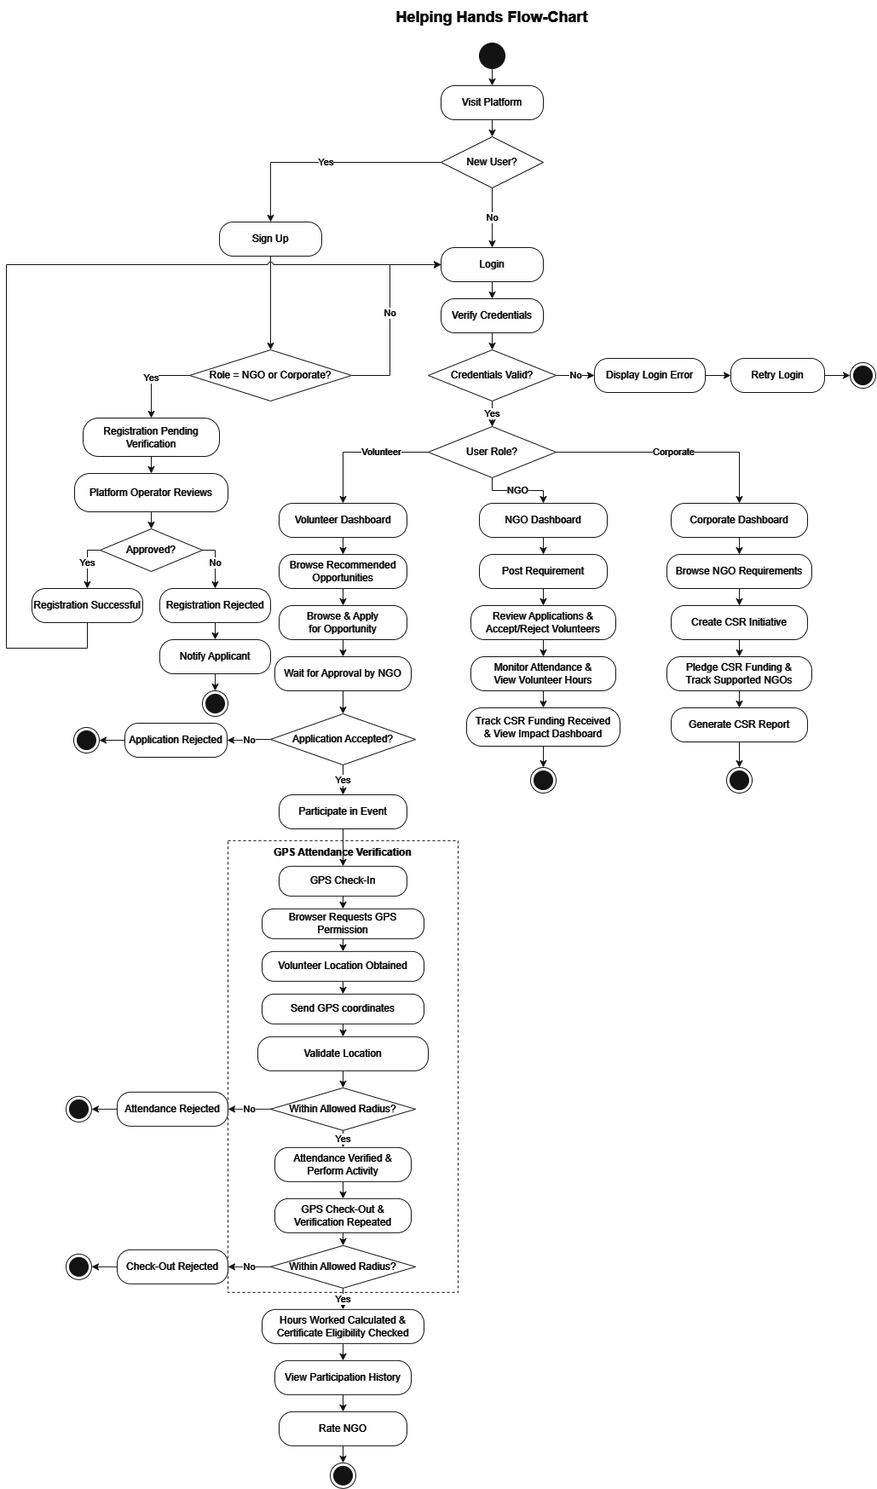
  - Use Case Diagram:

Use Case Diagram Volunteer

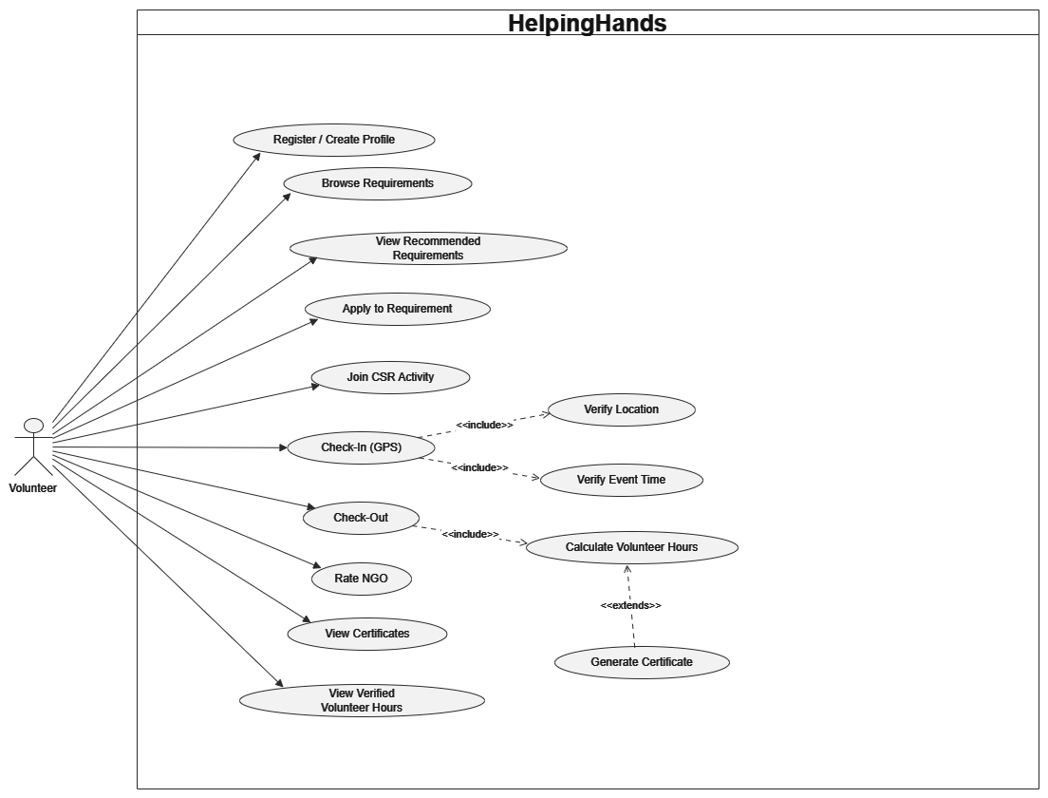

Use Case Diagram NGO

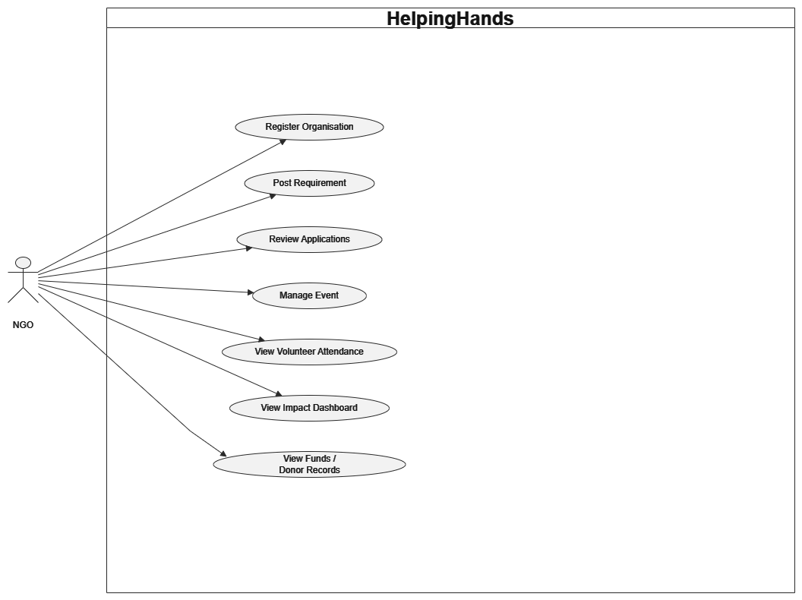

Use Case Diagram Corporate

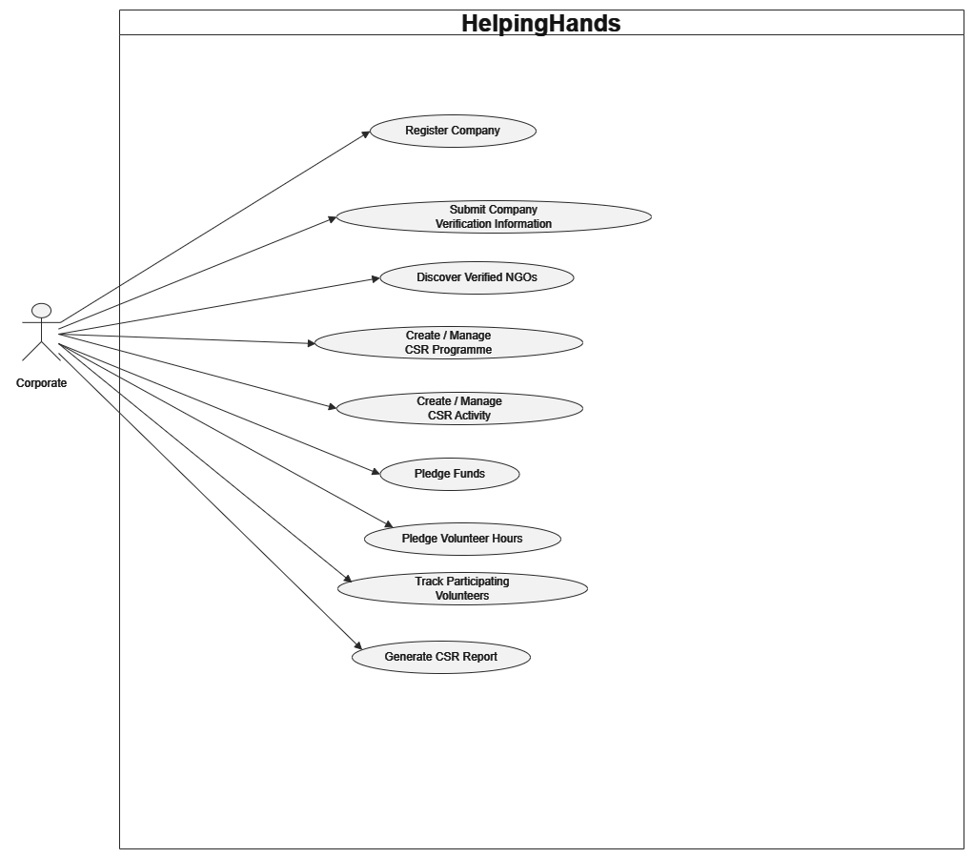

Use Case Diagram Platform Operator

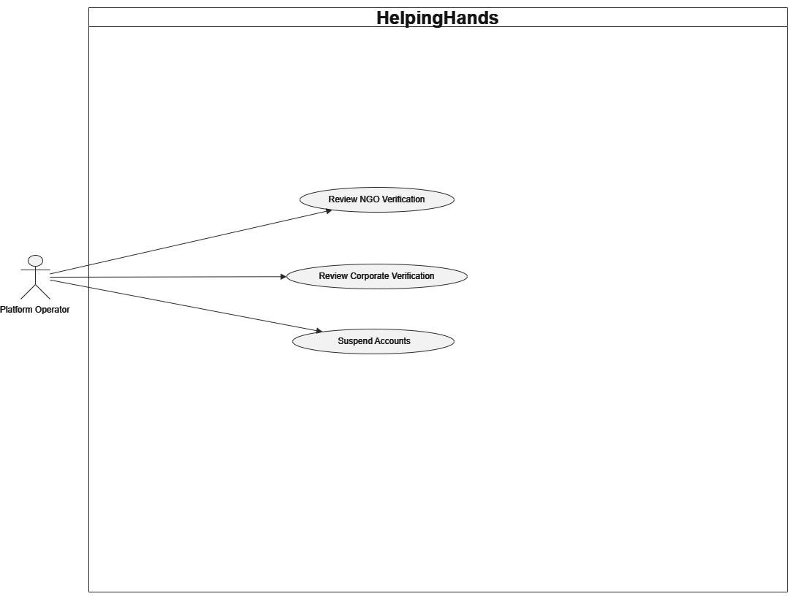

  - Activity Diagram:

Activity Diagram Volunteer

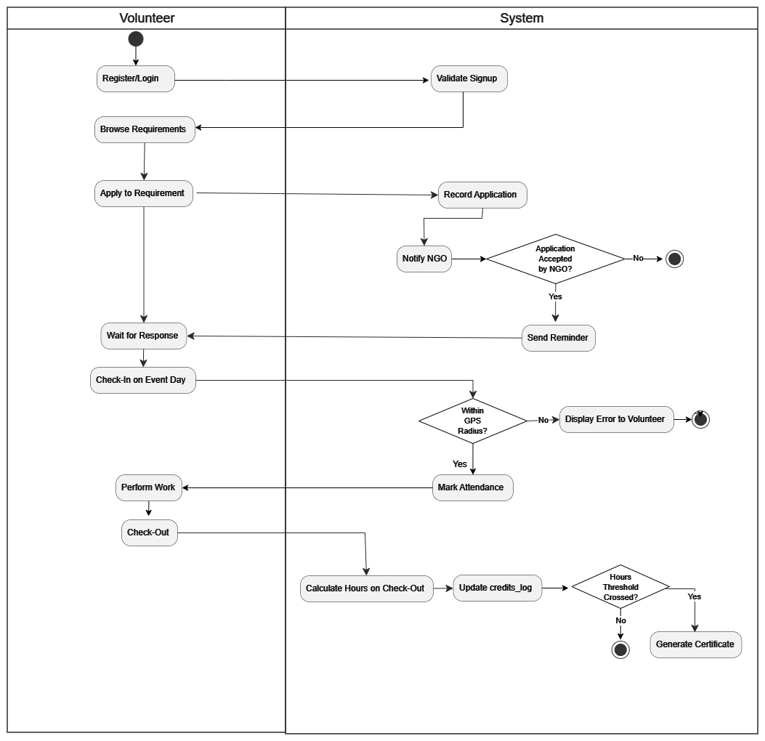

Activity Diagram NGO

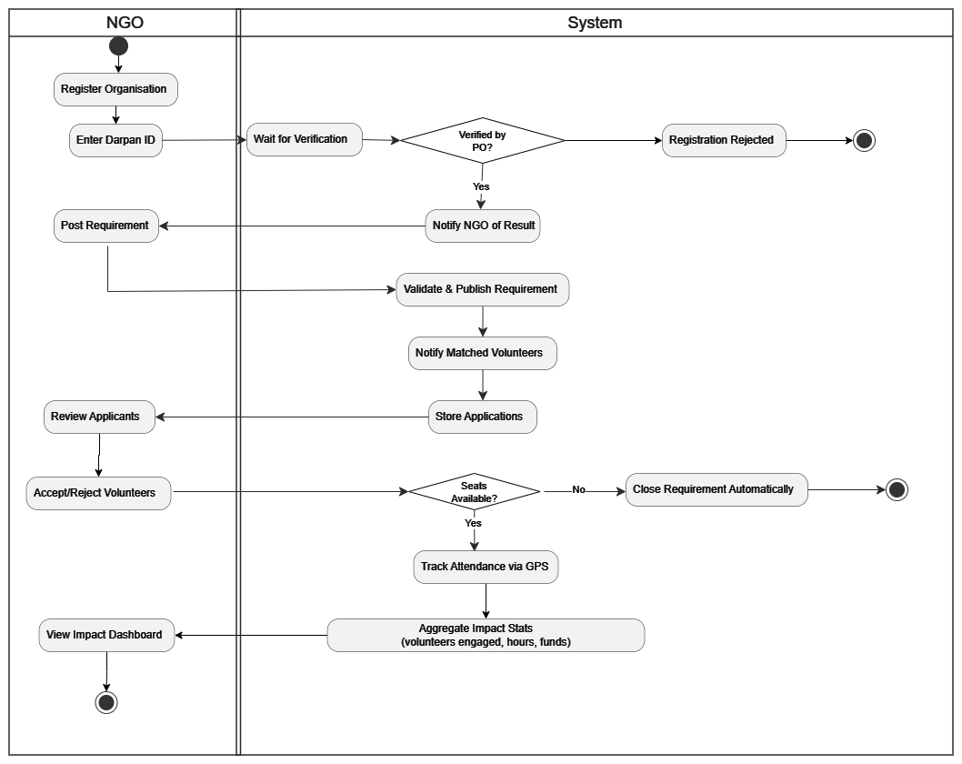

Activity Diagram Corporate

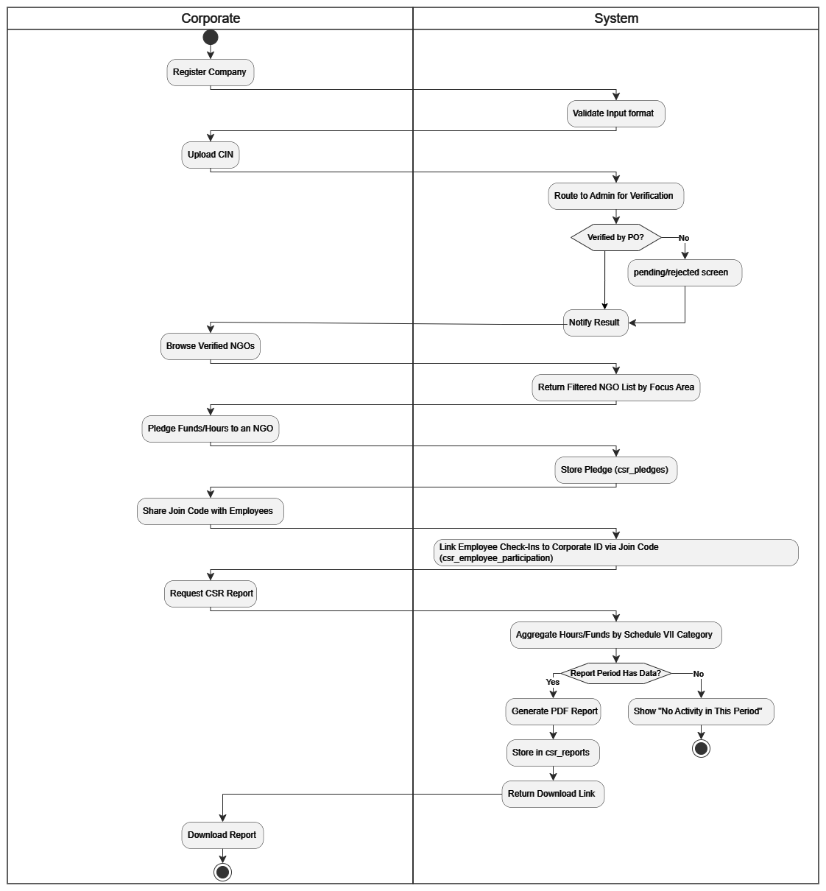

  - System Architecture:

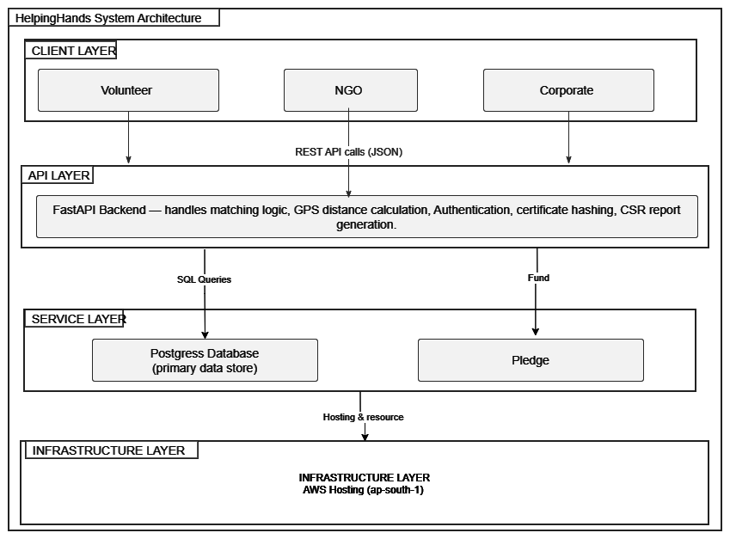

  - Sequence Diagram:

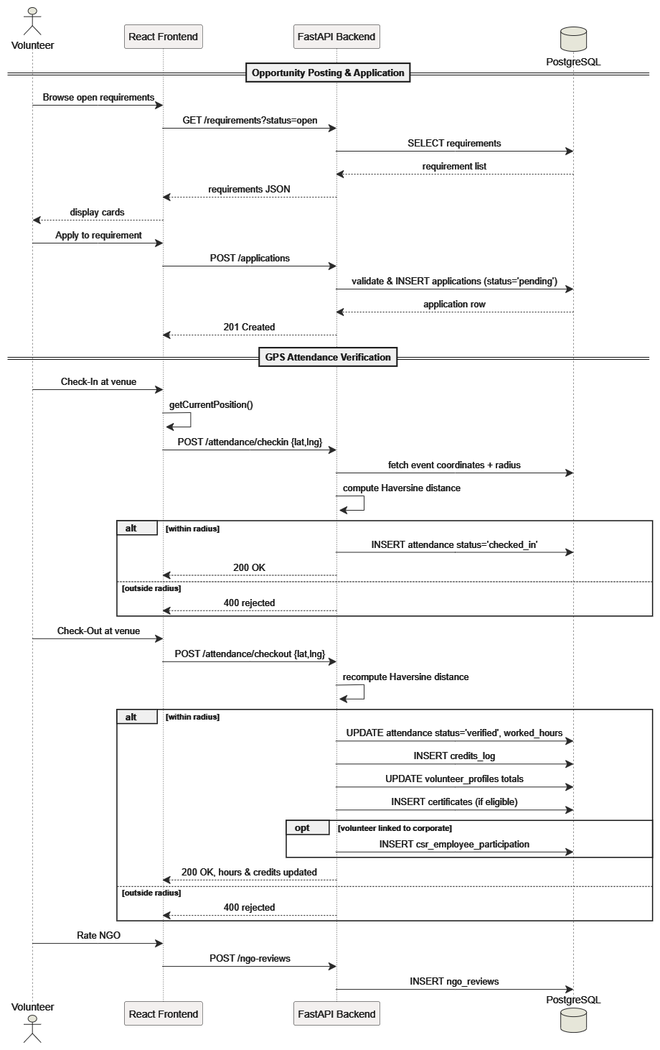

Sequence diagram NGO

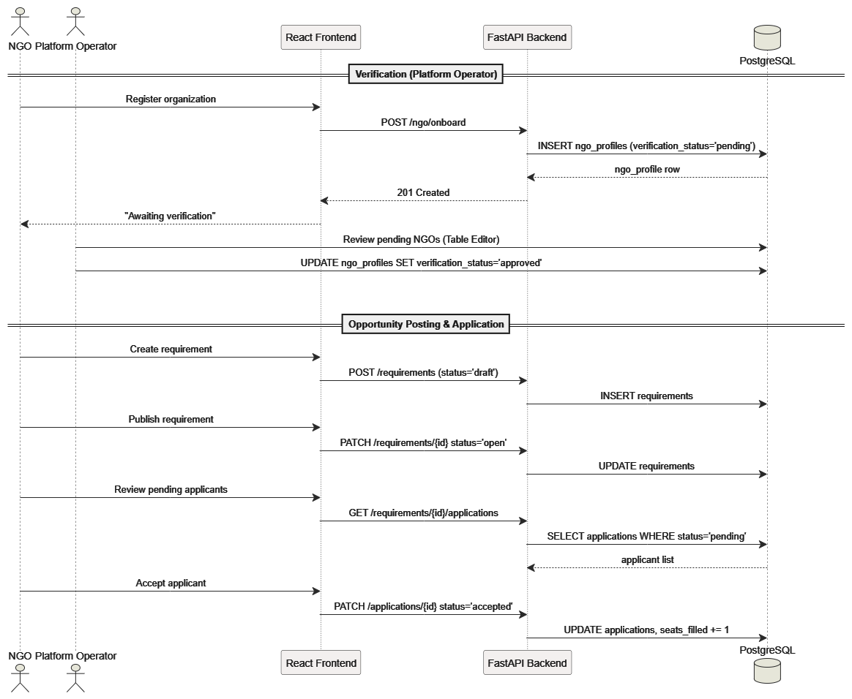

Sequence diagram Corporate

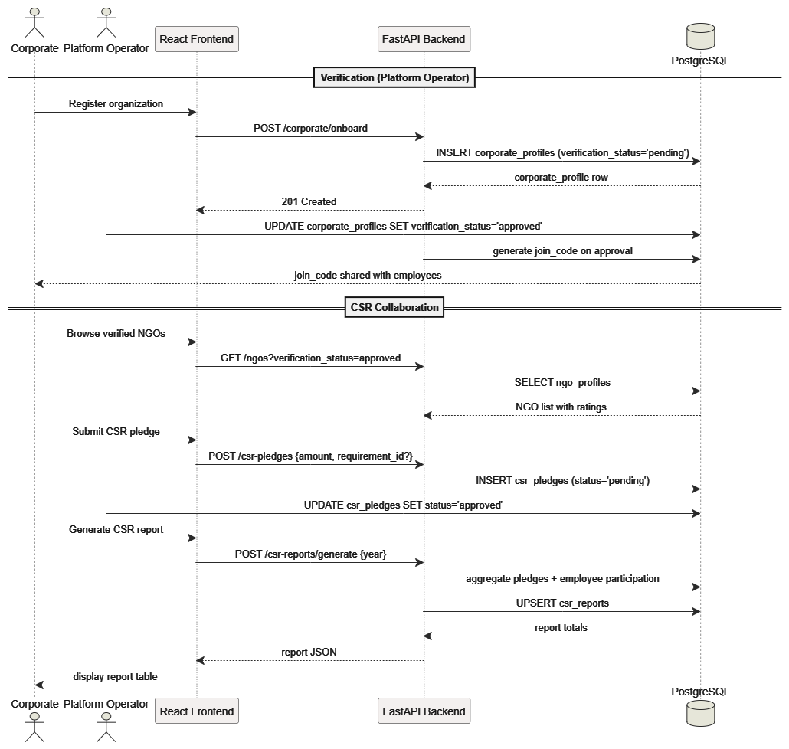

Sequence diagram Platform operator

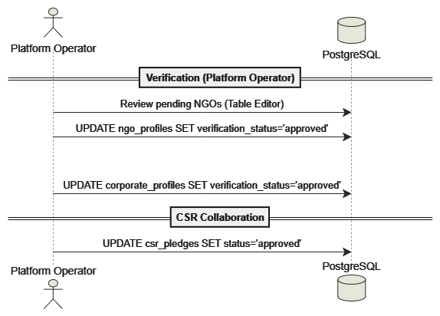

  - Class Diagram:

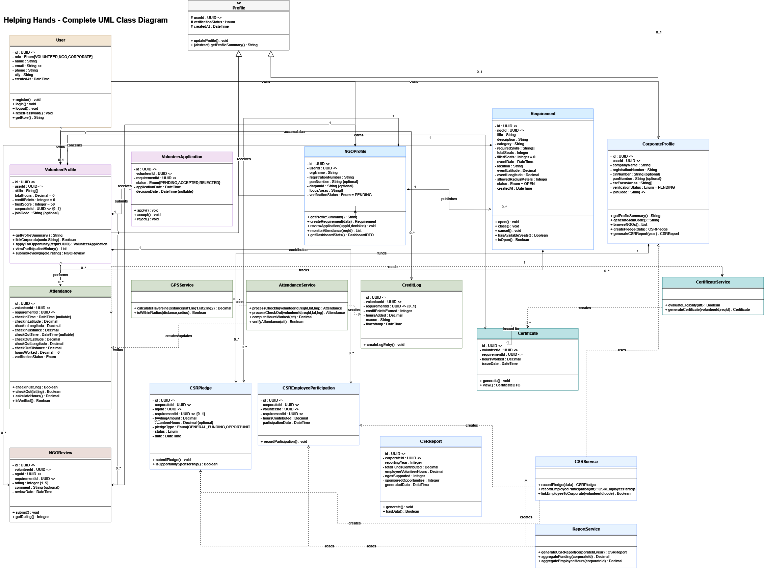

  - Data Dictionary:

Table: users
Column Name | Data Type | Nullable | Default | Key / Constraint | Description
Id | UUID | No | uuid_generate_v4() | Primary Key | Unique identifier assigned to each user account.
Role | VARCHAR(20) | No | - | Check ('volunteer', 'ngo', 'corporate') | Defines the role of the user within the platform.
Name | VARCHAR(150) | No | - | - | Stores the full name of the user or corporate/NGO contact person.
Email | VARCHAR(25) | No | - | Unique | Stores the official email address used for logging in and notifications.
Phone | VARCHAR(10) | No | - | - | Stores the contact phone number of the user.
City | VARCHAR(100) | No | - | - | Records the current city where the user is located.
created_at | TIMESTAMPTZ | No | NOW() | - | Timestamp recording when the user account was created.
updated_at | TIMESTAMPTZ | No | NOW() | - | Timestamp showing when the user details were last updated.

Table: volunteer_profiles
Column Name | Data Type | Nullable | Default | Key / Constraint | Description
Id | UUID | No | uuid_generate_v4() | Primary Key | Unique identifier for the volunteer profile.
user_id | UUID | No | - | Foreign Key, Unique | References the main user account in the users table.
skill_tags | TEXT[] | No | '{}' | - | Array of tags listing the core skills and interests of the volunteer.
total_hours | NUMERIC(8,2) | No | 0 | - | Calculates the total number of verified volunteer hours completed.
credit_points | INTEGER | No | 0 | - | Stores reward points earned by participating in activities.
trust_score | INTEGER | No | 50 | Check (0 to 100) | Numerical score representing the reliability rating of the volunteer.
corporate_profile_id | UUID | Yes | - | Foreign Key | Links the volunteer to a corporate employer if applicable.
created_at | TIMESTAMPTZ | No | NOW() | - | Timestamp when the volunteer profile was created.
updated_at | TIMESTAMPTZ | No | NOW() | - | Timestamp when the profile information was last updated.

Table: ngo_profiles

Column Name | Data Type | Nullable | Default | Key / Constraint | Description
Id | UUID | No | uuid_generate_v4() | Primary Key | Unique identifier for the NGO profile.
user_id | UUID | No | - | Foreign Key, Unique | References the base user account in the users table.
organization_name | VARCHAR(25) | No | - | - | Official registered name of the non-profit organization.
registration_number | VARCHAR(9) | No | - | - | Government registration number of the NGO.
pan_number | VARCHAR(10) | Yes | - | - | Permanent Account Number (PAN) of the NGO for financial verification.
darpan_id | VARCHAR(15) | Yes | - | - | NGO Darpan portal registration identifier.
focus_areas | TEXT[] | No | '{}' | - | List of social causes or sectors the NGO primarily works on.
verification_status | VARCHAR(20) | No | 'pending' | Check ('pending', 'approved', 'rejected', 'suspended') | Current administrative approval status of the NGO.
created_at | TIMESTAMPTZ | No | NOW() | - | Timestamp recording when the NGO profile was registered.
updated_at | TIMESTAMPTZ | No | NOW() | - | Timestamp showing when the profile was last modified.
Table: corporate_profiles
Column Name | Data Type | Nullable | Default | Key / Constraint | Description
Id | UUID | No | uuid_generate_v4() | Primary Key | Unique identifier for the corporate profile.
user_id | UUID | No | - | Foreign Key, Unique | References the base user account in the users table.
company_name | VARCHAR(25) | No | - | - | Official legal name of the corporate organization.
registration_number | VARCHAR(10) | No | - | - | Government business registration number.
cin_number | VARCHAR(21) | No | - | - | Corporate Identity Number (CIN) assigned to the company.
pan_number | VARCHAR(10) | No | - | - | Corporate PAN number for financial compliance.
csr_focus_areas | TEXT[] | No | '{}' | - | Key social sectors targeted for company CSR initiatives.
verification_status | VARCHAR(20) | No | 'pending' | Check ('pending', 'approved', 'rejected', 'suspended') | Verification status of the corporate entity.
join_code | VARCHAR(12) | No | - | Unique | Unique code shared with employees to link with this company.
join_code_active | BOOLEAN | No | TRUE | - | Flag indicating whether the employee join code is active.
created_at | TIMESTAMPTZ | No | NOW() | - | Timestamp when the company profile was created.
updated_at | TIMESTAMPTZ | No | NOW() | - | Timestamp when company details were last updated.

Table: requirements

Column Name | Data Type | Nullable | Default | Key / Constraint | Description
id | UUID | No | uuid_generate_v4() | Primary Key | Unique identifier for the volunteering requirement.
ngo_profile_id | UUID | No | - | Foreign Key | References the NGO that created this opportunity.
title | VARCHAR(200) | No | - | - | Title or headline of the volunteering drive.
description | TEXT | Yes | - | - | Detailed description of responsibilities and goals.
category | VARCHAR(100) | Yes | - | - | Category of the drive such as Education or Environment.
skill_tags | TEXT[] | No | '{}' | - | Required skills sought for the opportunity.
seats_total | INTEGER | No | - | Check (> 0) | Maximum number of volunteers needed for the event.
seats_filled | INTEGER | No | 0 | Check (>= 0 AND <= seats_total) | Number of accepted volunteer applications so far.
event_date | DATE | No | - | - | Scheduled date of the volunteering event.
event_start_time | TIME | No | '00:00:00' | - | Scheduled start time of the volunteering event.
event_end_time | TIME | No | '23:59:59' | - | Scheduled end time of the volunteering event.
location_name | VARCHAR(255) | No | - | - | Human-readable address or landmark name of the location.
event_latitude | NUMERIC(10,7) | No | - | - | Geographic latitude coordinate of the event location.
event_longitude | NUMERIC(10,7) | No | - | - | Geographic longitude coordinate of the event location.
attendance_radius | NUMERIC(8,2) | No | 3000 | Check (> 0) | Allowed distance radius in meters for GPS attendance check-in.
is_urgent | BOOLEAN | No | FALSE | - | Flag indicating if the requirement needs urgent volunteer fulfillment.
status | VARCHAR(20) | No | 'draft' | Check ('draft', 'open', 'completed', 'cancelled') | Current stage of the volunteering drive.
created_at | TIMESTAMPTZ | No | NOW() | - | Timestamp recording when the requirement was created.
updated_at | TIMESTAMPTZ | No | NOW() | - | Timestamp showing when details were last updated.

Table: applications

Column Name | Data Type | Nullable | Default | Key / Constraint | Description
Id | UUID | No | uuid_generate_v4() | Primary Key | Unique identifier for the application record.
requirement_id | UUID | No | - | Foreign Key, Unique (with volunteer_profile_id) | References the requirement applied for.
volunteer_profile_id | UUID | No | - | Foreign Key, Unique (with requirement_id) | References the applying volunteer profile.
Status | VARCHAR(20) | No | 'pending' | Check ('pending', 'accepted', 'rejected', 'withdrawn') | Status of the application after NGO review.
applied_at | TIMESTAMPTZ | No | NOW() | - | Timestamp when the volunteer submitted the application.
decided_at | TIMESTAMPTZ | Yes | - | - | Timestamp when the NGO accepted or rejected the application.

Table: attendance
Column Name | Data Type | Nullable | Default | Key / Constraint | Description
Id | UUID | No | uuid_generate_v4() | Primary Key | Unique identifier for the attendance record.
requirement_id | UUID | No | - | Foreign Key, Unique (with volunteer_profile_id) | References the associated volunteering event.
volunteer_profile_id | UUID | No | - | Foreign Key, Unique (with requirement_id) | References the volunteer attending the event.
status | VARCHAR(20) | No | 'pending' | Check ('pending', 'checked_in', 'verified', 'rejected') | Current verification state of the attendance record.
checkin_time | TIMESTAMPTZ | Yes | - | Check (checkout_time > checkin_time) | Exact timestamp when the volunteer checked in.
checkin_latitude | NUMERIC(10,7) | Yes | - | - | Latitude coordinate captured during check-in.
checkin_longitude | NUMERIC(10,7) | Yes | - | - | Longitude coordinate captured during check-in.
checkin_distance_meters | NUMERIC(10,2) | Yes | - | - | Calculated distance from event center point at check-in.
checkout_time | TIMESTAMPTZ | Yes | - | Check (checkout_time > checkin_time) | Exact timestamp when the volunteer checked out.
checkout_latitude | NUMERIC(10,7) | Yes | - | - | Latitude coordinate captured during check-out.
checkout_longitude | NUMERIC(10,7) | Yes | - | - | Longitude coordinate captured during check-out.
checkout_distance_meters | NUMERIC(10,2) | Yes | - | - | Calculated distance from event center point at check-out.
worked_hours | NUMERIC(6,2) | Yes | 0 | - | Total hours logged and calculated for the attendance session.
created_at | TIMESTAMPTZ | No | NOW() | - | Timestamp when the attendance record was initially created.
updated_at | TIMESTAMPTZ | No | NOW() | - | Timestamp when attendance status or check-out details were updated.
Table: credits_log
Column Name | Data Type | Nullable | Default | Key / Constraint | Description
Id | UUID | No | uuid_generate_v4() | Primary Key | Unique identifier for the credit transaction log entry.
volunteer_profile_id | UUID | No | - | Foreign Key | References the volunteer profile receiving the credit adjustment.
requirement_id | UUID | Yes | - | Foreign Key | References the specific requirement tied to the credit update.
points_change | INTEGER | No | 0 | - | Number of credit points added or deducted in this transaction.
hours_change | NUMERIC(6,2) | No | 0 | - | Number of volunteering hours added or adjusted.
reason | VARCHAR(20) | No | - | Check ('attendance', 'bonus', 'adjustment', 'penalty') | Specific trigger or cause for credit modification.
remarks | TEXT | Yes | - | - | Optional descriptive notes regarding the credit change.
created_at | TIMESTAMPTZ | No | NOW() | - | Timestamp when the credit transaction was executed.

Table: certificates
Column Name | Data Type | Nullable | Default | Key / Constraint | Description
Id | UUID | No | uuid_generate_v4() | Primary Key | Unique identifier for the certificate entry.
volunteer_profile_id | UUID | No | - | Foreign Key, Unique (with requirement_id) | References the volunteer recipient.
requirement_id | UUID | No | - | Foreign Key, Unique (with volunteer_profile_id) | References the completed requirement drive.
certificate_number | VARCHAR(20) | No | - | Unique | Unique auto-generated tracking code for official validation.
worked_hours | NUMERIC(6,2) | No | - | - | Total verified volunteering hours printed on the certificate.
issue_date | DATE | No | CURRENT_DATE | - | Date on which the certificate was formally issued.
status | VARCHAR(20) | No | 'generated' | Check ('generated', 'revoked') | Current validity status of the certificate.
created_at | TIMESTAMPTZ | No | NOW() | - | Timestamp when the certificate record was generated.

Table: ngo_reviews

Column Name | Data Type | Nullable | Default | Key / Constraint | Description
Id | UUID | No | uuid_generate_v4() | Primary Key | Unique identifier for the review entry.
volunteer_profile_id | UUID | No | - | Foreign Key, Unique (with requirement_id) | References the reviewing volunteer profile.
ngo_profile_id | UUID | No | - | Foreign Key | References the NGO receiving the rating and review.
requirement_id | UUID | No | - | Foreign Key, Unique (with volunteer_profile_id) | References the specific requirement drive evaluated.
rating | INTEGER | No | - | Check (1 to 5) | Numerical rating score given by the volunteer between 1 and 5.
review_comment | TEXT | Yes | - | - | Detailed text commentary provided by the volunteer.
created_at | TIMESTAMPTZ | No | NOW() | - | Timestamp when the review was posted.
updated_at | TIMESTAMPTZ | No | NOW() | - | Timestamp when the review was last modified.
Table: csr_pledges
Column Name | Data Type | Nullable | Default | Key / Constraint | Description
Id | UUID | No | uuid_generate_v4() | Primary Key | Unique identifier for the CSR pledge.
corporate_profile_id | UUID | No | - | Foreign Key | References the corporate entity making the pledge.
ngo_profile_id | UUID | No | - | Foreign Key | References the target NGO receiving the pledge.
requirement_id | UUID | Yes | - | Foreign Key | Optional reference to a specific requirement drive being sponsored.
pledged_amount | NUMERIC(14,2) | No | 0 | Check (>= 0) | Total monetary contribution pledged by the corporate body.
pledged_hours | NUMERIC(8,2) | Yes | 0 | Check (>= 0) | Total corporate volunteer hours committed.
status | VARCHAR(20) | No | 'pending' | Check ('pending', 'approved', 'rejected') | Current status of the CSR funding pledge.
created_at | TIMESTAMPTZ | No | NOW() | - | Timestamp when the pledge was formally submitted.

Table: csr_employee_participation

Column Name | Data Type | Nullable | Default | Key / Constraint | Description
Id | UUID | No | uuid_generate_v4() | Primary Key | Unique identifier for the employee participation entry.
corporate_profile_id | UUID | No | - | Foreign Key | References the corporate organization the employee belongs to.
volunteer_profile_id | UUID | No | - | Foreign Key | References the employee's volunteer profile.
attendance_id | UUID | No | - | Foreign Key, Unique | References the verified attendance record for the event.
credited_hours | NUMERIC(8,2) | No | 0 | - | Number of volunteering hours credited to corporate CSR stats.
recorded_at | TIMESTAMPTZ | No | NOW() | - | Timestamp when the participation was recorded into CSR history.

Table: csr_reports

Column Name | Data Type | Nullable | Default | Key / Constraint | Description
Id | UUID | No | uuid_generate_v4() | Primary Key | Unique identifier for the annual CSR report.
corporate_profile_id | UUID | No | - | Foreign Key, Unique (with report_year) | References the corporate entity generating the report.
report_year | INTEGER | No | - | Check (>= 2025), Unique (with corporate_profile_id) | Reporting year for the aggregated CSR statistics.
total_funds | NUMERIC(14,2) | No | 0 | - | Total financial contributions pledged and spent in the given year.
total_employee_hours | NUMERIC(10,2) | No | 0 | - | Total combined volunteer hours completed by employees in the year.
generated_at | TIMESTAMPTZ | No | NOW() | - | Timestamp when the report snapshot was generated.

- DEVELOPMENT:
The development phase involves implementing the Helping Hands platform according to the identified requirements and system design. The application is developed using React.js, FastAPI, and PostgreSQL, following proper coding standards, modular development practices, and a user-friendly interface.

  - Coding Standard:
The following coding standards will be followed during the development of the Helping Hands system to maintain consistency, readability, and maintainability of the source code.

- Naming Convention: Meaningful and descriptive names will be used for variables, functions, classes, components, and files.

- Indentation: Consistent indentation will be maintained throughout the code. Python code will use 4 spaces for indentation.

- Comments: Comments will be added where necessary to explain complex or important logic without adding unnecessary comments.

- Code Structure: Code will be organized into appropriate modules, components, routers, services, and other logical sections to maintain a modular structure.

- Code Reusability: Common functionality will be implemented in reusable functions or components instead of duplicating code.

- Error Handling: Appropriate error handling and meaningful error messages will be used to handle invalid inputs and application errors.

- Database Standards: Meaningful and consistent names will be used for database tables, columns, and relationships.

- Security Practices: Sensitive information such as passwords, secret keys, and credentials will not be hard-coded in the source code.

- Formatting: Consistent formatting and spacing will be maintained across the project files.

- Version Control: Meaningful commit messages and organized version control practices will be followed while working with the project repository.

  - Screenshots:
- Registration Form
- Volunteer
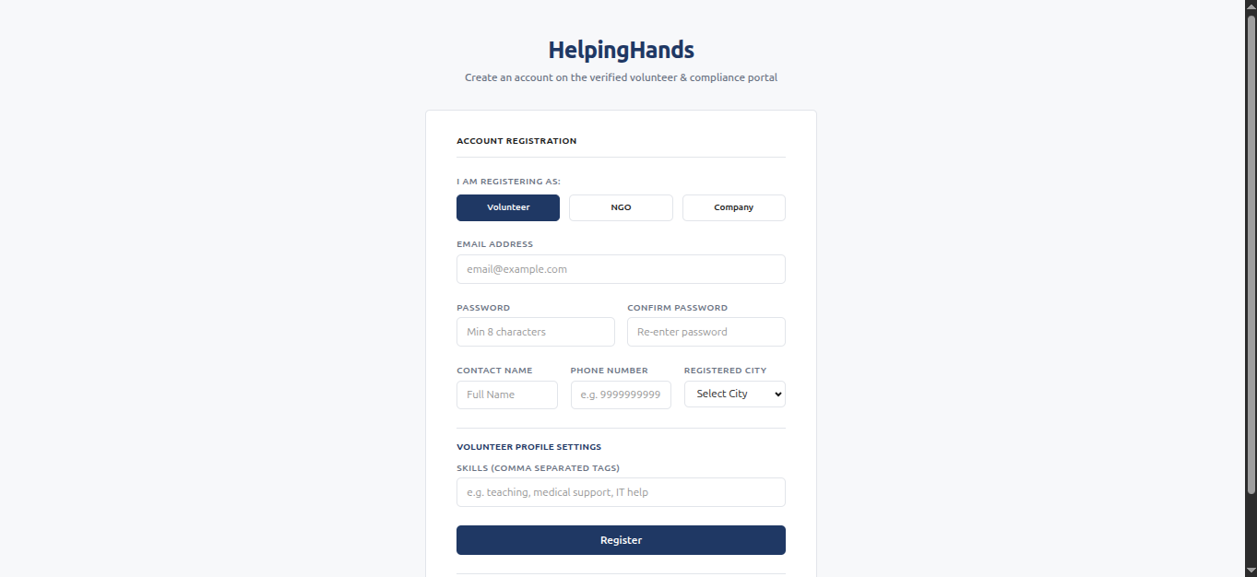

- NGO
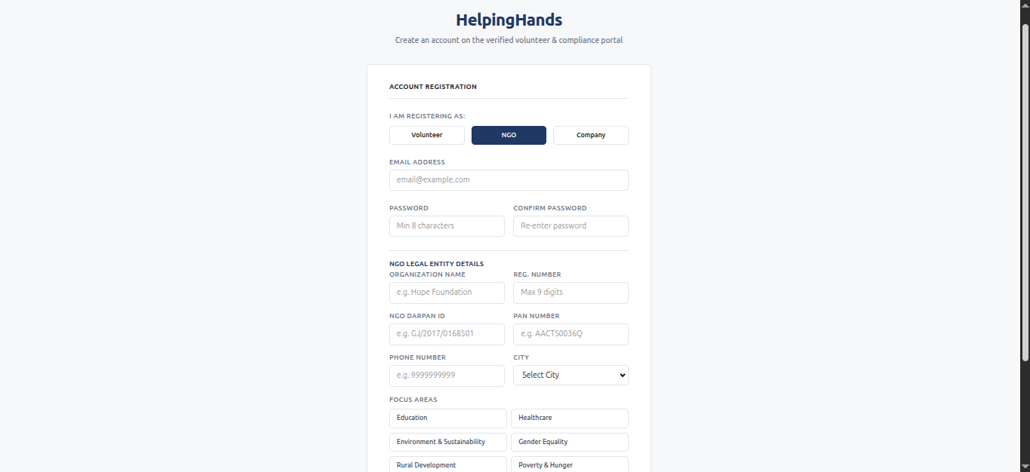

- Company
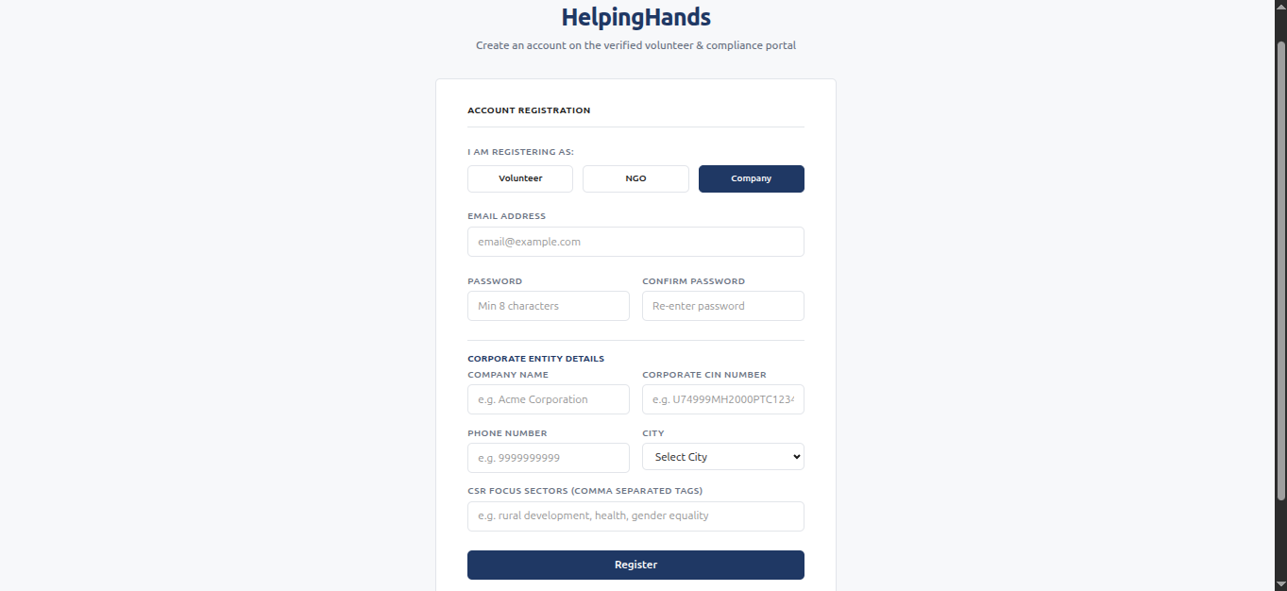
- Volunteer Dashboard
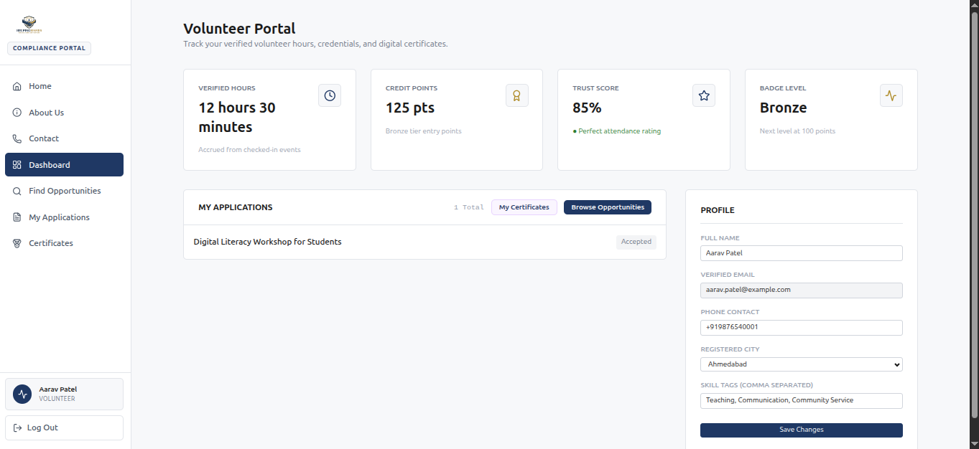
- Find Opportunities
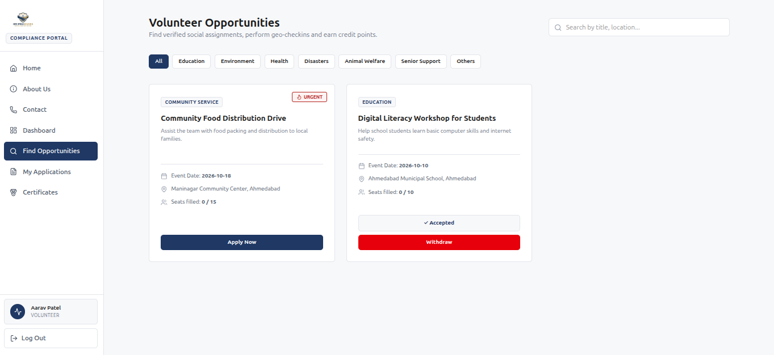

- My Application
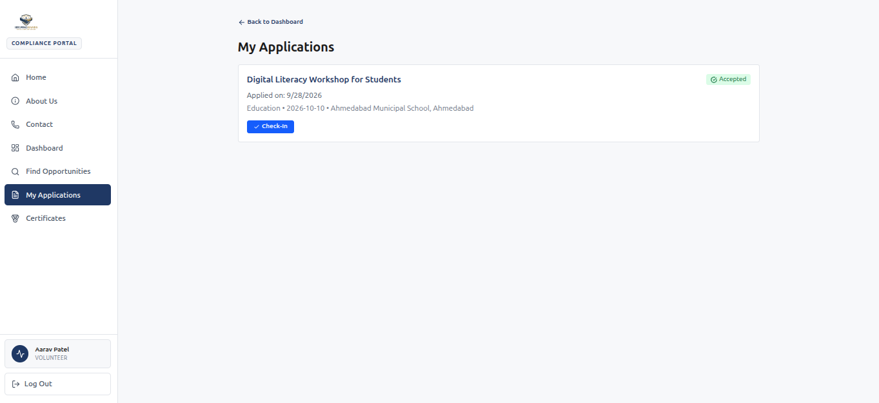

- My Certificates

- NGO Dashboard
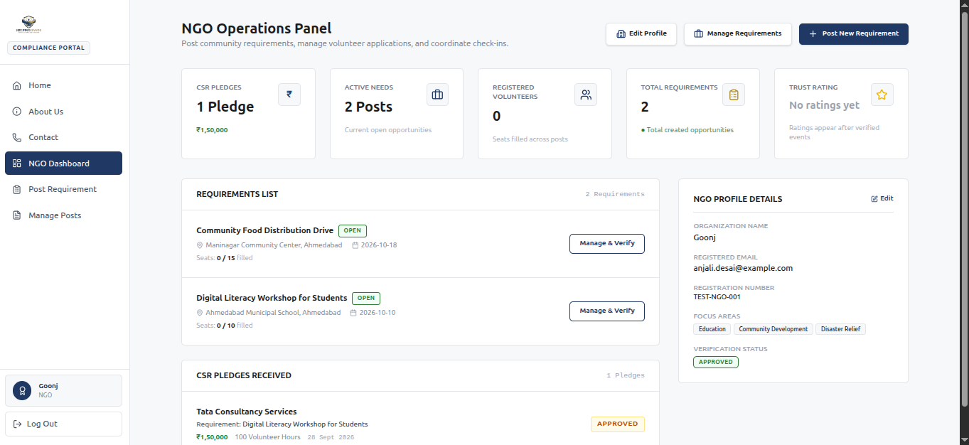

- Post Requirements
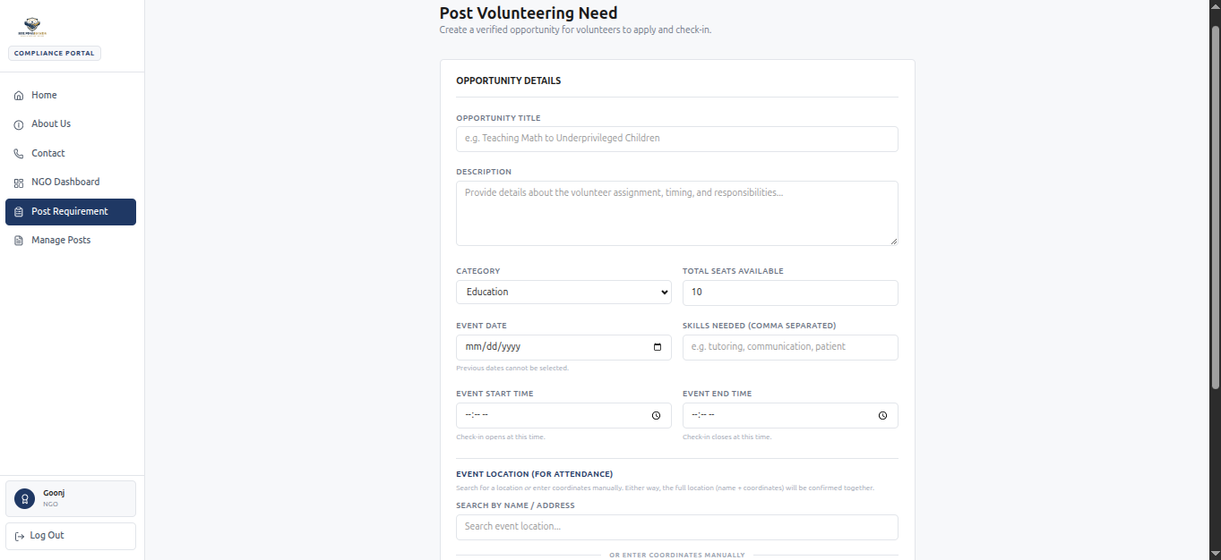
- Manage Posts

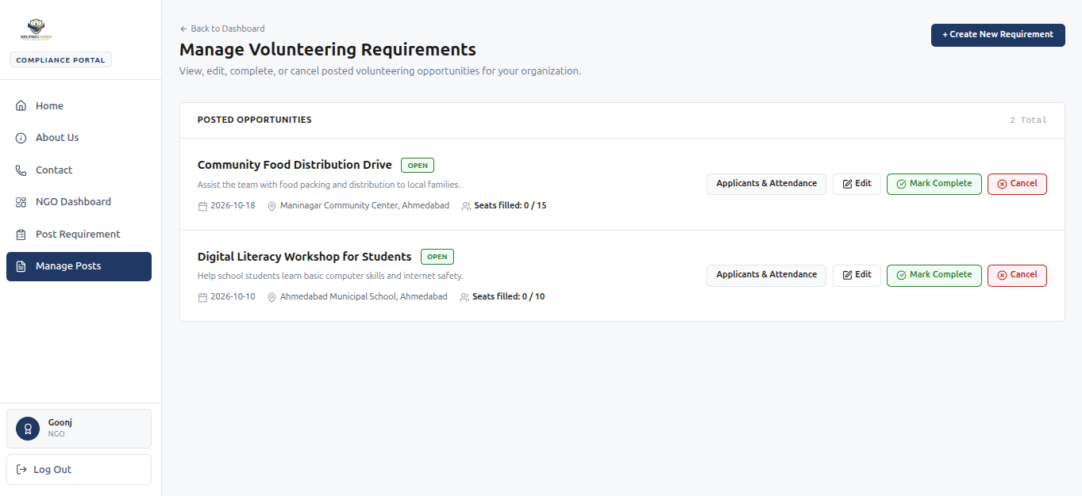
- Operations
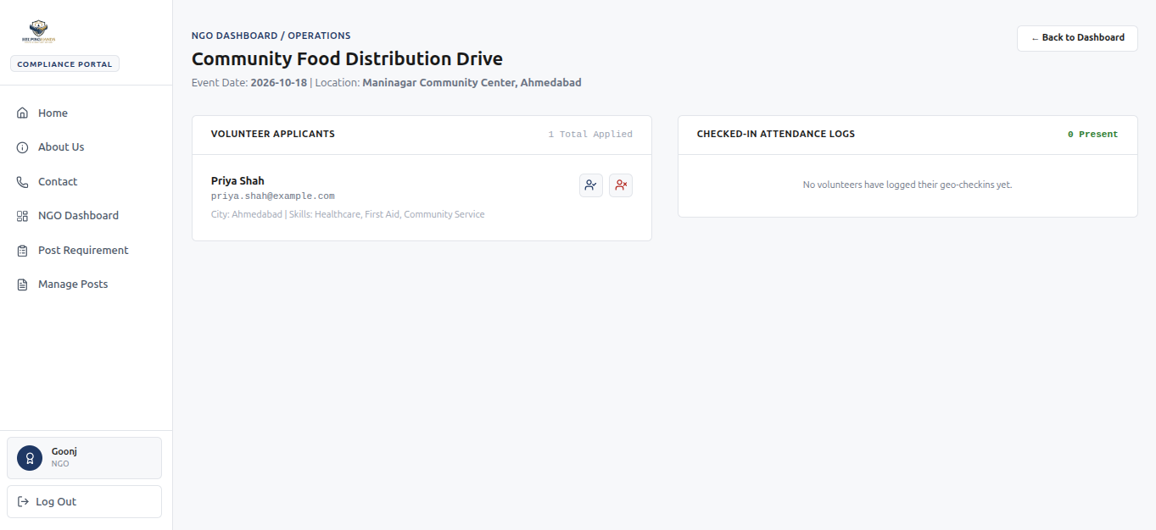

- Company Dashboard
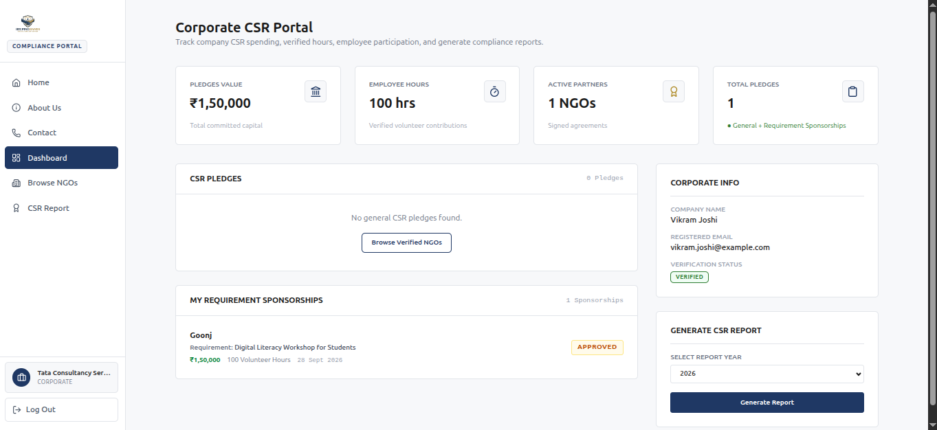

- Browse NGOs
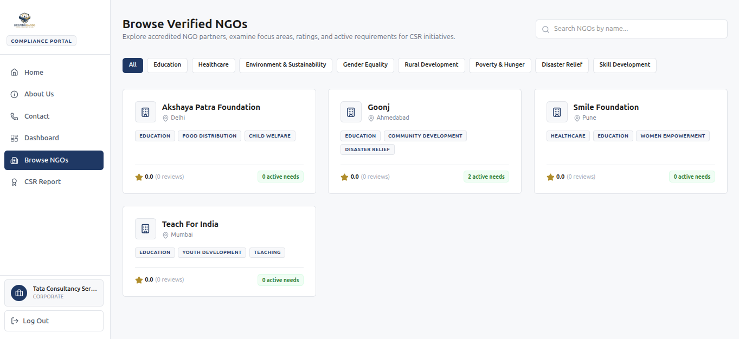

- NGO Details

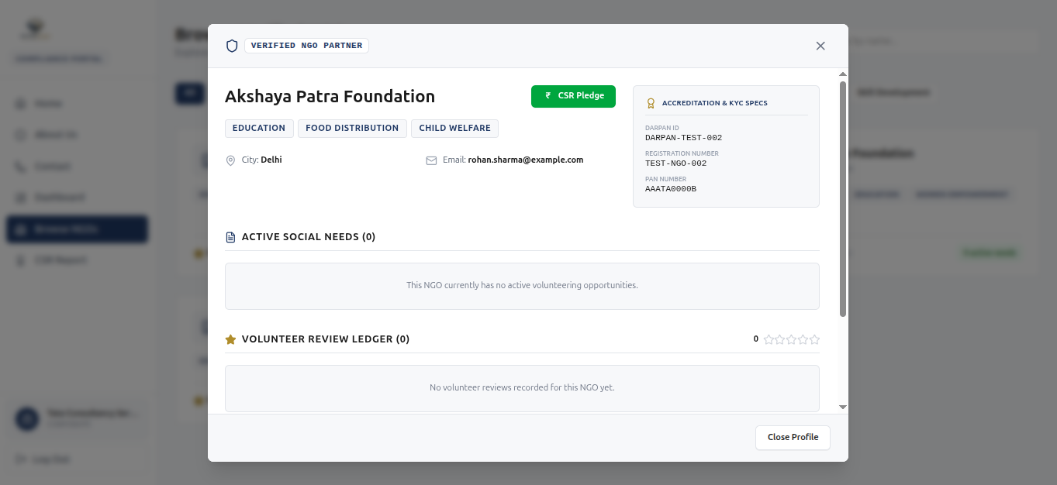

- CSR Pledge
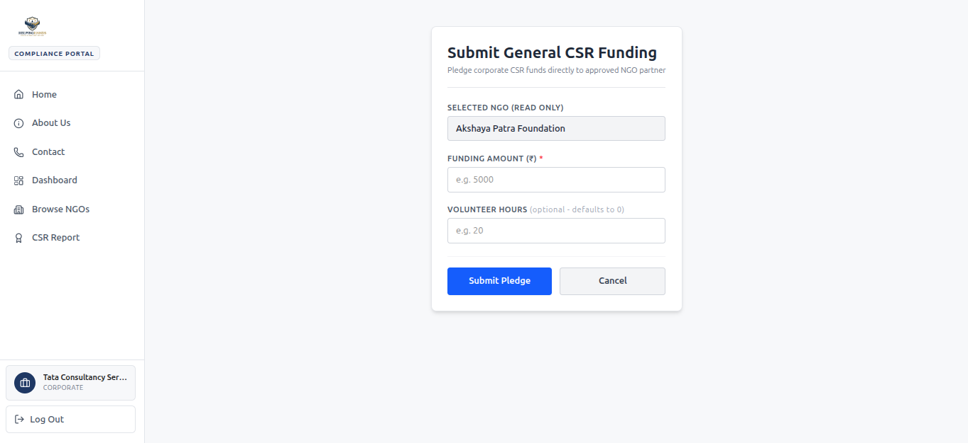
- CSR Report
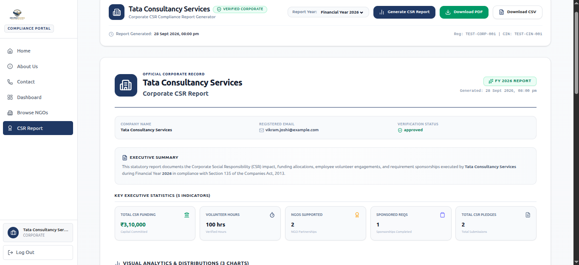

- Agile Documentation:

- Proposed Enhancements:
The following enhancements can be considered in the future to improve the functionality, security, and overall user experience of the Helping hands platform:

- Payment Gateway Integration: Integrate a real payment gateway to enable secure CSR fund transfers.

- Email Verification:Add email verification during registration to validate user email addresses.

- Change/Forgot Password: Provide secure options to change passwords and recover forgotten passwords through email.
- Corporate Employee Pledge Hours: Allow corporate organizations to pledge employee volunteering hours and nominate employees for suitable volunteering events.

- Employee Participation Tracking: Enable corporates to track pledged hours, employee participation, and completed volunteering hours.

- Mobile Application: Develop a dedicated mobile application for easier access to volunteering opportunities, attendance, and notifications.

- Conclusion:

The Helping Hands project provides a centralized platform for connecting volunteers, NGOs, and corporate organizations for volunteering and CSR activities.

The system addresses important challenges such as organization verification, attendance validation, volunteer hour tracking, and coordination between different stakeholders.

GPS-based attendance using location verification helps maintain more reliable participation records, while the Platform Operator Panel supports organization verification and platform-level management.

The system also provides structured volunteer records, credits, participation certificates in PDF format, and simulated CSR transactions for demonstration purposes.

Overall, Helping Hands provides a practical foundation for managing volunteering and CSR activities digitally, with scope for future enhancements such as real payment gateway integration, email verification, password recovery, and corporate employee pledge-hour management.

10.Bibliography:

- React Documentation – React.js, Meta Platforms, Inc.
- FastAPI Documentation – FastAPI Web Framework for Python.
- PostgreSQL Documentation – PostgreSQL Global Development Group.
- Python Documentation – Python Software Foundation.
- Haversine Formula – Reference material for calculating geographical distance between two coordinates.
- MDN Web Docs – Reference for HTML, CSS, JavaScript, and Web APIs.
- GitHub Documentation – Reference for version control and project repository management.

