SailPoint Identity Security Cloud (ISC)
GitOps CI/CD Enterprise Architecture Guide
AWS Secrets Manager & SailPoint CLI Integration Reference

Document Classification: | Technical Reference & Architecture Guide (Thales Team)
Target Platform: | GitHub Actions & SailPoint ISC (v3 / Beta APIs)
Key Vault Provider: | AWS Secrets Manager (sailpoint-config-dev/uat/prod)
Environments Supported: | Sandbox (DEV), Staging (UAT), Production (PROD)
Approval Control Gates: | UAT (1 Reviewer Required), PROD (2 Reviewers Required)
Log Masking Scheme: | Real-Time Server-Side Redaction (::add-mask:: via bash)

1. Executive Summary & Design Patterns
This document describes the design, security controls, and operational workflows of the SailPoint Identity Security Cloud (ISC) GitOps CI/CD pipeline. The pipeline provides a secure, automated gateway for managing and synchronizing configuration objects across three tenants (DEV, UAT, and PROD) using GitHub Actions, AWS Secrets Manager, and the official SailPoint CLI.
Key architectural design principles:
- Dynamic Tokenization: Configurations contain tenant-specific domain paths and identifiers. The pipeline substitutes these placeholders (e.g., {{domainPath}}) at deploy-time from environments/*.json configuration mapping files, separating configurations from parameters.
- Zero-Keys at Rest: No plain text credentials (passwords, secrets, client keys) exist in Git. All secrets are retrieved dynamically from AWS Secrets Manager and replaced in runner memory (volatile RAM) during execution.
- Always-Incremental Deployments: To bypass API bottlenecks and prevent 504 timeouts, the pipeline compares diffs against the parent commit (git diff HEAD~1) and only packages/deploys changed configurations.

2. Pipeline Architecture Map
The holistic end-to-end integration mapping between developers, GitHub Actions approval gates, compile scripts, and target tenants is illustrated below:
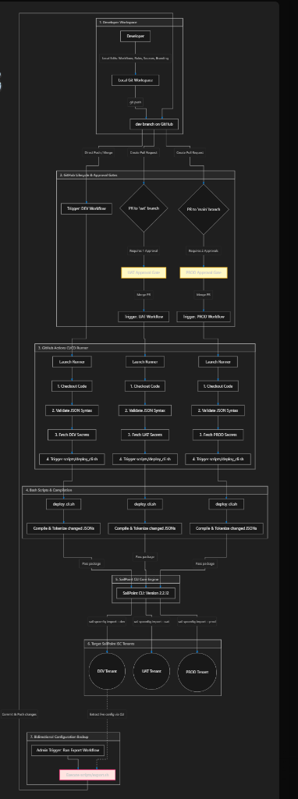
Figure 1: Holistic GitOps CI/CD Deployment Flowchart

The detail block flowchart showing the data transmission from AWS Secrets Manager to target tenants:
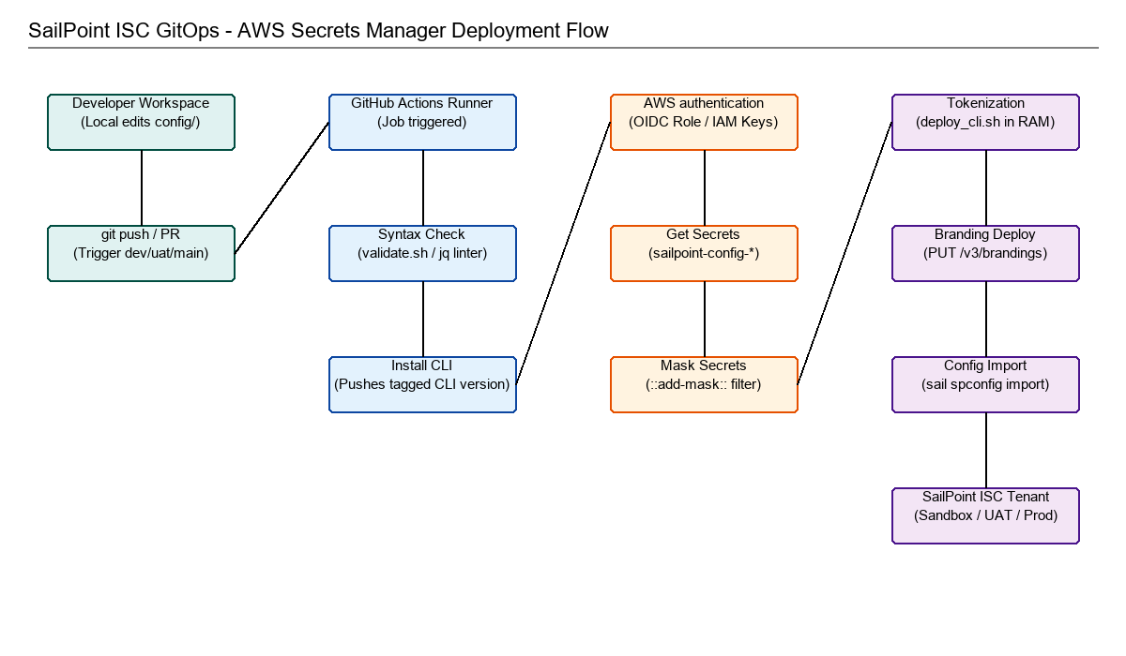
Figure 2: GitOps AWS Secrets Manager Pipeline Flow

3. Repository Directory Structure
The directory tree below illustrates the file structure of the GitOps repository:
SailPoint-ISC-GitOps-AWS/
├── .github/
│ └── workflows/
│ ├── deploy.yml # Dynamic deployment pipeline
│ ├── deploy_connectors.yml # SaaS Custom connector uploader
│ └── export.yml # Sync tenant config back to Git
├── config/
│ ├── branding/
│ │ ├── branding-meta.json # Branding UI configuration colors
│ │ └── logo.png # UI navigation logo file
│ ├── sources/ # Source connectors (e.g. AD, Workday)
│ ├── transforms/ # Attribute maps and mappings
│ └── identity-profiles/ # Identity schema profiles
├── environments/
│ ├── dev.json # Sandbox replacements
│ ├── uat.json # Staging replacements
│ └── prod.json # Production replacements
└── scripts/
├── deploy_cli.sh # Compilation and SailPoint CLI import script
├── deploy_local.ps1 # Developer offline testing PowerShell script
└── export.sh # Backup script using SailPoint CLI

4. GitHub Actions Workflows Line-by-Line Analysis

4.1 deploy.yml: Environment Resolution & Credentials
Below is the core deploy.yml logic showing the environment resolver, AWS integration, and secret masking:
environment:
name: >-
${{
github.event_name == 'workflow_dispatch' && github.event.inputs.environment ||
github.ref_name == 'main' && 'PROD' ||
github.ref_name == 'uat' && 'UAT' ||
'DEV'
}}
steps:
- name: Configure AWS Credentials
uses: aws-actions/configure-aws-credentials@v4
with:
aws-access-key-id: ${{ secrets.AWS_ACCESS_KEY_ID }}
aws-secret-access-key: ${{ secrets.AWS_SECRET_ACCESS_KEY }}
aws-region: ${{ env.AWS_REGION }}
- name: Fetch Secrets from AWS Secrets Manager
run: |
SECRET_NAME="sailpoint-config-${{ env.ENV_NAME }}"
SECRET_JSON=$(aws secretsmanager get-secret-value --secret-id "$SECRET_NAME" --query "SecretString" --output text)
while IFS="=" read -r key val; do
echo "::add-mask::$val" # Masking logic
echo "$key=$val" >> $GITHUB_ENV
done < <(echo "$SECRET_JSON" | jq -r 'to_entries[] | "\(.key)=\(.value)"')

4.2 deploy_connectors.yml: SaaS Custom Connector Uploader
This pipeline automatically packages and uploads custom web/SaaS connectors to your target SailPoint tenant whenever changes are committed to the connectors/ directory:
on:
push:
paths:
- 'connectors/**'
branches:
- dev
- uat
- main
...
- name: Upload SaaS Connector
uses: sailpoint-oss/upload-saas-connector@v1
with:
client-id: ${{ env.SAIL_CLIENT_ID }}
client-secret: ${{ env.SAIL_CLIENT_SECRET }}
base-url: ${{ env.SAIL_BASE_URL }}
connector-dir: ./connectors/custom-connector

Connector Directory Requirements:
The connectors/custom-connector/ folder must contain three core files:
- connector.json: Defines the connector metadata, configuration parameters, and permissions.
- package.json: Lists Node.js dependencies.
- index.js: The main entry point containing the connector's runtime execution logic.

5. Rollback Process & Object Lifecycle Mechanics
To revert a configuration update, developers commit a Git Revert in GitHub. The pipeline builds and redeploys the previous file states.
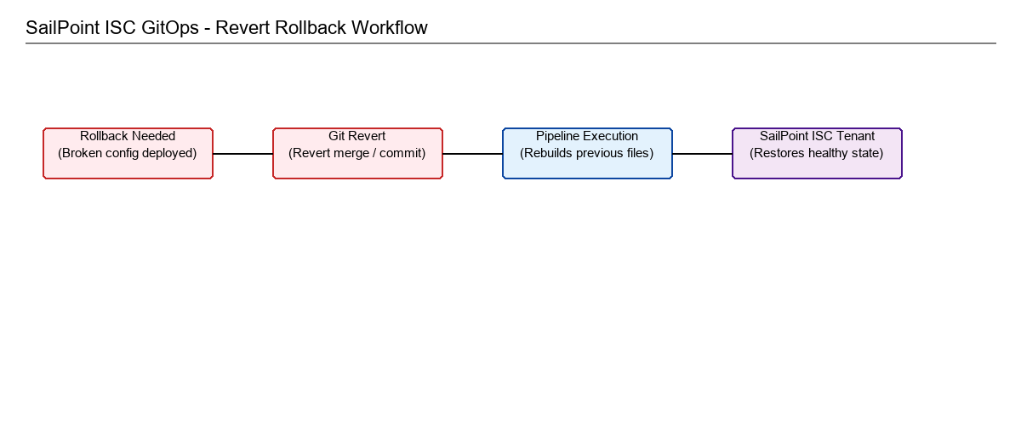
Figure 3: GitOps Revert/Rollback Logic

Crucial SailPoint Import Rule (Upsert Behavior):
SailPoint's import engine operates in update/insert (upsert) mode. It does NOT perform deletions of missing items. If a rollback is pushed to revert a newly created source or transform, the rollback WILL NOT delete that source or transform from the tenant. The configuration logic on existing objects will revert, but the new objects must be manually deleted from the SailPoint portal.

6. Dynamic CLI Upgrades6. Dynamic CLI Upgrades
The SailPoint CLI is pinned to a specific version at the top of the workflow file using a variable:
CLI_VERSION: '2.2.12'
During execution, the pipeline runs an automated update checker that queries the SailPoint GitHub releases API. If a newer version is available, it posts a yellow warning banner in your GitHub Actions interface. To upgrade, a developer simply edits the 'CLI_VERSION' variable in the workflow file to the new version number.

7. Step-by-Step Developer Onboarding
Follow these steps to configure your local machine and repository:
1. Clone the repository locally:
git clone https://github.com/Yash-Thales/WCQ_SailPoint_ISC_CI-CD_SailPoint_CLI_AWS.git
2. Add your AWS IAM credentials ('AWS_ACCESS_KEY_ID' and 'AWS_SECRET_ACCESS_KEY') to your GitHub Repository Secrets.
3. Set up your environments secret container ('sailpoint-config-dev') inside AWS Secrets Manager with key/value pairs.

8. Local Deployment Execution Guide (PowerShell)
To execute a local deployment directly from your Windows machine without pushing to GitHub, execute the following PowerShell command in the root folder:
./scripts/deploy_local.ps1 -Environment DEV
How the script executes locally:
- Validates the local installation of the SailPoint CLI.
- Prompts for credentials if they are not stored in the session environment, keeping secrets safe from disk writes.
- Runs token replacements in RAM and uploads the package to the target DEV tenant.

9. Configuration Drift Monitoring & Automated Reconciliation
Configuration Drift occurs when manual settings changes are made directly on the SailPoint tenant UI, bypassing Git. This causes Git to go out of sync with the live tenant state.
To monitor, detect, and reconcile drift, the export workflow can be scheduled as a nightly cron job. Below is the bash audit check logic integrated into the workflow:
# Run export to extract current tenant state
chmod +x scripts/export.sh
./scripts/export.sh
# Audit and verify differences against Git branch
if ! git diff --quiet config/; then
echo "❌ DRIFT DETECTED: Tenant has diverged from Git!"
exit 1 # Fails the pipeline to trigger team notifications
else
echo "✔ Tenant matches Git. No drift detected."
fi

Reconciliation Options:
1. Overwrite Tenant (Reconcile to Git): Force deployment (run deploy.yml) to push Git config back to the tenant, wiping out manual changes.
2. Update Repository (Reconcile to Tenant): Commit and push the exported drift files back into Git to match the tenant.

10. Strategic Operating Model Comparison: Full DevOps vs. Hybrid Model for WCQ
When planning the deployment strategy for WCQ, the team must choose between a Full DevOps Model and a Hybrid Operating Model. The comparison table below highlights the trade-offs:
Operational Dimension | Full DevOps Model | Hybrid Operating Model (Recommended)
Change Management | 100% of tenant changes are managed via code configurations in Git branches. | High-risk coding tasks (Rules/Transforms) are in Git. Admin configurations remain portal-based.
Manual Changes | Strictly prohibited on production. SailPoint UI portal is read-only for admins. | Allowed for standard configurations. Captured and backed up dynamically via export crons.
Operational Complexity | High. Simple setting edits require JSON coding, Git commits, PRs, and 2-signature reviewer sign-offs. | Low/Moderate. Allows rapid administrative edits via UI while maintaining tracking.
Auditing & Versioning | Enforced at the Git repository pull request level. | Supported via automated periodic export workflows committing state differences to Git branches.
Drift Risk | Zero. Any manual change on the tenant is immediately overwritten by Git. | Monitored. Pipeline alerts on any configuration drift, allowing reconciliation or overwrite.

Architectural Recommendation for WCQ:
For WCQ, the Hybrid Operating Model is recommended. It provides immediate version control, auditing, and drift detection without introducing operational bottlenecks. Since our GitOps pipeline architecture natively supports both models, WCQ can start in the Hybrid phase and transition smoothly to Full DevOps over time with zero code changes.

