
K. R. MANGALAM UNIVERSITY, GURUGRAM, HARYANA, INDIA

ASSIGNMENT-1
Analysis and Design Algorithm
Name: Yash Tiwari
Course: B-Tech CSE (Data Science)
Semester: 4th
Batch: 2024-2028

Submitted to- Signature
Dr Aarti Sangwan

Importing all necessary libraries
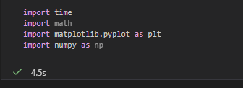

Task 1: Algorithm Growth Observation
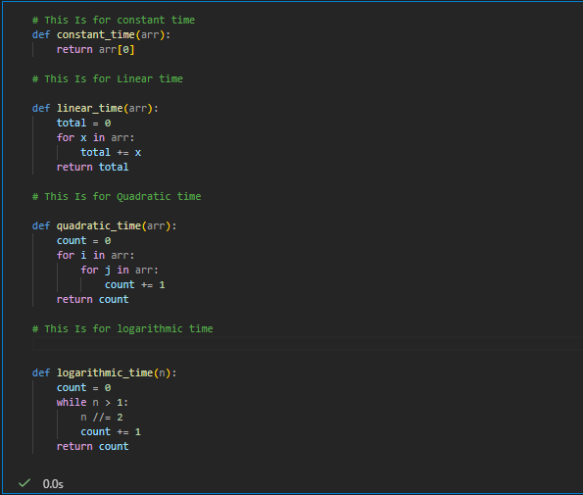

1.1 Measuring Time of Execution
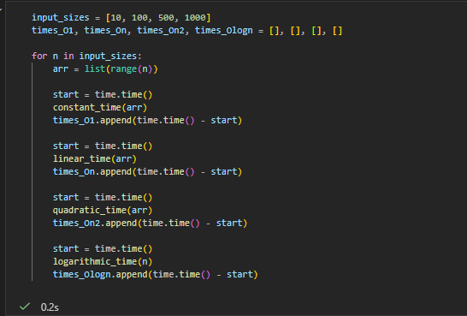

1.2 Plot Input Size vs Execution Time.
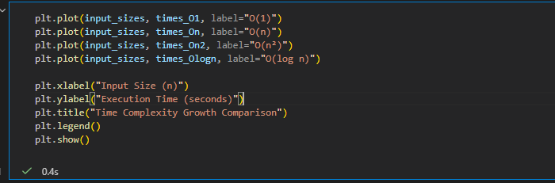

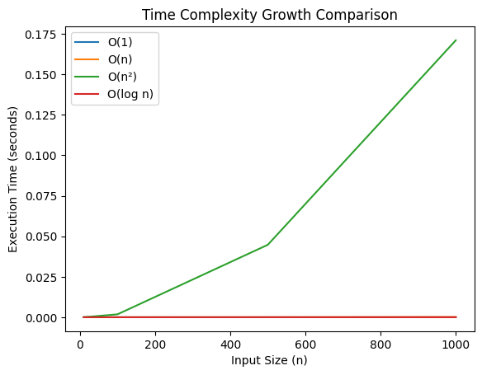

Task 2: Best, Average, and Worst Case Analysis
2.1 Implement Linear Search and Binary Search.
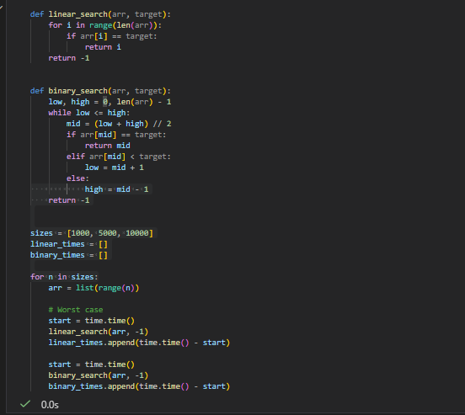

2.2 Plots for comparison
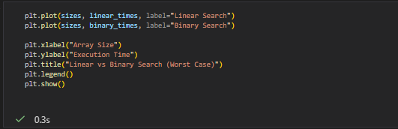
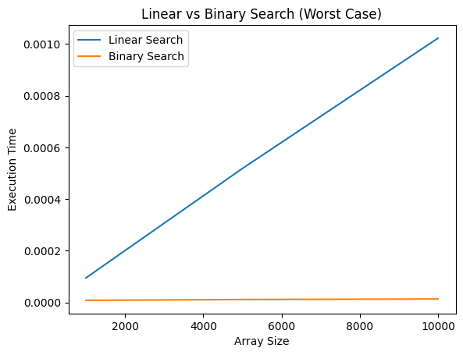

Task 3: Recursion and Recurrence Validation
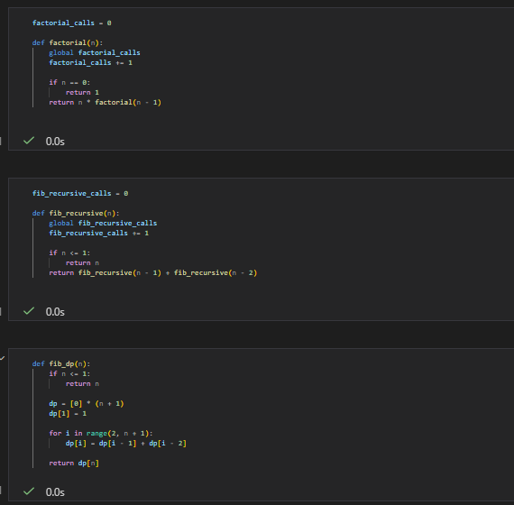
3.1 Execution Time analysis
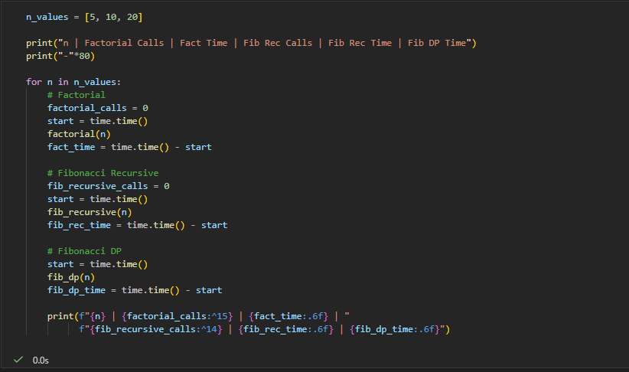
Output-
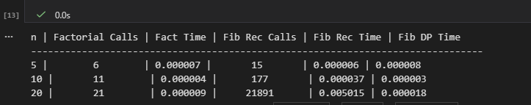

Task 4: Solving Recurrences through Code
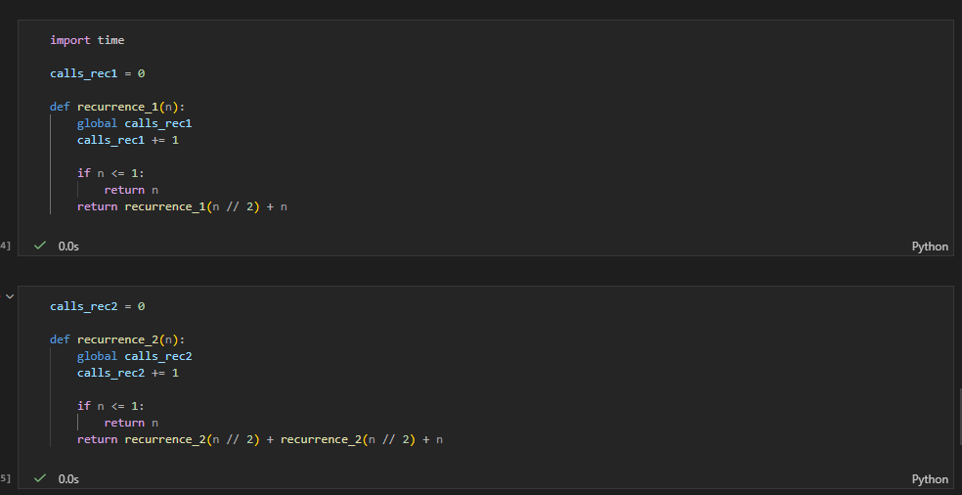
4.1: Execution Time
