**Stores Sales Prediction**

Wireframe Documentation

**Step 1: Enter values in every column. Enter Predict Button**

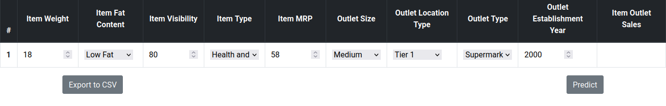

**Step 2: New row added. Fill it in if you need another one. Click on Export to CSV if you want to save your result.**

