**Admin App Documentation**

There are two methods to making Admin application working on your computer.

|  |  |
| --- | --- |
| 1. **Download GitHub repo as zip file as show in figure** [**Link**](https://github.com/mlpocprojects/mlsecurity_app) **and extract the file.** | 1. **clone repository**   Change the current working directory to the location where you want the clone directory  Type **git clone**, and then paste the URL you copied earlier  Ex. git clone ( [**Repo Url**](https://github.com/mlpocprojects/mlsecurity_app.git)) |

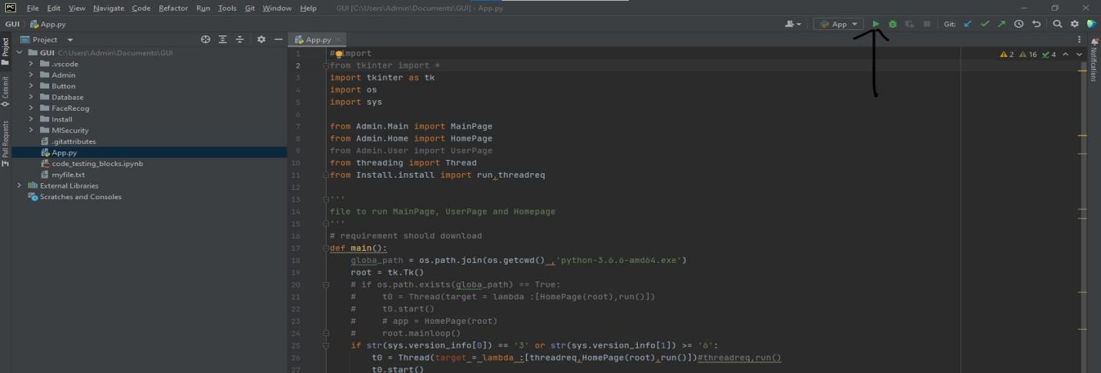After preforming one of the above steps, we can run our application.

* Open Extracted folder with PyCharm or any other IDE.
* Now go to **App.py and run the file by clicking on green play button** as shown in image.

If python version is not satisfied Frame1 will be displayed or else Frame2.

|  |  |
| --- | --- |
| **Frame 1**    Here, we need to click on install button which will install all requirement for Application. | **Frame 2**    Further functions / buttons are explained in detail below. |

There are Three buttons as we can see in above Frame2

* **Camera Management:**

It can be used to Mange camera settings (After checking your camera other two button will be enabled).

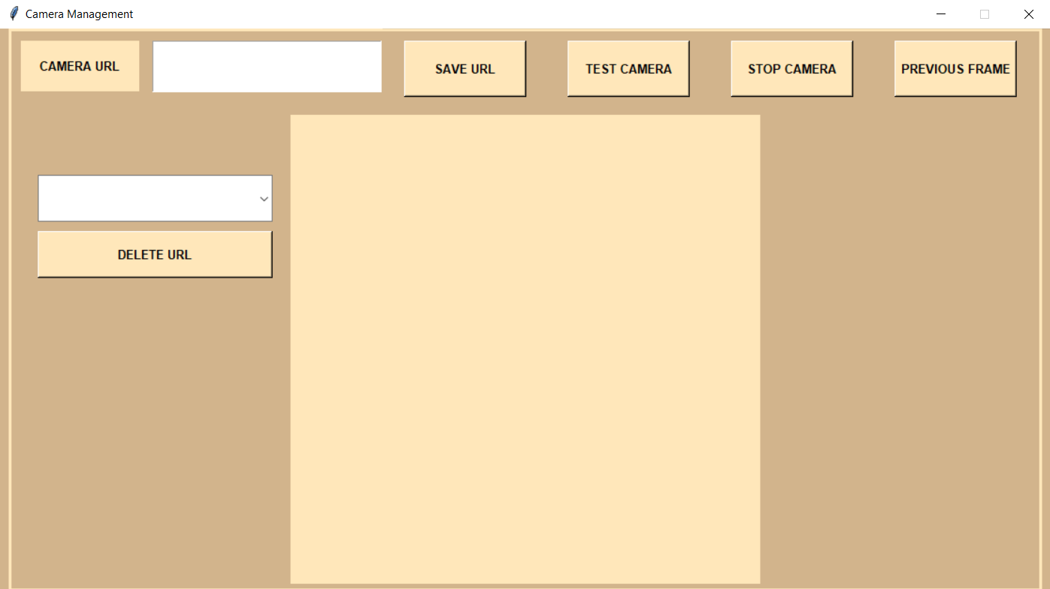

In Camera Management either you can click **test camera** button or paste your webcam link in Camera URL Entry box to test your Webcam / Camera.

If you want to save Webcam URL link for next time you can also save it by pressing **Save URL** button which will be saved to database so you can excess it next time.

Different button on camera management

* **Save URL**: it will save Webcam/ camera link to database.
* **Test camera**: Is used to test your camera
* **Stop camera**: To stop the camera
* **Previous frame**: To close the camera management frame and go back to system management.
* **Delete URL And Drop-Down Box:** Drop-down box will have all the webcam / camera link which are stored on database through delete URL you can delete unwanted link/URL
* **User Management:**

From frame2 by clicking **user management**, it will give user following screen which is also connected to database

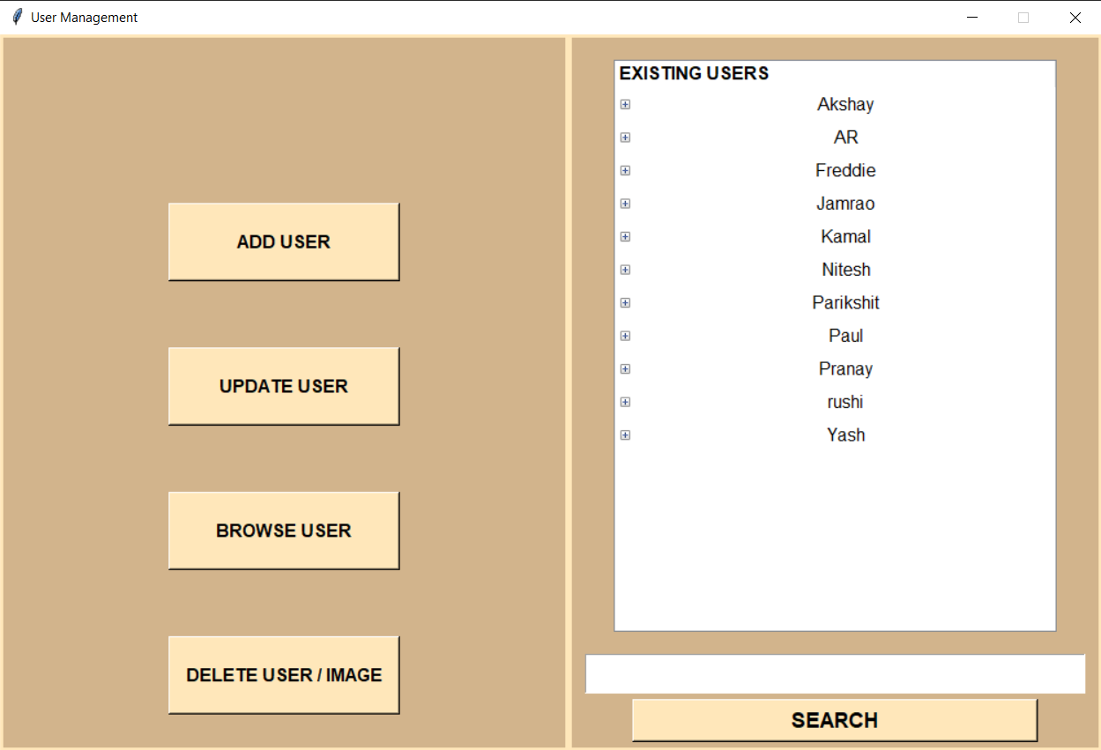

* There is search entry box where you can search user



* **Add User is used to add new user** (which will show entry box and browse button)
* where you can put new user name which you need to add and browse button will used to select images for that new user.

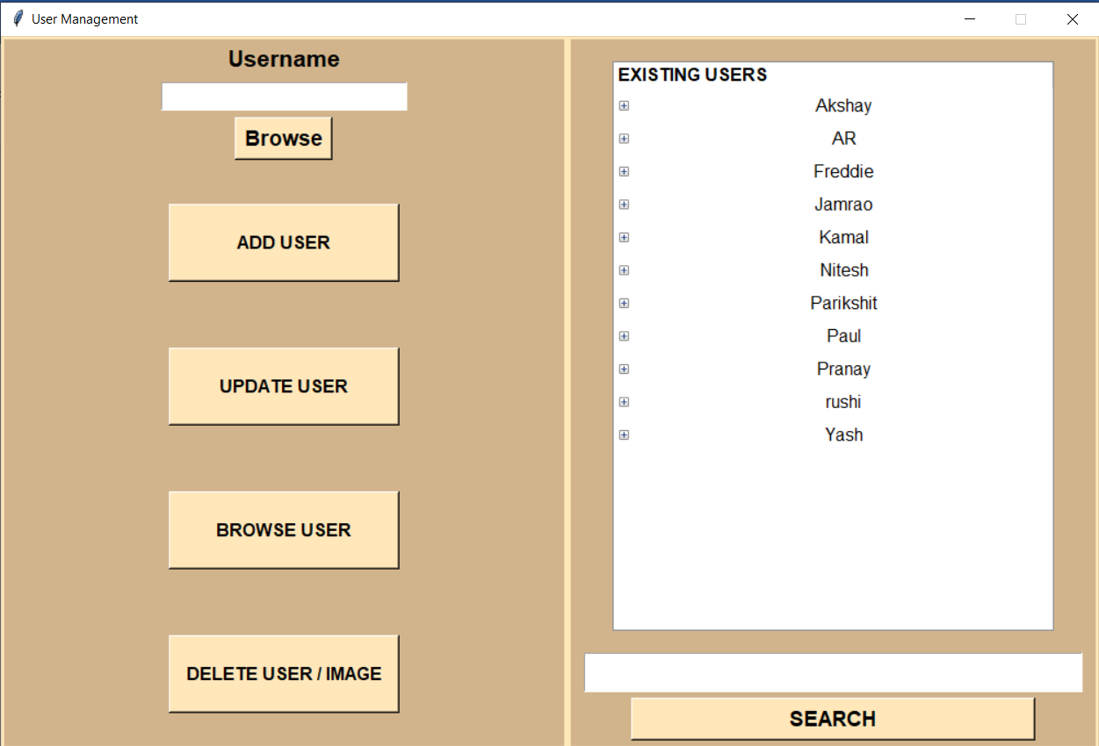

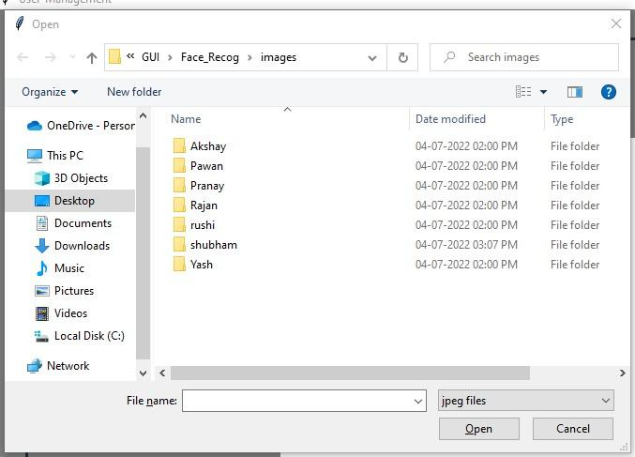

* **Update User** which is used to update user images from directory where user can add images to existing user
* You need to select username and click on update User button which will give us popup where you can select or browse desired images to add.

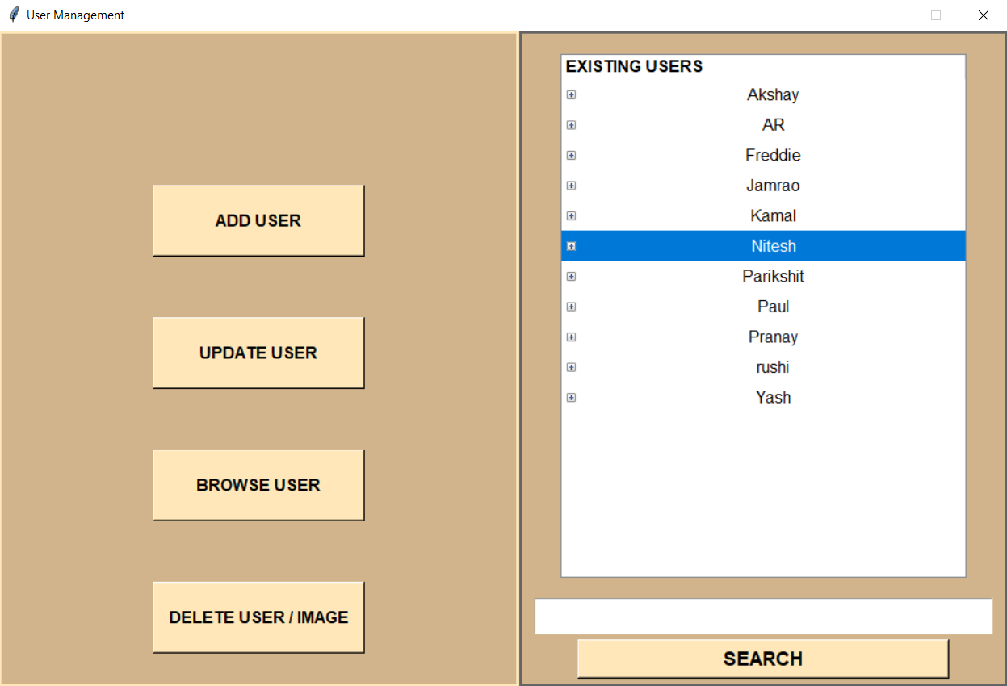

* **Browse User** it is used to browse user and see images present in existing users
* you just have to select user from list and press browse image button to browse.

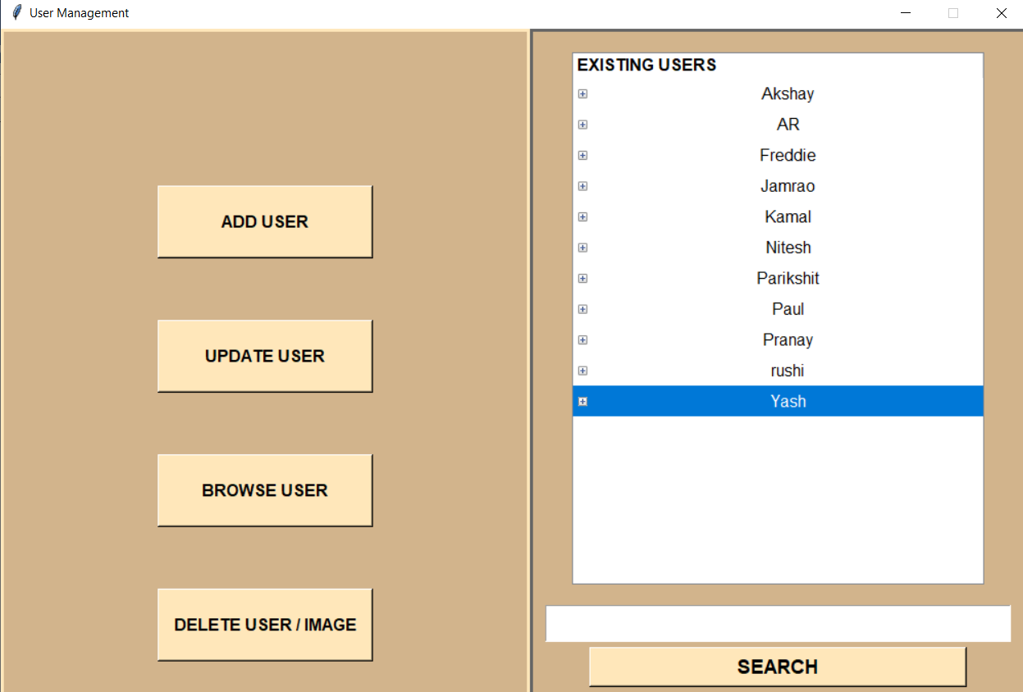

* **Delete User / Image** it is used to delete specific user images or image directory of Existing user you just have to select specific image or user directory and click on delete user / image button.



* **Start Verification:**

After performing user management and Camera Management

We can start face detection model by pressing start detection button.

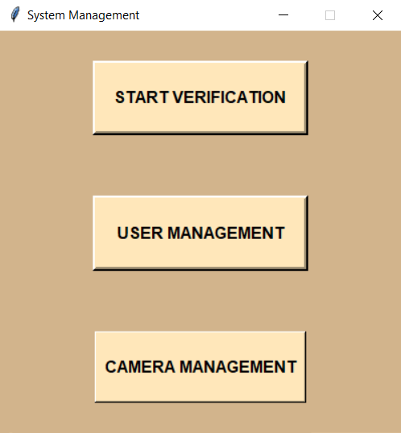

After That it takes some time and automatically opens a link in browser and start face detection. (If browser popup but you can’t see detection wait form 1-2 min and refresh the browser link)

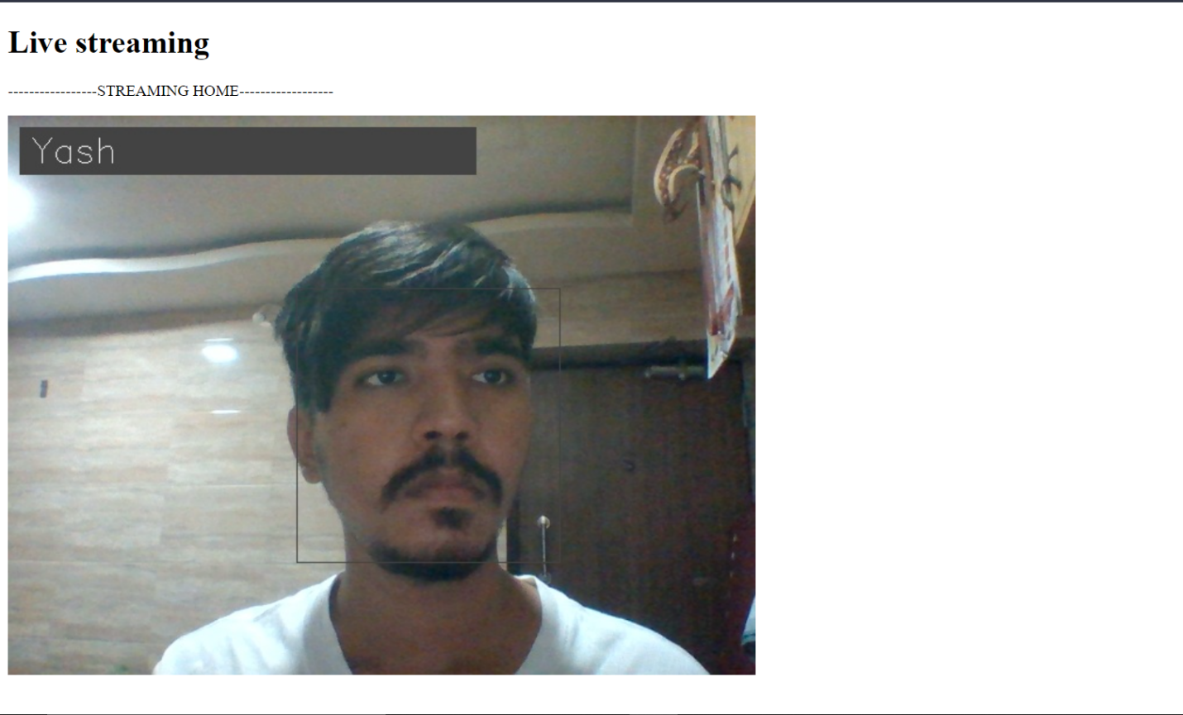

**Thank You.**