**Installation documentation**

**FaceNet GAIS**

#### Let us begin:

### **prerequisite** – Python version < 3.10

* How to Download python
* Document guide to download python: [***Document Link***](https://docs.python.org/3.6/using/windows.html#installing-python)
* Video guide to download python: [***Video Link***](https://www.youtube.com/watch?v=3lGhtIqT0Tk)

**After downloading python steps to follow**

* **1st method**

visit GitHub link and Download Repository - [**Repo Link**](https://github.com/mlpocprojects/mlsecurity_app/)

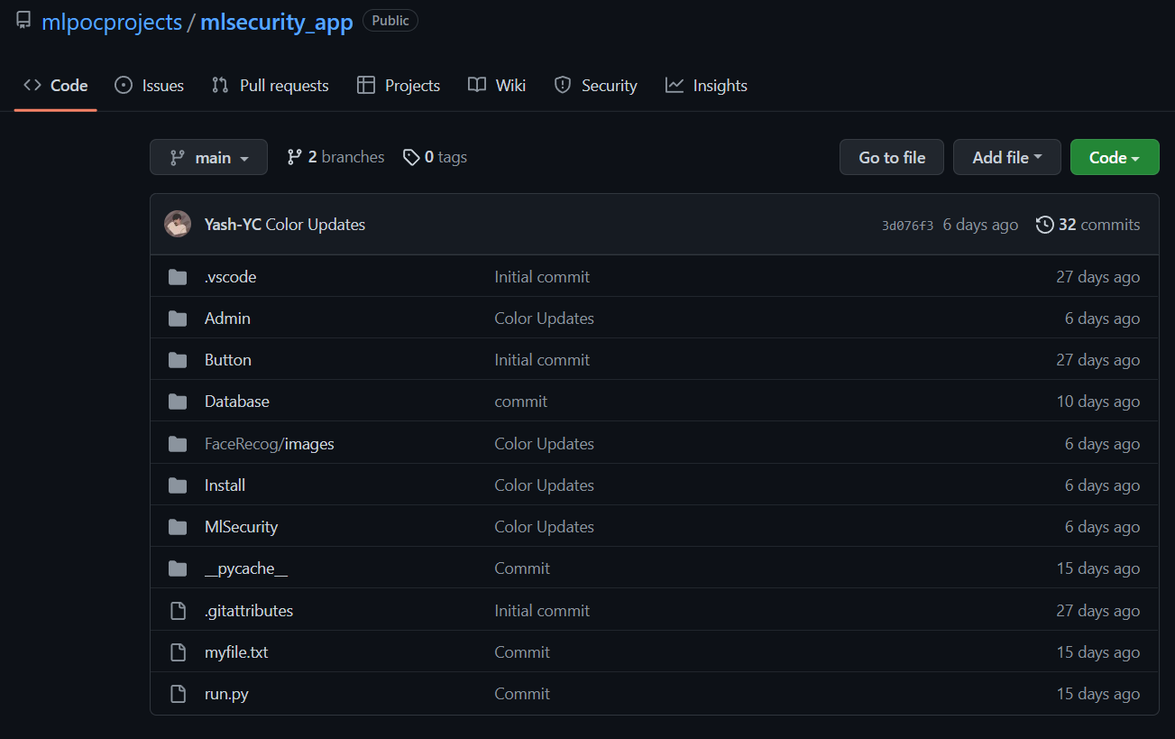

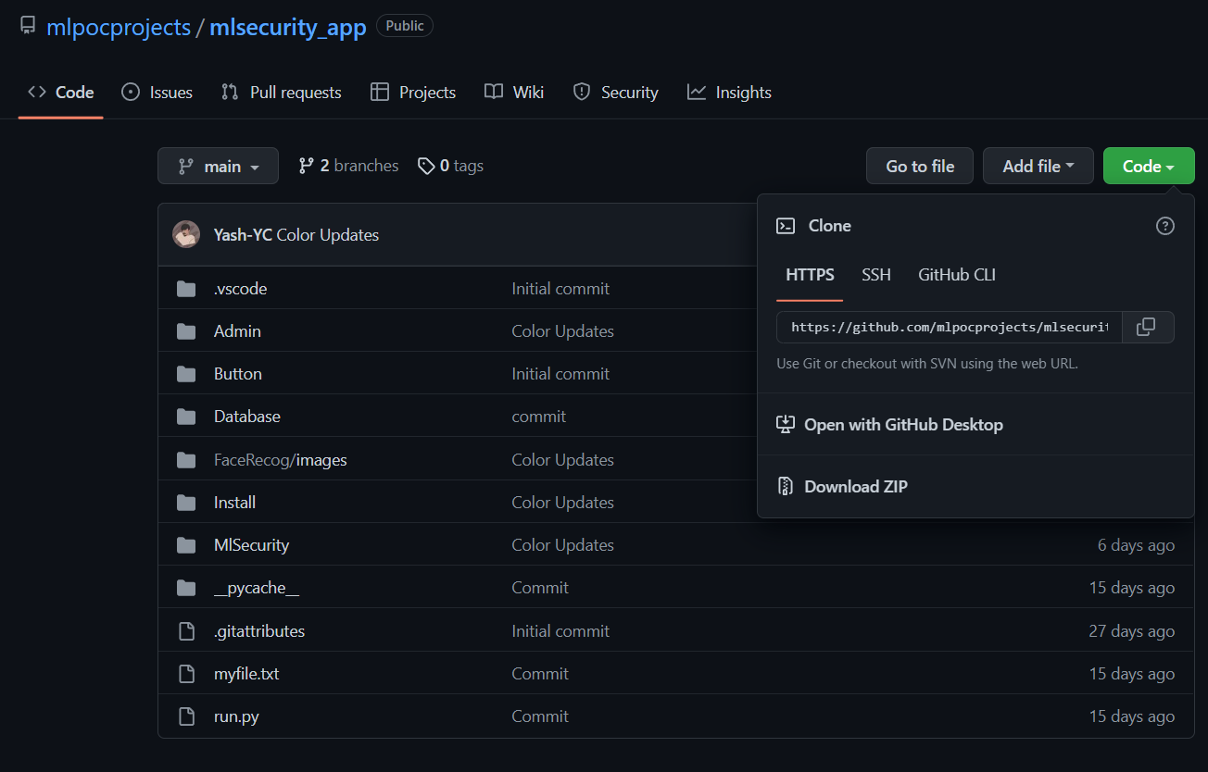

* **2nd method to clone repository**

Change the current working directory to the location where you want the clone directory

Type **git clone**, and then paste the URL you copied earlier

- $ git clone ( [**Repo Url**](https://github.com/mlpocprojects/mlsecurity_app.git))

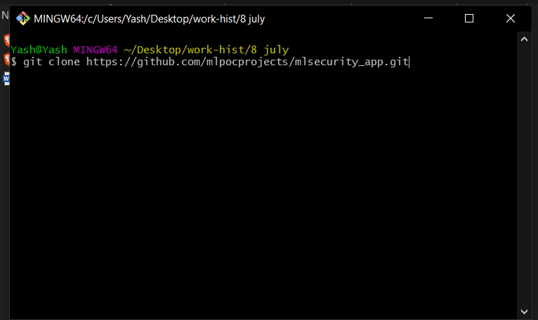

Now we can open the folder where we have our project then we can install requirement.txt

# **Steps**

# **pip install -r requirements.txt**

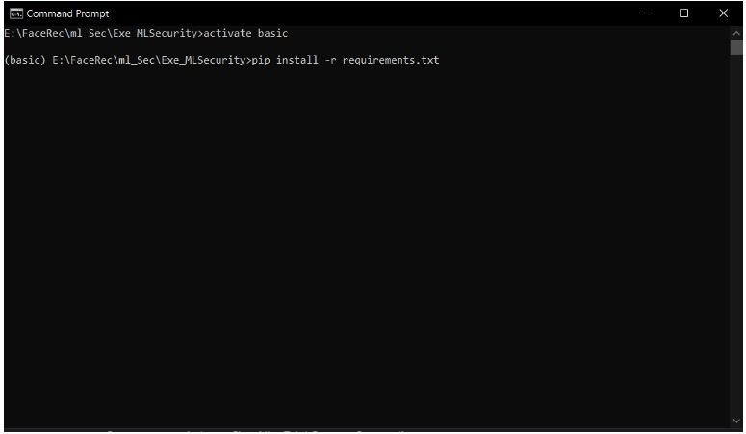

### Once the requirements are installed

### We can add user into “Face_Recog/Images” folder which we want to recognize

### **Images Folder Format Should be in this manner**

**Face_Recong**

**├── images**

**│ ├── Alice**

**│ │ ├── Alice1.jpg**

**│ │ ├── Alice2.jpg**

**│ ├── Bob**

**│ │ ├── Bob.jpg**

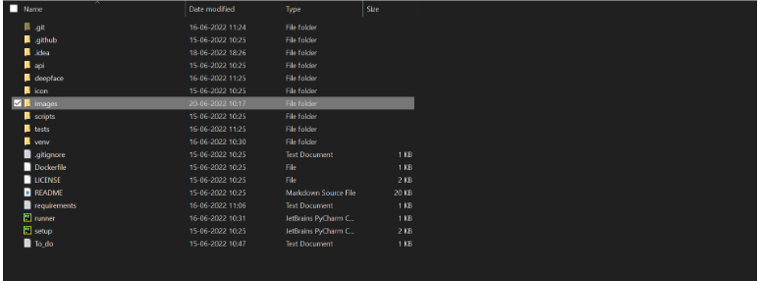

After completing all the above steps, we can

Run the project in Cmd (**command prompt**) with the help of following commands –

## - cd Folder_Path

## - python Runner.py

### After running above command, it will create embedding for user (can take 1-2 minutes)

### bowser will popup which will start detecting which user is present in live stream (if browser pop’s up and don’t detect wait for 1-2 minutes and refresh the page).

# **THANK YOU**