Git – Commands Assignment
TASK 1: Repository Setup
Goal: Initialize Git and create first commit
Steps:
- Create a folder named git-assignment-yourfullname
- Navigate into the folder
- Initialize Git repository
- Create a file named index.txt
- Check repository status
- Stage the file
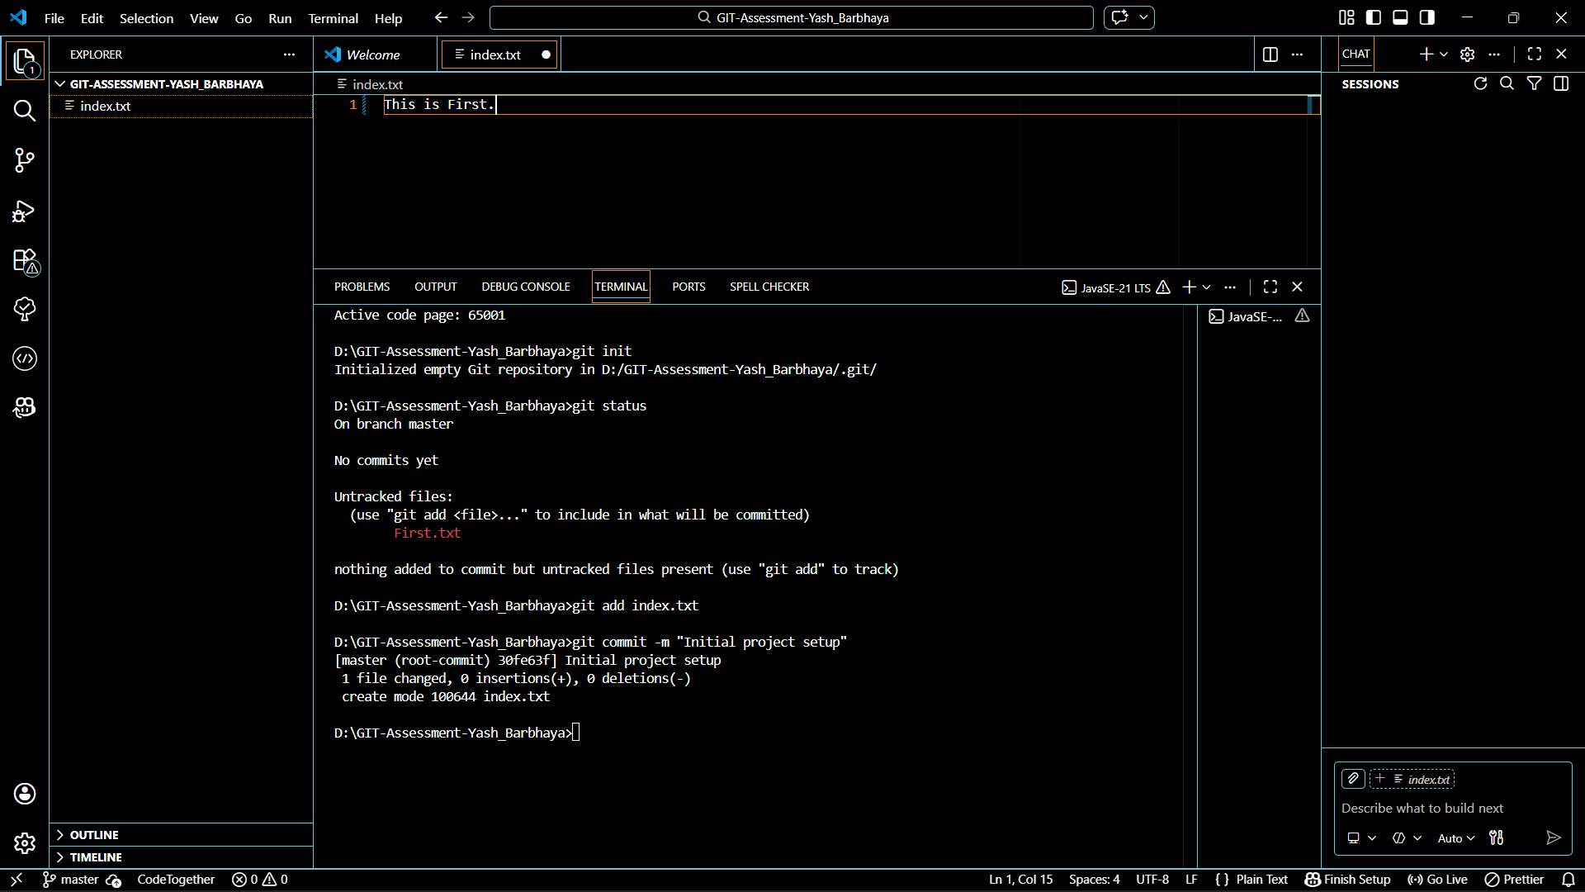
- Commit with message: Initial project setup

TASK 2:
Branch Creation & Work Goal: Work independently in a branch
Steps:
- Create a branch named feature-header
2. Switch to feature-header
3. Create a file named header.txt
4. Stage the file
5. Commit with message: Added header section
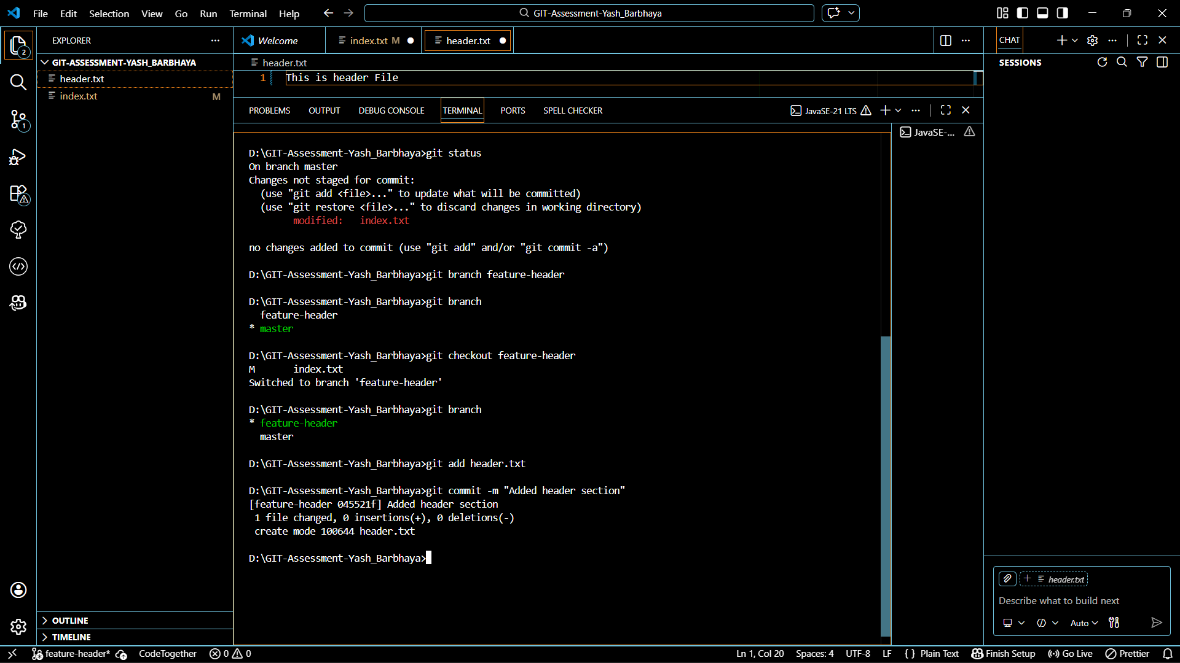

TASK 3:
Branch Switching Observation Goal: Observe branch isolation
Steps:
1. Switch back to master
2. List files and observe
3. Switch again to feature-header
4. List files and observe
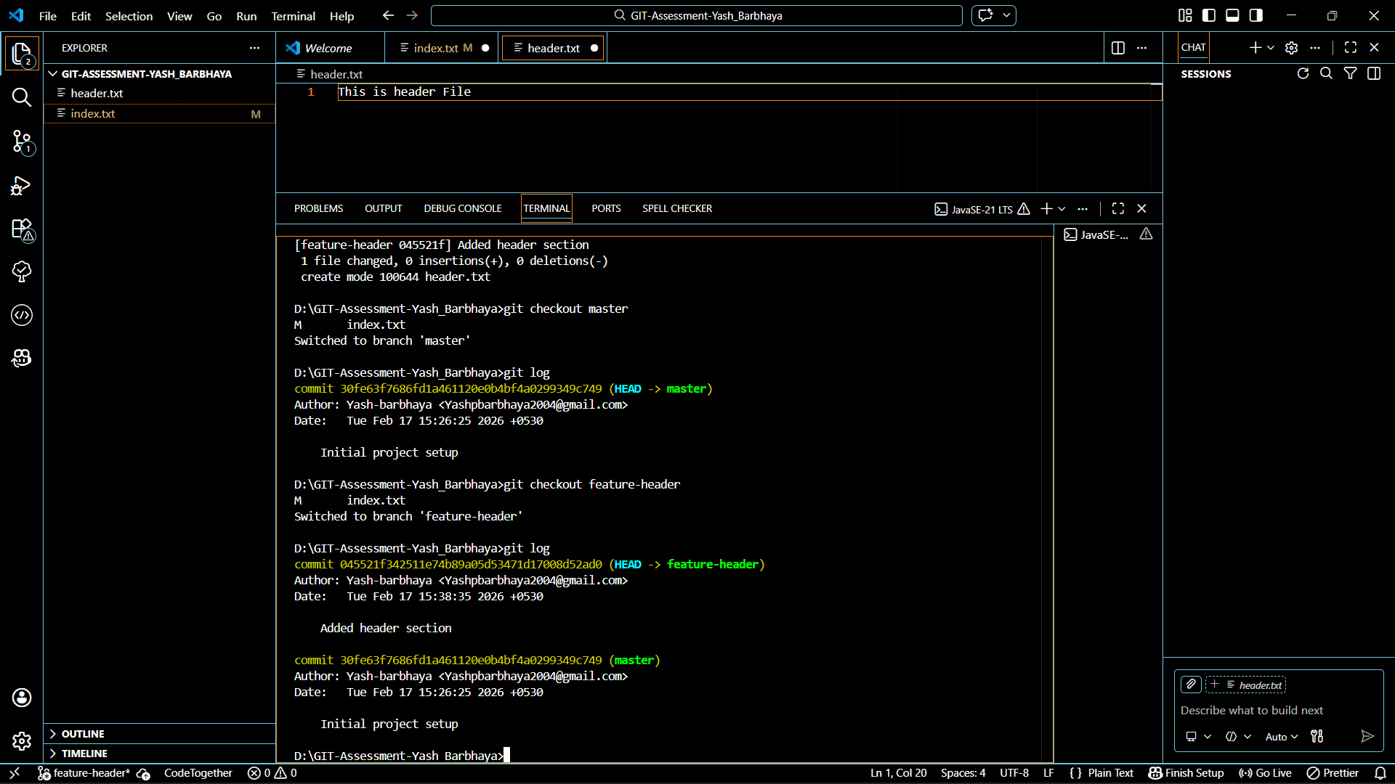

TASK 4:
Undo a Mistake Goal: Safely undo file changes
Steps:
1. In feature-header, modify index.txt
2. Check repository status
3. Undo the change using Git
4. Verify status again
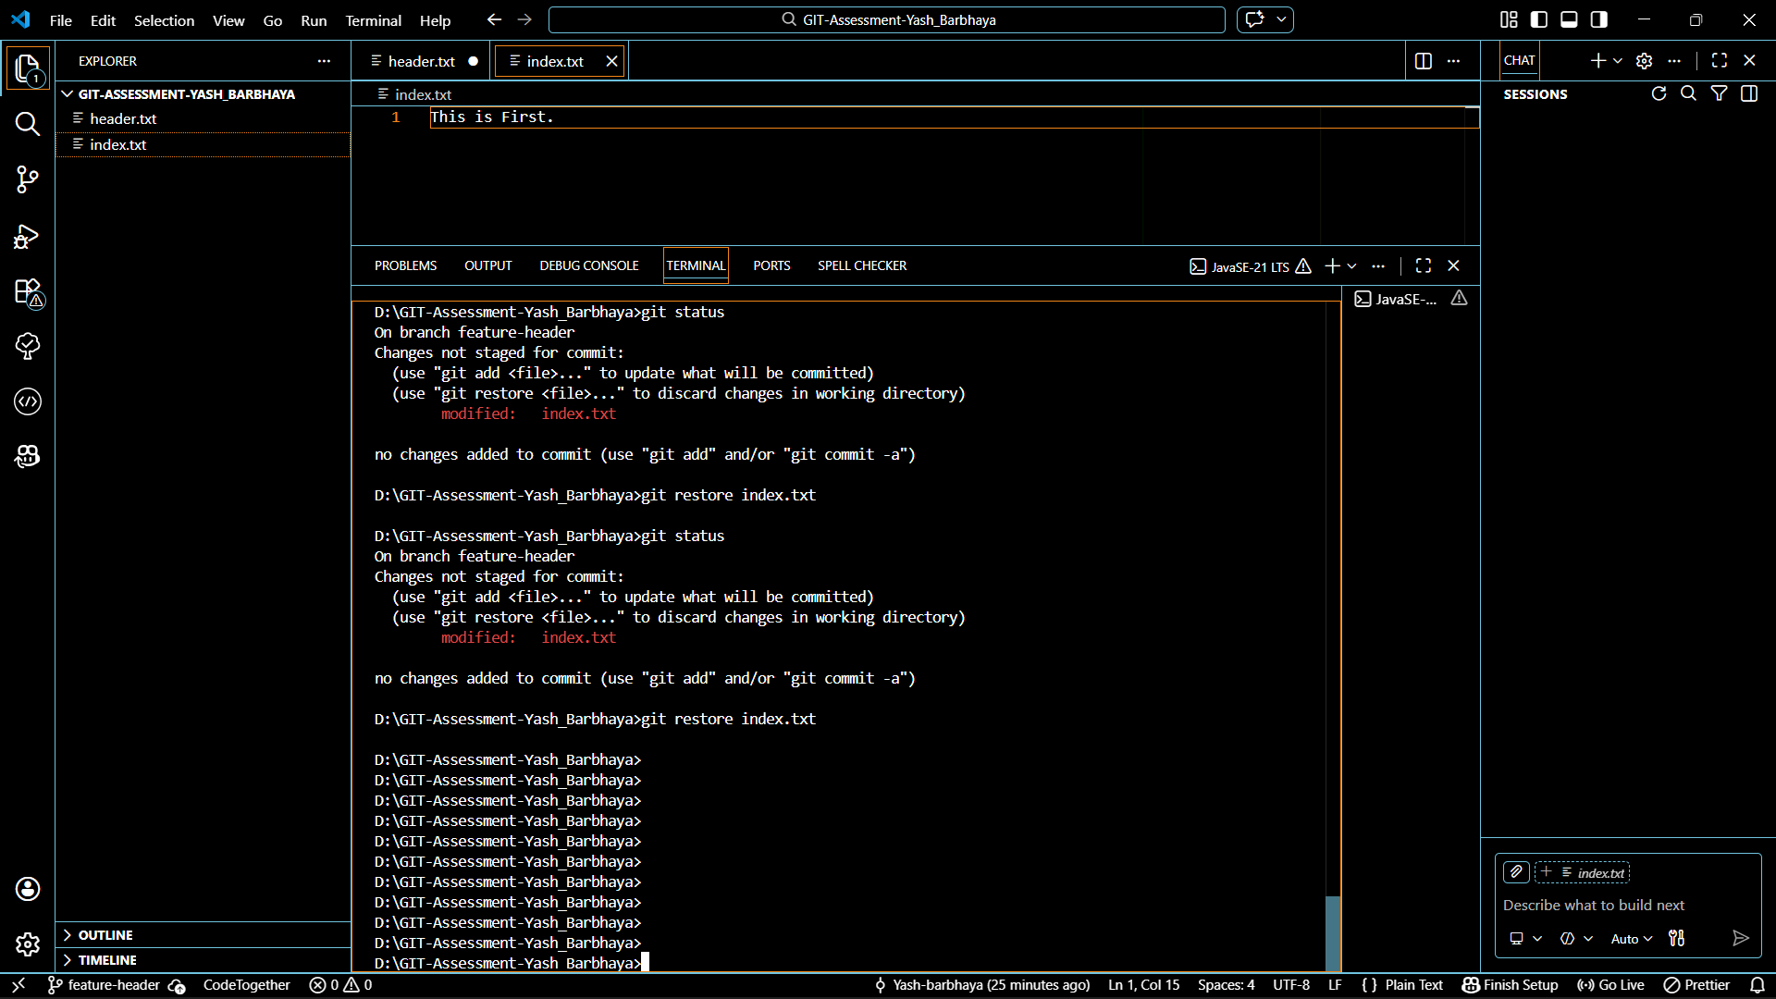

TASK 5:
Merge Feature Branch Goal: Combine work into master
Steps:
1. Switch to master
2. Merge feature-header
3. Verify merged files
4. Check commit history
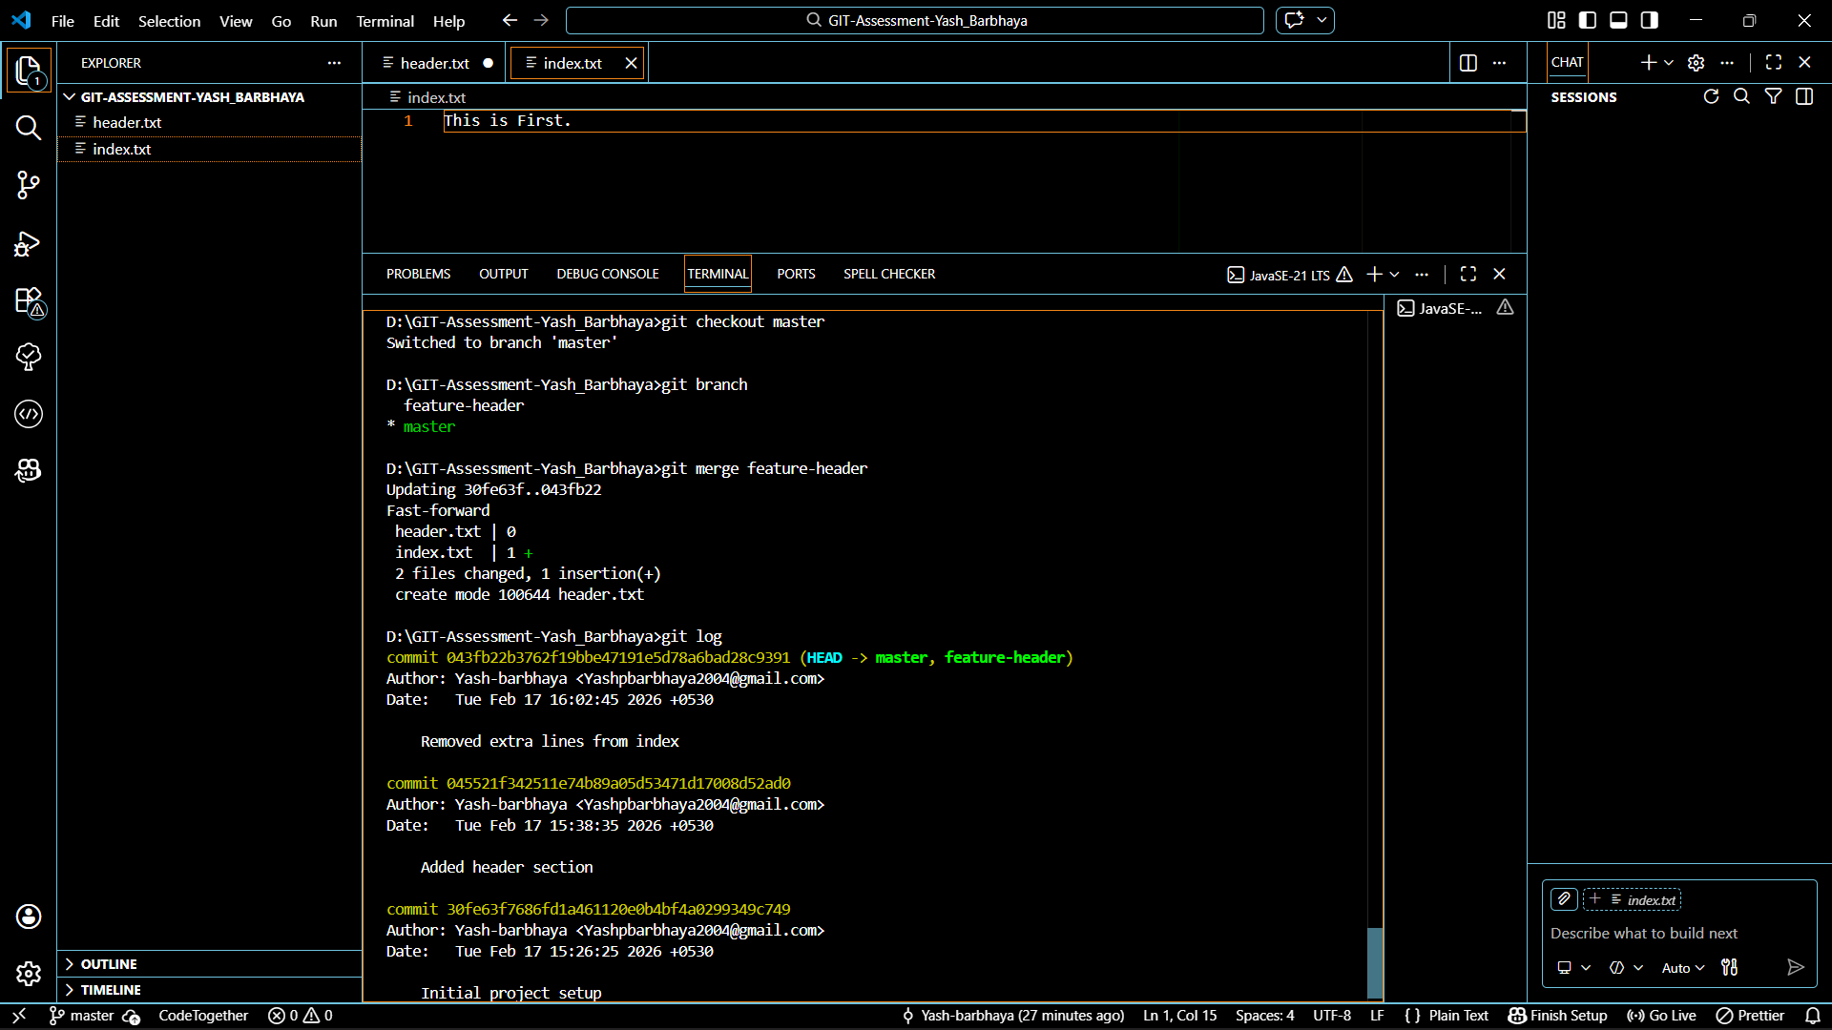

TASK 6:
Checkout a Commit (Detached HEAD) Goal: Understand commit-level navigation
Steps:
1. View commit history
2. Checkout any older commit
3. Check current branch status
4. Switch back safely to master
