An Internship Report
Of
C++ Programming
(CodeAlpha Virtual Internship Program)
Submitted
To
School of Computer Science and Engineering
IILM University, Greater Noida, U.P.
In partial fulfilment of the requirement of degree of
B-Tech (CSE)

By
Student ID:- CA/DF1/230640
Roll Number of Student:- 25SCS1003002584
Name of Student: YASH GAUTAM
Academic Batch: 2025-29

CANDIDATE'S DECLARATION
I, YASH GAUTAM, do hereby declare that the internship report titled “C++ Programming Internship”, undertaken under the CodeAlpha Virtual Internship Program, has been completed by me to fulfil the requirement for the award of the degree of Bachelor of Technology in Computer Science and Engineering. All the references have been quoted and I have not taken as such any material from any other source. I affirm that this report is my own and has not been submitted to any other institute for any degree/diploma requirement, and further I shall be solely responsible for any kind of copyright violation in this regard.

Signature:-
Student Name: YASH GAUTAM
Roll No.: 25SCS1003002584

ACKNOWLEDGEMENT
I am using this opportunity to express my gratitude to everyone who supported me throughout the Internship Program. I am thankful for their aspiring guidance, invaluably constructive criticism and friendly advice during this work. I am sincerely grateful to them for sharing their truthful and illuminating views on a number of issues related to this work.
I would like to thank the CodeAlpha Virtual Internship Program team for providing me the opportunity and the structured platform to learn and gain hands-on exposure in the domain of C++ Programming. I am also thankful to my institute, IILM University, Greater Noida, and the faculty of the School of Computer Science and Engineering for their continuous support and encouragement.
I express my gratitude to my parents for their blessings.

Signature:
Student Name: YASH GAUTAM
Roll No.: 25SCS1003002584

TABLE OF CONTENTS
1. Candidate's Declaration i
2. Acknowledgement ii
3. Internship Completion Certificate & Letter of Recommendation -
4. Project Description 1
4.1 Introduction 1
4.2 Organization Profile 2
4.3 Problem Statement 3
4.4 Project Objectives 3
4.5 Scope of the Project 4
4.6 Technologies and Tools Used 4
4.7 System Architecture 5
4.8 Methodology / Projects Undertaken 6
4.9 Skills and Learning Outcomes 7
4.10 Certificate of Completion and Communication Proof 8
5. Bibliography/References 9

3. INTERNSHIP COMPLETION CERTIFICATE
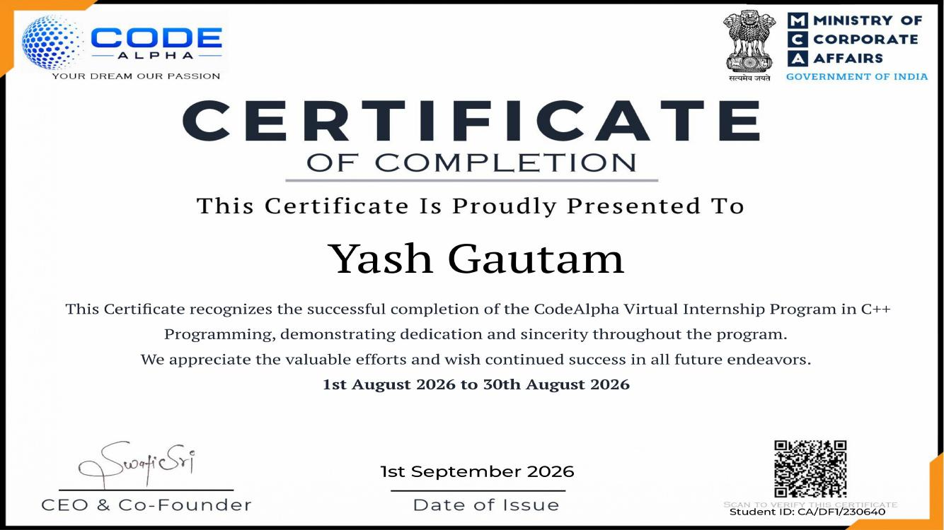

Letter of Recommendation
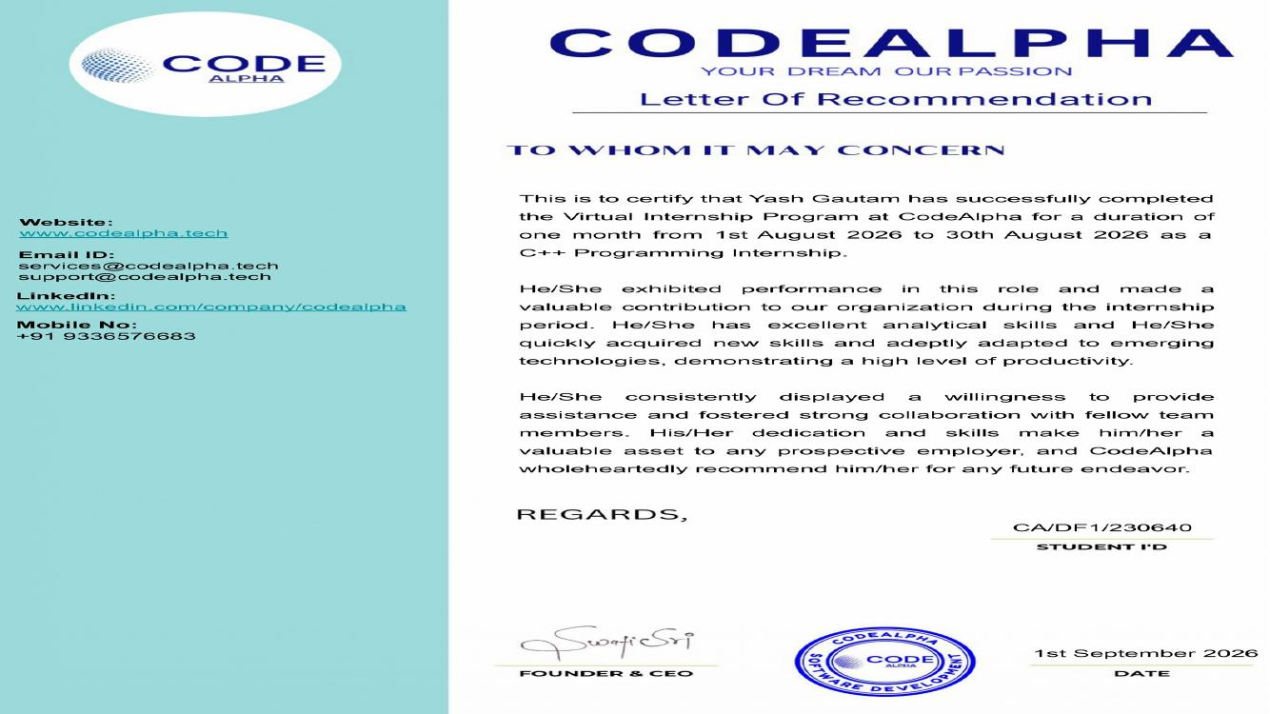

4. PROJECT DESCRIPTION

4.1 Introduction
This report presents a detailed account of the 1-month Virtual Internship undertaken under the CodeAlpha Virtual Internship Program, in the domain of “C++ Programming”. The internship was carried out from 1 August 2026 to 30 August 2026 as part of the requirement of the Bachelor of Technology (Computer Science and Engineering) programme at IILM University, Greater Noida. The primary aim of this internship was to bridge the gap between theoretical understanding of C++ programming concepts and their practical, real-world application development. Over the course of the programme, the learner was exposed to industry-style practices used to translate C++ syntax and concepts into complete, working console-based applications.
The internship followed a project-based, self-paced curriculum that combined practical assignments with hands-on application of Object-Oriented Programming, file handling, input validation and version control. Two industry-style capstone projects were undertaken as part of the programme: a Login & Registration System and a Banking System. On successful completion of all the requirements, a Certificate of Completion and a Letter of Recommendation were awarded by CodeAlpha.

4.2 Organization Profile
CodeAlpha is a private training organization and Ed-Tech platform that provides practical, project-oriented learning opportunities for students and aspiring developers, operating under the legal entity Codealpha Tech LLP (registered in India) and regulated by the Ministry of Corporate Affairs (MCA). Its vision is to empower learners with industry-relevant skills and build a future-ready workforce, and its mission is to bridge the gap between education and industry through practical, project-based learning and skill development.
The CodeAlpha Virtual Internship Program follows predefined, industry-style projects and curated practical assignments that emphasise hands-on programming experience, self-paced learning and flexible work schedules around college, work or personal commitments, with a focus on practical execution rather than passive learning. The organization's core focus areas include Artificial Intelligence, MLOps, Cloud Computing, Cybersecurity and Enterprise Automation, of which C++ Programming forms part of its practical software-development track.

4.3 Problem Statement
A major challenge for students learning programming is the gap between theoretical knowledge and practical implementation. Knowing C++ syntax and concepts is not enough to develop a complete application; practical development requires students to understand program structure and logic, Object-Oriented Programming, input validation, file handling and data storage, authentication and verification, error handling, debugging, testing and version control. This internship addressed that practical gap through project-based C++ assignments -- namely a Login & Registration System and a Banking System -- that required students to apply programming concepts to realistic application scenarios.

4.4 Project Objectives
The main objectives of the internship were:
- Strengthen C++ programming skills by applying core concepts to practical programming problems.
- Apply Object-Oriented Programming using classes, objects, attributes and functions to structure applications.
- Implement file handling to store and retrieve application data using files.
- Implement input validation to validate user inputs and handle incorrect or invalid data.
- Develop authentication features, including registration and login functionality with username and password verification.
- Develop banking operations such as deposits, withdrawals, fund transfers and account management.
- Maintain transaction records by storing and displaying transaction history and recent transactions.
- Improve debugging and development skills by testing programs, identifying errors and refining functionality.
- Use version control (Git and GitHub) for managing and maintaining project code.

4.5 Scope of the Project
The scope of this internship spans core C++ application development -- from applying Object-Oriented Programming and input validation to implementing file-based data storage, and building two complete, console-based capstone applications: a Login & Registration System and a Banking System. The work also covered maintaining project code using Git and GitHub for version control. The internship was limited to a self-paced, virtual/simulation-based environment provided by CodeAlpha and did not involve deployment on any live organizational production system.

4.6 Technologies and Tools Used
- Programming Language: C++
- Programming Concepts: Object-Oriented Programming (classes, objects, attributes and functions)
- Data Storage: File Handling (read/write files, persistent storage)
- Version Control: Git and GitHub (repositories, commit and push)
- Development Environment: C++ compiler (VS Code), console-based testing

4.7 System Architecture
The general architecture followed for the applications built during the internship can be summarised as a sequential workflow: User Input → Input Validation → Core Program Logic → Data Processing/Storage → Output/User Response.
In the Login & Registration System, the Registration flow takes a username and password, validates the input, checks for duplicate usernames, stores the credentials to a file, and returns a registration result; the Login flow takes a username and password, reads the stored credentials, verifies the user, and returns a success or error message.
In the Banking System, the architecture is built around three classes -- Customer (name, id, contact), Account (accountNo, balance, type) and Transaction (id, type, amount, date, description) -- with a Customer linked to one or more Accounts, and each Account linked to its Transactions. The transaction flow selects a customer/account, chooses an operation (deposit, withdrawal or transfer), validates the input and balance, updates the account and records the transaction, and finally shows a confirmation along with the transaction history.

4.8 Methodology / Projects Undertaken
The internship followed a project-based methodology comprising planning and design, code implementation, testing and debugging, version control and documentation, applied across two capstone projects.
Project 1: Login & Registration System
A console-based C++ application that allows users to create an account, store their credentials securely in a file, and log in to access the system. Key features include registration (taking username and password as input, validating the data and creating a new user account), duplicate-username checking, secure file-based credential storage (one file per user), a login function that reads and verifies stored credentials, and clear success/error messaging. Validation testing covered empty fields, invalid length, invalid characters and duplicate usernames.
Project 2: Banking System
A console-based application that manages customers, accounts and transactions using Object-Oriented Programming and file handling to store data and maintain transaction history. Key features include creating and managing customers, opening and managing accounts, deposits, withdrawals, fund transfers between accounts, viewing recent transactions, and displaying account details and balance. Validation and error handling covered invalid input, insufficient balance and duplicate account checks.
Both projects were tested through structured test cases (registration with valid/invalid data, login with correct/incorrect credentials, deposit/withdrawal limits, fund transfer and transaction-history display), debugged using print statements and logic-flow checks, re-tested after each fix, and maintained under version control using Git and GitHub.

4.9 Skills and Learning Outcomes
The internship helped build the following skills and outcomes:
- Technical skills in C++ programming, file handling, Object-Oriented Programming, Git/GitHub and debugging.
- Stronger grasp of core programming concepts: classes and objects, functions, input validation, error handling and file I/O.
- An industry-style development workflow: planning and design, code implementation, testing and debugging, version control and documentation.
- Improved problem-solving ability -- breaking down requirements, finding efficient solutions, handling edge cases and improving code structure.
- Built two complete, real-world console applications, gained a deeper understanding of OOP, greater confidence in C++, and developed disciplined coding habits.

4.10 Certificate of Completion and Communication Proof
The Certificate of Completion and the Letter of Recommendation issued by CodeAlpha, confirming successful completion of the CodeAlpha Virtual Internship Program in C++ Programming from 1 August 2026 to 30 August 2026, are attached in Chapter 3 of this report.

5. BIBLIOGRAPHY/REFERENCES
1. CodeAlpha, “Certificate of Completion – C++ Programming Internship,” Student ID: CA/DF1/230640, Issued on 1 September 2026.
2. CodeAlpha, “Letter of Recommendation – C++ Programming Internship,” Student ID: CA/DF1/230640, 1 September 2026.
3. CodeAlpha Official Website, https://www.codealpha.tech/
4. C++ Language Reference, https://cplusplus.com/
5. Git Documentation, https://git-scm.com/doc
6. GitHub Documentation, https://docs.github.com/

