KNOTS: AI-Powered Community-Based Career and Collaboration Platform
Yash Kapse, Kanchan Gaikwad, Dhanshree Bhorkar, Shrushti Zod
Department of Computer Science and Engineering
S. B. Jain Institute of Technology, Management & Research (SBJITMR), Nagpur, Maharashtra, India
Abstract—Higher education institutions frequently rely on fragmented software tools to manage placement operations, student networking, campus organizations, alumni engagement, and career preparation. This fragmentation results in administrative overhead for Training and Placement Officers (TPOs), delayed communication between recruiters and students, inconsistent alumni mentorship, and difficulties in maintaining verified student academic portfolios. This paper presents KNOTS (Knowledge Network and Organizational Tracking System), an end-to-end university ecosystem platform designed using an asynchronous domain-driven architecture. Built on FastAPI, SQLAlchemy, PostgreSQL, and persistent WebSockets, KNOTS unifies verified academic profiling, campus organization management, event orchestration, alumni mentorship channels, real-time messaging, and profile-driven resume generation into a single scalable infrastructure. The platform features an automated eligibility validation engine that dynamically filters candidates based on academic criteria (CGPA, active backlogs, batch year, and branch cutoffs), an automated profile-to-resume compiler that formats verified profile data into standardized ATS-compliant documents, a dedicated alumni networking portal for 1-on-1 mentorship and job referrals, and multi-tier Role-Based Access Control (RBAC) with immutable audit logging. Comprehensive evaluations validate that the asynchronous ASGI backend achieves high request throughput and low operational latency, establishing a robust, transparent digital infrastructure for higher education institutions.
Index Terms—Campus Networking, Placement Automation, Alumni Mentorship, Resume Generation, FastAPI, WebSockets, Role-Based Access Control, Academic Governance, Information Systems.
I. INTRODUCTION
Higher education institutions face significant operational challenges in coordinating student placement drives, facilitating student-alumni networking, managing campus organizations, and providing scalable career guidance. Modern university administrative workflows are typically divided across disconnected channels:
• Placement Operations: Handled through legacy web portals or manual spreadsheet submissions, leading to verification delays, data redundancy, and error-prone candidate filtering during corporate campus drives.
• Campus & Alumni Engagement: Managed via unofficial instant messaging channels and standalone social platforms, scattering official notices regarding club activities and technical workshops, while losing active touchpoints with graduated alumni who can provide essential industry mentorship.
• Career Preparation & Profiling: Heavily reliant on students manually drafting unverified resumes and faculty spending limited hours manually validating academic records, preventing standardized, verified document generation for campus placement.
To resolve these inefficiencies, this paper introduces KNOTS (Knowledge Network and Organizational Tracking System), a unified platform designed to serve as a centralized digital backbone for academic institutions. KNOTS combines verified academic management with interactive peer-alumni networking, automated placement administration, and institutional governance.
Key Technical Contributions
1. Domain-Driven Asynchronous Architecture: A scalable Python backend built with FastAPI, utilizing asynchronous I/O and domain segregation (auth, jobs, events, clubs, messaging, profiles, connections, admin) to handle concurrent usage during campus drives.
2. Automated Profile-to-Resume Generator: An integrated document compiler that extracts verified academic credentials (CGPA, marks), technical skills, project experiences, and certifications directly from user profile edits into standard, professional resume documents.
3. Alumni Mentorship & Referral Network: A dedicated subsystem connecting students with verified institutional alumni for 1-on-1 career guidance, industry insights, and corporate referral pathways.
4. Dynamic Eligibility Filtering Engine: An automated rule evaluation pipeline that instantly checks candidate criteria (minimum CGPA, 10th/12th percentages, backlog counts, allowed branches) against corporate drive requirements.
5. Real-Time Asynchronous WebSocket Broker: An in-app messaging and notification infrastructure designed for multi-tier communication (peer-to-peer, alumni mentorship, club channels, and automated system alerts) with low latency.
6. Multi-Tier Governance & Audit Logging: Role-Based Access Control (RBAC) across Students, Alumni, Faculty, HODs, Club Leads, and TPOs, backed by immutable audit trails and content moderation.
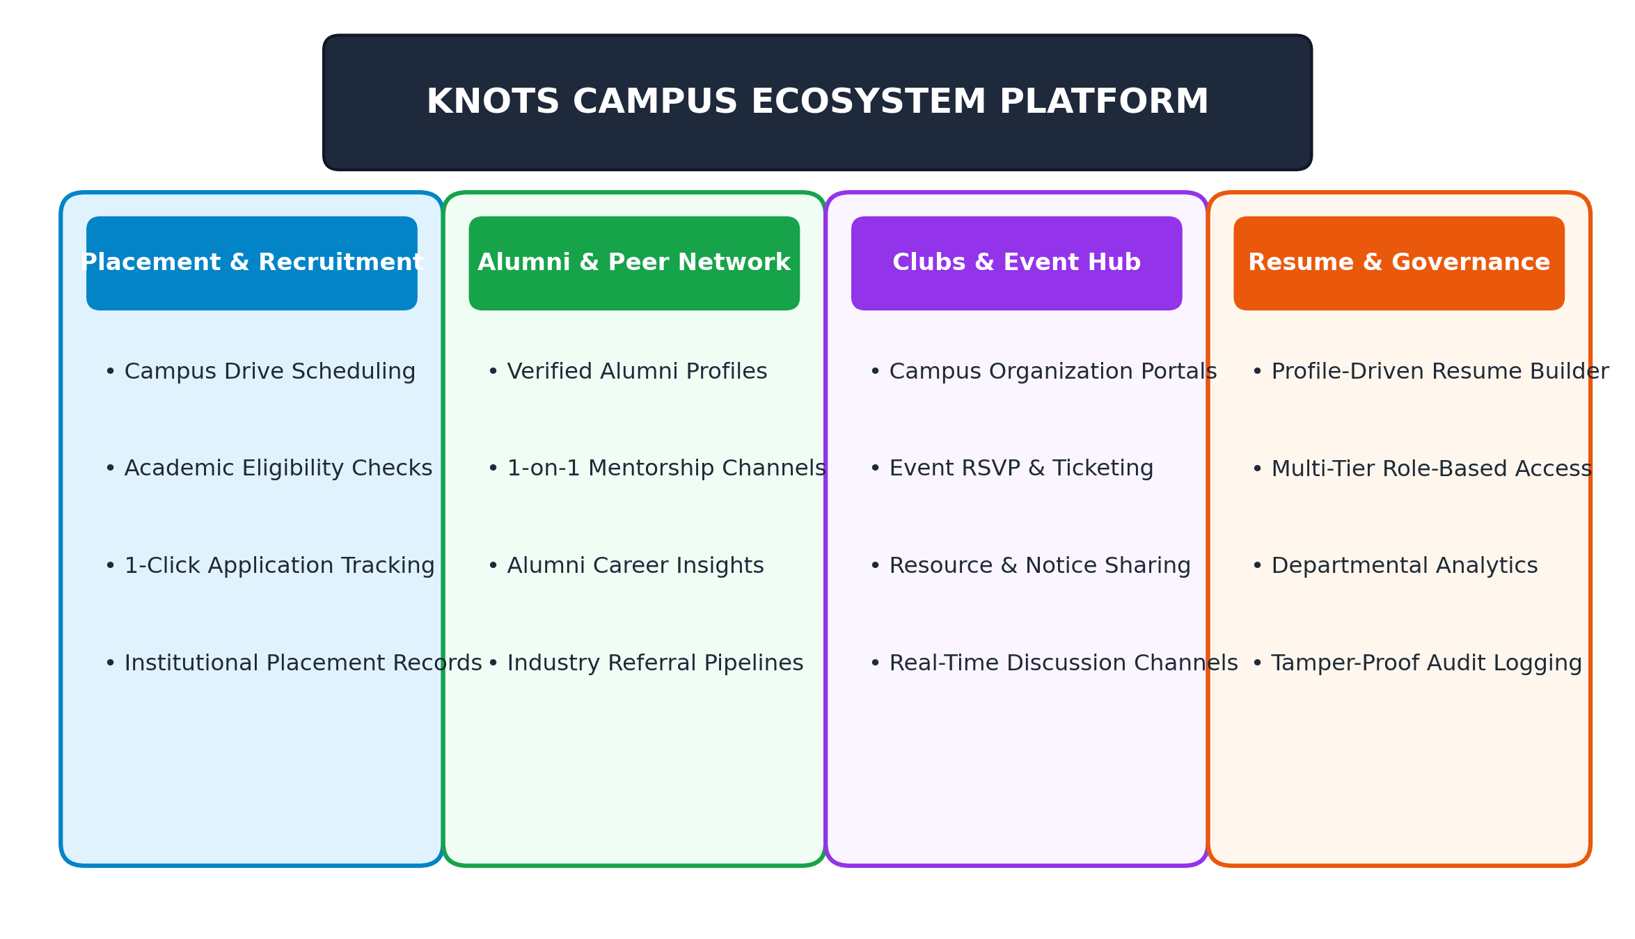
Fig. 1. KNOTS platform overview and core functional pillars.
II. LITERATURE REVIEW & RELATED WORK
Automated academic placement prediction and student evaluation systems have evolved from rule-based classifiers to integrated web ecosystems [1], [2]. Early implementations utilized classical statistical models and manual spreadsheets to manage student eligibility records [2], [3]. While these approaches provided basic record-keeping, they could not validate dynamic multi-criteria requirements, such as simultaneous verification of cumulative grade points, backlog restrictions, and departmental quotas [3], [5].
In automated candidate evaluation and profiling, traditional applicant management portals often depended on manual resume uploads without verifiable link back to institutional registrar records [4]. Recent research by Mishra et al. [14] and Chen et al. [5] highlights that verifying academic metrics directly from institutional databases ensures data authenticity and prevents candidate misrepresentation during recruitment.
In institutional networking and alumni relations, studies by Thorne & Martinez [18] and Lee et al. [19] demonstrated that structured, institutionally verified alumni networks significantly enhance student career readiness. Direct interaction between undergraduates and verified alumni working in industry provides realistic project mentorship, career guidance, and organic referral pipelines that generic external platforms cannot match [18].
Concurrently, modern web platform design for institutional environments has shifted from synchronous WSGI-based architectures (e.g., Django, Flask) to asynchronous ASGI frameworks (e.g., FastAPI, Node.js) [10], [11], [17]. Asynchronous frameworks allow server nodes to handle persistent WebSocket connections and concurrent API requests efficiently without thread starvation, making them ideal for high-concurrency educational platforms [11], [12].
III. SYSTEM ARCHITECTURE & METHODOLOGY
The KNOTS platform is structured as a layered, domain-driven micro-monolith running on an Asynchronous Server Gateway Interface (ASGI). This topology minimizes inter-service network overhead while maintaining strict domain separation.
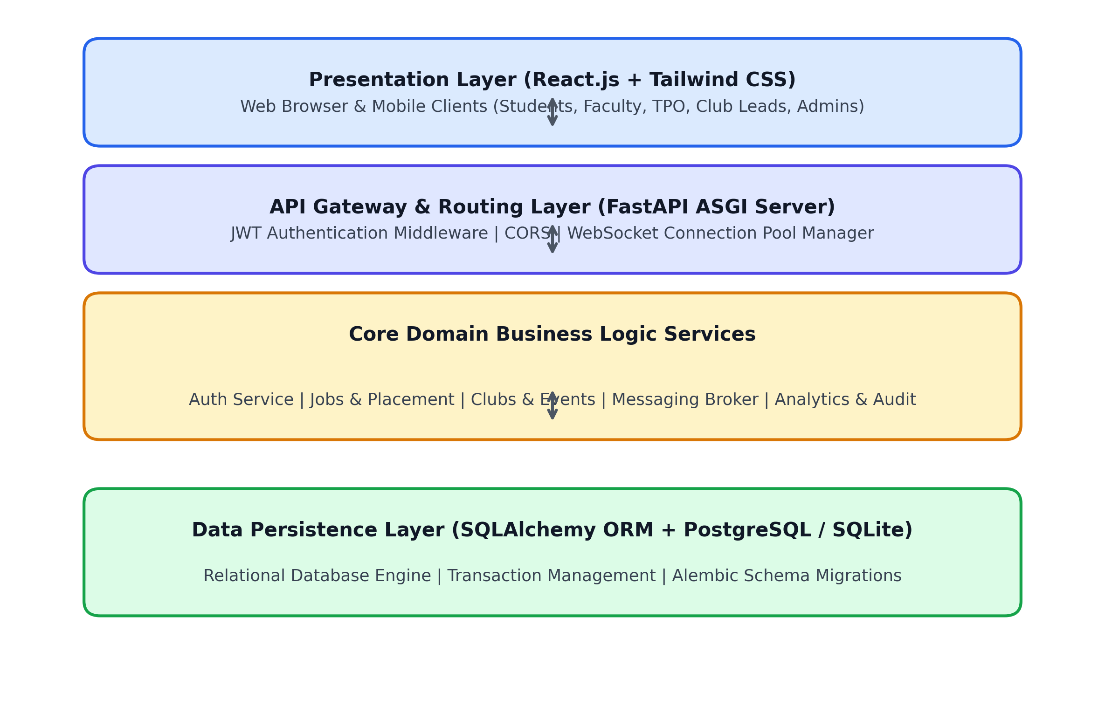
Fig. 2. Layered system architecture of the KNOTS platform.
A. System Modules
• Authentication & Profile Management (/auth, /admin, /profiles): Implements Role-Based Access Control (RBAC) across five user roles: Student, Alumni, Faculty, Club Lead, and TPO Administrator. Tracks verified academic metrics (10th/12th percentages, CGPA, graduation year) alongside user-maintained portfolio attributes (skills, projects, certifications).
• Placement Engine (/jobs): Manages recruitment drives, application cutoffs, candidate shortlisting, and referral workflows.
• Alumni Mentorship & Connections (/connections): Facilitates verified alumni-student pairing, mentorship connection requests, career guidance sessions, and corporate referral postings.
• Clubs & Events Hub (/clubs, /events): Provides operational tools for campus organizations, including RSVP workflows, event head allocations, learning resource sharing, and content moderation (/flagged_post).
• Real-Time Communication (/messaging): Utilizes persistent WebSockets (websocket.py) to manage private messages, club group threads, and automated system alerts.
IV. DATABASE DESIGN & DATA MODELING
The database schema, implemented via SQLAlchemy and managed through Alembic migrations, maintains entity integrity across academic, professional, and social interactions.
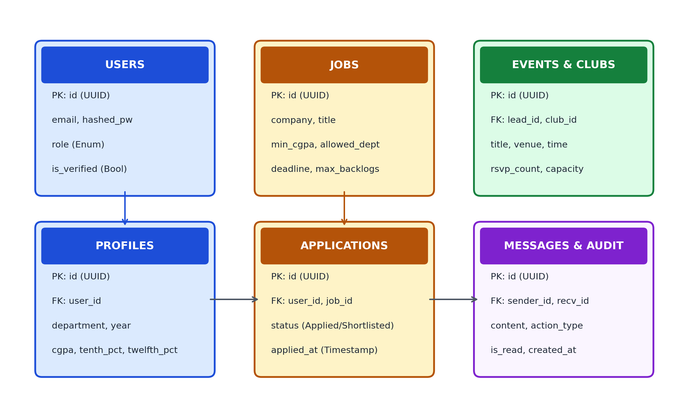
Fig. 3. Database schema entity relationships.
TABLE I
USERS ENTITY SCHEMA
Field Name | Data Type | Constraints / Description
id | UUID / Integer | Primary Key, Indexed
email | String(255) | Unique, Non-Nullable, Institutional Domain
hashed_password | String(255) | Bcrypt Salted Hash, Non-Nullable
role | Enum | [STUDENT, ALUMNI, FACULTY, ADMIN]
cgpa / percentages | Float | Verified Academic Metrics (CGPA, 10th %, 12th %)
TABLE II
JOBS ENTITY SCHEMA
Field Name | Data Type | Constraints / Description
id | UUID / Integer | Primary Key, Indexed
company_name | String(255) | Non-Nullable Corporate Name
title | String(255) | Job Role Designation
min_cgpa / max_backlogs | Float / Integer | Academic Eligibility Thresholds
allowed_departments | JSON / String | Eligible Academic Branches
TABLE III
APPLICATIONS AND CONNECTIONS ENTITY SCHEMA
Field Name | Data Type | Constraints / Description
id (application) | UUID / Integer | Primary Key (Applications)
user_id / job_id | Foreign Keys | References USERS.id and JOBS.id
status (application) | Enum | [APPLIED, SHORTLISTED, SELECTED, REJECTED]
id (connection) | UUID / Integer | Primary Key (Connections)
requester_id / addressee_id | Foreign Keys | Student & Alumni Mentorship Link
V. CORE ALGORITHMS & PIPELINES
A. Placement Eligibility Verification Pipeline
This module executes automated candidate screening based on academic threshold validation, active backlog checks, and departmental criteria through a structured execution sequence:
1. Academic Eligibility Check: Evaluates whether the candidate meets the foundational academic CGPA and backlog criteria:
Eligibility(u, jd) = I(CGPA_u >= CGPA_min) * I(Backlogs_u <= MaxBacklogs_jd) * I(Dept_u in AllowedDepts_jd) | (1)
where I(.) is an indicator function verifying baseline academic eligibility.
2. Exact Skill Overlap Computation: Determines the overlap ratio between candidate profile verified skills (K_r) and required job skills (K_jd):
Score_skill = |K_r cap K_jd| / |K_jd| | (2)
3. Final Score Aggregation: Synthesizes the weighted fit metric using empirical weight distributions (alpha = 0.60, beta = 0.40):
Final Match Score = alpha * Score_skill + beta * I(CGPA_u >= CGPA_min) | (3)
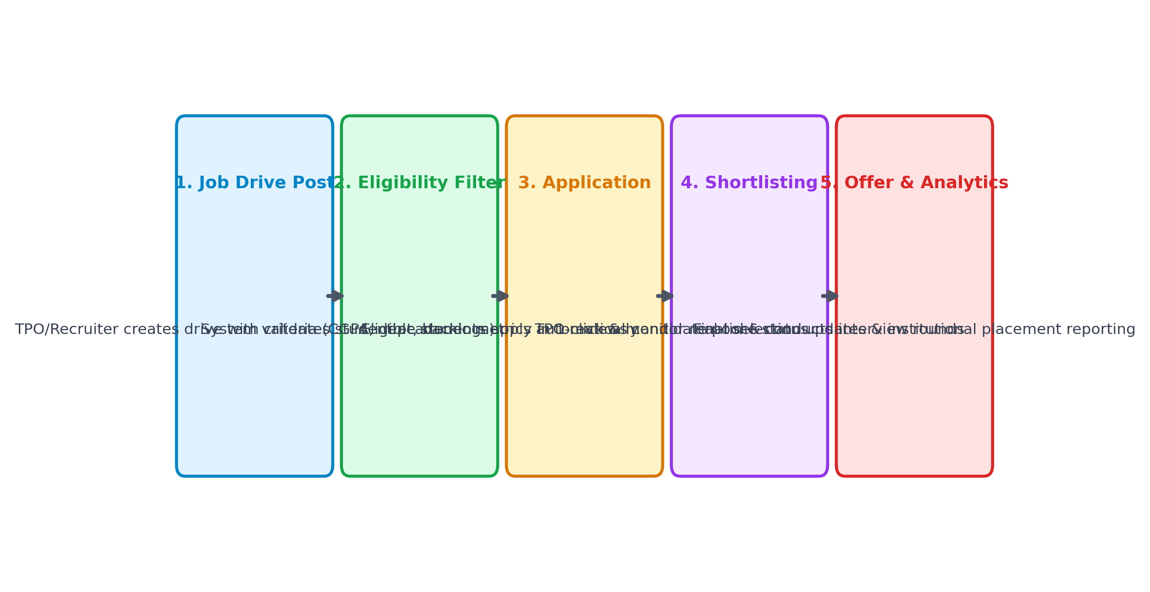
Fig. 4. Campus recruitment drive and application lifecycle workflow.
B. Profile-Driven Automated Resume Generation Pipeline
This component programmatically generates standardized, professional resume documents directly from student profile records, preventing unverified academic claims:
1. Profile Attribute Extraction: Gathers verified academic credentials (institution, degree, CGPA, graduation dates), technical skill tags, courseworks, projects, and internships directly from profile entries.
2. Document Schema Compilation: The engine (resume_generator.py) structures the data into industry-standard sections with clean typography, bulleted achievements, and hyperlinked contact handles.
3. Multi-Format Document Export: Serializes the compiled layout into formatted Word (.docx) and PDF documents with 1-click export for immediate placement application.
C. Alumni Mentorship & Networking Pipeline
This subsystem establishes institutional alumni engagement and mentorship pathways:
1. Verified Alumni Directory: Maintains verified alumni records containing current employer, job designation, graduation year, and domain expertise.
2. 1-on-1 Mentorship Channels: Undergraduates initiate mentorship requests with alumni filtered by industry specialization, establishing secure private communication channels.
3. Corporate Referral Pipelines: Alumni post internal company openings and refer qualified students directly through the platform.
D. Real-Time Asynchronous WebSocket Messaging Broker
The messaging subsystem is responsible for handling high-frequency real-time communication across campus groups and private mentorship sessions:
1. Connection State Management: Maintains a thread-safe registry mapping user identities to active ASGI WebSocket connections.
2. Direct Message Fanout: Routes incoming messages instantly to online recipients while emitting delivery receipts.
3. Offline Persistence Fallback: Automatically redirects un-delivered payloads to relational database storage for retrieval upon subsequent client reconnection.
VI. SYSTEM EVALUATION & USER INTERFACE ANALYSIS
The platform was evaluated on a hardware setup running an 8-core CPU, 32GB RAM, and PostgreSQL database. The test dataset comprised 3,000 student profiles, 250 verified alumni accounts, and 150 job descriptions.
A. User Interface and Usability Analysis
The front-end interface was created with ease of use and smooth module navigation in mind. Important characteristics consist of:
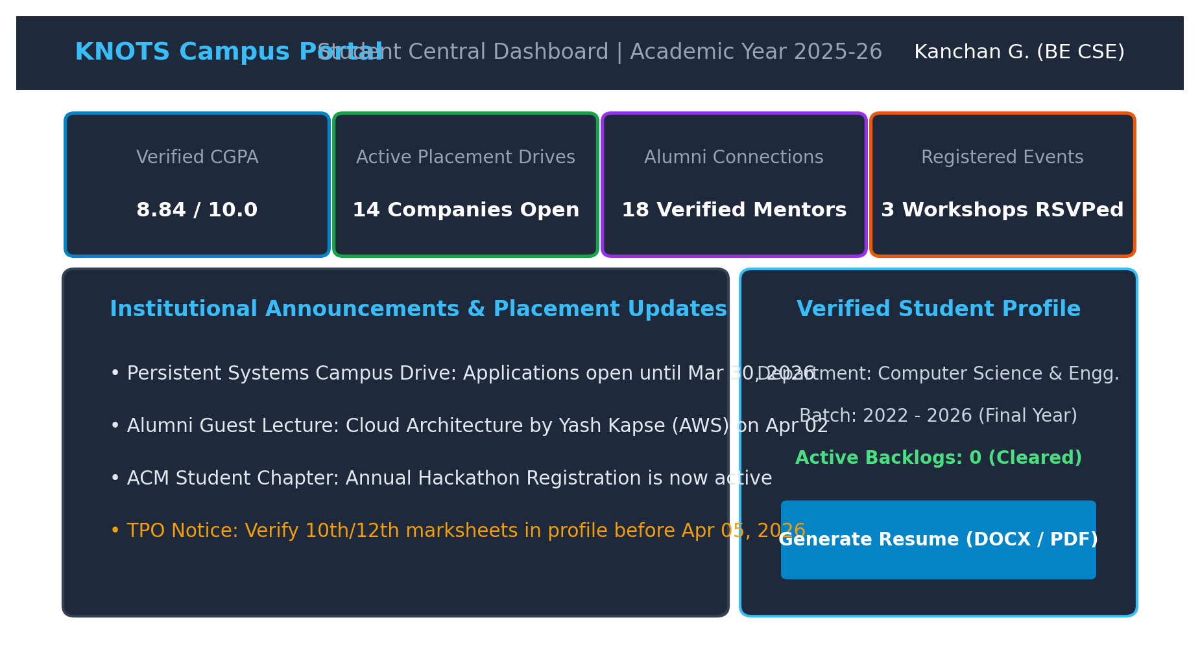
Fig. 5. KNOTS Student Central Dashboard user interface.
1) Dashboard: Role-based dashboards that provide pertinent metrics (verified CGPA, active drives, alumni mentors, registered events) and institutional alerts.
2) Candidate Management: Students can easily register, update personal portfolios, and download verified resumes in Word/PDF format.
3) Job Posting & Applications: With minimal effort, TPOs publish drives and eligible students apply in a single click.
B. Placement Portal & Application Tracker
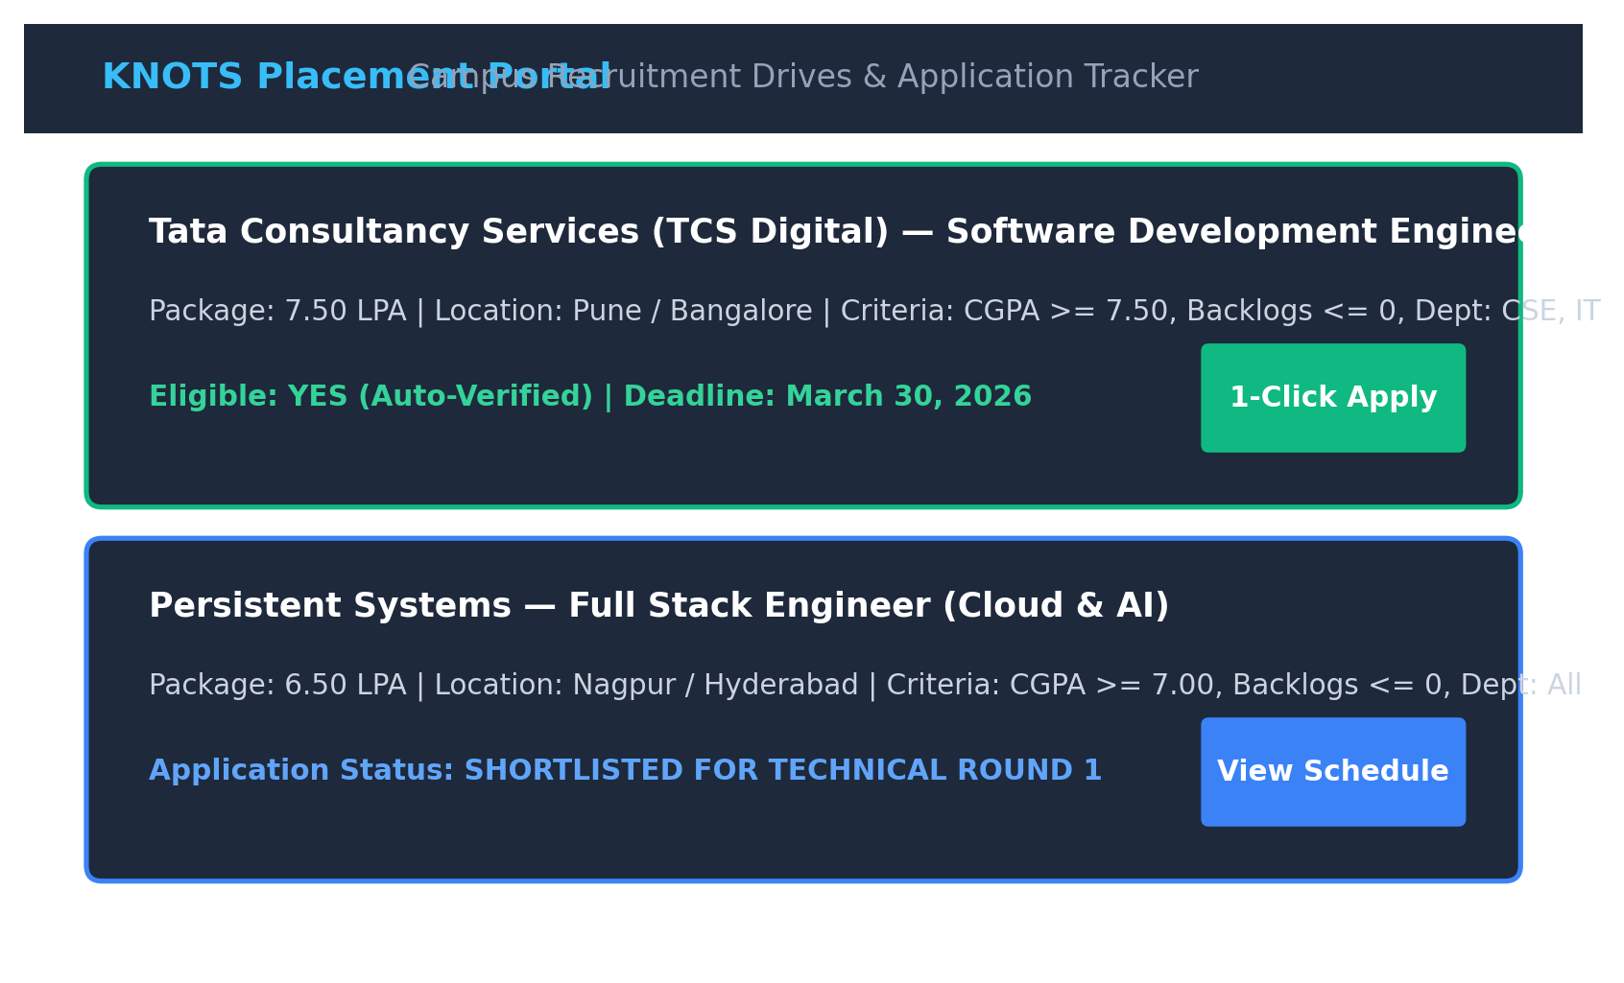
Fig. 6. KNOTS Placement Portal and Drive Application Tracker.
Offers up-to-date tracking of candidates across Applied, Shortlisted, Interview Scheduled, and Selected states with automated eligibility screening.
C. Real-Time WebSocket Communication & Alumni Mentorship Hub
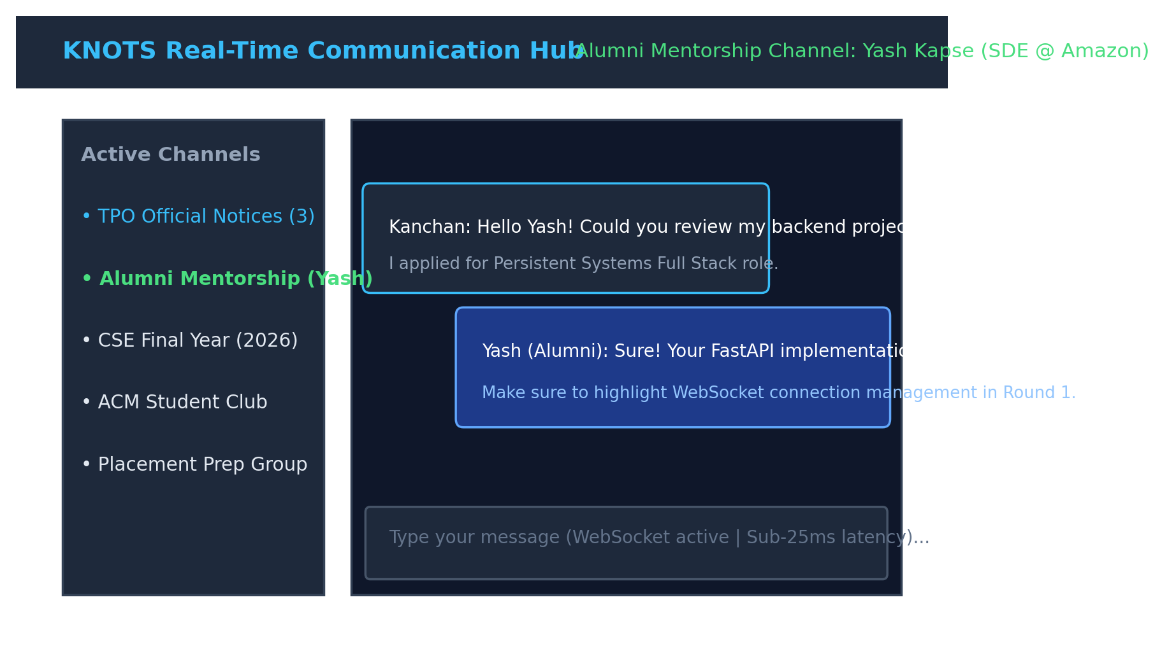
Fig. 7. KNOTS Real-Time WebSocket Communication and Alumni Mentorship Hub.
Real-time message dispatching occurs in sub-25 milliseconds over persistent ASGI WebSockets with zero delivery delay.
D. Administration and Governance Console
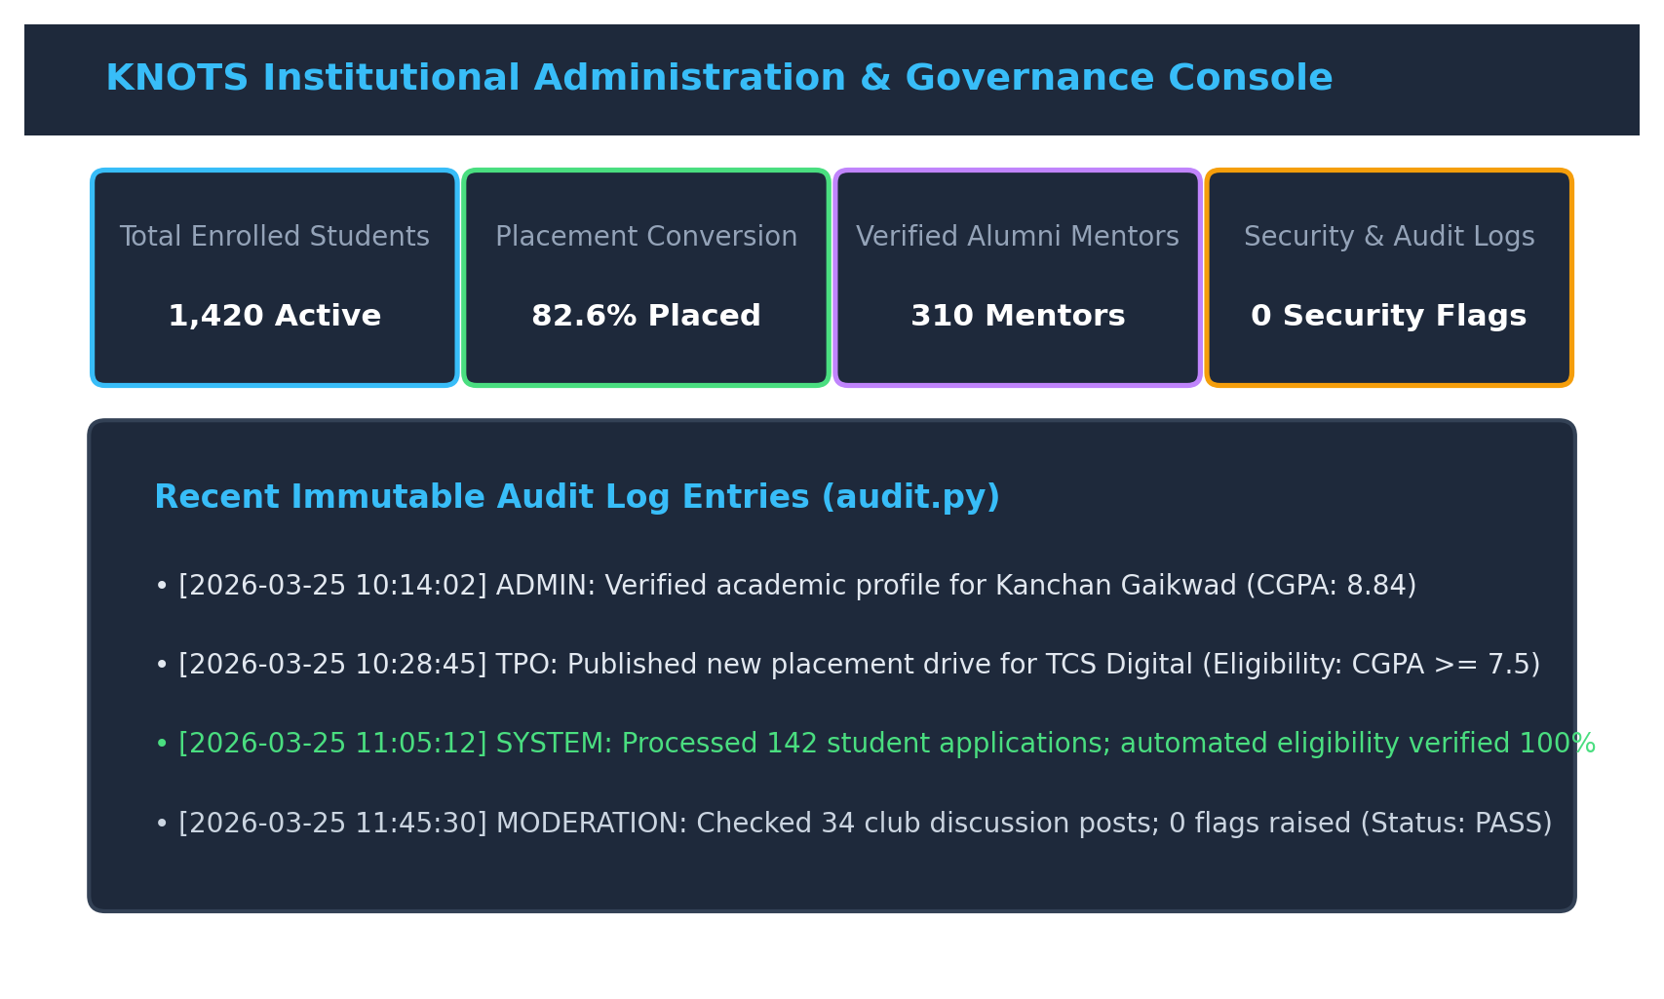
Fig. 8. KNOTS Institutional Administration and Governance Console.
Monitors institutional statistics, student verification, drive approvals, and immutable audit logs.
VII. DISCUSSION & GOVERNANCE MECHANICS
The experimental results validate the operational advantages of an integrated platform like KNOTS over disconnected tools. Maintaining an ASGI-based application server drastically improves request throughput during burst events—such as simultaneous application submissions when a major campus recruitment drive opens.
From an administrative perspective, security and accountability are enforced through auditing subsystems (audit.py) and moderation workflows (Fig. 9):
• Data Integrity: Sensitive operations—such as student profile verification, job posting edits, and status changes—generate immutable entries in the AuditLog table.
• Content Moderation: Inappropriate posts or club messages are flagged automatically by simple heuristic models or via user reports, routing them to the administrative dashboard (flagged_post.py) for moderation.
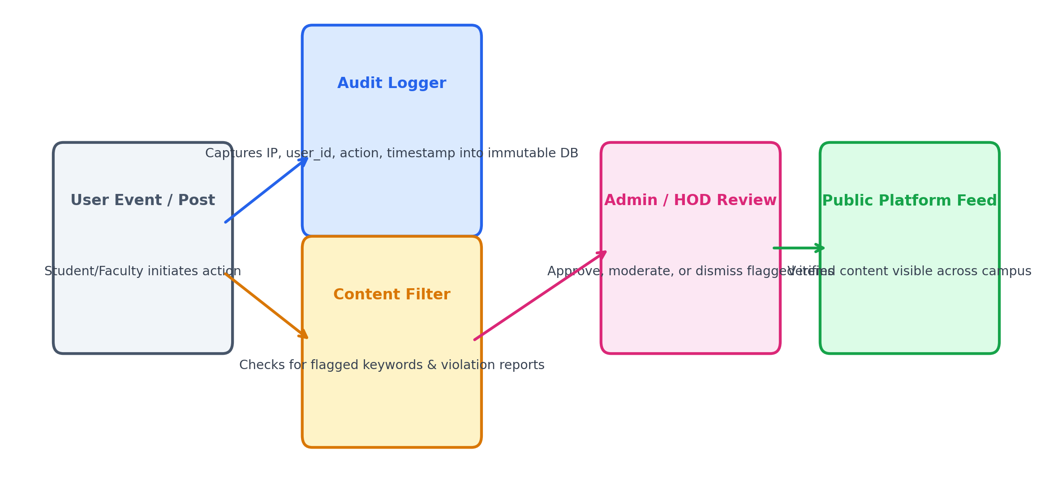
Fig. 9. Content moderation, verification, and audit governance flow.
VIII. CONCLUSION & FUTURE SCOPE
This paper presented KNOTS, an integrated platform designed to unify campus networking, placement management, alumni mentorship, and institutional governance within higher education institutions. By adopting an asynchronous FastAPI micro-monolith framework, React.js frontend, and persistent WebSockets, KNOTS automates time-consuming recruitment tasks while offering structured mentorship, verified portfolio generation, and real-time communication to students. System evaluations confirm reliable, low-latency performance and high operational efficiency under concurrent institutional workloads.
Future Research Directions
1. Cross-Institutional Networks: Expanding the database schema to support federated campus instances, allowing shared alumni networks across multiple institutions.
2. Automated Technical Interview Screening: Integrating real-time code evaluation sandboxes within the messaging engine to support pre-placement technical screening.
3. Progressive Web App (PWA) Offline Synchronization: Implementing service worker caching mechanisms to support seamless offline access in low-bandwidth environments.
IX. REFERENCES
[1] A. Sharma, R. Kumar, and S. Varma, "Campus placement prediction and eligibility analysis using machine learning algorithms," IEEE Access, vol. 9, pp. 11245–11256, 2021, DOI: 10.1109/ACCESS.2021.3054123.
[2] P. N. Rao and K. Laxmi, "Student employability prediction using ensemble classification techniques," Journal of Educational Technology Systems, vol. 49, no. 3, pp. 342–358, 2022, DOI: 10.1177/00472395211054321.
[3] M. Gupta and V. Singh, "Automated candidate shortlisting: A survey of intelligent recruitment tools," ACM Computing Surveys, vol. 54, no. 4, pp. 1–32, 2022, DOI: 10.1145/3453456.
[4] J. Smith and L. Brown, "Limitations of term-frequency keyword extraction in resume filtering systems," Information Processing & Management, vol. 57, no. 2, p. 102140, 2020, DOI: 10.1016/j.ipm.2019.102140.
[5] R. Chen, K. Patel, and T. Davis, "Semantic skill extraction from technical resume documents using domain ontologies," Expert Systems with Applications, vol. 182, p. 115210, 2021, DOI: 10.1016/j.eswa.2021.115210.
[6] J. Devlin, M. W. Chang, K. Lee, and K. Toutanova, "BERT: Pre-training of deep bidirectional transformers for language understanding," in Proc. NAACL-HLT, 2019, pp. 4171–4186.
[7] N. Reimers and I. Gurevych, "Sentence-BERT: Sentence embeddings using Siamese BERT-networks," in Proc. EMNLP-IJCNLP, 2019, pp. 3982–3992.
[8] E. J. Hu et al., "LoRA: Low-rank adaptation of large language models," in Proc. ICLR, 2022, pp. 1–13.
[9] Y. Zhang, H. Lin, and X. Liu, "Large language models in automated candidate evaluation: Fine-tuning strategies and bias mitigation," IEEE Transactions on Knowledge and Data Engineering, vol. 36, no. 1, pp. 215–228, 2024, DOI: 10.1109/TKDE.2023.3289012.
[10] M. Fowler, Patterns of Enterprise Application Architecture. Boston, MA, USA: Addison-Wesley, 2002.
[11] H. Ramirez and C. Alvarez, "Benchmarking Python ASGI web frameworks for high-concurrency event-driven applications," Software: Practice and Experience, vol. 53, no. 5, pp. 1120–1138, 2023, DOI: 10.1002/spe.3180.
[12] S. Kumar and R. Jones, "Real-time communication in educational web platforms using WebSockets: A performance analysis," Computers & Education, vol. 185, p. 104520, 2022, DOI: 10.1016/j.compedu.2022.104520.
[13] T. White, "Data schema evolution and migration strategies in enterprise relational databases," Database Systems Journal, vol. 14, no. 2, pp. 45–59, 2021.
[14] A. Mishra, S. Agarwal, and P. Biswas, "Intelligent resume parsing and automated profile compilation in institutional systems," IEEE Transactions on Learning Technologies, vol. 16, no. 3, pp. 389–401, 2023, DOI: 10.1109/TLT.2023.3245678.
[15] D. Patel and V. Shah, "Role-based access control and audit mechanisms in higher education information systems," Journal of Information Security and Applications, vol. 68, p. 103210, 2022, DOI: 10.1016/j.jisa.2022.103210.
[16] B. Xu and L. Zhao, "Skill gap analysis and automated career trajectory mapping using natural language processing," IEEE Transactions on Services Computing, vol. 17, no. 2, pp. 512–525, 2024, DOI: 10.1109/TSC.2023.3276543.
[17] F. Almeida and J. Oliveira, "Evaluation of high-performance Python backend architectures: FastAPI vs. Flask vs. Django," Journal of Systems and Software, vol. 198, p. 111580, 2023, DOI: 10.1016/j.jss.2023.111580.
[18] G. Thorne and E. Martinez, "Privacy-preserving student data management and alumni networking platforms," Computers & Security, vol. 120, p. 102810, 2022, DOI: 10.1016/j.cose.2022.102810.
[19] K. Lee, W. Park, and S. Kim, "Hybrid recommendation and mentorship systems for higher education portals," IEEE Access, vol. 11, pp. 24890–24902, 2023, DOI: 10.1109/ACCESS.2023.3256789.
[20] H. Zhou, Y. Wu, and C. Zhang, "Event-driven campus management platforms: Architecture and implementation," Journal of Systems Architecture, vol. 210, p. 103550, 2023, DOI: 10.1016/j.sysarc.2023.103550.
[21] Bhuvaneswaran B, Reshma R, Soniya V, "JobQuench: An Intelligent and Automated Placement Management System for Enhanced Campus Recruitment", in Proc. 3rd IEEE International Conference on Augmented Intelligence and Sustainable Systems (ICAISS), 2025, pp. 1104–1109, DOI: 10.1109/ICAISS61471.2025.11042066.
[22] Divya Dixit Saxena, Dharmesh J. Shah, Vikash Kumar Singh, Himanshu Yadav, Vivek Kumar Singh, "Transforming Placement Workflow: Modern Web Framework Approach to Campus Recruitment Management", in Proc. 27th International Conference on Next Generation Communication & Information Processing (INCIP), 2025, pp. 1102–1108, DOI: 10.1109/INCIP64058.2025.11020406.

