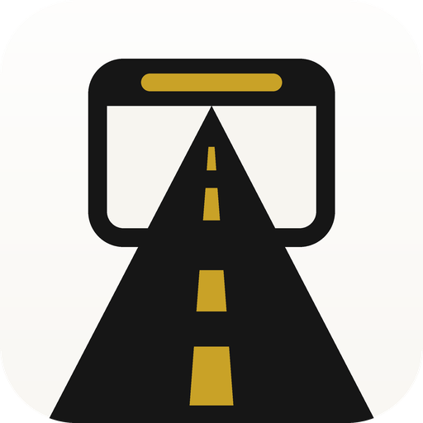
RoadBrowser
A car-first web browser for Android Auto head units
Yash V Maurya · Android / Kotlin · 2026
Source: github.com/Yash-v-maurya/RoadBrowser Download: latest release

Summary
A browser built for the car: a bottom toolbar sized for 800×480 head units, a media-session-backed playback engine that keeps YouTube playing while Maps owns the screen, steering-wheel controls that drive the page, and a premium warm-white design system with no third-party tracking.
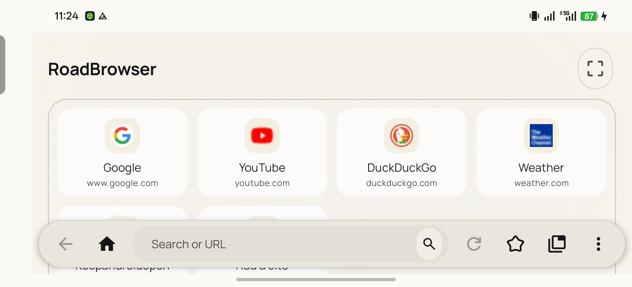
Start page on a landscape display — light theme, Manrope typography

The problem
Android Auto projects only a few app categories, and a general web browser is not one of them. Browsers that can be sideloaded onto a head unit are phone designs: tiny targets, a top-anchored URL bar, and a WebView the OS pauses the moment navigation covers it — so a video dies every time the driver glances at the map.

What I built
I designed and shipped:
- Car-first UI. Bottom toolbar (Back, Home, address pill, Reload, Bookmarks, Tabs with count, Menu); start page with four-across quick-link tiles and a “continue where you left off” card; landscape and sw600dp dimension sets.
- Playback lifecycle engine. A WebView subclass that spoofs window visibility, plus a page-injected shim that pins document.hidden = false and swallows visibilitychange / pagehide, so sites never see themselves go to the background.
- MediaSession foreground service. A mediaPlayback foreground service owning a platform MediaSession. A document-start JS bridge wraps navigator.mediaSession.setActionHandler so steering-wheel next / previous / play / pause call the page’s own handlers, with a <video> fallback. It also keeps the process out of the OEM app freezer.
- YouTube compatibility mode. Pins YouTube to the mobile identity, dismisses consent and unsupported-browser banners, exempts googlevideo.com from ad blocking.
- Brave Search + Shields. Brave as default engine and a bundled ad/tracker blocklist with a live blocked counter.
- Design system. Warm-white / charcoal / champagne-gold palette (no blue), Manrope variable font wired into all 15 Material 3 text roles, 12–32 dp shape scale, flat hairline-outlined cards, an adaptive launcher icon of a road running into a browser window, and a monochrome themed-icon layer.
- Privacy. Removed all third-party analytics; the only network traffic is the pages you open.
- Release engineering. Signed release builds, versioned APK naming, GitHub Actions CI on every push and a tag-triggered signed-release workflow that publishes the APK to GitHub Releases; Obtainium deep link for auto-updates.

Technical stack
Area | Detail
Language / SDK | Kotlin · minSdk 35 (Android 15) · targetSdk 37
UI | ViewBinding · Material 3 · ConstraintLayout · RecyclerView with drag-to-reorder
Web | android.webkit.WebView · AndroidX WebKit (document-start scripts, WebMessageListener, UA client hints)
Media | android.media.session.MediaSession · Notification.MediaStyle · FOREGROUND_SERVICE_MEDIA_PLAYBACK
Car | androidx.car.app · CAR_LAUNCHER / APP_MAPS categories · distractionOptimized metadata
Build | Gradle 9 · AGP 9 · R8 · custom APK rename task
CI/CD | GitHub Actions (JDK 21, Android SDK, cached Gradle) · base64 keystore secret

Hard problems and how I solved them

1. Video stopped when Android Auto showed Maps
Two layers were pausing playback independently: WebView.onPause() from the Activity lifecycle, and Blink flipping the Page Visibility API to hidden. Fixing the first still left YouTube’s own JS pausing on visibilitychange. The fix is a WebView subclass reporting VISIBLE from onWindowVisibilityChanged plus a capture-phase JS shim that pins visibility and stops the events before page listeners run — while still letting element-level blur through so text inputs keep working.

2. Steering-wheel buttons did nothing
Chromium takes audio focus for the page but exposes no MediaSession from a WebView. I added a foreground service that owns a session and forwards its callbacks into the page. Rather than guessing at DOM selectors, the shim captures the handlers the page registers through navigator.mediaSession.setActionHandler, so “next track” is exactly what YouTube would do itself.

3. The process was frozen by the OEM battery manager
On ColorOS a plain background app is frozen after a few minutes covered. A mediaPlayback foreground service is the sanctioned way to say “I’m playing audio”: it starts from the page’s play event, promotes itself with FOREGROUND_SERVICE_TYPE_MEDIA_PLAYBACK, and handles ForegroundServiceStartNotAllowedException cleanly when the OS refuses.

4. Light theme rendered with dark widgets
uiMode is in configChanges so the Activity is never recreated on a night-mode change (needed on head units). Calling setDefaultNightMode() in onCreate was therefore too late — views were already inflated with the system’s dark colours. Moving the call into Application.onCreate() fixed it.

Outcome
- Runs on an Android 16 OnePlus 12R and projects to Android Auto; YouTube keeps playing under Maps and responds to media-button presses.
- Zero third-party trackers; ~6.7 MB signed APK.
- Reproducible icon pipeline (scripts/render_icon.py → vector drawables + all mipmaps) and one-command release via git tag.

Links
Repository: https://github.com/Yash-v-maurya/RoadBrowser
Latest APK: https://github.com/Yash-v-maurya/RoadBrowser/releases/latest
Install guide: docs/INSTALL.md in the repository

