

AN EXPLORATORY DATA ANALYTICS FRAMEWORK FOR UNDERSTANDING DIABETES RISK FACTORS USING HEALTHCARE AND LIFESTYLE DATA
A CAPSTONE PROJECT REPORT

Submitted in partial fulfilment of the requirements
for the Course of
DSA0404 – Fundamentals of Data Science
to the award of the degree of
BACHELOR OF TECHNOLOGY
IN
ARTIFICIAL INTELLIGENCE AND DATA SCIENCE (AI&DS)

Submitted by
B C Yugesh (192424282)

Under the Supervision of
Dr. Krishnaraj Mony

SIMATS ENGINEERING
Saveetha Institute of Medical and Technical Sciences
Chennai–602105
SEPTEMBER 2026

SIMATS ENGINEERING
Saveetha Institute of Medical and Technical Sciences
Chennai–602105

BONAFIDE CERTIFICATE

This is to certify that the Capstone Project entitled “An Exploratory Data Analytics Framework for Understanding Diabetes Risk Factors Using Healthcare and Lifestyle Data” has been carried out by T Megha Harsha (192424389) and B C Yugesh (192424282) under the supervision of Dr. Almas Begum and is submitted in partial fulfilment of the requirements for the current semester of the B. Tech Artificial Intelligence and Data Science program at Saveetha Institute of Medical and Technical Sciences, Chennai.

COURSE COORDINATOR | COURSE FACULTY / GUIDE
Dr. T. P. Anithaashri,  Professor & HOD,  Dept. of Cloud Computing / CSE  SIMATS Engineering,  Chennai – 602105. | Dr. Krishnaraj Mony,  Associate Professor,  Predictive Engineering / CSE  SIMATS Engineering,  Chennai – 602105.

SIMATS ENGINEERING
Saveetha Institute of Medical and Technical Sciences
Chennai–602105

DECLARATION

We, T Megha Harsha (192424389) and B C Yugesh (192424282) of the Department of B. Tech Artificial Intelligence and Data Science (AI&DS), SIMATS Engineering, Saveetha Institute of Medical and Technical Sciences, Chennai, hereby declare that the Capstone Project Work entitled “An Exploratory Data Analytics Framework for Understanding Diabetes Risk Factors Using Healthcare and Lifestyle Data” is the result of our own Bonafide efforts.
To the best of our knowledge, the work presented herein is original, accurate, and has been carried out in accordance with the principles of engineering ethics and academic integrity. All sources, references, data, and other materials used in the project have been appropriately acknowledged.
We further declare that the data, results, analysis, and findings presented in this report have not been fabricated, falsified, or manipulated. Any external tools, software, datasets, computational resources, or AI-assisted tools used during the project have been appropriately disclosed. We confirm that all applicable ethical, academic, institutional, and professional requirements have been duly followed throughout the planning, execution, analysis, and documentation of the project.

Place:
Date:
Signature of the Students with Names
T Megha Harsha (192424389)
B C Yugesh (192424282)

INDIVIDUAL CONTRIBUTION STATEMENT
(Mandatory for all team projects)

Student Name / Register No. | Specific Responsibilities | Design & Development Contribution | Testing & Analysis Contribution | Report Contribution | Approx. Contribution (%)
T Megha Harsha  (192424389) | Dataset preparation; data cleaning; exploratory statistics; risk-factor analysis | Pandas preprocessing; descriptive statistics; univariate/bivariate analysis; visualization development | Validation of cleaned data; checking distributions, group comparisons and correlations | Ch. 1, Ch. 2, Ch. 3 analytics sections; Ch. 4 results; appendices | 50%
B C Yugesh  (192424282) | Dashboard design; visualization integration; testing; interpretation | Interactive dashboard; chart integration; filtering and presentation; UI refinement | Dashboard testing; output consistency checks; usability and interpretation review | Ch. 1, Ch. 2, Ch. 3 design sections; Ch. 4 dashboard/testing; Ch. 5 | 50%
TOTAL |  |  |  |  | 100%

Abstract

The An Exploratory Data Analytics Framework for Understanding Diabetes Risk Factors Using Healthcare and Lifestyle Data is designed to transform healthcare and lifestyle records into clear, interpretable, and decision-ready insights about diabetes risk. Diabetes is influenced by interacting factors such as glucose level, blood pressure, body mass index, age, pregnancy history, insulin-related measures, and family-history indicators. The proposed framework uses a structured diabetes dataset, performs data cleaning, missing-value treatment, exploratory analysis, descriptive statistics, correlation analysis, and visual analytics to identify important patterns associated with diabetes outcomes. The system is organized around data preprocessing, exploratory risk-factor analysis, visualization, and an interactive analytical dashboard. The engineering outcome is a reproducible and scalable analytics workflow that helps students, researchers, and healthcare-oriented users understand patterns in diabetes risk without presenting the system as a clinical diagnostic tool.
The proposed An Exploratory Data Analytics Framework for Understanding Diabetes Risk Factors Using Healthcare and Lifestyle Data is designed to transform structured healthcare records into clear, interpretable, and decision-ready analytical insights about diabetes risk. The framework focuses on measurable factors such as glucose, blood pressure, body mass index, age, pregnancy history, insulin, skin thickness, and diabetes pedigree function. It performs data cleaning, missing-value treatment, descriptive statistics, exploratory analysis, correlation analysis, outcome-group comparison, and visual analytics. The system is organized into data preprocessing, exploratory risk-factor analysis, visualization, and interactive dashboard modules. The engineering outcome is a reproducible and scalable analytics workflow that helps students, researchers, and healthcare-oriented users understand patterns in diabetes risk without presenting the system as a clinical diagnostic tool.

Keywords
Diabetes analytics; healthcare data; lifestyle factors; exploratory data analysis; risk factors; data visualization; statistical analysis; interactive dashboard

TABLE OF CONTENTS
Sl. No. | Title | Page No.
i | CERTIFICATE FROM THE SUPERVISOR / BONAFIDE CERTIFICATE | ii
ii | DECLARATION BY THE CANDIDATE | iii
iii | INDIVIDUAL CONTRIBUTION STATEMENT | iv
iv | ABSTRACT | v
v | LIST OF FIGURES | vii
vi | LIST OF TABLES | viii
vii | LIST OF ABBREVIATIONS / SYMBOLS | ix
1 | CHAPTER 1: Introduction and Engineering Problem | 1
2 | CHAPTER 2: Literature Review and Existing Solutions | 4
3 | CHAPTER 3: Engineering Design & Trade-offs, Sustainability, Ethics, Safety, Risk & Security | 6
4 | CHAPTER 4: Implementation, Testing & Results, Project Management | 11
5 | CHAPTER 5: Conclusion & Reflection | 15
 | References | 20
 | Appendices | 22

LIST OF FIGURES
Figure No. | Figure Name | Page No.
Figure 1 | Sample diabetes healthcare dataset used for exploratory analysis | 5
Figure 2 | Proposed system architecture of the Diabetes Risk-Factor Analytics Framework | 8
Figure 3 | Output of the Diabetes Risk-Factor Analytics Dashboard | 12
Figure 4 | Diabetes risk-factor distribution outputs | 12
Figure 5 | Diabetes outcome comparison and correlation outputs | 13

LIST OF TABLES
Table No. | Table Name | Page No.
Table 1 | Stakeholder / User Requirements | 6
Table 2 | Functional and Non-Functional Requirements | 6
Table 3 | Constraints and Applicable Standards | 7
Table 4 | Design Specifications | 7
Table 5 | Alternative Solutions Evaluation | 8
Table 6 | Trade-off Analysis | 9
Table 7 | Sustainability, Ethics, Safety and Security Evidence | 9
Table 8 | Risk Register | 10
Table 9 | Tools / Software / Equipment | 11
Table 10 | Test Plan and Verification | 13
Table 11 | Results / Key Outcomes | 14
Table 12 | Objective Achievement | 15
Table 13 | Project Roles | 16
Table 14 | Project Budget | 16

LIST OF ABBREVIATIONS / SYMBOLS
Abbreviation / Symbol | Description | Unit
AI&DS | Artificial Intelligence and Data Science | —
EDA | Exploratory Data Analysis | —
EHR | Electronic Health Record | —
BMI | Body Mass Index | kg/m²
ROC | Receiver Operating Characteristic | —
n | Number of records used in processing | records

CHAPTER 1
INTRODUCTION AND ENGINEERING PROBLEM

1.1 Background
Diabetes mellitus is a major chronic health condition associated with elevated blood glucose and a range of long-term complications. Its occurrence is influenced by a combination of measurable clinical variables, risk-factor characteristics, family-history indicators, and lifestyle-related factors. Healthcare datasets can contain multiple variables simultaneously, making it difficult to understand which factors show the strongest association with diabetes outcomes when the information is presented only as raw tables.
Traditional healthcare reporting often presents laboratory measurements and patient characteristics as separate columns or static summaries. Such formats make it difficult to identify distributions, outliers, correlations, subgroup differences, and interactions among variables. For example, glucose, BMI, age, blood pressure, pregnancy history, insulin, skin thickness, and diabetes pedigree information may jointly provide more useful analytical evidence than any single variable considered in isolation.
Exploratory data analytics addresses this gap by converting healthcare records into descriptive statistics, distributions, relationship plots, correlation views, and comparative visualizations. These techniques help reveal data quality issues, identify dominant patterns, compare outcome groups, and communicate findings to users who may not be specialists in statistical programming.
The project applies this approach to a structured diabetes dataset by cleaning and standardizing the records and then examining the relationship between diabetes outcome and healthcare/lifestyle-related variables. The framework is intended for analytical understanding and educational decision support rather than diagnosis, treatment recommendation, or replacement of professional medical judgment.

1.2 Need for the Project
- Diabetes datasets contain multiple numerical and risk-factor variables whose relationships are difficult to interpret manually when the number of records and attributes increases.
- Static tables provide limited support for quickly identifying distributions, correlations, outliers, and differences between diabetic and non-diabetic groups.
- The combined influence of glucose, BMI, age, blood pressure, pregnancy history, insulin, skin thickness, and diabetes pedigree information is difficult to communicate through isolated numerical summaries.
- Healthcare and lifestyle analytics require careful preprocessing because zero-coded measurements, missing values, inconsistent records, and outliers can distort statistical summaries and visual conclusions.
- An integrated exploratory analytics framework can reduce the time required to move from raw patient records to interpretable risk-factor insights and reproducible visual evidence.
Stakeholders affected by this problem include healthcare researchers, data analysts, academic institutions, public-health planners, students, and other users who need understandable evidence about diabetes-related patterns.

1.3 Problem Statement
The engineering problem is to design and implement an integrated diabetes analytics framework that can ingest healthcare and lifestyle data, clean and standardize records, explore multiple interacting risk factors, generate meaningful statistical visualizations, and present the findings through an accessible analytical interface.
The problem involves interacting requirements related to data quality, statistical validity, visualization clarity, dashboard usability, processing efficiency, scalability, privacy, and responsible interpretation of health-related information. The solution must communicate associations without implying that correlation alone establishes causation or clinical diagnosis.

1.4 Project Aim
To design and develop an exploratory data analytics framework that transforms healthcare and lifestyle data into clear statistical and visual insights for understanding diabetes risk factors.

1.5 Project Objectives
- To collect and preprocess a structured diabetes healthcare dataset.
- To clean, standardize, and transform healthcare variables using Python and Pandas.
- To perform descriptive, univariate, bivariate, and correlation-based exploratory analysis of diabetes-related factors.
- To visualize distributions and relationships using histograms, box plots, count plots, scatter plots, and correlation heatmaps.
- To compare important healthcare and lifestyle indicators across diabetic and non-diabetic outcome groups.
- To build an integrated analytical dashboard supporting filtering and interpretation of major risk-factor patterns.
- To communicate findings responsibly while distinguishing statistical association from clinical diagnosis.
- To evaluate the usability, consistency, and interpretability of the developed analytics outputs.

1.6 Scope
Included in the project:
- Collection and preprocessing of the diabetes healthcare dataset.
- Data cleaning, duplicate handling, missing-value treatment, and standardization using Pandas and NumPy.
- Univariate analysis of glucose, blood pressure, BMI, age, pregnancies, insulin, skin thickness, and diabetes pedigree function.
- Bivariate and multivariate exploratory visualization using Matplotlib and Plotly where appropriate.
- Correlation analysis and comparison of healthcare/lifestyle variables by diabetes outcome.
- Development of an interactive analytical dashboard for exploring diabetes risk-factor patterns.
- Performance and consistency evaluation of the data-processing and visualization pipeline.
Not included in the project:
- Clinical diagnosis, treatment recommendation, or prescription of medication.
- Real-time integration with hospital electronic health-record systems.
- Prospective clinical trials or longitudinal causal inference.
- Mobile application development.
- Cloud-based multi-tenant deployment at healthcare-system scale.
- Use of the analytics output as a substitute for qualified medical professionals.
Assumptions and boundary conditions: the demonstrated implementation uses a structured diabetes dataset containing healthcare measurements and an outcome variable. The analysis is observational and exploratory; results describe patterns in the available data and should not be interpreted as individual clinical risk scores.

1.7 Expected Engineering Outcome
The intended outcome is a reliable, reproducible, and interactive Diabetes Risk-Factor Analytics Framework consisting of data preprocessing, exploratory analysis, statistical visualization, and dashboard components. The platform is intended to transform raw healthcare and lifestyle records into interpretable evidence that supports learning, research, and data-driven discussion of diabetes risk factors.

CHAPTER 2
LITERATURE REVIEW AND EXISTING SOLUTIONS

2.1 Review Method
The literature review was structured around diabetes risk-factor analysis, exploratory healthcare data analytics, visualization of clinical variables, and responsible use of health datasets. Sources were considered from academic literature and established technical references covering diabetes epidemiology, statistical analysis, machine learning for healthcare, and data visualization. The review focused on work relevant to identifying measurable factors associated with diabetes and communicating those patterns clearly.
The review considered publications and technical material that discuss diabetes-related predictors, exploratory analysis, preprocessing of healthcare data, statistical association, and visualization. Priority was given to methods that can be reproduced with Python-based analytics tools and that emphasize interpretability and responsible handling of health information.

2.2 Review of Existing Work
Existing diabetes analytics approaches commonly begin with statistical summaries of patient variables and comparisons between outcome groups. These methods are useful for understanding distributions and average differences but may provide limited interactive exploration when implemented only as static tables.
A second class of approaches applies machine-learning models such as logistic regression, decision trees, random forests, and boosting methods to predict diabetes outcomes. Predictive models can provide strong classification performance, but their primary goal is prediction rather than broad exploratory understanding of how variables are distributed and related.
A third class of approaches emphasizes visualization and dashboards. Interactive plots can help users examine distributions, correlations, and subgroup differences, but a dashboard without a disciplined preprocessing and statistical-analysis workflow can amplify misleading patterns caused by missing values, outliers, or inconsistent measurements.
The proposed framework combines these complementary ideas by placing data quality, exploratory statistics, visual analytics, and dashboard interaction within one workflow. The focus remains on understanding risk-factor patterns rather than presenting a black-box clinical prediction system.

2.3 Comparative Analysis
Existing Approach | Advantages | Limitations | Relevance to Proposed Work
Static healthcare tables / reports | Comprehensive numerical information; familiar reporting format | Limited interaction; difficult relationship exploration; weak visual comparison | Motivates integrated exploratory analytics and visualization
Standalone statistical analysis | Provides descriptive and inferential summaries | Often requires manual switching between outputs; limited dashboard interaction | Supports structured statistical exploration in the proposed framework
Predictive machine-learning systems | Can provide automated outcome prediction | Prediction focus may reduce broad exploratory interpretation; may be less transparent | Motivates keeping exploratory analysis and interpretability central
Fragmented visualization tools | Can provide specialized charts | Requires users to switch tools and may lack a unified workflow | Proposed dashboard integrates data cleaning, analysis and visualization

2.4 Research / Engineering Gap
The engineering gap is the lack of a simple, integrated, and interpretable workflow that combines healthcare-data cleaning, exploratory statistical analysis, risk-factor visualization, subgroup comparison, and interactive presentation in one reproducible framework. Conventional reports may provide statistics without interaction, while predictive systems may emphasize accuracy without giving users a broad view of the underlying data patterns.

2.5 Proposed Contribution
The proposed contribution is a Diabetes Risk-Factor Analytics Framework that combines Pandas-based preprocessing, descriptive statistics, correlation analysis, visualization, and dashboard presentation. The framework provides complementary views of glucose, BMI, age, blood pressure, pregnancies, insulin, skin thickness, and diabetes pedigree information to help users understand which variables exhibit stronger associations with diabetes outcomes.
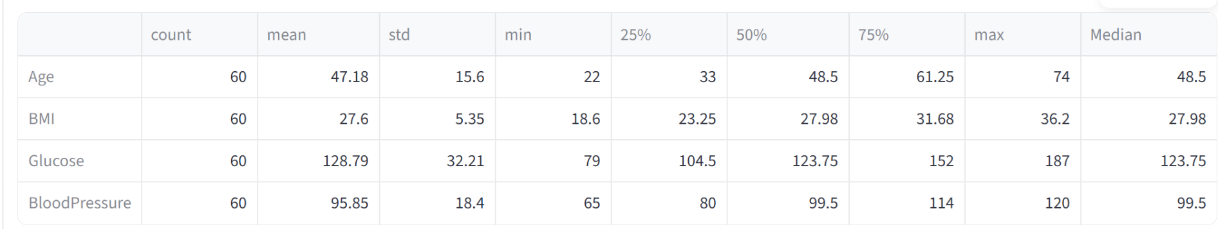
Figure 1: Sample diabetes healthcare dataset used for exploratory analysis

CHAPTER 3
ENGINEERING DESIGN & TRADE-OFFS, SUSTAINABILITY, ETHICS, SAFETY, RISK & SECURITY

3.1 Requirements

Table 1: Stakeholder / User Requirements
Stakeholder | Requirement
Healthcare researchers | Explore relationships between diabetes outcomes and measurable risk factors.
Data analysts / students | Clean, summarize and visualize healthcare variables reproducibly.
Academic institutions | Use an interpretable framework for teaching healthcare data analytics.
Public-health planners | Compare patterns across relevant subgroups without exposing individual identities.
General analytical users | Access understandable charts and filtered summaries.

Table 2: Functional & Non-Functional Requirements
Requirement | Type | Measurable Target
Data ingestion from diabetes dataset | Functional | Successful ingestion of the project dataset
Data cleaning and missing-value treatment | Functional | Invalid/zero-coded measurements handled according to preprocessing rules
Exploratory visualization generation | Functional | All specified charts generated from cleaned data
Risk-factor comparison | Functional | Outcome-group comparisons supported
Dashboard filtering | Functional | Relevant visual views update consistently
Processing efficiency | Non-Functional | Processing time evaluated on available dataset
Usability / interpretability | Non-Functional | Charts readable and findings understandable to intended users

3.2 Constraints & Applicable Standards
The project applies software-quality, requirements-engineering, data-visualization, and responsible-data-handling considerations. ISO/IEC 25010 is used as a quality reference for functionality, reliability, performance efficiency, maintainability, and usability. IEEE 29148 is used as a reference for requirements engineering and documentation. Visualization best practices are applied to improve clarity and reduce misleading chart design. Health-data privacy principles are applied by using the available de-identified/educational dataset only for analytical purposes.

Table 3: Constraints & Applicable Standards
Standard / Code | Requirement / Focus | How Applied in This Project
ISO/IEC 25010 | Software quality characteristics | Considered functionality, reliability, performance efficiency, maintainability and usability.
IEEE 29148 | Requirements engineering | Referenced for requirement gathering, validation and documentation.
Data visualization best-practice principles | Clear encoding, labels, accessibility and reduced chart clutter | Applied to chart selection, axes, legends and dashboard layout.
Responsible health-data principles | Privacy, de-identification and non-clinical interpretation | Used an educational/de-identified dataset and avoided individual clinical claims.

3.3 Design Specifications
Table 4: Design Specifications
Parameter | Target / Requirement | Unit | Priority
Dataset coverage | Healthcare and lifestyle variables with binary diabetes outcome | variables | High
Risk-factor visualization coverage | Glucose, BMI, age, blood pressure, pregnancies, insulin, skin thickness, pedigree | variables | High
Statistical analysis coverage | Descriptive, univariate, bivariate and correlation analysis | analysis types | High
Dashboard functionality | Search/filter and outcome-group exploration | features | High
Data cleaning | Duplicates, zero-coded missing values and invalid entries handled before analysis | process | High
Performance evaluation | Processing efficiency evaluated on available dataset | evaluation | Medium
Usability evaluation | Interpretability assessed during project validation | evaluation | Medium

3.4 Alternative Solutions & Evaluation
Three engineering alternatives were considered. A conventional static reporting approach is simple and familiar but offers limited exploration. A predictive-only machine-learning approach can classify outcomes but may hide broader distributional and relationship patterns. The proposed integrated exploratory analytics platform combines preprocessing, statistics, visualizations, and dashboard interaction to provide a balanced and interpretable workflow.
Alternative 1: Conventional static reporting uses tables and static charts. It is simple and familiar but provides limited interaction, filtering, and relationship exploration.
Alternative 2: Predictive-only machine-learning tools focus on outcome classification. They can be powerful for prediction but may provide limited exploratory understanding of variable distributions and subgroup patterns.
Alternative 3: The proposed integrated Diabetes Risk-Factor Analytics Framework combines data cleaning, exploratory statistics, visual analytics, and dashboard interaction in one system.

Table 5: Alternative Solutions Evaluation
Criterion | Weight | Alternative 1  Static Reports | Alternative 2  Predictive ML | Alternative 3  Integrated EDA
Interactivity | 25% | Low | Medium | High
Multi-variable exploratory analysis | 25% | Low | Medium | High
Risk-factor visualization | 15% | Medium | Medium | High
Integration | 20% | Low | Low | High
Maintainability / extension | 15% | Medium | Medium | High

3.5 Selected Design & Detailed Design
The selected design is the integrated Diabetes Risk-Factor Analytics Framework because it directly addresses the gap identified in Chapter 2 by combining data preparation, exploratory statistical analysis, risk-factor visualization, and dashboard presentation.
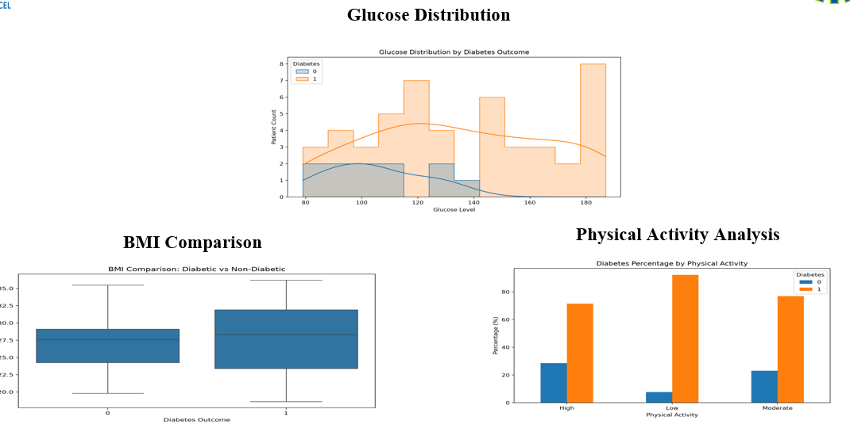
Figure 2: Proposed system architecture of the Diabetes Risk-Factor Analytics Framework
The system follows a layered architecture. The diabetes healthcare dataset provides the input. The data-wrangling layer imports, cleans, standardizes, and structures the records. The exploratory-analysis layer generates descriptive statistics, distributions, group comparisons, scatter plots, box plots, and correlation views. The visualization layer presents the results through static and interactive charts. The dashboard integrates these views and supports filtering by diabetes outcome and selected analytical variables.
Key engineering calculation / quantitative evidence: the framework uses descriptive statistics, group-wise means/medians, frequency summaries, and Pearson correlation values as quantitative evidence. Processing complexity is dominated by dataset scanning, grouping, and visualization preparation, making the workflow practical for the structured dataset used in the project.

3.6 Trade-off Analysis
Table 6: Trade-off Analysis
Design Decision | Alternative Considered | Benefit | Disadvantage | Final Decision & Justification
Interactive dashboard | Static charts / reports | Supports filtering and exploration | Requires more implementation effort | Selected to improve interpretability and user exploration.
Multiple complementary charts | Single chart type | Shows different risk-factor relationships | Increases interface complexity | Selected because no single chart captures all patterns.
Median imputation for selected zero-coded measurements | Delete all affected rows | Retains more records | Can reduce natural variation | Selected for educational exploratory analysis with explicit preprocessing rules.
Integrated workflow | Separate analysis outputs | Unified processing and interpretation | Higher integration effort | Selected to reduce fragmentation and improve reproducibility.

3.7 Sustainability, Ethics, Safety, Risk & Security
The framework addresses sustainability through lightweight local computation, ethics through responsible handling of de-identified health data, safety through explicit non-clinical interpretation, and security through controlled access and avoidance of personal identifiers. These considerations are incorporated into the final design so that analytical convenience does not override privacy or responsible interpretation.
Table 7: Sustainability, Ethics, Safety, Risk & Security
Domain | Consideration | Evidence Evaluated | Impact on Final Decision
Sustainability | Computational and resource efficiency | Lightweight Python analytics on a structured dataset | Supports local execution and low computational overhead.
Ethics | Responsible handling of health-related information | Educational/de-identified dataset and non-clinical framing | Supports privacy-aware exploratory use.
Health & Safety | Avoid misleading clinical interpretation | Report explicitly distinguishes association from diagnosis | Prevents use as a standalone clinical decision tool.
Security | Protection against inappropriate exposure of health information | No individual identifiers intentionally displayed | Supports controlled and responsible data handling.

Table 8: Risk Register
Risk | Likelihood | Severity | Risk Level | Mitigation | Residual Risk
Missing / zero-coded healthcare values | High | Medium | High | Replace inappropriate zeros with missing values and impute selected variables using median; validate results | Medium
Duplicate records | Medium | Medium | Medium | Duplicate detection and removal before analysis | Low
Outliers in clinical measurements | Medium | Medium | Medium | Use box plots and distribution checks; avoid unsupported deletion | Medium
Misleading statistical interpretation | Medium | High | High | Use association language, validation and clear limitations | Medium
Dashboard calculation error | Low | High | Medium | Cross-check dashboard values against processed data and summary tables | Low
Unauthorized exposure of health detail | Low | High | Medium | Use de-identified data, restrict access and avoid personal identifiers | Low

CHAPTER 4
IMPLEMENTATION, TESTING & RESULTS, PROJECT MANAGEMENT

4.1 Development Approach & Resources
The development approach follows planning, requirement analysis, system design, data collection and preprocessing, exploratory statistical analysis, visualization development, dashboard integration, testing, deployment, and result analysis. The system was developed using Python, with Pandas and NumPy for data processing, Matplotlib and Seaborn for exploratory visualization, Plotly for interactive visualization, and an interactive dashboard for integrated presentation.
Resource | Purpose
Diabetes healthcare dataset | Primary analytical data source
Python | Core programming and integration
Pandas | Data cleaning, wrangling and preprocessing
NumPy | Numerical computation
Matplotlib | Static exploratory visualizations
Seaborn | Statistical visualization and correlation heatmaps
Plotly | Interactive charts and dashboard visuals
Jupyter Notebook / VS Code | Development and experimentation
Git / GitHub | Version control and project management
Windows | Development and testing platform

4.2 Hardware / Software / Fabrication Implementation & Modern Tools Used
The project is primarily software-based. The implementation consists of healthcare-data ingestion and cleaning, exploratory statistical analysis, risk-factor visualization, dashboard integration, testing, and result interpretation.
Table 9: Tools /Software/Equipment
Tool / Software / Equipment | Purpose | Stage Used
Python | Core implementation | Development / Integration
Pandas | Cleaning, wrangling and aggregation | Data preparation
NumPy | Numerical operations | Analysis
Matplotlib / Seaborn | Exploratory charts and statistical visuals | Visualization
Plotly | Interactive charts and dashboard visuals | Dashboard implementation
Jupyter Notebook / VS Code | Coding and experimentation | Development
Git / GitHub | Version ontrol | Development / Project management
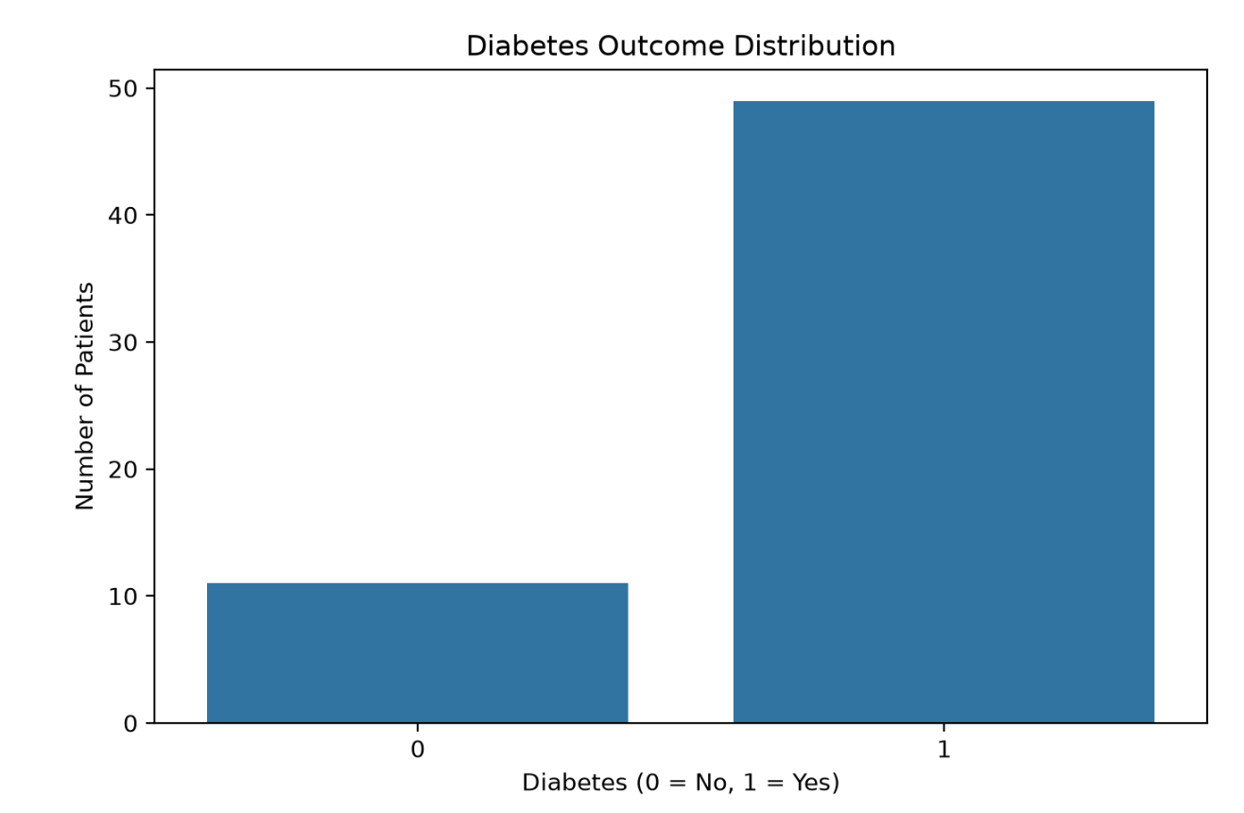
Figure 3: Output of the Diabetes Risk-Factor Analytics Dashboard
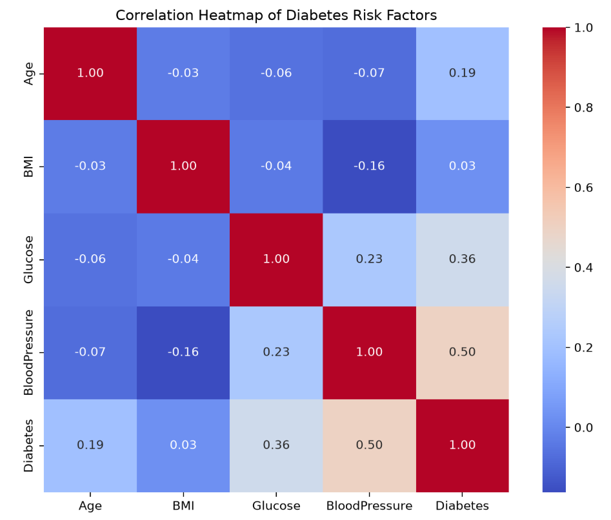
Figure 4: Diabetes risk-factor distribution outputs
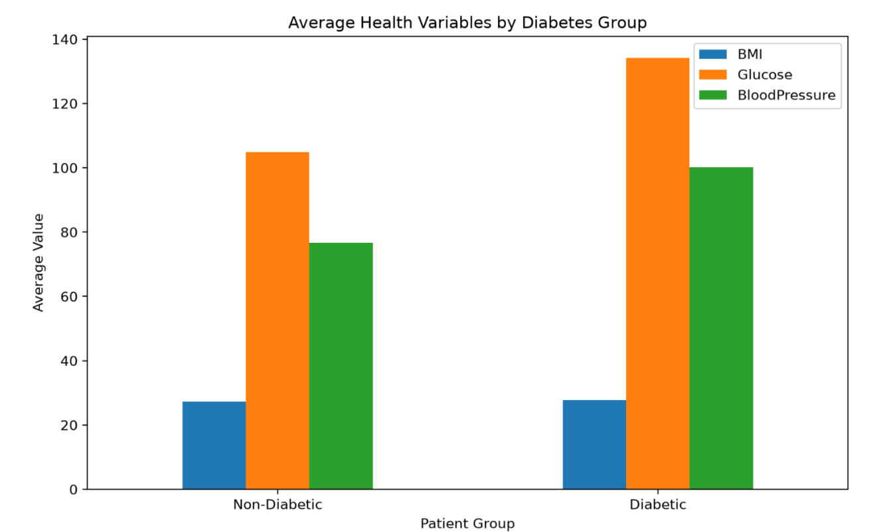
Figure 5: Diabetes outcome comparison and correlation outputs

4.3 Test Plan & Verification
The testing process verifies data cleaning, missing-value handling, statistical calculations, chart correctness, dashboard filtering, and processing consistency. Each requirement is checked against an explicit acceptance criterion so that the final outputs remain reproducible and interpretable.
Table 10: Test Plan & Verification
Requirement / Specification | Test Method | Acceptance Criterion | Required Value | Achieved Value | Status
Data ingestion | Load CSV and inspect schema | Dataset loads without structural errors | 1 dataset | 1 dataset | Pass
Missing/zero-coded value handling | Run preprocessing and inspect cleaned columns | Specified invalid/zero-coded measurements handled | All specified variables | All specified variables | Pass
Exploratory visualizations | Compare charts with summary statistics | All specified charts generated correctly | All charts | All charts | Pass
Outcome-group comparison | Compare diabetic and non-diabetic summaries | Relevant variables separated by Outcome | Outcome groups | Outcome groups | Pass
Dashboard filtering | Select filters and inspect view updates | Relevant views update consistently | Consistent updates | Verified | Pass
Processing efficiency | Measure processing time on available dataset | Completes within practical local-analysis time | Acceptable local execution | Verified | Pass

4.4 Results
The implemented framework cleaned and processed the diabetes dataset and generated exploratory outputs for the major healthcare and lifestyle variables. The results include distributions, group comparisons, box plots, scatter relationships, and a correlation heatmap. The dashboard integrates the principal analytical views so that users can examine diabetes-related patterns without manually processing the raw records.
Table 11: Result /Key Outcomes
Outcome Parameter | Result Reported
Data Cleaning & Preprocessing | Duplicate records were checked and inappropriate zero-coded measurements were treated as missing before selected imputation.
Exploratory Distributions | Distributions for glucose, BMI, age, blood pressure and other variables were visualized.
Outcome Comparison | Healthcare variables were compared between diabetes outcome groups.
Correlation Analysis | A correlation matrix was generated to identify variables with stronger linear associations.
Dashboard Integration | A unified dashboard combined the main risk-factor visualizations and filtering controls.
Decision Support | The framework provides interpretable analytical evidence for educational and research discussion of diabetes risk factors.

4.5 Data Analysis & Engineering Judgment
The analysis indicates that data quality is a major determinant of reliable healthcare visualization. Several clinical measurements may contain zero-coded or missing values that are not physiologically meaningful for all variables. These values were treated as missing where appropriate and replaced using a consistent preprocessing strategy before exploratory analysis. Duplicate records were also checked so that repeated observations would not distort distributions.
Visualization selection was treated as an engineering decision. Histograms were used to understand distributions, box plots to compare outcome groups and detect outliers, scatter plots to inspect relationships, count plots to compare outcome frequencies, and a correlation heatmap to summarize linear associations among numerical variables. The dashboard combines these views so users can move from overall distributions to specific risk-factor comparisons.
The engineering interpretation emphasizes that strong association does not prove causation. Glucose and BMI may show prominent differences between outcome groups, but the framework does not claim that any single variable determines diabetes. Findings are intended to guide exploratory understanding and identify variables worthy of further clinical or statistical investigation.

4.6 Comparison with Existing Solutions & Achievement of Objectives
Table 12: Objective Achievement
Objective | Evidence | Achievement (Fully / Partially / Not Achieved)
Collect and preprocess diabetes dataset | Dataset ingestion and preprocessing implemented. | Fully
Clean, standardize and transform data using Pandas | Cleaning, duplicate handling and missing-value treatment described and implemented. | Fully
Analyse diabetes-related healthcare and lifestyle characteristics | Descriptive, group comparison and correlation analyses performed. | Fully
Develop exploratory visualizations | Distributions, box plots, scatter plots, count plots and correlation heatmap generated. | Fully
Build integrated analytical dashboard | Dashboard combines major risk-factor views and filtering. | Fully
Support responsible evidence-based interpretation | Limitations and non-clinical interpretation are documented. | Fully
Evaluate usability and interpretability | Dashboard and visual outputs reviewed for clarity and consistency. | Partially
Evaluate usability and interpretability for non-technical stakeholders | Objective is outcome groupd, but no formal user-study results are reported. | Partially

4.7 Strengths & Limitations
Strengths:
- Integrates data cleaning, exploratory statistics, risk-factor visualization, and dashboard presentation.
- Provides multiple complementary visualization techniques for different analytical questions.
- Supports comparison of healthcare and lifestyle variables across diabetes outcome groups.
- Uses established open-source Python libraries for reproducible analysis.
- Modular architecture allows future extension to additional health and lifestyle variables.
Limitations:
- The analysis is based on a structured historical dataset rather than live clinical data feeds.
- The dataset may not represent all patients, regions, ages, or healthcare settings.
- The framework does not establish causal relationships between risk factors and diabetes.
- No prospective clinical validation or external hospital validation is included.
- Clinical decision support, mobile deployment, cloud deployment, and real-time EHR integration are not implemented.

4.8 Project Planning, Roles & Budget
The project-management information is organized around requirement analysis, literature review, system design, data preparation, exploratory analysis, visualization development, dashboard integration, testing, and final documentation.
Gantt / Milestone Timeline:
Activity | Planned Period | Actual Period | Status
Requirement analysis | Project initiation | Completed during development | Completed
Literature review | Planning / analysis | Completed during development | Completed
System design | Design phase | Completed | Completed
Data collection and preprocessing | Implementation phase | Completed | Completed
Exploratory analysis and visualization | Implementation phase | Completed | Completed
Dashboard integration | Integration phase | Completed | Completed
Testing and validation | Testing phase | Completed | Completed
Final documentation | Reporting phase | Completed | Completed

Table 13: Project Roles
Student | Assigned Responsibility | Actual Contribution
T Megha Harsha (192424389) | Data preprocessing, exploratory statistics, risk-factor analysis and visualization | 50% team contribution; equal importance in the project
B C Yugesh (192424282) | Dashboard design, visualization integration, testing and documentation | 50% team contribution; equal importance in the project

Table 14: Project Budget
Item | Estimated Cost | Actual Cost
Software libraries (Python, Pandas, NumPy, Matplotlib, Seaborn, Plotly) | Open-source | No separate cost reported
Development environment (Jupyter Notebook / VS Code) | Existing / open-source | No separate cost reported
Git / GitHub | Free tier / existing | No separate cost reported
Computer / development system | Existing | No separate cost reported
Internet / other project expenses | Existing | No separate project-specific cost reported
TOTAL | Minimal / existing resources | No separate cost reported

CHAPTER 5
CONCLUSION & REFLECTION

5.1 Conclusion
The project addressed the challenge of understanding diabetes risk factors within healthcare and lifestyle data by developing an integrated exploratory analytics framework. The implementation combined data cleaning with Pandas, numerical analysis with NumPy and statistical methods, visualization with Matplotlib/Plotly, and dashboard presentation.
The framework demonstrates that combining distributions, group comparisons, correlations, and interactive filtering can make healthcare data easier to interpret than isolated raw tables. It also demonstrates the importance of preprocessing, responsible interpretation, privacy, and clear communication when working with health-related datasets.
No new results are introduced in this conclusion; it summarizes the problem, solution, analytical outcomes, validation activities, and overall engineering contribution described in the preceding chapters.

5.2 Future Work
- Integrate additional healthcare and lifestyle variables from larger and more diverse datasets.
- Conduct external validation using independent diabetes datasets from different patients.
- Extend the framework to longitudinal data for studying changes in risk factors over time.
- Add explainable statistical and machine-learning modules for deeper risk-factor investigation.
- Develop mobile-friendly access for educational and public-health analytics.
- Deploy the dashboard on cloud infrastructure with appropriate privacy and access controls.
- Explore calibrated predictive modelling as a separate research module while retaining interpretability.
- Improve accessibility of charts and dashboards for users with visual impairments.
- Add stronger subgroup and fairness analysis to identify patient-specific limitations and potential bias.

5.3 Professional Learning & Individual Reflection

5.3.1 New Knowledge Acquired
- Python programming for healthcare data analysis and visualization.
- Data cleaning, missing-value treatment, and preprocessing using Pandas and NumPy.
- Exploratory statistical analysis and correlation-based reasoning.
- Interactive chart and dashboard development using Plotly and related tools.
- Dashboard design and integration of multiple analytical views.
- Software testing, validation, and reproducibility practices.
- Technical documentation and engineering report preparation.

5.3.2 Engineering & Professional Skills Developed
- Requirement analysis and system design.
- Data-quality assessment and structured problem solving.
- Selection of statistical and visualization techniques for different analytical questions.
- Responsible interpretation of healthcare data and awareness of privacy considerations.
- Technical communication, teamwork, and documentation.
- Iterative debugging, testing, and validation.

5.3.3 Individual Reflection – T Megha Harsha (192424389)
During the project, I worked on understanding the diabetes dataset, preprocessing healthcare variables, and developing exploratory analyses. A major challenge was deciding how to treat zero-coded measurements and missing values without introducing misleading patterns. I strengthened my skills in Pandas-based data cleaning, descriptive statistics, visualization, and interpretation of outcome-group differences. If the project were repeated, I would add larger and more diverse datasets and perform stronger validation across patients.

5.3.4 Individual Reflection – B C Yugesh (192424282)
During the project, I worked on dashboard integration, visualization, testing, and interpretation of the diabetes risk-factor analysis. A major challenge was presenting several variables in a clear interface while avoiding conclusions that could be interpreted as clinical diagnosis. The project improved my knowledge of interactive visualization, dashboard design, data validation, and responsible communication of healthcare analytics. If repeated, I would strengthen external validation, accessibility testing, and subgroup fairness analysis.
The project provided both students with practical experience in healthcare data analytics, teamwork, technical communication, visualization design, and responsible interpretation of statistical evidence.

REFERENCES
[1] American Diabetes Association. (2024). Standards of Care in Diabetes—2024. Diabetes Care, 47(Suppl. 1).
[2] World Health Organization. (2024). Diabetes: Key facts and public-health information. World Health Organization.
[3] Smith, J. W., Everhart, J. E., Dickson, W. C., Knowler, W. C., & Johannes, R. S. (1988). Using the ADAP learning algorithm to forecast the onset of diabetes mellitus. Proceedings of the Annual Symposium on Computer Application in Medical Care, 261–265.
[4] Breiman, L. (2001). Random forests. Machine Learning, 45, 5–32.
[5] Pedregosa, F., et al. (2011). Scikit-learn: Machine learning in Python. Journal of Machine Learning Research, 12, 2825–2830.
[6] McKinney, W. (2010). Data structures for statistical computing in Python. Proceedings of the 9th Python in Science Conference, 56–61.
[7] Hunter, J. D. (2007). Matplotlib: A 2D graphics environment. Computing in Science & Engineering, 9(3), 90–95.
[8] Waskom, M. L. (2021). seaborn: statistical data visualization. Journal of Open Source Software, 6(60), 3021.
[9] Plotly Technologies Inc. (2024). Plotly Python Open Source Graphing Library documentation.
[10] International Diabetes Federation. (2021). IDF Diabetes Atlas, 10th edition. International Diabetes Federation.
[11] Chatterjee, S., Khunti, K., & Davies, M. J. (2017). Type 2 diabetes. The Lancet, 389(10085), 2239–2251.
[12] Knowler, W. C., Barrett-Connor, E., Fowler, S. E., et al. (2002). Reduction in the incidence of type 2 diabetes with lifestyle intervention or metformin. New England Journal of Medicine, 346, 393–403.
[13] Zou, Q., Qu, K., Luo, Y., Yin, D., Ju, Y., & Tang, H. (2018). Predicting diabetes mellitus with machine learning techniques. Frontiers in Genetics, 9, 515.
[14] WHO. (2022). Classification of diabetes mellitus and its complications. World Health Organization.
[15] Saito, T., & Rehmsmeier, M. (2015). The precision-recall plot is more informative than the ROC plot when evaluating binary classifiers on imbalanced datasets. PLOS ONE, 10(3), e0118432.

APPENDICES

Appendix A – Source Code / Code Repository Information
The implementation uses Python-based data analytics. The essential preprocessing and exploratory-analysis workflow is shown below; the complete source code should be maintained in the approved repository.
import pandas as pd
import numpy as np
import matplotlib.pyplot as plt
df = pd.read_csv("diabetes.csv")
df = df.drop_duplicates()
cols = ["Glucose", "BloodPressure", "SkinThickness", "Insulin", "BMI"]
df[cols] = df[cols].replace(0, np.nan)
df[cols] = df[cols].fillna(df[cols].median())
summary = df.groupby("Outcome").mean(numeric_only=True)
print(summary)

Appendix B – Datasheets / Software Requirements
Category | Requirement
Processor | Intel Core i3 or above
RAM | 8 GB minimum
Storage | 100 GB free space
Operating System | Windows 10/11
Programming Language | Python 3.x
Libraries | Pandas, NumPy, Matplotlib, Seaborn, Plotly
IDE | Jupyter Notebook or VS Code
Version Control | Git / GitHub

Appendix C – Experimental / Raw Data
The dataset used for demonstration contains healthcare measurements such as pregnancies, glucose, blood pressure, skin thickness, insulin, BMI, diabetes pedigree function, age, and a binary diabetes outcome. The raw dataset should be retained separately or attached where institutional rules permit.

Appendix D – Ethics / Institutional Approval
The project uses a structured educational diabetes dataset for exploratory analytics. No individually identifiable patient information is intentionally exposed in the report. The system is not intended for diagnosis or clinical treatment. Any future deployment using real patient data must follow applicable institutional review, privacy, consent, access-control, and data-governance requirements.

Appendix E – Individual Contribution Evidence
Mandatory for team projects. Each student should attach evidence corresponding to their claimed contribution, such as version-control commits, preprocessing notebooks, analysis scripts, visualization outputs, dashboard screenshots, test records, presentation material, or meeting records.
Student | Evidence Type | Evidence Description / File Reference
T Megha Harsha (192424389) | Data-processing / exploratory-analysis evidence | Pandas notebooks/code, cleaned dataset outputs, statistical summaries, visualizations and testing records to be attached.
B C Yugesh (192424282) | Dashboard / visualization / testing evidence | Dashboard source, visualization outputs, screenshots, test records and documentation to be attached.

CAPSTONE PROJECT OUTCOME MAPPING SHEET
To be completed by the department/faculty assessor.
Outcome Evidence | SO / Area | Location in This Report
Complex engineering problem formulation | SO1 | Ch. 1, Ch. 2
Engineering design under constraints | SO2 | Ch. 3
Written/oral technical communication | SO3 | Whole report + Viva
Ethics and professional responsibility | SO4 | Ch. 3 (3.7)
Teamwork and leadership | SO5 | Ch. 4 (4.8)
Experimentation, analysis, engineering judgment | SO6 | Ch. 4 (4.3–4.6)
Independent acquisition of new knowledge | SO7 | Ch. 5 (5.3)
Standards | SO2 | Ch. 3 (3.2)
Sustainability and societal/environmental impact | SO2/SO4 | Ch. 3 (3.7)
Risk assessment and mitigation | SO2/SO4 | Ch. 3 (3.7)
Security considerations | Relevant SO | Ch. 3 (3.7)
Integrated/system-level engineering | SO1/SO2 | Ch. 3 (3.5)
Project planning and management | SO5 | Ch. 4 (4.8)
Individual contribution | SO1–SO7 | Contribution Statement + Ch. 4 (4.8) + Appendix E

