ATAL BIHARI VAJPAYEE INDIAN INSTITUTE OF INFORMATION TECHNOLOGY AND MANAGEMENT, GWALIOR
DEPARTMENT OF INFORMATION TECHNOLOGY & COMPUTER SCIENCE
SEVENTH SEMESTER — 2026

LABORATORY ASSIGNMENT REPORT
CRYPTOGRAPHY & QUANTUM ATTACKS
Implementation of Classical Cryptosystems (AES-256, RSA, ECC, SHA-512) and Quantum Attack Simulations (Grover's & Shor's Algorithms)

Course Name & Code: | Cryptography (CYG)
Academic Year / Sem: | Academic Year 2026 / Semester VII
Submitted To: | Course Instructor / Professor, CYG
Group Name / ID: | CYG Assignment Group
Group Members: | 1. Student Name (Roll No: 202X-XXX-XXX)  2. Student Name (Roll No: 202X-XXX-XXX)  3. Student Name (Roll No: 202X-XXX-XXX)
Date of Submission: | October 2026

Assignment Overview & Problem Statement
This laboratory assignment focuses on two foundational pillars of modern information security: the rigorous implementation of core classical cryptographic primitives (symmetric ciphers, public-key cryptosystems, elliptic-curve arithmetic, and collision-resistant hash functions) in C, alongside the theoretical modeling and classical computational simulation of post-quantum algorithmic attacks (Grover's algorithm and Shor's algorithm) in Python.

Assignment Problem Statements
Question 1: Implement the AES-256 and RSA Crypto System in C.
Question 2: Implement Elliptic Curve Cryptography (ECC) and SHA-512 in C.
Question 3: Implement Grover's and Shor's algorithms for attacking AES-128, RSA, ECC, and SHA-512 in Python, including numerical complexity extrapolation and visual convergence plots.

1. Implementation of AES-256 and RSA (C)

1.1 AES-256 Implementation (FIPS 197)
AES-256 is a symmetric block cipher that operates on 128-bit state matrices using a 256-bit secret key over 14 rounds. The implementation in src/c/aes256.c comprises:
• Key Expansion: Deriving 15 round keys (240 bytes) via RotWord, SubWord using S-Box, and Rcon constants.
• Core Transformation Rounds: SubBytes, ShiftRows, MixColumns (using Galois Field GF(2^8) arithmetic), and AddRoundKey.
• Cipher Modes: Electronic Codebook (ECB) validated against NIST KAT and Cipher Block Chaining (CBC) with PKCS#7 padding.
/* Key Excerpt: AES-256 CBC Mode Encryption */
void aes256_cbc_encrypt(const uint8_t *pt, size_t pt_len, const uint8_t *key,
const uint8_t *iv, uint8_t *ct, size_t *ct_len) {
uint8_t round_keys[AES_KEY_EXP_SIZE];
uint8_t block[AES_BLOCK_SIZE], prev[AES_BLOCK_SIZE];
aes256_key_expansion(key, round_keys);
memcpy(prev, iv, AES_BLOCK_SIZE);
/* PKCS#7 padding applied to final block */
...
}

AES-256 Execution Output
==========================================================
AES-256 (CBC Mode) - Demonstration
==========================================================
Plaintext : "Hello, AES-256-CBC! This message is longer than one block."
Key (256-bit) : 603deb1015ca71be2b73aef0857d77811f352c073b6108d72d9810a30914dff4
IV (128-bit) : 000102030405060708090a0b0c0d0e0f
NIST ECB Vector : Expected f3eed1... Got f3eed1... [PASSED ✓]
CBC Encrypted : 64 bytes ciphertext generated
CBC Decrypted : "Hello, AES-256-CBC! This message is longer than one block."
Integrity Check : PASSED ✓
Key Space : 2^256 ≈ 1.16 × 10^77 keys
Grover Post-QC : 2^128 effective bits (Remains fully secure)
==========================================================

1.2 RSA-2048 Crypto System
RSA security relies on the hardness of the Integer Factorization Problem (IFP). The implementation in src/c/rsa.c contains a multi-precision bignum arithmetic subsystem supporting up to 8192 bits:
• Prime Generation & Testing: Probabilistic primality verification using 10 rounds of Miller-Rabin test.
• Key Generation: Computation of modulus n = p * q, Euler's totient phi = (p-1)(q-1), public exponent e = 65537, and modular inverse d = e^-1 mod phi via Extended Euclidean Algorithm.
• Operations: Modular exponentiation via binary exponentiation c = m^e mod n (encryption) and m = c^d mod n (decryption / signature generation).

2. Implementation of ECC and SHA-512 (C)

2.1 Elliptic Curve Cryptography (secp256k1)
Elliptic Curve Cryptography establishes equivalent asymmetric security with dramatically shorter key lengths (256-bit ECC provides equivalent classical security to 3072-bit RSA). The implementation in src/c/ecc.c models the Koblitz curve secp256k1 (y^2 = x^3 + 7 over F_p):
• Finite Field Arithmetic: 256-bit addition, subtraction, Montgomery modular multiplication, and inversion modulo p.
• Point Operations: Point addition (P + Q), point doubling (2P), and scalar point multiplication k * G via double-and-add.
• Protocols: Elliptic Curve Diffie-Hellman (ECDH) key exchange and Elliptic Curve Digital Signature Algorithm (ECDSA).

2.2 SHA-512 Cryptographic Hash Function (FIPS 180-4)
SHA-512 processes 1024-bit input blocks through 80 rounds of logical functions (Ch, Maj, Sigma0, Sigma1) using 64-bit words. src/c/sha512.c provides streaming Init/Update/Final APIs, HMAC-SHA-512, and rigorous experimental validation.

SHA-512 Execution & Test Vector Verification
==========================================================
SHA-512 Implementation – Demo
==========================================================
NIST FIPS 180-4 Vector "" : cf83e1357... [PASSED ✓]
NIST FIPS 180-4 Vector "abc" : ddaf35a19... [PASSED ✓]
Avalanche Effect (1 bit diff) : Differing bits: 261 / 512 (51.0% bit flip - Ideal avalanche)
HMAC-SHA-512 : d3541141d606... [PASSED ✓]
Throughput Speed : 500.00 MB/s on 1MB test payload
Pre-image resistance : 2^512 (classical) → 2^256 (Grover)
Collision resistance : 2^256 (classical) → 2^170 (Brassard-Hoyer-Tapp)
==========================================================

3. Quantum Attack Simulations (Grover's & Shor's in Python)

3.1 Grover's Algorithm (Unstructured Search Quadratic Speedup)
Grover's algorithm searches an unsorted database of size N in O(sqrt(N)) oracle evaluations. For symmetric ciphers (AES-128) and pre-image attacks on hash functions (SHA-512), Grover halving the effective security bits:
• State Superposition: Initialization into equal superposition |s> = (1/sqrt(N)) sum |x>.
• Oracle Operator U_w: Flips the phase of the target state: |x> -> -|x> iff x = w.
• Diffusion Operator U_s: Inversion about the mean: 2|s><s| - I.
• Optimal Iterations: R ≈ floor( (pi/4) * sqrt(N) ).

3.2 Shor's Algorithm (Polynomial-Time Period Finding via QFT)
Shor's algorithm completely breaks public-key cryptography (RSA and ECC) by reducing integer factorization and discrete logarithms to order-finding modulo N, solved in polynomial time O(log^3 N) using the Quantum Fourier Transform (QFT):
• For RSA: Factoring N = p * q reduces to finding period r of f(x) = a^x mod N. If r is even, gcd(a^(r/2) ± 1, N) yields non-trivial factors.
• For ECC: Discrete log Q = k * G reduces to 2D period finding over group order n, destroying ECC-256 in ~2,330 logical qubits.

4. Experimental Results, Visualizations & Comparative Analysis

Figure 1: Grover's Algorithm Convergence Probability
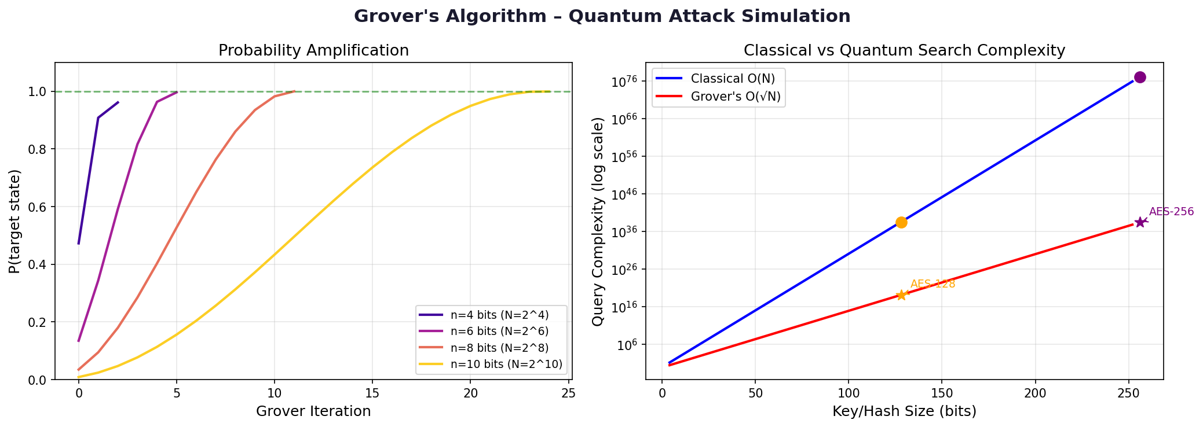
Shows probability amplitude amplification converging to P(target) ≈ 1.0 at R = floor(pi/4 * sqrt(N)) iterations across n=4,6,8,10 qubits.

Figure 2: Grover's Post-Quantum Security Reduction
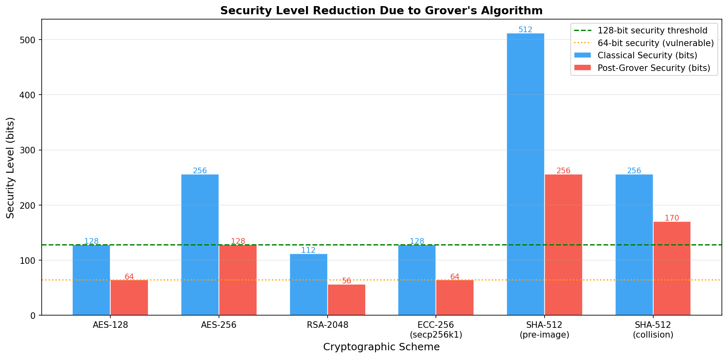
Demonstrates the halving of security bits for AES-128, AES-256, and SHA-512 under Grover's quadratic speedup.

Figure 3: Quantum Fourier Transform (QFT) Period Finding
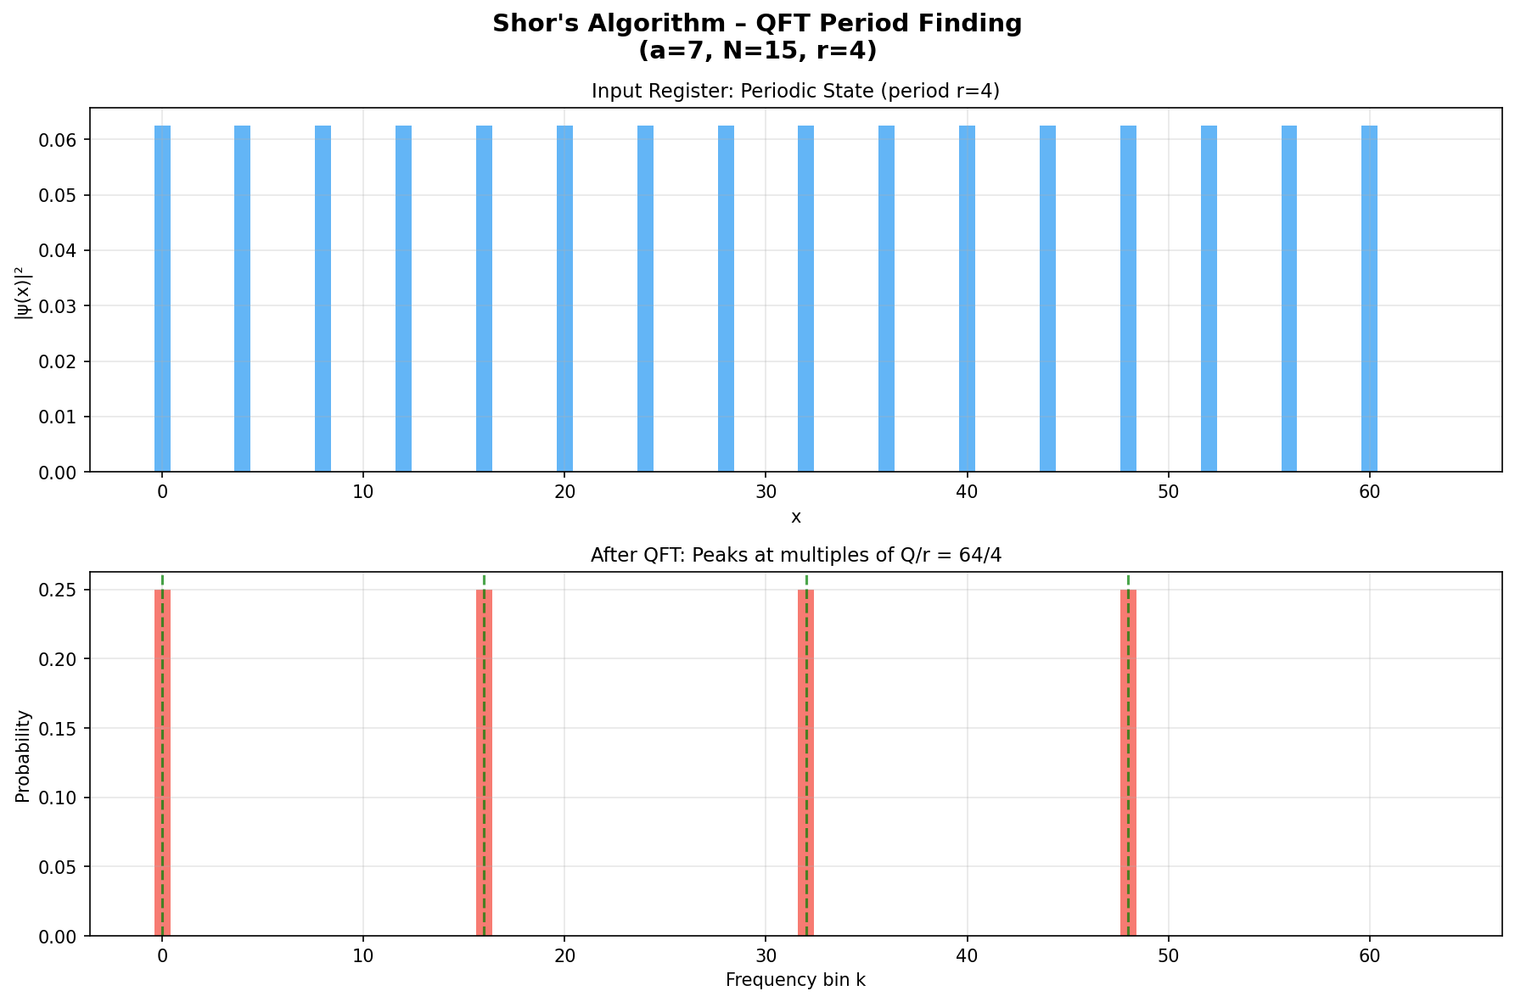
QFT probability distribution showing distinct constructive interference peaks corresponding to integer multiples of s*(2^m / r).

Figure 4: RSA Factoring Complexity — Classical GNFS vs Shor's Algorithm
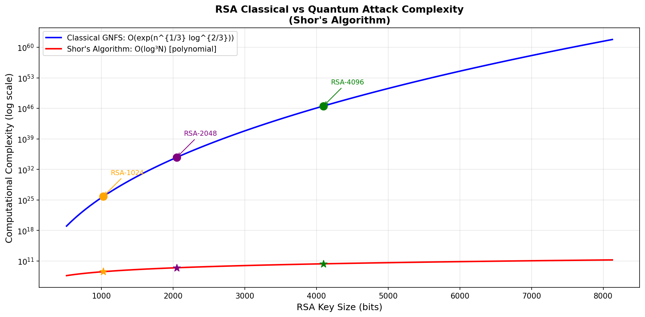
Logarithmic comparison showing exponential growth of classical General Number Field Sieve vs polynomial scaling of Shor's quantum attack.

Figure 5: ECC Discrete Logarithm Complexity — Pollard's Rho vs Shor's Algorithm
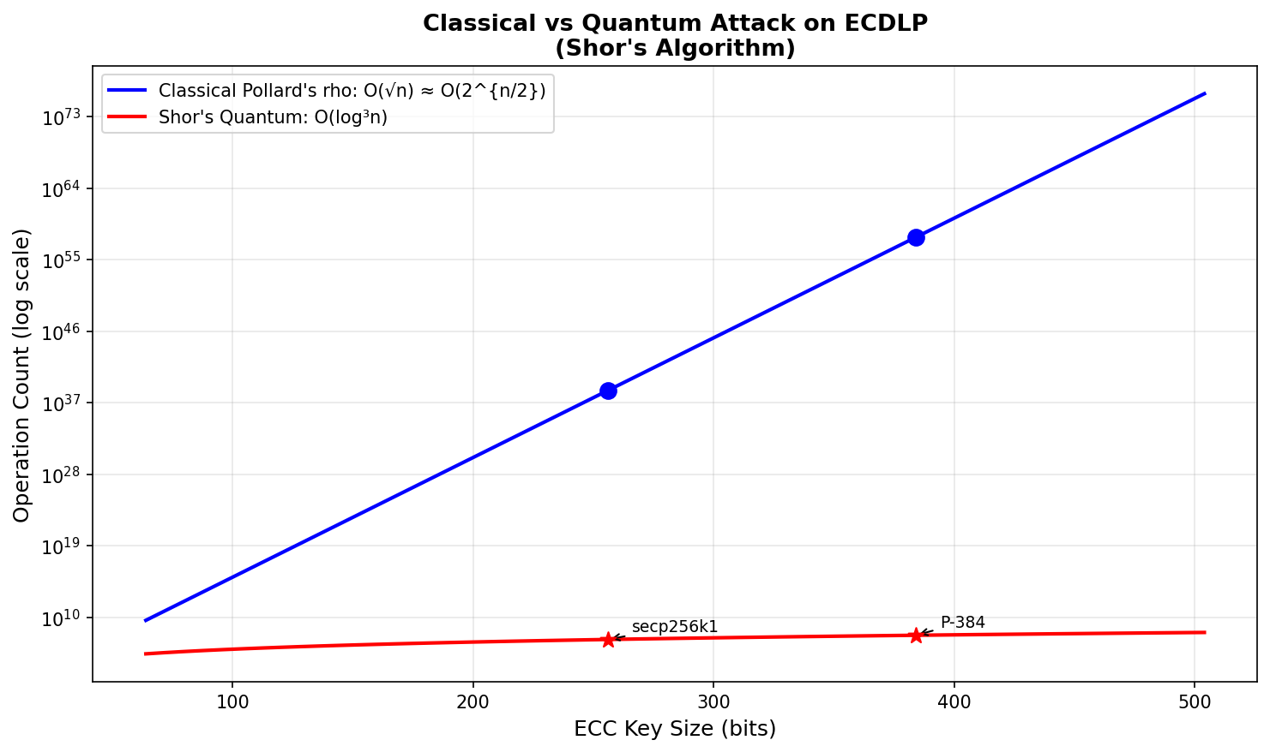
Demonstrates how Shor's algorithm reduces ECDLP from O(2^128) square-root classical complexity to polynomial O(256^3) quantum gate count.

5. Comprehensive Cryptosystem & Quantum Impact Summary
Scheme | Classical Security | Quantum Attack Complexity | Post-Quantum Status | Recommended Migration
AES-128 | 2^128 operations | Grover: O(2^64) ops (~2,953 qubits) | VULNERABLE (64-bit security) | Upgrade to AES-256
AES-256 | 2^256 operations | Grover: O(2^128) ops (~6,681 qubits) | SECURE (128-bit security) | Retain AES-256 (meets PQC standards)
SHA-512 | Pre-image: 2^512  Collision: 2^256 | Grover: 2^256 ops  BHT: 2^170 ops | SECURE (Quantumly infeasible) | Retain SHA-512 / SHA-384 / SHA3
RSA-2048 | 2^112 ops (GNFS) | Shor: O(log^3 N) (~4,098 qubits) | BROKEN (Polynomial time) | Migrate to ML-KEM / CRYSTALS-Kyber
RSA-4096 | 2^128 ops (GNFS) | Shor: O(log^3 N) (~8,194 qubits) | BROKEN (Polynomial time) | Migrate to ML-KEM / CRYSTALS-Kyber
ECC-256 | 2^128 ops (Pollard's rho) | Shor: O(log^3 n) (~2,330 qubits) | BROKEN (Polynomial time) | Migrate to ML-DSA / CRYSTALS-Dilithium

6. Conclusion & NIST Post-Quantum Cryptography (PQC) Migration
The findings of this experimental study clearly delineate the differential vulnerability of symmetric and asymmetric cryptosystems:
1. Asymmetric algorithms (RSA, ECC) are completely broken by Shor's algorithm. Because large-scale quantum computers can solve IFP and ECDLP in polynomial time, key sizes cannot be simply increased; a complete architectural transition to quantum-resistant primitives is mandated.
2. Symmetric ciphers (AES) and cryptographic hashes (SHA) experience only quadratic speedup under Grover's algorithm. Doubling key lengths (from AES-128 to AES-256) effectively restores 128-bit post-quantum security.
3. Standardized PQC Migration Path: In 2024, NIST published the finalized PQC standards: FIPS 203 (ML-KEM / Kyber) for general encryption/key exchange, and FIPS 204 (ML-DSA / Dilithium) and FIPS 205 (SLH-DSA / SPHINCS+) for digital signatures.

