**NAME: Yash Nandkumar Morankar**

**ROLL_NO: TECOB220**

**ASSIGNMENT NO. 7**

Title: RIP Configuration using CISCO Packet Tracer

**1] Initial GUI of CISCO Packet Tracer:**

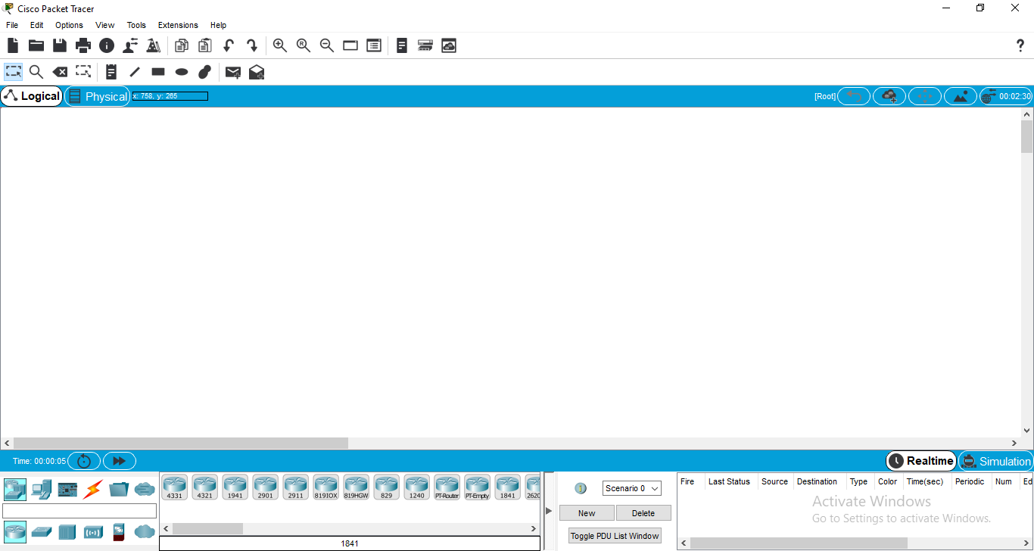

**2] Design of Network:**

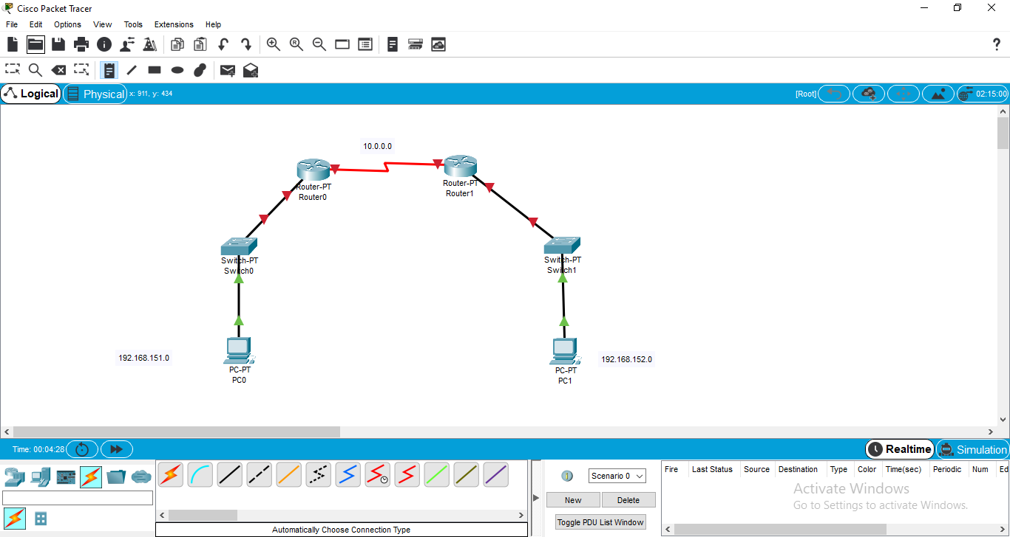

**3] Configuration of Computer System**

**PC0**

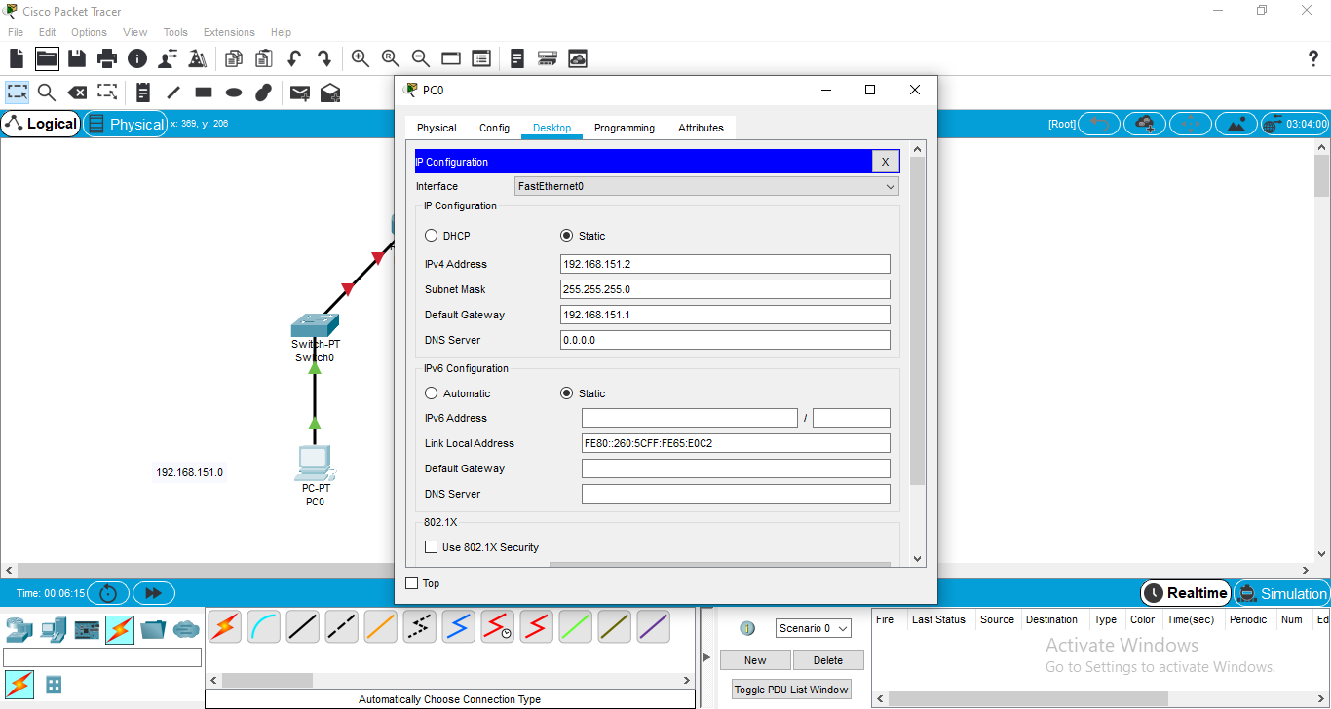

**PC1**

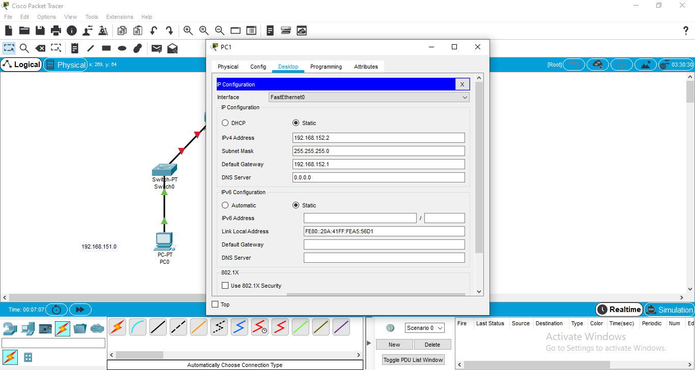

**4] Configuration of Router**

**Router0**

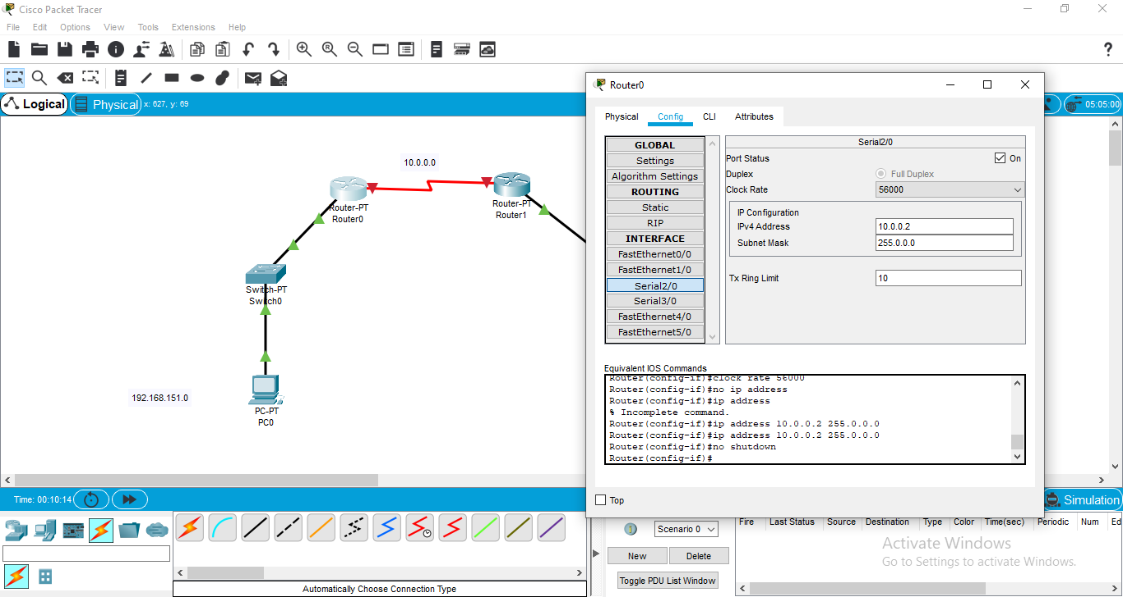

**Router1**

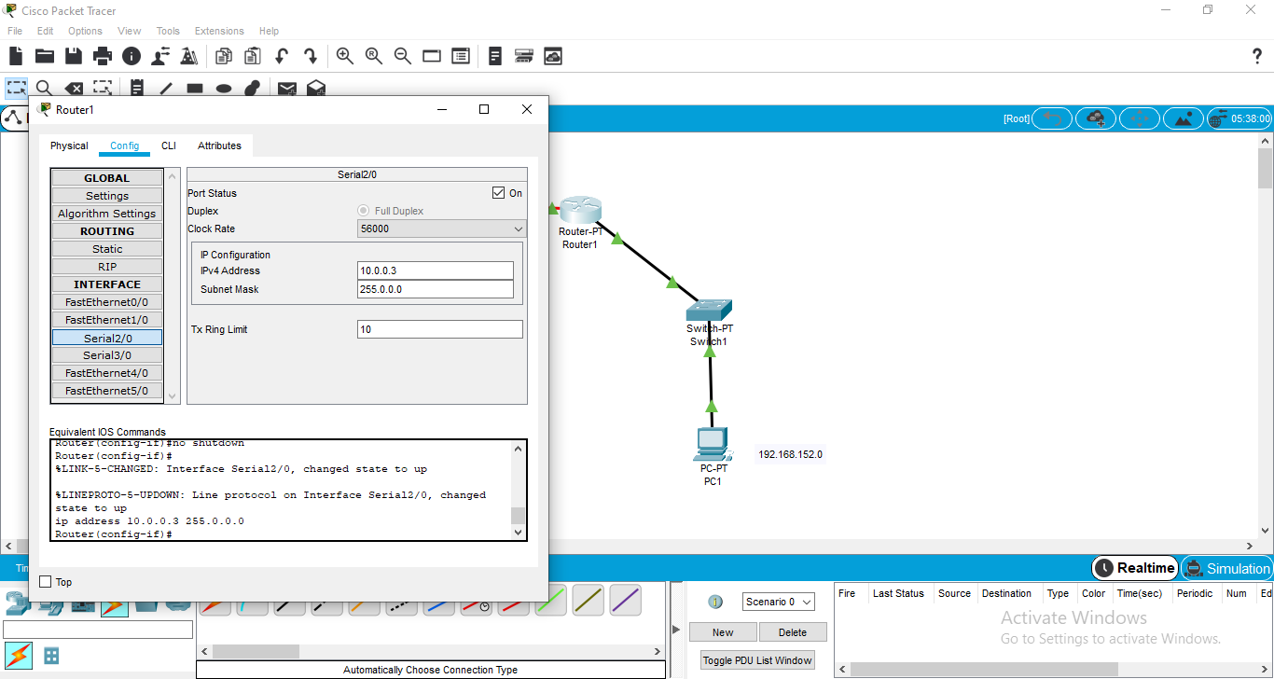

**5] Configuration of RIP Protocol:**

**Router0**

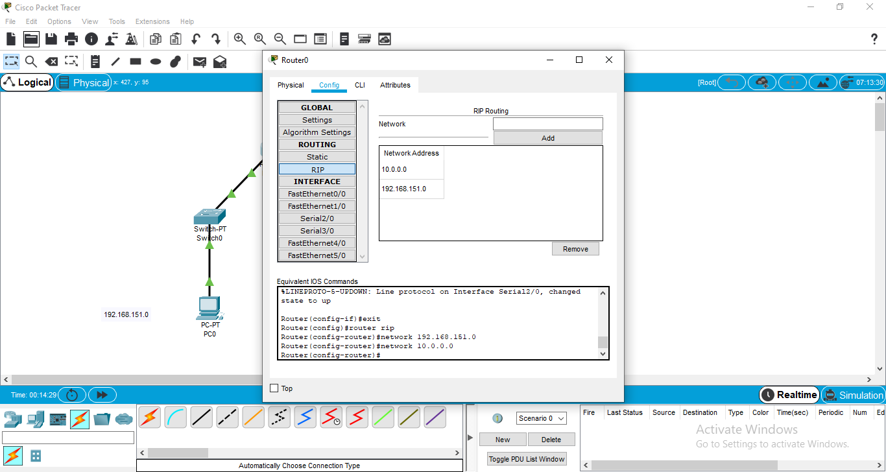

**Route1**

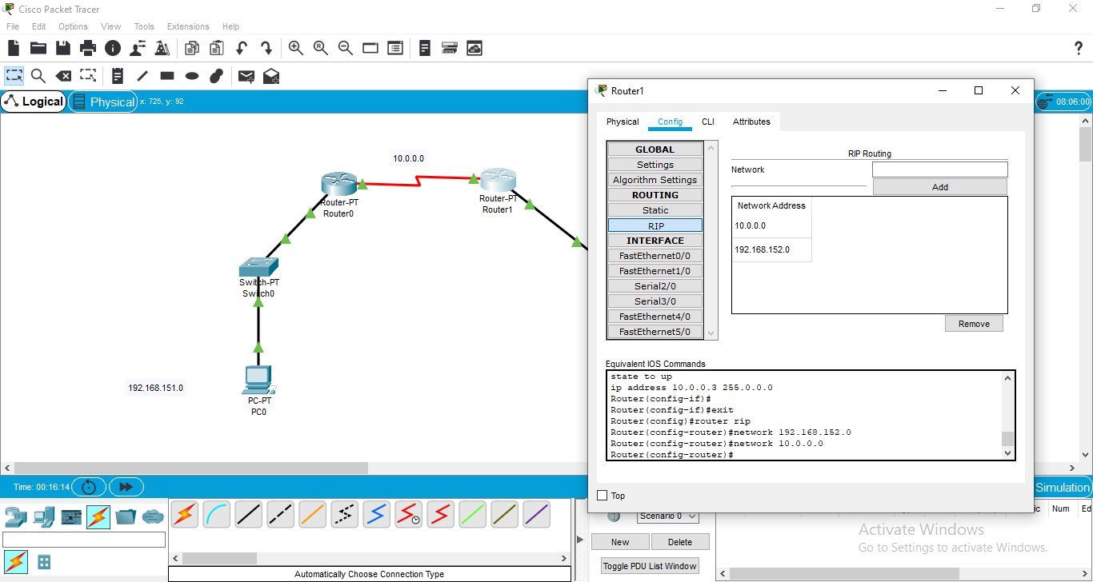

**6] Packet Flow from one computer system to other computer system:**

**1]PC0 to PC1**

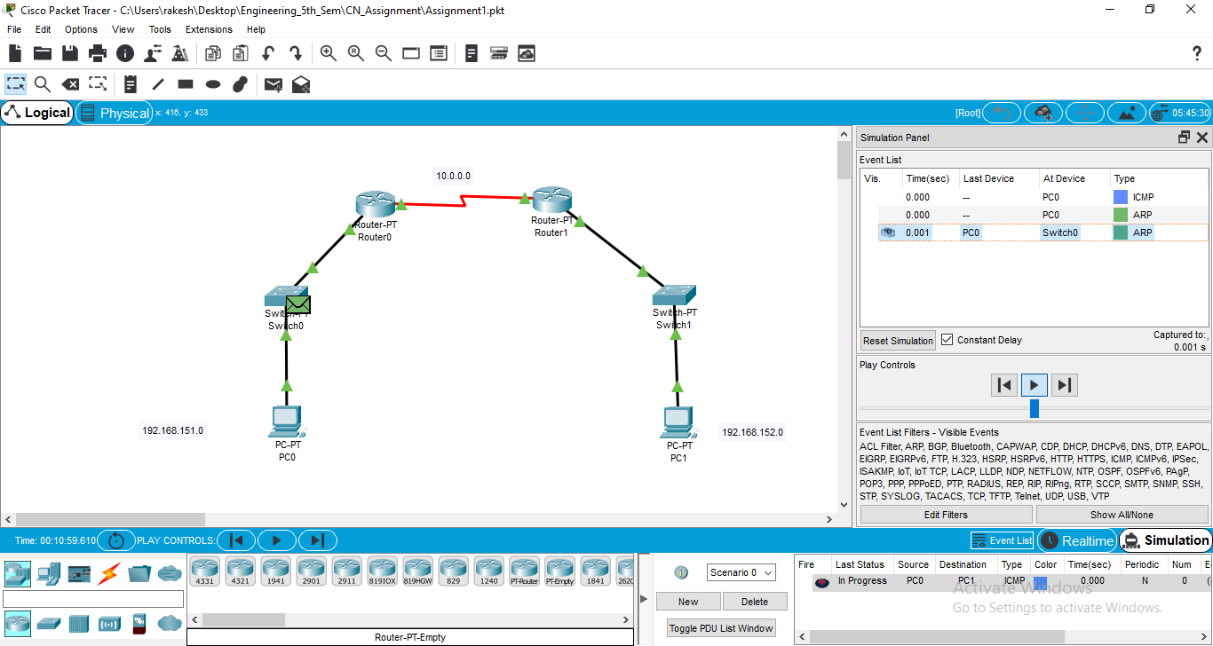

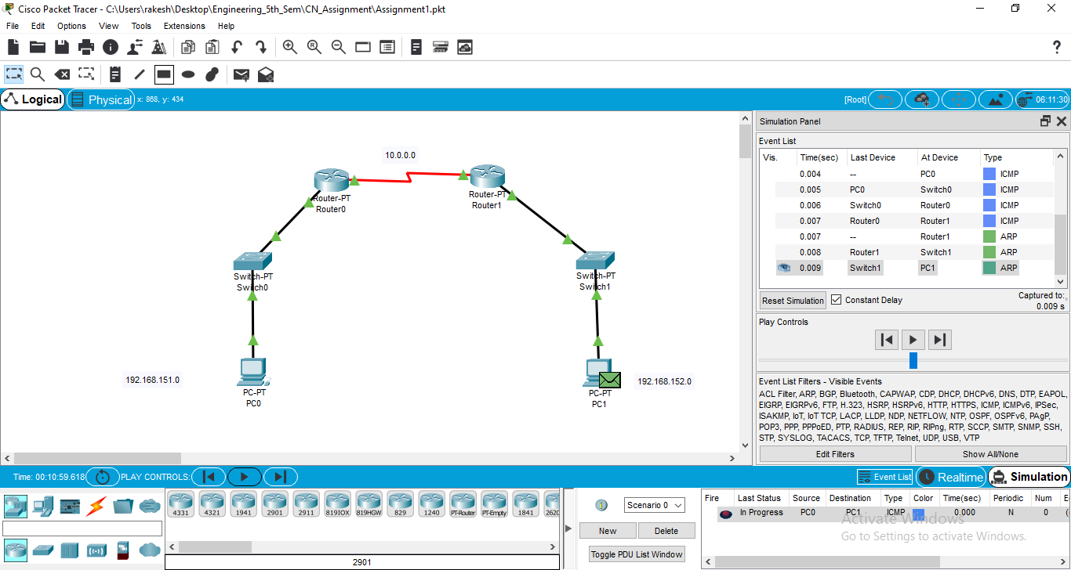

**2] PC1 to PC0**

