**Name :- Yash Nandkumar Morankar**

**Roll number :- TECOB220**

Assignment 5

**1. Write a PL/SQL stored Procedure for following requirements and call the procedure in appropriate PL/SQL block**.

1. Borrower(roll_no , name , date_of_i , book_name , status)

2. Fine(rollno , date_of_r , amount)

· Accept roll_no & name of book from user.

· Check the number of days (from date of issue), if days are between 15 to 30 then

fine amount will be Rs 5 per day.

· If no. of days>30, per day fine will be Rs 50 per day & for days less than 30, Rs.

5 per day.

· After submitting the book, status will change from I to R.

· If condition of fine is true, then details will be stored into fine table.

**Solution:-**

Contents of borrower table:-

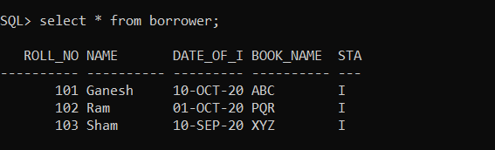

Procedure creation:-

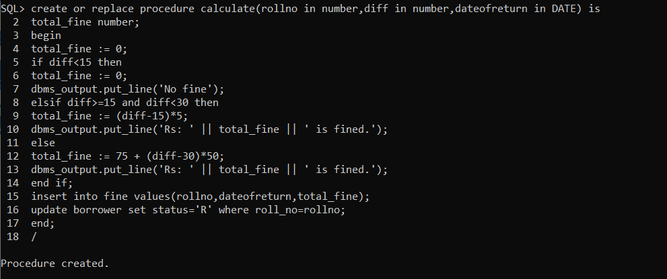

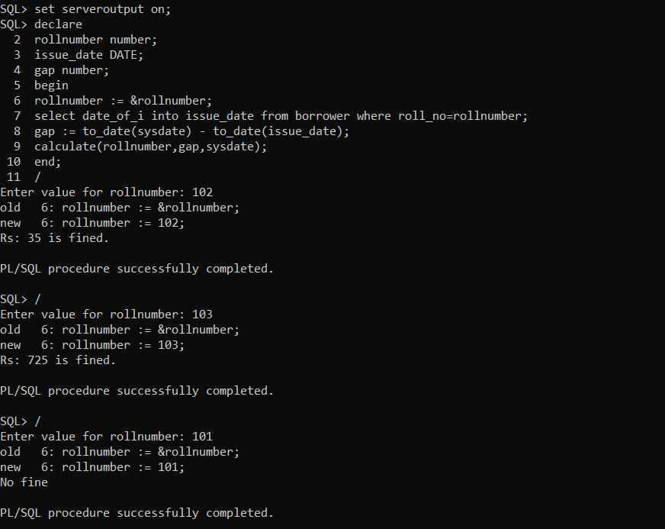

Contents of fine table:-

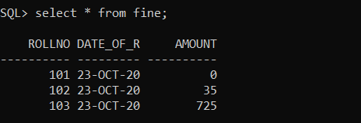

Contents of borrower table after return:-

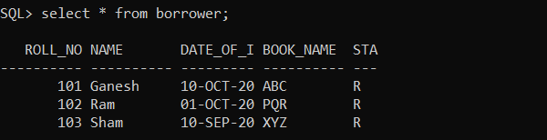

**2. Write a stored function in PL/SQL for given requirement and use the same in PL/SQL block.**

Account no. and branch name will be accepted from user. The same will be searched in table acct_details. If status of account is active then display appropriate message and also store the account details in active_acc_details table, otherwise display message on screen “account is inactive”.

**Solution:-**

Contents of acct_details table:-

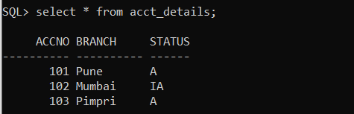

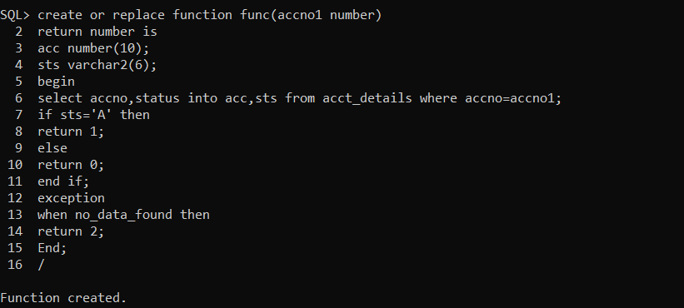

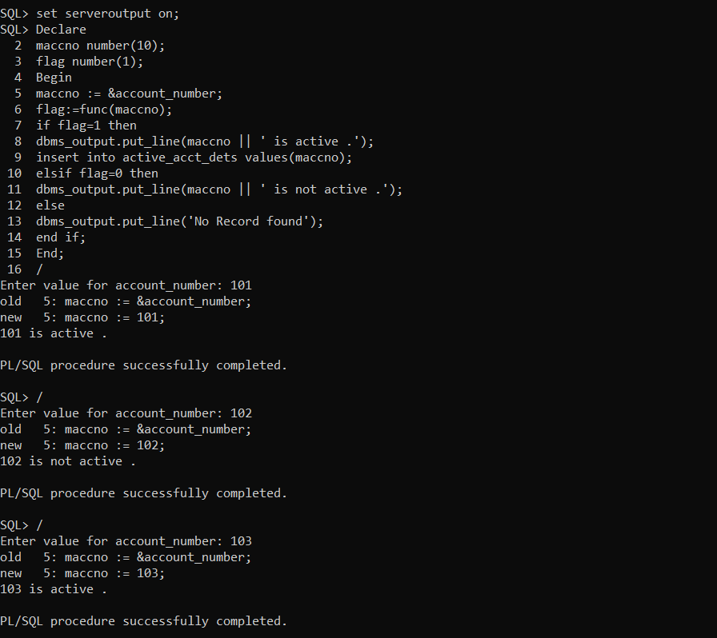

Contents of active_acct_dets table:-

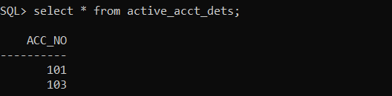

**3. Write a Stored Procedure namely proc_Grade for the categorization of student.**

If marksscored by students in examination is <=1500 and marks>=990 then student will be placed in distinction category if marks scored are between 989 and900 category is first class, if marks 899 and 825 category is Higher Second Class

Write a PL/SQL block for using procedure created with above requirement.

Stud_Marks(name, total_marks)

Result(Roll,Name, Class)

**Solution :-**

Contents of Stud_marks table:-

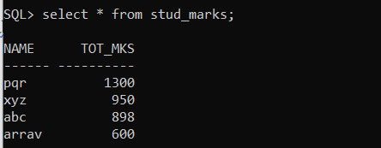

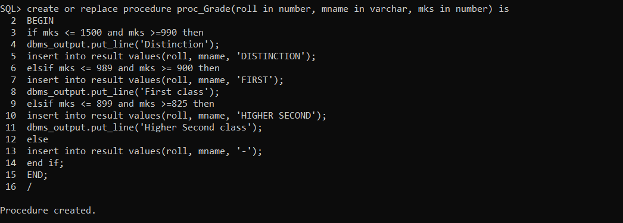

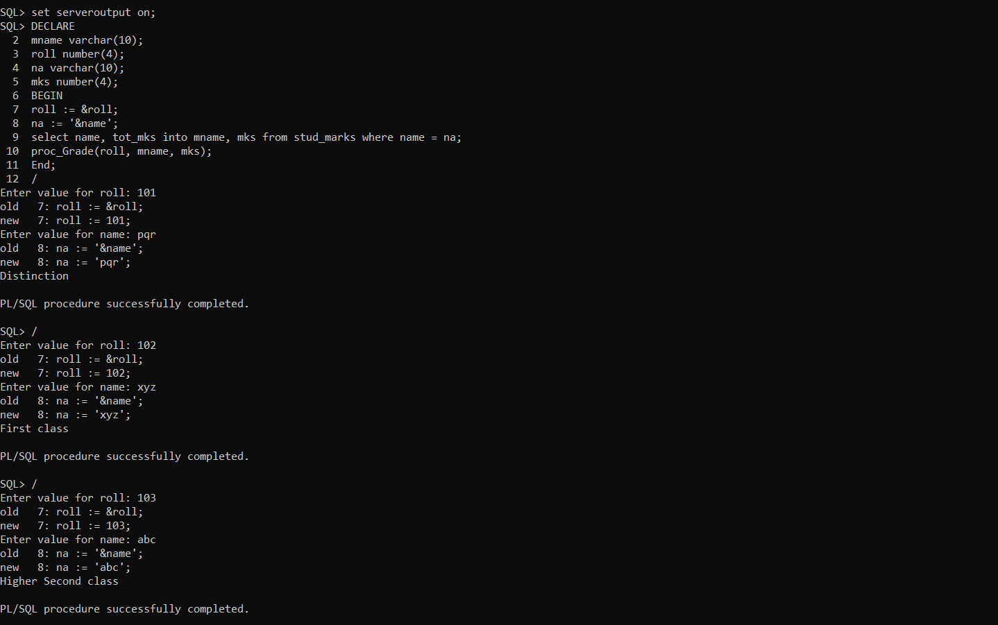

Contents of result table:-

