**Name :- Yash Nandkumar Morankar**

**Roll number :- TECOB220**

Assignment 6 (Cursor)

**1.** The bank manager has decided to activate all those accounts which were previously marked as inactive for performing no transaction in last 365 days. Write a PL/SQ block (using implicit cursor) to update the status of account, display an approximate message based on the no. of rows affected by the update.

**(Use of %FOUND, %NOTFOUND, %ROWCOUNT)**

**Soln:-**

Contents of account (acct) table:-

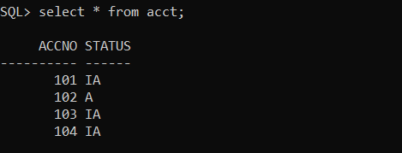

Implicit cursor execution:-

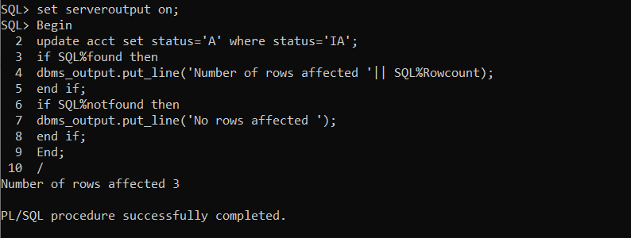

After Execution acct table contents:-

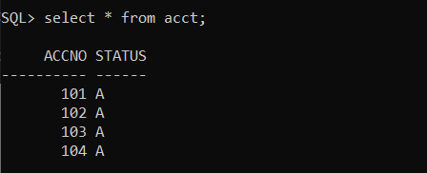

**2.** Organization has decided to increase the salary of employees by 10% of existing salary, who are having salary less than average salary of organization, Whenever such salary updates takes place, a record for the same is maintained in the increment_salary table.

**EMP (E_no , Salary)**

**increment_salary(E_no , Salary)**

**Soln :-**

Contents of EMP table:-

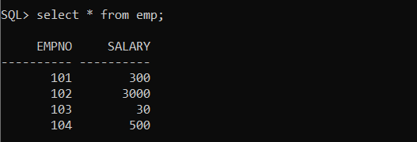

Contents of increment_salary table:-

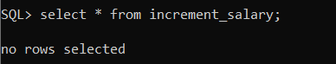

Query Statement Execution:-

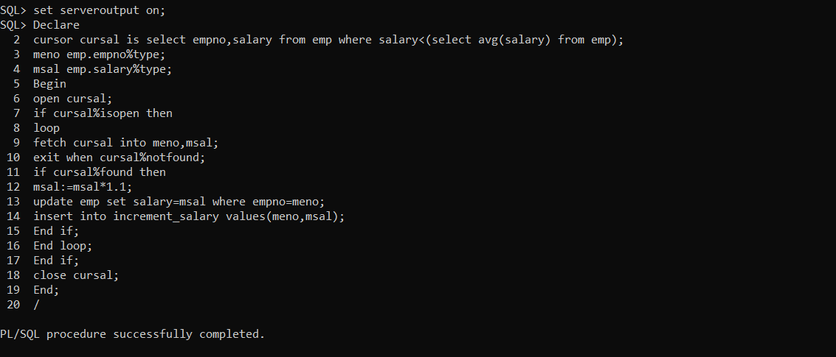

Contents of EMP table:-

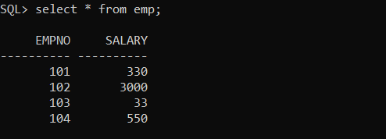

Contents of increment_salary table:-

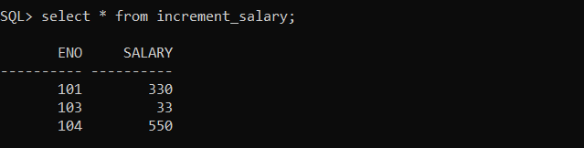

**3. Write PL/SQL block using explicit cursor for following requirements:**

College has decided to mark all those students detained (D) who are having attendance less than 75%.

Whenever such update takes place, a record for the same is maintained in the D_Stud table.

create table stud21(roll number(4), att number(4), status varchar(1));

create table d_stud(roll number(4), att number(4));

**Soln:-**

Contents of stud21 table :-

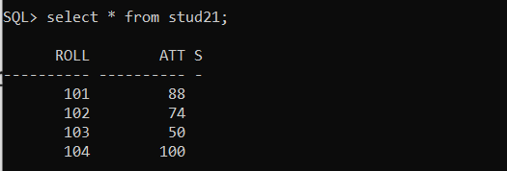

Contents of d_stud table :-

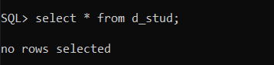

Query Statement and Execution :-

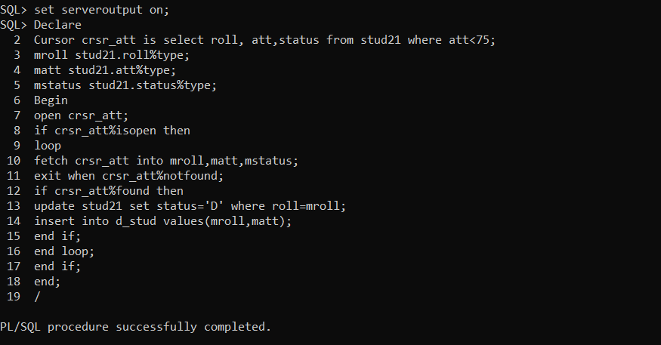

Contents of stud21 table :-

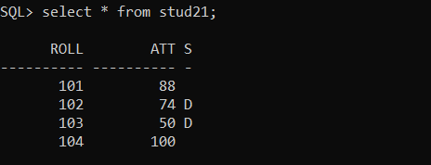

Contents of d_stud table :-

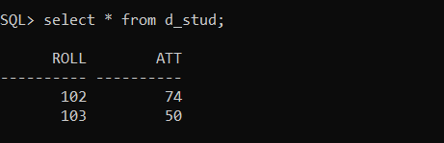

**4.** **Write a PL/SQL block of code using parameterized Cursor,** that will merge the data available in the newly created table N_RollCall with the data available in the table O_RollCall. If the data in the first table already exist in the second table then that data should be skipped.

Create table new_class(roll number(10), name varchar(10));

Create table old_class(roll number(10), name varchar(10));

**Soln:-**

Contents of old_class table:-

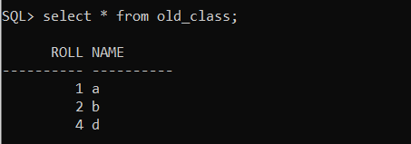

Contents of new_class table:-

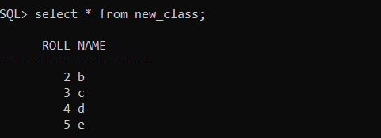

Query Statement and Execution :-

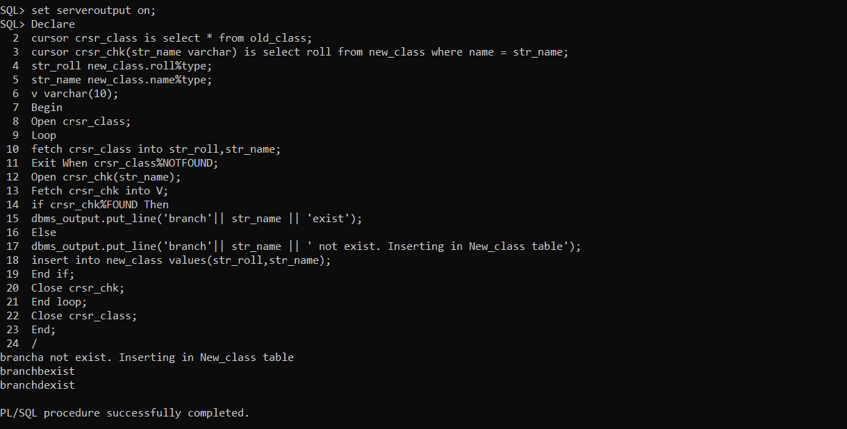

Contents of old_class table:-

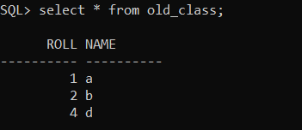

Contents of new_class table:-

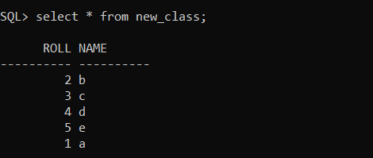

**5.** **Write the PL/SQL block for following requirements using parameterized Cursor**:

Consider table EMP(e_no, d_no, Salary), department wise average salary should be inserted into new table dept_salary(d_no, Avg_salary)

**Soln:-**

Contents of EMP table:-

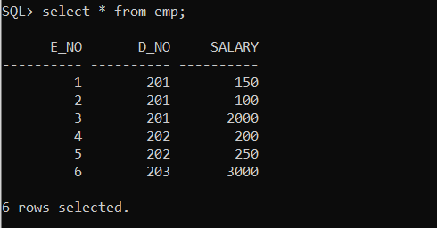

Contents of dept_salary table:-

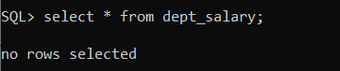

Query Statements and Execution:-

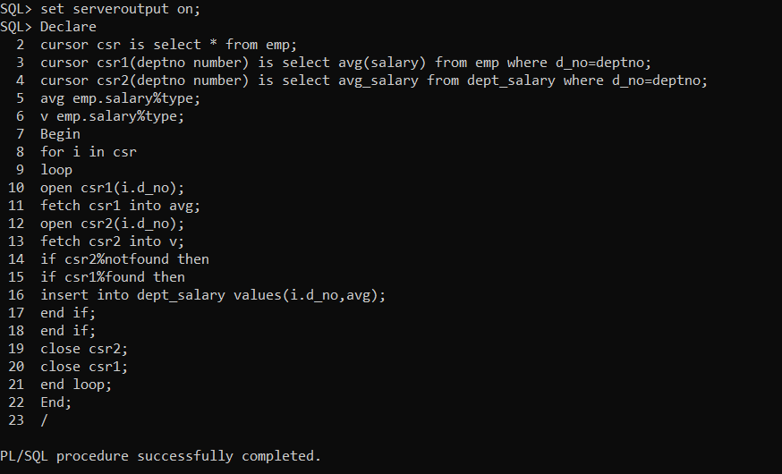

Contents of EMP table:-



Contents of dept_salary:-

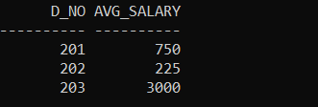

**6.** **Write PL/SQL block using explicit cursor: Cursor FOR Loop for following requirements**:

College has decided to mark all those students detained (D) who are having attendance less than 75%. Whenever such update takes place, a record for the same is maintained in the D_Stud table.

create table stud21(roll number(4), att number(4), status varchar(1));

create table d_stud(roll number(4), att number(4));

**Soln :-**

Contents of stud21 table:-



Contents of d_stud table:-



Query Statements and Execution:-

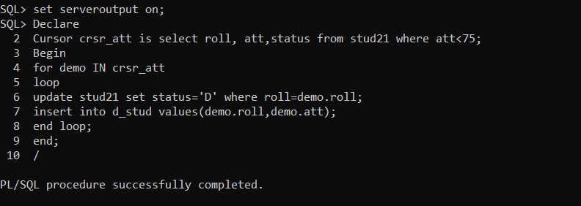

Contents of stud21 table:-



Contents of d_stud table:-

