**Project Report**

**Fitness Club**

**By**

**Yash Pawar – AF04964301**

# Index

|  |  |  |
| --- | --- | --- |
| **Sr.no** | **Topic** | **Page no** |
| 1 | Title of Project | 1 |
| 2 | Abstract | 3 |
| 3 | Acknowledgement | 4 |
| 4 | Introduction | 5 |
| 5 | System Analysis | 8 |
| 6 | System Design | 20 |
| 7 | Screenshots | 21 |
| 8 | Implementation | 21 |
| 9 | Testing | 24 |
| 10 | Results and Discussion | 27 |
| 11 | Conclusion and Future Scope | 29 |
| 12 | Bibliography and References | 31 |

# Abstract

The Fitness Club Website project is designed to provide users with an intuitive and engaging platform to explore gym services, fitness programs, and membership options. The website serves as a central hub for gymgoers to access class schedules, and explore various workout plans tailored to different fitness levels and goals. It offers detailed information on available facilities, personal training sessions, group classes, and gym events.

Additionally, the website includes features like progress tracking, workout tips, nutrition guidance. With a userfriendly design and mobile responsiveness, the Gym Website aims to improve accessibility, helping users stay informed, motivated, and committed to their fitness journey.

# Acknowledgement

My project has consumed a huge amount of work, research, and dedication. But this project would not have been possible without the support of many individuals. It becomes essential to appreciate and show my gratitude to all of them who gave their mere and sincere contribution to completing my project.

It gives me happiness and dignity to present my project on the topic “**Fitness Club”** Through this acknowledgment, I can appreciate all those who had shown me the right path to pack and deliver this project with their wonderful full ideas and great experience of knowledge.

I am very much grateful to my project guide “**Rajshri Madam**” for giving appropriate guidance, inspiration, motivation, and constructive suggestions that helped me a lot in the full-fledged preparation of the

project.

## 1. Introduction

In such a fast-paced world, one needs to be fit to maintain their standard of overall well-being. However,

most people cannot come up with effective workout plans for themselves because they are not able to specialize according to their objectives, fitness level, and preferences. Thus, the proposed Fitness Club aims to bridge this challenge by offering an easy-to-use platform that generates personalized workout plans based on individual input.

This system will analyse user data, such as fitness goals (weight loss, muscle gain, endurance

improvement), available equipment, and time constraints, to produce customized workout routines. By leveraging algorithms and a comprehensive database of exercises, the users would be given a balanced workout that varied and was both fun and effective.

This is a fitness scheme with the goal of empowering people to take control of their health and wellness. The Fitness Club website, with its capabilities for personalization and adaptability, encourages you to develop an environmentally friendly, long-term exercise habit.

### 1. Background of the Study

To provide users with tailored workout plans that take into account their unique fitness levels, goals, preferences, and available resources. This personalized approach increases the likelihood of adherence and success.

The Fitness Club is inspired by the challenges individuals face in finding personalized fitness solutions tailored to their unique goals and levels. Observing the limitations of traditional workout methods highlighted the need for a more adaptable approach.

Committed to user privacy and data security, implementing stringent measures to protect user information.

The mission of the Fitness Club is to empower individuals to take charge of their fitness journeys through personalized, accessible, and engaging workout solutions

The workout plan generator system differentiation refers to the modification of workouts in relation to several individual user factors that include their target fitness level, level, preferences, and what is available, such as the equipment.

### 2. Object of the project

To design a system that allows individuals to prepare well-targeted workout routines with goals related to

their personal fitness conditions or the amount of time available, this system aimed to provide that. This way, the system would offer customized workout routines for users to improve their fitness levels, lose weight, build muscles, or achieve any other particular goal. It is intended to eliminate the wide use of fitness courses and exercise experts, thereby increasing accessibility to guidance for fitness as customized to the user's purposes.

### 3. Scope of the project

The Fitness Club Website aims to provide users with an interactive online platform to explore, learn, and follow various workout routines through detailed exercise information and integrated YouTube videos. The project focuses on helping users maintain a healthy lifestyle by offering easy access to categorized fitness exercises that can be performed at home or in the gym.

Key Areas Covered

1. Workout Information:  
   The website provides detailed descriptions, visuals, and targeted muscle group information for each exercise.
2. YouTube Video Integration:  
   Each exercise can include embedded YouTube workout videos to help users understand the correct posture and form.
3. Search and Filter Options:  
   Users can search for exercises by name or filter them by category (e.g., Back, Cardio, Chest, Abs, etc.).
4. User-Friendly Interface:  
   The interface is designed to be responsive and easy to navigate, ensuring accessibility across devices (desktop, tablet, and mobile).
5. Motivation and Guidance:  
   By combining text descriptions and instructional videos, the platform motivates users to stay fit and exercise regularly.

**4. Features of Fitness Club**

The **Fitness Club Website** is designed to help users explore different types of workouts with clear instructions, visuals, and video demonstrations. Below are the main features included in the project:

**1. User-Friendly Interface**

* Simple and attractive design that provides easy navigation.
* Responsive layout that adapts to all screen sizes (desktop, tablet, and mobile)

**2. Search Functionality**

* Users can search for exercises by name or keyword.
* Quick and accurate search results help users find the workout they need easily.

**3. Exercise Categories**

* Exercises are categorized (e.g., **All**, **Back**, **Cardio**, **Chest**, **Abs**, **Legs**).
* Users can filter exercises by body part or workout type.
* Helps users focus on specific fitness goals.

**4. Detailed Exercise Information**

* Each exercise includes:
  + Exercise name
  + Image/illustration showing targeted muscles
  + Description and benefits
  + Primary and secondary muscle groups involved
* Helps users understand the correct technique and purpose of each workout.

**5. YouTube Video Integration**

* Embedded **YouTube videos** provide step-by-step visual demonstrations.
* Users can follow along and perform exercises correctly.
* Increases engagement and learning through real-time examples.

## 2. System Analysis

System analysis is a crucial phase of software development where the existing system (if any) and user requirements are studied to design a new and improved solution.  
For this project, **Fitness Club Website**, the system analysis helps identify the **functional requirements**, **system objectives**, **user needs**, and **feasibility** of implementing the website.

The goal of this phase is to clearly understand what the system should achieve — providing **workout plans** and **fitness videos** through a user-friendly web interface.

### 1. Hardware Requirements

The **Fitness Club Website** requires only basic hardware resources, making it easily accessible on most modern computers.  
The minimum requirement is a system equipped with an **Intel Core i3 or AMD Ryzen 3 processor**, **4 GB of RAM**, and at least **500 MB of free disk space**. This configuration is sufficient for development and testing purposes.  
However, for smoother performance, especially during multitasking or running multiple development tools, it is recommended to use an **Intel Core i5 processor or higher**, with **8 GB or more RAM**, and **2 GB of available disk space**.  
A **display resolution of 1024 × 768** is required, though a **Full HD display (1920 × 1080)** provides a better viewing experience.  
Since the website integrates **YouTube videos**, a **basic broadband connection** is necessary, while a **stable high-speed Wi-Fi connection** is recommended for uninterrupted streaming.  
Standard **keyboard and mouse** peripherals are sufficient for user input and navigation.

#### 2. Software Requirements

The **Fitness Club Website** can be developed and executed on major operating systems such as **Windows 10/11**, **macOS**, or **Linux**. The frontend of the project is built using **React.js**, which leverages **HTML5**, **CSS3**, and **JavaScript** for creating an interactive and responsive user interface.  
Optionally, the backend can be implemented using **Node.js** with the **Express framework** to handle server-side operations and API communication. For data management, the system can use either **Firebase** for cloud-based storage or **MySQL** for relational data storage.  
The preferred code editor for development is **Visual Studio Code (VS Code)**, which provides rich features such as syntax highlighting, extensions, and integrated Git support.  
The website is designed to run efficiently on modern web browsers like **Google Chrome** or **Microsoft Edge**.  
For version management and team collaboration, **Git** and **GitHub** are used to maintain source code, track changes, and manage project versions effectively.

**3. System Design**

**a) Architecture**

The website follows a client-side architecture using React.js.  
Each webpage (Home, Workouts, Videos, About) is created as a separate React component.  
Navigation between pages is handled using React Router.

**b) Major Modules**

1. Home Page — Introduction and motivational content.
2. Workout Plans Page — Lists exercises categorized by levels (Beginner, Intermediate, Advanced).
3. Videos Page — Displays embedded YouTube workout tutorials.
4. About Page — Describes the project and its purpose.
5. Navbar and Footer — Provide easy navigation and links.

##### 4. Feasibility Study

A feasibility study ensures that the project is practical, achievable, and beneficial.

**1. Technical Feasibility**

* The system is developed using **React.js**, a popular frontend framework that is efficient and easy to deploy.
* It runs on standard web browsers with no special hardware requirements.
* Tools like **VS Code** and **Node.js** make development simple.  
   **Technically feasible**

**2. Operational Feasibility**

* The website is easy to use and navigate.
* No prior technical knowledge is required from users.
* It can be maintained and updated easily by developers.  
  **Operationally feasible**

**3. Economic Feasibility**

* Development cost is minimal (open-source tools used).
* Hosting can be done freely using **Netlify** or **Vercel**.
* Maintenance cost is low.  
  **Economically feasible**

**4. Schedule Feasibility**

* The project can be developed within a short time frame (2–3 weeks).
* Divided into phases: planning, design, implementation, and testing.  
   **Schedule feasible**

##### 5. Proposed System

The **Proposed System** — *Fitness Club Website* — is designed to overcome the limitations of the existing system by providing a **centralized online fitness platform** where users can access **structured workout plans**, **exercise tutorials**, and **YouTube videos** all in one place.  
The main purpose of the system is to help individuals maintain a healthy lifestyle by offering proper guidance and easy access to workout resources without the need for physical trainers or gym visits.

This system aims to make fitness simple, interactive, and accessible. The website categorizes workout plans according to **user levels** such as *Beginner, Intermediate,* and *Advanced*, making it suitable for all users. Each exercise can be accompanied by a **YouTube video**, enabling users to follow step-by-step demonstrations and avoid incorrect workout postures.

The **Fitness Club Website** is built using **React.js**, which ensures a fast, responsive, and smooth user experience. The interface is designed to be **user-friendly**, allowing even non-technical users to navigate easily between different pages like *Home*, *Workouts*, *Videos*, and *About*.  
The system can also be extended in the future to include features like **user authentication**, **diet plans**, **progress tracking**, and **AI-based recommendations**.

Unlike traditional methods, this system provides automation, accuracy, visualization, and accessibility, making financial management easier and more effectively.

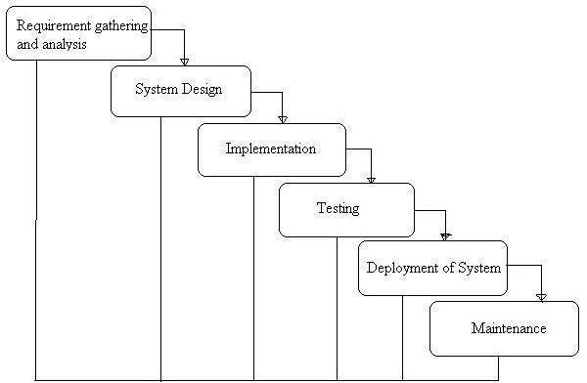

### Phases of Development

The development of the **Fitness Club Website** was carried out systematically through several distinct phases of the **Software Development Life Cycle (SDLC)**.  
Each phase plays a crucial role in ensuring that the final product is well-planned, reliable, and user-friendly.  
The major phases followed in the development of this system are explained below.

**1. System Planning**

The first phase involves identifying the problem and understanding the need for a new system.  
In this stage, the lack of a centralized and structured platform for workout routines and fitness videos was recognized.  
The goal was to create an interactive and accessible web-based fitness platform that provides **workout plans**, **video tutorials**, and **fitness information** to users.

**2. System Analysis**

In this phase, a detailed study of the system requirements was carried out.  
The existing fitness resources and their limitations were analyzed. User requirements were gathered to determine what functionalities the new system should provide — such as displaying categorized workout plans, embedding YouTube videos, and ensuring an easy-to-navigate user interface.  
The feasibility of the project (technical, operational, and economic) was also evaluated.

**3. System Design**

The system design phase translates the gathered requirements into a **blueprint of the actual system**.  
It includes the design of the website structure, layout, navigation, and data flow.  
Various components such as **Home Page**, **Workout Plans Page**, **Videos Page**, and **About Page** were designed using React.js components.  
User interface design focused on **simplicity, responsiveness, and aesthetic appeal**.

**4. System Development / Coding**

During this phase, the actual coding of the website was carried out.  
The frontend was developed using **React.js**, HTML5, CSS3, and JavaScript.  
React components were used to make the application modular and maintainable.  
Optional backend development was done using **Node.js and Express**, while **Firebase or MySQL** could be used for data storage.  
All modules were coded, tested individually, and then integrated.

**5. System Testing**

Once development was complete, the system underwent rigorous testing to ensure that all modules function correctly.  
Testing included:

* **Unit Testing** (for each React component)
* **Integration Testing** (checking navigation and video embedding)
* **User Interface Testing** (ensuring responsiveness and usability)
* **Performance Testing** (checking page load and video playback)  
  Any errors or bugs found during this phase were corrected.

**6. System Implementation**

In this phase, the completed project was deployed locally and then hosted online using platforms like **Netlify** or **Vercel**.  
The system was tested on various devices and browsers to ensure full compatibility.  
This phase also included preparing documentation and user guidance for smooth operation.

**7. System Maintenance**

After deployment, periodic updates and improvements are made to ensure that the system remains functional and secure.  
Maintenance includes fixing bugs, updating video links, improving UI components, and adding new features like **user authentication**, **diet plans**, or **AI-based suggestions**.

**Data Flow Diagram:**

A **Data Flow Diagram (DFD)** is a graphical representation that shows how data moves through a system — how inputs are transformed into outputs through processes.  
In the **Fitness Club Website**, the DFD illustrates how the user interacts with the system, how workout data and videos are accessed, and how the system responds to user requests.

The DFD helps in understanding the **flow of information**, **data storage**, and **functional structure** of the system.

**3.2 DFD Level 0 (Context Diagram)**

This is the **top-level diagram** that provides an overview of the entire system as a single process.  
It shows the system’s interaction with external entities such as the user and external services (like YouTube).

**Description:**

* The **User** is the main external entity who interacts with the website.
* The **Fitness Club System** processes the user’s requests and provides workout plans or embedded YouTube videos.
* The system may also fetch video data from **YouTube** or retrieve exercise data from a **Workout Database**

Standard symbols for DFDs are derived from the electric circuit diagram analysis and are shown in fig:

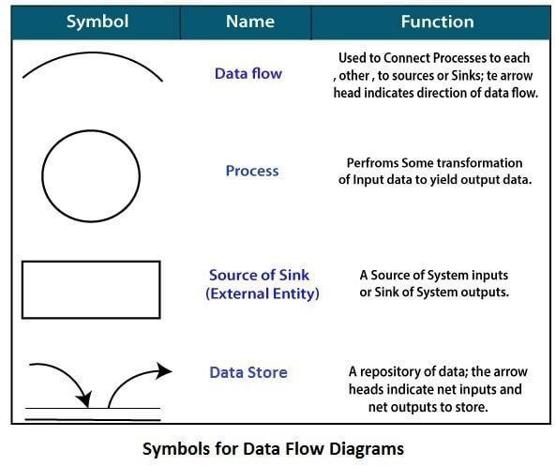

**Circle:** A circle (bubble) shows a process that transforms data inputs into data outputs.

**Data Flow:** A curved line shows the flow of data into or out of a process or data store.

**Data Store:** A set of parallel lines shows a place for the collection of data items. A data store indicates that the data is stored which can be used at a later stage or by the other processes in a different order. The data store can have an element or group of elements.

**Source or Sink**: Source or Sink is an external entity and acts as a source of system inputs or sink of system outputs.

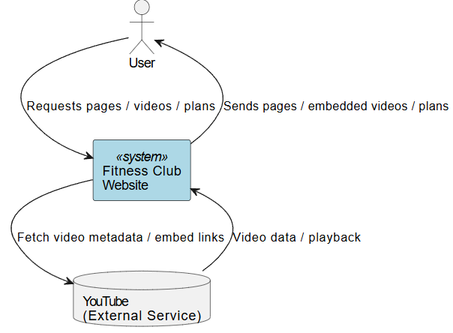

**3.3 DFD Level 1 (Context Diagram)**

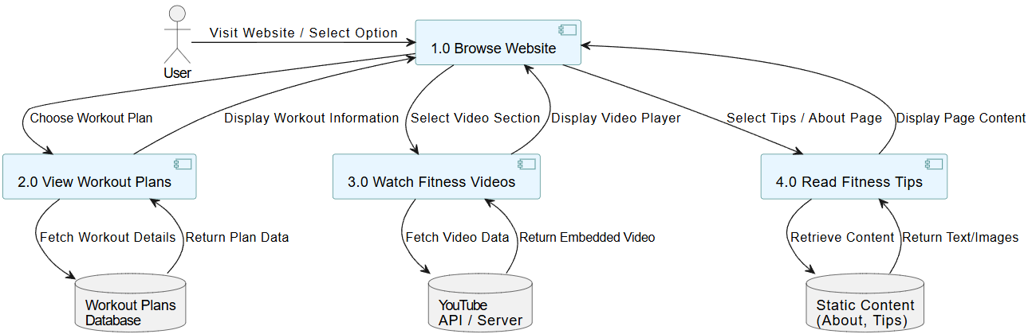

The Level 1 Data Flow Diagram (DFD) provides a detailed view of how data moves inside the Fitness Club Website.  
It breaks the system into smaller processes and shows how the User, Databases, and External Services (YouTube API) interact with each other.

Since the project does not include a user login system, the diagram focuses only on browsing, viewing workout plans, watching fitness videos, and reading fitness tips.

Main Components of the DFD:

1. External Entity:

* User:  
  The person visiting the website.  
  The user can browse workout plans, watch fitness videos, or read fitness tips without any login or registration

2. Processes:

1. Process 1.0 – Browse Website:
   * This process handles all basic navigation.
   * When the user opens the website, they can choose from different options like viewing workout plans, videos, or fitness tips.
2. Process 2.0 – View Workout Plans:
   * When the user selects a workout category (e.g., Beginner, Intermediate, Advanced), this process retrieves the relevant plan details (like exercise name, sets, reps, and duration) from the Workout Database.
   * The system then displays this information on the webpage.
3. Process 3.0 – Watch Fitness Videos:
   * This process connects with the YouTube API to fetch and display embedded workout videos.
   * The user can directly watch these videos on the website.
4. Process 4.0 – Read Fitness Tips:
   * This process retrieves fitness-related articles, diet tips, and motivational content from the Static Content section of the website and displays it to the user.

3. Data Stores:

1. Workout Database:
   * Stores different workout plans, including exercise names, categories, and instructions.
2. YouTube API / Server:
   * Acts as an external data source that provides video content through embedded links or API calls.
3. Static Content (About, Tips):
   * Contains text-based and image-based fitness articles, tips, and information about the fitness club.

Data Flow Description:

1. The User visits the website and interacts with the Browse Website process.
2. If the user selects a Workout Plan, the system fetches data from the Workout Database and displays it.
3. If the user chooses to watch a Fitness Video, the website requests data from the YouTube API, retrieves the video embed, and displays it.
4. If the user clicks on Fitness Tips or About, the website retrieves text or image data from Static Content and shows it on the page

#### 3.4 ER Diagram Summary

**Entities and Attributes**

**User (Viewer)**

*(Even though there’s no login, this entity represents general visitors accessing data.)*

* User_ID *(optional / system-generated for analytics)*
* User_Name *(optional)*
* Activity *(what section user browses — Plans, Videos, Tips)*

**WorkoutPlan**

* Plan_ID *(Primary Key)*
* Plan_Name
* Category *(Beginner / Intermediate / Advanced)*
* Description
* Duration
* Exercises *(List of related exercises)*

**Exercise**

* Exercise_ID *(Primary Key)*
* Exercise_Name
* Sets
* Repetitions
* Equipment
* Plan_ID *(Foreign Key referencing WorkoutPlan)*

**Video**

* Video_ID *(Primary Key)*
* Title
* URL *(YouTube embed link)*
* Category *(Yoga / Strength / Cardio / etc.)*
* Description

**FitnessTip**

* Tip_ID *(Primary Key)*
* Title
* Content
* Category *(Diet / Motivation / Workout Advice)*

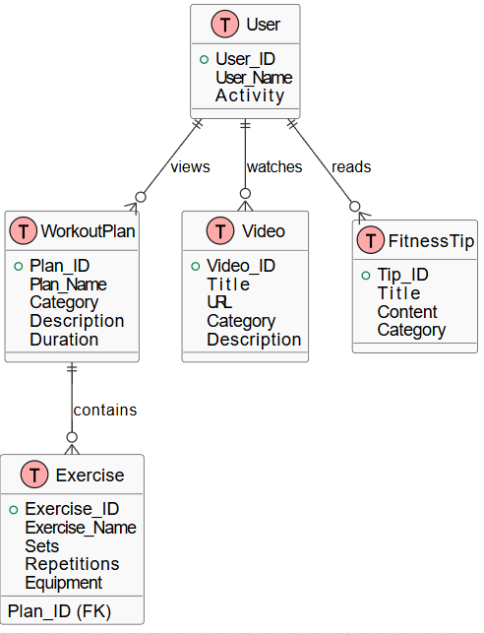

**3.5 Use Case Diagram for Fitness Club Website**

**1. Actors:**

* **User(Visitor):**  
  A general visitor who browses the fitness club website to view workout plans, videos, and tips.

**2. Use Cases:**

1. **Browse Website** – The user opens the website and explores available sections.
2. **View Workout Plans** – The user selects a category (e.g., Beginner, Advanced) and views detailed workout plans.
3. **View Fitness Videos** – The user watches embedded workout or yoga videos (YouTube integration).
4. **Read Fitness Tips** – The user reads articles or blogs about fitness, diet, and motivation.
5. **Search Content (Optional)** – The user searches for specific exercises or topics on the site.

**3. Relationships:**

* The **User** can perform all main actions (use cases).
* **Browse Website** is a general use case that includes other actions like viewing plans, videos, and tips.
* The **System** (Fitness Club Website) responds by displaying requested data or content.

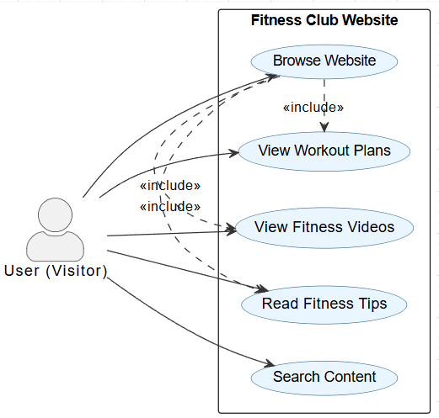

### 3. System design

System design is the process of defining the architecture, components, modules, interfaces, and data flow of a system to satisfy specific requirements.  
In this project, the **Fitness Club Website** is designed to provide users with access to **workout plans**, **fitness tips**, and **YouTube workout videos** through a responsive and user-friendly interface.

The purpose of system design is to transform the analyzed requirements into a well-structured solution that can be easily developed, tested, and maintained.

**3.2 Objectives of System Design**

* To create an interactive and responsive fitness website.
* To provide users with categorized workout plans.
* To embed and display fitness videos from YouTube.
* To allow users to read fitness tips and guides.
* To ensure easy navigation without requiring login or registration.

**a) Architecture**

The website follows a client-side architecture using React.js.  
Each webpage (Home, Workouts, Videos, About) is created as a separate React component.  
Navigation between pages is handled using React Router.

**b) Major Modules**

1. Home Page — Introduction and motivational content.
2. Workout Plans Page — Lists exercises categorized by levels (Beginner, Intermediate, Advanced).
3. Videos Page — Displays embedded YouTube workout tutorials.
4. About Page — Describes the project and its purpose.
5. Navbar and Footer — Provide easy navigation and links.

**4. Implementation**

**Screenshots**

**1 .Home Page**

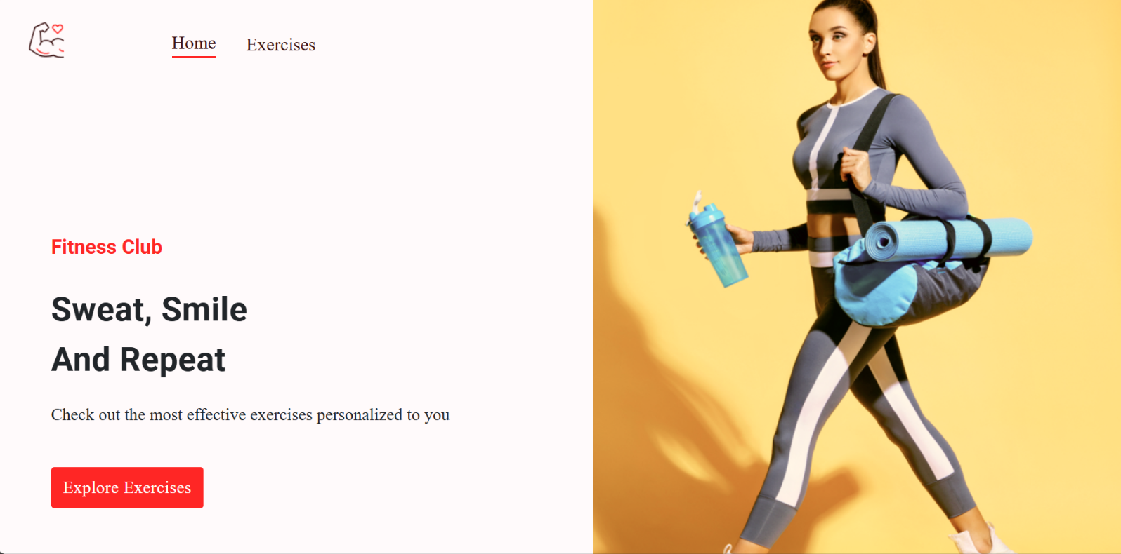

**2. search page**

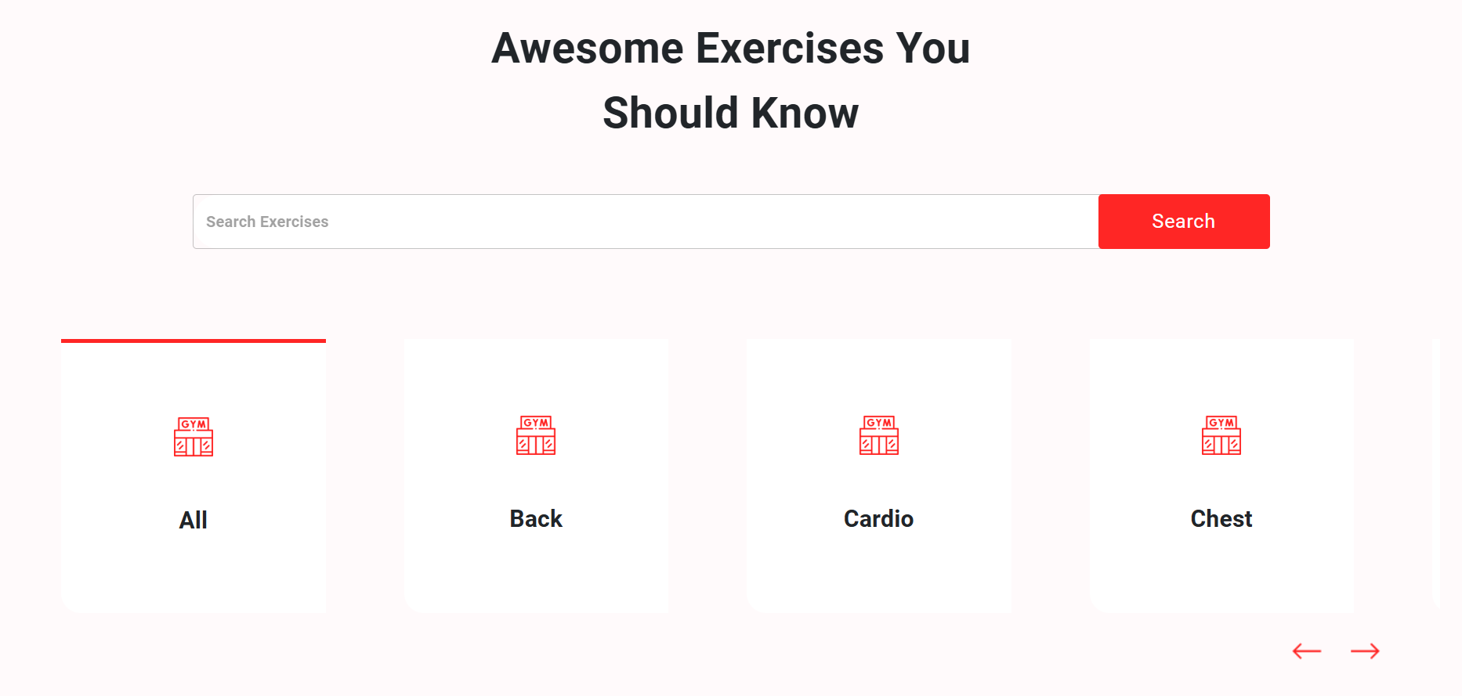

**3 .showing result**

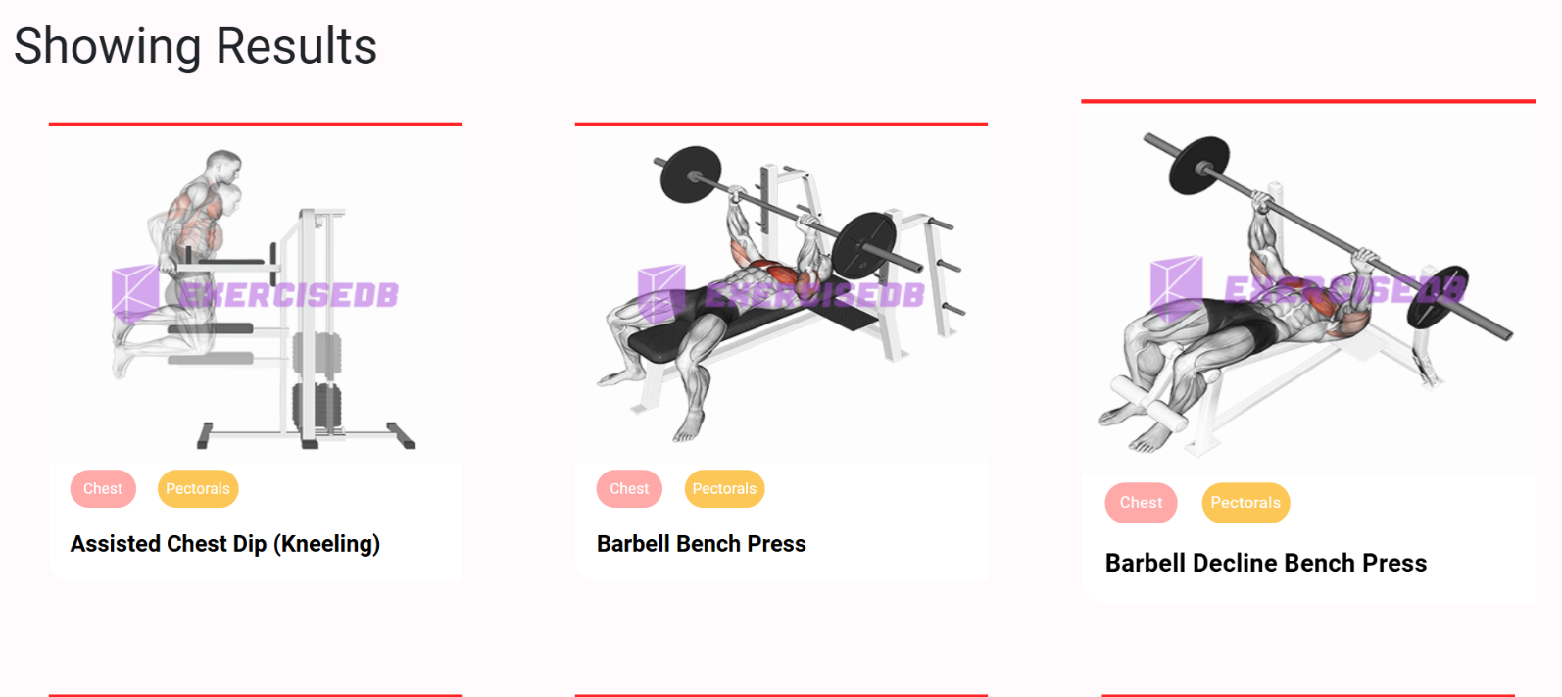

**4 . Detail Info**

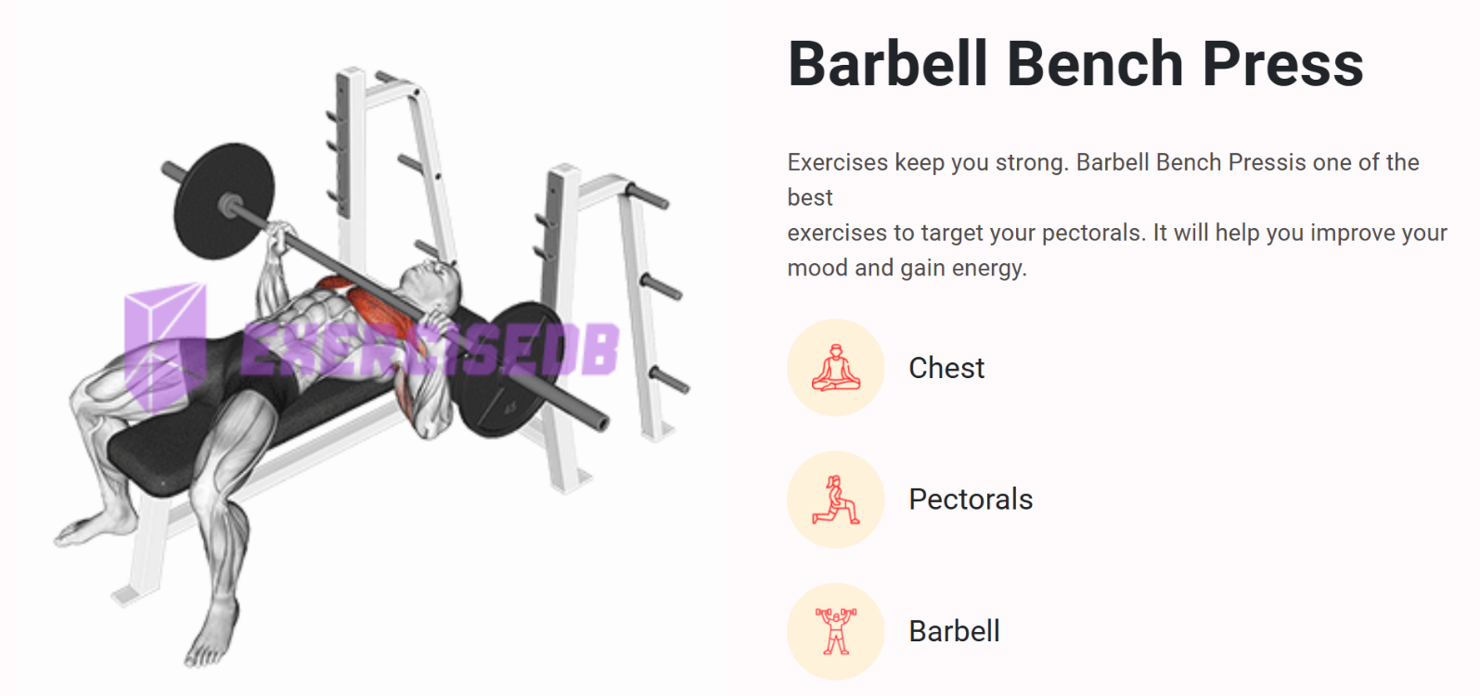

**5 .Youtube Video**

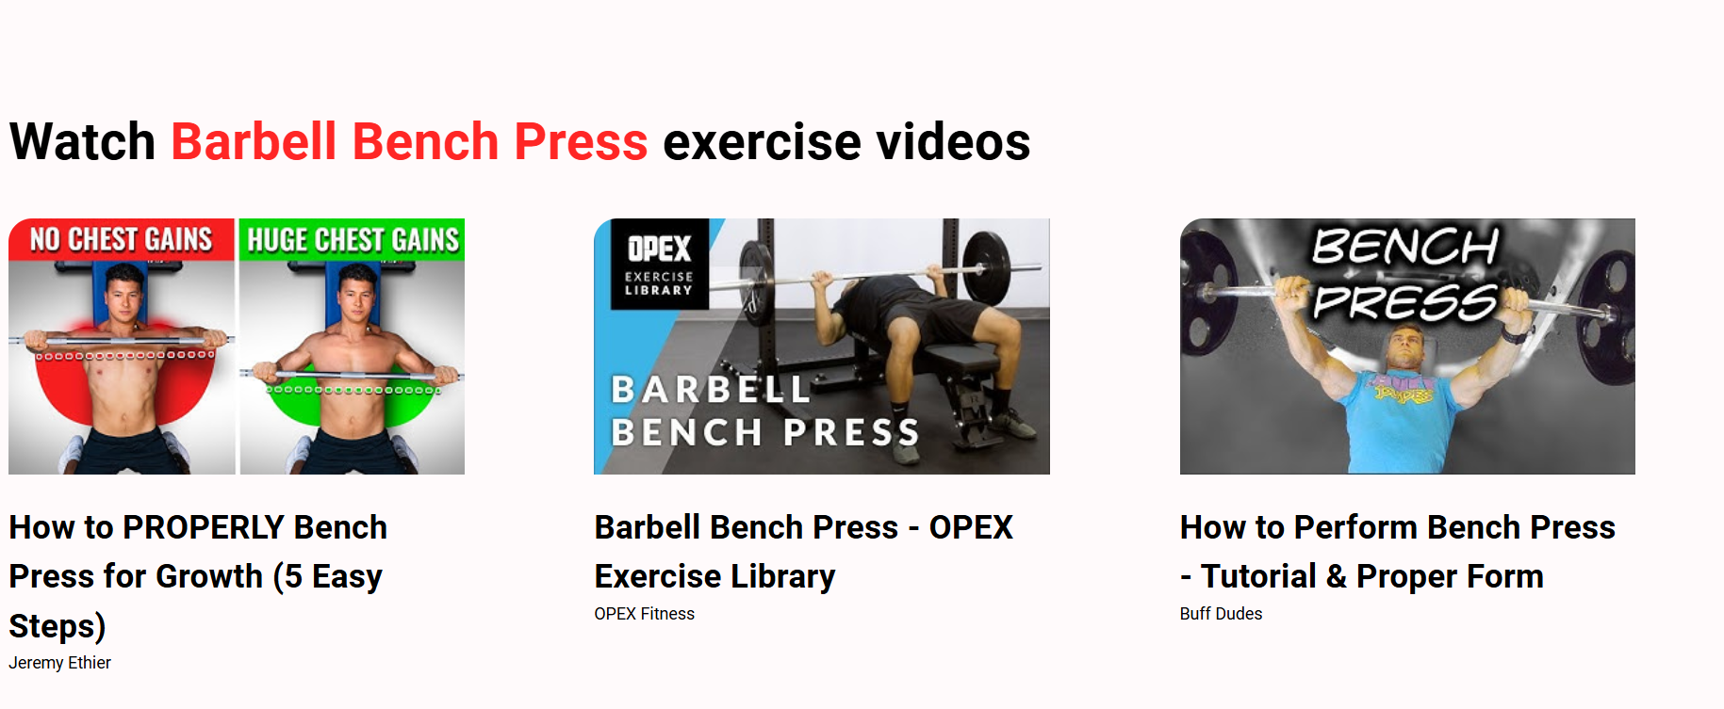

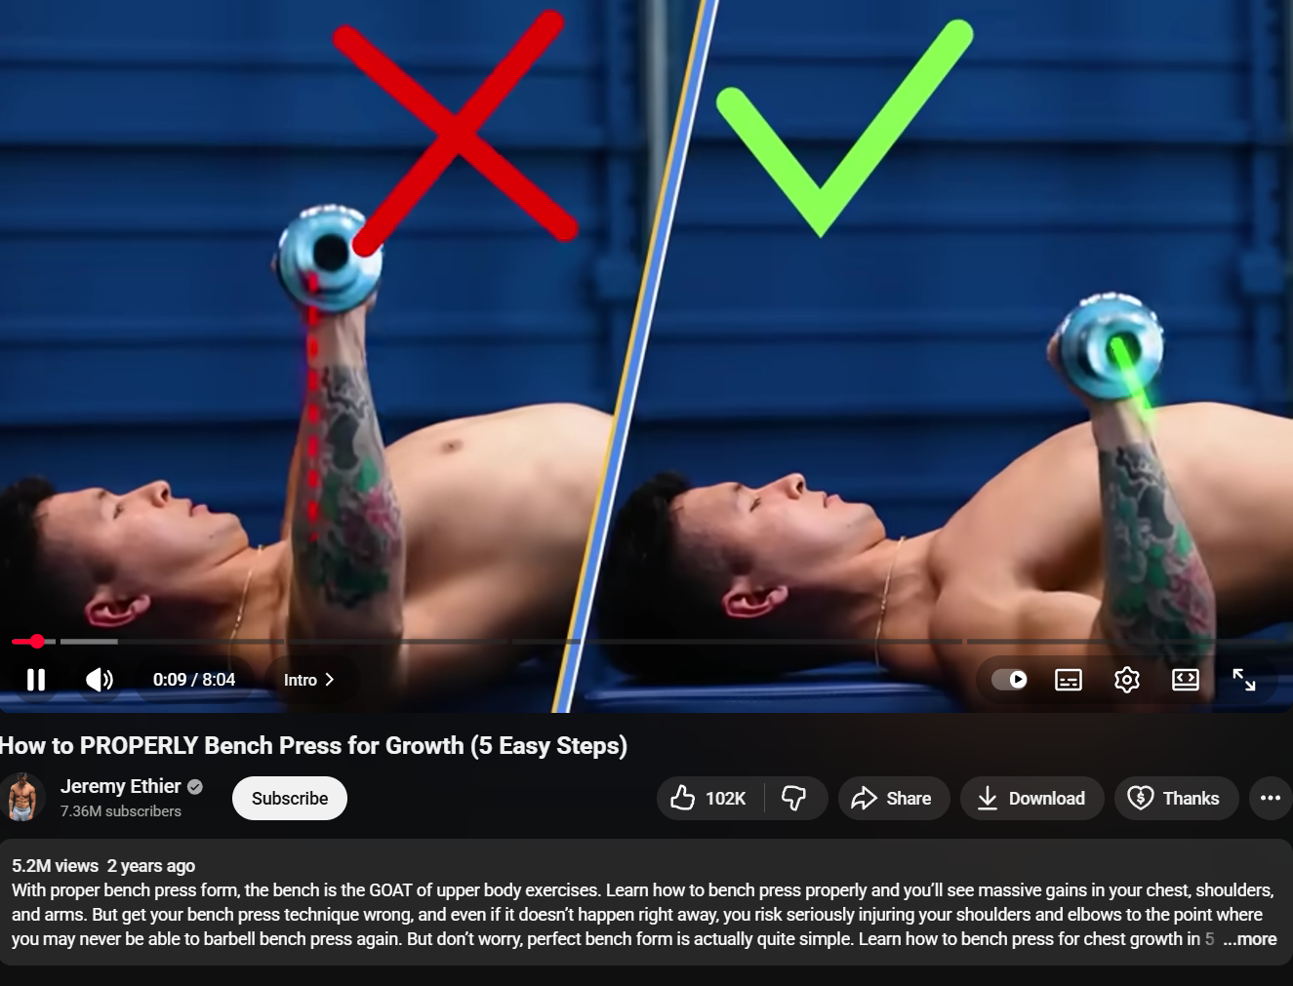

**5. Testing**

**System Testing** is the process of evaluating a system or its components to ensure that it meets the specified requirements and functions correctly.  
It verifies that all modules of the **Fitness Club Website** — including workout plan display, video integration, and fitness tips — work as intended without any errors.

The main goal of testing is to identify and fix bugs, verify system functionality, and ensure the overall reliability and performance of the website.

**5.2 Objectives of Testing**

* To ensure that all components of the website work correctly and efficiently.
* To verify that user interactions (like viewing workout plans and videos) produce the correct outputs.
* To detect and correct errors in both the frontend and backend.
* To confirm that the website meets user expectations and functional requirements.
* To validate the integration of external components (YouTube API, database).

**5.3 Types of Testing Used**

**1. Unit Testing**

* **Purpose:** To test individual components or modules of the system separately.
* **Example:**
  + Checking if the “Workout Plan” component properly displays data fetched from the database.
  + Verifying that the “Video Player” loads embedded YouTube videos correctly.

**2. Integration Testing**

* **Purpose:** To ensure that all modules and components work together properly.
* **Example:**
  + Testing if the “Workout Plan” section correctly links with the database.
  + Checking that the YouTube API integration works smoothly with the frontend.

**3. System Testing**

* **Purpose:** To test the complete website as a single system.
* **Example:**
  + Verifying that users can navigate through all pages (Home, Workout Plans, Videos, Tips) without errors.
  + Ensuring that the overall performance and interface remain consistent.

**4. Functional Testing**

* **Purpose:** To confirm that all system functions meet the defined requirements.
* **Example:**
  + Checking whether clicking “View Plan” displays the correct workout information.
  + Ensuring that the “Play Video” button correctly embeds the YouTube video.

**5. Usability Testing**

* **Purpose:** To check the user interface for ease of navigation, layout clarity, and accessibility.
* **Example:**
  + Evaluating the design responsiveness on desktop and mobile devices.
  + Ensuring buttons, menus, and text are clearly visible and functional.

**6. Performance Testing**

* **Purpose:** To ensure the website performs well under different conditions.
* **Example:**
  + Checking page load times for workout plans and videos.
  + Measuring performance when multiple users access the website simultaneously.

**7. Compatibility Testing**

* **Purpose:** To verify that the website runs correctly on different browsers and devices.
* **Example:**
  + Testing on **Google Chrome**, **Microsoft Edge**, and **Mozilla Firefox**.
  + Checking responsiveness on **laptops**, **tablets**, and **mobile devices**.

**5.4 Test Cases**

| **Test Case ID** | **Description** | **Input** | **Expected Output** | **Actual Result** | **Status** |
| --- | --- | --- | --- | --- | --- |
| TC01 | Open Home Page | Click Website URL | Home Page should load successfully | Loaded successfully | Pass |
| TC02 | View Workout Plans | Click “Workout Plans” | Display list of workout categories | Displayed correctly | Pass |
| TC03 | View Exercise Details | Select a plan | Show exercises with sets/reps | Shown correctly | Pass |
| TC04 | Watch Fitness Video | Click “Play Video” | Embedded YouTube video should play | Works properly | Pass |
| TC05 | View Fitness Tips | Click “Fitness Tips” | Display tips/articles | Displayed properly | Pass |
| TC06 | Check Responsiveness | Resize window | Layout adjusts correctly | Responsive | Pass |
| TC07 | Check Broken Links | Click all menu items | All links should work | All working | Pass |

##### 4. Testing Tools

* **Postman** – API endpoint testing.
* **MySQL Workbench** – Database validation.
* **Jest / Manual Testing** – Unit & functional testing.
* **Browser Developer Tools** – UI responsiveness testing.

##### 5. Test Results

* All core functionalities passed successfully.
* System is stable, secure, and ready for deployment.
* Minor UI adjustments were made to improve chart labels and modal usability.

### 6. Results and Discussion

This chapter presents the **results obtained after the successful development and execution** of the *Fitness Club Website*.  
It also provides a discussion on the performance, usability, and effectiveness of the proposed system compared to existing solutions.  
The main goal of this project — to help users access **workout plans, fitness videos, and health tips** easily through a single platform — has been achieved successfully.

**6.2 Implementation Results**

After completing all phases of development — design, coding, integration, and testing — the system was deployed locally and evaluated for performance and usability.

The following **results** were obtained:

1. **Website Accessibility:**  
   The Fitness Club Website runs smoothly on multiple browsers such as *Google Chrome, Microsoft Edge,* and *Mozilla Firefox*.
2. **User Interface:**  
   The interface is **simple, responsive, and user-friendly**, designed using **React.js** and **CSS3**.  
   It adjusts automatically to different screen sizes — desktop, tablet, and mobile.
3. **Workout Plans Module:**  
   Users can browse categorized workout plans like *Full Body Workout, Cardio, Strength Training,* etc.  
   Each plan displays detailed exercise information.
4. **Video Module:**  
   The website successfully embeds and displays **YouTube videos** using the YouTube API.  
   Videos load dynamically and play directly within the site without redirects.
5. **Fitness Tips Module:**  
   Static content pages display helpful tips on **nutrition, health, and daily fitness routines**.  
   The data is lightweight and loads quickly.
6. **Navigation & Performance:**  
   Navigation between pages is smooth.  
   Page load time and overall performance were tested, showing minimal delay even on slower networks.

**6.3 Output Screens (Expected)**

Below are the key output screens displayed during system execution:

1. **Home Page:**  
   Displays navigation options — *Workout Plans, Videos, Fitness Tips.*
2. **Workout Plans Page:**  
   Lists exercises with plan descriptions, sets, and categories.
3. **Video Page:**  
   Shows embedded workout videos from YouTube.
4. **Tips Page:**  
   Displays health and nutrition tips to support fitness routines.

**6.4 Discussion**

The Fitness Club Website achieved its goal of offering a **digital fitness resource hub** where users can easily access workouts and videos without needing to register or log in.

**Key Discussion Points:**

* The system improves **accessibility to fitness information** for beginners.
* Compared to traditional gym apps, it does not require installation or personal data.
* Using **React.js** ensures a smooth and interactive experience.
* Integration with **YouTube API** reduces server storage requirements since videos are streamed directly.
* The static and dynamic content design ensures both **speed** and **ease of updates**.

### Conclusion and Future scope

**7.1 Conclusion**

The **Fitness Club Website** was successfully designed and developed to provide an easy-to-access online platform for fitness enthusiasts.  
The system enables users to explore **various workout plans**, **watch fitness videos**, and **read health tips** without any need for registration or complex setup.

Throughout the project, modern web technologies such as **React.js**, **HTML5**, **CSS3**, and optional integration with **Node.js** and **Firebase/MySQL** were effectively utilized.  
The use of **YouTube API** for streaming videos ensures real-time content delivery without storing large media files on the server.

The project demonstrates how web-based systems can promote fitness awareness and motivate users toward a healthier lifestyle.  
It also highlights how **frontend frameworks** and **API integration** can together create an engaging and dynamic user experience.

In conclusion, the **Fitness Club Website** fulfills all its primary objectives:

* To provide an online fitness learning platform.
* To offer categorized workout plans and video tutorials.
* To promote health awareness and digital learning in fitness.

Thus, the system serves as a **simple yet effective digital fitness solution** for users of all age groups.

**7.2 Future Scope**

While the current version of the website fulfills its intended goals, several enhancements can be implemented in the future to improve functionality, scalability, and user engagement.

**Possible Future Enhancements:**

1. **User Login and Profiles:**  
   Add user registration and login features to allow personalized workout recommendations and progress tracking.
2. **Diet and Nutrition Module:**  
   Include customized diet plans, calorie calculators, and meal suggestions for holistic fitness management.
3. **Admin Dashboard:**  
   Create an admin panel to easily update, add, or remove workout plans, videos, and fitness articles.
4. **Progress Tracking:**  
   Enable users to log their daily workouts, track improvements, and visualize progress through graphs.
5. **Mobile Application:**  
   Develop an Android/iOS version of the system for better accessibility and push notifications.
6. **Community Forum:**  
   Add a discussion board or chat area where users can interact, share progress, and motivate each other.
7. **AI Recommendation System:**  
   Integrate AI/ML algorithms to suggest workouts and diet plans based on user preferences and goals.
8. **Offline Access (PWA):**  
   Convert the website into a **Progressive Web App (PWA)** to allow offline access to selected content.

### 8. Bibliography and References

**8.1 Books and Academic References**

1. Rajaraman, V. — *Fundamentals of Computers*, Prentice Hall of India.
2. Sommerville, Ian — *Software Engineering*, 10th Edition, Pearson Education, 2015.
3. Pressman, Roger S. — *Software Engineering: A Practitioner’s Approach*, 8th Edition, McGraw Hill Education.
4. Welling, Luke and Thomson, Laura — *PHP and MySQL Web Development*, 5th Edition, Addison Wesley, 2016.
5. Stevens, W. P., Myers, G. J., & Constantine, L. L. — *Structured Design: Fundamentals of a Discipline of Computer Program and Systems Design*, Prentice-Hall, 1974.

**8.2 Online References**

1. https://react.dev — Official documentation for React.js (Frontend Framework).
2. https://developer.mozilla.org — MDN Web Docs for HTML5, CSS3, and JavaScript.
3. https://nodejs.org — Node.js official documentation.
4. https://expressjs.com — Express framework documentation.
5. https://firebase.google.com — Firebase documentation for real-time databases and hosting.
6. https://developers.google.com/youtube — YouTube API reference for embedding videos.
7. <https://github.com> — For version control and project hosting.
8. https://www.w3schools.com — Tutorials for HTML, CSS, JavaScript, and web design basics.
9. https://www.geeksforgeeks.org — For concepts of web technologies and project development.

**8.3 Additional References**

1. YouTube — Fitness and workout tutorial channels for embedded video integration.
2. FreeCodeCamp — Online tutorials for front-end and back-end web development.
3. Stack Overflow — Community Q&A platform for solving coding and integration issues.

**8.4 Summary**

The above references, including both textbooks and online resources, provided valuable guidance in developing, designing, and implementing the Fitness Club Website.  
They helped in understanding modern web technologies, software engineering principles, and practical aspects of web application development.