 | DEPARTMENT OF COMPUTER ENGINEERING
PBLE ReportPBLE Report
Semester | S.E. Semester III – Computer Engineering
Subject | Analysis of Algorithm
Subject Professor In-charge | Dr. Swapnil S. Sonawane
Roll Number: 25102B0915 | Name of Student: Yash Karwa
Name of the Project
Smart Delivery Planning Using the Fractional Knapsack Greedy Algorithm
Project Description
This project develops a menu-driven C application for a delivery company that must load packages into a vehicle with limited carrying capacity. Each package has a value/profit and a weight. The program calculates each package's value-to-weight ratio, sorts packages in decreasing ratio order, and selects packages greedily. A package is taken completely when it fits; otherwise, only the fraction that fits in the remaining capacity is selected. The program displays package details, ratios, selected fractions, total weight used, unused capacity, and maximum value.
Objectives
• Understand and implement the Greedy Method.
• Calculate value/weight ratios and sort packages in descending order.
• Select complete packages where possible and a fraction when required.
• Display the selected quantities and maximum achievable value.
• Analyze the time complexity of the implemented solution.
Algorithm / Working
1. Read the number of packages, each package's value and weight, and the vehicle capacity.
2. Compute ratio[i] = value[i] / weight[i] for every package.
3. Sort packages by decreasing value/weight ratio.
4. Traverse the sorted packages. If a package fits, take it completely; otherwise, take remaining_capacity / package_weight of it.
5. Add the selected weight and corresponding value until capacity is full or all packages are considered.
6. Display selected fractions, total weight used, unused capacity, and maximum value.
Project Code
Complete C source code is also provided separately as fractional_knapsack.c. The program uses structures, arrays, functions, a menu loop, input validation, and ratio-based greedy selection.

Appendix A — C Source Code
/*
* PBLE 1: Smart Delivery Planning - Fractional Knapsack
* Subject: Analysis of Algorithms (AOA)
*
* Algorithm:
* 1. Calculate value/weight ratio for every package.
* 2. Sort packages in descending order of ratio.
* 3. Select a whole package when it fits; otherwise take the fraction
* that fits in the remaining capacity.
*
* Time Complexity: O(n^2) for insertion sort; O(n) for selection.
* Overall worst-case time complexity: O(n^2).
*/

#include <stdio.h>
#include <stdlib.h>

#define MAX_PACKAGES 100

typedef struct {
int id;
double value;
double weight;
double ratio;
double fractionTaken;
double valueTaken;
double weightTaken;
} Package;

void calculateRatios(Package packages[], int n) {
int i;
for (i = 0; i < n; i++) {
packages[i].ratio = packages[i].value / packages[i].weight;
}
}

void sortByRatio(Package packages[], int n) {
int i, j;
Package key;

/* Insertion sort: easy to follow for an AOA lab experiment. */
for (i = 1; i < n; i++) {
key = packages[i];
j = i - 1;
while (j >= 0 && packages[j].ratio < key.ratio) {
packages[j + 1] = packages[j];
j--;
}
packages[j + 1] = key;
}
}

void displayPackages(Package packages[], int n, int showRatio) {
int i;
printf("\n%-10s %-14s %-14s", "Package", "Value", "Weight");
if (showRatio) printf(" %-14s", "Value/Weight");
printf("\n");
for (i = 0; i < 58; i++) printf("-");
printf("\n");

for (i = 0; i < n; i++) {
printf("%-10d %-14.2f %-14.2f", packages[i].id,
packages[i].value, packages[i].weight);
if (showRatio) printf(" %-14.2f", packages[i].ratio);
printf("\n");
}
}

void findMaximumValue(Package packages[], int n, double capacity) {
int i;
double remaining = capacity, totalValue = 0.0, totalWeight = 0.0;

for (i = 0; i < n; i++) {
packages[i].fractionTaken = 0.0;
packages[i].valueTaken = 0.0;
packages[i].weightTaken = 0.0;
}

calculateRatios(packages, n);
sortByRatio(packages, n);

printf("\nPackages sorted by decreasing Value/Weight ratio:\n");
displayPackages(packages, n, 1);

for (i = 0; i < n && remaining > 0.000001; i++) {
if (packages[i].weight <= remaining) {
packages[i].fractionTaken = 1.0;
packages[i].weightTaken = packages[i].weight;
packages[i].valueTaken = packages[i].value;
} else {
packages[i].fractionTaken = remaining / packages[i].weight;
packages[i].weightTaken = remaining;
packages[i].valueTaken =
packages[i].value * packages[i].fractionTaken;
}

remaining -= packages[i].weightTaken;
totalWeight += packages[i].weightTaken;
totalValue += packages[i].valueTaken;
}

printf("\nSelected packages:\n");
printf("%-10s %-14s %-14s %-14s %-14s\n",
"Package", "Fraction", "Weight Taken", "Value Taken", "Ratio");
for (i = 0; i < 70; i++) printf("-");
printf("\n");
for (i = 0; i < n; i++) {
if (packages[i].fractionTaken > 0.000001) {
printf("%-10d %-14.2f %-14.2f %-14.2f %-14.2f\n",
packages[i].id, packages[i].fractionTaken,
packages[i].weightTaken, packages[i].valueTaken,
packages[i].ratio);
}
}

printf("\nTotal weight used : %.2f\n", totalWeight);
printf("Unused capacity : %.2f\n", capacity - totalWeight);
printf("Maximum value : %.2f\n", totalValue);
}

int main(void) {
Package packages[MAX_PACKAGES];
int n = 0, choice, i, dataEntered = 0, ratiosReady = 0;
double capacity = 0.0;

do {
printf("\n========== SMART DELIVERY PLANNING ==========\n");
printf("1. Enter Package Details\n");
printf("2. Display Package Details\n");
printf("3. Calculate Value/Weight Ratio\n");
printf("4. Sort Packages by Ratio\n");
printf("5. Find Maximum Value\n");
printf("6. Display Selected Packages\n");
printf("7. Exit\n");
printf("Enter your choice: ");

if (scanf("%d", &choice) != 1) {
printf("Invalid input. Please enter a menu number.\n");
while (getchar() != '\n') { }
choice = 0;
continue;
}

switch (choice) {
case 1:
printf("Enter number of packages (1-%d): ", MAX_PACKAGES);
if (scanf("%d", &n) != 1 || n < 1 || n > MAX_PACKAGES) {
printf("Invalid number of packages.\n");
n = 0;
dataEntered = 0;
while (getchar() != '\n') { }
break;
}
for (i = 0; i < n; i++) {
packages[i].id = i + 1;
printf("\nPackage %d value/profit: ", i + 1);
if (scanf("%lf", &packages[i].value) != 1 ||
packages[i].value <= 0) {
printf("Value must be a positive number. Re-enter details.\n");
n = 0; dataEntered = 0;
while (getchar() != '\n') { }
break;
}
printf("Package %d weight: ", i + 1);
if (scanf("%lf", &packages[i].weight) != 1 ||
packages[i].weight <= 0) {
printf("Weight must be a positive number. Re-enter details.\n");
n = 0; dataEntered = 0;
while (getchar() != '\n') { }
break;
}
packages[i].ratio = 0.0;
packages[i].fractionTaken = 0.0;
packages[i].valueTaken = 0.0;
packages[i].weightTaken = 0.0;
}
if (n > 0) {
printf("Enter vehicle capacity: ");
if (scanf("%lf", &capacity) != 1 || capacity <= 0) {
printf("Capacity must be a positive number.\n");
dataEntered = 0;
while (getchar() != '\n') { }
} else {
dataEntered = 1;
ratiosReady = 0;
printf("Package details saved successfully.\n");
}
}
break;

case 2:
if (!dataEntered) {
printf("Please enter valid package details first.\n");
} else {
displayPackages(packages, n, ratiosReady);
printf("Vehicle capacity: %.2f\n", capacity);
}
break;

case 3:
if (!dataEntered) {
printf("Please enter valid package details first.\n");
} else {
calculateRatios(packages, n);
ratiosReady = 1;
printf("\nCalculated Value/Weight ratios:\n");
displayPackages(packages, n, 1);
}
break;

case 4:
if (!dataEntered) {
printf("Please enter valid package details first.\n");
} else {
calculateRatios(packages, n);
sortByRatio(packages, n);
ratiosReady = 1;
printf("Packages sorted in decreasing ratio order.\n");
displayPackages(packages, n, 1);
}
break;

case 5:
if (!dataEntered) {
printf("Please enter valid package details first.\n");
} else {
findMaximumValue(packages, n, capacity);
ratiosReady = 1;
}
break;

case 6:
if (!dataEntered) {
printf("Please enter valid package details first.\n");
} else {
int found = 0;
printf("\nSelected packages (run option 5 first):\n");
for (i = 0; i < n; i++) {
if (packages[i].fractionTaken > 0.000001) {
printf("Package %d: fraction %.2f, weight %.2f, value %.2f\n",
packages[i].id, packages[i].fractionTaken,
packages[i].weightTaken, packages[i].valueTaken);
found = 1;
}
}
if (!found) printf("No selection available. Choose option 5 first.\n");
}
break;

case 7:
printf("Exiting program. Thank you!\n");
break;

default:
printf("Invalid menu choice. Please select 1 to 7.\n");
}
} while (choice != 7);

return 0;
}

Test Case and Expected Output
Input test case (as given in the PBLE sheet):
Package | Value / Profit | Weight
1 | 40 | 5
2 | 30 | 10
3 | 50 | 5
4 | 20 | 4
Vehicle capacity = 15 units
Ratios: Package 1 = 8.00, Package 2 = 3.00, Package 3 = 10.00, Package 4 = 5.00. The sorted order is 3, 1, 4, 2. The algorithm takes packages 3, 1 and 4 completely (weight 14, value 110), then takes 1/10 of package 2 (weight 1, value 3). Therefore, the maximum value is 113.00.
Output Screenshots
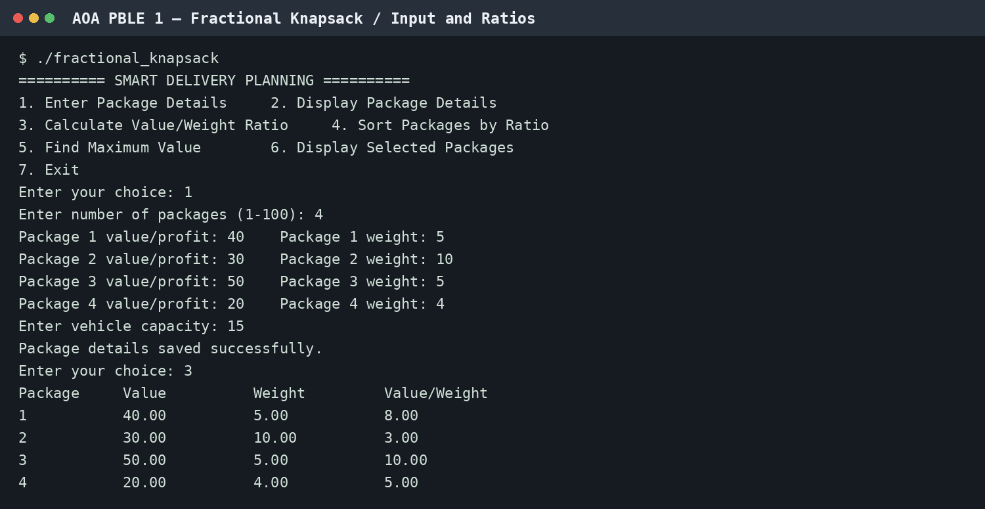
Figure 1. Entering package details and calculating ratios.
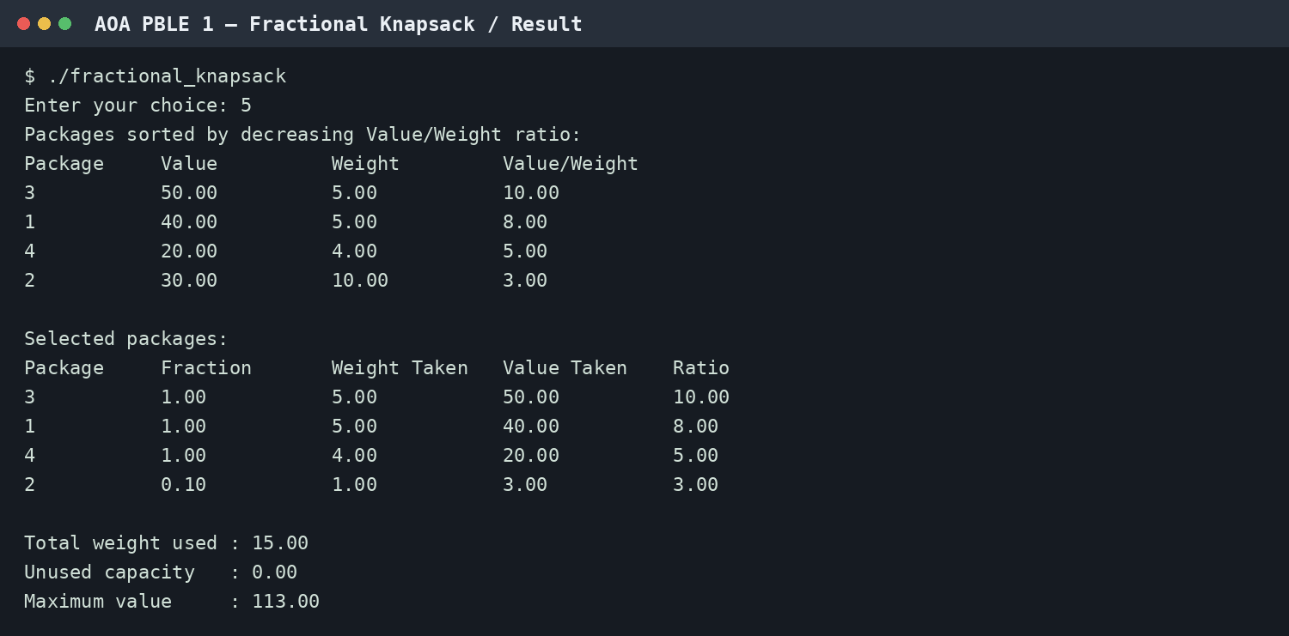
Figure 2. Sorted packages and final greedy selection.
Time Complexity Analysis
Let n be the number of packages. Calculating ratios takes O(n), insertion sort takes O(n²) in the worst case, and selecting packages takes O(n). Therefore, the overall worst-case time complexity of this implementation is O(n²). The auxiliary space complexity is O(n) for storing the package array.
Conclusion
The project demonstrates how the Greedy Method solves the Fractional Knapsack problem by prioritizing packages with the highest value per unit weight. For the sample data and capacity of 15, the program achieves a maximum value of 113.00. The solution is menu-driven and displays intermediate ratios, sorted order, chosen fractions, and the final result.
GitHub Repository Link of Project
To be added after uploading fractional_knapsack.c and this report to GitHub.

