Sanjeevani: Early Warning of Water-Borne Disease Risk
Using Machine Learning
A Synthetic Simulation Study
Ayush Kr. Burnwal  RA2411056010256  SRM Institute of Science and Technology  Kattankulathur, Chennai, India | Yash A  RA2411056010262  SRM Institute of Science and Technology  Kattankulathur, Chennai, India | Arya Phanase  RA2411056010308  SRM Institute of Science and Technology  Kattankulathur, Chennai, India

ABSTRACT
Delayed recognition of localized waterborne outbreaks motivates earlier, reviewable surveillance signals. This paper presents Sanjeevani as a reproducible machine learning prototype evaluated entirely with generated data. A simulator creates 43 Tamil Nadu-style units, weather and water-system conditions, latent cases, operational outbreak events, and delayed observations under three surveillance scenarios. At the end of each Monday, M1 estimates whether a new operational outbreak will start within seven days for an inactive unit; M2 estimates whether an operational outbreak is active at that time. We compare seasonal and rule baselines, a handwritten logistic regression, library logistic regression, random forest, and XGBoost. A software smoke run with one training, one validation, and one test world selected XGBoost by validation average precision. On the single synthetic test world, pooled across the three observation scenarios, average precision was 0.545 for M1 (5.22% positive prevalence) and 0.771 for M2 (26.40% prevalence). These figures verify the runnable pipeline only; the planned multiworld study and independent real-world validation remain unfinished. No real outbreak, drinking-water safety, or clinical prediction is claimed.
Keywords—synthetic simulation; waterborne outbreak; early warning; outbreak detection; machine learning; surveillance.
I. INTRODUCTION
Disease surveillance can benefit from timely signals assembled from several imperfect sources. Digital disease detection has a long research history [1], while Indian outbreak compilations such as EpiClim [2] provide useful context for the kinds of public-health questions that motivate this work. Neither source is used to train or validate the results reported here. The present project asks a narrower technical question: can a reproducible pipeline generate point-in-time surveillance observations, learn two distinct outbreak tasks, and expose its predictions for inspection?
The contribution is an executable synthetic study with a written provenance contract, world-level evaluation split, a hand-implemented logistic model for the course requirement, library baselines, event-oriented timing metrics, and a local application demonstration. The study is intentionally bounded: its units, cases, sensors, reports, and labels are generated. A high score inside this simulator cannot establish utility for an actual district or justify an automatic public alert.
A. Relationship to prior work
Web-based surveillance research illustrates why a second signal channel may be useful when routine reporting is delayed [1]. EpiClim assembles reported Indian outbreaks with climate context [2]; it is an example of a public retrospective dataset, not a complete continuous record of every unreported local event. The present work does not benchmark against HealthMap, EpiClim predictors, or any deployed public-health system. Its comparison is internal: a set of learning algorithms and simple baselines face the same generated worlds and observation scenarios. This distinction matters because synthetic visibility of hidden events makes measured event timing possible here, whereas a real study would require carefully linked onset and report dates.
II. STUDY DESIGN AND DATA
A. Synthetic world and observation scenarios
Each seed generates an independent six-year world spanning 1 January 2017 through 31 December 2022. The first 365 days supply warm-up history; scoring begins afterward. The 43 configured units resemble Tamil Nadu administrative and neighborhood settings but are synthetic study units, not linked real district surveillance records. The world generator models stochastic weather, water-system disturbances, exposure, infection, symptomatic cases, spatial interaction, and operational outbreak episodes. Its assumptions are explicit configuration values rather than parameters estimated from patient data.
For each world, a single hidden event registry is observed through baseline, improved, and enhanced surveillance streams. These streams vary sensor availability and noise, laboratory sampling, ASHA-style reports, outpatient observations, and simulated formal reporting delays. For example, configured sensor coverage is 30%, 65%, and 90% across the three scenarios. The same hidden truth under all three scenarios permits within-world comparisons, but also means their rows are correlated and must not be treated as independent outbreaks.
Public EpiClim/IDSP records [2], NFHS-5 indicators, and NASA POWER weather are background material only. They supply no training row, feature, target, or external test in this study. The published repository contains code, configuration, documentation, and a 120-row synthetic schema preview; complete generated cohorts and fitted model artifacts from the smoke run remain local.
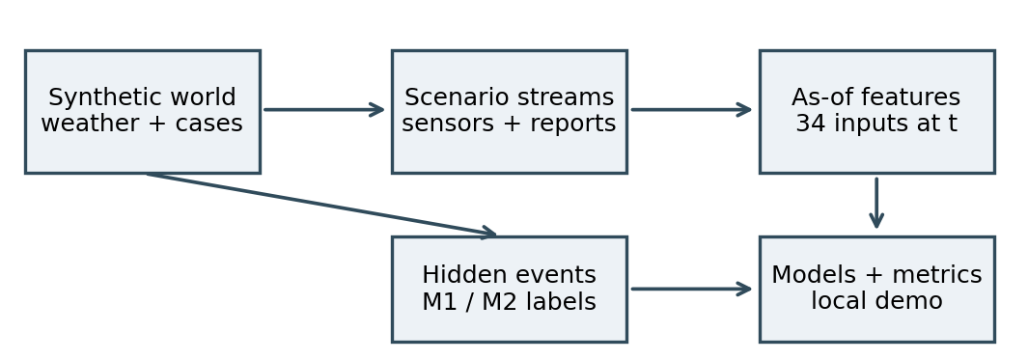
Fig. 1. Synthetic truth and scenario observations feed separate labels and point-in-time model inputs.
B. Decision time, labels, and features
A prediction is issued at the end of a configured Monday t, after observations available by that time. M1 is evaluated only for units with no active event at t; its positive label means a new operational onset falls in (t, t+7 days]. M2 is evaluated for every unit-week; its positive label means an operational event is active at t. Operational onset is determined by the simulator's case threshold and can occur after first symptoms. Consequently, an M1 warning before operational onset is not necessarily a warning before infection or first illness.
The feature builder emits 34 observed or derived inputs from recent weather, water measurements, supply disruption, case reports, outpatient activity, prior formal reports, neighboring signals, and calendar history. It uses as-of availability timestamps, excluding hidden truth, future observations, and later backfill. A stricter first-case onset is retained as a sensitivity definition in the pipeline, but the primary results below use operational onset.
C. Provenance and reproducibility
The generator, label builder, feature builder, and evaluators are versioned in the project repository. A run saves its YAML configuration, world seeds, generated cohorts, model files, row-level synthetic test predictions, summary metrics, package versions, and SHA-256 hashes of source and outputs. The smoke command is run.ps1 -Mode Smoke inside the ml directory on a configured Windows environment [5]. Re-running with fixed seeds should reproduce the intended cohort construction, subject to the pinned software environment. The evidence manifest explicitly marks the run as synthetic and real-world validation as false. This record lets a reviewer inspect how each reported table was produced rather than relying on an isolated score.
III. MODELS AND EVALUATION
A. Comparison and mathematical implementation
The comparison includes a seasonal-rate baseline, a simple weather/water rule, a NumPy logistic regression written for this project, scikit-learn logistic regression and random forest [3], and XGBoost [4]. The scratch classifier maps an input vector to a probability with the sigmoid. It minimizes class-weighted binary cross-entropy with L2 regularization by gradient descent; for class weight a_i and target y_i, its weight gradient is shown below. Missing-value medians and scaling parameters are fitted using training worlds only.
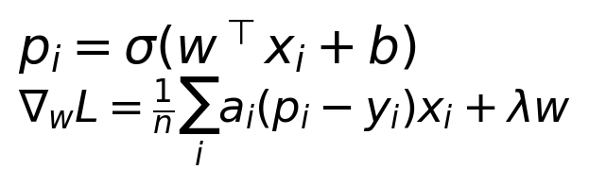
Eq. 1. Scratch logistic probability and regularized weighted-loss gradient.
B. Split and measures
An entire generated world is the split unit, so its three observation scenarios and shared event truth remain together. The completed smoke run used seed 1001 for training, 2001 for validation, and 3001 for test. The configured full study calls for 20 training, five validation, and ten test worlds and has not yet run. Model choice and operating thresholds are set on the validation world. The held-out test world is then used to calculate average precision (AP or area under the precision-recall curve), ROC area, Brier score, thresholded precision/recall, false alarms, and event-level timing. AP is read alongside positive prevalence; the repeated scenarios are pooled for the compact model comparison below.
All worlds share the same simulated 2017–2022 calendar and the same 43 unit templates. Thus the test is a holdout by random world seed, not a later-year forecast test or a held-out-geography evaluation. The Monday decision schedule yields 259 scored dates from 1 January 2018 through 12 December 2022 per unit and scenario, leaving follow-up time for event labels. This design tests whether the code generalizes across independent random realizations of one specified generator. It does not test whether the chosen generator reflects the actual data-generating process in Tamil Nadu.
IV. SMOKE-RUN RESULTS
The one test world produced 11,137 unit-weeks per scenario. For M1, 8,197 unit-weeks per scenario were eligible and 428 were positive. For M2, all 11,137 were eligible and 2,940 were positive. Pooling three scenario views gives 24,591 M1 rows and 33,411 M2 rows, but these represent repeated observations of the same underlying events. Table I compares test-world AP after the classifier was selected on validation data. It is a code check, not a stable performance estimate.
TABLE I. TEST-WORLD AVERAGE PRECISION, THREE SCENARIOS POOLED
Method | M1 AP | M2 AP
Seasonal baseline | 0.117 | 0.446
Weather/water rule | 0.063 | 0.265
Scratch logistic | 0.464 | 0.724
Library logistic | 0.503 | 0.743
Random forest | 0.492 | 0.768
XGBoost (selected) | 0.545 | 0.771
Positive prevalence | 0.052 | 0.264

For selected XGBoost, pooled M1 ROC area was 0.886 and Brier score was 0.033; M2 ROC area was 0.868 and Brier score was 0.121. Brier is a measured probability error, not evidence of a separate calibration procedure. M1 AP changed from 0.514 to 0.548 to 0.575 across baseline, improved, and enhanced observation scenarios; corresponding M2 AP was 0.742, 0.775, and 0.795. These differences are conditional on the simulator's surveillance assumptions.
At the F1-oriented validation threshold, the pooled test precision/recall pair was 0.596/0.508 for M1 and 0.754/0.594 for M2. A lower validation threshold targeting event recall changed those pairs to 0.322/0.701 and 0.550/0.785. The corresponding false-alarm counts were 0.333 and 0.735 per simulated unit-month. This threshold trade-off shows why a model score alone is not an alert policy: raising recall can create substantially more investigations. Those operating points were chosen in a synthetic validation world and require review under a real workload before any operational use.
At thresholds chosen on validation to target event recall, M1 warned about 290/427, 304/427, and 303/427 eligible operational events under baseline, improved, and enhanced surveillance. Median lead among warned events was three days before operational onset in each scenario. M2 detected 416/427, 420/427, and 424/427 active events, with median detection delays of four, four, and three days after onset. Among events with at least one scored opportunity while still unreported, M2 detected 395/424, 352/370, and 233/254 respectively. Among detected events with a simulated formal-report date, median lead over that report was eight, four, and three days. These are different time origins; a report lead must not be read as pre-onset warning. Ninety-two censored events per scenario were excluded from each task's event recall denominator. These event figures use the validation target-recall threshold, not the separate F1 threshold.
V. SOFTWARE DEMONSTRATION
The repository provides a Vite/React interface with a Simulation Lab and a local read-only Python result service [5]. The service reads a completed run, exposes status, summaries, and saved synthetic test predictions, and can replay a selected generated row through the saved model using its as-of features. Other application dashboards are prototype/mock views. This is a demonstration of a stored synthetic result, not live surveillance, sensor ingestion, a clinical decision system, or an operational alert channel.
VI. LIMITATIONS AND NEXT STEPS
All outcomes and observations ultimately come from the same simulator. In particular, ASHA-style and outpatient signals are generated from the cases that define active events, which may make M2 easier than a real reporting task. The operational threshold can also be reached after early case observations, affecting M1's apparent lead. The sole test world cannot quantify variation across seeds or generalization beyond the assumed generator. Pooled scenario rows share labels, and the current study does not validate prevalence, sensor noise, reporting delay, or clinical relevance against linked real observations.
This is also a study of an explicitly chosen operational definition, not an adjudicated epidemiological outbreak register. Changing the seven-day case threshold, background incidence, or observation lag could change both labels and predictive strength. The three scenarios encode improvements in coverage and timeliness by construction; their AP ordering is a property of these assumptions, not causal evidence that installing more sensors would improve public-health outcomes. The model has no fitted probability-calibration layer, and one held-out seed is inadequate for interval estimates. No external population, time period, geography, or health service was evaluated.
The next research steps are to freeze code and assumptions, run the configured 20/5/10-world experiment, report world-wise uncertainty and sensitivity to first-case onset, and test on permissioned, time-aligned real outbreak and surveillance data if available. Any real deployment would additionally require data governance, calibration and alert-policy review, field usability testing, and human oversight. None of these steps has been completed or is implied by the synthetic scores.
VII. CONCLUSION
Sanjeevani now has a reproducible synthetic pipeline for two distinct surveillance questions and a local interface for inspecting saved predictions. The smoke run demonstrates that generation, training, evaluation, model saving, and replay execute end to end. Its measured scores are simulator-specific and preliminary. The project is suitable as an ML coursework prototype; evidence for real public-health use remains to be established.
REFERENCES
[1] J. S. Brownstein, C. C. Freifeld, and L. C. Madoff, "Digital disease detection—harnessing the Web for public health surveillance," New England Journal of Medicine, vol. 360, no. 21, pp. 2153–2157, 2009. doi: 10.1056/NEJMp0900702.
[2] G. Kaur et al., "EpiClim: Weekly District-Wise all-India multi-epidemics Climate-Health Dataset for accelerated GeoHealth research," Zenodo, version 1, 2024. doi: 10.5281/zenodo.14580510.
[3] F. Pedregosa et al., "Scikit-learn: Machine learning in Python," Journal of Machine Learning Research, vol. 12, no. 85, pp. 2825–2830, 2011.
[4] T. Chen and C. Guestrin, "XGBoost: A scalable tree boosting system," Proc. 22nd ACM SIGKDD Int. Conf. Knowledge Discovery and Data Mining, pp. 785–794, 2016. doi: 10.1145/2939672.2939785.
[5] Sanjeevani project repository, commit 3cb383ec6b91bb5e3bc575508142fbbce258774b, 2026. https://github.com/Yash13606/sanjeevani.

