# CNN - Convolutional Neural Network

## Convolutions

Mathematical term to describe the process of combining two functions to produce third.  
In the context of image processing and computer vision, convolutions are used to extract features from images.

Basically, the first Function is the image that is combined with the Kernel or Filter which produces a Feature Map

**Image * Kernel = Feature Map**

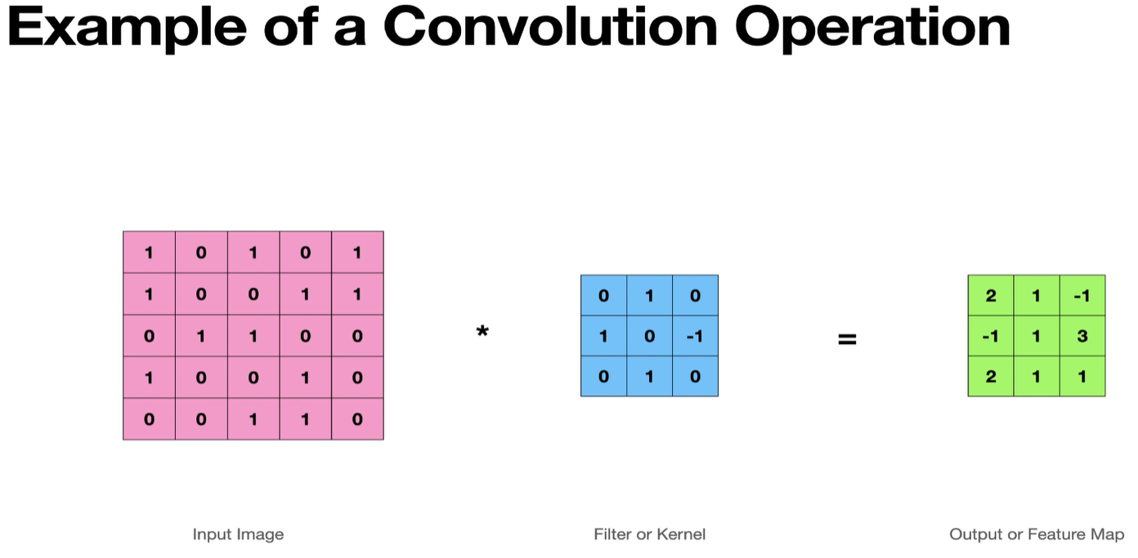

### Calculating Feature Map Size:

* For CNN the images & kernel are assumed to be square, it makes calculation fast and easier.

## Feature Detectors

Kernels or Filters are the matrix which works as Feature detectors. This matrix works as a sliding window which looks for a specific feature for which it is trained for.   
The output we get is the Feature map which is then consumed by the hidden layers to determine the image class.

## Convolution on Color Images

## Kernel Size & Depth

Parameters that control the Convolutional Filter:

* Kernel Size (k x k)
  + One point to note about Kernel size is that it needs to be square, and the dimension should be an odd number.
* Depth (1 for Grayscale or 3 for RGB)
  + Depth typically refers to the color channel.  
    However, in some nomenclature it can refer to the 3rd dimension of any layer in our CNN e.g. our Feature Map has depth of 4.  
    A black and white image of a stack of cubes

    Description automatically generated
* Padding
  + It can be noted that Conv Filters produce an output smaller than the input. Now in most of the cases it is desirable to have the size of output same as input.
  + The image size can be preserved by padding the image.  
    A screenshot of a math game

    Description automatically generated  
    A screenshot of a math application

    Description automatically generated
  + The padding is required so that we don’t keep losing the image size as the image moves across different deep network layers.
  + Also, without padding the corner pixels are considered only ones while which are available in between the sliding kernel goes over it multiple times. So, padding provided almost equal weightage to the corner pixels.
* Stride
  + Stride defines how many steps we take when sliding our Convolutional Window across the input image.

* + A larger Stride produces smaller Feature Map output.
  + Larger Stride has less overlap.
  + Basically, we can use the stride to control the size of the Feature map output.
  + Output size of feature map can be calculated as :  
    A diagram of a mathematical equation

    Description automatically generated

## Activation Layer – ReLU

ReLU stands for Rectified Linear UNits

## Pooling