Dear Intern

Interim project report is an inherent component of your internship. We are enclosing a reference table of content for the interim project report.

The key objective of this report is for you to capture how far you have got in completing the internship work against milestones expected to be achieved within a specific duration and seek the mentor’s feedback. Depending on the internship project and your progress (IT/Non-IT, Technical/Business Domain), you may choose to include or exclude or rename sections or leave some sections blank from the table of content mentioned below. You can also add additional sections. You can refer the project presentation to view the milestones related to your internship project. Please populate milestone# (1 / 2 / 3) and the milestone description in the interim project report based on the milestone for which you are submitting the interim project report.

You can refer the project presentation to view the milestones related to your internship project.

|  |  |
| --- | --- |
| Internship Project Title | RIO-125: UI Testing using Selenium WebDriver and Cucumber Framework Batch 01 |
| Name of the Company | TCS iON |
| Name of the Industry Mentor | Debashis_Roy |
| Name of the Institute | K.B.N College |

|  |  |  |  |  |  |  |
| --- | --- | --- | --- | --- | --- | --- |
| Start Date | End Date | | Total Effort (hrs.) | | Project Environment | Tools used |
| 16/07/2022 | 16/08/2022 | | 100 | | phptravels.com | Selenium tools, Eclipse IDE, Maven repository |
| Milestone # | Milestone-3 | Milestone: | | End of the Project. | | |

**TABLE OF CONTENT**

* Acknowledgements
* Objective
* Introduction / Description of Internship
* Internship Activities
* Approach / Methodology
* Assumptions
* Exceptions / Exclusions
* Charts, Table, Diagrams
* Algorithms
* Challenges & Opportunities
* Risk Vs Reward
* Reflections on the Internship
* Recommendations
* Outcome / Conclusion
* Enhancement Scope
* Link to code and executable file
* Research questions and responses

**Acknowledgements:**

I am very grateful to Mr. Debashis Roy sir for his support and guidance in completing this project. I am thankful to my college mentors as well. I was able to successfully complete this project with the help of their guidance and support. Finally, I want to thank all my dear friends as well.

**Objectives:**

Cucumber framework in Selenium allows test scenarios to be written using natural language constructs that describe the expected behavior of the software for a given scenario, making it ideal for user acceptance testing.

**Introduction / Description of Internship:**

**Title of the Internship project:** UI Testing using Selenium WebDriver and Cucumber Framework**Description:**

Cucumber tool is based on the Behavior Driven Development (BDD) framework that acts as the bridge between the following people:

1. Developing/Performing browser based automation testing project using Selenium Web Driver and Cucumber Framework for <https://phptravels.com/demo/> available in public domain.
2. Cucumber Framework integrates well with selenium webDriver to provide Behavior Driven Development (BDD) based UI automation testing. The Gherkin script-based Test Scenarios enables sophisticated automated UI testing.
3. The site has 4 parts to test.

* Customer Front-End.
* Agent Front-End.
* Admin Back-End.
* Supplier Back-End.

1. Testing all needs to be performed on all web elements with appropriate test design and test cases with End to End functionalities.

**Internship Activities:**

Create an automation script that would perform the following:

**For Customers:**

1. Login using credentials. Check for valid and invalid test cases.

2. Test the links My Bookings, Add Funds, Create Profile, Logout by auto-clicking all the links to verify functionality.

3. Make an automated payment of USD 50 using PayPal.

4. Check bookings and display the voucher.

5. Read from test cases and update address in profile.

**For Agents:**

1. Login using credentials. Check for valid and invalid test cases.

2. Test the links My Bookings, Add Funds, Create Profile, Logout by auto-clicking all the links to verify functionality.

3. Test the links Home, Hotel, Flights, Tour, Visa, Blog, Offers.

4. Search hotels by city and test results.

5. Update USD to INR for the account

**For Admins:**

1. Login using credentials. Check for valid and invalid test cases.

2. Test link Bookings and then display of booking invoice where payment is successful.

3. Delete a record having Booking Status as Cancelled.

4. Change the booking status from “Pending” to “Confirmed” and verify the count in dashboard.

5. Check whether the website link is working and redirecting to a different page.

**For Suppliers:**

1. Login using credentials. Check for valid and invalid test cases.

2. Check the Dashboard view and check the text “Sales overview and summary”.

3. Test whether it displays the Revenue Breakdown.

4. Change the booking status from “Pending” to “Confirmed” and verify the count in dashboard.

5. Check whether the modules “Flight”, ”Visa”, ”Tours”, ”Bookings” are displayed and can be clicked.

**Approach / Methodology:**

Observing/Visiting the websites which is provided in the industry martial, all the tasks are checked step by step on designing test design, test scenario, test case templates.

**Assumptions:**

Step 1: Add dependencies to pom.xml.

Step 2: Install Web Drivers.

Step 3: Add your first feature.

Step 4: Add your first JUnit test (Test Runner).

Step 5: Add step definitions for your feature.

Step 6: Add setup logic for Selenium Web Driver.

Step 7: Running the Tests.

Step 8: Output.

**Exceptions / Exclusions:**

* Install Cucumber.
* Write your first Scenario using the Gherkin syntax.
* Write your first step definition in Java.
* Run Cucumber.
* Learn the basic workflow of Behavior-Driven Development (BDD).
* Basic understanding of the Java programming language.

**Charts, Table, Diagrams:**

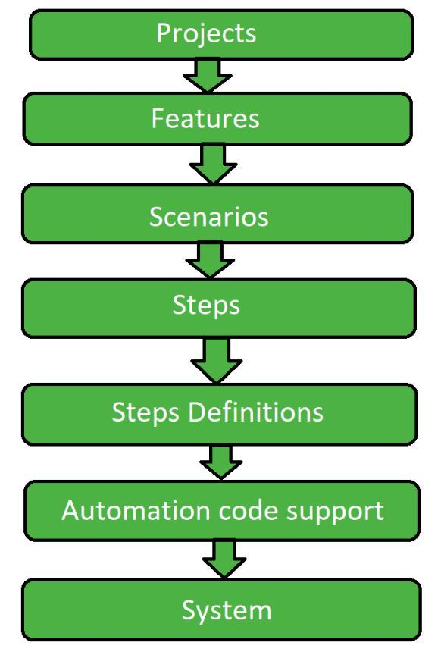

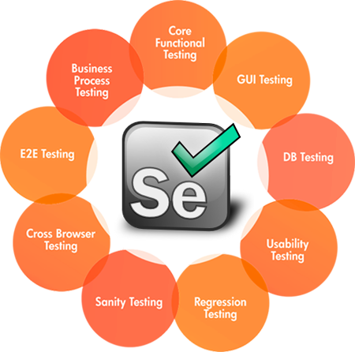

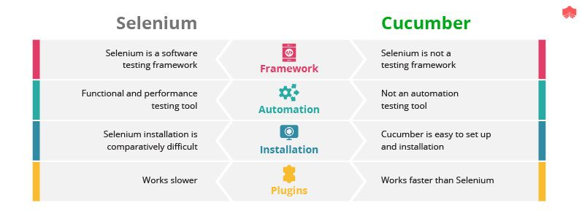

**Algorithms:**

* Selenium End to End Automation Test.
* Download Cucumber and Selenium Jar files.
* The next step is to install Cucumber on your Eclipse. For that, you need to go to Help -> Eclipse Marketplace -> Search Cucumber and install Cucumber and Naturals on your eclipse. Below snapshot depicts the same.
* Once you configure Cucumber, the next step is to create a feature file. First, you have to create a new source folder and then add a feature file.
* After that, you need to implement the scenarios with the help of step definitions.
* Now, the last step is to create the ‘runner class’ and execute the program.
* And also import the recommended import packages and statements, which is used to debug the errors.
* Then Run the Runner class.

**Challenges & Opportunities:**

**Challenges:** 1. Cross Browser Testing, 2. Handling Pop-Ups, 3. Synchronizing Events, 4. Captcha

1. Handling Dynamic Elements, 6. Limited Reporting.

**Opportunities:** 1. Core Functional Testing, 2. GUI Testing, 3. DB Testing, 4. Cross BrowserTesting, 5. E2E Testing, 6. Business Process Testing.

**Risk Vs Reward:**

* **Risk:** 
  + Non-qualified Test Team.
  + Inadequacy of the Test Tool.
  + High Script Maintenance Costs.
  + Attempt to automate every type of test.
  + Lack of planning and control of the automation process.
* **Rewards:** 
  + Test Automation Feasibility Study.
  + ROI Study for Test Automation.
  + Identity Automation Framework.
  + Develop Automation Framework.
  + Review Automation Test Script.

**Reflections on the Internship:**

An internship experience is a form of reflective writing that allows you to document the ways in which your internship experience helped you develop new skills, learn new concepts and increase your knowledge in a professional setting. It has helped guide my career aspirations and will definitely help me in my future career. I also gained technical knowledge in testing.

A reflection paper should follow a basic essay structure that allows you to briefly describe the nature of the internship how your experience helped you achieved your goals, how your contributions added to the organization and how your experience will apply to your academic/ professional growth and achievements.

**Recommendations:**

Improve the stability of the website. And also improve the quality of the tools which is used to test the website.

**Outcome / Conclusion:**

Performed Behavior Driven Development (BDD) based testing to test the Use cases and their functionalities as explained in the Test Documents.**Enhancement Scope:**

Increases the lack of awareness on UI Testing using Selenium Web Driver and Cucumber Framework in the society in different social media platforms. It’s gives most of the software companies are recommends to test their code using Selenium Web Drivers and Cucumber Frameworks. And also increase the tools that used to test the code in an easy manner.

**Link to code and executable file:**

**URL:** https://github.com/Yash14092002/UI-Testing-using-Selenium-WebDriver-and-Cucumber-Framework