RV INSTITUTE OF TECHNOLOGY AND MANAGEMENT

Sy.No.171/5, Kothanur,8th Phase, JP Nagar, Bengaluru-560076


Environmental Studies and E-Waste Management

Course Code: BCS508
2022 Scheme

Assignment on

“Recycling Habits Among Students and Household Members”

Prepared by

Shubham Kumar– 1RF23CS161

Swarnit Kumar – 1RF23CS173

Tejaswi - 1RF23CS177

Yash A Jain-1RF23CS188

Semester: CSE V C

Department of Computer Science and Engineering

RVITM, Bengaluru – 560076

2025-2026

Introduction
Recycling is a vital element of sustainable waste management and environmental preservation. It plays a key role in conserving natural resources, reducing the volume of waste sent to landfills, and limiting ecological degradation. However, rapid urbanization, population growth, and rising consumption levels have led to an unprecedented increase in waste generation. When waste is not disposed of responsibly, it contributes significantly to air, water, and soil pollution, while also accelerating the depletion of natural resources and disrupting ecological balance. These environmental issues reinforce the urgent need for proper waste segregation and recycling at both the household and community levels.
Within this context, examining the recycling habits of different social groups becomes particularly important. This study focuses on understanding the recycling behaviors of students and household members. It explores the types of materials they recycle, their level of awareness regarding waste segregation, the factors that motivate them to adopt environmentally responsible practices, and the challenges that prevent consistent recycling efforts. The insights gained from this analysis will help assess how prepared the community is to embrace sustainable behavior and will identify areas that require improvement—whether through enhanced infrastructure, educational initiatives, or supportive policies.
Ultimately, the findings of this study aim to guide the development of targeted awareness programs and more effective waste management strategies that contribute to a cleaner, healthier, and more sustainable living environment.

Methodology
A structured survey was designed and conducted using an online questionnaire to collect relevant data regarding recycling habits among students and household members. The survey contained a balanced set of demo-graphic, behavioural, and opinion-based questions to ensure that both quantitative and qualitative aspects of recycling practices were captured effectively. The questionnaire included multiple-choice questions, Likert-scale responses (ranging from frequency to attitude-based ratings), and optional open-ended questions where respondents could share personal thoughts or challenges faced in recycling.
The survey was distributed digitally through social media groups, academic networks, residential community WhatsApp groups, and direct personal contacts to reach participants from varied backgrounds. This approach enabled the survey to gather responses from individuals belonging to different age groups, educational levels, and living environments. A total of 200 valid responses were recorded, ensuring a sufficiently large dataset for reliable analysis. Participants included students, household members, and a small fraction categorized as others (such as working professionals or retired individuals). All responses were collected anonymously to maintain privacy and encourage honest and unbiased input.
Once the data collection phase was completed, responses were compiled and cleaned using spreadsheet tools. Descriptive statistical methods were applied to analyze the frequency and distribution patterns within the dataset. The analysis primarily focused on two key variables:
- Respondent Category (Student / Household Member / Other)
- Recycling Frequency and Habits (Yes, Regularly / Occasionally / Rarely / Not at All)
In addition to these, supplementary variables such as types of materials recycled, segregation practices, and perceived challenges were also considered to gain deeper insights. Visualizations such as pie charts and bar graphs were generated to clearly illustrate the trends and differences in recycling behavior among different respondent groups. These visual aids helped in simplifying data interpretation and supported the discussion and conclusions drawn from the findings.
Through this structured methodology, the survey was able to provide a comprehensive and reliable overview of current recycling practices, awareness levels, and potential gaps that may require attention from educational institutions, households, or community waste management authorities.

Results and Data Analysis

(A) Respondent Category Distribution
What the chart shows: Share of respondents by group (Student vs. Household).
Interpretation:
Students:65.5%
Household Members:34.5%
This split indicates the dataset is student-leaning, but still includes a substantial household sample, enabling comparisons across academic and domestic settings.
(B) Recycling Practice Distribution
What the chart shows: How frequently respondents recycle.
Interpretation (by frequency):
Monthly: 26.7%
A few times a week: 23.3%
Weekly: 16.7%
Rarely: 16.7%
Bi-weekly: 10%
Daily: ~3.3%
Never: ~3.3%
Takeaway: A clear majority engage in recycling at least occasionally, but high-consistency recycling (daily/weekly) remains limited. The modal behavior is monthly, suggesting convenience and access may be barriers to more frequent participation.
(C) Awareness About Local Recycling Programs
What the chart shows: Awareness and participation status.
Interpretation:
Yes, I participate: 30%
Yes, but I do not participate: 30%
No, I am not aware: 40%
Takeaway: Awareness alone does not ensure action—half of those aware do not participate. Moreover, two in five respondents lack awareness entirely, highlighting a communication gap.
(D) Perceived Impact of Recycling (“How strongly do you feel recycling makes a difference?”)
What the chart shows: 1–10 rating; average = 8.43.
Interpretation:
Respondents hold a strong pro-recycling belief, providing a favorable attitudinal base. The high mean suggests motivation is present; bridging the intent–action gap will depend on improving ease, access, and habit formation.

Respondent Category Distribution

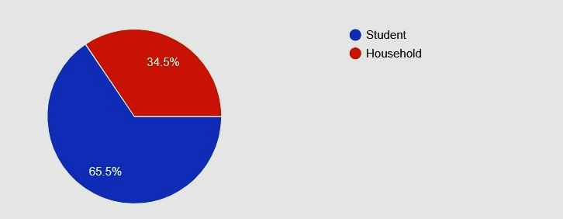

Recycling Practice Distribution

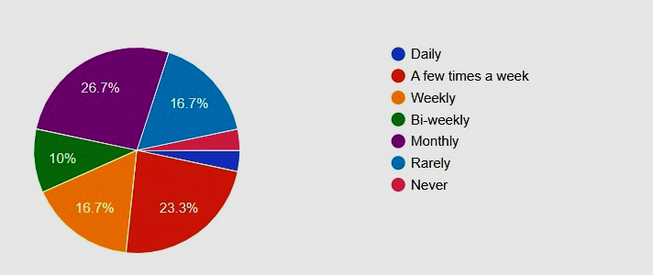
Awareness about local recycling programs

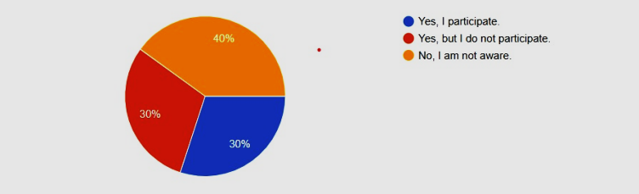
How strongly do you recycling makes a difference?

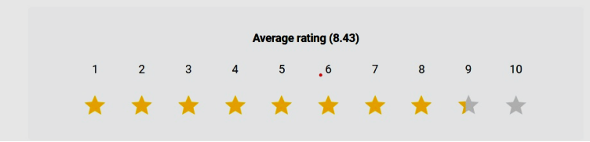

Discussion

The findings suggest that while general recycling awareness exists among both students and households, actual participation varies based on convenience, infrastructure availability, and personal motivation.
Key Observations:
Positive Indicators | Challenges
High awareness and willingness to recycle | Lack of separate waste collection spaces
Many respondents already recycle paper & plastic | Confusion about recyclable materials (e.g., e-waste, glass)
Students more engaged in waste sorting | Limited municipal collection services
Recycling behavior is influenced less by awareness and more by accessibility.
Even respondents who understand the importance of recycling may fail to do so due to lack of:
- Dedicated recycling bins
- Clear instructions
- Regular scrap/waste pickup services

Conclusion & Recommendations
Recycling habits among both students and households show positive trends, but there is room for improvement in consistency and waste segregation quality.
Recommendations:
- Install clearly labeled multi-bin waste segregation systems in residential complexes and campuses.
- Conduct awareness drives emphasizing how to recycle (not just why).
- Increase collaboration with local scrap collectors and recycling centers.
- Promote incentives such as discounts, reward points, or community recognition programs.

Appendix

Item | Link/Details
Google Form Used | Google Form
Dataset Used | Excel Sheet

