**Edge and Cloud Computing: A Comprehensive Survey of Architectures, Challenges, and Opportunities**

Aryan Manhas1, Gajanan M Naik2,

1Department of Computer Science and Engineering, RV Institute of Technology and Management, JP Nagar-560076 Bengaluru

2Department of Mechanical Engineering, RV Institute of Technology and Management, JP Nagar-560076 Bengaluru

**Abstract**

The popularity of Internet of Things (IoT) devices these days demands low-latency applications have exposed the limitations of traditional Cloud Computing. Edge Computing has emerged with a different approach, by bringing computation and data storage closer to the sources of data. This paper provides a comprehensive survey on Edge-Cloud computing by focusing on its architecture models, challenges faced in adopting the said models and future opportunities. Finally, we explore the promising future of this system as well as its implementation in the synergy with AI/ML and impact on 5G/6G networks. This survey serves as a valuable lesson for understanding the current state and future evolution of Edge and Cloud Computing.

**Keywords:**

1. **Introduction**

The formal definition of cloud computing is a technology that allows users to store, manage, and process data on data (remote) centers instead of on their local computers. Multiple companies provide this service such as Amazon (AWS), Google (GCP), or Microsoft (Azure) to name a few. In the past decade, Cloud Computing has established itself as a cornerstone of modern digital infrastructure, offering unprecedented scalability, on-demand resources, and centralized data processing power. But nowadays Internet Of Things (IoT) is being used in every sector of our live such as vehicles to Augmented Reality (AR), due to this specific needs such as ultra-low latency, real-time decision-making, and efficient use of network bandwidth have become necessary and which were not fulfilled due to physical distance of remote cloud data centers.

To address these limitations, Edge Computing has emerged in recent years. What edge computing does is that it brings data processing closer to the source of data - like IoT devices, sensors, or smartphones - rather than relying on distant cloud servers which in turn reduces the latency and are important for mission - critical services. However the true strength is not in replacing cloud computing with edge but creating a symbiotic cloud - edge system that leverages the strength of both such as the responsiveness and context-awareness of the edge with the robust computational and storage capabilities of the cloud. Cloud - Edge system sounds revolutionary in planning but its possibility for implementation still remains a mystery.

This paper presents a comprehensive survey of the Edge-Cloud computing paradigm. We provide 3 major contributions. First we provide a systematic taxonomy of Edge-Cloud architectures, classifying existing models to bring more clarity for pros and cons for each model. Second, we conduct a critical analysis of the key challenges that impede the global implementation of these systems. Finally, we will discuss future possible implementation of this system in technologies like 5G/6G networks and Artificial Intelligence (AI). This survey aims to serve as a foundation and the future roadmap for this everchanging field.

1. **Literature Selection Process**

To ensure that the quality of this paper is maintained and to follow the systematic review of this field, this survey is based on a very strict literature selection process. Prominent academic databases, such as IEEE Xplore, ACM Digital Library, and Google Scholar were further reviewed so that the paper follows the original key structure mentioned above. The search queries used keywords related to the paper’s main themes, such as “Edge and Cloud Computing”, “Edge-Cloud architectures”, “Edge AI” and “Edge security”.

Our literature selection process made sure that all the information was relevant and was published between the years 2018 and 2025 to make sure that the advancements were recent. We also excluded patents, technical reports, and non-English publications. The initial search yielded hundreds of papers that were further reviewed and refined to make sure that they were relevant to our topics.

1. **Results and Discussion**
2. Architecture: In this section we will discuss about the working architecture and models present for both Cloud and Edge Computing:
3. Cloud Computing: Cloud computing allows for sharing of resources over the Internet. These resources are shared using infrastructure provided by a cloud service provider (CSP). The cloud consumer accesses the resources, on-demand as–you–use and pay–as–you–go basis. Cloud computing also enables a level of abstraction between the required computing resource and the underlying architecture such as storage, network and services. Servers are used by the CSPs to provide the three primary services delivery types. These primary ones are Platform-as-a-Services (PaaS), Infrastructure-as-a-Service (IaaS), and Software-as-a-Service (SaaS).
   * Platform-as-a-Service (PaaS) : PaaS is a development service offered to the user through the Internet. The user does not require any software installation or hardware requirements, thereby saving cost. It is a middleware upon which applications are built. PaaS has built–in tools, built–in-security and web service interfaces for the deployed applications. The deployed application can be integrated with other applications on the same platform and interfaced with other applications outside the platform. PaaS has software comprising a database, middleware and development tools.

Examples of PaaS:

1. Business Intelligence
2. Database
3. Development and testing
4. Integration
5. Application Deployment

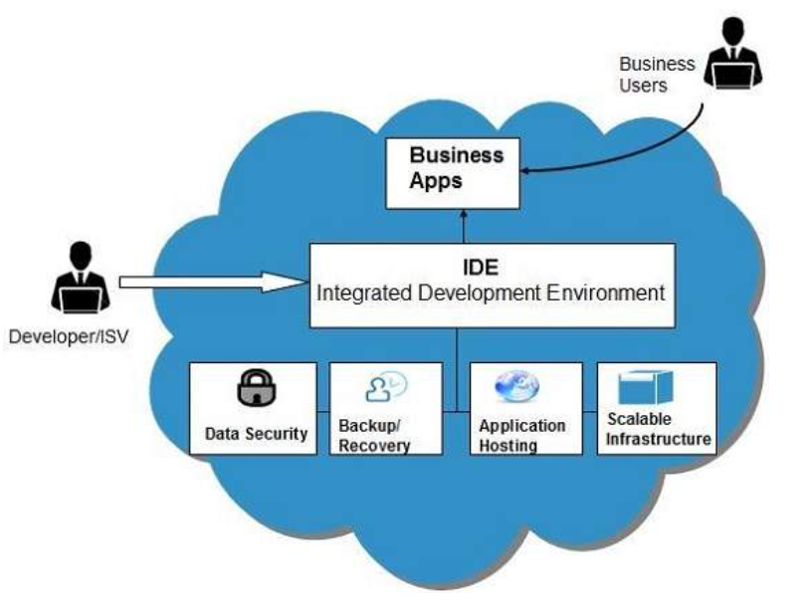

* + Infrastructure-as-a-Service (IaaS) : This is delivery of servers, storage, network and operating system, as a service. IaaS provides an abstract machine with an operating system already installed and configured. IaaS enables data to be stored in different geographical locations. IaaS providers control activities in the cloud data centres while allowing users the flexibility to deploy and manage software services themselves. The user has access to a virtual computer, storage, network infrastructure, computing resources for deploying and running software. The cloud provider only manages the software and hardware, such as servers, storage devices, host OS and hypervisor for virtualization.

Examples of IaaS:

1. Content Delivery Networks (CDNs): CDNs record user content and files to improve the system performance such as speed and the cost associated with the delivery content for web-based systems.
2. Backup and Recovery: This provides the ability for seamless backup and restoration of files.
3. Compute: This involves server requirements for maintaining cloud systems that can be configured and provisioned dynamically.
4. Storage: Highly scalable storage ability useful for recording activities of applications, file backups and recovery and storing files are also available.

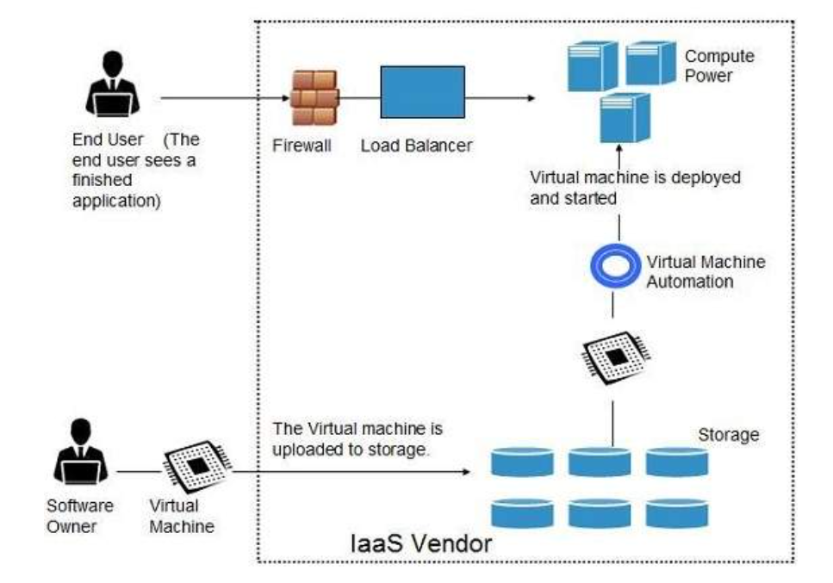

* + Software-as-a-Service (SaaS) : The user is offered a hosted set of software running on a platform and infrastructure owned by the cloud provider. Applications are designed and developed to be simultaneously accessed by various cloud consumers over the Internet. The hosted application is managed by the CSP, who maintains and ensures up-to-date running of the system. The hosted application supports multitenancy, it is available on demand and can be scaled up on down. Some SaaS providers run on other cloud provider’s PaaS or IaaS offerings.

Examples of SaaS:

1. Email and Office Productivity: Email applications, word editors and processors, spreadsheets applications, presentations applications are typical examples in this category.
2. Billing: There are applications designed to monitor and manage customer billing. This is determined by users’ system usage and subscriptions to products and services.
3. Customer Relationship Management (CRM): CRM are typical call-centre applications.
4. Financials: These are applications useful for tracking and reporting financial activities including processing of expenditure, generating invoices, payroll, and managing taxes.

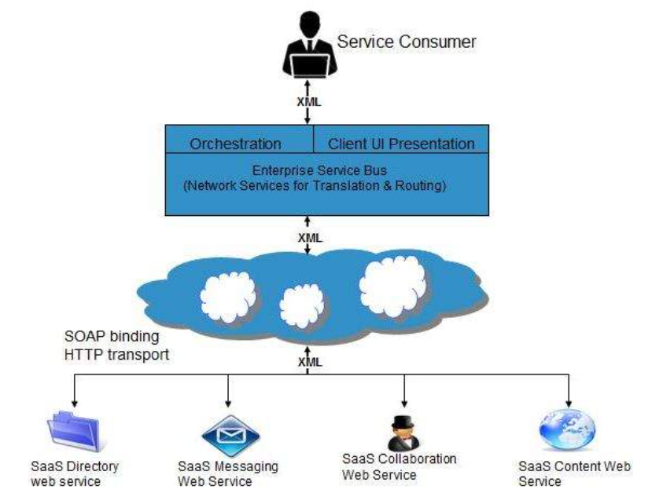

2. Edge Computing: The speeding growth of mobile internet and the internet of things (IoT) resulted in serious problems for the currently-available centralized cloud computing architectures. Mobile devices in connection with a faraway centralized cloud server have obtained complex applications, giving rise to additional burden on the radio access network as well as the backhaul network which can lead to great latency. The development of IoT will result in several issues (e.g. latency, restricted capacities, resource-limited devices, continual services with sporadic connectivity, security) that may not be sufficiently resolved through the centralized cloud computing architectures. In this regard, edge computing can be considered a new paradigm aimed at providing storage and computing resources and serving as the new layer, consisting of edge devices between the end-users of IoT devices and the cloud layers. From the perspective of edge computing, an “edge” is defined as a computing and network resource within the initial source of the data path to the destination data storage (fog nodes, cloud data centers). Now there are few technologies that solve the above mentioned problems:

1. Cloudlet: Also known as micro cloud data centers, cloudlets operate similarly to the small cloud computing architectures inherited from the centralized Cloud Computing. Cloudlets are concentrated on serving time-critical applications under limited bandwidth conditions. The cost difference between traditional cloud computing and cloudlet is justified due to how crucial the role is. The cloudlets are mainly aimed to support interactive mobile applications with huge resource requirements and provide strong computing resources for mobile devices at decreased latency. A cloudlet-based open ecosystem can support and enable diverse interesting compute-intensive and latency-sensitive mobile applications. Empirical results indicated 51% and up to 42% decline in the response time and energy consumption in a mobile device upon using cloudlets rather than cloud offload. Cloudlet is famously known as “data center in a box”.

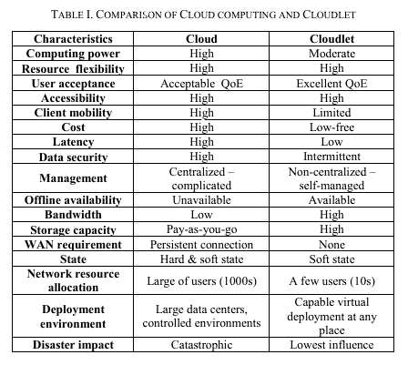

1. Mobile Edge Computing (MEC) in Internet of Things (IoT):

MEC offers the possibility of computation at the edge. For instance, micro cloud nodes can serve as an edge node linking mobile devices to the cloud. Gateways the edge devices could connect home IoT to cloud; while a smartphone can be regarded as an edge device linking body things to the cloud. MEC is mainly situated in the mobile network base station; it is occasionally called mobile cloud computing (MCC). Within the MCC structure, data storage, as well as data processing, is handled outside the mobile device. The logic behind the edge computing concept lies in the preference of deploying the computational facilities in the vicinity of the data generation site. By offloading the tasks to the Internet cloud using an MCC network of mobile operators, mobile devices can exploit the strong computing resources and storage capacity of the cloud to carry out the intended tasks. As an evolved form of MCC, MEC was first introduced in 2014 by the European Telecommunications Standards Institute. MEC managed to dramatically decrement the process duration and energy requirements of mobile devices through the deployment of computing resources, network controlling, and cached data in the vicinity of Small-cell Base Station (SBS) and Macro-cell Base Station (MBS).

1. **Conclusions**

**References**

I. Odun-Ayo, M. Ananya, F. Agono and R. Goddy-Worlu, "Cloud Computing Architecture: A Critical Analysis," 2018 18th International Conference on Computational Science and Applications (ICCSA), Melbourne, VIC, Australia, 2018, pp. 1-7, doi: 10.1109/ICCSA.2018.8439638.

II. Hamdan, S.; Ayyash, M.; Almajali, S. Edge-Computing Architectures for Internet of Things Applications: A Survey. Sensors 2020, 20, 6441. https://doi.org/10.3390/s20226441

III. M. Talebkhah, A. Sali, M. Marjani, M. Gordan, S. J. Hashim and F. Z. Rokhani, "Edge computing: Architecture, Applications and Future Perspectives," 2020 IEEE 2nd International Conference on Artificial Intelligence in Engineering and Technology (IICAIET), Kota Kinabalu, Malaysia, 2020, pp. 1-6, doi: 10.1109/IICAIET49801.2020.9257824

IV.