**Project Report**

**On**

**Animal Disease Prediction Using Machine Learning**

Group No. 09

**Submitted by**

Abhiyansh Gupta (2104500100005)

Sumit Mishra (2104500100060)

Yash Vardhan Gupta (2104500100069)

**Project Guide**

Dr. Manvi Mishra

**Submitted To**

Dr. Manvi Mishra

(Project-In-Charge)



Department of Computer Science and Engineering

Shri Ram Murti Smarak of College of Engineering Technology and Research,

Bareilly

**TABLE OF CONTENT**

Page. No.

DECLARATION.............................................................................................. ii

CERTIFICATE.................................................................................................iii

ACKNOWLEDGEMENT................................................................................iv

ABSTRACT......................................................................................................v

LIST OF FIGURES..........................................................................................vi

CHAPTER 1 INTRODUCTION, STATEMENT OF PROBLEM

1.1 INTRODUCTION......................................................................................1

1.2 MOTIVATION...........................................................................................2

1.3 PROBLEM STATEMENT.........................................................................3

1.4 OBJECTIVES.............................................................................................4

1.5 TOOLS & TECHNOLOGY.......................................................................5

CHAPTER 2 LITERATURE REVIEW/BACKGROUND

2.1 LITERATURE REVIEW...........................................................................6

CHAPTER 3 METHODOLOGY

3.1 METHODOLOGY....................................................................................8

CHAPTER 4 RESULT & DISCUSSION.......................................................11

CHAPTER 5 CONCLUSION AND FUTURE ENHANCEMENT

5.1 APPLICATION.........................................................................................16

5.2 CONCLUSION………………………………………………………….18

5.2.1 FUTURE ENHANCEMENT.....................................................18

REFERENCES................................................................................................19

**DECLARATION**

I hereby declare that this submission is my own work and that, to the best of my knowledge and belief, it contains no material previously published or written by another person or material which to substantial extent has been accepted for the award of other degree or diploma of the university or other institute of higher learning except where due acknowledgment has been made in the text.

Signature Signature

Name Name

Roll No Roll No

Date Date

Signature

Name

Roll No

Date

I

**CERTIFICATE**

This is to certify that the Project Report entitle “Animal Disease Prediction Using Machine Learning” which is submitted by Abhiyansh Gupta (2104500100005), Sumit Mishra (2104500100060), Yash Vardhan Gupta (2104500100069) in partial fulfillment of the requirement for the award of degree B. Tech in Department of **Computer Science Engineering** of **SRMS College of Engineering, Technology and Research** affiliated to **Dr. A.P.J Abdul Kalam Technical University, Lucknow (U.P)**, is a record of the candidates own work and carried out by them under my supervision. The matter embodied in this work is original and has not been submitted for the award of any other word or degree.

Date:

**Project In-charge (CSE) Supervisor**

**Head of Department**

**ACKNOWLEDGEMENT**

It gives us a great sense of pleasure to present the report of the B. Tech Project Undertaken during B. Tech Final Year. We owe special debt of gratitude to Head of Department Dr. Manvi Mishra CSE, S.R.M.S.C.E.T&R, Bareilly for his constant support and guidance throughout the course of our work. His sincerity, thoroughness and perseverance have been a constant source of inspiration for us. It is only his cognizant efforts that our endeavors have seen light of day.

We also take the opportunity to acknowledge the contribution of Dr. Shailesh Saxena, Dean Academics, S.R.M.S.C.E.T&R for his full support and assistance during the development of the project.

We also do not like to miss the opportunity to acknowledge the contribution of all faculty members of the department for their kind assistance and cooperation during the development of our project. Last but not least, we acknowledge our friends for their contribution in the complete project

Signature Signature

Name Name

Roll No Roll No

Date Date

Signature

Name

Roll No

Date

**ABSTRACT**

This research endeavors to cope with the crucial need for proactive animal disease identity and mitigation, serving as a keystone for animal fitness, financial stability in agriculture and international health safety. The main motive is to give a complete framework for animal disease prediction that combine data-driven strategies, computer vision and machine learning algorithms, to facilitate early detection and intervention. The importance of this search lies in its capability to bridge the differences in disease prediction. By studying data from multiple sources, including images and symptoms, and using technologies such as Convolutional Neural Network (CNN) and frontend tool, this framework aims to provide a cost-effective, easily accessible solutions, and sustainable solution for all stakeholders in animal health ecosystem. The final beneficiaries of this research are manifold, encompassing animals, farmers, veterinarians, and public fitness, as it gives a proactive technique to animal disease management and prediction.

 Machine Learning is the field of study that deals with making machines/computers learn on their own so that further predictions can be made for varied Applications. Human disease detection using Machine Learning Techniques has been there from quite a while but very few advancements have been made for Animal Diseases. Through this research paper we make a new contribution in the aforementioned field by deploying ML techniques to classify certain Animal Diseases along with predicting the spread of the disease.

**List of figures**

**Page. No.**

Fig.1 Methodology Approach………………………………………………………10

Fig.2 Login Page……………………………………………………………………11

Fig.3 Registration Page…………..…………………………………………………11

Fig.4 Front Page………..…………………………………………………………...12

Fig.5 Bar Chart……………………………………………………………………...13

Fig.6 Pie Chart………………………………………………………………………14

Fig.7…………………………………………………………………………………

**CHAPTER 1**

**1.1 Introduction**

On Animal Farm, healthcare is really important. With effective therapy, health diseases can be recognized and prevented at an early stage. Subclinical ketosis (SCK) is a metabolic illness that affects dairy cows during early lactation and is characterized by an elevated concentration of ketone bodies in the absence of clinical indications of disease. A typically used threshold to outline subclinical ketosis is a βhydroxybutyrate (BHB) awareness in the blood > 1.2 mmol/L. To discover subclinical ketosis in dairy cows, diverse hand-held gadgets are commercially available, and have been evaluated for use on farms.

The livestock sector plays an important role in the socioeconomic development of rural households. A large number of people in India, being less literate and unskilled, depend on agriculture for their livelihoods. Livestock is a source of subsidiary income for many families in India, especially the resource-poor, who maintain few heads of animals. One of the major obstacles to achieving the targeted growth rates in the sector is the prevalence and outbreaks of diseases. This livestock disease is a great threat to animal health as well as to humans who are in direct contact with animals and who consume the product of an animal that has been infected by a certain disease. Livestock animals usually distribute in remote areas with relatively poor conditions for disease diagnosis rapidly and accurately. It is necessary to detect the disease outcome in the livestock and take precautionary measures in order to avoid its spread among them.

There is a need for a system that helps to create awareness among livestock owners about the disease prevailing in the animal, takes the necessary precautions, and also makes the owner aware that disease can be the reason for the death of animals. In the existing system, the disease outbreak among the animals is predicted based on certain conditions and is also concerned with a specific animal and disease.

Animal owners are often unaware of whether the disease is mild or might prove fatal and whether precautions should be taken at the appropriate time. Our proposed system will predict livestock (cow, sheep, and goat) diseases based on the symptoms and also provide precautionary measures based on the disease predicted. It will also alert the livestock owner if the predicted disease causes sudden death.

**1.2 Motivation**

Developing a machine learning model for predicting animal diseases is a powerful way to enhance veterinary medicine and animal husbandry. Here are some compelling motivations for pursuing such a model:

1. **Early Detection and Prevention**: Machine learning models can analyze patterns in data to identify early signs of disease outbreaks. Early detection can lead to timely intervention, potentially preventing the spread of disease and reducing the severity of outbreaks.
2. **Improved Animal Health**: Accurate predictions can help veterinarians and farmers implement preventive measures, leading to healthier animals and reduced mortality rates. This is especially critical in high-value livestock and endangered species.
3. **Economic Benefits**: By preventing disease outbreaks and improving animal health, such a model can save significant amounts of money for farmers and the livestock industry. Reduced treatment costs and minimized production losses translate to increased profitability.
4. **Resource Optimization**: Machine learning can help optimize the allocation of resources, such as veterinary services and medications. By predicting where and when diseases are likely to occur, resources can be directed more efficiently to where they are needed most.
5. **Enhanced Surveillance**: Predictive models can improve disease surveillance systems by integrating data from various sources, such as animal health records, environmental factors, and geographic information. This holistic approach allows for more comprehensive monitoring and response strategies.
6. **Research and Development**: Machine learning can identify new patterns and correlations that might not be apparent through traditional research methods. This can lead to breakthroughs in understanding disease mechanisms and developing new treatments or vaccines.
7. **Public Health Protection**: Some animal diseases can pose a risk to human health (zoonoses). By predicting and controlling animal diseases, we can also protect human populations from potential outbreaks.
8. **Sustainability and Welfare**: Predictive models contribute to more sustainable farming practices and improved animal welfare by reducing the need for reactive treatments and minimizing the impact of diseases on animal populations.

**1.3 Problem Statement**

To develop a predictive model that can accurately identify the presence of various diseases in animals based on their symptoms, historical health data, and environmental factors. Animal diseases can have significant impacts on animal welfare, human health, and the economy. Early detection and accurate diagnosis of animal diseases can help prevent the spread of infectious diseases, reduce animal mortality rates, and improve overall animal health. However, animal diseases can be complex and difficult to diagnose, and traditional diagnostic methods can be time-consuming and costly.

Machine learning can help address these challenges by analyzing large volumes of data to identify patterns and make predictions about the presence of diseases. The goal of this project is to develop and implement machine learning algorithms that can accurately predict the presence of various animal diseases based on available data. This can aid veterinarians and animal health professionals in making more informed decisions about disease management and prevention, ultimately leading to improved animal health outcomes and reduced economic losses in the animal industry.

Animal diseases pose significant threats to livestock, impacting food security, public health, and economic stability. Traditional diagnostic methods are often time-consuming and costly, highlighting the need for innovative solutions. The objective of this project is to develop a machine learning model capable of predicting the onset of diseases in animals, based on historical and real-time data, to assist veterinarians and farmers in early detection and intervention. The project will involve collecting comprehensive data, including animal health records, environmental conditions, nutrition, and genetic information. The model will be trained, validated, and tested using this data, with an emphasis on ensuring data quality and selecting relevant features. Challenges include handling inconsistent data and integrating various data sources while maintaining ethical standards and privacy. The expected outcome is a reliable model for disease prediction, accompanied by a user-friendly interface for real-time use, ultimately leading to improved animal health, reduced economic losses, and enhanced data-d

riven decision-making in veterinary medicine.

**1.4 Objectives**

1. To develop a machine learning model capable of accurately predicting animal diseases using a variety of data sources.
2. To integrate diverse datasets, including veterinary records, environmental conditions, and real-time health metrics from IoT sensors, for comprehensive disease prediction.
3. To enhance early detection of potential disease outbreaks and identify early signs of illness in animals.
4. To optimize resource allocation and preventive measures by providing actionable insights to veterinarians, farmers, and wildlife conservationists.
5. To reduce disease-related losses and improve animal health management through predictive analytics.
6. To contribute to economic and public health benefits by minimizing the impact of diseases on livestock productivity and public health.
7. To continuously refine and update the model with new data to maintain its accuracy and relevance over time.
8. To ensure compliance with ethical standards and regulatory requirements for data privacy and model fairness.

.

**1.5 Tools and Technology**

### **Data Collection and Management**

* **Databases**: SQL databases (e.g., MySQL, PostgreSQL) and NoSQL databases (e.g., MongoDB) for storing structured and unstructured data.
* **APIs**: To collect data from various sources like veterinary records, weather data, or environmental sensors (e.g., RESTful APIs).
* **IoT Devices**: Sensors and monitoring devices that provide real-time data on animal health and environmental conditions.

### 2. **Data Preprocessing**

* **Programming Languages**: Python and R are popular for data manipulation and preprocessing.
* **Libraries and Tools**:
  + **Pandas** (Python) for data manipulation and analysis.
  + **NumPy** (Python) for numerical computations.
  + **Scikit-learn** (Python) for basic preprocessing tasks.
  + **OpenCV** for image data processing (if applicable).

### 3. **Exploratory Data Analysis (EDA)**

* **Visualization Libraries**:
  + **Matplotlib** and **Seaborn** (Python) for creating plots and charts.
  + **Plotly** for interactive visualizations.
  + **Tableau** for advanced data visualization and dashboards.
* **Jupyter Notebooks** for interactive data analysis and visualization.

### 4. **Machine Learning and Model Building**

* **Machine Learning Frameworks**:
  + **TensorFlow** and **Keras** for deep learning and neural networks.
  + **PyTorch** for flexible deep learning model development.
  + **Scikit-learn** for classical machine learning algorithms.
* **APIs**:
  + **Flask** or **FastAPI** for creating RESTful APIs to serve the model.

**CHAPTER 2**

**2.1 Literature review**

The field of animal disease prediction has witnessed significant advancements in recent years, particularly with the integration of machine learning (ML) techniques. In the realm of ML-based animal disease prediction, a comprehensive literature survey is crucial to understand the existing methodologies, datasets, and evaluation metrics. This literature survey aims to explore the current state of research in ML-based animal disease prediction, with a focus on classification algorithms, data collection strategies, and performance evaluation methods.

In [1**] Arifin, S., Kibria, Firoza, A. Amini & Yan H et al. “Dermatologist Disease Diagnosis using color-skin images”,** they proposed a two-stage method to detect the disease based on color texture based identification and by using a classification to identify the name of the disease. The first stage has an accuracy of 95.99%, and the second stage has 94.016% accuracy. **In [2], Nawal Soliman ALKolifi ALEnezi. “A method of skin disease detection using Image Processing and machine learning”** has proposed early detection method on image processing based on Convolutional neural network to feature extraction and then using color to identify the features.

**In [3], Pravin S. Ambad and A. S. Shirsat et al. “An image analysis System to detect skin diseases”** has proposed a system for early identification of skin problem using statistical analysis and ad boost classifier. Their research mainly focused on early identification of skin cancer symptoms based on statistical analysis with correlation algorithms.

**In [4], Kumar, V., Kumar S., & Saboo, V. et al, "Dermatological disease detection using Image Processing and machine learning**," proposed a model that uses computer vision and machine learning. The features of the image are extracted and algorithms are applied to it to detect six types of diseases with an accuracy of 95%.

**In [5], Pollap D. et al., "An Intelligent for Monitoring Skin Disease,**" proposed a method of clustering images using Naive Bayes for classification. They have used SIFT method for the detection of key points in the image. After that, they used CNN and SVM for classification and segmentation. They have an accuracy of 84% and a precision of 82%.

**In [6], Rahat Yasir, Md. Ashiqur Rahman, and Nova Ahmed et al., "Dermatological Disease Detection using Image Processing and Artificial Neural Networks,"** used various kinds of different image processing algorithms for feature extraction and feed forwarding using an artificial neural network for training and testing the model. The system works in two parts, in the first part, feature extraction has taken place based on the color texture, and in the second stage, the classifier identifies the possible disease.

**In [7], Nidhai K, Al Abbadi, Nizar Saadi et al., "Psoriasis detection using skin color and texture features,"** proposed a model for the identification of psoriasis using color feature extraction and classification of the skin image.

**CHAPTER 3**

**3.1 Methodology**

### **Data Collection**

* **Identify Data Sources**: Gather data from various sources such as veterinary records, environmental sensors, IoT devices, historical disease outbreaks, and weather data.
* **Data Acquisition**:
  + **Structured Data**: Veterinary records, health indicators, and historical outbreak data.
  + **Unstructured Data**: Notes from veterinarians, free-text disease descriptions.
  + **Sensor Data**: Temperature, humidity, and other environmental variables.
* **Data Integration**: Combine data from different sources into a unified format for analysis.

### **Data Preprocessing**

* **Data Cleaning**:
  + **Handle Missing Values**: Use imputation techniques or remove records with missing critical information.
  + **Remove Outliers**: Identify and address anomalies that may skew results.
* **Data Transformation**:
  + **Normalization/Standardization**: Scale features to bring them to a common range.
  + **Encoding**: Convert categorical variables into numerical formats using techniques like one-hot encoding.
* **Feature Engineering**:
  + **Create New Features**: Derive features from existing data that could improve model performance (e.g., aggregating weather data into seasonal patterns).
  + **Feature Selection**: Identify the most relevant features using methods such as correlation analysis or feature importance scores.

### **Exploratory Data Analysis (EDA)**

* **Statistical Analysis**: Perform descriptive statistics to understand data distributions and relationships.
* **Visualization**: Use tools like Matplotlib, Seaborn, or Tableau to create plots that reveal patterns, trends, and correlations in the data.

### **Model Selection**

* **Choose Algorithms**: Select appropriate machine learning algorithms based on the nature of the data and the problem. Common choices might include:
  + **Classification Algorithms**: Logistic Regression, Decision Trees, Random Forests, Gradient Boosting Machines.
  + **Regression Algorithms**: Linear Regression, Support Vector Regression.
  + **Time Series Analysis**: ARIMA, LSTM if working with temporal data.
* **Consider Ensemble Methods**: Combine multiple models to improve accuracy and robustness.

### **Model Training**

* **Split Data**: Divide the data into training, validation, and test sets to evaluate model performance.
* **Train Model**: Use the training dataset to fit the model, adjusting parameters and tuning hyperparameters.
* **Cross-Validation**: Implement techniques like k-fold cross-validation to ensure the model generalizes well to unseen data.

### **Model Evaluation**

* **Performance Metrics**:
  + **Classification Metrics**: Accuracy, Precision, Recall, F1 Score, ROC-AUC.
  + **Regression Metrics**: Mean Absolute Error (MAE), Mean Squared Error (MSE), R-Squared.
* **Confusion Matrix**: For classification problems, analyze the confusion matrix to understand false positives and false negatives.
* **Validation**: Test the model on the validation dataset to tune hyperparameters and avoid overfitting.

### **Deployment**

* **Model Integration**: Integrate the trained model into a production environment where it can make predictions on new data.
* **APIs**: Develop RESTful APIs using frameworks like Flask or FastAPI to serve the model and enable interactions with other systems.

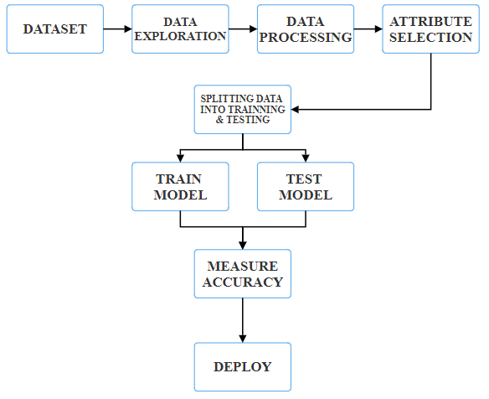

**Fig.1** Methodology Approach

**CHAPTER 4**

**Result & Discussion**

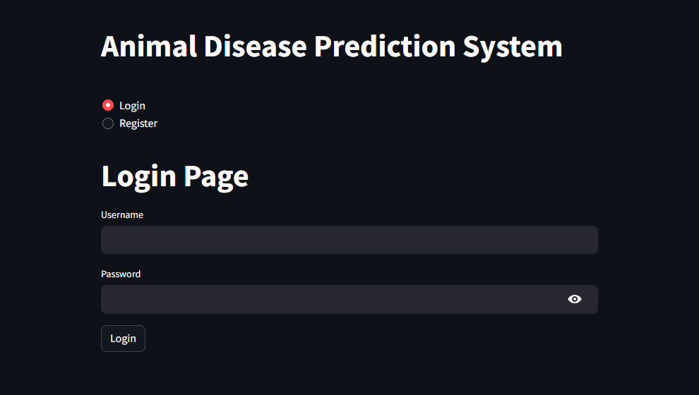

**Fig 2:** Login Page

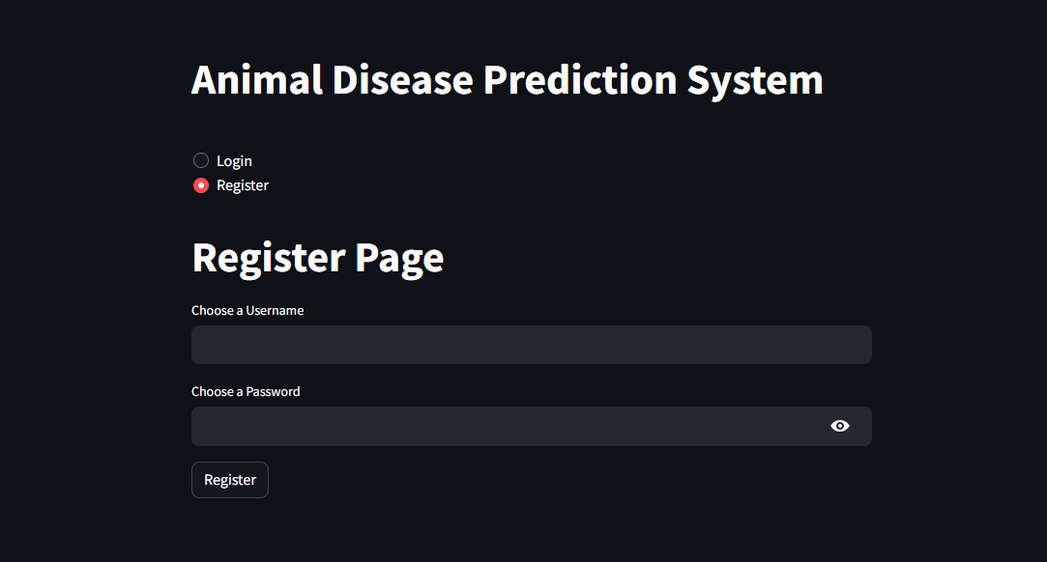

**Fig 3:** Registration Page

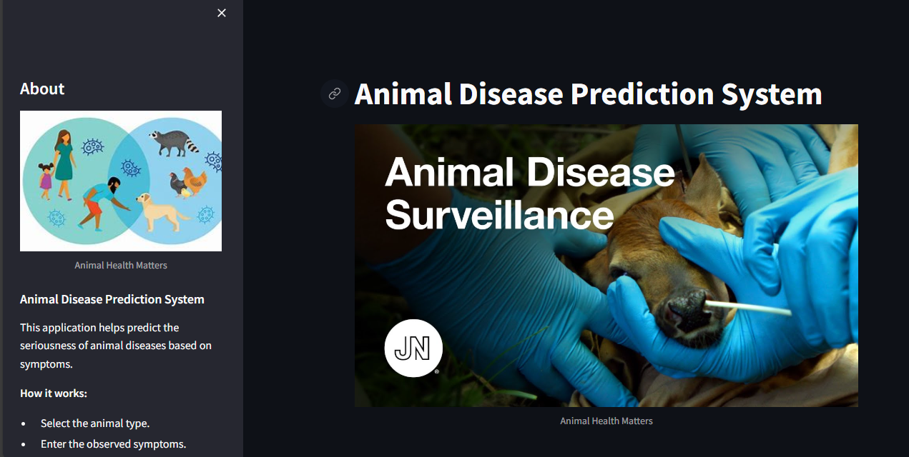

**Fig 4:** Front Page

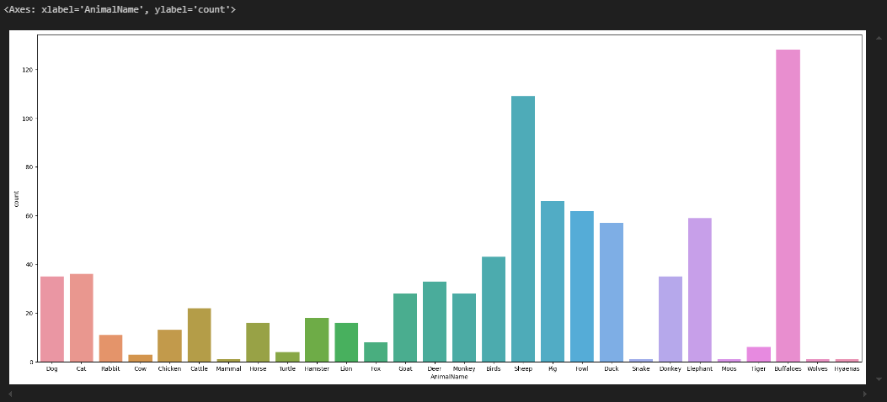 **Fig 5:** Bar Chart (Animal Name Vs Count)

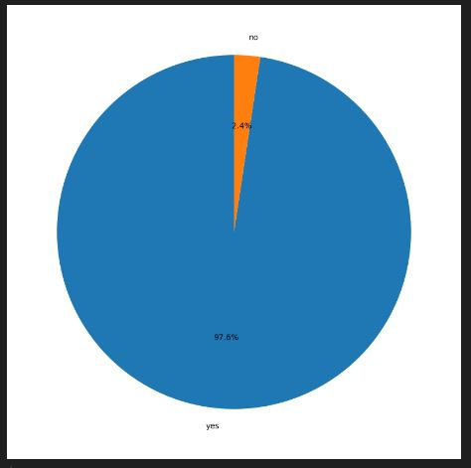

**Fig 6:** Pie Chart (Danger Vs Non Danger)

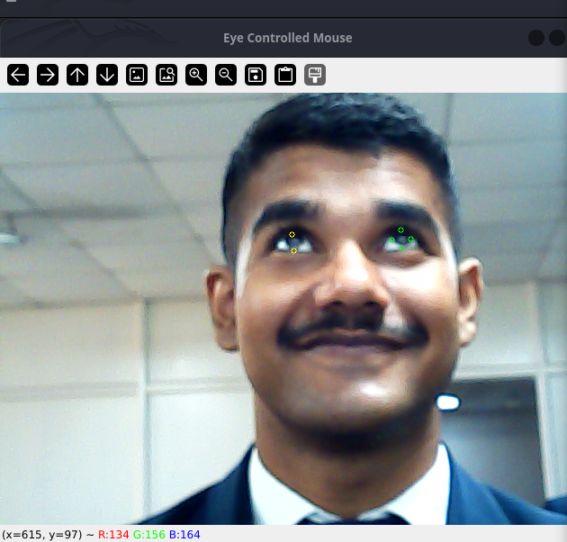 **Fig 7:** Subject is looking at camera in upward position. The cursor position captured to be up.

**CHAPTER 5**

**CONCLUSION AND FUTURE ENHANCEMENT**

**5.1 Applications**

The application of a machine learning model for predicting animal diseases can have profound implications across various sectors. Here are some key applications of such a project:

### 1. **Veterinary Clinics and Hospitals**

* **Early Diagnosis**: Predict potential outbreaks and identify early symptoms of diseases in individual animals, allowing for timely diagnosis and treatment.
* **Treatment Planning**: Use predictive analytics to recommend personalized treatment plans based on historical data and disease progression patterns.

### 2. **Livestock Management**

* **Disease Prevention**: Predict and prevent outbreaks in livestock herds, reducing the need for widespread medication and minimizing losses.
* **Health Monitoring**: Continuously monitor health metrics from IoT devices to identify and address issues before they become severe.

### 3. **Agriculture and Farming**

* **Optimized Resource Use**: Allocate resources such as vaccines, medications, and veterinary services more efficiently based on predictive insights.
* **Productivity Improvement**: Enhance overall productivity by maintaining healthier livestock and reducing disease-related downtimes.

### 4. **Wildlife Conservation**

* **Species Protection**: Monitor and predict diseases that could affect endangered species, implementing targeted interventions to protect them.
* **Ecosystem Management**: Understand disease patterns in wildlife populations to better manage ecosystems and prevent potential outbreaks that could impact biodiversity.

### 5. **Public Health**

* **Zoonotic Disease Control**: Predict and manage diseases that could potentially transfer from animals to humans (zoonoses), such as avian influenza or rabies.
* **Outbreak Prevention**: Collaborate with public health agencies to prevent cross-species transmission and control potential outbreaks.

### 6. **Animal Research and Development**

* **Drug Development**: Use predictive models to identify potential efficacy and safety of new veterinary drugs or vaccines before clinical trials.

**5.2 Conclusion**

# In conclusion, developing a machine learning model for predicting animal diseases represents a significant advancement in veterinary science and public health. By integrating diverse data sources such as veterinary records, environmental conditions, and real-time health metrics .The model aims to enhance early detection and prevention of disease outbreaks. This proactive approach enables timely interventions, reducing economic losses for farmers and improving livestock health. Moreover, by optimizing resource allocation and improving risk assessment, the model contributes to more efficient and cost-effective disease management. In wildlife conservation, it aids in protecting endangered species by forecasting and mitigating potential threats. The project also supports public health by managing zoonotic diseases that can impact human populations. Ongoing updates and adherence to ethical standards ensure the model’s accuracy and relevance. Ultimately, this project offers a transformative tool for managing animal health, optimizing resources, and safeguarding both animal and human health, demonstrating the profound impact of advanced analytics and real-time data integration in addressing complex challenges.

**5.2.1 Future Enhancements**

* Developing systems for continuous data collection can help capture the latest trends and outbreaks. This includes veterinary health records, environmental data, and socio-economic factors.
* Developing applications that offer tailored recommendations based on predictions can guide veterinarians, farmers, and policymakers in implementing effective strategies.
* Implementing a framework for regular validation of the model’s predictions against actual outbreak data will ensure its accuracy and relevance.
* Establishing mechanisms for users to provide feedback on the model’s predictions and recommendations can help refine and enhance its functionality.
* Developing applications that offer tailored recommendations based on predictions can guide veterinarians, farmers, and policymakers in implementing effective strategies.
* The animal disease prediction model can evolve into a more robust tool, improving its predictive power and operational relevance.

**References**

1. **Shamsul Arifin et al.** “Dermatological disease diagnosis using color-skin images,” Proceedings - International Conference on Machine Learning and Cybernetics. Vol. 5 2012. pp. 1675-1680.
2. **Nawal Soliman ALKolifi ALEnezi**, “A Method of Skin Disease Detection Using Image Processing And Machine Learning,” Procedia Computer Science 163 (2019) 85–92.
3. **Pravin S. Ambad, A. S. Shirsat**, “An Image analysis System to Detect Skin Diseases,” IOSR Journal of VLSI and Signal Processing (IOSR-JVSP), Volume 6, Issue 5, Ver. I (Sep. - Oct. 2016), PP 17- 25, e-ISSN: 2319 – 4200, p-ISSN No. : 2319 – 4197.
4. **Kumar, Vinayshekhar Bannihatti, Sujay S. Kumar and Varun Saboo.** “Dermatological disease detection using image processingand machine learning.” 2016 Third International Conference on Artificial Intelligence and Pattern Recognition (AIPR) (2016): 1-6.
5. **Ahmed A. Elngar** et al.“Intelligent System for Skin Disease Prediction using Machine Learning,” Journal of Physics: Conference Series, Volume 1998, 3rd International Conference on Smart and Intelligent Learning for Information Optimization (CONSILIO 2021) 9-10 July 2021, Hyderabad, India.