**1. Create three buttons and write a text on those button as Red, Green, Yellow. On click of any of these buttons, the color of that button should be changed according to their name.**

**Requirement 1: Create three buttons and named it as Red, Green, Yellow respectively.**

**Requirement 2: On click of a particular button, the color of that button should get changed according to their name.**

**Code:**

<html>

<head>

<h1> Color Buttons </h1>

</head>

<Body>

<script>

function changecolor(elmnt,clr){

elmnt.style.backgroundColor = clr;

}

</script>

<input type="Button" onClick="changecolor(this,'red')" value="RED" >

<input type="Button" onClick="changecolor(this,'green')" value="GREEN" >

<input type="Button" onClick="changecolor(this,'yellow')" value="YELLOW" >

</Body>

</html>

**Output**:

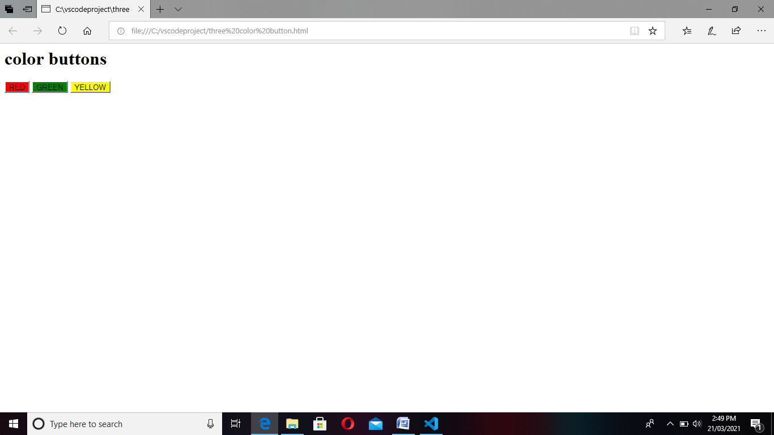

**Code using jQuery:**

<!DOCTYPE html>

<html>

    <head>

        <title></title>

    </head>

    <body>

        <script src="https://ajax.googleapis.com/ajax/libs/jquery/2.1.1/jquery.min.js"></script>

        <script>

            $(document).ready(function ()

            {

            $("#red").click(function () { $("#red").css("background-color","red");})

            $("#green").click(function () { $("#green").css("background-color","green");})

            $("#yellow").click(function () { $("#yellow").css("background-color","yellow");})

            });

        </script>

        <div>

            <center>

                <button type="button" id="red">red</button>

                <button type="button" id="green">green</button>

                <button type="button" id="yellow">yellow</button>

            </center>

        </div>

    </body>

</html>

**Output:**

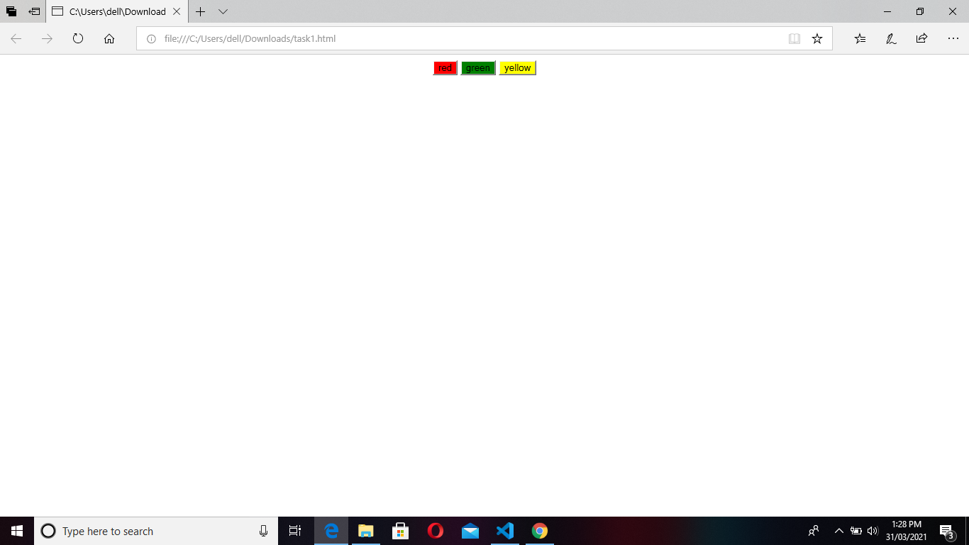

**2. Create three different colored buttons (Red, Green, Yellow) and one Rotate button. On click of the Rotate button, color of the buttons should rotate clockwise.**

**Code:-**

<html>

<head>

<script>

function myFunction()

{

var x = document.getElementById(1).style.backgroundColor;

var y = document.getElementById(2).style.backgroundColor;

var z =document.getElementById(3).style.backgroundColor;

document.getElementById(1).style.backgroundColor = z;

document.getElementById(2).style.backgroundColor = x;

document.getElementById(3).style.backgroundColor = y;

}

</script>

</head>

<body>

<center>

<input type="button" style="background-Color:Red" value="RED" id=1>

<input type="button" style="background-Color:green" value="GREEN" id=2>

<input type="button" style="background-Color:yellow" value="YELLOW" id=3>

<br><br>

<input type="button" onclick="myFunction()" value="ROTATE" id="main">

</center>

</body>

</html>

**Output**:

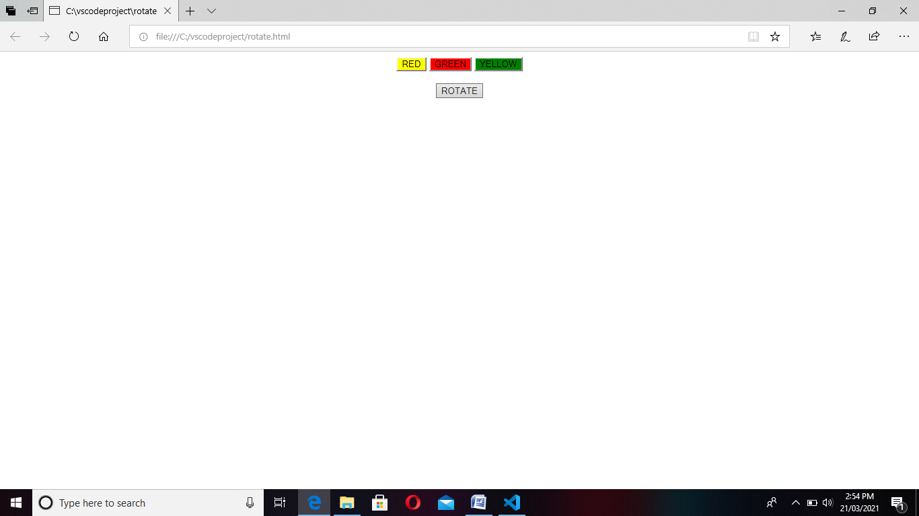

**Code using jQuery:**

<!DOCTYPE html>

    <html lang="en">

    <head>

        <meta charset="UTF-8">

        <meta name="viewport" content="width=device-width, initial-scale=1.0">

        <script src="https://ajax.googleapis.com/ajax/libs/jquery/3.5.1/jquery.min.js"></script>

        <title>Rotate Button Color</title>

        <style>

            *{

                font-family: cambria, 'Times New Roman', Times, serif;

            }

            .btn

            {

                margin-left: 70px;

                padding: 10px 20px;

                font-weight: bolder;

                font-size: 20px;

                border-radius: 15px;

            }

            #rotbtn

            {

                margin-left: 225px;

                padding: 10px 20px;

                font-weight: bolder;

                font-family: cambria;

                font-size: 20px;

                border-radius: 15px;

            }

        </style>

    </head>

    <body>

         <div class="btncont">

                <!-- creating buttons  -->

                <input type="button" id="BTN1" value="Red" class="btn" >

                <input type="button" id="BTN2" value="Green" class="btn" >

                <input type="button" id="BTN3" value="Yellow" class="btn" ><br><br>

                <input type="button" id="rotbtn" value="Rotate" onclick="RotateFunction()">

         </div>

    <script>

    $(document).ready(function()

    {

    $("#BTN1").css({"background-color":"red"});

    $("#BTN2").css({"background-color":"GREEN"});

    $("#BTN3").css({"background-color":"YELLOW"});

    $("#rotbtn").click(function()

     {

     var x=$("#BTN3").css("background-color");

     $("#BTN3").css("background-color",$("#BTN2").css("background-color"));

     $("#BTN2").css("background-color",$("#BTN1").css("background-color"));

     $("#BTN1").css("background-color",x);

     });

    });

    </script>

    </body>

    </html>

**Output:**

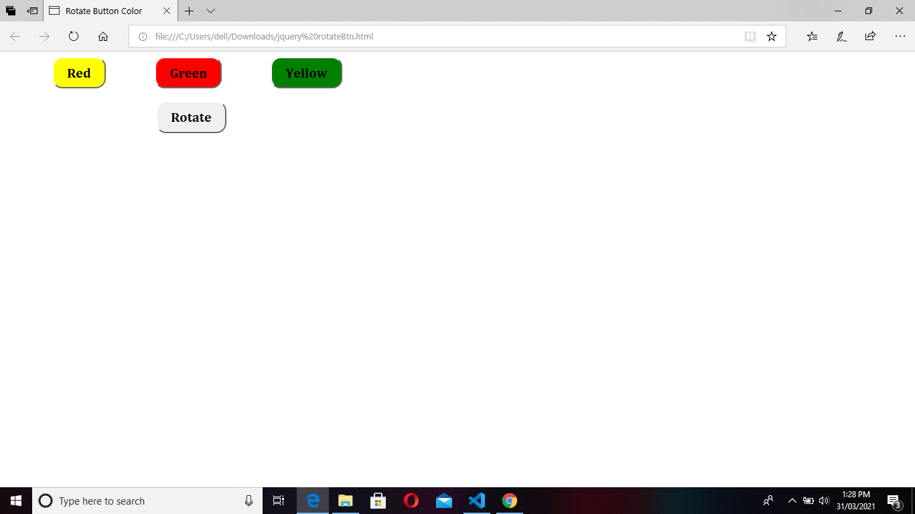

**3. Create three buttons with initial values "0" as text and one button as "Validate".**

**1: On click of any of the three buttons, value of that particular button should be increased by 1.**

**2: On click of Validate button:**

**(i) The value of un-clicked buttons (among three buttons) should get increased by 1**

**(ii) If all the three buttons are clicked, the value of oldest (first) clicked button (among three buttons) should get increased by 1.**

**Code:**

<!DOCTYPE html>

<html>

<body>

<script>

var arr = [];

function validate()

{

if (arr.length == 0)

{

var x = parseInt(document.getElementById("btn1").value);

x++;

document.getElementById("btn1").value = x;

var y= parseInt(document.getElementById("btn2").value);

y++; document.getElementById("btn2").value = y;

var z = parseInt(document.getElementById("btn3").value);

z++; document.getElementById("btn3").value = z

}

else

{

if(arr.length==1)

{

if(arr[0]=="btn1")

{

var y= parseInt(document.getElementById("btn2").value);

y++;

document.getElementById("btn2").value = y;

var z = parseInt(document.getElementById("btn3").value);

z++;

document.getElementById("btn3").value = z;

}

else if(arr[0] =="btn2")

{

var x = parseInt(document.getElementById("btn1").value);

x++;

document.getElementById("btn1").value = x;

var z = parseInt(document.getElementById("btn3").value);

z++;

document.getElementById("btn3").value = z;

}

else if(arr[0]=="btn3")

{

var x = parseInt(document.getElementById("btn1").value);

x++;

document.getElementById("btn1").value = x;

var y= parseInt(document.getElementById("btn2").value);

y++;

document.getElementById("btn2").value = y;

}

}

if( arr.length == 2)

{

if(arr[0] =="btn1" && arr[1] =="btn2")

{

var z = parseInt(document.getElementById("btn3").value);

z++;

document.getElementById("btn3").value = z;

}

else if(arr[0] == "btn1" && arr[1]=="btn3")

{

var y= parseInt(document.getElementById("btn2").value);

y++;

document.getElementById("btn2").value = y;

}

else if(arr[0]=="btn2" && arr[1]=="btn1")

{

var z = parseInt(document.getElementById("btn3").value);

z++;

document.getElementById("btn3").value = z;

}

else if(arr[0]=="btn2" && arr[1]=="btn3")

{

var x = parseInt(document.getElementById("btn1").value);

x++;

document.getElementById("btn1").value = x;

}

else if(arr[0]=="btn3" && arr[1]=="btn1" )

{

var y= parseInt(document.getElementById("btn2").value);

y++;

document.getElementById("btn2").value = y;

}

else if(arr[0]=="btn3" && arr[1]=="btn2")

{

var x = parseInt(document.getElementById("btn1").value);

x++;

document.getElementById("btn1").value = x;

}

}

if(arr.length == 3)

{

document.getElementById(arr[0]).value= parseInt(parseInt(document.getElementById(arr[0]).value)+1);

}

}

}

function btnClick(clicked_id, clicked_value)

{

document.getElementById(clicked_id).value = parseInt(parseInt(clicked_value)+1);

var n = arr.includes(clicked_id);

if(arr.length <3)

{

if(n == false)

{

arr.push(clicked_id);

}

}

else

{

var index = arr.indexOf(clicked_id);

var r_id = arr.splice(index , 1).toString();

arr.push(r_id);

}

}

</script>

<center>

<br></br>

<input type="button" namme="val" value="0" id="btn1" onclick="btnClick(this.id,this.value)" >

<br><br/>

<input type="button" name="val" value="0" id="btn2" onclick="btnClick(this.id,this.value)">

<br><br/>

<input type="button" name="val" value="0" id="btn3" onclick="btnClick(this.id,this.value)">

<br></br>

<input type="button" value="Validate" id="btn4" onclick="validate()" >

</center>

</body>

</html>

**Output:**

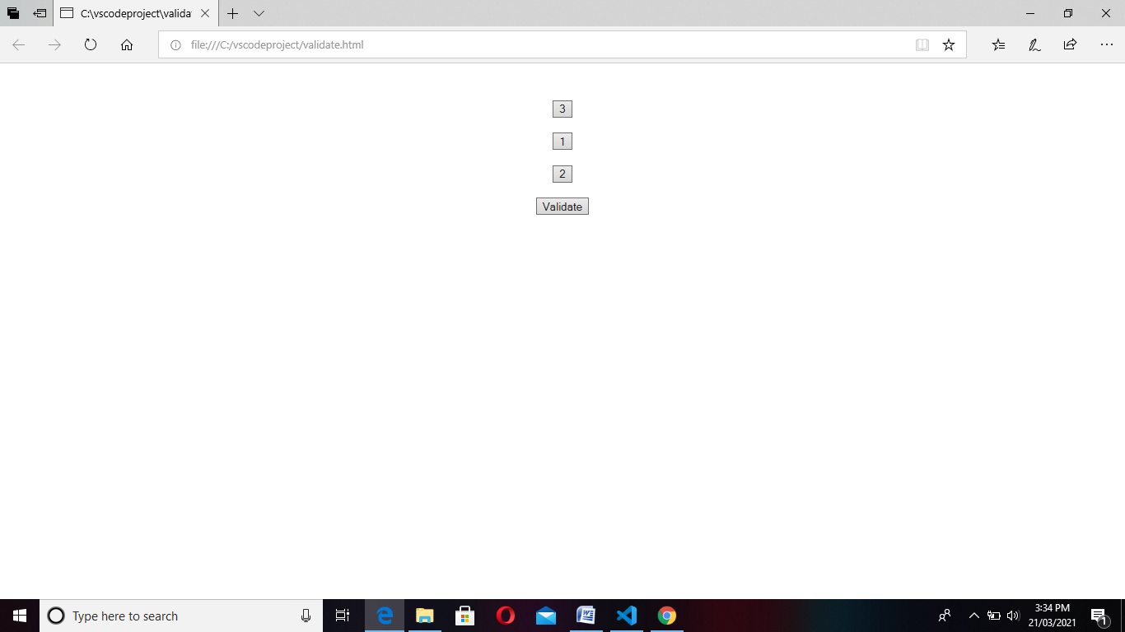

**4. Create two input box. Provide inputs in digit to both the input box and perform Add, Sub, Mul, Div and Mod operation.**

**Requirement 1: Create two input box.**

**Requirement 2: Create four buttons and text as Add for performing Addition, Sub for Subtraction, Mul for Multiplication and Div for Division respectively.**

**Requirement 3: Enter any digit in both the input box and click on a particular button for performing operations according to your requirement.**

**Requirement 4: Display the result as a text or use any message box.**

**Code:**

<html>

<head>

<title>javascript calculate two numbers</title>

<script>

function showresult(choise){

var n1=parseFloat(document.getElementById('num1').value);

var n2=parseFloat(document.getElementById('num2').value);

var r;

var c=choise;

switch(c)

{

case '1':

  if (Number.isInteger(n1)) {

r=n1+n2;

break;

} else {

 alert ("Invalide error")

}

case '2':

r=n1-n2;

break;

case '3':

r=n1*n2;

break;

case '4':

r=n1/n2;

break;

case '5':

r=n1%n2;

break;

default:

break;

}

document.getElementById('result').value=r;

}

</script>

</head>

<body>

Num1:<input type="number" id="num1"/><br/><br/>

Num2:<input type="number" id="num2"/><br/><br/>

<button onclick="showresult('1');" >Addition</button><br>

<button onclick="showresult('2');" >Substract</button><br>

<button onclick="showresult('4');" >Divide</button><br>

<button onclick="showresult('3');" >Multiple</button><br>

<button onclick="showresult('5');" >Mod</button><br>

Result:<input type="text" id="result"/>

</body>

</html>

**Output(a):**

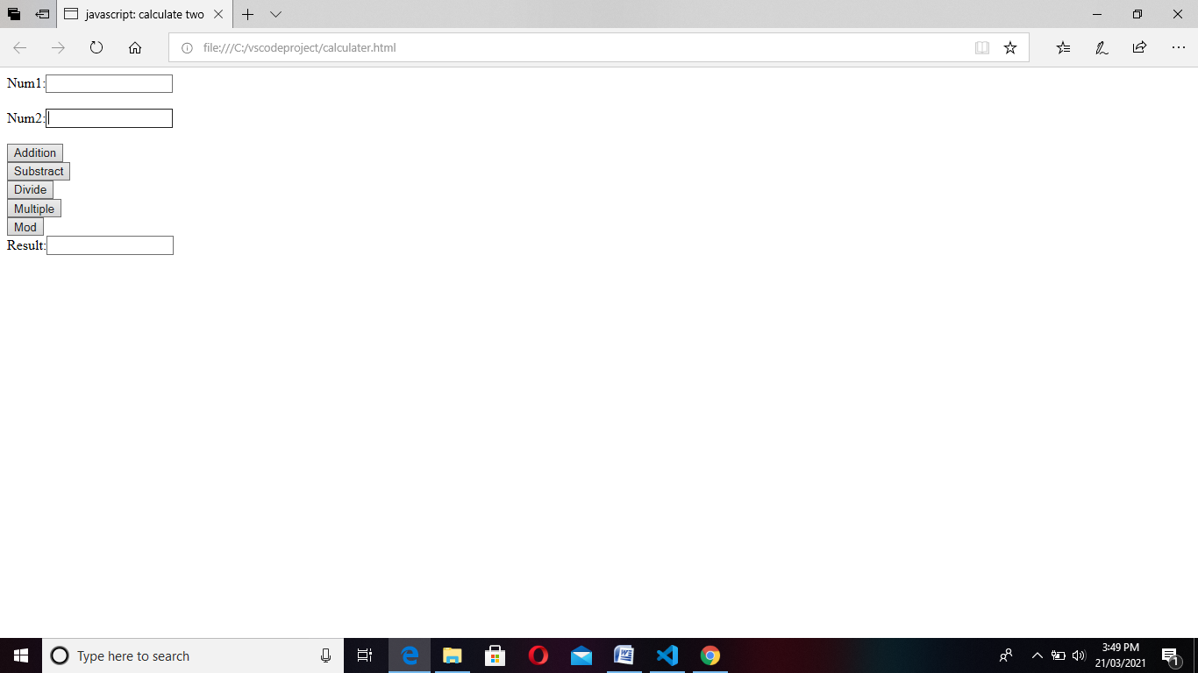

**Output(b):**

