ITUE203: WEB DEVELOPMENT FRAMEWORKS 25CS083 – Yash

Faculty of Technology and Engineering
Chandubhai S. Patel Institute of Technology (CSPIT)
Department of Computer Science & Engineering
Date: 30 / 7 / 26
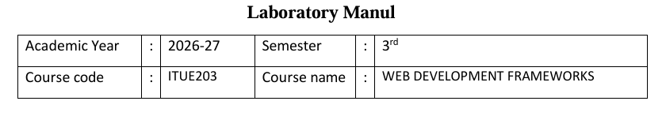
Practical – 1
PROBLEM STATEMENT : Develop static HTML5 skeletons for at least 10 StudentHub pages such as Home, About, Register, Login, Dashboard, Events, Profile, Contact,
Admin, FAQ, and Feedback. Use semantic tags and accessibility-friendly
structure.
Objective:-
Develop static HTML5 skeletons for at least 10 StudentHub pages using semantic HTML5 elements and an accessibility-friendly structure to ensure a consistent, well-organized, and user-friendly website layout.

Screenshot :
Page 1
<!DOCTYPE html>
<html lang="en">
<head>
<meta charset="UTF-8">
<meta name="viewport" content="width=device-width, initial-scale=1.0">
<title>Campus Portal</title>
</head>
<body>
<div class="page-shell">
<header class="site-header">
<a class="brand" href="index.html">Campus Portal</a>
<nav class="site-nav">
<a href="index.html">Home</a>
<a href="student-dashboard.html">Student</a>
<a href="faculty-dashboard.html">Faculty</a>
<a href="admin-dashboard.html">Admin</a>
<a href="academic.html">Academic</a>
<a href="support.html">Support</a>
</nav>
</header>

<section class="hero hero-home">
<div class="hero-copy">
<p class="eyebrow">Home / Landing Page</p>
<h1>Login securely by role.</h1>
<p>Professional campus management starts here. Choose a role and enter your credentials to reach the appropriate dashboard.</p>
<div id="role-message" class="role-message">Select a role to begin secure login.</div>
</div>
<div class="hero-panel">
<div class="panel-card">
<h2>Student access</h2>
<p>Sign in with your student ID to view your classes, attendance, results, and assignments.</p>
<button class="button button-primary role-select-button" data-role="student" type="button">Login as Student</button>
</div>
<div class="panel-card panel-card-alt">
<h2>Faculty access</h2>
<p>Use your faculty credentials to manage courses, grade work, and review student performance.</p>
<button class="button button-secondary role-select-button" data-role="faculty" type="button">Login as Faculty</button>
</div>
<div class="panel-card panel-card-alt">
<h2>Admin access</h2>
<p>Sign in as administrator to manage users, notifications, and system configuration.</p>
<button class="button button-secondary role-select-button" data-role="admin" type="button">Login as Admin</button>
</div>
</div>
</section>

<main>
</main>
</div>

<div id="login-modal" class="login-modal" aria-hidden="true">
<div class="login-modal-backdrop" data-close="true"></div>
<div class="login-modal-content" role="dialog" aria-modal="true" aria-labelledby="login-title">
<button id="login-close" class="modal-close" type="button" aria-label="Close login form">×</button>
<div class="form-panel">
<h2 id="login-title">Login as <span id="login-role">Student</span></h2>
<p>Enter your campus credentials to continue.</p>
<form id="login-form">
<div class="form-field">
<label for="login-id">Campus ID</label>
<input id="login-id" name="loginId" type="text" placeholder="Enter your ID" required>
</div>
<div class="form-field">
<label for="login-password">Password</label>
<input id="login-password" name="loginPassword" type="password" placeholder="Enter your password" required>
</div>
<div id="login-error" class="login-error" aria-live="polite"></div>
<button class="button button-primary" type="submit">Continue</button>
</form>
</div>
</div>
</div>
<script src="script.js"></script>
</body>
</html>

Output of page 1:
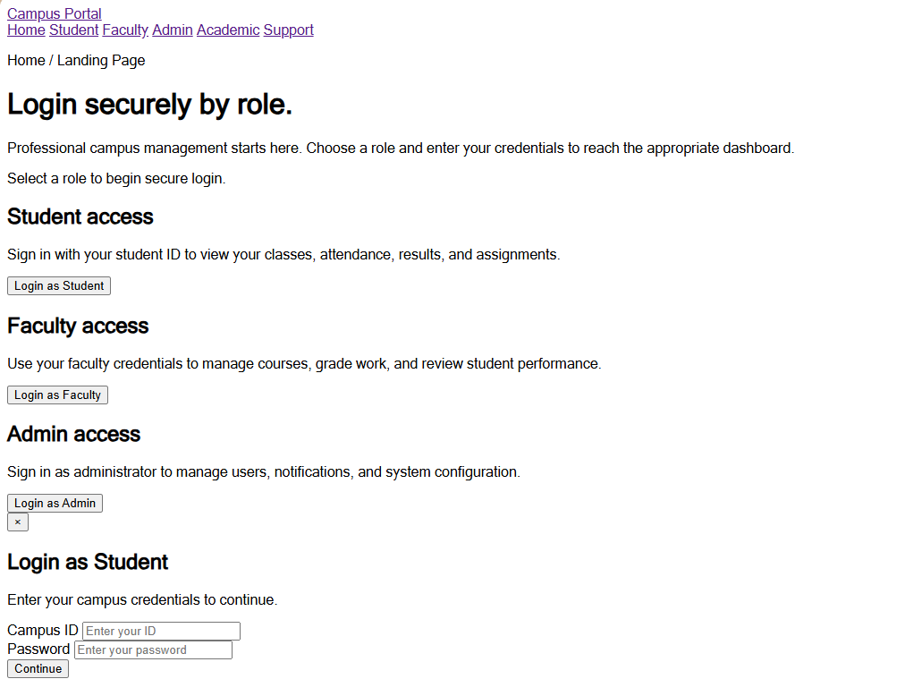
Page 2
<!DOCTYPE html>
<html lang="en">
<head>
<meta charset="UTF-8">
<meta name="viewport" content="width=device-width, initial-scale=1.0">
<title>Academic Modules | Campus Portal</title>
<!-- <link rel="stylesheet" href="styles.css"> -->
</head>
<body>
<div class="page-shell">
<header class="site-header">
<a class="brand" href="index.html">Campus Portal</a>
<nav class="site-nav">
<a href="index.html">Home</a>
<a href="login.html">Login</a>
<a href="register.html">Register</a>
<a href="student-dashboard.html">Student</a>
<a href="faculty-dashboard.html">Faculty</a>
<a href="admin-dashboard.html">Admin</a>
<a href="academic.html">Academic</a>
<a href="support.html">Support</a>
</nav>
</header>

<section class="hero hero-simple">
<div>
<p class="eyebrow">Academic modules</p>
<h1>Courses, attendance, results, and assignments</h1>
<p>Structured academic tools give students and faculty the clarity they need to stay on schedule and track progress.</p>
</div>
</section>

<main class="detail-grid">
<div class="detail-card">
<div class="section-header">
<h2>Key academic areas</h2>
</div>
<div class="detail-grid">
<div class="detail-card">
<strong>Courses</strong>
<p>Browse active course listings, schedules, and instructor details.</p>
</div>
<div class="detail-card">
<strong>Attendance</strong>
<p>Monitor attendance percentages and class participation status.</p>
</div>
<div class="detail-card">
<strong>Results</strong>
<p>Review grades and results across semesters and assignments.</p>
</div>
<div class="detail-card">
<strong>Assignments</strong>
<p>Submit or grade tasks with deadline reminders and status tracking.</p>
</div>
</div>
</div>

<aside class="detail-card">
<h3>Academic support</h3>
<p>Work with the portal’s integrated academic tools to simplify planning, reporting, and grading workflows.</p>
<a class="button button-tertiary" href="support.html">Need support?</a>
</aside>
</main>

<footer class="page-footer">Campus Portal © 2026 — Academic workflow details.</footer>
</div>
</body>
</html>

Output of page2:
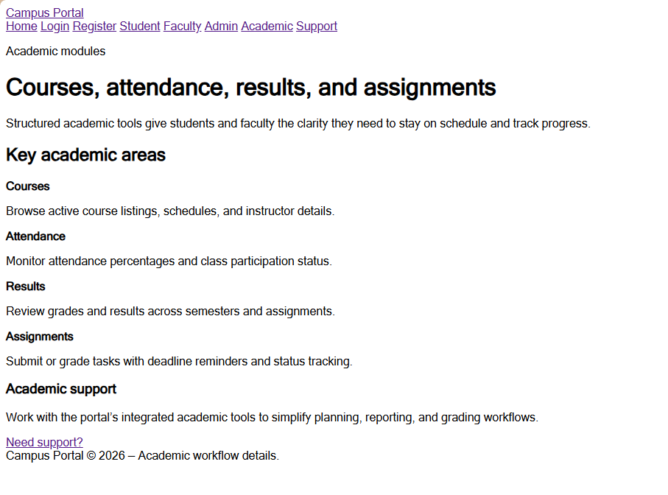
Page 3:
<!DOCTYPE html>
<html lang="en">
<head>
<meta charset="UTF-8">
<meta name="viewport" content="width=device-width, initial-scale=1.0">
<title>Admin Dashboard | Campus Portal</title>
<link rel="stylesheet" href="styles.css">
</head>
<body>
<div class="page-shell">
<header class="site-header">
<a class="brand" href="index.html">Campus Portal</a>
<nav class="site-nav">
<a href="index.html">Home</a>
<a href="login.html">Login</a>
<a href="register.html">Register</a>
<a href="student-dashboard.html">Student</a>
<a href="faculty-dashboard.html">Faculty</a>
<a href="admin-dashboard.html">Admin</a>
<a href="academic.html">Academic</a>
<a href="support.html">Support</a>
</nav>
</header>

<section class="hero hero-simple">
<div>
<p class="eyebrow">Admin dashboard</p>
<h1>Administrator control panel</h1>
<p>Oversee the portal, manage user roles, and review system status in a strong executive dashboard.</p>
</div>
</section>

<main class="detail-grid">
<aside class="detail-card">
<h3>Admin operations</h3>
<p>Configure user access, monitor activity, and keep notifications and announcements centralized.</p>
<strong>System health</strong>
<p>Review active sessions, role assignments, and support requests in one place.</p>
</aside>

<section class="detail-card">
<div class="section-header">
<h2>Admin overview</h2>
<a class="text-link" href="support.html">Open support</a>
</div>
<div class="detail-grid">
<div class="detail-card">
<strong>Active users</strong>
<p>1,248 accounts currently active.</p>
</div>
<div class="detail-card">
<strong>Pending approvals</strong>
<p>5 new registrations need review.</p>
</div>
<div class="detail-card">
<strong>Recent alerts</strong>
<p>2 system notifications sent today.</p>
</div>
<div class="detail-card">
<strong>Support tickets</strong>
<p>3 open support requests.</p>
</div>
</div>
</section>
</main>

<footer class="page-footer">Campus Portal © 2026 — Administrator workspace.</footer>
</div>
</body>
</html>

Output of page 3:
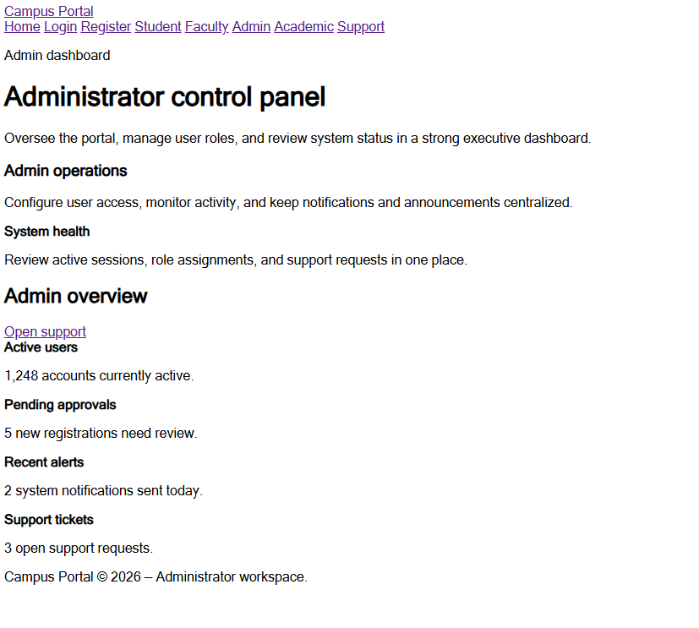

Page 4:
<!DOCTYPE html>
<html lang="en">
<head>
<meta charset="UTF-8">
<meta name="viewport" content="width=device-width, initial-scale=1.0">
<title>Faculty Dashboard | Campus Portal</title>
<!-- <link rel="stylesheet" href="styles.css"> -->
</head>
<body>
<div class="page-shell">
<header class="site-header">
<a class="brand" href="index.html">Campus Portal</a>
<nav class="site-nav">
<a href="index.html">Home</a>
<a href="login.html">Login</a>
<a href="register.html">Register</a>
<a href="student-dashboard.html">Student</a>
<a href="faculty-dashboard.html">Faculty</a>
<a href="admin-dashboard.html">Admin</a>
<a href="academic.html">Academic</a>
<a href="support.html">Support</a>
</nav>
</header>

<section class="hero hero-simple">
<div>
<p class="eyebrow">Faculty dashboard</p>
<h1>Faculty control center</h1>
<p>Manage courses, oversee assignments, and track student performance from one polished faculty page.</p>
</div>
</section>

<main class="detail-grid">
<aside class="detail-card">
<h3>Instructor tools</h3>
<p>Review upcoming lectures, grade submissions, and publish announcements without clutter.</p>
<strong>Course management</strong>
<p>Update syllabi, schedule sessions, and review student attendance at a glance.</p>
</aside>

<section class="detail-card">
<div class="section-header">
<h2>Faculty overview</h2>
<a class="text-link" href="academic.html">Manage academic modules</a>
</div>
<div class="detail-grid">
<div class="detail-card">
<strong>Active courses</strong>
<p>4 courses this semester.</p>
</div>
<div class="detail-card">
<strong>Assignment reviews</strong>
<p>8 submissions pending grading.</p>
</div>
<div class="detail-card">
<strong>Student feedback</strong>
<p>New messages from course participants.</p>
</div>
<div class="detail-card">
<strong>Notifications</strong>
<p>Classroom update posted.</p>
</div>
</div>
</section>
</main>

<footer class="page-footer">Campus Portal © 2026 — Faculty management workspace.</footer>
</div>
</body>
</html>

Output of page 4:
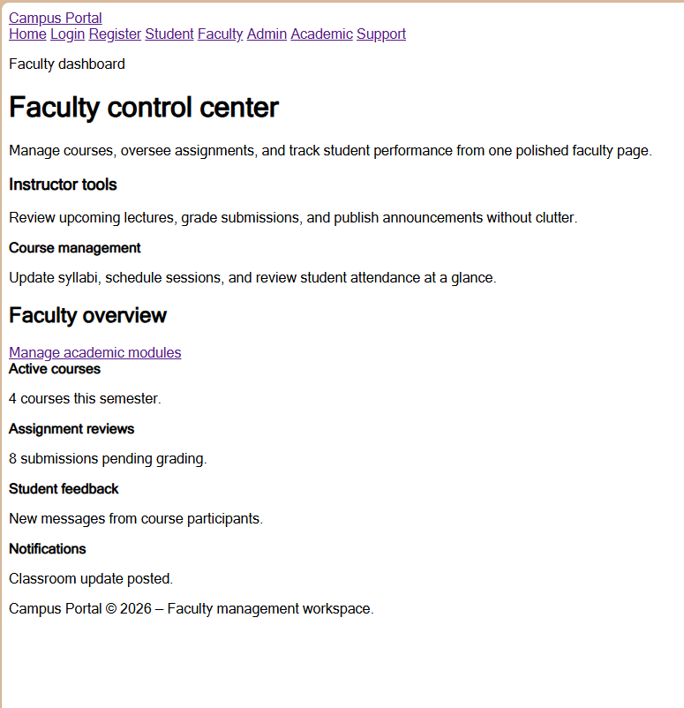
Page 5:
<!DOCTYPE html>
<html lang="en">
<head>
<meta charset="UTF-8">
<meta name="viewport" content="width=device-width, initial-scale=1.0">
<title>Login | Campus Portal</title>
<!-- <link rel="stylesheet" href="styles.css"> -->
</head>
<body>
<div class="page-shell">
<header class="site-header">
<a class="brand" href="index.html">Campus Portal</a>
<nav class="site-nav">
<a href="index.html">Home</a>
<a href="login.html">Login</a>
<a href="register.html">Register</a>
<a href="student-dashboard.html">Student</a>
<a href="faculty-dashboard.html">Faculty</a>
<a href="admin-dashboard.html">Admin</a>
<a href="academic.html">Academic</a>
<a href="support.html">Support</a>
</nav>
</header>

<main class="detail-grid">
<section class="form-panel">
<h2>Login to your account</h2>
<p>Enter your credentials to continue to the portal dashboard for your role.</p>
<form>
<div class="form-field">
<label for="email">Email address</label>
<input id="email" type="email" placeholder="you@example.com">
</div>
<div class="form-field">
<label for="password">Password</label>
<input id="password" type="password" placeholder="Enter your password">
</div>
<div class="checkbox-field">
<input id="remember" type="checkbox">
<label for="remember">Remember me</label>
</div>
<a class="button button-primary" href="student-dashboard.html">Sign in</a>
</form>
</section>

<aside class="detail-card">
<h3>Login information</h3>
<p>Use your registered campus email and password. Students, faculty, and administrators each have tailored access and dashboard views.</p>
<strong>Need help?</strong>
<p>If you lost access, open the support page and submit a request.</p>
</aside>
</main>

<footer class="page-footer">Campus Portal © 2026 — Designed for modern academic workflows.</footer>
</div>
</body>
</html>

Output of Page 5:
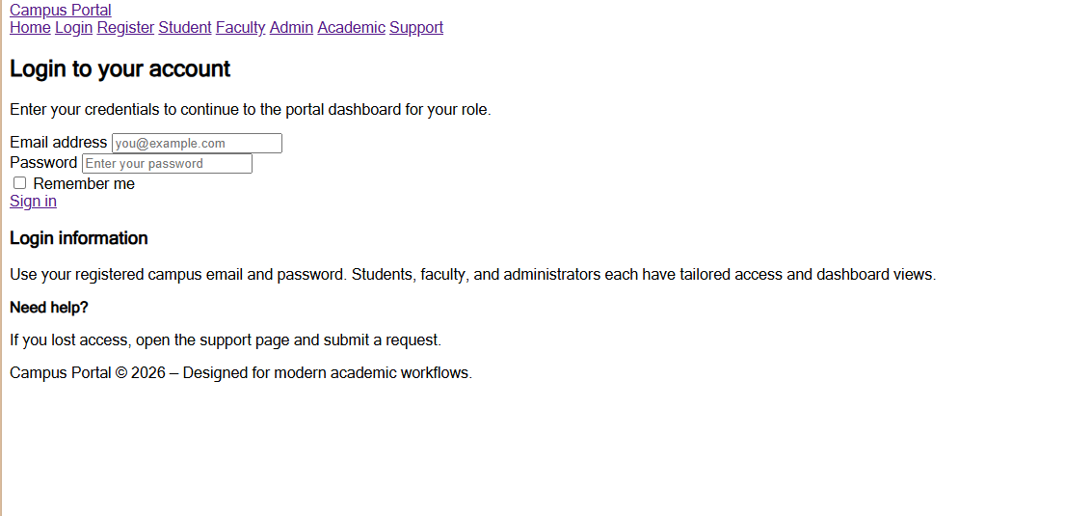
Page 6:
<!DOCTYPE html>
<html lang="en">
<head>
<meta charset="UTF-8">
<meta name="viewport" content="width=device-width, initial-scale=1.0">
<title>Register | Campus Portal</title>
<!-- <link rel="stylesheet" href="styles.css"> -->
</head>
<body>
<div class="page-shell">
<header class="site-header">
<a class="brand" href="index.html">Campus Portal</a>
<nav class="site-nav">
<a href="index.html">Home</a>
<a href="login.html">Login</a>
<a href="register.html">Register</a>
<a href="student-dashboard.html">Student</a>
<a href="faculty-dashboard.html">Faculty</a>
<a href="admin-dashboard.html">Admin</a>
<a href="academic.html">Academic</a>
<a href="support.html">Support</a>
</nav>
</header>

<main class="detail-grid">
<section class="form-panel">
<h2>Create a new campus account</h2>
<p>Register with your role to get the correct dashboard and access level immediately.</p>
<form>
<div class="form-field">
<label for="name">Full name</label>
<input id="name" type="text" placeholder="Your name">
</div>
<div class="form-field">
<label for="email-register">Email address</label>
<input id="email-register" type="email" placeholder="you@example.com">
</div>
<div class="form-field">
<label for="role">Role</label>
<input id="role" type="text" placeholder="Student, Faculty, Admin">
</div>
<div class="form-field">
<label for="password-register">Password</label>
<input id="password-register" type="password" placeholder="Create a password">
</div>
<a class="button button-primary" href="student-dashboard.html">Create account</a>
</form>
</section>

<aside class="detail-card">
<h3>Registration guide</h3>
<p>One account gives access to the appropriate dashboard based on your role: student, faculty, or administrator.</p>
<strong>Already registered?</strong>
<p>Go to the login page to sign in and access your personal portal.</p>
</aside>
</main>

<footer class="page-footer">Campus Portal © 2026 — Designed for modern academic workflows.</footer>
</div>
</body>
</html>

Output of page 6:
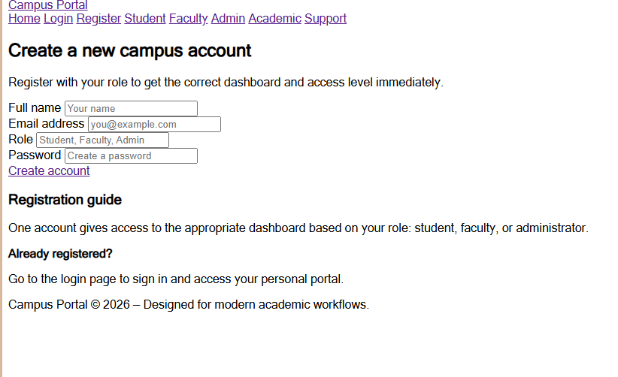
Page 7:
<!DOCTYPE html>
<html lang="en">
<head>
<meta charset="UTF-8">
<meta name="viewport" content="width=device-width, initial-scale=1.0">
<title>Student Hub - Result</title>
<link rel="stylesheet" href="style.css">
</head>
<body>

<div class="result-container">
<h2>Student Result</h2>
<!DOCTYPE html>
<html lang="en">
<head>
<meta charset="UTF-8">
<meta name="viewport" content="width=device-width, initial-scale=1.0">
<title>Student Dashboard | Campus Portal</title>
<!-- <link rel="stylesheet" href="styles.css"> -->
</head>
<body>
<div class="page-shell">
<header class="site-header">
<a class="brand" href="index.html">Campus Portal</a>
<nav class="site-nav">
<a href="index.html">Home</a>
<a href="login.html">Login</a>
<a href="register.html">Register</a>
<a href="student-dashboard.html">Student</a>
<a href="faculty-dashboard.html">Faculty</a>
<a href="admin-dashboard.html">Admin</a>
<a href="academic.html">Academic</a>
<a href="support.html">Support</a>
</nav>
</header>

<section class="hero hero-simple">
<div>
<p class="eyebrow">Student dashboard</p>
<h1>Student workspace</h1>
<p>Stay on top of your courses, attendance, results, and assignments with a clean academic view.</p>
</div>
</section>

<main class="detail-grid">
<aside class="detail-card">
<h3>Quick actions</h3>
<p>Jump directly to your course list, attendance summary, grades overview, and assignment tracker.</p>
<strong>Course progress</strong>
<p>Review your current course load and upcoming deadlines in one place.</p>
</aside>

<section class="detail-card">
<div class="section-header">
<h2>Student overview</h2>
<a class="text-link" href="academic.html">Academic details</a>
</div>
<div class="detail-grid">
<div class="detail-card">
<strong>Current GPA</strong>
<p>3.82</p>
</div>
<div class="detail-card">
<strong>Attendance</strong>
<p>96% overall in active courses.</p>
</div>
<div class="detail-card">
<strong>Upcoming assignment</strong>
<p>Research essay due in 4 days.</p>
</div>
<div class="detail-card">
<strong>Notifications</strong>
<p>New instructor message available.</p>
</div>
</div>
</section>
</main>

<footer class="page-footer">Campus Portal © 2026 — Student workflow view.</footer>
</div>
</body>
</html>

Output of page 7:
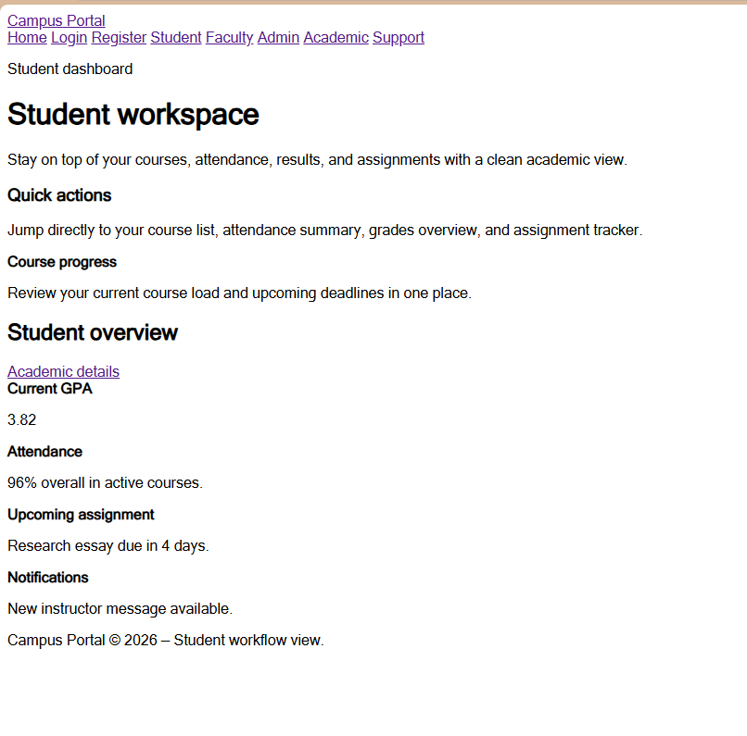
Page 8:
<!DOCTYPE html>
<html lang="en">
<head>
<meta charset="UTF-8">
<meta name="viewport" content="width=device-width, initial-scale=1.0">
<title>Support | Campus Portal</title>
<!-- <link rel="stylesheet" href="styles.css"> -->
</head>
<body>
<div class="page-shell">
<header class="site-header">
<a class="brand" href="index.html">Campus Portal</a>
<nav class="site-nav">
<a href="index.html">Home</a>
<a href="login.html">Login</a>
<a href="register.html">Register</a>
<a href="student-dashboard.html">Student</a>
<a href="faculty-dashboard.html">Faculty</a>
<a href="admin-dashboard.html">Admin</a>
<a href="academic.html">Academic</a>
<a href="support.html">Support</a>
</nav>
</header>

<section class="hero hero-simple">
<div>
<p class="eyebrow">Account & support</p>
<h1>Support and account resources</h1>
<p>Access profile settings, notifications, and contact resources to keep every portal user supported.</p>
</div>
</section>

<main class="detail-grid">
<section class="detail-card">
<h2>Help topics</h2>
<div class="detail-grid">
<div class="detail-card">
<strong>Profile</strong>
<p>Update your account details, password, and contact information.</p>
</div>
<div class="detail-card">
<strong>Notifications</strong>
<p>Manage alerts for deadlines, announcements, and system updates.</p>
</div>
<div class="detail-card">
<strong>About</strong>
<p>Learn how the portal works and what each dashboard provides.</p>
</div>
<div class="detail-card">
<strong>Contact</strong>
<p>Submit a request or reach support directly for any issue.</p>
</div>
</div>
</section>

<aside class="detail-card">
<h3>Submit a request</h3>
<p>If you have an issue logging in, registering, or using the portal, contact support for faster help.</p>
<strong>Email</strong>
<p>support@campusportal.example</p>
</aside>
</main>

<footer class="page-footer">Campus Portal © 2026 — Support center.</footer>
</div>
</body>
</html>

Output of page 8:

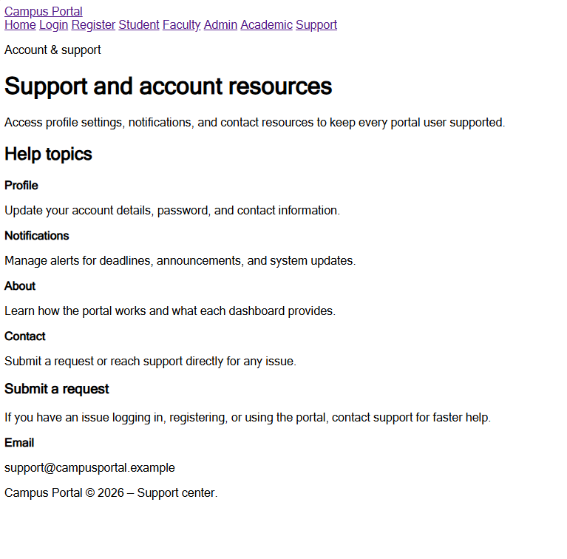
Learning outcome :
Students will create clean, linked, and accessibility-ready HTML page structures.

