Faculty of Technology and Engineering
Chandubhai S. Patel Institute of Technology (CSPIT)
Department of Computer Science & Engineering
Date: 6 /8 / 26
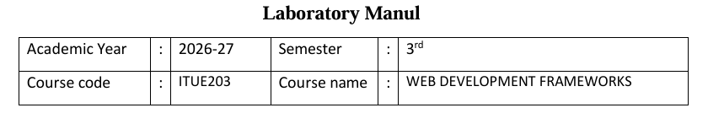
Practical – 3
PROBLEM STATEMENT : Design responsive layouts for Home, About, Registration, Dashboard, and Events pages using CSS Grid and Flexbox. Optional to use CSS
framework such as Bootstrap or Tailwind. Ensure mobile-first responsiveness.
Objective:-
To design responsive and mobile-first layouts for the Home, About, Registration, Dashboard, and Events pages using CSS Grid and Flexbox (or a CSS framework like Bootstrap or Tailwind) to ensure an accessible, user-friendly, and consistent experience across different screen sizes.
Code:
:root {
color-scheme: light;
font-family: Inter, 'Segoe UI', Tahoma, Geneva, Verdana, sans-serif;
font-size: 16px;
background: #f1f5f9;
color: #0f172a;
--surface: #ffffff;
--surface-muted: #f8fafc;
--border: #e2e8f0;
--text: #0f172a;
--muted: #475569;
--accent: #24546f;
--accent-soft: #dbeafe;
--shadow: 0 24px 80px rgba(15, 23, 42, 0.08);
}

* {
box-sizing: border-box;
}

html, body {
margin: 0;
min-height: 100%;
}

body {
background: radial-gradient(circle at top, rgba(37, 99, 235, 0.08), transparent 40%),
linear-gradient(180deg, #f8fafc 0%, #e2e8f0 100%);
}

img, svg {
max-width: 100%;
}

button, input, textarea {
font: inherit;
}

.page-shell {
width: min(1140px, calc(100% - 32px));
margin: 0 auto;
padding: 28px 0 48px;
}

.site-header {
display: flex;
align-items: center;
justify-content: space-between;
gap: 24px;
padding: 16px 24px;
margin-bottom: 24px;
border-radius: 24px;
background: rgba(255, 255, 255, 0.85);
border: 1px solid rgba(226, 232, 240, 0.9);
backdrop-filter: blur(16px);
}

.brand {
color: var(--accent);
font-size: 1.15rem;
font-weight: 700;
text-decoration: none;
}

.site-nav {
display: flex;
flex-wrap: wrap;
gap: 16px;
}

.site-nav a {
color: var(--muted);
text-decoration: none;
padding: 8px 10px;
border-radius: 14px;
transition: background-color 0.2s ease, color 0.2s ease;
}

.site-nav a:hover,
.site-nav a:focus-visible {
background: var(--accent-soft);
color: var(--accent);
}

.hero {
display: grid;
grid-template-columns: 1.4fr 1fr;
gap: 32px;
align-items: center;
padding: 42px;
border-radius: 32px;
background: linear-gradient(180deg, rgba(255,255,255,0.96), rgba(241,245,249,0.98));
border: 1px solid var(--border);
box-shadow: var(--shadow);
}

.hero-copy {
max-width: 620px;
}

.eyebrow {
margin: 0 0 16px;
display: inline-flex;
align-items: center;
gap: 10px;
padding: 10px 16px;
border-radius: 999px;
background: #e2eff9;
color: #1e3a57;
font-size: 0.88rem;
font-weight: 700;
letter-spacing: 0.08em;
text-transform: uppercase;
}

.hero h1 {
margin: 0 0 22px;
font-size: clamp(2.5rem, 3.4vw, 3.8rem);
line-height: 1.05;
color: var(--text);
}

.hero p {
margin: 0 0 30px;
color: var(--muted);
font-size: 1.05rem;
line-height: 1.8;
}

.hero-actions {
display: flex;
flex-wrap: wrap;
gap: 16px;
}

.button {
display: inline-flex;
align-items: center;
justify-content: center;
min-height: 52px;
padding: 0 24px;
border-radius: 999px;
text-decoration: none;
font-weight: 700;
transition: transform 0.2s ease, box-shadow 0.2s ease, background-color 0.2s ease, color 0.2s ease;
}

.button:hover,
.button:focus-visible {
transform: translateY(-1px);
}

.button-primary {
background: var(--accent);
color: #ffffff;
box-shadow: 0 16px 32px rgba(36, 84, 111, 0.18);
}

.button-secondary {
background: transparent;
color: var(--accent);
border: 1px solid rgba(36, 84, 111, 0.16);
}

.button-tertiary {
background: #f8fafc;
color: var(--text);
border: 1px solid var(--border);
}

.hero-panel {
display: grid;
gap: 20px;
}

.panel-card {
padding: 28px;
border-radius: 28px;
background: var(--surface);
border: 1px solid var(--border);
box-shadow: var(--shadow);
transition: transform 0.24s ease, border-color 0.24s ease;
}

.panel-card-alt {
background: #f8fbfd;
}

.panel-card:hover {
transform: translateY(-2px);
border-color: rgba(36, 84, 111, 0.18);
}

.panel-card h2 {
margin: 0 0 12px;
font-size: 1.45rem;
color: var(--text);
}

.role-select-button.active-role {
box-shadow: 0 0 0 3px rgba(36, 84, 111, 0.18);
}

.role-message {
margin-top: 16px;
padding: 18px 20px;
border-radius: 18px;
background: #eff8ff;
color: #1e3a57;
font-size: 0.98rem;
border: 1px solid rgba(56, 117, 183, 0.15);
}

.login-modal {
position: fixed;
inset: 0;
display: none;
align-items: center;
justify-content: center;
z-index: 40;
}

.login-modal.visible {
display: flex;
}

.login-modal-backdrop {
position: absolute;
inset: 0;
background: rgba(15, 23, 42, 0.55);
backdrop-filter: blur(3px);
}

.login-modal-content {
position: relative;
width: min(540px, calc(100% - 32px));
padding: 0;
border-radius: 28px;
background: var(--surface);
box-shadow: 0 40px 120px rgba(15, 23, 42, 0.2);
z-index: 1;
}

.form-panel {
padding: 36px 32px 32px;
}

.modal-close {
position: absolute;
top: 18px;
right: 18px;
border: none;
background: transparent;
color: var(--muted);
font-size: 1.8rem;
cursor: pointer;
line-height: 1;
}

.login-error {
min-height: 24px;
margin-bottom: 16px;
color: #b91c1c;
font-weight: 600;
}

main {
display: grid;
gap: 28px;
margin-top: 34px;
}
.overview-grid,
.feature-grid,
.detail-grid {
display: grid;
gap: 24px;
}

.overview-grid {
grid-template-columns: repeat(3, minmax(0, 1fr));
}

.feature-grid {
grid-template-columns: repeat(2, minmax(0, 1fr));
}

.dashboard-card,
.feature-card,
.detail-card,
.form-panel {
padding: 30px;
border-radius: 28px;
background: var(--surface);
border: 1px solid var(--border);
box-shadow: var(--shadow);
}

.dashboard-card span {
display: inline-flex;
margin-bottom: 16px;
font-size: 0.95rem;
font-weight: 700;
color: var(--accent);
}

.dashboard-card h2,
.feature-card h3,
.detail-card h3,
.form-panel h2 {
margin: 0 0 16px;
color: var(--text);
font-size: 1.5rem;
}

.dashboard-card p,
.feature-card p,
.detail-card p {
margin: 0 0 20px;
color: var(--muted);
line-height: 1.75;
}

.text-link {
color: var(--accent);
text-decoration: none;
font-weight: 700;
}

.text-link:hover {
text-decoration: underline;
}

.section-header {
display: flex;
align-items: center;
justify-content: space-between;
gap: 16px;
}

.section-header h2 {
margin: 0;
font-size: 1.8rem;
}

.detail-grid {
grid-template-columns: repeat(2, minmax(0, 1fr));
}

.detail-card {
display: flex;
flex-direction: column;
gap: 12px;
}

.detail-card strong {
display: block;
color: var(--text);
margin-bottom: 8px;
}

.form-panel {
max-width: 520px;
}

.form-field {
display: grid;
gap: 10px;
margin-bottom: 18px;
}

.form-field label {
font-weight: 600;
color: var(--text);
}

.form-field input {
width: 100%;
min-height: 50px;
padding: 0 16px;
border: 1px solid var(--border);
border-radius: 16px;
background: #fff;
color: var(--text);
}

.form-field input:focus {
outline: none;
border-color: #84b2d1;
box-shadow: 0 0 0 4px rgba(36, 84, 111, 0.1);
}

.checkbox-field {
display: flex;
align-items: center;
gap: 12px;
color: var(--muted);
}

.page-footer {
margin-top: 36px;
padding-top: 22px;
border-top: 1px solid #e2e8f0;
color: var(--muted);
font-size: 0.95rem;
}

@media (max-width: 980px) {
.site-header {
flex-direction: column;
align-items: flex-start;
}

.hero {
grid-template-columns: 1fr;
padding: 28px;
}

.overview-grid,
.feature-grid,
.detail-grid {
grid-template-columns: 1fr;
}
}

@media (max-width: 640px) {
.page-shell {
width: min(100%, calc(100% - 24px));
padding: 20px 0 32px;
}

.hero {
border-radius: 24px;
}

.hero-actions {
flex-direction: column;
align-items: stretch;
}

.site-nav {
width: 100%;
justify-content: flex-start;
}
}

Screenshot :

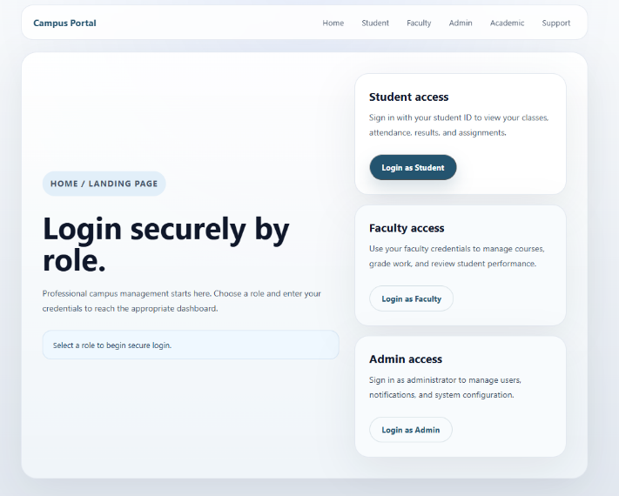
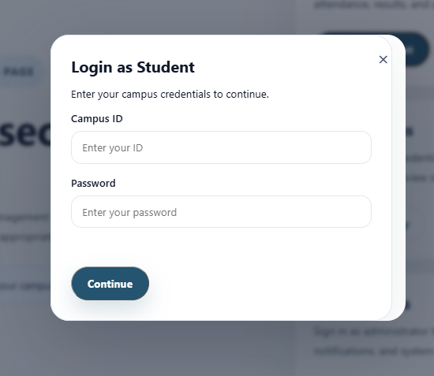
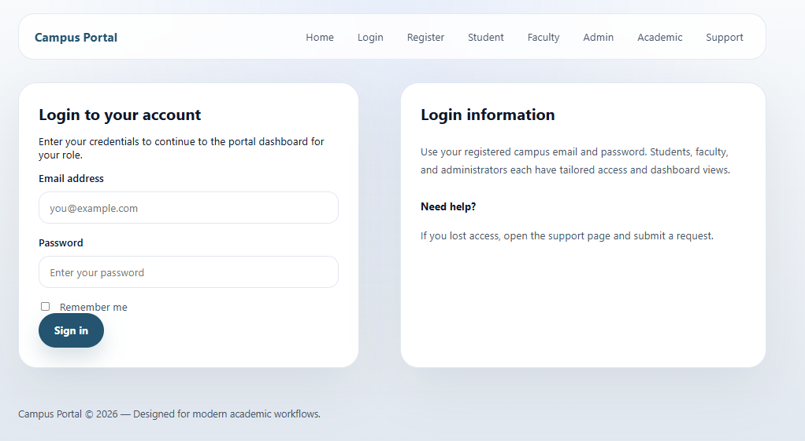
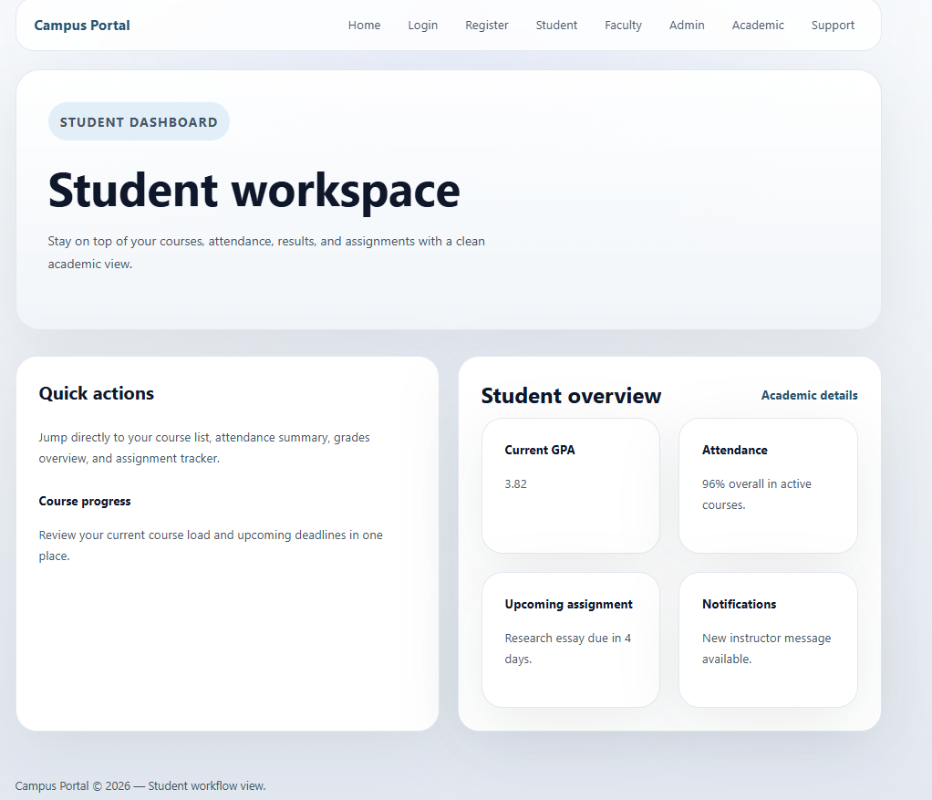
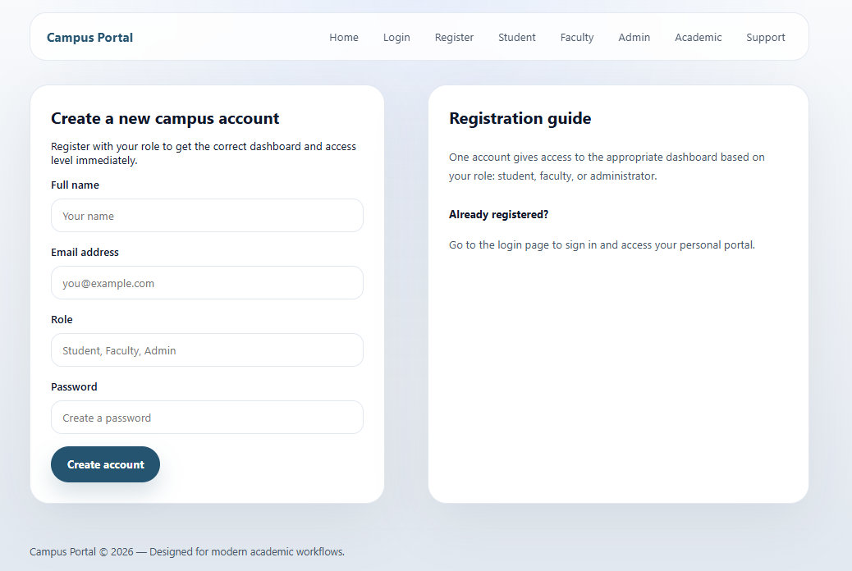
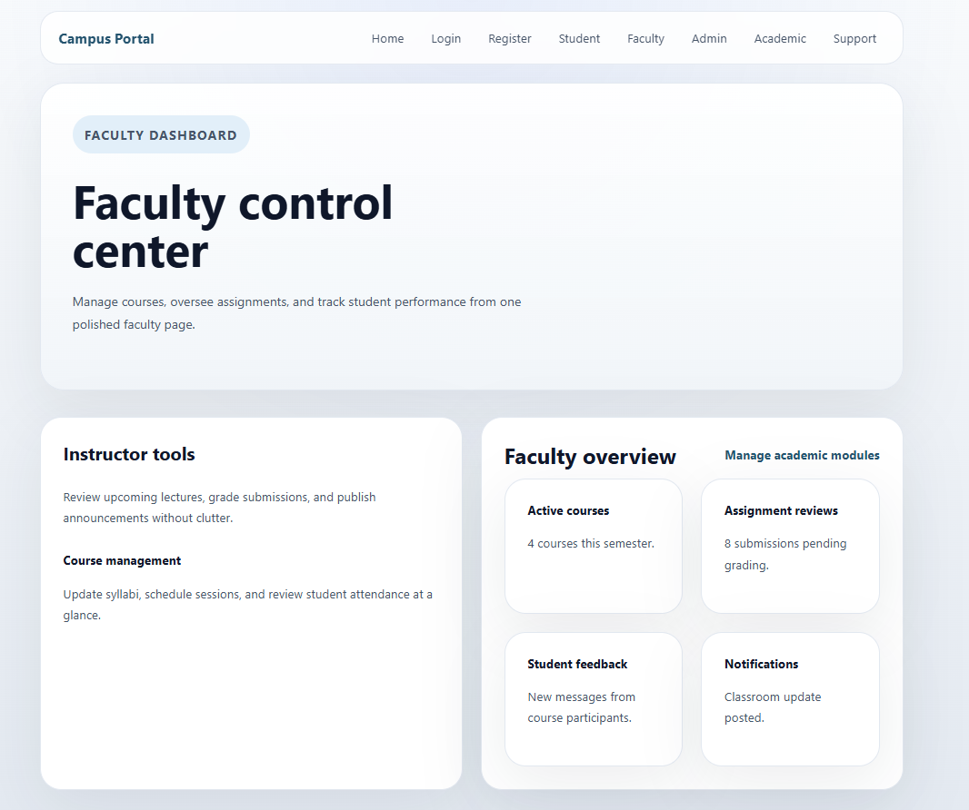
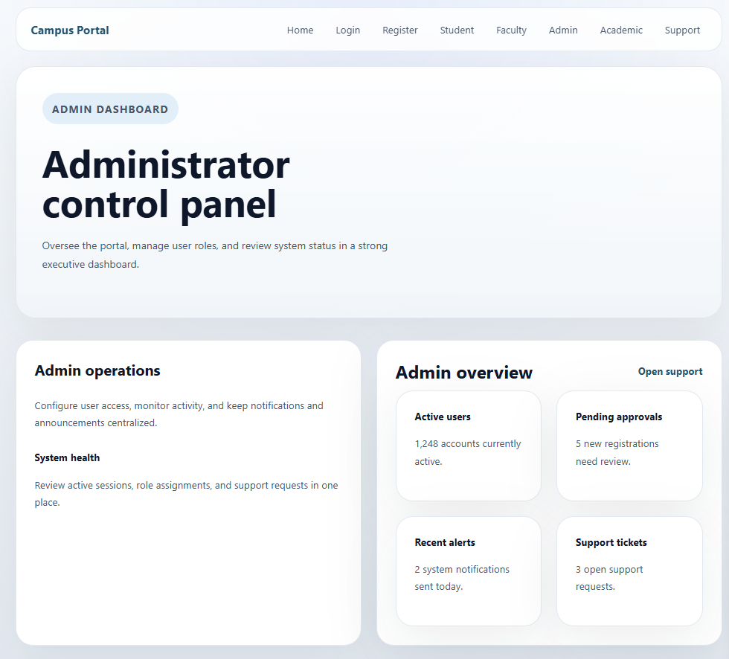
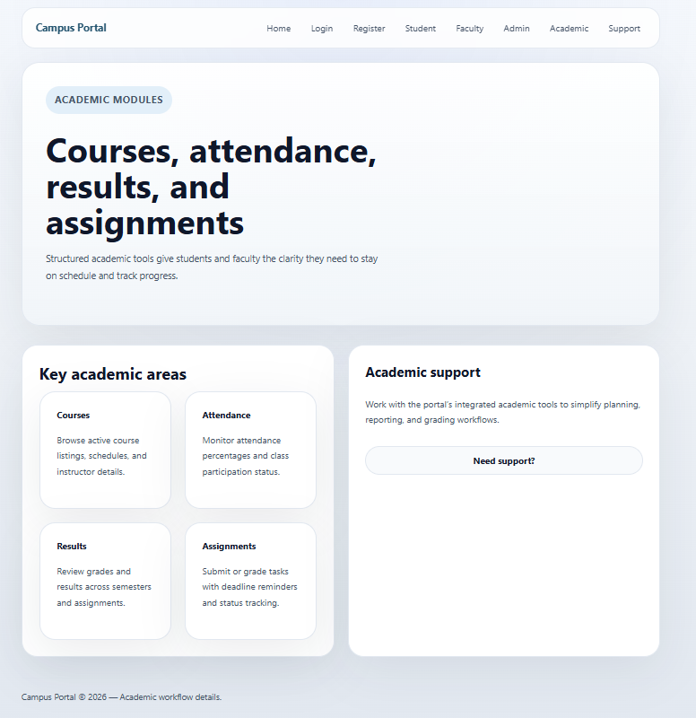
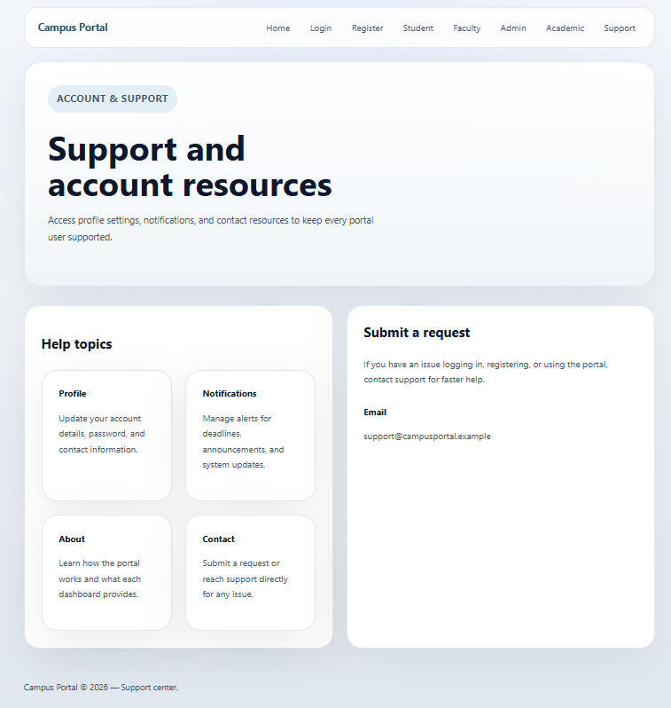

Learning outcome :
Students will design a professional, responsive, and reusable UI layout.

