Faculty of Technology and Engineering
Chandubhai S. Patel Institute of Technology (CSPIT)
Department of Computer Science & Engineering
Date: 6 /8 / 26
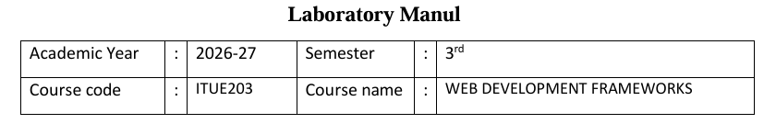
Practical – 4
PROBLEM STATEMENT : Design responsive layouts for Home, About, Registration, Dashboard, and Events pages using CSS Grid and Flexbox. Optional to use CSS
framework such as Bootstrap or Tailwind. Ensure mobile-first responsiveness.
Objective:-
To design responsive and mobile-first layouts for the Home, About, Registration, Dashboard, and Events pages using CSS Grid and Flexbox (or a CSS framework like Bootstrap or Tailwind) to ensure an accessible, user-friendly, and consistent experience across different screen sizes.
Code:

For Slider :
.hero-gallery {
display: block;
padding: 36px 42px;
}

.slider-card {
margin-top: 24px;
padding: 24px;
border-radius: 32px;
background: rgba(255, 255, 255, 0.95);
border: 1px solid var(--border);
box-shadow: var(--shadow);
}

.slider-frame {
position: relative;
display: grid;
align-items: center;
}

.slider-track {
position: relative;
min-height: 460px;
overflow: hidden;
border-radius: 24px;
}

.slide {
position: absolute;
inset: 0;
opacity: 0;
transform: translateX(24px);
transition: opacity 0.45s ease, transform 0.45s ease;
}

.slide.active {
opacity: 1;
transform: translateX(0);
}

.slide img {
width: 100%;
height: 460px;
object-fit: cover;
display: block;
}

.slide-caption {
position: absolute;
left: 24px;
right: 24px;
bottom: 24px;
padding: 20px 24px;
border-radius: 18px;
background: rgba(15, 23, 42, 0.72);
color: #ffffff;
backdrop-filter: blur(6px);
}

.slide-caption h2 {
margin: 0 0 8px;
font-size: 1.3rem;
}

.slide-caption p {
margin: 0;
color: rgba(255,255,255,0.9);
}

.slider-control {
position: absolute;
top: 50%;
transform: translateY(-50%);
z-index: 2;
border: none;
width: 46px;
height: 46px;
border-radius: 50%;
background: rgba(255, 255, 255, 0.9);
color: var(--accent);
font-size: 1.2rem;
cursor: pointer;
box-shadow: 0 12px 24px rgba(15, 23, 42, 0.14);
}

.slider-control.prev {
left: 16px;
}

.slider-control.next {
right: 16px;
}

.slider-dots {
display: flex;
justify-content: center;
gap: 10px;
margin-top: 16px;
}

Screenshot :

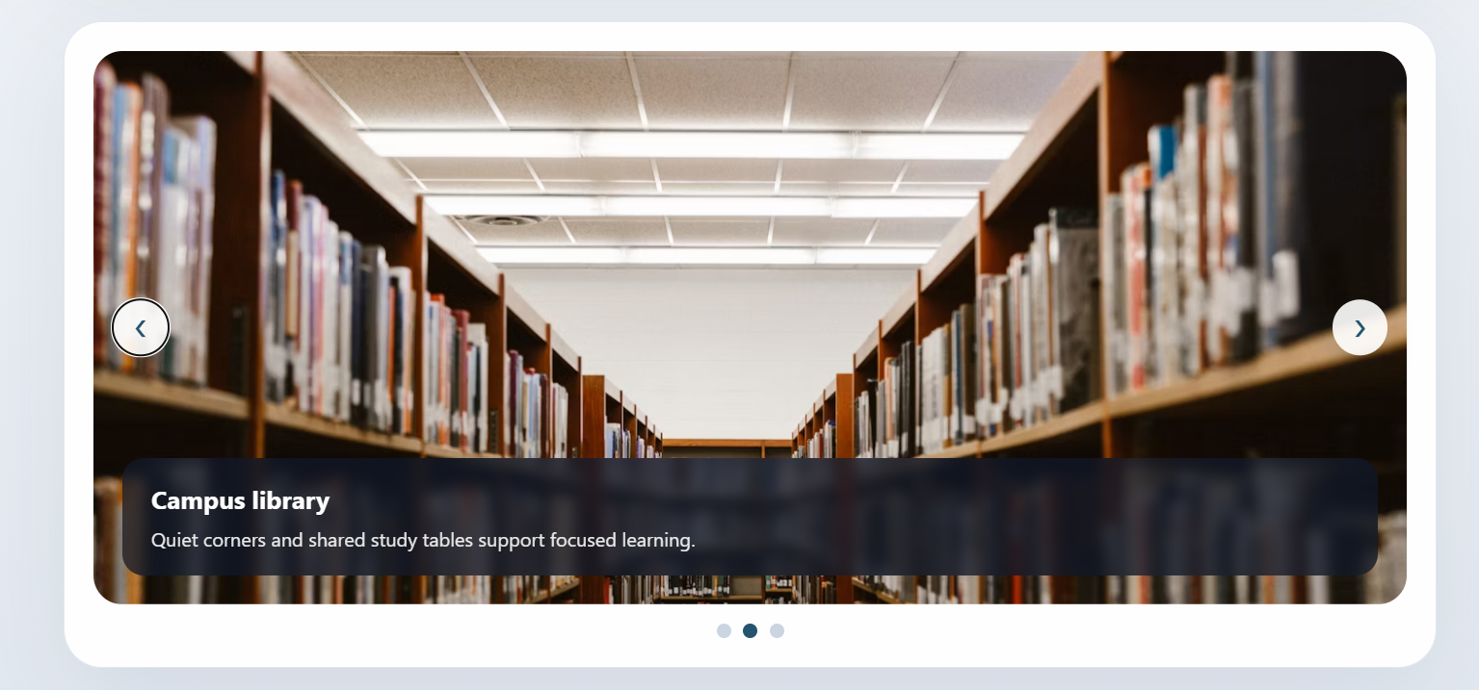
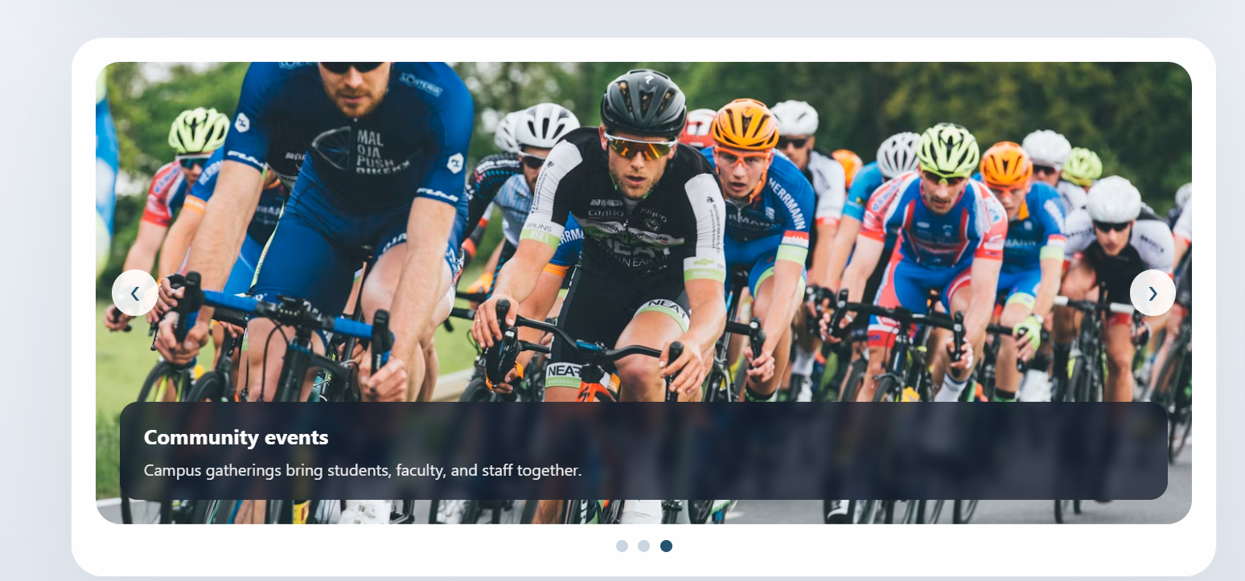

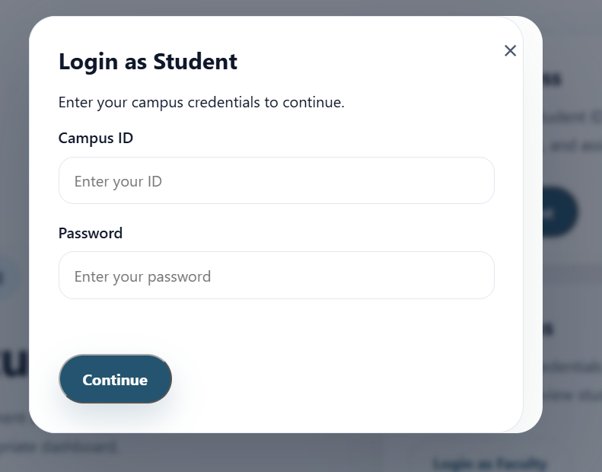
Menu:
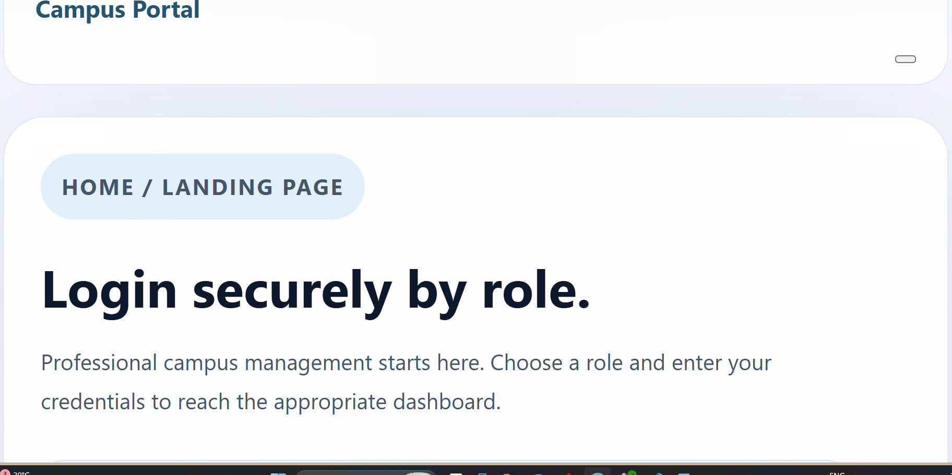
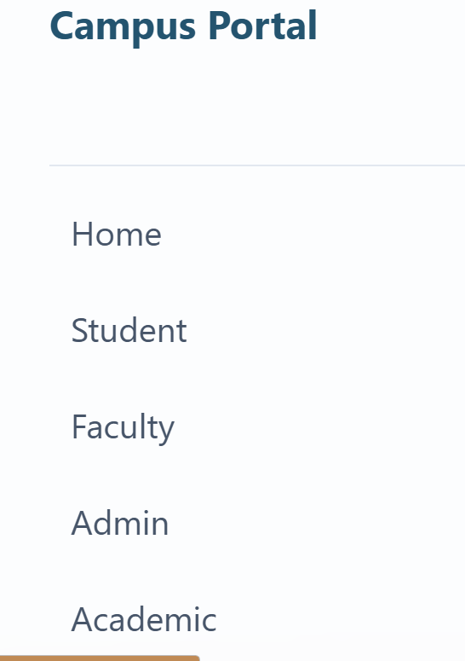
Learning outcome :
Students will design a professional, responsive, and reusable UI layout.

