

**UNITEDWORLD SCHOOL OF COMPUTATIONAL INTELLIGENCE (USCI)**

**Submitted By**

**Yash Gedia**

**(Enrl. No.: 20200701007)**

**Course Code and Title: 21BSCS23C02**

**R programming**

**B.Sc. (Hons.) Computer Science / Data Science / AIML**

**III Semester – July – Nov 2023**



Nov/Dec 2023

**US Minimum Wage by State in 1968**

**Dataset:**

US Minimum Wage by State from 1968 to 2020 by LISLEJOEM via Kaggle.

Introduction to the dataset:

In order to guarantee that residents in the United States have a minimal standard of living, states and the federal government set minimum hourly compensation, or "minimum wage," that employees can receive. The minimum wage data from 1968 to 2020, as set by the federal government and each state, are provided in this dataset.

**Objective:**

The Main goal was to examine the trends in US minimum wage rates from 1968 to 2020. This could be done by looking at the minimum wage rates for each state and the federal minimum wage rate. The report could also examine how the minimum wage has changed in real terms, adjusted for inflation.

**Structure of Dataset:**

This is a dataset with 2863 Rows and 15 columns named

"Year"

"State"

"State.Minimum.Wage"

"State.Minimum.Wage.2020.Dollars"

"Federal.Minimum.Wage"

"Federal.Minimum.Wage.2020.Dollars"

"Effective.Minimum.Wage"

"Effective.Minimum.Wage.2020.Dollars"

"CPI.Average"

"Department.Of.Labor.Uncleaned.Data"

"Department.Of.Labor.Cleaned.Low.Value"

"Department.Of.Labor.Cleaned.Low.Value.2020.Dollars"

"Department.Of.Labor.Cleaned.High.Value"

"Department.Of.Labor.Cleaned.High.Value.2020.Dollars"

"Footnote".

**Source:**

<https://www.kaggle.com/datasets/lislejoem/us-minimum-wage-by-state-from-1968-to-2017>

**Functions Used:**

1. **Filter():** Only Selects the Rows and columns that matches with the given condition.

Input:

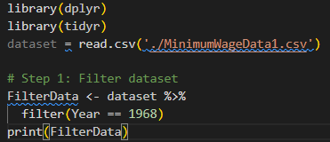

**Output:**

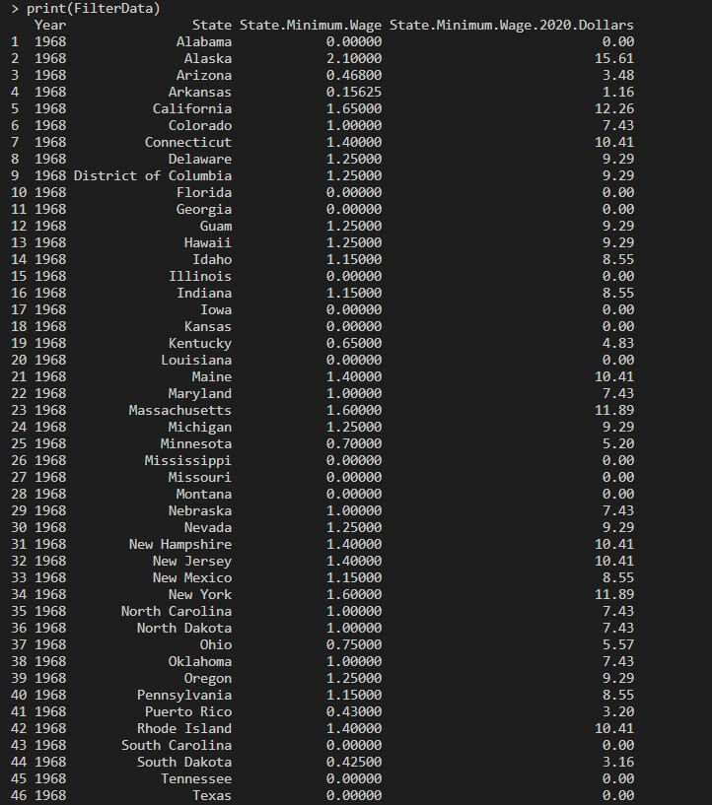

1. nrows():- Displays the number of rows present in a dataset.

**Input:**

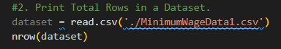

**Output:**



1. **ncol:** Print the number ofcolumn in dataset.

**Input:**

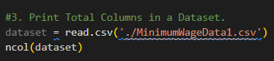

**Output:-**



1. **dim():** Prints the dimension of Dataset.

Input:

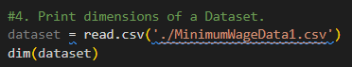

Output:



1. **names():** Prints the name of every column.

Input:

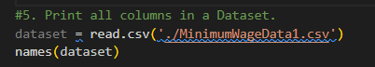

**Output:**

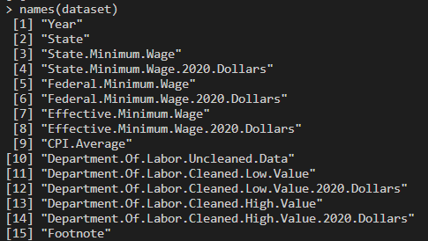

1. **sort():** Sorts the Rows from a selected column and sorts in ascending order by default.

**Input:-**

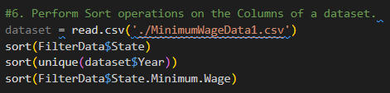

**Output:**

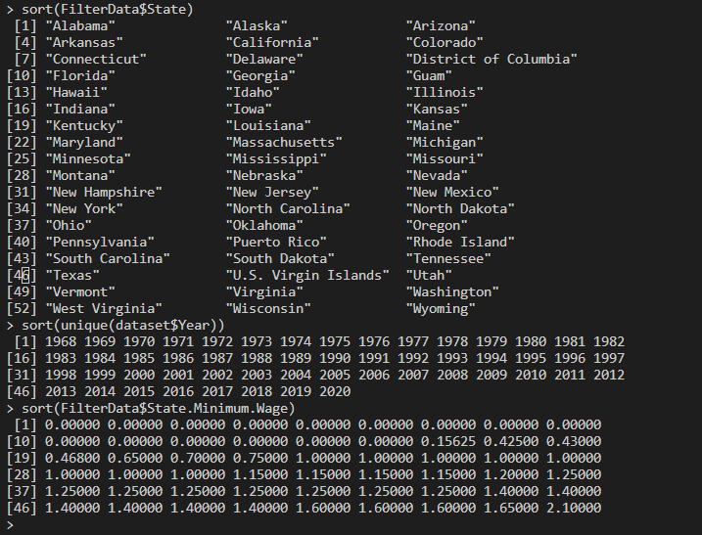

1. **summary():** This function will calculate the Minimum, 1st Quartile, Median, Mean, 3rd Quartile and Maximum of the selected column from dataset.

**Input:**

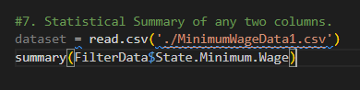

**Output:**



So this was the statistical summary of the dataset but this summary is done on only the data of the year 1968.

Data Visualization

The act of producing graphical representations of data in R to aid in understanding and interpretation of the relationships, patterns, and trends discovered in the data is known as data visualization. R has an extensive ecosystem of functions and packages designed specifically for generating different types of visualizations, making it a useful tool for undertaking exploratory data analysis and disseminating research findings.

1. Scatter Chart:- graphical display that shows individual data points on a two-dimensional graph is called a scatter plot.

Input:-

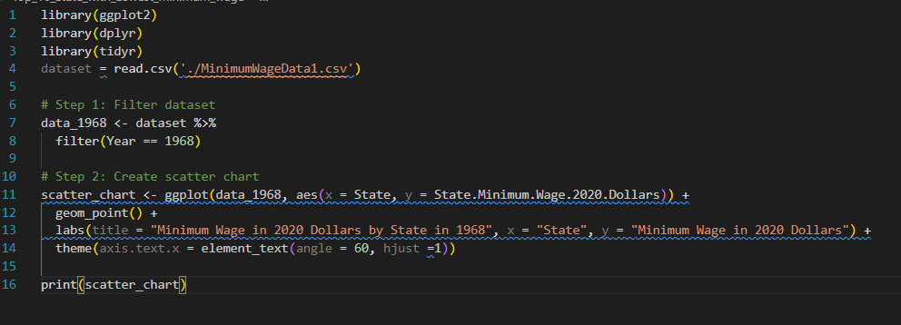

Output:-

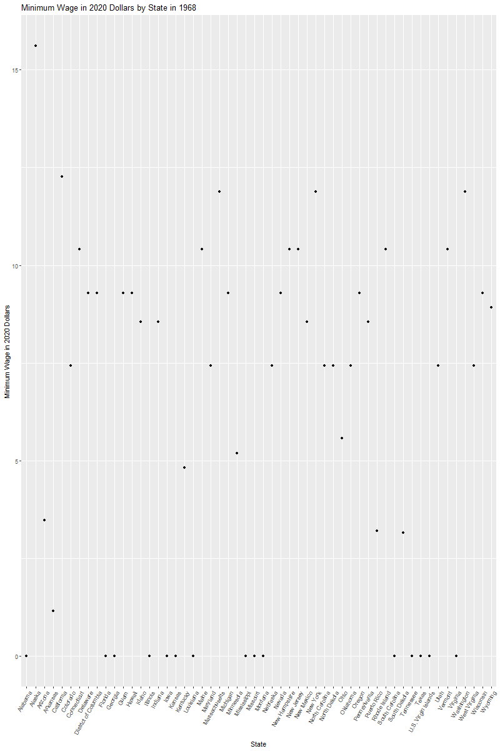

1. Histogram: A histogram is a graph that shows the frequency of numerical data using rectangles.

Input:

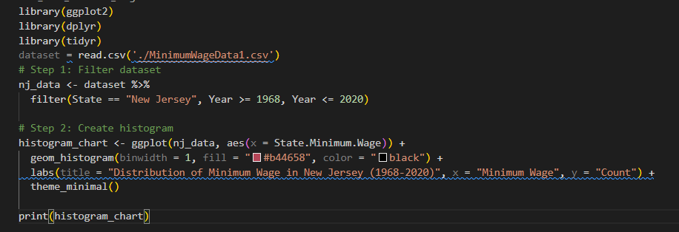

Output:

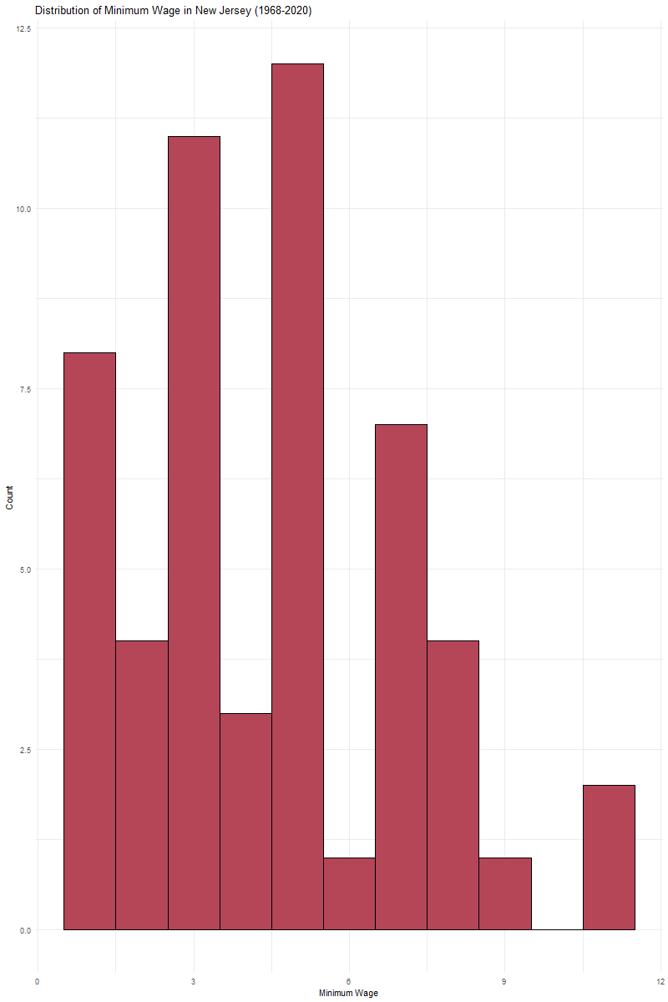

1. Line Chart:- This chart plots the data in a 2D graph and each point I joined by a line.

Input:-

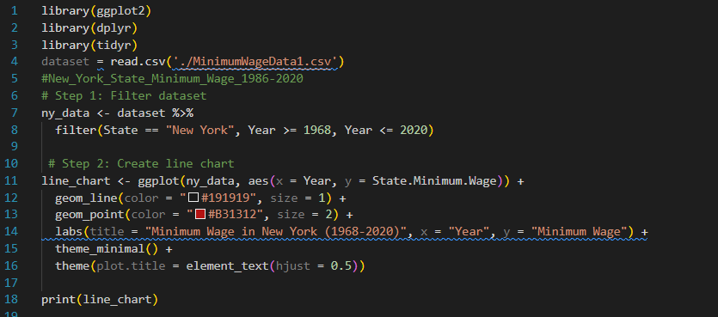

Output:-

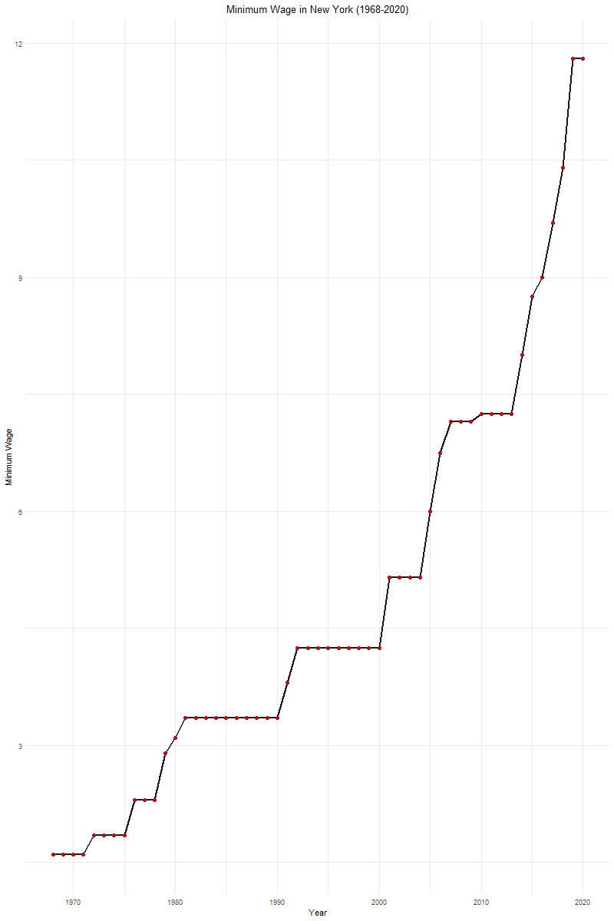

1. Bar chart: This is Similar to histogram but here there is space between each rectangle bar.

Input:-

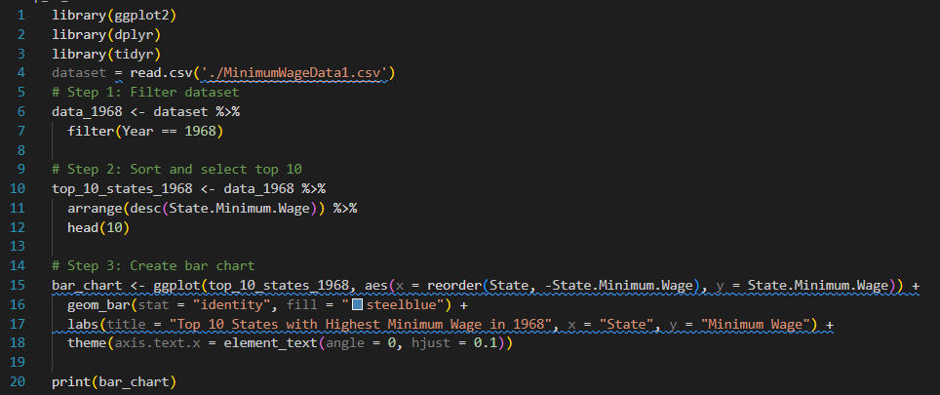

Output:-

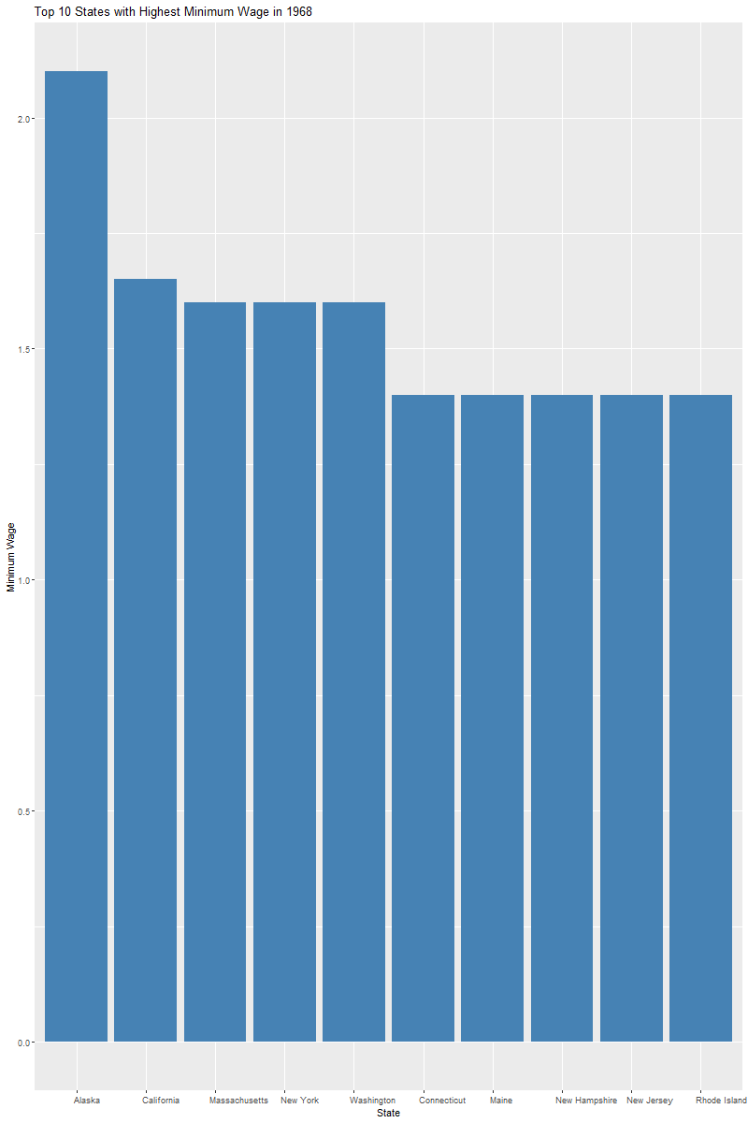

1. Pie chart:- Circular representation of data is called pie chart.

Input:-

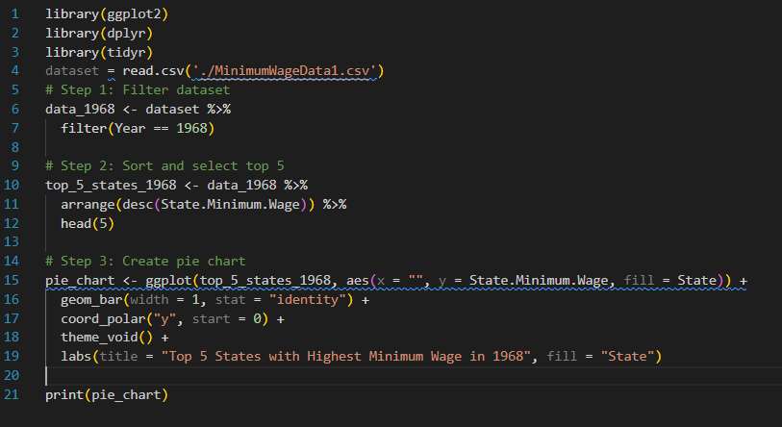

Output:-

