***TASK-2***

***PROBLEM_STATEMENTS_2***

***SQL***

**1. Create a table named ‘matches’ with appropriate data types for columns.**

CREATE TABLE MATCHES (

ID INT PRIMARY KEY,

CITY VARCHAR(40),

DATE DATE,

PLAYER_OF_MATCH VARCHAR(40),

VENUE VARCHAR(80),

NEUTRAL_VENUE INT,

TEAM1 VARCHAR(80),

TEAM2 VARCHAR(80),

TOSS_WINNER VARCHAR(80),

TOSS_DECISION VARCHAR(20),

WINNER VARCHAR(80),

RESULT VARCHAR(40),

RESULT_MARGIN INT,

ELIMINATOR VARCHAR(10),

METHOD VARCHAR(10),

UMPIRE1 VARCHAR(40),

UMPIRE2 VARCHAR(40)

);

**2. Create a table named ‘deliveries’ with appropriate data types for columns.**

CREATE TABLE DELIVERIES (

ID INT,

INNING INT,

OVER INT,

BALL INT,

BATSMAN VARCHAR(40),

NON_STRIKER VARCHAR(40),

BOWLER VARCHAR(40),

BATSMAN_RUNS INT,

EXTRA_RUNS INT,

TOAL_RUNS INT,

IS_WICKET INT,

DISMISSAL_KIND VARCHAR(40),

PLAYER_DISMISSED VARCHAR(40),

FIELDER VARCHAR(100),

EXTRAS_TYPE VARCHAR(40),

BATTING_TEAM VARCHAR(40),

BOWLING_TEAM VARCHAR(40),

FOREIGN KEY(id) REFERENCES matches(id)

);

**3. Import data from CSV file ’IPL_matches.csv’ attached in resources to ‘matches’**

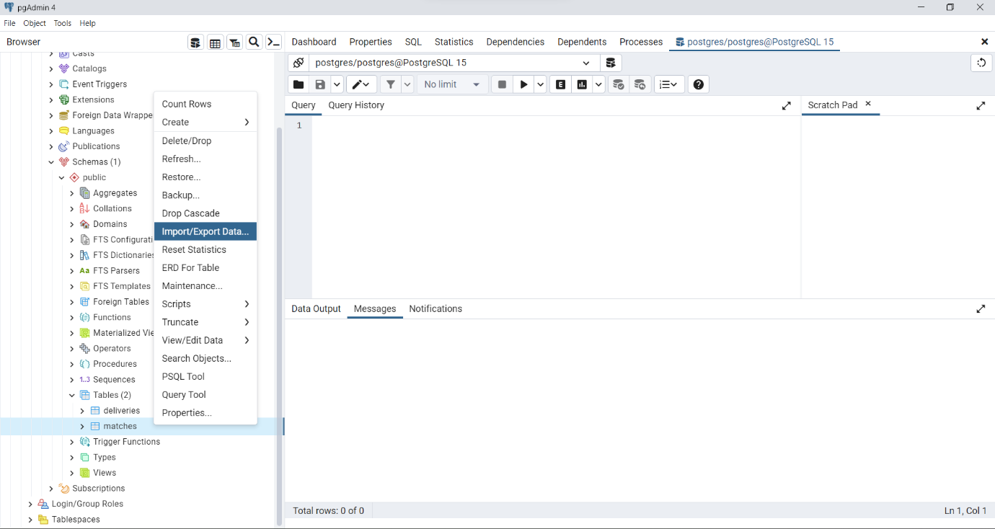

**4. Import data from CSV file ’IPL_Ball.csv’ attached in resources to ‘deliveries’**

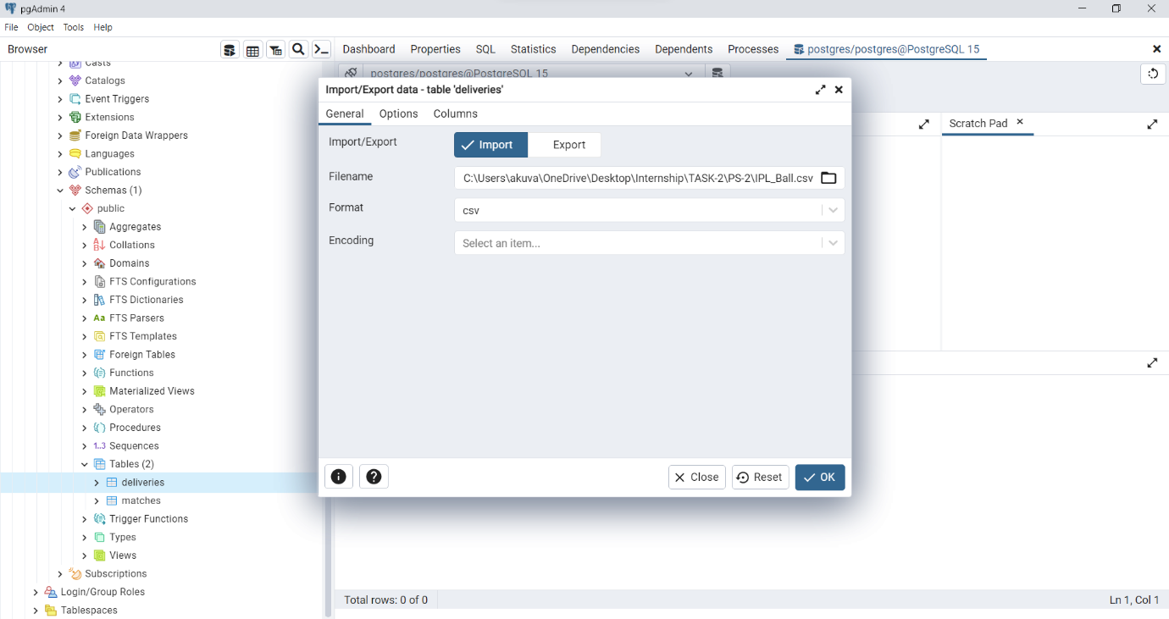

**5. Select the top 20 rows of the deliveries table.**

SELECT *FROM DELIVERIES LIMIT 20;

**6. Select the top 20 rows of the matches table.**

SELECT *FROM MATCHES LIMIT 20;

**7. Fetch data of all the matches played on 2nd May 2013.**

SELECT *FROM MATCHES WHERE DATE='02-05-2013';

**8. Fetch data of all the matches where the margin of victory is more than 100 runs.**

SELECT *FROM MATCHES WHERE RESULT_MARGIN>100;

**9. Fetch data of all the matches where the final scores of both teams tied and order it in descending order of the date.**

SELECT *FROM MATCHES WHERE RESULT='tie' ORDER BY DATE DESC;

**10. Get the count of cities that have hosted an IPL match.**

SELECT COUNT(DISTINCT CITY)FROM MATCHES;