ENSE 375 – Final exam Report

Name : Yash Patel

SID : 200385731

Test cases are designed with the help of the pair-wise test cases generated :-

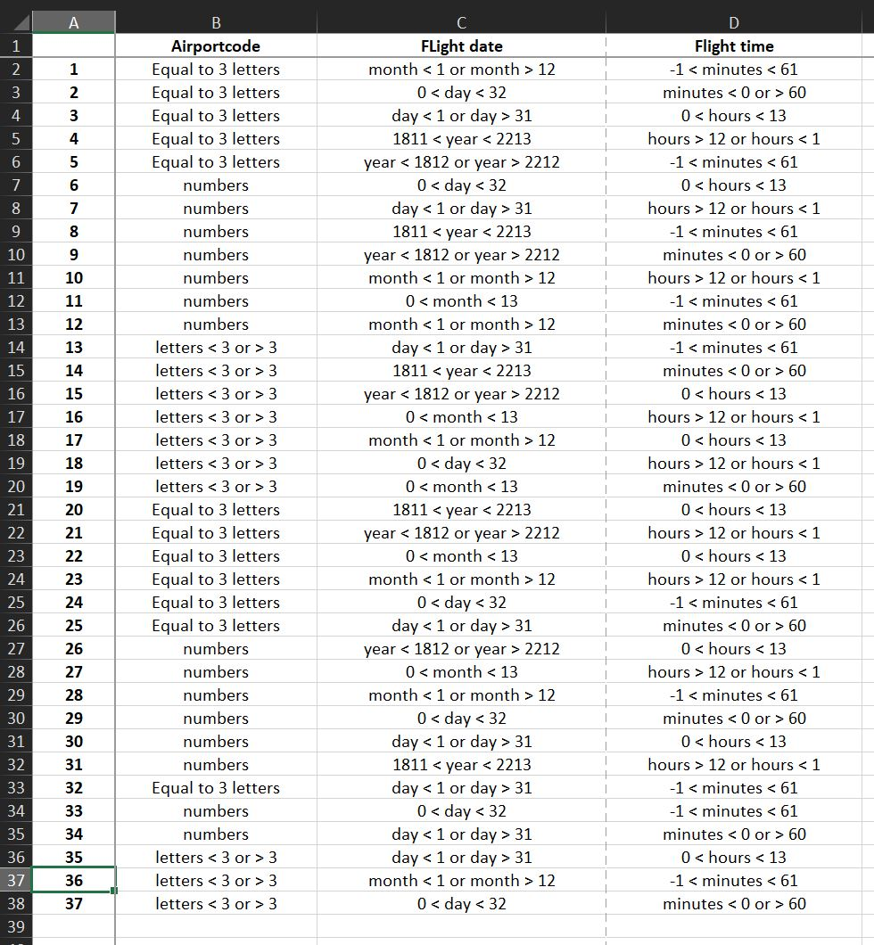

I tried to incorporate as many of these test scenarios as I could in the given time frame. Although I was not able to create every test case scenario as per the pair-wise testing sheet.

I have used variables , airport_code_of_departure and airport_code_of_arrival for the codes of the cities where the airports are located. I have used variables for decleration of the arrival date and time along with the departure date and time.

The test case structure for every test case written follows the same basic structure, where initially the variables are declared and initialized with the ticket values. These values are later passed in the ticket.checkTicket function for checking if the details for the ticket are valid.

I have written a total of 8 test cases out of which 7 have passed but I was unable to solve the 8th test case.

Each test case tries to incorporate 1 of the values as ‘not working’ or ‘invalid’ to showcase what happens when any of the values are invalidly entered.

1 test case exists which incorporates all the valid values and entries, to show how a truly valid format would work.

For the purpose of testing, I have made the assumption that the user entered values for the ‘max flight count’ and the ‘max flight time’ will always be a very large number = 10000. This was done so the code can work without any interruptions and check the ticket for the other details such as flight time, city, date, etc. But I have entered a single test case which has very small values for the max flight time and count fields to showcase what will happen in case the user entered flight time and count gets exceeded by the existing fields of the flight values.

For this coding question, I was not able to make the case for layover in flights as I did not have enough time to write and solve it. Due to this, I was also not able to show a working for the cyclic function of the checkTicket.