Neural Truth – Fake News Detection System
Neural Truth is an AI-powered fake news detection platform designed to identify, analyze, and verify online news content using intelligent machine learning techniques. The system provides users with real-time verification, credibility scoring, and advanced analytics through a modern futuristic interface.

Project Overview
Neural Truth is developed to combat misinformation spread across digital platforms. The software analyzes textual news content and predicts whether the information is real or fake. The platform focuses on speed, accuracy, and user-friendly interaction.

Main Features
• AI-based fake news detection
• Live news analyzer dashboard
• Real-time credibility scoring
• Accuracy metrics and analytics
• Modern futuristic UI/UX
• Verification prediction system
• Interactive visualization dashboards
• News confidence percentage analysis

Technology & Interface
The software uses a dark futuristic design inspired by modern AI platforms. Interactive charts, glowing UI elements, animated sections, and responsive layouts improve the user experience while maintaining professional presentation.

System Workflow
1. User enters or pastes a news article.
2. The AI model processes textual patterns.
3. The system evaluates credibility indicators.
4. Prediction confidence is generated.
5. Results are displayed through dashboards and analytics.

Uses of Neural Truth
• Detecting misinformation online
• Helping users verify viral news
• Educational research and AI demonstrations
• Journalism support tools
• Social media misinformation analysis
• AI and machine learning project showcase

Advantages
Neural Truth provides fast verification, visual analytics, modern interface design, and an intelligent detection system that improves awareness regarding misinformation.

Project Screenshots
Screenshot 1

Screenshot 2

Screenshot 3
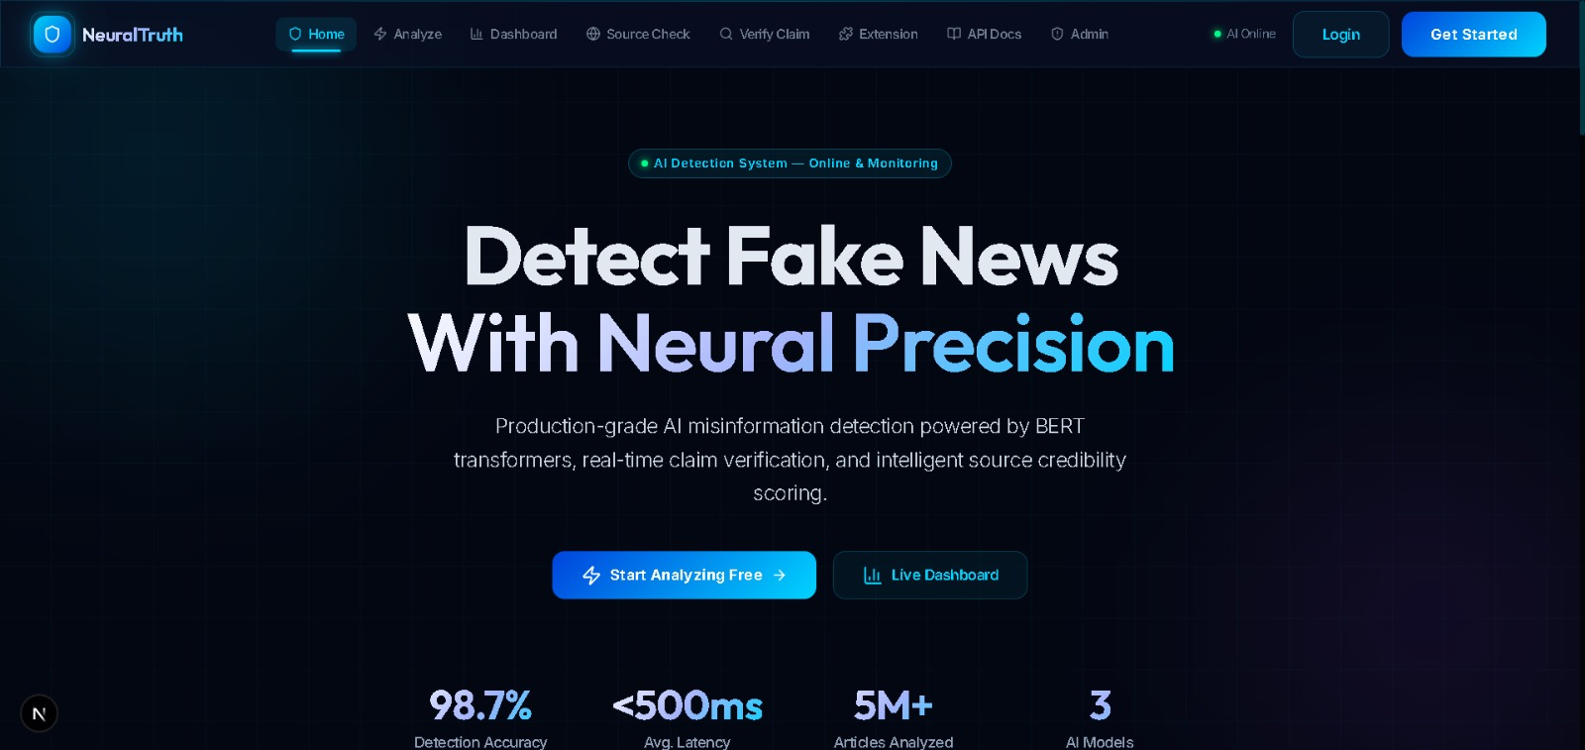
Screenshot 4
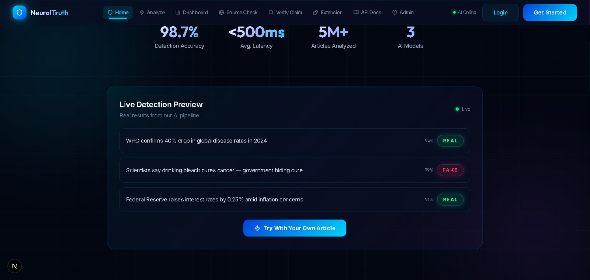
Screenshot 5

Screenshot 6

Screenshot 7

Screenshot 8

Screenshot 9

Screenshot 10

Screenshot 11

Screenshot 12


Conclusion
Neural Truth is a complete AI-based fake news detection solution combining machine learning concepts with a highly interactive interface. The project demonstrates practical implementation of artificial intelligence for solving real-world misinformation problems.

