YUVA INTERNSHIP
WEEK 4 TASK
Comprehensive Data Science Report and Insights Presentation Plan

Field | Details
Prepared By | Yash Patil
Program | MCA
Internship | YUVA Internship
Task | Week 4 — Comprehensive Data Science Report & Insights Presentation Plan
Project Type | Hypothetical Data Science Project
Planned Effort | 33 Hours
A professional report and communication plan showing how analytical results can be translated into clear, actionable recommendations for non-technical stakeholders.

1. Executive Summary
This report presents a hypothetical data science project focused on understanding and predicting student academic performance using structured academic indicators. The project objective is to convert raw educational records into reliable insights that can support early academic intervention, resource planning, and evidence-based decision-making.
The hypothetical analysis suggests that previous academic performance, internal assessment results, attendance, assignment performance, and study time are useful indicators of expected outcomes. The illustrative findings indicate that students with stronger prior performance and consistent internal assessment tend to have higher expected final scores, while lower attendance and weaker continuous assessment can be associated with increased academic risk. These statements are planning assumptions, not measured results from a real dataset.
The report focuses on how findings would be communicated rather than claiming actual model results. Mock charts are intentionally labelled as hypothetical and are used to demonstrate the proposed storytelling structure. The final communication will emphasize what changed, why it matters, what action is recommended, and how success will be measured.

2. Project Purpose & Business/Academic Context
Educational data often contains multiple indicators that can be analyzed together to identify patterns in performance. A structured data science approach can help convert these records into understandable evidence. The purpose of this hypothetical project is to create a repeatable analytical framework that supports academic teams without replacing professional judgment.
- Understand major patterns in student performance.
- Identify factors associated with stronger or weaker outcomes.
- Estimate expected performance using an appropriate predictive model.
- Translate analytical outputs into practical, understandable actions.
- Create a reporting framework that can be reused as new data becomes available.

3. Key Questions
- What patterns are visible in academic performance?
- Which available variables show the strongest relationship with the outcome?
- Where are unusual observations or potential data-quality issues?
- How accurately can expected performance be estimated?
- Which findings are actionable for academic stakeholders?
- How should results be monitored and updated over time?

4. Methodology Overview
The proposed analytical process uses a structured lifecycle beginning with problem definition and data understanding, followed by data quality checks, exploratory analysis, feature preparation, predictive modeling, evaluation, interpretation, and communication. The methodology is designed to avoid data leakage and to separate exploratory findings from predictive claims.
Stage | Approach | Purpose
Problem framing | Define target, users, decision context | Keep analysis aligned to a real need
Data understanding | Schema, data dictionary, distributions | Understand what the data represents
Data quality | Missing values, duplicates, invalid values, outliers | Improve reliability
EDA | Univariate, bivariate, multivariate analysis | Discover patterns and relationships
Feature preparation | Encoding, scaling where required, derived features | Create model-ready inputs
Modeling | Baseline + multiple candidate models | Compare predictive approaches
Validation | Cross-validation + held-out test set | Estimate generalization
Interpretation | Error analysis + feature importance | Understand model behavior
Communication | Charts, narrative, recommendations | Turn evidence into action

5. Hypothetical Findings & Analysis
The following findings are illustrative scenarios that the final report would test against actual data. They are included to demonstrate how analytical evidence should be converted into a stakeholder narrative.

5.1 Performance Trend
A time-based trend chart would show whether average performance is improving, stable, or declining. For illustration, the mock trend below shows a gradual increase from 61 to 76. In an actual project, the values would be calculated from the dataset and accompanied by the relevant sample size and time period.
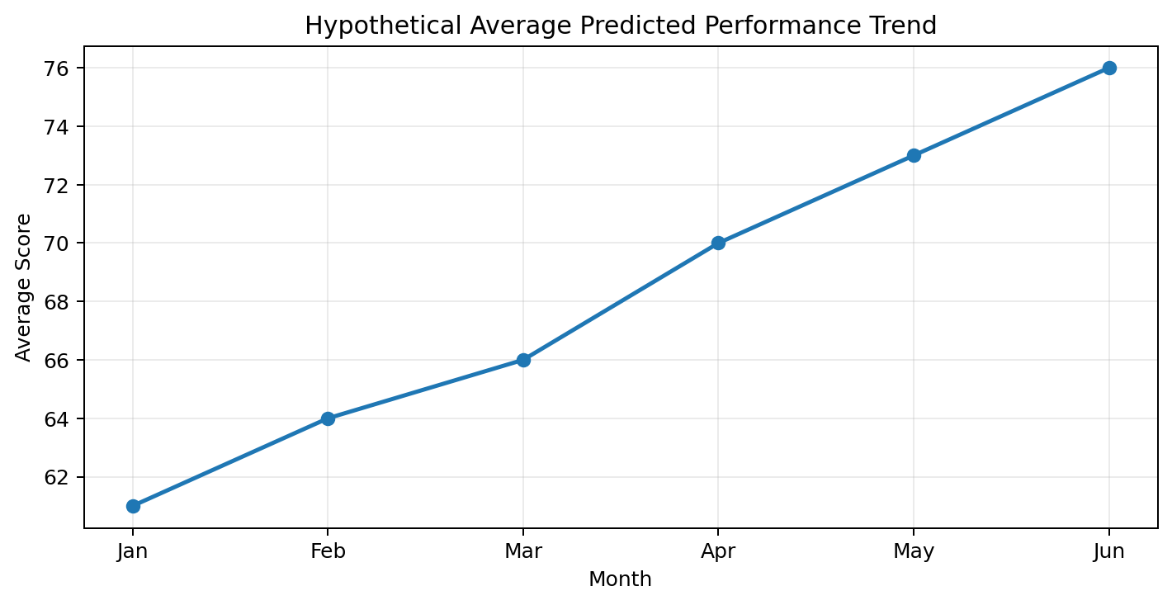
Figure 1. Hypothetical trend visualization — illustrative values only.

5.2 Relative Feature Impact
A feature-importance visualization can summarize which variables contribute most to a selected predictive model. The mock chart below illustrates a possible ranking. Importance does not prove causation; the final report would describe it as model-specific evidence.
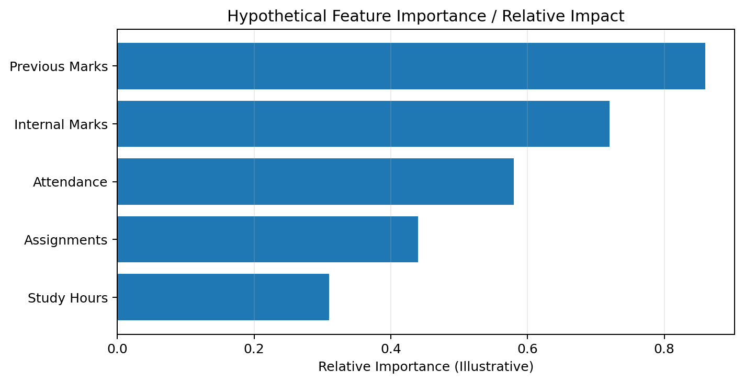
Figure 2. Hypothetical model feature-importance visualization — illustrative values only.

5.3 Potential Statistical Insights
- Previous marks may show a positive association with final performance.
- Internal assessment and assignment results may provide useful signals before the final examination.
- Attendance may be associated with performance, but association should not be interpreted as proof that attendance alone causes higher scores.
- Study hours may have a non-linear relationship with performance, meaning additional study time may not produce equal gains for every student.
- Outliers should be investigated individually because unusual scores can represent either genuine exceptional cases or data-quality problems.

6. Visualization Plan & Rationale
Question / Insight | Planned Visual | Why It Helps
Distribution of scores | Histogram / KDE | Shows center, spread, skewness and unusual ranges
Category comparison | Bar chart / box plot | Compares groups clearly
Relationship between two numeric variables | Scatter plot + trend line | Shows direction, strength and possible non-linearity
Performance over time | Line chart | Makes trends and changes easy to follow
Relationships among numeric variables | Correlation heatmap | Provides a compact relationship overview
Multiple variable relationships | Pair plot / selected small multiples | Supports deeper exploration
Model errors | Residual plot | Checks systematic prediction errors
Model drivers | Feature-importance bar chart | Communicates which inputs the model relies on
Actual vs predicted | Scatter plot with reference line | Shows prediction quality visually

7. Mock-Up Reporting Dashboard
KPI / Section | Illustrative Content | Decision Use
Average Score | 76 / 100 (hypothetical) | Overall performance snapshot
At-Risk Group | 12% (hypothetical) | Prioritize support review
Model MAE | 4.2 marks (hypothetical) | Typical prediction error
Top Indicator | Previous Marks | Focus on early academic signals
Trend | Improving (hypothetical) | Assess whether interventions align with progress
Action Status | Intervention review pending | Track next steps
The dashboard values above are mock values for layout demonstration only. They must be replaced by actual calculated results before being presented as evidence.

8. Turning Analysis into Actionable Insights
Evidence Pattern | Interpretation | Potential Action | Success Measure
Weak prior performance + low internal scores | Higher likelihood of weak final outcome | Early academic support and mentoring | Change in subsequent assessment performance
Low attendance + declining marks | Potential early-warning signal | Attendance follow-up and academic counselling | Improved attendance and assessment trend
Strong assignments but weak exam performance | Possible assessment-format or exam-preparation gap | Targeted exam-preparation support | Improved exam score
Large prediction errors for a subgroup | Model may not generalize equally | Investigate data coverage and model behavior | Reduced subgroup error gap
Performance trend improves after intervention | Possible positive program signal | Continue and evaluate intervention | Sustained improvement over later periods

9. Communication Strategy for Non-Technical Stakeholders
The report will avoid leading with algorithms or technical terminology. Instead, the presentation will follow a simple evidence-to-action story: <b>What is happening? Why does it matter? What evidence supports it? What should we do? How will we know it worked?</b>
- Start with the decision problem, not the model.
- Use one main message per slide or report section.
- Show the most important chart before explaining technical details.
- Translate metrics into practical language—for example, explain MAE as the typical size of prediction error in score units.
- Separate facts, interpretations, assumptions, and recommendations.
- Use examples and annotations to direct attention to important patterns.
- Include limitations so stakeholders understand what the analysis cannot prove.
- End with prioritized actions, owners or responsible teams, and measurable success criteria.

10. Presentation Storyboard
Slide | Message | Suggested Visual
1. Title | Project purpose and audience | Clean title slide
2. Executive Summary | Three key takeaways | KPI cards / summary
3. Problem | Why the analysis matters | Simple problem diagram
4. Data | What information was analyzed | Dataset overview table
5. Method | How evidence was produced | Process flow
6. Key Finding 1 | Main performance pattern | Trend chart
7. Key Finding 2 | Important drivers | Feature-importance chart
8. Key Finding 3 | Risk / anomaly / subgroup insight | Box plot or comparison chart
9. Recommendations | What should happen next | Prioritized action table
10. Measurement | How success will be tracked | KPI framework
11. Limitations | What to interpret carefully | Risk/limitation list
12. Closing | Decision requested / next steps | Three-point summary

11. Recommendations
- Establish a repeatable academic-performance dashboard using validated definitions and refresh schedules.
- Use early indicators as support signals rather than as automatic labels or high-stakes decisions.
- Prioritize targeted academic support for groups showing consistent evidence of declining performance.
- Review model errors regularly and investigate cases where predictions are systematically inaccurate.
- Collect additional representative data when important variables are missing or poorly measured.
- Conduct a controlled evaluation of any intervention before claiming that it caused improvement.
- Maintain documentation for data definitions, model versions, assumptions, limitations, and changes.

12. Future Work
- Implement the planned pipeline using a real dataset.
- Compare multiple algorithms using consistent cross-validation.
- Perform deeper error and subgroup analysis.
- Add explainability methods where appropriate.
- Develop a Streamlit dashboard or Flask/FastAPI service.
- Introduce data and model monitoring.
- Evaluate model drift and establish a retraining policy.
- Study whether interventions informed by the insights actually improve outcomes.

13. Risks, Limitations & Responsible Use
Risk / Limitation | Response
Hypothetical results | Clearly label mock values and replace them with measured results before submission as evidence
Correlation vs causation | Use causal language only when supported by an appropriate study design
Data quality | Document sources, definitions, missingness and validation rules
Bias / unequal performance | Evaluate performance across meaningful groups and review limitations
Privacy | Minimize personal data and apply appropriate access controls
Model uncertainty | Report error metrics and avoid overconfident predictions
Stakeholder misinterpretation | Use plain language and explicitly distinguish prediction from certainty

14. 33-Hour Work Plan
Activity | Work | Hours
Project framing | Purpose, audience, questions and success criteria | 3
Methodology consolidation | Analytical pipeline and assumptions | 4
Findings design | Hypothetical insight structure and interpretation | 4
Visualization planning | Chart selection, mock-ups and annotations | 5
Actionable recommendations | Evidence-to-action mapping and KPIs | 4
Stakeholder storytelling | Narrative, presentation flow and plain-language communication | 3
Report development | Tables, sections, formatting and integration | 4
Quality review | Consistency, limitations, responsible-use review | 2
Final submission preparation | Proofreading and final packaging | 4
TOTAL |  | 33

15. Expected Deliverables
- Professional comprehensive data science report.
- Clearly labelled mock visualizations and supporting tables.
- Executive-level insight summary.
- Non-technical presentation storyboard.
- Actionable recommendation framework.
- Future-work and monitoring plan.
- Documented assumptions, limitations, and responsible-use considerations.

16. Evaluation Criteria
- Clarity and completeness of the report.
- Ability to translate technical analysis into actionable insights.
- Quality and relevance of charts, tables, and visual aids.
- Clear communication strategy for non-technical stakeholders.
- Logical connection between evidence, interpretation, and recommendations.
- Professional structure suitable for executive-level review.
- Realistic 30–35 hour plan with 33 hours allocated.

17. Final Submission Checklist
- ☐ Executive summary included.
- ☐ Methodology explained clearly.
- ☐ Findings are separated from assumptions and mock examples.
- ☐ Visualizations have a clear purpose and audience.
- ☐ Recommendations are actionable and measurable.
- ☐ Limitations and responsible-use considerations are documented.
- ☐ Presentation storyboard is complete.
- ☐ 33-hour work plan is included.
- ☐ Document has been proofread and formatted consistently.

18. Conclusion
This Week 4 report demonstrates how a data science project can move beyond analysis to effective communication and decision support. The hypothetical project shows a complete path from analytical evidence to visual storytelling, actionable recommendations, measurement, and future improvement. The use of mock visualizations makes the communication plan concrete while explicitly avoiding unsupported claims about real data. In a real implementation, each illustrative value would be replaced by validated results, accompanied by context and uncertainty. The final approach is designed to help technical and non-technical stakeholders understand what the analysis means, why it matters, what action is recommended, and how outcomes should be monitored.

Appendix A — Recommended Report Structure for the Final Real Project
- Executive Summary
- Business / Academic Problem
- Data Description
- Methodology
- EDA Findings
- Model Results
- Key Insights
- Recommendations
- Limitations
- Monitoring Plan
- Appendix / Technical Details

