YUVA INTERNSHIP
WEEK 3 TASK
Python-Based Machine Learning Model Development and Evaluation Plan

Field | Details
Prepared By | Yash Patil
Program | MCA
Internship | YUVA Internship
Task | Week 3 — Machine Learning Model Development & Evaluation Plan
Project Type | Hypothetical Python-based Machine Learning Project
Planned Effort | 33 Hours
Submission-ready strategic plan covering problem definition, preprocessing, feature engineering, model selection, training, hyperparameter tuning, evaluation, validation, deployment, monitoring, risks, and future scope.

1. Executive Summary
This report presents a detailed Week 3 plan for developing and evaluating a hypothetical machine learning system using Python. The selected problem is Student Academic Performance Prediction, where the objective is to estimate a student's expected final score from non-sensitive academic indicators such as attendance, study hours, previous marks, assignment performance, and internal assessment.
The plan follows a complete machine learning lifecycle: problem definition, data understanding, preprocessing, feature engineering, feature selection, model selection, training, hyperparameter tuning, validation, performance evaluation, interpretation, and conceptual deployment. No actual code execution or dataset-specific result is claimed because the internship task is planning-focused.
The strategy emphasizes reproducibility, prevention of data leakage, appropriate metric selection, cross-validation, model comparison, interpretability, privacy, and human oversight. A 33-hour schedule is provided to keep the work within the required 30–35 hour range.

2. Problem Definition
The hypothetical problem is to predict a student's final academic score using historical and currently available academic indicators. Educational institutions may have multiple performance indicators but may not always have a consistent analytical process for identifying patterns or estimating expected performance.
<b>Problem statement:</b> Can a Python-based supervised machine learning model predict a student's expected final score from relevant academic features while maintaining acceptable accuracy, generalization, interpretability, and responsible data-use practices?
<b>Machine learning task:</b> Supervised regression, because the target variable (final marks/score) is numeric.
<b>Business/academic relevance:</b> A validated prediction can support academic analysis and early identification of students who may benefit from additional support. It must not be used as the sole basis for high-stakes decisions.

3. Objectives
- Define a clear prediction target and success criteria.
- Prepare a clean, consistent, model-ready dataset.
- Identify meaningful predictors through EDA and feature engineering.
- Compare baseline, linear, tree-based, and ensemble regression approaches.
- Use cross-validation and a held-out test set to estimate generalization.
- Tune important hyperparameters without leaking test information.
- Evaluate models using MAE, RMSE, R² and supporting error analysis.
- Select a model using both predictive performance and practical considerations.
- Design a conceptual deployment and monitoring strategy for future implementation.

4. Scope
<b>In Scope</b>
- Structured academic data and non-sensitive predictors.
- Data cleaning, encoding, scaling where required, and feature engineering.
- Regression model development and comparative evaluation.
- Cross-validation, hyperparameter tuning, and test-set evaluation.
- Model interpretation, documentation, and conceptual deployment.
<b>Out of Scope</b>
- Automated admission, disciplinary, employment, or other high-stakes decisions.
- Use of medical, financial, or unnecessary sensitive personal information.
- Production deployment during Week 3.
- Claiming model accuracy before actual data and testing are available.
- Replacing teachers or academic professionals with automated predictions.

5. Proposed Data and Target
Feature / Variable | Type | Role
Student ID | Identifier | Tracking only; excluded from model features
Attendance | Numeric | Predictor
Study Hours | Numeric | Predictor
Previous Marks | Numeric | Predictor
Assignment Score | Numeric | Predictor
Internal Marks | Numeric | Predictor
Course / Semester | Categorical | Optional predictor/grouping variable
Final Marks | Numeric | Target variable

6. Machine Learning Workflow
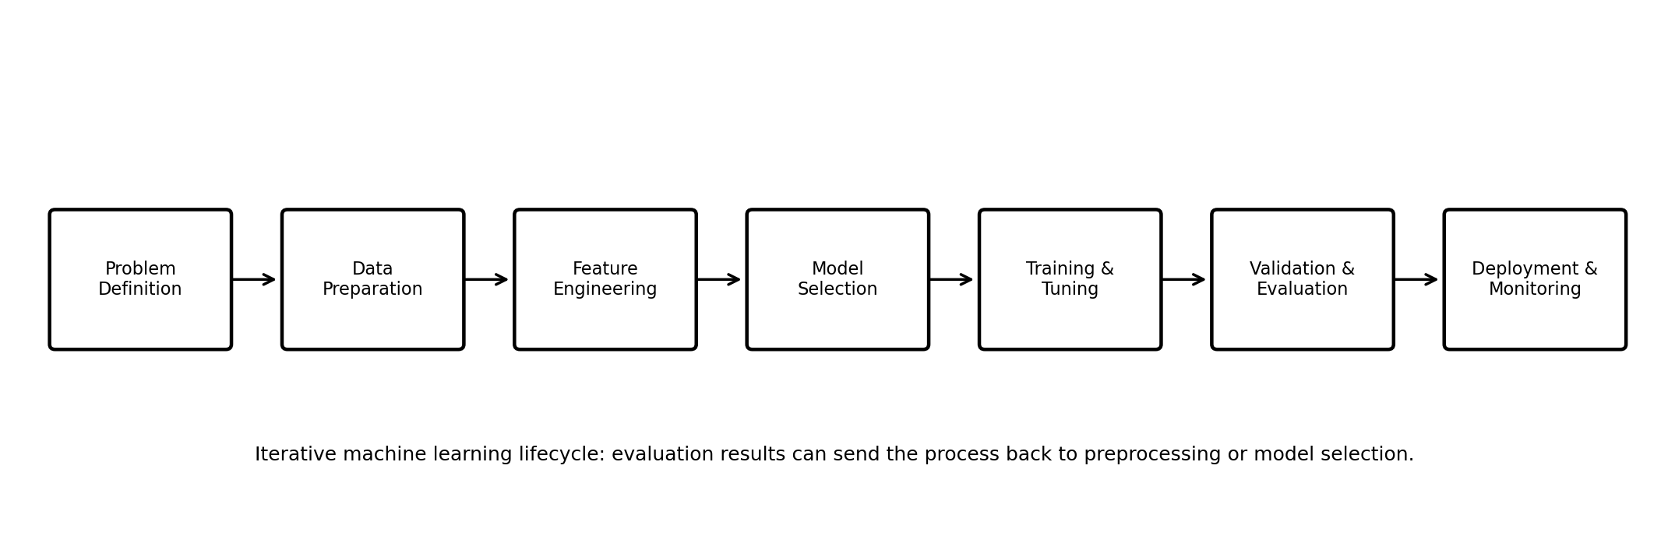
Figure 1. Planned end-to-end machine learning workflow.

7. Data Preprocessing Strategy
Preprocessing converts raw records into a reliable representation for machine learning. The exact treatment will depend on the dataset after inspection.
- Data validation: verify ranges, formats, units, duplicate records, and impossible values.
- Missing values: quantify missingness; use justified imputation or controlled removal; preserve a missing indicator when analytically useful.
- Duplicate handling: identify exact duplicates and repeated IDs, then investigate before removing.
- Categorical encoding: use one-hot encoding for nominal categories and ordinal encoding only where a real order exists.
- Numerical scaling: standardize or normalize numeric variables for models sensitive to feature scale; tree-based models generally do not require scaling.
- Outlier treatment: investigate context first; use robust approaches, transformation, capping, or correction when justified.
- Data splitting: create train/test partitions before fitting preprocessing steps so test information does not influence training.
- Pipeline construction: combine preprocessing and model steps into a reproducible pipeline.

8. Feature Engineering
Feature engineering transforms available variables into meaningful model inputs without introducing information that would not be available at prediction time.
- Create meaningful aggregate indicators such as continuous-assessment totals when justified.
- Convert dates into useful components only when temporal information is relevant.
- Create ratios or normalized indicators only when their denominator is valid and meaningful.
- Consider transformations for highly skewed numeric variables.
- Document every derived feature, formula, reason, and expected effect.
- Avoid target leakage—for example, do not use final marks or information calculated after the prediction point as a predictor.

9. Feature Selection Strategy
- Start with domain relevance and data availability.
- Remove identifiers that do not carry legitimate predictive information.
- Inspect correlations and relationships for numeric variables.
- Use model-based importance cautiously as supporting evidence, not proof of causation.
- Check multicollinearity for linear models where highly correlated predictors can affect coefficient stability.
- Prefer a simpler feature set when performance is similar and interpretability is improved.

10. Candidate Model Selection
Model | Strengths | Limitations | Role
Baseline / Mean Predictor | Simple benchmark; easy to interpret | Usually weak predictive power | Reference point
Linear Regression | Simple, fast, interpretable coefficients | Assumes linear relationships | Primary baseline
Decision Tree Regressor | Captures non-linear rules; interpretable structure | Can overfit | Non-linear candidate
Random Forest Regressor | Strong non-linear performance; robust ensemble | Less transparent; larger model | Main candidate
Gradient Boosting Regressor | Often strong predictive performance | More tuning and sensitivity to settings | Advanced candidate
Proposed selection: Random Forest Regressor is the preferred initial final-model candidate because it can capture non-linear relationships and feature interactions with limited preprocessing. However, it will not be selected automatically. Linear Regression, Decision Tree, and other suitable models will be compared using the same validation framework. The final choice will balance predictive performance, stability, interpretability, and operational simplicity.

11. Training Process
- Load and validate the prepared data.
- Separate predictors (X) and target (y).
- Split data into training and held-out test sets.
- Build preprocessing and model steps into a pipeline.
- Fit a baseline model first.
- Train candidate models on the training data.
- Use cross-validation on training data for comparison and tuning.
- Select the best model using predefined criteria.
- Retrain the selected pipeline on the complete training portion.
- Evaluate once on the held-out test set.
- Save the complete preprocessing and model pipeline for future deployment.

12. Hyperparameter Tuning Strategy
Hyperparameter tuning will be performed only within the training data using cross-validation. The test set will remain untouched until final evaluation.
Model | Example Hyperparameters | Tuning Approach
Decision Tree | max_depth, min_samples_split, min_samples_leaf | Grid Search / Randomized Search
Random Forest | n_estimators, max_depth, min_samples_leaf, max_features | Randomized Search followed by focused search
Gradient Boosting | n_estimators, learning_rate, max_depth, subsample | Randomized or Grid Search
Linear / Regularized | alpha for Ridge/Lasso | Cross-validated regularization
RandomizedSearchCV may be preferred when the parameter space is large because it can explore more combinations under a fixed computation budget. The tuning objective will be selected before experimentation, for example minimizing cross-validated RMSE.

13. Evaluation Metrics
Because the proposed problem is regression, accuracy, precision, recall, F1-score, and ROC-AUC are not the primary metrics. They become appropriate only if the project is later reframed as a classification problem.
Metric | Meaning | Why Use It
MAE | Average absolute prediction error | Easy to interpret in marks/score units
MSE | Average squared error | Penalizes larger errors strongly
RMSE | Square root of MSE | Interpretable in target units and emphasizes larger errors
R² | Proportion of variance explained | Useful comparative measure of predictive fit
Primary comparison: MAE and RMSE, supported by R² and residual/error analysis. No single metric will be treated as sufficient evidence of real-world usefulness.

14. Cross-Validation & Validation Strategy
- Use K-fold cross-validation on the training set, for example 5-fold CV, when the dataset is sufficiently sized.
- Use the same folds and evaluation metric when comparing candidate models.
- Use stratified or grouped splitting when dataset structure requires it; for time-series data, use time-aware validation instead of random shuffling.
- Keep the final test set isolated until model selection and tuning are complete.
- Report the mean and variability of cross-validation scores rather than only one score.
- Inspect residuals and error patterns across relevant groups to identify instability or systematic errors.
- Avoid repeated test-set tuning, because it gradually turns the test set into training information.

15. Overfitting, Underfitting & Leakage Controls
Risk | How It Appears | Mitigation
Overfitting | Excellent training score but weaker validation/test performance | Cross-validation, regularization, complexity controls, representative data
Underfitting | Poor performance on both training and validation | Better features, suitable non-linear models, appropriate complexity
Data leakage | Unusually strong validation/test performance | Fit preprocessing only on training folds; exclude future/target-derived information
Selection bias | Model works on one subgroup but not others | Representative data, subgroup evaluation, documented limitations

16. Model Interpretation
- Review coefficients for linear models to understand directional relationships, subject to model assumptions.
- Review tree/ensemble feature importance as a model-specific indicator, not causal evidence.
- Use permutation importance or SHAP in a later technical phase if required.
- Compare errors across meaningful groups to identify potential performance disparities.
- Present explanations in language suitable for non-technical stakeholders.

17. Conceptual Model Deployment & Maintenance
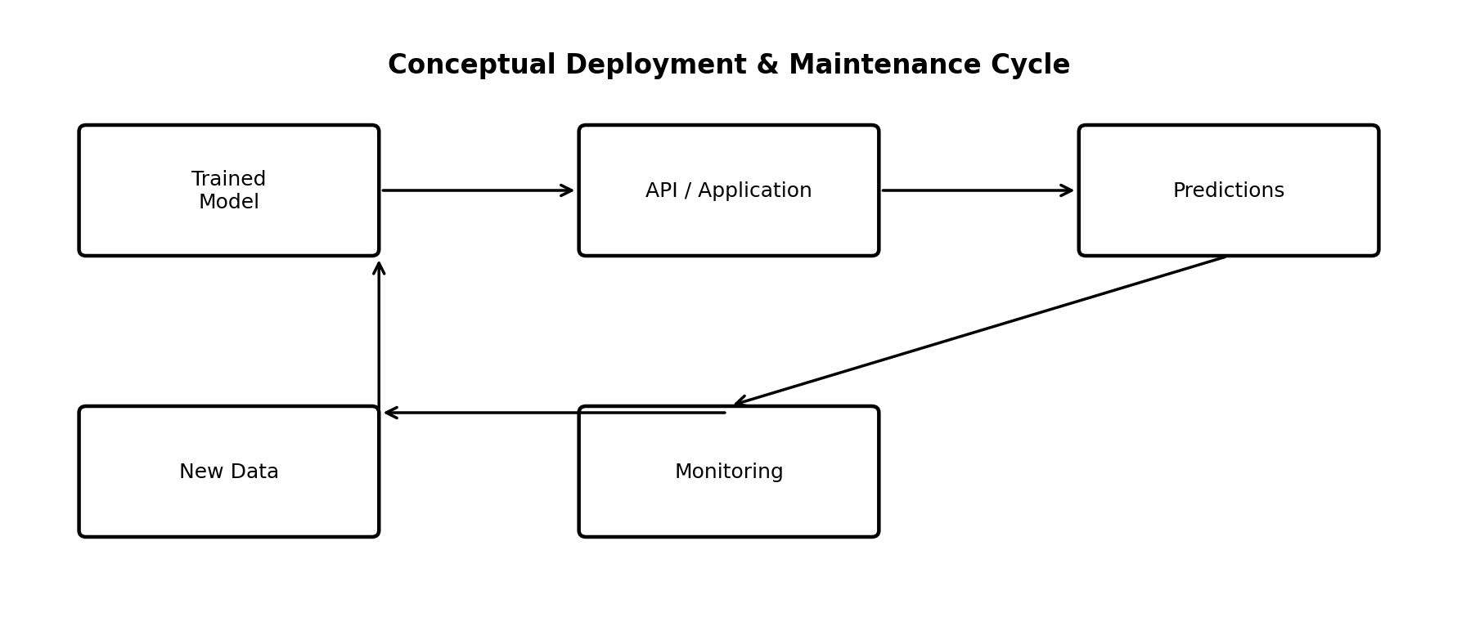
Figure 2. Conceptual model deployment and maintenance cycle.
A future implementation could expose the trained pipeline through a Flask/FastAPI service or a Streamlit application. The deployment would validate input fields, apply the same preprocessing pipeline used during training, generate predictions, and monitor model behavior.
- Version the model, preprocessing pipeline, training-data snapshot, and configuration.
- Monitor input-data drift, missingness, prediction distributions, and model performance when ground truth becomes available.
- Set review thresholds for retraining rather than retraining blindly.
- Retrain periodically or when documented drift/performance conditions are met.
- Maintain rollback capability to a previously validated model.
- Protect student data through minimization, anonymization, access control, and appropriate governance.

18. Potential Challenges & Solutions
Challenge | Potential Impact | Planned Solution
Insufficient data | Unstable model performance | Collect more representative data; use cross-validation; report limitations
Missing/inconsistent records | Biased or unreliable predictions | Validation, documented imputation, and source-quality checks
Outliers | Distorted model behavior | Investigate context; robust treatment where justified
Feature leakage | Artificially high performance | Strict feature-availability rules and pipeline-based preprocessing
Overfitting | Poor generalization | Cross-validation and complexity controls
Bias across groups | Unequal performance | Subgroup error analysis and responsible feature review
Model drift | Performance deterioration after deployment | Monitoring and controlled retraining
Privacy risk | Exposure of student information | Data minimization, anonymization, access control

19. 33-Hour Work Plan
Activity | Planned Work | Hours
Problem definition & research | Problem statement, relevance, target, assumptions | 3
Data strategy | Data requirements, quality checks, privacy plan | 3
Preprocessing design | Cleaning, missing values, encoding, scaling, leakage controls | 4
Feature engineering & selection | Derived variables, feature relevance, selection strategy | 4
Model research & selection | Baseline and candidate model comparison plan | 4
Training & tuning plan | Training pipeline, CV, hyperparameter strategy | 4
Evaluation strategy | Metrics, residual analysis, test-set protocol | 3
Deployment & monitoring | API/application concept, versioning, monitoring, retraining | 2
Diagrams & documentation | Workflow, deployment diagram, tables, formatting | 2
Review & submission preparation | Proofreading, completeness check, final package | 4
TOTAL |  | 33

20. Expected Outcomes
- A complete and reproducible machine learning development plan.
- Clear preprocessing and feature-engineering decisions ready for implementation.
- A justified model-comparison and hyperparameter-tuning strategy.
- A validation and evaluation framework that reduces overfitting and leakage.
- A conceptual deployment and monitoring plan.
- Documentation capable of guiding the future technical implementation.

21. Evaluation Criteria for This Task
- Thorough coverage of problem definition, preprocessing, modeling, training, evaluation, and deployment.
- Logical and technically correct explanation of the machine learning lifecycle.
- Clear justification for model selection and evaluation metrics.
- Effective workflow and deployment diagrams.
- Correct understanding of cross-validation, held-out testing, overfitting, underfitting, and data leakage.
- Realistic 30–35 hour work plan.
- Professional documentation suitable for an internship submission.

22. Final Implementation Checklist
- ☐ Problem and target variable clearly defined.
- ☐ Data source and feature definitions documented.
- ☐ Train/test strategy finalized.
- ☐ Preprocessing pipeline designed.
- ☐ Missing values and outlier strategy documented.
- ☐ Feature engineering and selection rules defined.
- ☐ Baseline model established.
- ☐ Candidate models compared fairly.
- ☐ Hyperparameter search defined.
- ☐ Cross-validation strategy selected.
- ☐ Primary and secondary metrics defined.
- ☐ Final test set kept isolated.
- ☐ Model interpretation and subgroup checks planned.
- ☐ Deployment, monitoring, versioning, and retraining considered.
- ☐ Limitations and responsible-use requirements documented.

23. Conclusion
This Week 3 plan provides a structured roadmap for developing a Python-based machine learning system from problem definition through conceptual deployment. The proposed Student Academic Performance Prediction problem is suitable for demonstrating supervised regression, preprocessing, feature engineering, model comparison, hyperparameter tuning, cross-validation, and evaluation. The plan deliberately separates training and validation from final testing and emphasizes leakage prevention, interpretability, responsible data use, and monitoring. With 33 hours allocated across the major activities, the framework is realistic for an internship planning task and can directly guide the next technical implementation phase once a suitable dataset is available.

Appendix A — Suggested Technical Deliverables for the Next Phase
- Jupyter Notebook containing the implementation.
- Dataset and data dictionary.
- Preprocessing and modeling pipeline.
- EDA and visualization outputs.
- Baseline and candidate model results.
- Cross-validation and hyperparameter tuning results.
- Final held-out test evaluation.
- Feature importance / explainability output.
- Saved model pipeline.
- Optional Streamlit or Flask/FastAPI demonstration.

