LOGISTICS DATA ANALYTICS INTERNSHIP

WEEK 3 TASK
ADVANCED DATA ANALYSIS AND VISUALIZATION IN LOGISTICS

Submission Detail | Information
Internship Domain | Logistics Data Analytics
Project Title | Strategic Logistics Data Analysis for Delivery Performance and Route Optimization
Submitted By | Yash Patil
Internship Role | Logistics Data Analyst Intern
Week | Week 3 – Advanced Data Analysis and Visualization
Dataset Type | Hypothetical Logistics Operations Dataset
Tools | Python, Pandas, NumPy, Matplotlib, Seaborn

Week 3 Objective
Perform exploratory data analysis on a hypothetical logistics dataset, visualize operational patterns, interpret relationships among delivery, volume, distance, and cost variables, and translate analytical findings into logistics decision-support insights.

Table of Contents
- 1. Executive Summary
- 2. Connection with Week 1 and Week 2
- 3. Hypothetical Dataset Definition
- 4. Data Preparation for EDA
- 5. Exploratory Data Analysis Methodology
- 6. Central Tendency and Descriptive Statistics
- 7. Distribution Analysis
- 8. Logistics Performance Visualizations
- 9. Correlation and Relationship Analysis
- 10. Regional and Operational Analysis
- 11. Analytical Insights
- 12. Python Visualization Code
- 13. Business Recommendations
- 14. Limitations
- 15. Week 3 Execution Plan
- 16. Expected Outcomes
- 17. Conclusion
- 18. References
- Appendix A. Dataset Dictionary
- Appendix B. Visualization Checklist

1. Executive Summary
This Week 3 project advances the logistics analytics workflow from data preparation to exploratory data analysis and visualization. A hypothetical logistics operations dataset containing shipment volume, delivery time, distance, transportation cost, fuel cost, delay, order value, customer rating, and regional information is analyzed using Python.
The EDA focuses on central tendency, distributions, relationships, regional differences, and correlations. Multiple visualizations are used because different charts answer different operational questions. Bar charts compare regional shipment volume and service rates, histograms show distributions, box plots reveal variation and potential outliers, scatter plots examine relationships between distance, volume, cost, and delivery time, and a correlation matrix provides a compact view of numerical relationships.
The simulated analysis indicates several operational patterns by design: longer transportation distance is associated with longer delivery time, larger shipment volume is associated with higher transportation cost, and higher delay is associated with lower customer rating. These are analytical relationships within the hypothetical dataset and should not be interpreted as measured results from a real logistics company.
Key Analytical Principle
A visualization is useful only when it answers a defined logistics question. The report therefore connects every major chart to a specific operational interpretation.

2. Connection with Week 1 and Week 2
Week 1 defined the strategic logistics problem and KPI framework. Week 2 established data collection, cleaning, and preprocessing methods. Week 3 uses those foundations to explore patterns and communicate findings visually.
Previous Week | Week 3 Extension
Week 1: Delivery KPIs | Analyze service-performance distributions and regional differences
Week 1: Route optimization | Explore distance, delivery time, volume, and cost relationships
Week 2: Cleaning | Use prepared analytical variables for EDA
Week 2: Feature engineering | Analyze delay, distance, freight/cost, and operational features
Future modeling | Use EDA findings to select meaningful predictors

3. Hypothetical Dataset Definition
For the Week 3 simulation, a hypothetical logistics dataset containing 1,200 shipment-level observations is created. Each row represents one shipment or delivery event. The dataset is designed to resemble the structure of an operational logistics dataset without claiming to represent an actual company.
Variable | Type | Description
region | Categorical | Operational/customer region
shipment_volume | Numerical | Number of units handled for the shipment event
distance_km | Numerical | Estimated transportation distance
transport_cost | Numerical | Estimated transportation cost
delivery_time_days | Numerical | Delivery duration in days
delay_days | Numerical | Delay beyond the service expectation
on_time | Binary | 1 if on time, 0 otherwise
fuel_cost | Numerical | Estimated fuel-related cost
order_value | Numerical | Value associated with shipment/order
customer_rating | Numerical | Customer rating from 1 to 5

3.1 Dataset Generation Logic
The simulated values are generated using distributions and relationships that are plausible for logistics analysis. Distance influences delivery time, shipment volume contributes to transportation cost, and delay is associated with customer rating. Small amounts of missingness are also introduced into selected variables to reflect realistic analytical conditions.
import numpy as np
import pandas as pd
np.random.seed(42)
n = 1200
regions = ["West", "North", "South", "East", "Central"]
df = pd.DataFrame({
"region": np.random.choice(
regions, n,
p=[0.30, 0.23, 0.22, 0.15, 0.10]
),
"shipment_volume": np.maximum(
np.random.normal(180, 55, n), 25
).round(),
"distance_km": np.maximum(
np.random.normal(450, 150, n), 35
).round(1)
})
# Additional variables can be generated from
# distance, volume, and controlled random variation.

4. Data Preparation for EDA
Although this is a simulated dataset, the same validation principles from Week 2 are applied before analysis.
print(df.shape)
print(df.info())
print(df.isna().sum())
print(df.duplicated().sum())
print(df.describe())
- Verify numerical columns contain valid numeric values.
- Check missing values before calculating statistics.
- Remove or investigate duplicate records.
- Confirm that delivery time and distance are non-negative.
- Confirm on_time is binary.
- Use consistent region labels.
- Use median/robust statistics when extreme values influence the mean.

5. Exploratory Data Analysis Methodology
EDA Stage | Analysis | Purpose
Univariate analysis | Mean, median, standard deviation, min/max | Understand individual variables
Distribution analysis | Histogram, density-style views | Identify skewness and concentration
Categorical analysis | Counts and regional comparisons | Compare operational segments
Bivariate analysis | Scatter plots, grouped summaries | Identify relationships
Variation analysis | Box plots | Compare spread and outliers
Correlation analysis | Correlation matrix | Identify linear relationships
Performance analysis | On-time rate, delay summaries | Measure logistics service performance

6. Central Tendency and Descriptive Statistics
Central tendency describes the typical value of a variable. Mean is sensitive to extreme values, while median is more robust when logistics data is skewed. Standard deviation describes variability.
Variable | Mean | Median | Std Dev | Min | Max
Shipment Volume | 182.57 | 182.00 | 54.75 | 25.00 | 356.00
Distance Km | 453.24 | 445.25 | 157.66 | 35.00 | 1120.40
Transport Cost | 1632.28 | 1655.14 | 454.15 | 250.00 | 3371.16
Delivery Time Days | 5.96 | 5.90 | 1.53 | 1.60 | 11.48
Delay Days | 1.50 | 1.31 | 1.39 | 0.00 | 6.53
On Time | 0.27 | 0.00 | 0.44 | 0.00 | 1.00
Fuel Cost | 398.23 | 397.14 | 107.52 | 87.87 | 819.68
Order Value | 3507.48 | 3013.55 | 2069.86 | 361.35 | 19102.23
Customer Rating | 4.18 | 4.20 | 0.51 | 1.90 | 5.00

6.1 Interpretation
The descriptive table provides a baseline for the dataset. Differences between mean and median indicate potential skewness. For example, transportation cost and order value can naturally have long right tails because a small number of large shipments may be substantially more expensive than typical shipments.

7. Distribution Analysis

7.1 Delivery Time Distribution
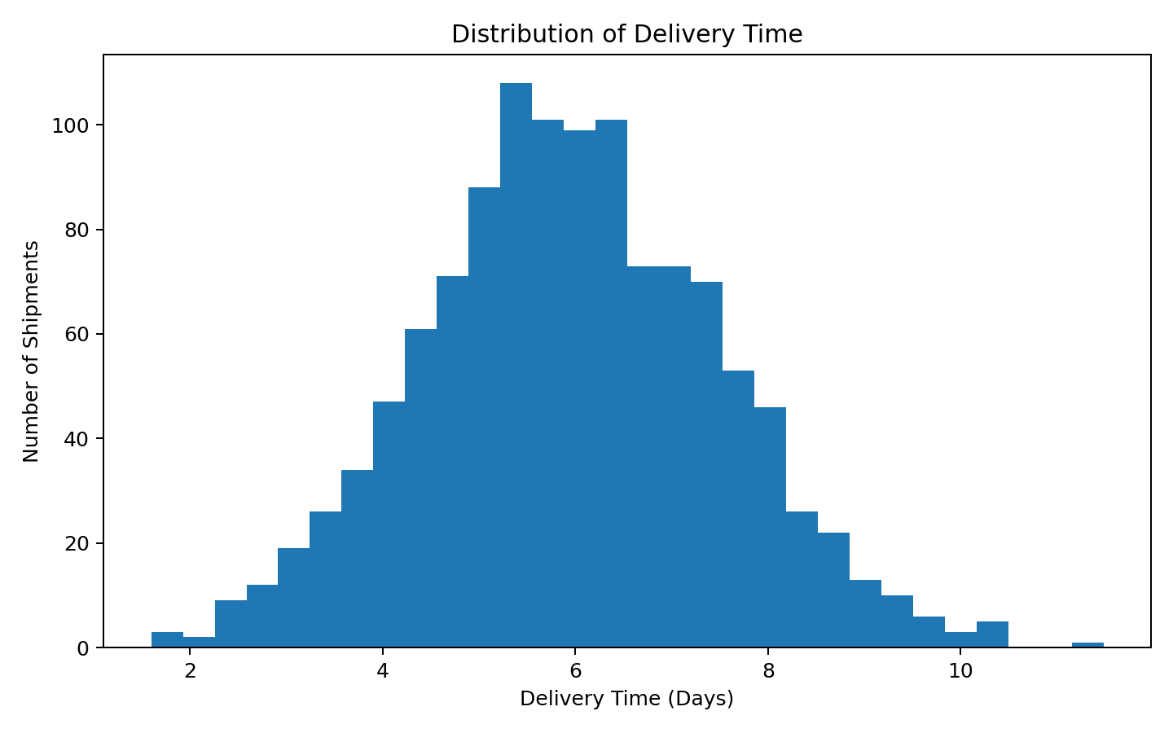
The histogram shows how delivery duration is distributed across shipments. It helps determine whether most shipments are concentrated around a typical delivery window or whether a long tail of slow deliveries exists. This is useful for service-level planning because averages alone can hide a small but operationally important group of very slow deliveries.

7.2 Transportation Cost Distribution
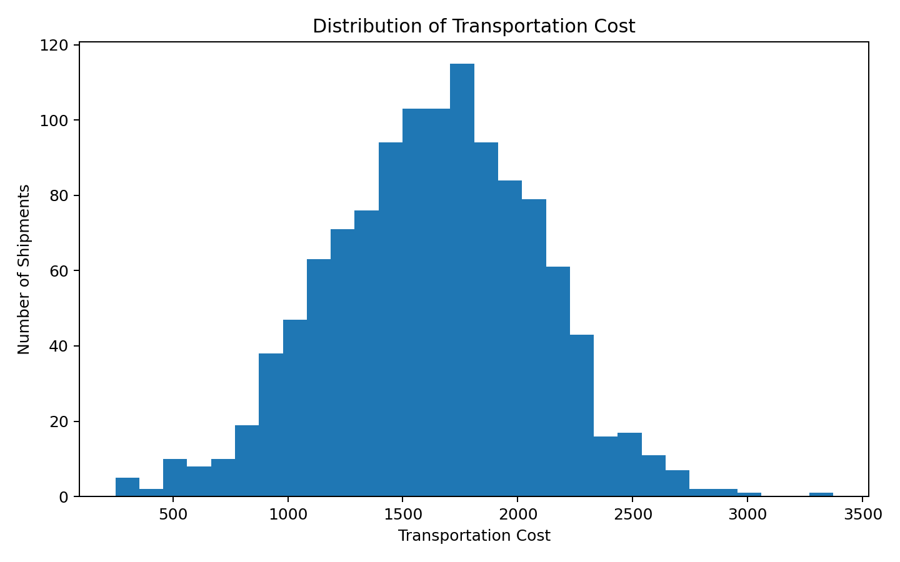
Transportation cost distribution helps identify the typical cost range and whether high-cost shipment events are common or exceptional. A right-skewed distribution would indicate that a small number of expensive shipments can significantly increase the mean.

8. Logistics Performance Visualizations

8.1 Shipment Volume by Region
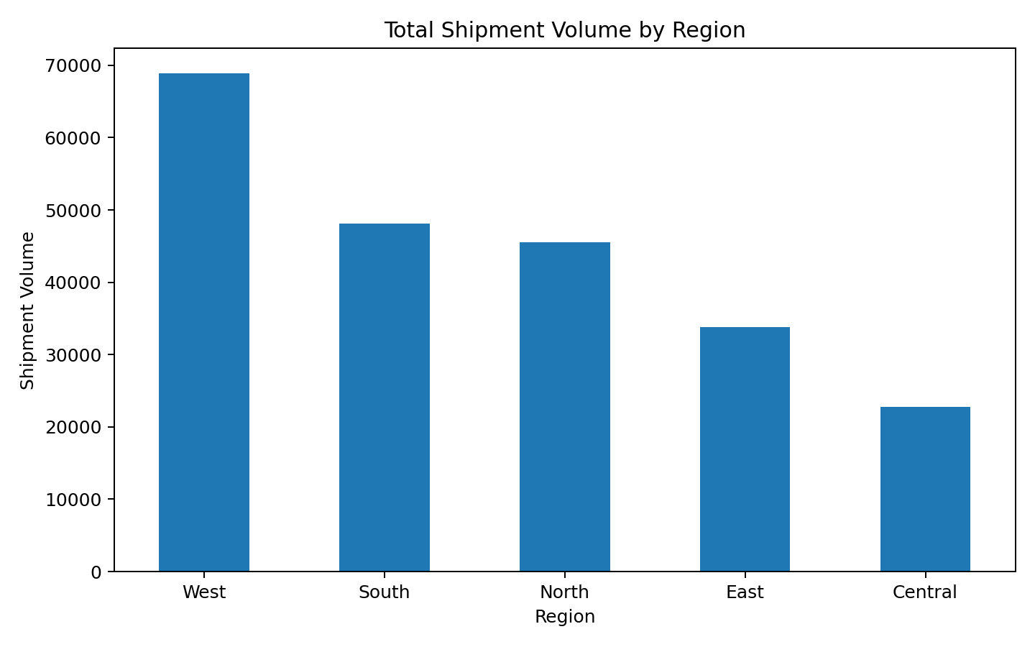
The regional shipment-volume chart identifies where operational activity is concentrated. High-volume regions may require more delivery capacity, warehouse resources, vehicles, or dispatch planning. However, volume alone does not indicate poor performance, so it should be compared with service and cost KPIs.

8.2 Delivery Time by Region
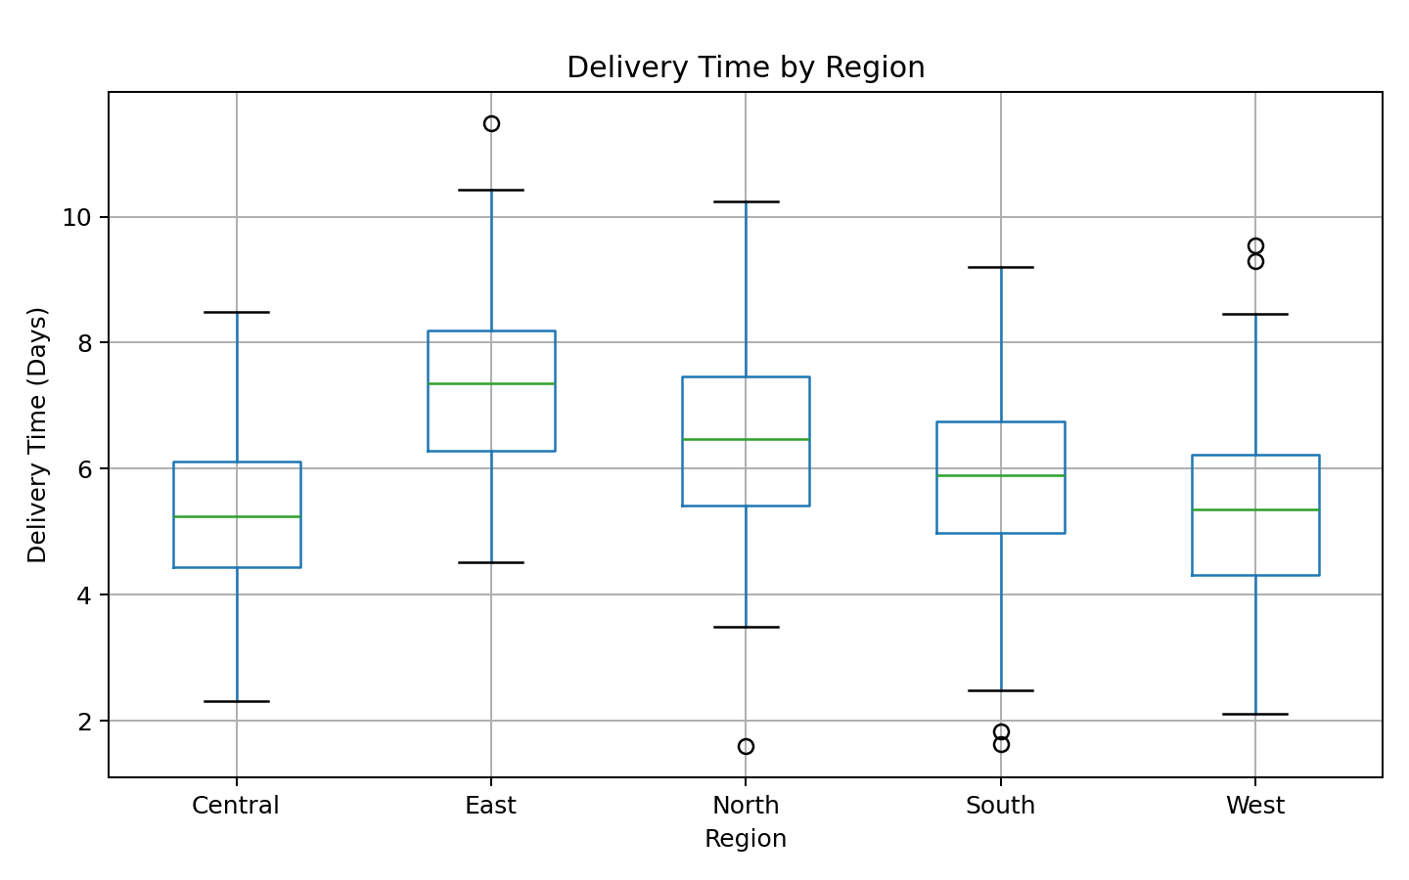
The box plot compares both the central delivery time and variation across regions. A region with a wide box or long upper whisker may have inconsistent delivery performance even if its average is acceptable.

8.3 On-Time Delivery Rate by Region
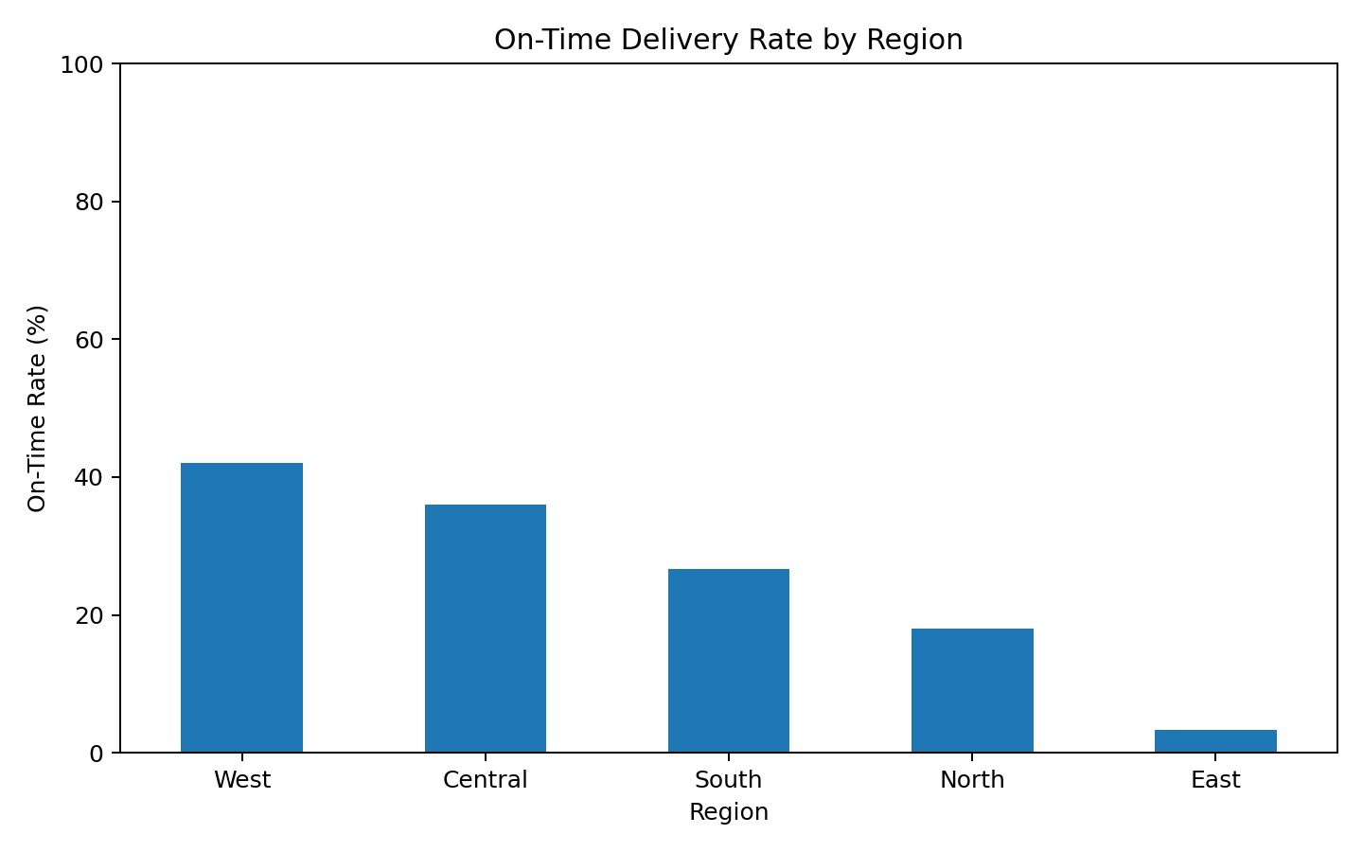
The on-time rate provides a direct service-performance comparison. Combining this chart with shipment volume helps distinguish a high-rate region with low volume from a high-volume region where service reliability is weaker.

9. Correlation and Relationship Analysis

9.1 Correlation Matrix
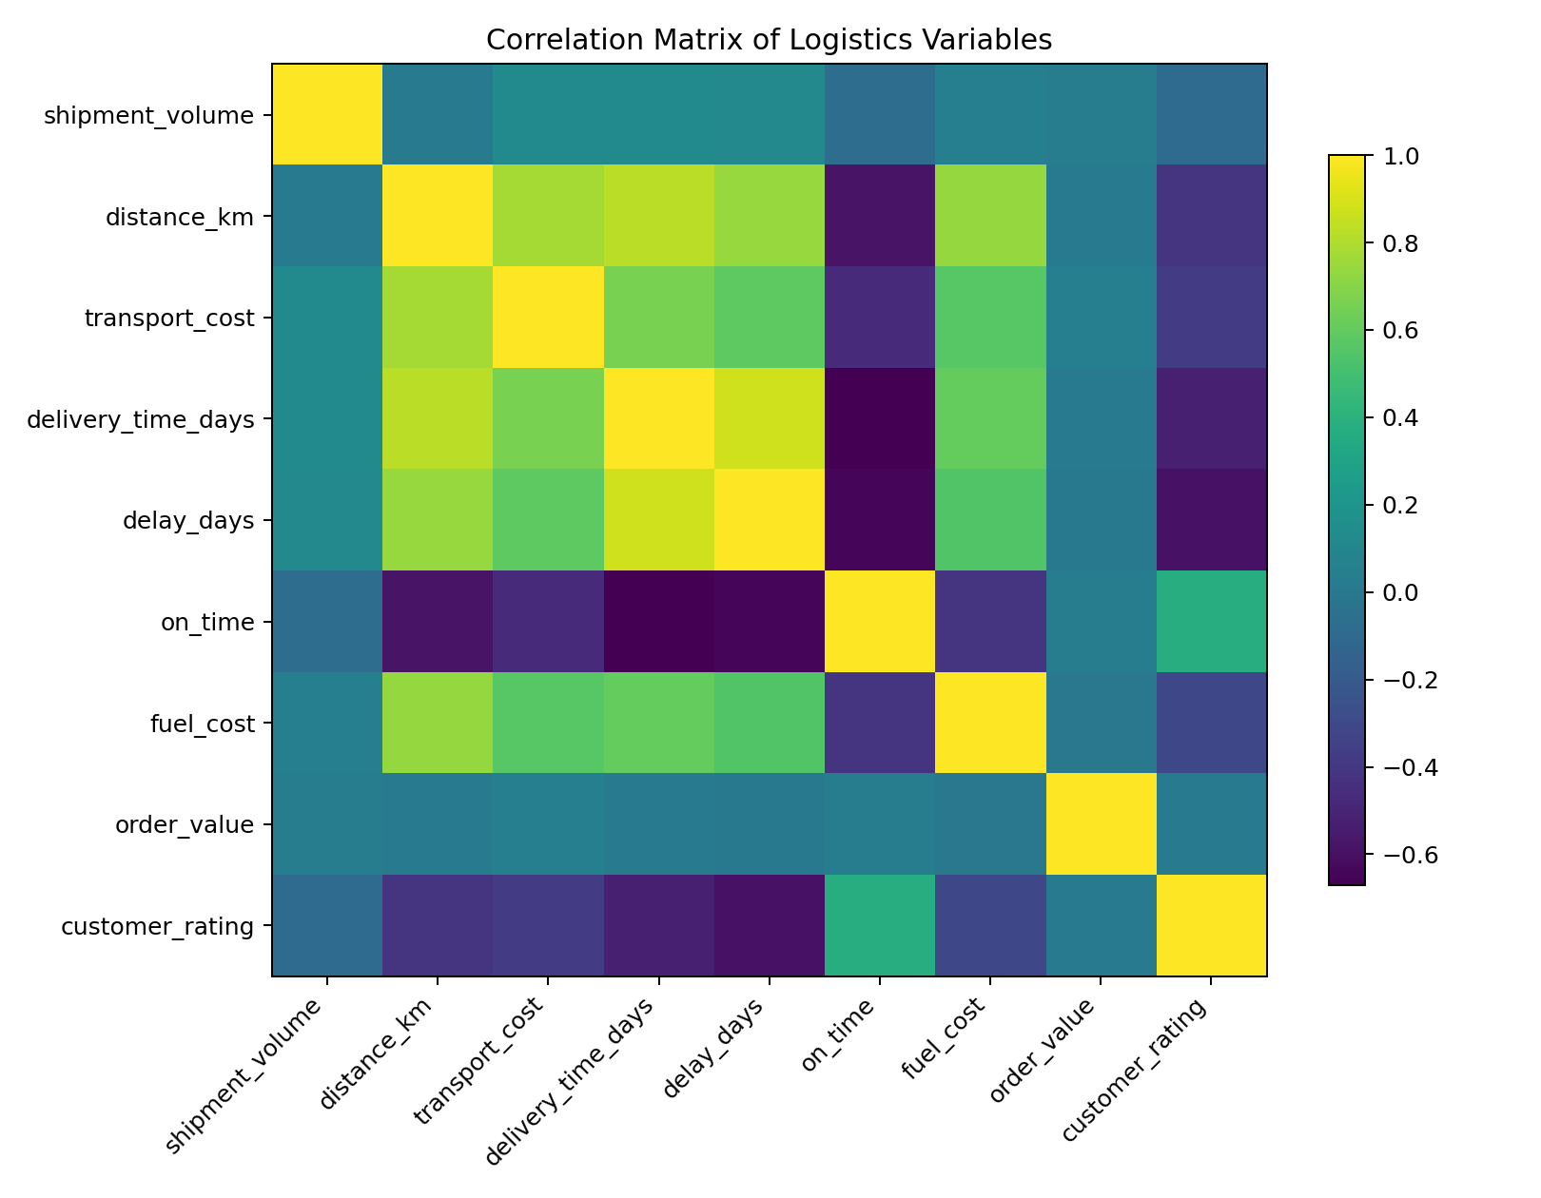
The correlation matrix summarizes linear relationships between numerical variables. It is useful for identifying candidate predictors and potential redundancy, but correlation alone does not prove causation.

9.2 Key Simulated Correlations
Relationship | Correlation | Interpretation
Distance vs Delivery Time | 0.83 | Positive relationship in the simulated data
Shipment Volume vs Transport Cost | 0.13 | Higher volume tends to coincide with higher cost
Delay vs Customer Rating | -0.59 | Higher delay is associated with lower rating

9.3 Distance vs Delivery Time
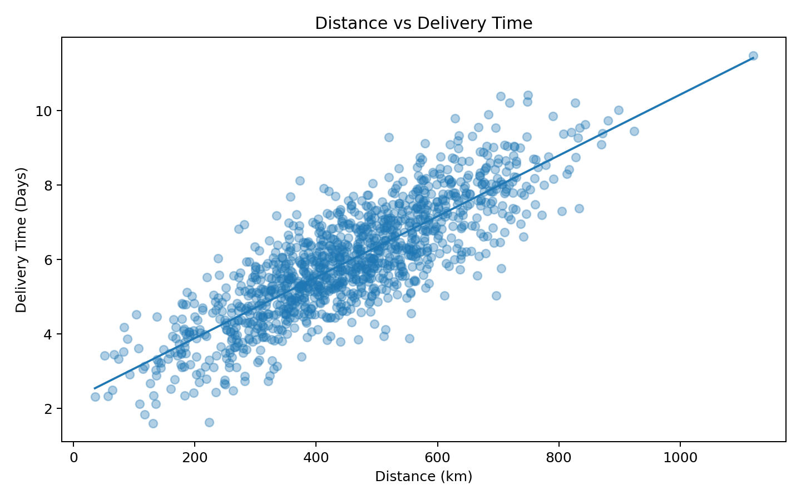
The scatter plot indicates a positive relationship in the simulated data: as distance increases, delivery time tends to increase. This supports distance as a candidate feature for delivery-time or late-delivery models. In a real system, traffic, carrier, road type, depot capacity, and weather could also affect the relationship.

9.4 Shipment Volume vs Transportation Cost
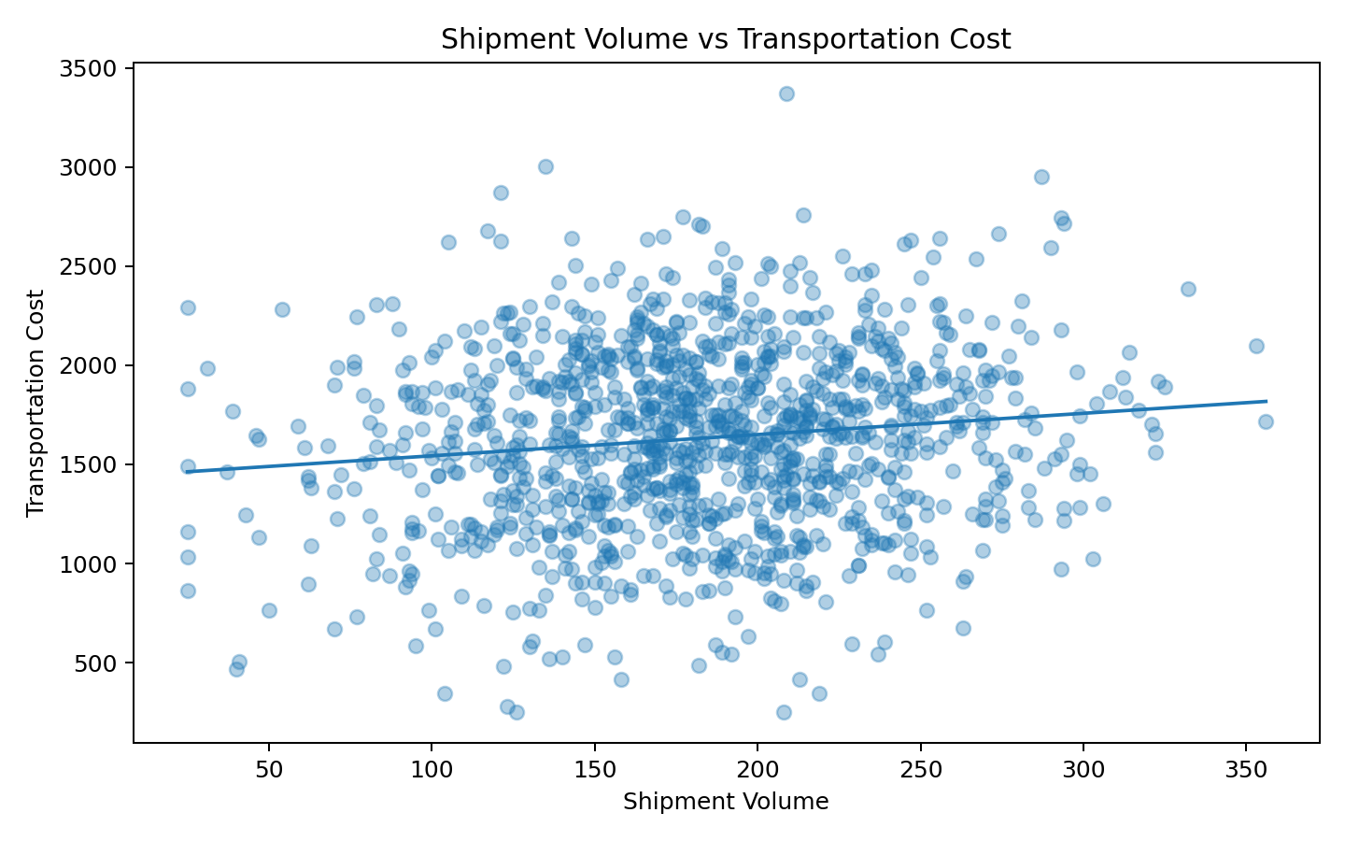
The relationship suggests that larger shipment volumes can increase transportation cost. The operational implication is that cost analysis should consider both volume and route distance rather than comparing raw transportation costs without context.

10. Regional and Operational Analysis

10.1 Regional Volume
In the simulated dataset, West has the highest total shipment volume. This indicates higher operational activity in that segment. Resource planning should consider volume together with on-time rate, delivery variation, and cost before allocating additional capacity.

10.2 On-Time Performance
The simulated regional comparison shows variation in on-time performance, with West having the highest observed on-time rate and East the lowest in this generated sample. These values are properties of the hypothetical dataset and are not claims about actual regions.

10.3 Operational Bottleneck Identification
- High shipment volume + low on-time rate can indicate a capacity or process bottleneck.
- High distance + high delivery time can indicate a route/network efficiency issue.
- High transportation cost + high volume may require consolidation or route redesign analysis.
- High delay + lower customer rating indicates a customer-experience risk signal.
- High variability is important even when average performance looks acceptable.

11. Analytical Insights
The following insights are derived from the hypothetical dataset and demonstrate how an analyst would translate charts into operational conclusions.
Delivery time is distance-sensitive: The positive distance-delivery relationship suggests that longer routes require greater delivery-time allowance. Route design should therefore consider geographic distance during planning.
Transportation cost rises with operational load: The simulated positive relationship between shipment volume and cost indicates that capacity and consolidation decisions can affect transportation expenditure.
Average values are not enough: Histograms and box plots show that distribution and variability matter. A high average can result from a small number of extreme shipments.
Regional performance should be multi-dimensional: Shipment volume, on-time rate, delivery time, and cost must be viewed together. Ranking regions on a single metric can hide operational trade-offs.
Delay is a customer-experience signal: The simulated relationship between delay and rating suggests that service reliability should be monitored alongside operational KPIs.
EDA informs modeling: Distance, volume, freight/transport cost, region, and operational timing are logical candidate features for future predictive models.

12. Python Visualization Code

12.1 Histogram
import matplotlib.pyplot as plt
plt.figure(figsize=(8,5))
plt.hist(df["delivery_time_days"].dropna(), bins=30)
plt.title("Distribution of Delivery Time")
plt.xlabel("Delivery Time (Days)")
plt.ylabel("Number of Shipments")
plt.tight_layout()
plt.show()

12.2 Regional Bar Chart
regional_volume = (
df.groupby("region")["shipment_volume"]
.sum()
.sort_values(ascending=False)
)
regional_volume.plot(kind="bar", figsize=(8,5))
plt.title("Total Shipment Volume by Region")
plt.xlabel("Region")
plt.ylabel("Shipment Volume")
plt.xticks(rotation=0)
plt.tight_layout()
plt.show()

12.3 Scatter Plot
plt.figure(figsize=(8,5))
plt.scatter(
df["distance_km"],
df["delivery_time_days"],
alpha=0.35
)
plt.title("Distance vs Delivery Time")
plt.xlabel("Distance (km)")
plt.ylabel("Delivery Time (Days)")
plt.tight_layout()
plt.show()

12.4 Box Plot
df.boxplot(
column="delivery_time_days",
by="region",
figsize=(8,5)
)
plt.suptitle("")
plt.title("Delivery Time by Region")
plt.xlabel("Region")
plt.ylabel("Delivery Time (Days)")
plt.tight_layout()
plt.show()

12.5 Correlation Matrix
numeric_cols = df.select_dtypes(include="number")
corr = numeric_cols.corr()
import seaborn as sns
plt.figure(figsize=(9,7))
sns.heatmap(
corr,
annot=True,
cmap="coolwarm",
fmt=".2f"
)
plt.title("Logistics Variable Correlation Matrix")
plt.tight_layout()
plt.show()

12.6 Plotly Alternative
import plotly.express as px
fig = px.scatter(
df,
x="distance_km",
y="delivery_time_days",
color="region",
title="Distance vs Delivery Time"
)
fig.show()

13. Business Recommendations
- Use regional shipment volume together with on-time rate to prioritize capacity planning.
- Monitor high-distance routes separately because distance can increase delivery time and transportation effort.
- Use percentile-based delivery metrics to detect slow-tail performance rather than relying only on average delivery time.
- Investigate high-cost shipment segments by volume, distance, and route rather than treating cost as a standalone metric.
- Use EDA findings to select features for future late-delivery prediction.
- Use geographic and volume patterns as inputs to the Week 1 route-optimization framework.
- Build a dashboard with KPI cards, regional comparisons, trend charts, and exception segments for management use.

14. Limitations
- The dataset is hypothetical and generated for internship analysis.
- The numerical relationships are simulated and cannot be interpreted as real company performance.
- The analysis does not include live traffic, road-network travel times, weather, vehicle capacity, driver availability, or depot constraints.
- Correlation does not establish causation.
- Visualization conclusions should be validated against actual operational data before business deployment.

15. Week 3 Execution Plan
Day | Activity | Deliverable
Day 1 | Define hypothetical dataset and analytical questions | Dataset schema + EDA plan
Day 2 | Generate/load dataset and perform descriptive statistics | Statistical summary
Day 3 | Analyze distributions and regional performance | Distribution + comparison charts
Day 4 | Analyze relationships and correlations | Scatter plots + correlation matrix
Day 5 | Interpret operational bottlenecks | Insight notes
Day 6 | Prepare Python visualization code and recommendations | Code + recommendations
Day 7 | Embed charts and finalize report | Week 3 submission

16. Expected Outcomes
- A structured hypothetical logistics dataset suitable for EDA.
- Descriptive statistics covering central tendency and variability.
- Multiple visualizations covering trends, distributions, comparisons, and relationships.
- Identification of simulated operational patterns involving distance, volume, cost, delay, and customer rating.
- Python code that can be reused with a real logistics dataset.
- Analytical recommendations connected directly to logistics decision-making.
- A clear foundation for predictive modeling and route optimization in later stages.

17. Conclusion
Week 3 demonstrates how exploratory data analysis transforms prepared logistics data into interpretable operational information. The analysis combines descriptive statistics, distributions, regional comparisons, relationship analysis, and correlation analysis to understand delivery performance, shipment volume, transportation cost, distance, and customer outcomes.
The visualizations are intentionally matched to analytical questions. Histograms reveal distributions, box plots compare variation, bar charts compare categories, scatter plots reveal relationships, and correlation matrices summarize numerical dependencies. This combination prevents over-reliance on a single metric and supports more complete logistics interpretation.
Because the dataset is hypothetical, the findings are methodological demonstrations rather than real-world claims. The next analytical stage can use actual operational data to validate these patterns, develop predictive models, and connect the results to route optimization.
Week 3 Outcome
A complete EDA and visualization workflow that converts logistics data into interpretable patterns, operational insights, and evidence for future predictive and route-optimization decisions.

18. References
- World Bank. Logistics Performance Index and logistics performance concepts.
- Olist / Kaggle. Brazilian E-Commerce Public Dataset by Olist.
- Python pandas documentation. Data analysis and descriptive statistics.
- Matplotlib documentation. Python visualization library.
- Seaborn documentation. Statistical data visualization in Python.
- Plotly documentation. Interactive visualization in Python.
- Scikit-learn documentation. Preprocessing and machine-learning workflows.

Appendix A. Dataset Dictionary
Field | Meaning | Analytical Role
region | Logistics operating region | Segmentation
shipment_volume | Units handled | Capacity/load
distance_km | Estimated route distance | Route efficiency
transport_cost | Transportation expenditure | Cost analysis
delivery_time_days | Delivery duration | Service performance
delay_days | Delivery delay | Exception analysis
on_time | On-time flag | KPI/target
fuel_cost | Fuel-related expenditure | Cost driver
order_value | Order/shipment value | Economic context
customer_rating | Customer score | Outcome indicator

Appendix B. Visualization Checklist
Visualization | Question | Included
Regional bar chart | Where is shipment volume concentrated? | Yes
Delivery histogram | How is delivery time distributed? | Yes
Cost histogram | How is transportation cost distributed? | Yes
Box plot | How does delivery variation differ by region? | Yes
Scatter plot | How does distance relate to delivery time? | Yes
Scatter plot | How does volume relate to transportation cost? | Yes
Correlation matrix | Which numerical variables move together? | Yes
On-time bar chart | Which regions differ in service reliability? | Yes

