Earlier javascript was only available on browser that is why generally run in html file later on node.js and other frameworks came to make js available .
ECMA script gives standards for writing javascript code.
Setting up environment in a GitHub codespace editor:
- Create a repository with a readme.
- In the repo click code and got to codespaces and create new.
- Now you have a code editor but it has no extensions or env.
- Go to view command palette or ctrl+shift+P .Type container add dev configuration files.
- Now select create new and select node js and js.
- Wait for rebuild then create new folder.
- After writing code to run in terminal type : node path of file/file.js
- To save go on git button in sidebar and commit then push.
- But remember that we get only a limited hours free so go to codespaces in repo and close or delete it.
Datatypes:
Const -- value cannot be changed
Varc // Changeable but now not used because no scope defined for it so entirely changeable and overriding.
Let // Changeable if no assignment then undefined value.
Console.log(what to print) // To print things
Console.log(a op b)
Console.table([var1,var2,……]) // To print multiple things

“use strict” // treat all JS code as newer version.
Here if you use alert(something) // It will not run because we are using node.js not browser.
- Without ; code runs but ; used when in same line breaks are needed.

- NUMBER:
Size around 2^53.
Bigint – very larger number
- Boolean:
- String:
- Null: // Standalone value . No value empty .
Console.log(typeof null) // Gives object
- Undefined // no value assigned
Console.log(typeof undefined) // Gives undefined
- Symbol // Unique
Number(variable) // Converts to number. Gives Nan if has string also.
Boolean(variable) // Converts to bool.
String(variable) // Convert to string.
Console.log(1+2+”3”) // 33
Console.log(“1”+2+3) //123

Num1=num2=num3= 2+2
X++ ++X
Console.log(“2” >1) // Allowed in js true but not in typescript

Null > 0 //false
Null == 0 //false
Null >= 0 // Comparisons convert null to a number, treating it as 0 true

2 === “2” // === checks datatype and value both

Types of datatypes:
Primitive:
String
Number
Boolean
Null
Undefined
Symbol // Symbol makes uniqueness means if :
Const id= Symbol(“123”)
Const id2=Symbol(“123”) // These both are not equal they are unique and different
BigInt

Non primitive / Reference:
Array:
Const heroes= [hello,boy]
Objects:
Obj={
Name:”yash”
Class:22
}
Functions:
Const myFunction= function(){
Do something
}
Memory in javascript:
Stack – Primitive
Heap -Non-Primitive // Means if you make another reference and do changes in that reference then the original will also change.

String:
Earlier concatenation was done as - “My name” +rep+vara
New way :
Console.log(`Hello my name is ${name} and my repo is ${var} `) ; // Using backticks ` and $.
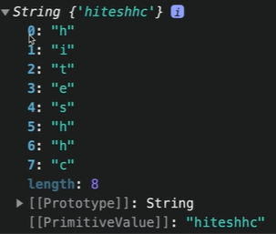
Declaring :
Const str = new String(“yashare”)
If you see this makes as new object that means –
Go to prototype and you can see multiple methods in this.

.length()
.toUpperCase()
charAt(index)
indexOf(char)
slicing: .substring(start,stop)
.slice(start,stop) // Slice can take negative indexing that is reverse
If string has spaces we need to remove
.trim()

.replace(“to be replaced” , replacement)

.includes(“hhh”)

Str1= str.split(Based on what ie “ “ / “_”)

Numbers:
Const score =100 // JS automatically guesses it as a number but you can explicitly define it as number as
Const score = new Number(100)
.toString()
.toFixed(precision value) // Decimal precision
Num.toPrecision(precision value before the decimal ) //returns string
.toLocalString(“en-IN”) // Converts large number to indian standard of writing
Number.MAX_VALUE()

Math.abs(number)
Math.round(num)
Math.ceil(num)
Math.floor(num)
Math.sqrt(num)
Math.random() // Gives random values between 0 and 1
Use (math.random()*10) +1 // +1 because sometimes 0.0 also na . We can also use floor with this .

Date:
Let myDate =new Date() //Type of -Object
.toString()
.toDateString()
.toLocaleString()

Let myCreatedDate =new Date(2023, 0, 23) // Gives date Jan 23,2023 means months start from 0
Let myDate= new Date(“month-date-year”)
myDate.getTime() // Gives exact milliseconds on date to convert to seconds-

let myTime =Date.now()
console.log(Math.floor(Date.now() / 1000)); // Gives in seconds

.getMonth()
.getDAY() // Uses are like- `${newDate.getDay()} and time`

newDate.toLocaleString( customiseable )

Arrays:
Const myArr= [0,1…….]
Const myArr=new arr(1,3,5,7)
Here arrays are resizable. JS create shallow copies

Arr.push(element)
Arr.pop() // Pops last element
Arr.includse(4)
Arr.indexOf(el)
Arr.join() // Joins and converts to string

Arr.splice(start,end) // Returns part of an array
Arr.splice(start,end) // It also keeps end inclusive but it deleted the elements from the array. Means if 1 to3 then the numbers 1 to 3 are now deleted from the original array.

If you push array array to another array like arr.push(arr2) , they don’t merge instead arr2 is a element inside of the arr
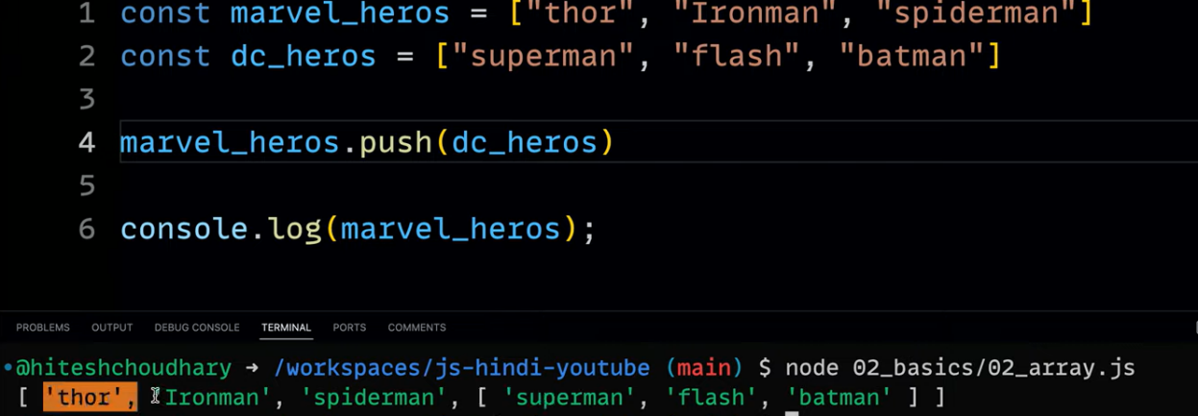

Arr.concat(arr2); // merges arrays
Another way is using spread:
Const merge = [ … arr, …arr2] // Adds as single elements
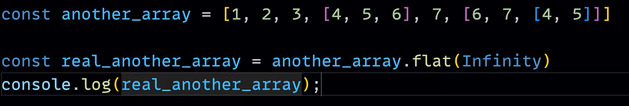
Converting Strings to array:
Array.from(“String------“”)

Array.of(var1,var2,………) // Gives an array from a number of single variables

OBJECTS:
Const obj = {
Name: “Yash”
Mail: [“Hello@gmail”,”round@”]

To access uses:
Obj.mail // Don’t always use dot as ther are cses like if key is mores than one word like full name , can’t use.full name .So use bracket
Or
Obj[“Mail”] // obj.[“full name”]
If any symbol to be added to then can’t do normally or it will take it to be string .
So const sym= Symbol(“key1”)
Obj= {
[sym] : “key1”,
Age: 12
}
Change values:
Obj.age = 34

If you set any object to freeze then it is unchangeable.
Object.freeze(obj)
You can also keep object inside an object.
Merging two objects:
Obj3 ={obj1,oobj2} // It will make object in object
Const Obj3= Object.assign( { }, obj1,obj2) // Merges two objects . We put an empty object in it because if wew don’t all objects will be combined into obj1
Const obj3 = {…obj1, …obj2}

Object.keys(obj) // returns an array of keys which can now be looped
Object.entries(obj) // returns multi level array of entries

Obj.hasOwnProperty(“key”)

Destructuring objects:
Course {
Name:
Full_instruction: hello”
}
To accees you will have to write everytime course.Full_instruction very long so we use deconstructor –
Cosnt { Full_instruction: instructor} = course
{ Key : Alias to use } = object name
Console.log(instructor);
JSON:
Object without name:
{
“Name”:”yash”
}
Now this is difficult to read so go to JSON formatter online there you can read it easily. JSON is returned by Apis.

Function:

Function addTwo(num1,num2) { // No need to give datatype
Let result =num1+num2
Console.log(result);
Return result;
}

Function loginMessage(username){
Return `${username} just logged in`

Function calculate(…num1){
return
Objects in function:
Const user = {
Username: “hitesh”,
Prices: 99
}
Function handleObject(anyObject){
Console.log(`Username is ${anyobject.username} and price is$ {anyobject.price};
}

Handleobject(user) OR handleobject( {
Username: “hitesh”,
Prices: 99)
}
Don’t use var for variable declaration because it does not follow scope it acts like a global

Const add=function(num){
Return num+2
AND
Function add(num){
Return num +1} // Both ways are correct

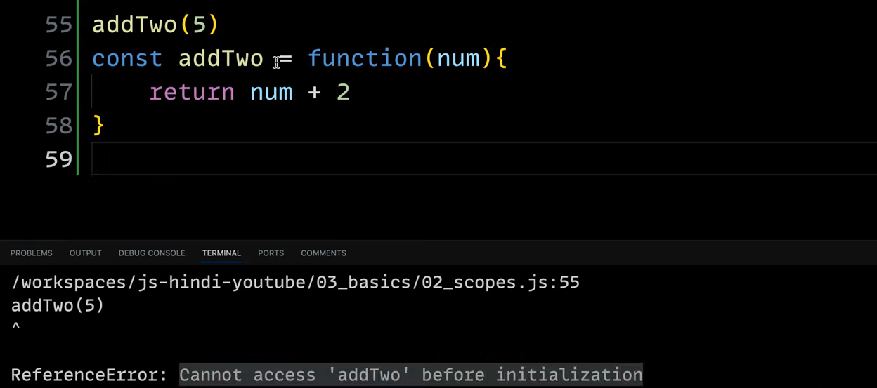
Cannot access this before initaitalization

This:
Used to refer to the current context.
Like:
Obj{
Name:”Yash”
Age:34
Welcome:function () {
Console.log(`${this.username}` )’
}
}
Console.log(this); // Herer if you do this as a global you get{} means an empty object
But in browser consoleif youy do global this it will return you windows object- Tabhi to you are able to use click,and all fucntions.
Arrow Function:
() => {
}
Const addTwo = (num1+num2) => {
Return num1+num2
}
You can also do implicit return :
Cosnt addTwo = (num1 +num2) => (num1+num2 ) // It assumes last statement is return. Use paranthesis.

Immediately Invoked Function Expressions:
Global scope pollution se protect karne ke liye we use this:
Simple paranthesis –
(function chai(){
Console.log(`something`);
} )( );
Function and then its execution( ) immediately. Always followed by semi-colon else it will never end and if you write another IFEE it will never run because first one never ended.
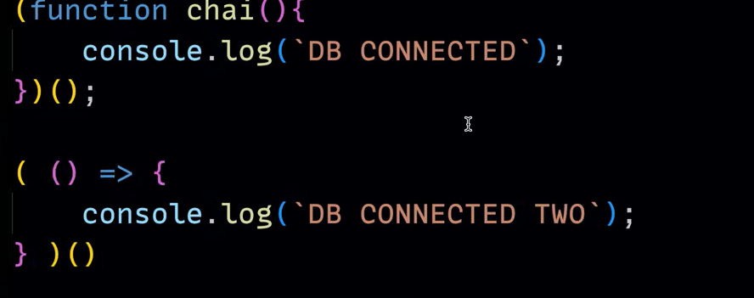

( (name) => {
Console.log(`something ${name} `)
{ ) (`yash`) //Unnamed IFEEE

How is code executed ? :
Javascript execution context:
Single threaded.
First :
Global execution context and function execution context
Is made => this
Then memeory creation phase:
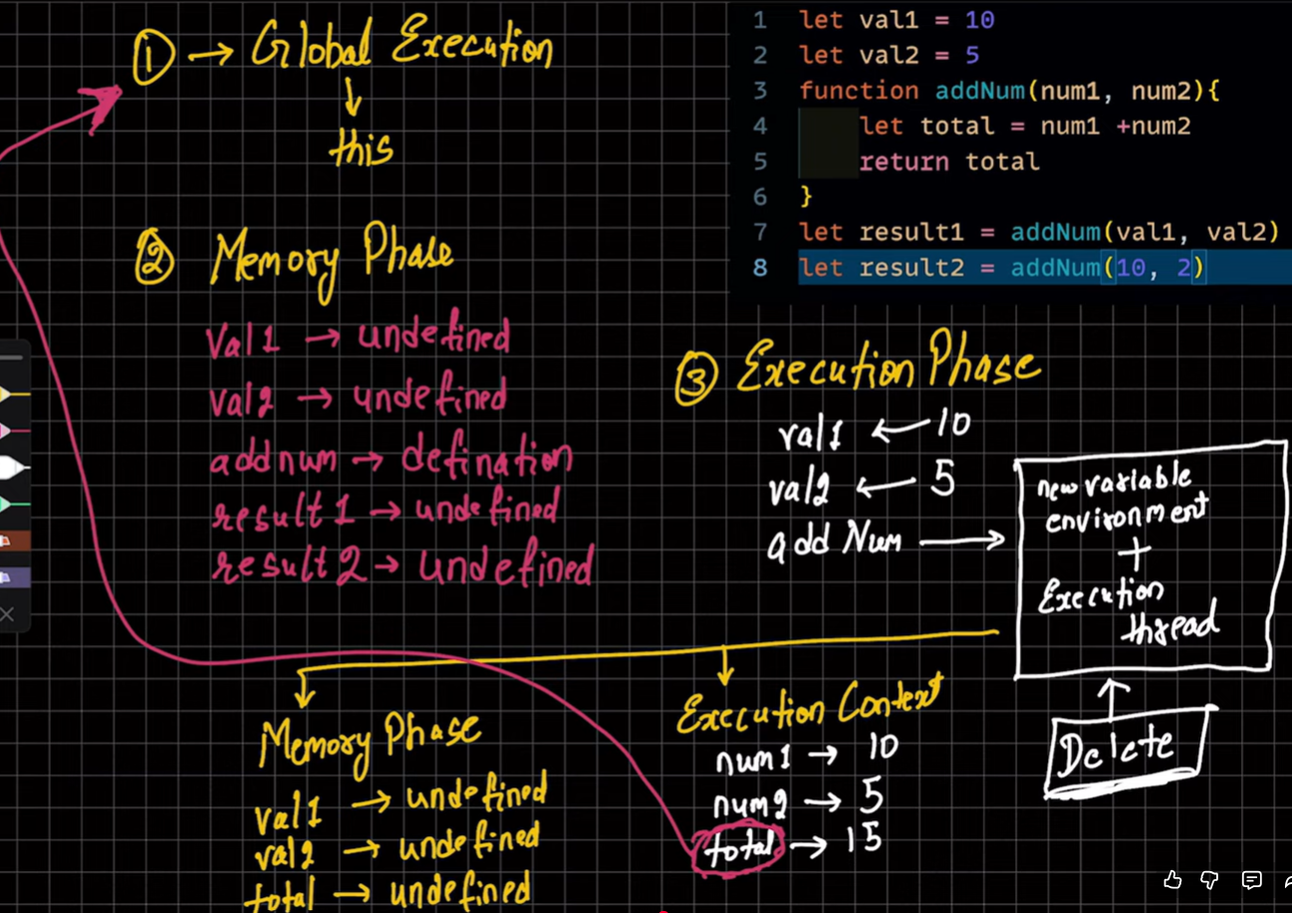
Call Stack :

Falsy values:
Fsle,0, -1, BigInt 0n, “”, null, undefined, NaN

Trutth values:
“0” , “false:, “ “, [], {}, function(){}

If you want to check if array is empty:
Arr.length === 0
If you want to check is object is empty :
(Object.keys(obj).length === 0)

Nullish Coalescing operator (??):
Let val1;
Val1 = 5 ?? 10 // Gives value 5 because it is first but if first value becomes null then we will need to adjust so this operator does this by itself it will give 10.
Val1 – null ?? 10 // Gives 10
Val1 = undefined ?? 12 // 12
Val1 = null ?? 10 ?? 20 //10

Ternary operator :
Condition ? true : f alse

