TERMINAL
Imagine you're in a large office building where the shell is the main server room that processes all the company's data and commands. The terminal is like a receptionist's desk that serves as a point of communication to the server room. You go to the receptionist (terminal) to deliver instructions or requests to the server room (shell).
SHELL
The most commonly used shell in Linux is the Bourne-Again Shell (BASH), and is part of the GNU project. Everything we do through the GUI we can do with the shell. The shell gives us many more possibilities to interact with programs and processes to get information faster. Besides, many processes can be easily automated with smaller or larger scripts that make manual work much easier.
The PS1 variable in Linux systems controls how your command prompt looks in the terminal. It's like a template that defines the text you see each time the system is ready for you to type a command. By customizing the PS1 variable, you can change the prompt to display information such as your username, your computer's name, the current folder you're in, or even add colors and special characters. This allows you to personalize the command-line interface to make it more informative or visually appealing.
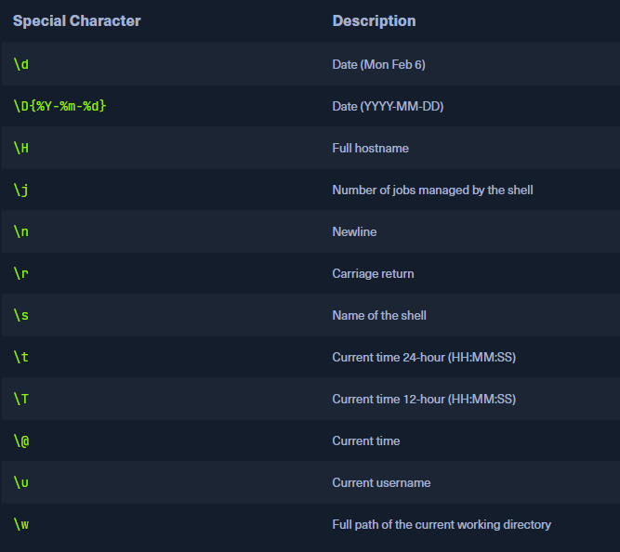

Tool help
$ represents you logged in as a user
man command //tells you about the command
command -h
command –help
apropos type need //it will give command needed
ps //current processes or terminal name eg bash
id
hostname
uname
ip
netstat
who
lsusb
yash@kali$ <tool> --help

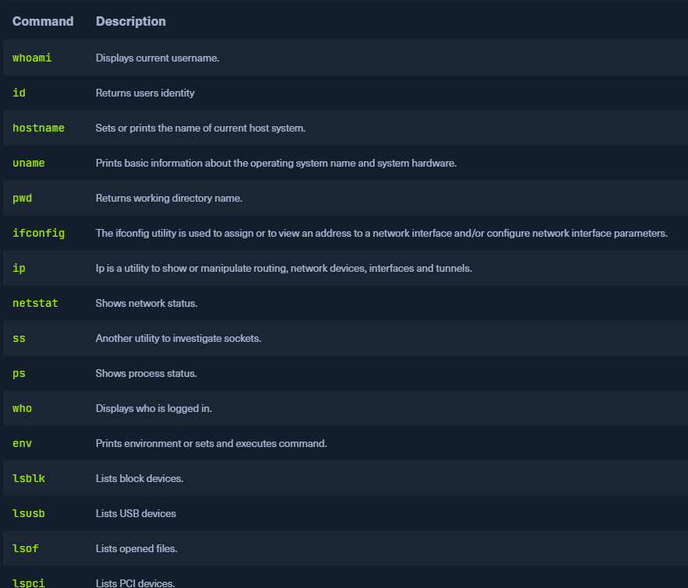

File Structure:

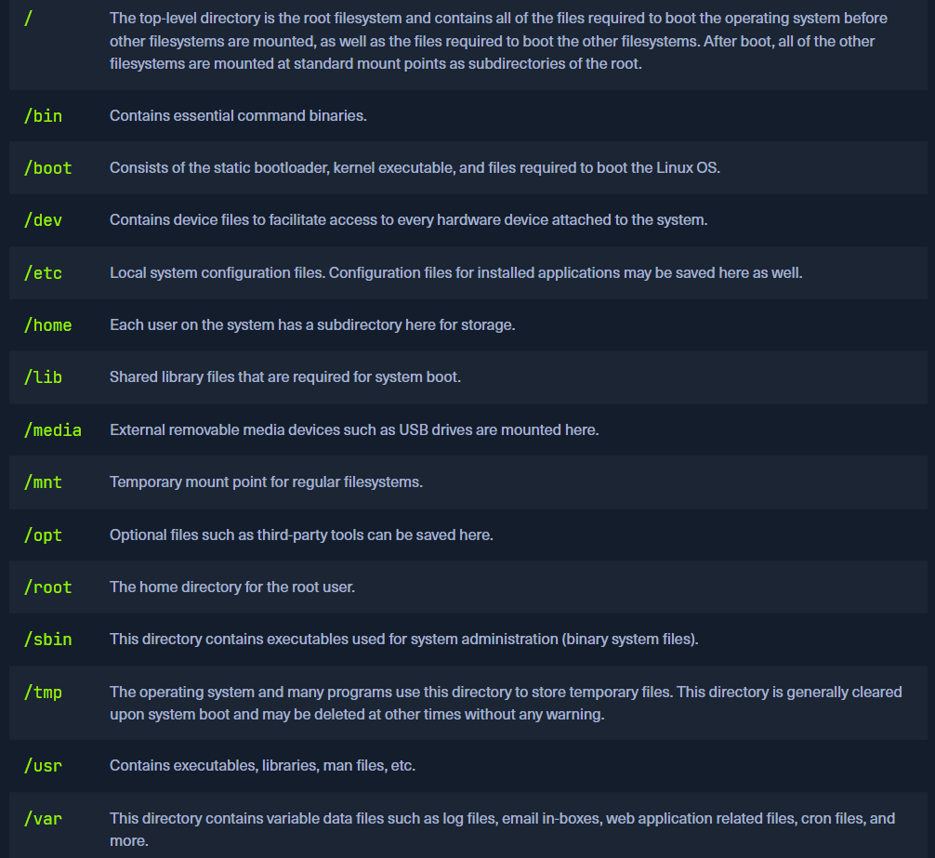
File movement:
- Pwd
- ls -al or only la //shows hidden files also
- cd //Use “For longer names”
- cd .. //back the directory
- cd /
- cd ../ // Takes one directory back
- cd // only cd brings you back to the root folder
- cd - // Go back to the directory you were just before
- cat filename/filepath
- cp file to be copied file name to be copied to //Sometimes it needs permission so do sudo
- rm file to be deleted
- which command/file it is used because our files are in bin also and users bin also so which one are we using this is told by which then command name
- adduser

Ctrl + l or clear command // Clear terminal

Ctrl + A Move to the beginning of line
Ctrl + E Move to the end of the line
Ctrl + U Deletes everything before your cursor
Ctrl + Y Pastes the deleted content back
Ctrl + X+E Opens command in editor
Ctrl + R Reverse search the used commands

Sudo !! // Run the previous command with sudo

Cat / less for big files

Tab // Complete the command
Tab Tab // Gives choices if you forget a path

tail path_file // Brings the last 10 lines of the file
tail -f // Shows file live

FIND:
tryhackme@linux1:~$ find -name passwords.txt
tryhackme@linux1:~$ find -name *.txt

SEARCH in FILE:
grep "81.143.211.90" access.log

SEARCH in Multiple FILES:
grep -R "PRETTY_NAME" /etc/
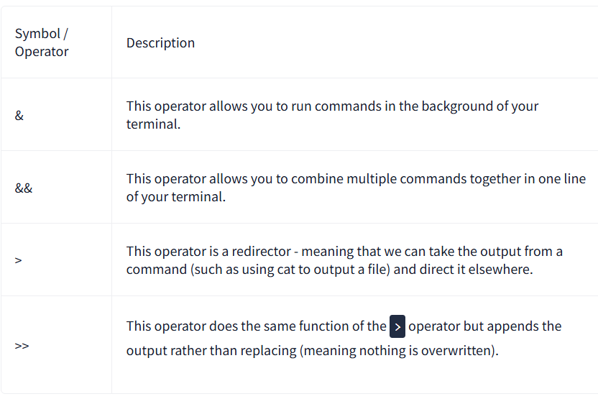
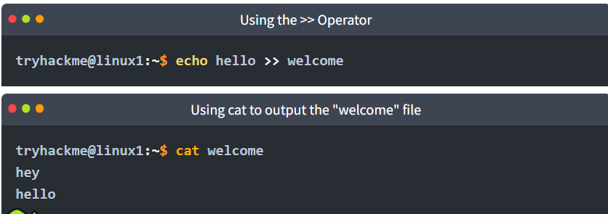

sudo means Super user do
Su - //switches you to root user DANGER
Su- a user name to impersonate as
sudo adduser name //Add user
also works useraddd name //Lazy command i.e. no home no pass
cannot use sudo command
Every user has a Uid and group id then home directory then bin/bash
cat etc/passwd
Modifiying added user :
passwd name of user //Gives password to the user
usermod //Modifies user account
sudo usermod name –shell
sudo usermod -l Newname oldName
useradd hulk -m //do help
sudo usermod -aG name_group name_user //Appends user to a group
sudo gpasswd -d name // Delete group
Sudoers file:
You can do edits and there are checks to protect the file from getting destroyed.
sudo visudo to edit a sudoers file
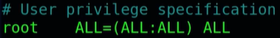
ALL systems access

sudo userdel // delete user
sudo groupdel //delete group but leave users
sudo groupadd name //Add group
cat/etc/group
Package Installer:
dpkg //low level . It needs sudo and it is dumb it cannot install dependencies so errors occur on installation and problems. It needs us to download the deb file then use:
sudo dpkg -i filename
apt // also needs sudo but installs all required dependencies . It works with repositories it does need the user to download the deb file it goes to repo asks the package and downloads it .
sudo apt install package_name
always use apt update first
sudo apt show tool/package //Tells about package
suo apt –installed | grep ^starts with

sudo apt remove pidgin // Safe command does not remove the user data
sudo apt purge pidgin //Hard
sudo apt purge pidgin-data //secondary files

snap is a like a store where new packages can be installed or uploaded.

Programming language specific installers :
Python -pip
pip3 install -r rewuiredfile.txt

Ruby -gem
ctrl + c
ctrl +z // Process sleep
ctrl +\
Externally managed error – It is the way to protect the system programming files. Use virtual environment .
Daemons:
Daemons are services which run every processes. Every daemon process has d at end .
Master daemon – Systemd controls other daemons and calls them Units
Pstree //Process tree
ps -aux
Controlling Daemons :
systemctl stop/
start/
status/
restart/
reload/
reload-or-restart
disable/
enable/
is-active/
is-enabled daemon name
sudo systemctl list-units //List of active daemons
sudo systemctl list-units -t service //Only service daemons are listed
jounalctl – Shows logs of active daemons . If it shows no entries restart it .
sudo syemctl restart systemd-journald

ps -u useraccount //Shows all processes running in the user’s account
ps -u htb-ac-2430635 | grep firefox // Showws firefox process , it will also give process id.
KILL:
kill process id
pgrep firefox // Returns you the process id of firefox
ps -aux
top // Lists the processes based on Cpu usage
htop
Foreground jobs :
ping -c no of times ping request Website url // Ping is like handshake to check if active
fg job no
jobs // Current jobs sleeping or running with job id
Background jobs:
bg job no // Goes to run in backfround but now cannot be stopped make it foreground to kill it .
or
ping -c 300 hackthebox.eu & // & makes it background
kill // It will show multiple kill signals SIGTERM is default but it asks process nicely so can not kill sometimes .
SIGKILL -19 is the most powerful .
kill -19 process id.
Ctrl + c is stopped .
If ping running you can also open other terminal and then use
pkill -9 ping

Starting a python server on linux terminal :
python -m http.server specify a server port if you want or else it is 8000
127.0.0.1 Always goes back to your machine called Loopback Address.

Sudo nano /etc/apahce2/ports.config //Here we can change the port listening address and solve our issue of not starting
curl localhost:7600 // Used to interact with websites. It generally gives the html code of the website
curl -o filename website //It downloads the data to the file
curl -v website
wget localhost: // Get code downloaded

