VISVESVARAYA TECHNOLOGICAL UNIVERSITY
“JnanaSangama”, Belgaum -590014, Karnataka.



LAB REPORT
on

OPERATING SYSTEMS

Submitted by

YASH ANAND (1BF24CS335)

in partial fulfillment for the award of the degree of

BACHELOR OF ENGINEERING
in
COMPUTER SCIENCE AND ENGINEERING


B.M.S. COLLEGE OF ENGINEERING
(Autonomous Institution under VTU)
BENGALURU-560019
Feb-2026 to June-2026

B. M. S. College of Engineering,
Bull Temple Road, Bangalore 560019
(Affiliated To Visvesvaraya Technological University, Belgaum)

Department of Computer Science and Engineering


CERTIFICATE
This is to certify that the Lab work entitled “OPERATING SYSTEMS – 23CS4PCOPS” carried out by Yash Anand(1BF24CS335), who is Bonafide student of B. M. S. College of
Engineering. It is in partial fulfilment for the award of Bachelor of Engineering in Computer Science and Engineering of the Visvesvaraya Technological University, Belgaum during the year Feb-2026 to June-2026
. The Lab report has been approved as it satisfies the academic requirements in respect of a OPERATING SYSTEMS - (23CS4PCOPS) work prescribed for the said degree.

Dr. Kavitha Sooda
Assistant Professor Professor and Head
Department of CSE Department of CSE
BMSCE, Bengaluru BMSCE, Bengaluru

Index Sheet
Sl.  No. | Experiment Title | Page No.
1. | Write a C program to simulate the following non-pre-emptive CPU scheduling algorithm to find turnaround time and waiting time.  →FCFS  → SJF (pre-emptive & Non-preemptive)  → Priority (pre-emptive & Non-pre-emptive)  →Round Robin (Experiment with different quantum sizes for  RR algorithm) | 1-21
2. | Write a C program to simulate multi-level queue scheduling algorithm considering the following scenario. All the processes in the system are divided into two categories – system processes and user processes. System processes are to be given higher priority than user processes. Use FCFS scheduling for the processes in each queue. | 21-26
3. | Write a C program to simulate Real-Time CPU Scheduling algorithms:  - Rate- Monotonic  - Earliest-deadline First  c)Proportional scheduling | 26-32
4. | Write a C program to simulate  a)producer-consumer problem using semaphores  b) Dining Philosophers problem. | 32-38
5. | Write a C program to simulate:  - Bankers’ algorithm for the purpose of deadlock avoidance  - Deadlock Detection | 39-46
6. | Write a C program to simulate the following contiguous memory allocation techniques. a) Worst-fit b) Best-fit  c) First-fit | 46-52
7. | Write a C program to simulate page replacement algorithms. a)  FIFO  - LRU  - Optimal | 52-60

Course Outcomes
C01 | Apply the different concepts and functionalities of Operating System
C02 | Analyse various Operating system strategies and techniques
C03 | Demonstrate the different functionalities of Operating System.
C04 | Conduct practical experiments to implement the functionalities of Operating system.

Program -1
Question:
Write a C program to simulate the following non-pre-emptive CPU scheduling algorithm to find turnaround time and waiting time.
→FCFS
→ SJF (pre-emptive & Non-preemptive)

Code:
=>FCFS:
#include<stdio.h>

void sort(int proc_id[],int at[],int bt[],int n)
{ int
min=at[0],temp=0; for(int i=0;i<n;i++)
{
min=at[i];
for(int j=i;j<n;j++)
{ if(at[j]<min)
{ temp=at[i]; at[i]=at[j]; at[j]=temp; temp=bt[j]; bt[j]=bt[i]; bt[i]=temp; temp=proc_id[i]; proc_id[i]=proc_id[j]; proc_id[j]=temp;
}
}
}
}

void main()
{ int n,c=0; printf("Enter number of processes: "); scanf("%d",&n); int proc_id[n],at[n],bt[n],ct[n],tat[n],wt[n]; double avg_tat=0.0,ttat=0.0,avg_wt=0.0,twt=0.
0; for(int i=0;i<n;i++) proc_id[i]=i+1; printf("Enter arrival times:\n"); for(int i=0;i<n;i++) scanf("%d",&at[i]); printf("Enter burst times:\n"); for(int i=0;i<n;i++) scanf("%d",&bt[i]);

sort(proc_id,at,bt,n); //completion time for(int i=0;i<n;i++)
{ if(c>=at[i]) c+=bt[i]; else c+=at[i]-ct[i-1]+bt[i]; ct[i]=c;
}
//turnaround time for(int i=0;i<n;i++) tat[i]=ct[i]-at[i]; //waiting time for(int i=0;i<n;i++) wt[i]=tat[i]-bt[i];

printf("FCFS scheduling:\n"); printf("PID\tAT\tBT\tCT\tTAT\tWT\n");
for(int i=0;i<n;i++)
printf("%d\t%d\t%d\t%d\t%d\t%d\n",proc_id[i],at[i],bt[i],ct[i],tat[i],wt[i]);

for(int i=0;i<n;i++)
{ ttat+=tat[i];twt+=wt[i];
}
avg_tat=ttat/(double)n;
avg_wt=twt/(double)n;
printf("\nAverage turnaround time:%lfms\n",avg_tat);
printf("\nAverage waiting time:%lfms\n",avg_wt);
}

Result:
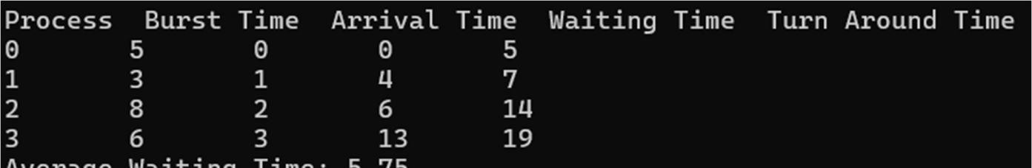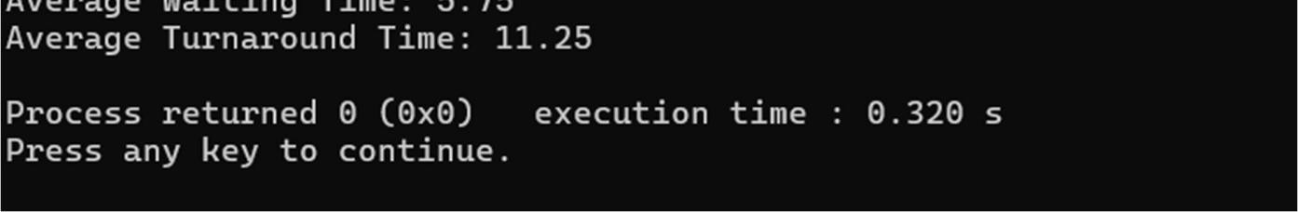

=>SJF(Non-preemptive):
#include <stdio.h>

struct Process {
int pid;
int at; // Arrival Time int bt; // Burst Time int ct; // Completion Time int tat; // Turnaround Time int wt; // Waiting Time int done;
};

int main() {
int n;

printf("Enter number of processes: ");
scanf("%d", &n);

struct Process p[n];

for(int i = 0; i < n; i++) {
printf("\nEnter Arrival Time and Burst Time for P%d: ", i + 1);
p[i].pid = i + 1;
scanf("%d %d", &p[i].at, &p[i].bt);
p[i].done = 0;
}

int completed = 0, time = 0;
float totalWT = 0, totalTAT = 0;

while(completed < n) {
int idx = -1; int
minBT = 9999;

// Find process with shortest burst time for(int i = 0; i < n; i++) { if(p[i].at <= time && p[i].done == 0) { if(p[i].bt < minBT) { minBT = p[i].bt; idx = i;
}
}
}

// If no process is available if(idx == -1) { time++; } else { time += p[idx].bt; p[idx].ct = time; p[idx].tat = p[idx].ct - p[idx].at; p[idx].wt = p[idx].tat - p[idx].bt;

totalWT += p[idx].wt; totalTAT += p[idx].tat;

p[idx].done = 1; completed++;
}
}

printf("\nPID\tAT\tBT\tCT\tTAT\tWT\n");

for(int i = 0; i < n; i++) {
printf("P%d\t%d\t%d\t%d\t%d\t%d\n",
p[i].pid,
p[i].at, p[i].bt, p[i].ct, p[i].tat, p[i].wt);
}

printf("\nAverage Turnaround Time = %.2f", totalTAT / n); printf("\nAverage Waiting Time = %.2f\n", totalWT / n);

return 0;
}

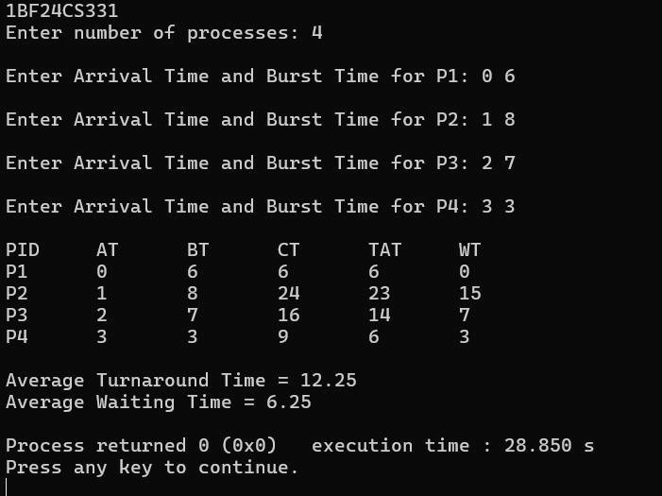
1BF24CS335

SJF(PREEMPTIVE):
#include <stdio.h>

struct Process {
int pid;
int at; // Arrival Time int bt; // Burst Time int rt; // Remaining Time int ct;
// Completion Time int tat;
// Turnaround Time int wt;
// Waiting Time
};

int main() {
int n;

printf("Enter number of processes: "); scanf("%d", &n);

struct Process p[n];

for(int i = 0; i < n; i++) {
printf("\nEnter Arrival Time and Burst Time for P%d: ", i + 1);

p[i].pid = i + 1;
scanf("%d %d", &p[i].at, &p[i].bt);

p[i].rt = p[i].bt;
}

int completed = 0, time = 0;
float totalWT = 0, totalTAT = 0;

while(completed < n) {
int idx = -1; int
minRT = 9999;

// Find process with shortest remaining time for(int i = 0; i < n; i++) { if(p[i].at <= time && p[i].rt > 0) { if(p[i].rt < minRT) { minRT = p[i].rt; idx = i;
}
}
}

// If no process has arrived if(idx == -1) { time++;
} else {
// Execute process for 1 unit time p[idx].rt--; time++;

// If process completed if(p[idx].rt == 0) {
completed++;

p[idx].ct = time; p[idx].tat = p[idx].ct - p[idx].at; p[idx].wt = p[idx].tat - p[idx].bt;

totalWT += p[idx].wt; totalTAT += p[idx].tat;
}
}
}

printf("\nPID\tAT\tBT\tCT\tTAT\tWT\n");

for(int i = 0; i < n; i++) {
printf("P%d\t%d\t%d\t%d\t%d\t%d\n",
p[i].pid,
p[i].at, p[i].bt, p[i].ct, p[i].tat, p[i].wt); } printf("\nAverage Turnaround Time = %.2f", totalTAT / n);
printf("\nAverage Waiting Time = %.2f\n", totalWT / n);

return 0;
}
1BF24CS335
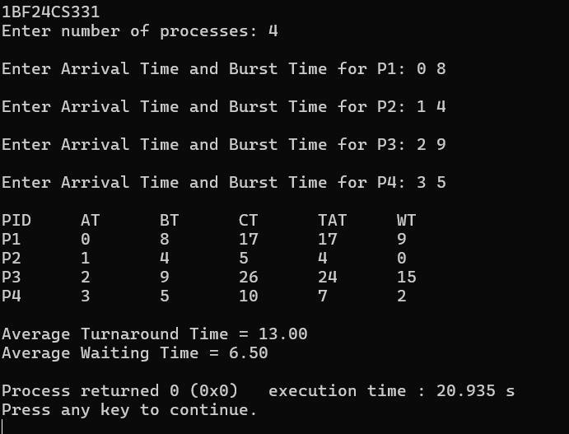

PRIORITY(NON-PREEMPTIVE):

#include <stdio.h>

int main() {
int n, i, j;

printf("Enter number of processes: "); scanf("%d", &n);

int pid[n], at[n], bt[n], pr[n]; int ct[n], tat[n], wt[n]; int completed[n];

for(i = 0; i < n; i++)
{
printf("\nEnter details for Process P%d\n", i + 1);

pid[i] = i + 1;

printf("Arrival Time: "); scanf("%d", &at[i]);

printf("Burst Time: "); scanf("%d", &bt[i]);

printf("Priority: "); scanf("%d", &pr[i]);

completed[i] = 0;
}

int current_time = 0; int completed_count = 0;

while(completed_count < n)
{
int highest_priority = 9999; int selected = -1;

for(i = 0; i < n; i++)
{
if(at[i] <= current_time && completed[i] == 0)
{
if(pr[i] < highest_priority)
{
highest_priority = pr[i]; selected = i;
}
}
}

if(selected == -1)
{
current_time++;
} else
{
ct[selected] = current_time + bt[selected];

tat[selected] = ct[selected] - at[selected]; wt[selected] = tat[selected] - bt[selected];

current_time = ct[selected];

completed[selected] = 1; completed_count++;
}
}

printf("\n----- Priority Scheduling (Non-Preemptive) -----\n");

printf("\nPID\tAT\tBT\tPR\tCT\tTAT\tWT\n");

float total_tat = 0, total_wt = 0;

for(i = 0; i < n; i++)
{
printf("P%d\t%d\t%d\t%d\t%d\t%d\t%d\n",
pid[i], at[i], bt[i], pr[i],
ct[i], tat[i], wt[i]);

total_tat += tat[i]; total_wt += wt[i];
}

printf("\nAverage Turnaround Time = %.2f", total_tat / n); printf("\nAverage Waiting Time = %.2f\n", total_wt / n);

return 0;
}
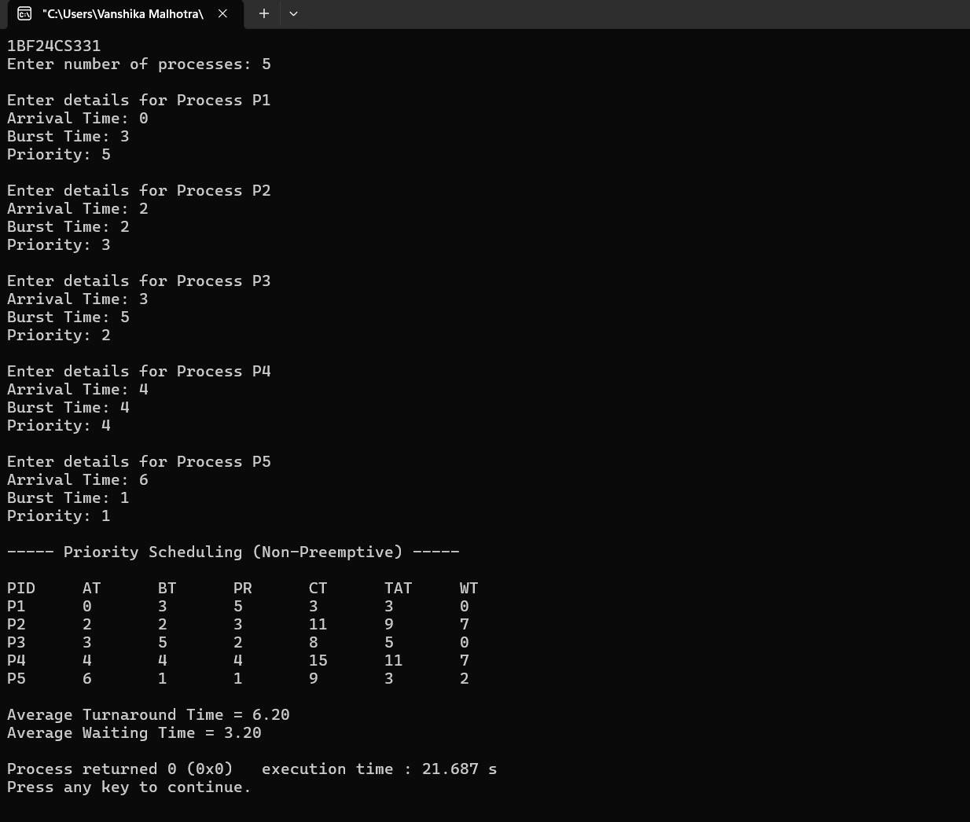
1BF24CS335

PRIORITY(PREEMPTIVE):
#include <stdio.h>

int main() {
int n, i;
printf("Enter number of processes: ");
scanf("%d", &n);

int pid[n], at[n], bt[n], pr[n]; int rt[n], ct[n], tat[n], wt[n]; for(i = 0; i < n; i++)
{
printf("\nEnter details for Process P%d\n", i + 1);

pid[i] = i + 1;

printf("Arrival Time: "); scanf("%d", &at[i]);

printf("Burst Time: "); scanf("%d", &bt[i]);

printf("Priority: "); scanf("%d", &pr[i]);
rt[i] =
bt[i]; }

int current_time = 0; int completed = 0;

while(completed < n)
{
int highest_priority = 9999; int selected = -1;

for(i = 0; i < n; i++)
{
if(at[i] <= current_time && rt[i] > 0)
{
if(pr[i] < highest_priority)
{
highest_priority = pr[i];
selected = i;
}
}
}

if(selected == -1)
{
current_time++;
} else
{
rt[selected]--;

current_time++;

if(rt[selected] == 0)
{
ct[selected] = current_time;

tat[selected] = ct[selected] - at[selected];

wt[selected] = tat[selected] - bt[selected];

completed++;
}
}
}

printf("\n----- Priority Scheduling (Preemptive) -----\n"); printf("\nPID\tAT\tBT\tPR\tCT\tTAT\tWT\n");

float total_tat = 0, total_wt = 0;

for(i = 0; i < n; i++)
{
printf("P%d\t%d\t%d\t%d\t%d\t%d\t%d\n",
pid[i], at[i], bt[i], pr[i],
ct[i], tat[i], wt[i]);

total_tat += tat[i]; total_wt += wt[i];
}

printf("\nAverage Turnaround Time = %.2f", total_tat / n); printf("\nAverage Waiting Time = %.2f\n", total_wt / n);

return 0;
}

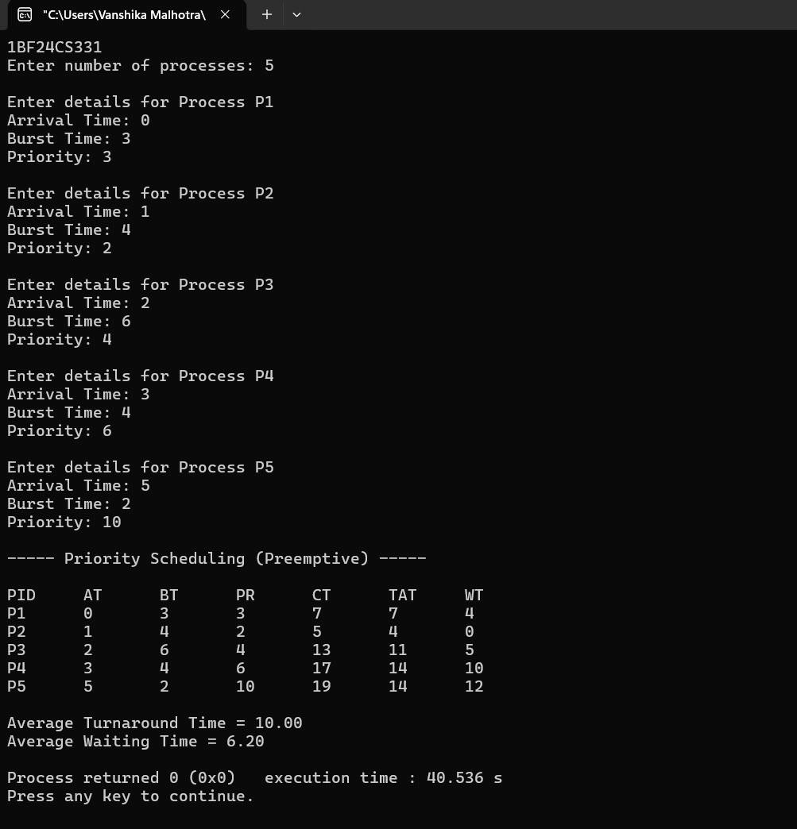
1BF24CS335

ROUND ROBIN:
#include <stdio.h>

int main() {
int n, tq, i;
printf("Enter number of processes: ");
scanf("%d", &n);

printf("Enter Time Quantum: "); scanf("%d", &tq);

int pid[n], at[n], bt[n], rt[n]; int ct[n], tat[n], wt[n];

for(i = 0; i < n; i++)
{
printf("\nEnter details for Process P%d\n", i + 1);

pid[i] = i + 1;

printf("Arrival Time: "); scanf("%d", &at[i]);

printf("Burst Time: "); scanf("%d", &bt[i]);
rt[i] =
bt[i]; }

int completed = 0, current_time = 0;

while(completed < n)
{ int executed
= 0;

for(i = 0; i < n; i++)
{
if(at[i] <= current_time && rt[i] > 0)
{ executed = 1;
if(rt[i] > tq)
{
current_time += tq; rt[i] -= tq; } else
{ current_time += rt[i];

ct[i] = current_time;

tat[i] = ct[i] - at[i];

wt[i] = tat[i] - bt[i]; rt[i] =
0;

completed++;
}
}
}

if(executed == 0)
{
current_time++;
}
}

printf("\n----- Round Robin Scheduling -----\n"); printf("\nPID\tAT\tBT\tCT\tTAT\tWT\n");

float total_tat = 0, total_wt = 0;

for(i = 0; i < n; i++)
{
printf("P%d\t%d\t%d\t%d\t%d\t%d\n",
pid[i], at[i], bt[i], ct[i], tat[i], wt[i]);

total_tat += tat[i]; total_wt += wt[i];
}

printf("\nAverage Turnaround Time = %.2f",
total_tat / n);

printf("\nAverage Waiting Time = %.2f\n",
total_wt / n);

return 0;
}

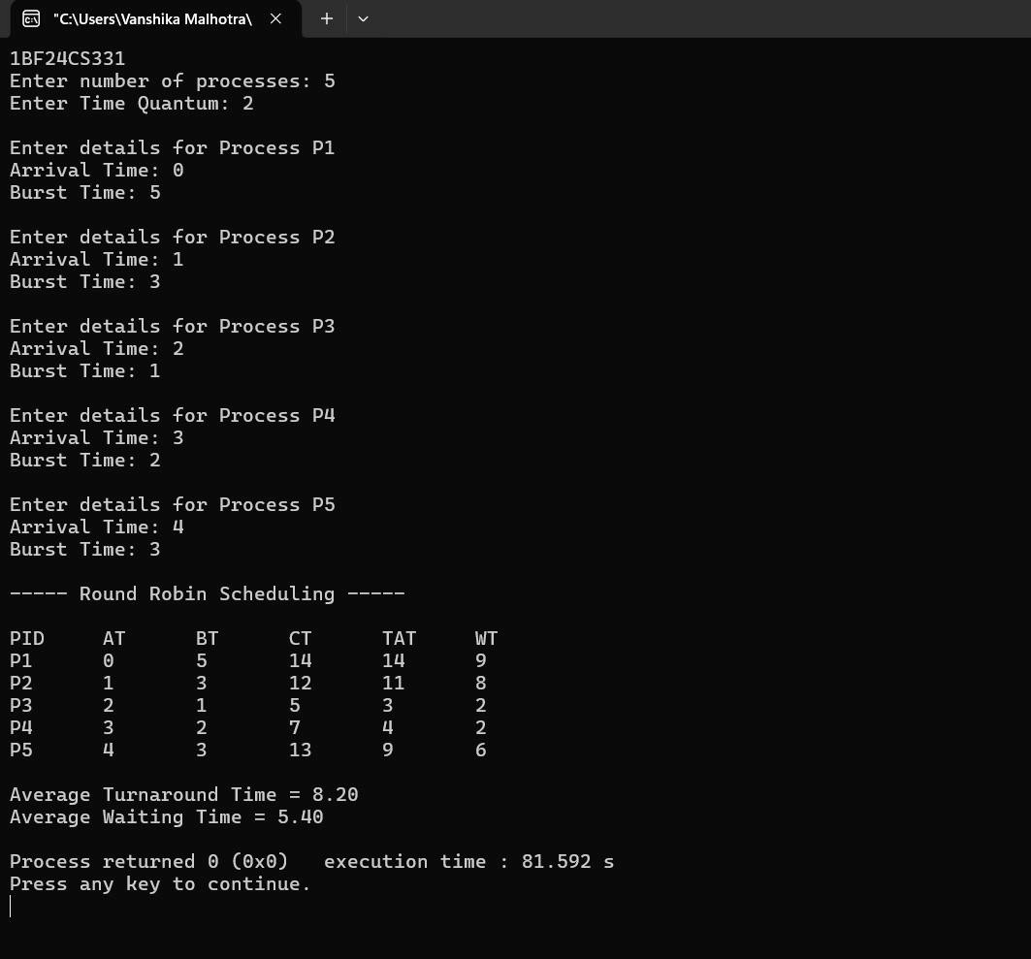
1BF24CS335

PROGRAM-2
MULTI-LEVEL QUEUE
#include <stdio.h>

struct Process {
int pid;
int qn; // Queue Number
int at; // Arrival Time
int bt; // Burst Time
int rt; // Remaining Time int ct; // Completion Time int tat; // Turnaround Time int wt; // Waiting Time
};

int main() {
int n, tq;

printf("1BF24CS331\n");
printf("Enter number of processes: "); scanf("%d", &n);

struct Process p[n];

printf("Enter Time Quantum for Queue 1: ");
scanf("%d", &tq);

// Input
for(int i = 0; i < n; i++) {
p[i].pid = i + 1;

printf("\nEnter Queue No, Arrival Time and Burst Time for P%d: ", i+1);
scanf("%d %d %d", &p[i].qn, &p[i].at, &p[i].bt);

p[i].rt = p[i].bt;
}

int completed = 0, time = 0; float avgTAT = 0, avgWT = 0; // Multi-Level Queue Scheduling while(completed < n) {

int executed = 0;

// Queue 1 - Round Robin (Higher Priority) for(int i = 0; i < n; i++) {

if(p[i].qn == 1 && p[i].at <= time && p[i].rt > 0) {

executed = 1;

if(p[i].rt > tq) {
time += tq; p[i].rt -= tq;
} else { time += p[i].rt; p[i].rt =
0;

p[i].ct = time;
p[i].tat = p[i].ct - p[i].at; p[i].wt = p[i].tat - p[i].bt;

avgTAT += p[i].tat;
avgWT += p[i].wt; completed++;
}
}
}

// Queue 2 - FCFS (Executed only if Queue 1 empty) if(!executed) { int idx = -1; int earliest = 9999;

for(int i = 0; i < n; i++) {
if(p[i].qn == 2 && p[i].at <= time && p[i].rt > 0) {
if(p[i].at < earliest) { earliest = p[i].at; idx = i;
}
}
}

if(idx != -1) {
time += p[idx].rt; p[idx].rt = 0;

p[idx].ct = time;
p[idx].tat = p[idx].ct - p[idx].at; p[idx].wt = p[idx].tat - p[idx].bt;

avgTAT += p[idx].tat;
avgWT += p[idx].wt; completed++;
} else { time++;
}
}
}

// Output
printf("\nPID\tQNo\tAT\tBT\tCT\tTAT\tWT\n");

for(int i = 0; i < n; i++) {
printf("P%d\t%d\t%d\t%d\t%d\t%d\t%d\n",
p[i].pid,
p[i].qn, p[i].at, p[i].bt, p[i].ct, p[i].tat, p[i].wt);
}

printf("\nAverage Turnaround Time = %.2f", avgTAT/n);
printf("\nAverage Waiting Time = %.2f\n", avgWT/n);

return 0;
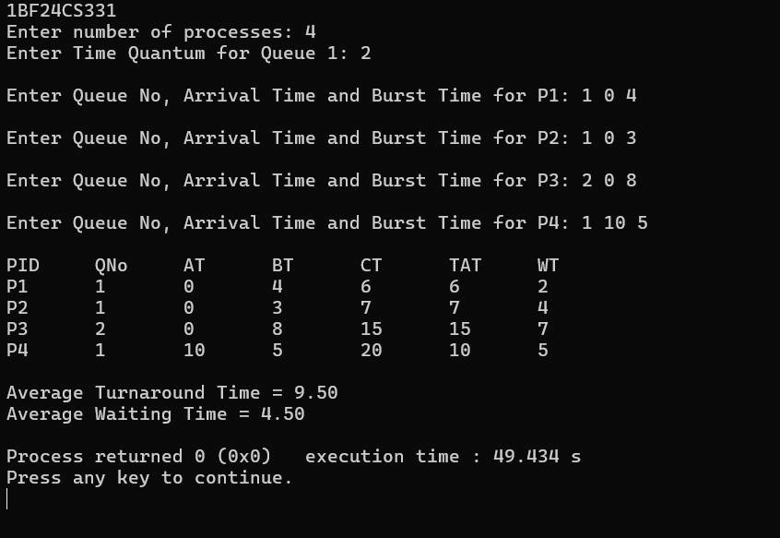
1BF24CS335

PROGRAM-3
RATE MONOTONIC
#include <stdio.h>

struct Process {
int pid; int burst; int period; int remaining;
};

int main() { int n, time, hyper = 20;

printf("1BF24CS331\n"); printf("Enter number of processes: "); scanf("%d", &n);

struct Process p[n];

for(int i = 0; i < n; i++) {
printf("\nEnter Burst Time and Period for P%d: ", i + 1);

p[i].pid = i + 1;
scanf("%d %d", &p[i].burst, &p[i].period);

p[i].remaining = 0;
}

printf("\nGantt Chart:\n");

for(time = 0; time < hyper; time++) {

// Release process at start of period for(int i = 0; i < n; i++) { if(time % p[i].period == 0) { p[i].remaining = p[i].burst;
}
}
int idx = -1; int minPeriod = 9999;

// Higher priority = smaller period for(int i = 0; i < n; i++) {
if(p[i].remaining > 0 && p[i].period < minPeriod) {
minPeriod = p[i].period;
idx = i;
}
}

if(idx != -1) {
printf("P%d ", p[idx].pid);
p[idx].remaining--;
} else {
printf("Idle ");
}
}

return 0;
}

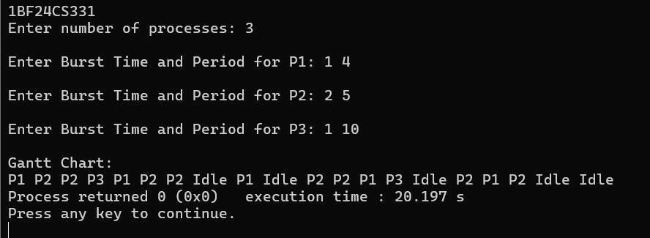
1BF24CS335

Earliest-deadline First :

#include <stdio.h>

struct Process
{ int pid; int burst; int period; int deadline; int
remaining;
};

int main() { int n,
time, hyper = 20;

printf("Enter number of processes: ");
scanf("%d", &n);

struct Process p[n];

for(int i = 0; i < n; i++) { printf("\nEnter Burst Time
and Period for P%d: ", i + 1);

p[i].pid = i + 1; scanf("%d %d", &p[i].burst, &p[i].period);

p[i].remaining = 0;
p[i].deadline = p[i].period;
}

printf("\nGantt Chart:\n");

for(time = 0; time < hyper; time++) {

// Release tasks for(int i = 0; i < n; i++) { if(time % p[i].period == 0) { p[i].remaining = p[i].burst; p[i].deadline = time + p[i].period;
}
} int idx = -1; int earliest = 9999;

// Select earliest deadline for(int i = 0; i < n; i++) { if(p[i].remaining > 0 && p[i].deadline < earliest) { earliest = p[i].deadline; idx = i;
}
} if(idx != -1) { printf("P%d ", p[idx].pid); p[idx].remaining--;
} else { printf("Idle ");
}
}

return 0;
}

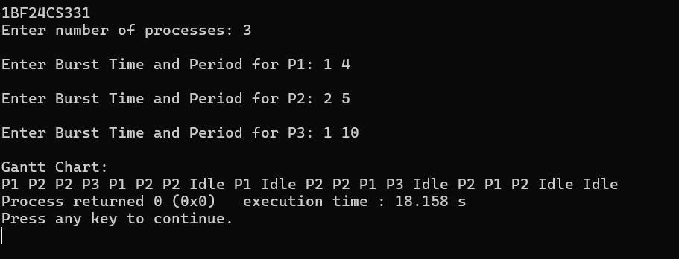
1BF24CS335

Proportional scheduling
#include <stdio.h>

struct Process {
int pid; int share;
};

int main() {
int n, total = 0;

printf("Enter number of processes: "); scanf("%d", &n);

struct Process p[n];

for(int i = 0; i < n; i++) { printf("\nEnter
CPU share for P%d: ", i + 1);

p[i].pid = i + 1;
scanf("%d", &p[i].share);

total += p[i].share;
}

printf("\nCPU Allocation:\n");

for(int i = 0; i < n; i++) {

float percent =
((float)p[i].share / total) * 100;

printf("P%d -> %.2f%% CPU Time\n",
p[i].pid, percent);
}

return 0;
}
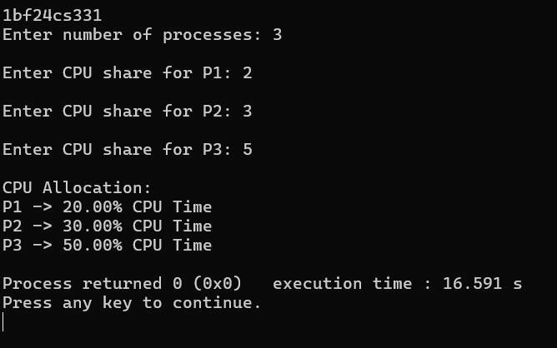
1BF24CS335

PROGRAM-4
PRODUCER-CONSUMER PROBLEM USING SEMAPHORES

#include <stdio.h>
#include <stdlib.h>

#define BUFFER_SIZE 5

int buffer[BUFFER_SIZE]; int in = 0; int
out = 0;

int empty = BUFFER_SIZE; int full = 0;

void produce() { if (empty == 0) {
printf("\nBuffer is full! Cannot produce.\n"); return;
}

int item;
printf("Enter item to produce: "); scanf("%d", &item);

buffer[in] = item;
printf("Produced: %d at index %d\n", item, in);

in = (in + 1) % BUFFER_SIZE; empty--; full++;
}

void consume() { if (full == 0) {
printf("\nBuffer is empty! Cannot consume.\n"); return;
}

int item = buffer[out];
printf("Consumed: %d from index %d\n", item, out);

out = (out + 1) % BUFFER_SIZE; full--;
empty++;
}

int main() { int choice;
printf("1BF24CS331\n");

printf("Buffer Size: %d\n", BUFFER_SIZE);

while (1) {
printf("\n1. Produce\n2. Consume\n3. Exit\n");
printf("Current State: [Full slots: %d | Empty slots: %d]\n", full, empty);
printf("Enter choice: ");

if (scanf("%d", &choice) != 1) break;

switch (choice) { case 1: produce(); break; case 2:
consume(); break; case 3:
printf("Exiting...\n"); exit(0); default:
printf("Invalid choice!\n");
}
}

return 0;
}
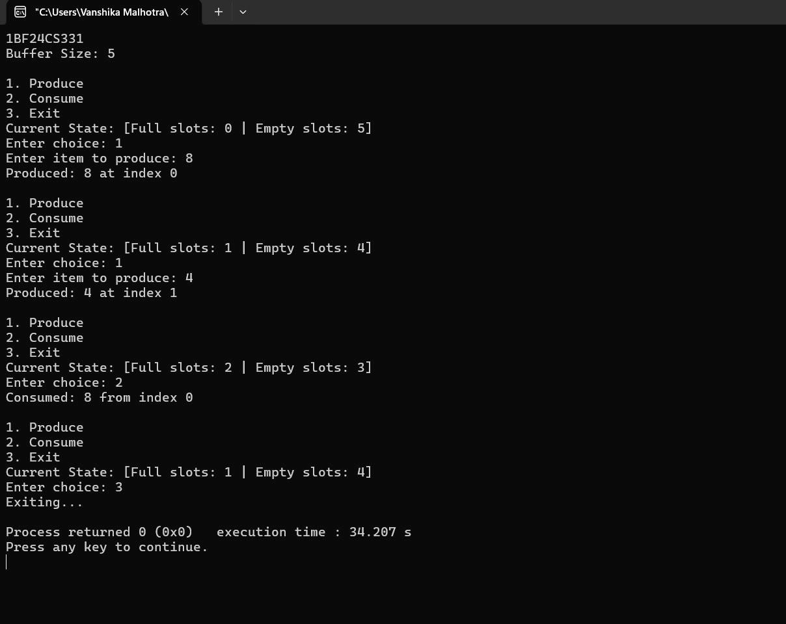
1BF24CS335
DINNING PHILOSOPHERS PROBLEM
#include<stdio.h>
#include<pthread.h>
#include<unistd.h>
#define N 5 // Number of philosophers pthread_mutex_t forks[N]; // One mutex per fork pthread_t philosophers[N]; void* philosopher(void* num)
{
int id = *(int*)num; int left = id; // left fork index int right = (id + 1) % N; // right fork index while (1) {
printf("Philosopher %d is thinking.\n", id);
sleep(1); // Thinking
// To avoid deadlock, philosophers with even id pick left then right, // odd id pick right then left.
if (id % 2 == 0)
{
// Pick up left fork pthread_mutex_lock(&forks[left]);
printf("Philosopher %d picked up left fork %d.\n", id, left);
// Pick up right fork

pthread_mutex_lock(&forks[right]);
printf("Philosopher %d picked up right fork %d.\n", id, right); } else
{ // Pick up right fork pthread_mutex_lock(&forks[right]);
printf("Philosopher %d picked up right fork %d.\n", id, right); // Pick up left fork
pthread_mutex_lock(&forks[left]);
printf("Philosopher %d picked up left fork %d.\n", id, left);
} //
Eating printf("Philosopher %d is eating.\n", id); sleep(2);
// Put down forks
pthread_mutex_unlock(&forks[left]); pthread_mutex_unlock(&forks[right]);
printf("Philosopher %d put down forks %d and %d.\n", id, left, right);
} return
NULL;
}

int main() { int i;
int ids[N]; // Initialize forks (mutexes) for (i = 0; i < N; i++)
{ pthread_mutex_init(&forks[i], NULL);
ids[i] = i;
}
// Create philosopher threads for
(i = 0; i < N; i++)
{
pthread_create(&philosophers[i], NULL, philosopher, &ids[i]);
} // Join threads (will never happen here, but good practice) for
(i = 0; i < N; i++)
{
pthread_join(philosophers[i], NULL); } // Destroy mutexes (unreachable here) for (i = 0; i < N; i++)
{
pthread_mutex_destroy(&forks[i]);
} return
0;
}
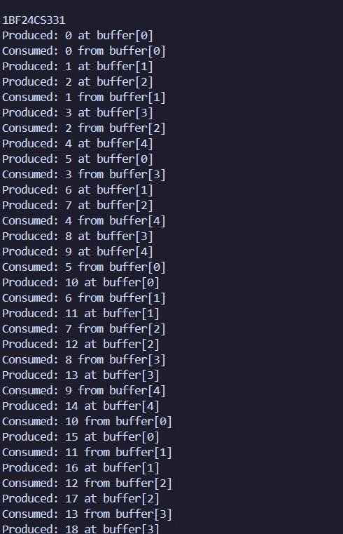

PROGRAM-5
BANKER’S ALGORITHM
#include<stdio.h>

int main() {
int allocation[10][10], max[10][10], need[10][10]; int available[10], finish[10], safeSequence[10]; int i, j, k, p, r, count = 0;

printf("1BF24CS331\n");

printf("Enter number of processes: "); scanf("%d", &p);

printf("Enter number of resources: "); scanf("%d", &r);

printf("Enter Allocation Matrix:\n"); for(i = 0; i < p; i++) { for(j = 0; j < r; j++)
{
scanf("%d", &allocation[i][j]);
}
}

printf("Enter Maximum Demand Matrix:\n"); for(i = 0; i < p; i++) { for(j = 0; j < r; j++) { scanf("%d", &max[i][j]);
}
}
printf("Enter Available Resources:\n"); for(i = 0; i < r; i++)
{
scanf("%d", &available[i]);
}

// Calculate Need Matrix for(i = 0; i < p; i++) { for(j = 0; j < r; j++)
{
need[i][j] = max[i][j] - allocation[i][j];
}
}

// Initialize finish array for(i = 0; i < p; i++)
{ finish[i]
= 0;
}

while(count < p)
{ int found
= 0;

for(i = 0; i < p; i++)
{ if(finish[i] == 0) { for(j = 0; j < r; j++)
{
if(need[i][j] > available[j])
{ break;
} } if(j == r)
{ for(k = 0; k < r; k++)
{
available[k] += allocation[i][k];
}

safeSequence[count] = i;
count++; finish[i] = 1; found = 1;
}
}
}

if(found == 0)
{
printf("\nSystem is not in a safe state.\n"); return 0;
}
}

printf("\nSystem is in a safe state.\n"); printf("Safe sequence is: ");

for(i = 0; i < p; i++)
{
printf("P%d", safeSequence[i]);
if(i != p - 1)
{
printf(" -> ");
}
}

return 0;
}
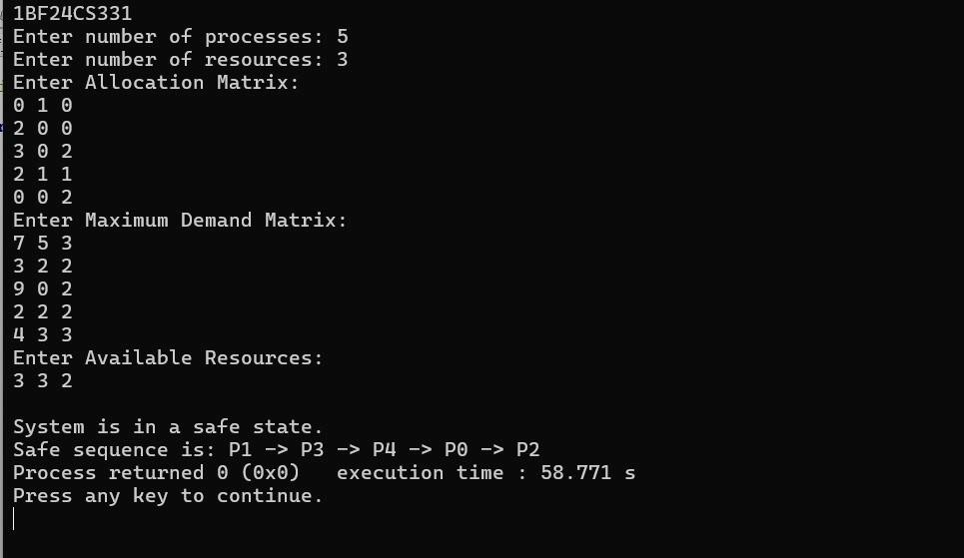
1BF24CS335

DEADLOCK DETECTION:
#include<stdio.h>

int main() {
int allocation[10][10], request[10][10];
int available[10]; int finish[10], safeSequence[10]; int i, j, k, p, r, count
= 0;
printf("USN-1BF24CS331\n");

printf("Enter the number of processes: "); scanf("%d", &p);

printf("Enter the number of resources: "); scanf("%d", &r);

// Allocation Matrix printf("Enter the allocation matrix:\n"); for(i = 0; i < p; i++)
{ printf("Process %d:
", i);

for(j = 0; j < r; j++)
{
scanf("%d", &allocation[i][j]);
}
}

// Request Matrix printf("Enter the request matrix:\n"); for(i = 0; i < p; i++)
{
printf("Process %d: ", i);

for(j = 0; j < r; j++)
{
scanf("%d", &request[i][j]);
}
}
// Available Resources printf("Enter the available resources: "); for(i = 0; i < r; i++)
{
scanf("%d", &available[i]);
}

// Initialize finish array for(i = 0; i < p; i++)
{ finish[i]
= 0;
}

while(count < p)
{ int found
= 0;

for(i = 0; i < p; i++)
{
if(finish[i] == 0)
{ for(j = 0; j < r; j++)
{
if(request[i][j] > available[j])
{ break;
}
} if(j == r)
{ for(k = 0; k < r; k++)
{
available[k] += allocation[i][k];
}

safeSequence[count++] = i; finish[i] = 1; found = 1;
}
}
}

if(found == 0)
{ break;
}
}

if(count == p)
{
printf("\nSystem is in safe state.\n"); printf("Safe Sequence is: ");

for(i = 0; i < p; i++)
{
printf("P%d ", safeSequence[i]);
} } else
{
printf("\nDeadlock detected in the system.\n");
}

return 0;
}

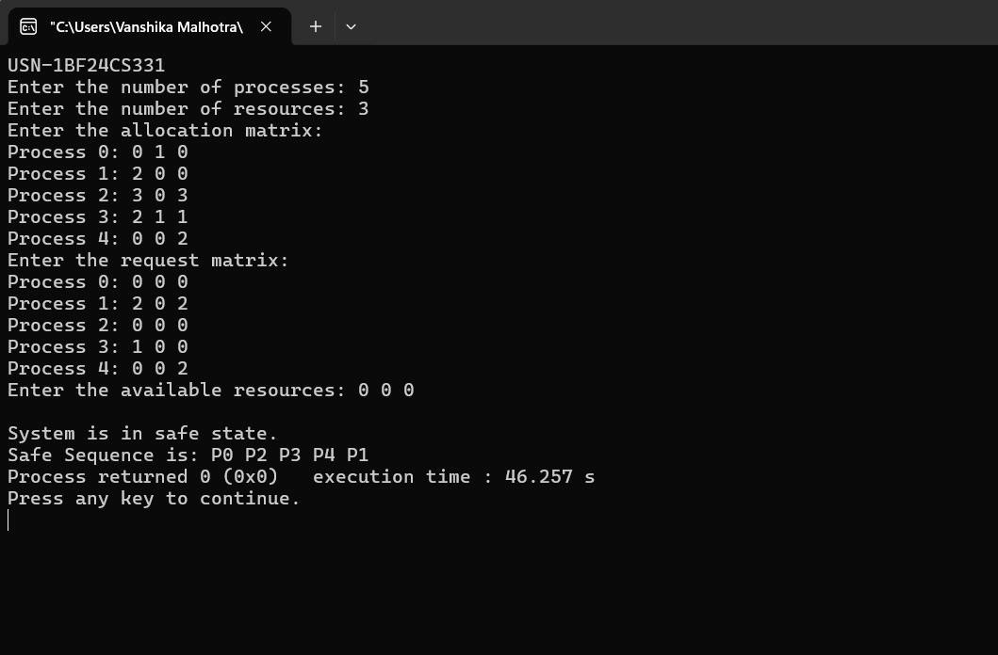
1BF24CS335

PROGRAM-6
FIRST FIT, BEST FIT, WORST FIT
#include <stdio.h>

void firstFit(int blockSize[], int blocks, int processSize[], int processes) {
int allocation[processes];

for (int i = 0; i < processes; i++)
allocation[i] = -1;

int used[blocks]; for (int i = 0; i < blocks; i++) used[i] = 0;

for (int i = 0; i < processes; i++) {
for (int j = 0; j < blocks; j++) {

// block must be unused
if (!used[j] && blockSize[j] >= processSize[i]) {
allocation[i] = j;
used[j] = 1; // mark block as used
break;
}
}
}

printf("\n--- First Fit ---\n");
printf("Process No.\tProcess Size\tBlock No.\n");

for (int i = 0; i < processes; i++) {
printf("%d\t\t%d\t\t", i + 1, processSize[i]);

if (allocation[i] != -1)
printf("%d\n", allocation[i] + 1); else printf("Not Allocated\n");
}
}

void bestFit(int blockSize[], int blocks, int processSize[], int processes) {
int allocation[processes];

for (int i = 0; i < processes; i++)
allocation[i] = -1;

int used[blocks]; for (int i = 0; i < blocks; i++) used[i] = 0;

for (int i = 0; i < processes; i++) {
int bestIdx = -1;

for (int j = 0; j < blocks; j++) {

if (!used[j] && blockSize[j] >= processSize[i]) {

if (bestIdx == -1 || blockSize[j] < blockSize[bestIdx]) {
bestIdx = j;
}
}
}

if (bestIdx != -1) {
allocation[i] = bestIdx; used[bestIdx] = 1;
}
}

printf("\n--- Best Fit ---\n");
printf("Process No.\tProcess Size\tBlock No.\n");

for (int i = 0; i < processes; i++) {
printf("%d\t\t%d\t\t", i + 1, processSize[i]);

if (allocation[i] != -1)
printf("%d\n", allocation[i] + 1); else
printf("Not Allocated\n");
}
}

void worstFit(int blockSize[], int blocks, int processSize[], int processes) {
int allocation[processes];

for (int i = 0; i < processes; i++)
allocation[i] = -1;

int used[blocks]; for (int i = 0; i < blocks; i++) used[i] = 0;

for (int i = 0; i < processes; i++) {
int worstIdx = -1;

for (int j = 0; j < blocks; j++) {

if (!used[j] && blockSize[j] >= processSize[i]) {

if (worstIdx == -1 || blockSize[j] > blockSize[worstIdx]) {
worstIdx = j;
}
}
}

if (worstIdx != -1) {
allocation[i] = worstIdx; used[worstIdx] = 1;
}
}

printf("\n--- Worst Fit ---\n"); printf("Process No.\tProcess Size\tBlock No.\n");

for (int i = 0; i < processes; i++) { printf("%d\t\t%d\t\t", i + 1, processSize[i]);

if (allocation[i] != -1) printf("%d\n", allocation[i] + 1); else
printf("Not Allocated\n");
}
}

int main() { int blocks, processes; printf("1BF24CS331\n");

printf("Enter number of memory blocks: "); scanf("%d", &blocks);

int blockSize[blocks];

printf("Enter sizes of memory blocks:\n"); for (int i = 0; i < blocks; i++) { scanf("%d", &blockSize[i]);
}

printf("Enter number of processes: "); scanf("%d", &processes);

int processSize[processes];

printf("Enter sizes of processes:\n"); for (int i = 0; i < processes; i++) { scanf("%d", &processSize[i]);
}

firstFit(blockSize, blocks, processSize, processes); bestFit(blockSize, blocks, processSize, processes); worstFit(blockSize, blocks, processSize, processes);

return 0;
}
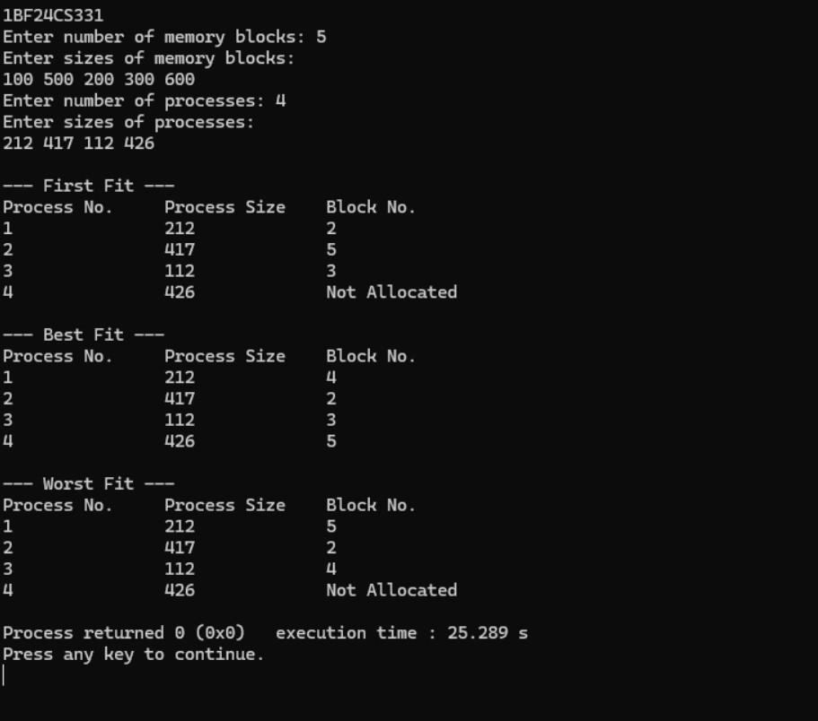
1BF24CS335

PROGRAM-7
Write a C program to simulate page replacement algorithms. a) FIFO b)
LRU
c) Optimal
#include <stdio.h>

#define MAX 50

// Function to check if page exists in frames int isPresent(int frames[], int num_frames, int page) { for (int i = 0; i < num_frames; i++) { if (frames[i] == page) return 1; } return 0;
}

// Function to print frames void printFrames(int frames[], int num_frames)
{ printf("["); for (int i = 0; i < num_frames; i++)
{ if (frames[i] != -1) printf("%d", frames[i]); else printf(" ");

if (i != num_frames - 1) printf(" "); } printf("]\n");
}

// ---------------- FIFO ---------------- void
FIFO(int pages[], int n, int num_frames)
{ int
frames[MAX]; int page_faults = 0; int next = 0;

for (int i = 0; i < num_frames; i++) frames[i] = -1;

printf("\n--- FIFO Page Replacement ---\n\n");

for (int i = 0; i < n; i++)
{ int page = pages[i];

if (!isPresent(frames, num_frames, page))
{
frames[next] = page; next = (next + 1) % num_frames; page_faults++;
}

printf("Page %d -> ", page); printFrames(frames, num_frames);
}

printf("\nTotal Page Faults (FIFO): %d\n", page_faults);
}

// ---------------- LRU ---------------- void
LRU(int pages[], int n, int num_frames) { int frames[MAX]; int last_used[MAX]; int page_faults = 0;

for (int i = 0; i < num_frames; i++)
{ frames[i] = 1; last_used[i] =
-1;
}

printf("\n--- LRU Page Replacement ---\n\n");

for (int i = 0; i < n; i++)
{ int page = pages[i]; int found
= 0;

// Check if page exists for (int j = 0; j < num_frames; j++)
{ if (frames[j]
== page)
{ found = 1; last_used[j] = i; break;
}
}

// Page Fault if (!found) { int pos = -1;

// Empty frame available for (int j = 0; j < num_frames; j++)
{ if
(frames[j] == -1) { pos = j; break;
}
}

// Replace least recently used if (pos == -1)
{
int min = last_used[0]; pos = 0;

for (int j = 1; j < num_frames; j++)
{
if (last_used[j] < min)
{
min = last_used[j];
pos = j;
}
}
}

frames[pos] = page;
last_used[pos] = i; page_faults++;
}

printf("Page %d -> ", page); printFrames(frames, num_frames);
}

printf("\nTotal Page Faults (LRU): %d\n", page_faults); }

// ---------------- Optimal ---------------- void
Optimal(int pages[], int n, int num_frames)
{ int
frames[MAX]; int page_faults = 0;

for (int i = 0; i < num_frames; i++) frames[i] = -1;

printf("\n--- Optimal Page Replacement ---\n\n");

for (int i = 0; i < n; i++) { int page = pages[i];

if (!isPresent(frames, num_frames, page))
{ int pos = -1;

// Empty frame for (int j =
0; j < num_frames; j++)
{ if
(frames[j] == -1)
{ pos = j; break;
}
}

// Find optimal replacement if (pos == -1)
{ int farthest = -
1;

for (int j = 0; j < num_frames; j++)
{ int k; for (k = i + 1; k < n; k++)
{
if (frames[j] == pages[k]) break;
}

// Page never used again if (k == n) { pos = j; break;
}

// Farthest use if (k > farthest) { farthest = k; pos = j;
}
}
}

frames[pos] = page; page_faults++;
}

printf("Page %d -> ", page); printFrames(frames, num_frames);
}

printf("\nTotal Page Faults (Optimal): %d\n", page_faults);
}

// ---------------- Main ---------------- int main() { int n, num_frames; int pages[MAX]; printf("1BF24CS331");

printf("Enter number of pages: "); scanf("%d", &n);

printf("Enter page reference string:\n"); for (int i = 0; i < n; i++) scanf("%d",
&pages[i]);

printf("Enter number of frames: "); scanf("%d", &num_frames);

FIFO(pages, n, num_frames);
LRU(pages, n, num_frames);
Optimal(pages, n, num_frames);

return 0;
}
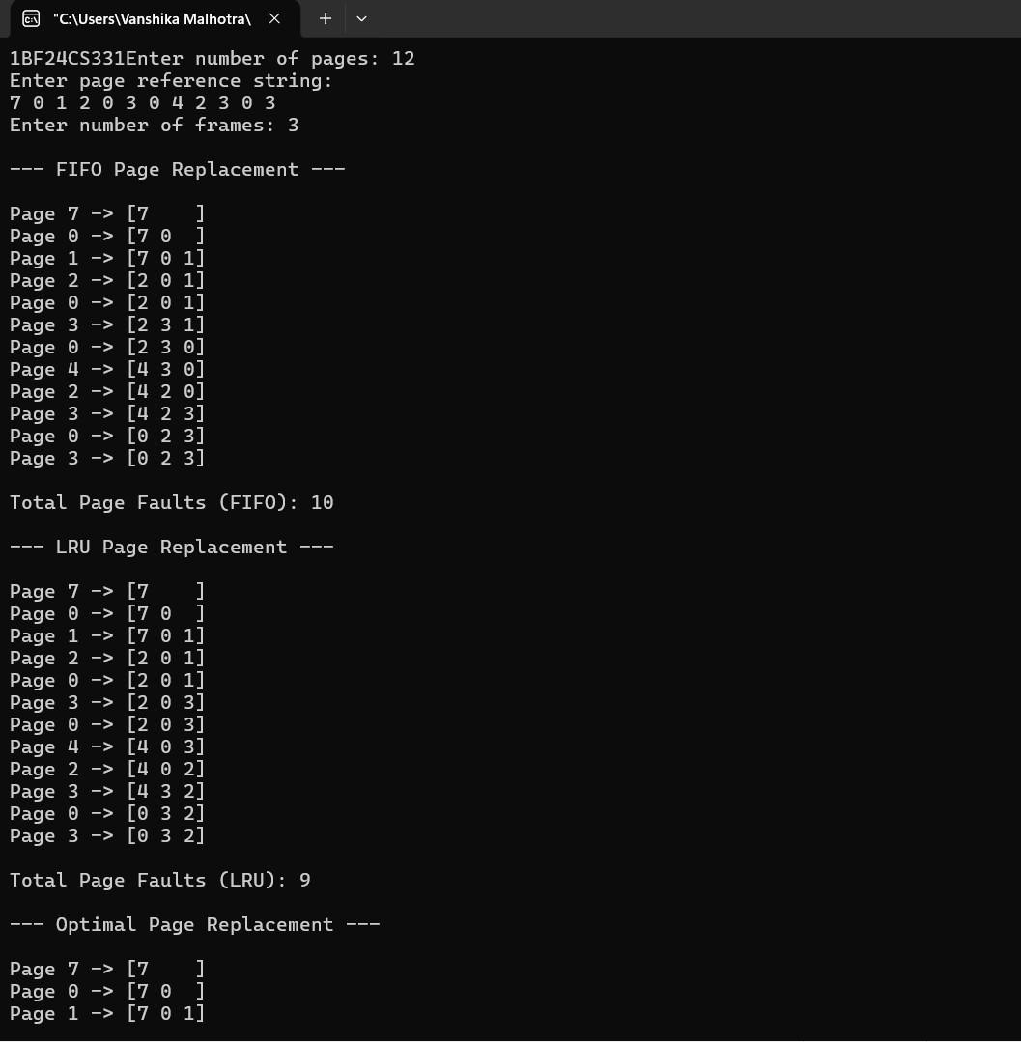
1BF24CS335 Enter number of pages: 12

