Contents

**USCSP301 – USCS303: Operating System (OS) Practical – 07** 2

**Practical – 07: Synchronization** 2

**Practical Date**: 25th August 2021 2

**Practical Aim**: Bounded Buffer Problem, Reader-Writers Problem, Sleeping Barber Problem 2

➢ **Synchronization** 2

➢ **Bounded Buffer Problem** 2

➢ **Question – 01** 4

⬥ Write a java program for Bounded Buffer Problem using synchronization. 4

➢ **Source Code** 5

❖ Implement Bounded Buffer Problem using synchronization. 5

**File Name:** **P7_Q1_Buffer_YP.java** 5

**File Name:** **P7_Q1_CircularBuffer_YP.java** 5

**File Name: P7_Q1_Producer_YP.java** 7

**File Name: P7_Q1_Consumer_YP.java** 7

**File Name: P7_Q1_Test_YP.java** 8

➢ **Output** 9

➢ **Reader-Writer Problem** 12

➢ **Question – 02** 12

⬥ Write a java program for Readers Writers Problem using Semaphore 12

➢ **Source Code** 12

❖ Implement Readers Writers Problem using Semaphore 12

**File Name: P7_Q2_ReaderWriter_YP.java** 12

➢ **Output** 14

➢ **Question – 03** 15

⬥ Write a program to coordinate the barber and the customers using Java synchronization. 15

➢ **Source Code** 15

❖ Implement Sleeping Barber Problem using synchronization 15

**File Name: P7_Q3_Barber_YP.java** 15

**File Name: P7_Q3_Customer_YP.java** 16

**File Name: P7_Q3_BarberShop_YP.java** 17

➢ **Output** 18

**USCSP301 – USCS303: Operating System (OS) Practical – 07**

**Practical – 07: Synchronization**

**Practical Date**: 25th August 2021

**Practical Aim**: Bounded Buffer Problem, Reader-Writers Problem, Sleeping Barber Problem

➢ **Synchronization**

➢ **Bounded Buffer Problem**

* The **producer-consumer problem,** also known as **Bounded Buffer Problem,** illustrates the need for synchronization in systems where many processes share a resource.
* In the problem, two processes **share a fixed-size buffer.**
* One process produces information and puts it in the buffer, while the other process consumes information from the buffer.
* These processes do not take turns accessing the buffer, they both work concurrently. Herein lies the problem.
* What happens if the producer tries to put an item into a full buffer?
* What happens if the consumer tries to take an item from an empty buffer?
* In order to synchronize these processes, we will block the producer when the buffer is full, and we will block the consumer when the buffer is empty.
* So the two processes, Producer and Consumer, should work as follows:
  1. The producer must first create a new widget.
  2. Then, it checks to see if the buffer is full. If it is, the producer will put itself to sleep until the consumer wakes it up. A “wakeup” will come if the consumer finds the buffer empty.
  3. Next, the producer puts the new widget in the buffer. If the producer goes to sleep in step (ii), it will not wake up until the buffer is empty, so the buffer will not overflow..
  4. Then, the producer checks to see if the buffer is empty. If it is, the producer assumes that the consumer is sleeping, and so it will wake the consumer. Keep in mind that between any of the steps, an interrupt might occur, allowing the consumer to run.

**Producer:**

**1.Make new widget**



**W**

**2.If buffer is full,go to sleep**

|  |  |  |
| --- | --- | --- |
| **W** | **W** | **W** |

|  |
| --- |
| **Producer** |



|  |  |  |  |  |  |
| --- | --- | --- | --- | --- | --- |
|  |  | |  |  |  | | --- | --- | --- | | **W** |  |  |   **3.Put widget in buffer** |

**4.If buffer was empty, wake consumer**



**Wake**

**up!**

|  |
| --- |
| **Consumer** |

**Producer**

* **So the two processes, Producer and Consumer, should work as follows:**

1. The consumer checks to see if the buffer is empty. If so, the consumer will put itself to sleep until the producer wakes It up. A "wakeup" will occur if the producer finds the buffer empty after it puts an item into the buffer.
2. Then, the consumer will remove a widget. from the buffer. The consumer will never try to remove a widget from an empty buffer because it will not wake up until the buffer is full. If the buffer was full before it removed the widget, the consumer will wake the producer.
3. If the buffer was full before it removed the widget, the consumer will wake the producer.
4. Finally, the consumer will consume the widget. As was the case with the producer, an interrupt could occur between any of these steps, allowing the producer to run.

**Consumer:**

**1.If buffer is empty, go to sleep**

**2.Take widget from buffer**

**2**



Consumer



**W**



**W**



**W**



**Consumer**



**Producer**



**Wake**

**up!**

**3.If buffer was full, wake producer**

**4.Consume the Widget**



**W**

➢ **Question – 01**

⬥ Write a java program for Bounded Buffer Problem using synchronization.

➢ **Source Code**

❖ Implement Bounded Buffer Problem using synchronization.

**File Name:** **P7_Q1_Buffer_YP.java**

//Name: Yash Parab

// Batch: B1

// PRN: 2020016400922513

// Date: 25th August,2021

// Prac-07: Synchronization

public interface P7_Q1_Buffer_YP

{

public void set(int value) throws InterruptedException;

public int get() throws InterruptedException;

}

**File Name:** **P7_Q1_CircularBuffer_YP.java**

//Name: Yash Parab

// Batch: B1

// PRN: 2020016400922513

// Date: 25th August,2021

// Prac-07: Synchronization

public class P7_Q1_CircularBuffer_YP implements P7_Q1_Buffer_YP

{

private final int[] buffer = {-1,-1,-1};//shared buffer

private int occupiedCells = 0; // count number of buffers used

private int writeIndex = 0; // index of next element to write to

private int readIndex = 0; // index of next element to read

public synchronized void set(int value) throws InterruptedException

{

while(occupiedCells == buffer.length)

{

System.out.println("Buffer is full. Producer waits.");

wait();

}

buffer[writeIndex]=value;

writeIndex = (writeIndex + 1) % buffer.length;

++occupiedCells;

displayState("Producer write "+value);

notifyAll();

} // set() ends

public synchronized int get() throws InterruptedException

{

while(occupiedCells == 0)

{

System.out.println("Buffer is empty. Consumer waits.");

wait();

}

int readValue = buffer[readIndex];

readIndex = (readIndex + 1) % buffer.length;

--occupiedCells;

displayState("Consumer reads "+readValue); notifyAll();

return readValue;

} // get() ends

public void displayState(String operation)

{

System.out.printf("%s%s%d)\n%s",operation,"(buffer cells occupied: ", occupiedCells,"buffer cells: "); for(int value: buffer)

System.out.printf(" %2d ", value); System.out.print("\n "); for(int i = 0; i<buffer.length;i++) System.out.print(" ---- ");

System.out.print("\n ");

for(int i=0; i < buffer.length; i++)

{

if(i == writeIndex && i == readIndex) System.out.print(" WR"); else if(i == writeIndex) System.out.print(" W"); else if(i == readIndex) System.out.print(" R");

else

System.out.print(" ");

}

System.out.println("\n");

} // displayState() ends

}// CircularBuffer class ends

**File Name: P7_Q1_Producer_YP.java**

//Name: Yash Parab

// Batch: B1

// PRN: 2020016400922513

// Date: 25th August,2021

// Prac-07: Synchronization

import java.util.Random;

public class P7_Q1_Producer_YP implements Runnable

{

private final static Random generator = new Random();

private final P7_Q1_Buffer_YP sharedLocation;

public P7_Q1_Producer_YP(P7_Q1_Buffer_YP shared)

{

sharedLocation=shared;

}

public void run()

{

for(int count = 1;count <= 10;count++)

{

try{

Thread.sleep(generator.nextInt(3000)); sharedLocation.set(count); }catch(InterruptedException e){ e.printStackTrace();

}

}

System.out.println("Producer done producing.Terminating Producer");

}//run() ends

}//Producer class ends

**File Name: P7_Q1_Consumer_YP.java**

//Name: Yash Parab

// Batch: B1

// PRN: 2020016400922513

// Date: 25th August,2021

// Prac-07: Synchronization

import java.util.Random;

public class P7_Q1_Consumer_YP implements Runnable

{ private final static Random generator = new Random(); private final P7_Q1_Buffer_YP sharedLocation;

public P7_Q1_Consumer_YP(P7_Q1_Buffer_YP shared)

{

sharedLocation=shared;

}

public void run()

{ int sum=0;

for(int count = 1;count <= 10;count++)

{ try{

Thread.sleep(generator.nextInt(3000)); sum += sharedLocation.get(); }catch(InterruptedException e){ e.printStackTrace();

}

}

System.out.printf("\n%s %d\n%s\n","Consumer read values totaling",sum,"Terminating Consumer");

}//run() ends

}//Consumer class ends

**File Name: P7_Q1_Test_YP.java**

//Name: Yash Parab

// Batch: B1

// PRN: 2020016400922513

// Date: 25th August,2021

// Prac-07: Synchronization

import java.util.concurrent.*;

public class P7_Q1_Test_YP

{

public static void main(String args[])

{

ExecutorService application = Executors.newCachedThreadPool();

P7_Q1_CircularBuffer_YP sharedLocation = new P7_Q1_CircularBuffer_YP();

sharedLocation.displayState("Initial State");

application.execute(new P7_Q1_Producer_YP(sharedLocation));

application.execute(new P7_Q1_Consumer_YP(sharedLocation));

application.shutdown();

}

}

➢ **Output**

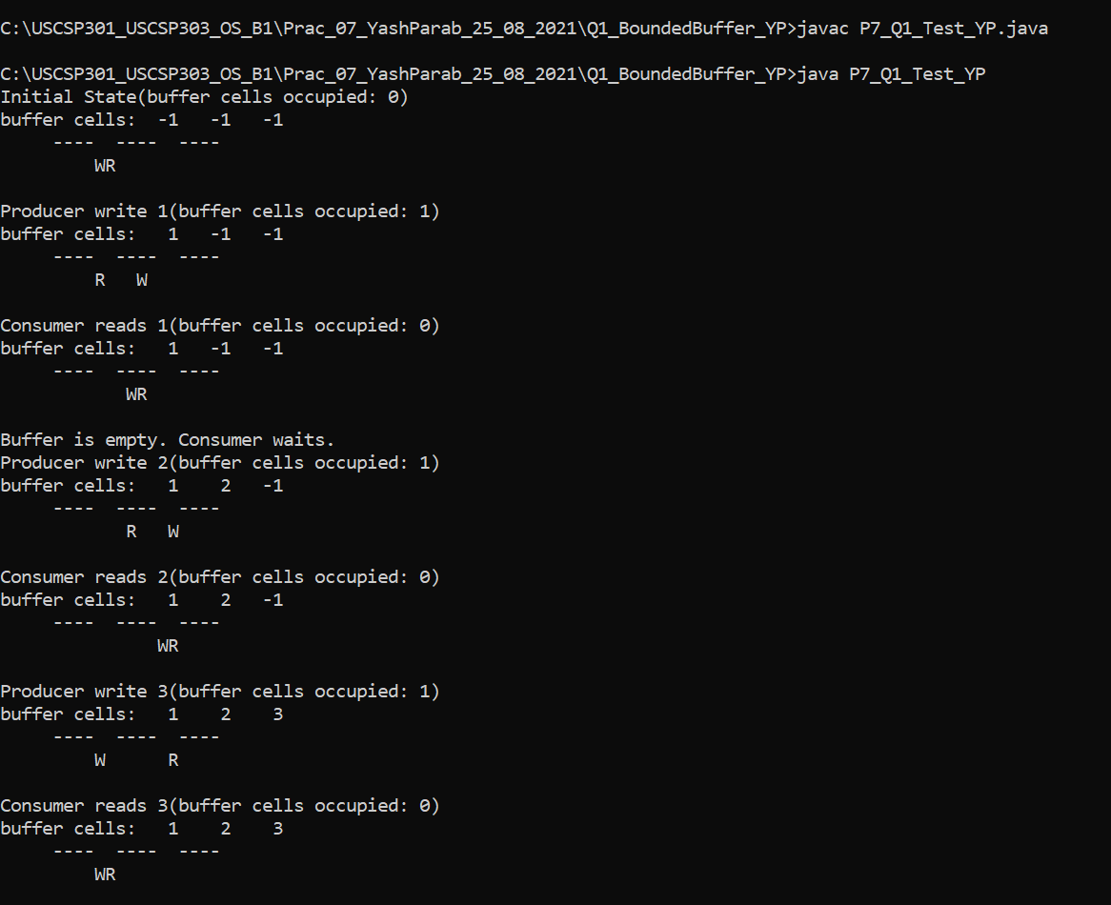

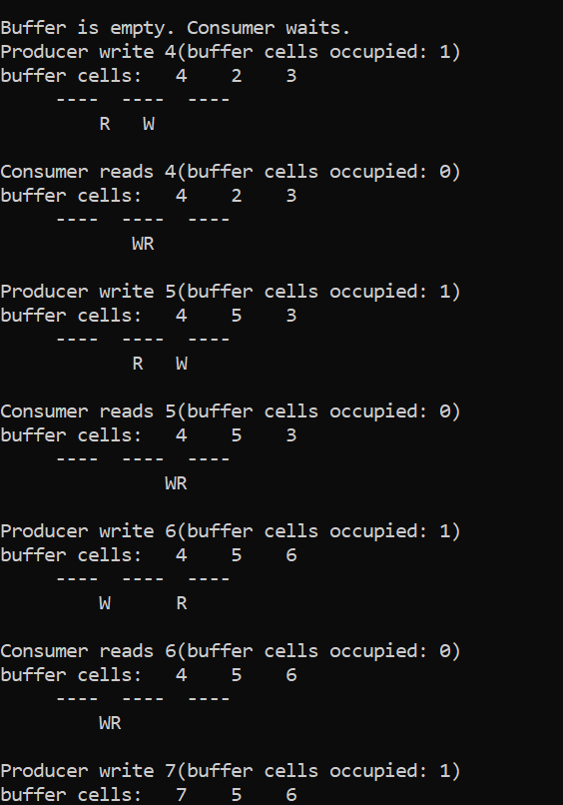

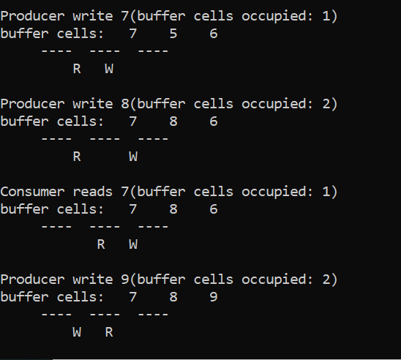

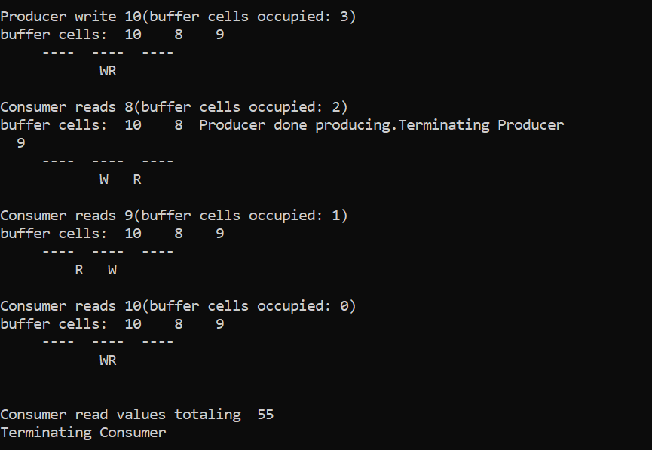

➢ **Reader-Writer Problem**

* In computer science, the **readers-writers problems** are examples of a common computing problem in concurrency.
* Here many threads (small processes which share data) try tom access the same shared resource at one time.
* Some threads may read and some may write, with the constraint that no process may access the shared resource for either reading or writing while another process is in the act of writing to it.
* (In particular, we want to prevent more than one thread modify the shared resource simultaneously and allowed for two or more readers to access the shared resource at the same time).
* A readers-writer lock is a data structure that solves one or more of the readers-writers problems.

➢ **Question – 02**

⬥ Write a java program for Readers Writers Problem using Semaphore

➢ **Source Code**

❖ Implement Readers Writers Problem using Semaphore

**File Name: P7_Q2_ReaderWriter_YP.java**

//Name: Yash Parab

// Batch: B1

// PRN: 2020016400922513

// Date: 25th August,2021

// Prac-07: Synchronization

import java.util.concurrent.Semaphore;

class P7_Q2_ReaderWriter_YP

{

static Semaphore readLock = new Semaphore(1, true); static Semaphore writeLock = new Semaphore(1, true); static int readCount = 0;

static class Read implements Runnable{

@Override

public void run() {

try{

//Acquire Section readLock.acquire(); readCount++;

if (readCount == 1) {

writeLock.acquire();

}

readLock.release(); //Reading section

System.out.println("Thread" +

Thread.currentThread().getName()+ "is READING");

Thread.sleep(1500);

System.out.println("Thread"+Thread.currentThread().getName() + " has FINISHED READING");

//Releasing section readLock.acquire(); readCount--;

if(readCount == 0) {

writeLock.release();

}

readLock.release();

}//try ends

catch (InterruptedException e){ System.out.println(e.getMessage());

}

}//run() ends

}//static class Read ends

static class Write implements Runnable{

@Override

public void run(){

try {

writeLock.acquire();

System.out.println("Thread"+Thread.currentThread().getName()+"is WRITING");

Thread.sleep(2500);

System.out.println("Thread"+Thread.currentThread().getName()+"has finished WRITING");

writeLock.release();

}catch (InterruptedException e){

System.out.println(e.getMessage());

}

}//run ends

}//class Write ends

public static void main(String[] args) throws Exception{

Read read = new Read();

Write write = new Write();

Thread t1 = new Thread(read); t1.setName("thread1"); Thread t2 = new Thread(read); t2.setName("thread2"); Thread t3 = new Thread(write); t3.setName("thread3"); Thread t4 = new Thread(read); t4.setName("thread4"); t1.start(); t3.start(); t2.start(); t4.start();

}//main ends

}//class P7_Q2_ReadWriter_YP ends

➢ **Output**

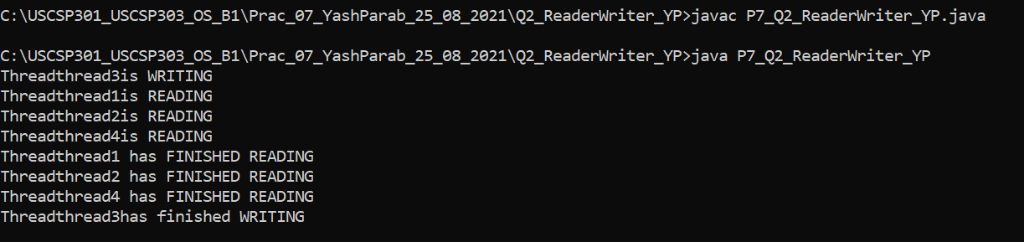

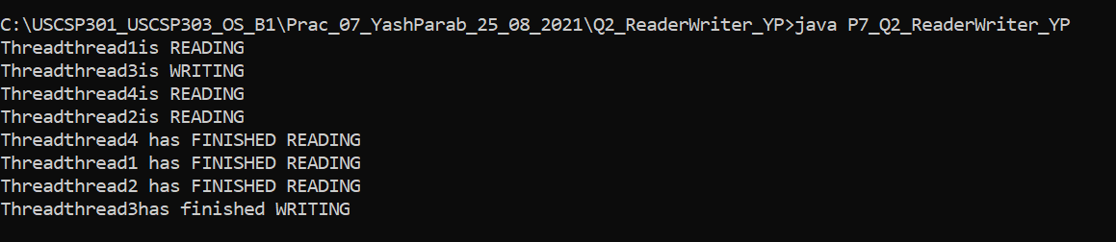

**Note:** The output keeps on changing based on the run due to random calls made to Threads.

➢ **Sleeping Barber Problem**

* A barber shop consists of awaiting room with n chairs and a barber room with one barber chair.
* If there are no customers to be served, the barber goes to sleep.
* If a customer enters the barbershop and all chairs are occupied, then the customer leaves the shop.
* If the barber is busy but chairs are available, then the customer sits in one of the free chairs. If the barber is asleep, the customer wakes up the barber.

➢ **Question – 03**

⬥ Write a program to coordinate the barber and the customers using Java synchronization.

➢ **Source Code**

❖ Implement Sleeping Barber Problem using synchronization

**File Name: P7_Q3_Barber_YP.java**

//Name: Yash Parab

// Batch: B1

// PRN: 2020016400922513

// Date: 25th August,2021

// Prac-07: Synchronization

import java.util.concurrent.*;

import java.util.concurrent.atomic.AtomicInteger; import java.util.Random;

public class P7_Q3_Barber_YP implements Runnable

{

private AtomicInteger spaces; private Semaphore bavailable; private Semaphore cavailable; private Random ran = new Random();

public P7_Q3_Barber_YP(AtomicInteger spaces, Semaphore bavailable, Semaphore cavailable){

this.spaces = spaces;

this.bavailable = bavailable;

this.cavailable = cavailable;

}

@Override

public void run(){

while(true){

try{

cavailable.acquire();

//Space freed up in waiting area

System.out.println("Customer getting hair cut");

Thread.sleep(ThreadLocalRandom.current().nextInt(1000,10000+1000));

//Sleep to imitate length of time to cut hair System.out.println("Customer pays and leaves"); bavailable.release();

}catch(InterruptedException e){}

}//while ends

}//run ends

}//class ends

**File Name: P7_Q3_Customer_YP.java**

//Name: Yash Parab

// Batch: B1

// PRN: 2020016400922513

// Date: 25th August,2021

// Prac-07: Synchronization

import java.util.concurrent.*;

import java.util.concurrent.atomic.AtomicInteger; import java.util.Random;

public class P7_Q3_Customer_YP implements Runnable

{

private AtomicInteger spaces; private Semaphore bavailable; private Semaphore cavailable; private Random ran = new Random();

public P7_Q3_Customer_YP(AtomicInteger spaces, Semaphore

bavailable, Semaphore cavailable){ this.spaces = spaces; this.bavailable = bavailable;

this.cavailable = cavailable;

}

@Override public void run(){ try{

cavailable.release();

if(bavailable.hasQueuedThreads()){

spaces.decrementAndGet();

System.out.println("Customer in waiting area");

bavailable.acquire();

spaces.incrementAndGet();

}

else

{

bavailable.acquire();

}

}catch(InterruptedException e){}

}//run ends

}//P7_Q3_Customer_YP class

**File Name: P7_Q3_BarberShop_YP.java**

//Name: Yash Parab

// Batch: B1

// PRN: 2020016400922513

// Date: 25th August,2021

// Prac-07: Synchronization

import java.util.concurrent.atomic.AtomicInteger; import java.util.concurrent.*;

class P7_Q3_BarberShop_YP{

public static void main(String[] args)

{

AtomicInteger spaces = new AtomicInteger(15);

final Semaphore barbers = new Semaphore(3, true);

final Semaphore customers = new Semaphore(0, true);

ExecutorService openUp = Executors.newFixedThreadPool(3);

P7_Q3_Barber_YP[] employees = new P7_Q3_Barber_YP[3];

System.out.println("Opening up shop");

for(int i = 0; i < 3; i++){

employees[i] = new P7_Q3_Barber_YP(spaces, barbers, customers); openUp.execute(employees[i]);

} while(true) {

try{

Thread.sleep(ThreadLocalRandom.current().nextInt(100, 1000+100)); //Sleep until next person gets in

}

catch(InterruptedException e){} System.out.println("Customer walks in");

if(spaces.get() >= 0){

new Thread(new P7_Q3_Customer_YP(spaces, barbers,customers)).start();

}

else{

System.out.println("Customer walks out, as no seats are available");

}

}//while ends

}//main ends

}//P7_Q3_BarberShop_YP class ends

➢ **Output**

