**PANDIT DEENDAYAL ENERGY UNIVERSITY**



**Name :** Barochiya Yash

**Roll No. :** 22BCP310

**Branch:** Computer Science & Engineering

**Division:** 4

**Group:** 8

**Subject:** DBMS

**Topic :** Game Management

**Submitted to:** Prof. Yogesh Kumar

# Project Statement:

The project appears to be a database-driven application built using MySQL for data storage and Python with Streamlit for the user interface. It facilitates various operations related to managing a gaming environment, such as adding players, creating matches, handling clans, managing inventory, squads, servers, and match modes.

Use Cases/Applications:

User Management:

The system allows for the management of users, including their email addresses and usernames. Users can be added, updated, and viewed.

This functionality provides a foundation for associating players with their respective accounts and managing their profiles within the gaming environment.

Player Management:

Players are the individuals who participate in matches and belong to squads and clans.

The system enables the creation, updating, and viewing of player details, such as their level, associated squad ID, and clan ID.

Players' levels can be adjusted, and they can be assigned to different squads or clans as per the game's dynamics.

Match Management:

Matches are organized gaming events that take place on specific servers and follow predefined modes and maps.

Users can create, update, and view match details, including the match mode, map, duration, and the server where it takes place.

This functionality ensures efficient scheduling and tracking of matches, providing a seamless gaming experience for participants.

Clan Management:

Clans are groups of players who collaborate and compete together in the gaming environment.

The system allows for the creation, updating, and viewing of clan details, such as the clan name, level, and associated match ID.

Clan details can be adjusted as per the progression of the clan within the gaming ecosystem.

Inventory Management:

Inventories represent the items and equipment owned by players within the game.

Users can create and view inventory details, facilitating the management of in-game assets.

This functionality is essential for players to track their possessions and customize their gameplay experience.

Squad Management:

Squads consist of groups of players who team up to participate in matches together.

The system supports the creation, updating, and viewing of squad details, including the squad name and associated match ID.

Squad details can be modified to accommodate changes in team compositions or match participation.

Server Management:

Servers are the computing resources that host and facilitate gaming sessions.

Users can view server details, such as the server ID, name, and location, providing transparency and accessibility to gaming infrastructure.

Match Mode Management:

Match modes define the rules and objectives of gameplay within a match.

The system allows for the viewing of different match modes available, providing players with options for varied gaming experiences.

Objective:

The primary objective of the project is to create a comprehensive management system for organizing and optimizing various aspects of a gaming environment.

By providing functionalities for user, player, match, clan, inventory, squad, server, and match mode management, the system aims to enhance the gaming experience for users and streamline administrative tasks for administrators.

Ultimately, the project seeks to create a robust platform that fosters community engagement, competitive gameplay, and enjoyment within the gaming ecosystem.

Overall, your project demonstrates a systematic approach to building a game management system that caters to the diverse needs of players, administrators, and stakeholders within the gaming community.

# Entity Relationship Diagram (ERD):

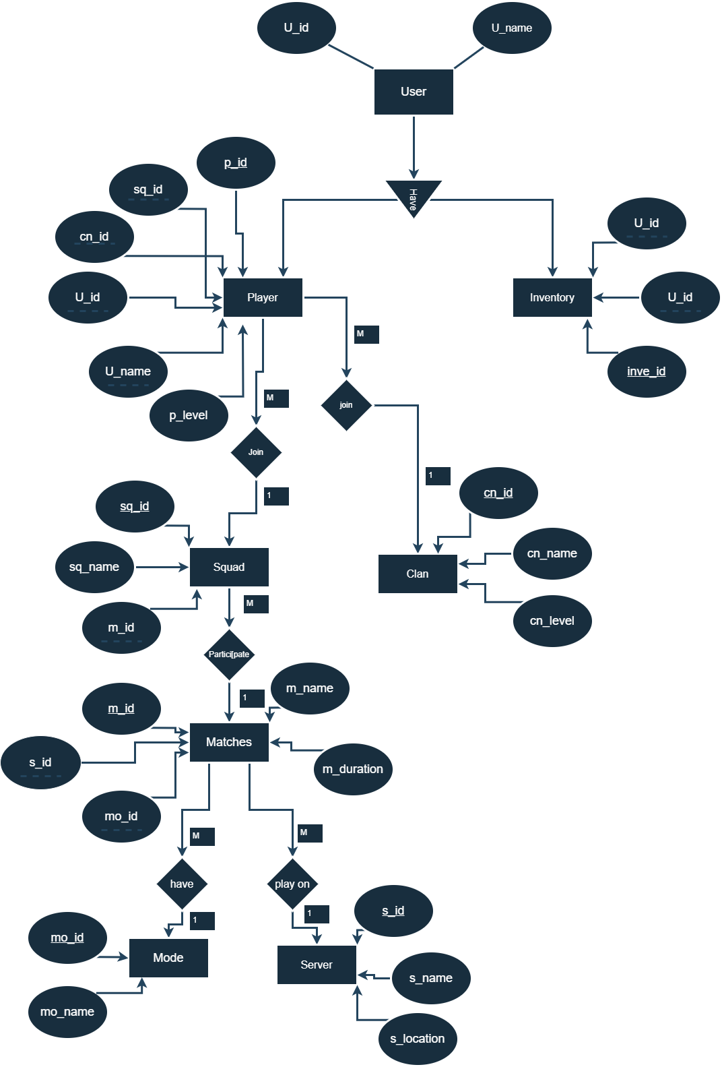

# Schema :

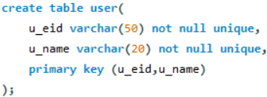

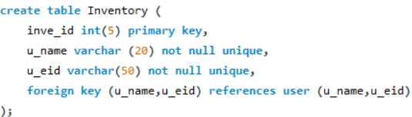

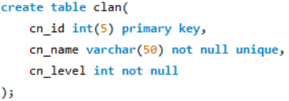

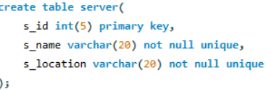

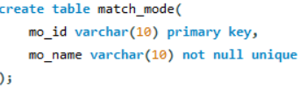

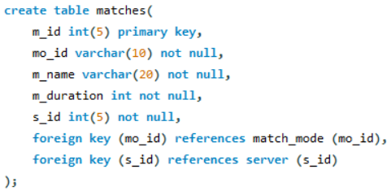

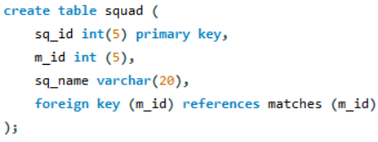

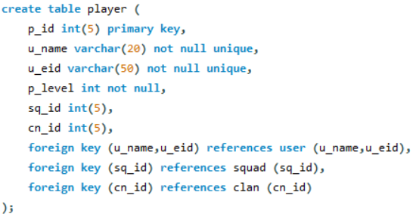

# 1NF:

* Each table cell should contain a single value.
* Each record needs to be unique.

Here every entity have only single valued attribute hence here every table of our entity is in 1NF.

# 2NF:

* Be in 1NF
* Single Column Primary Key that does not functionally dependent on any subset of candidate key relation

Here you can see that every attribute of their entity is fully dependant on their primary key attribute.

In this Diagram:

Plarey( p_id, sq_id,cn_id,u_id,u_name,p_level)

Here p_id is a player id and it is the primary key of player entity

And every attribute sq_id(squad id) is fully dependent on p_id

Like wise cn_id u_id,u_name,p_level is fully dependent on p_id

Squad(sq_id,sq_name,m_id)

Here sq_id a primary key for this table

And sq_name is only dependent on sq_name

And m_id is foreign key of table matches and it is dependent on sq_id

Matches (m_id,m_name,mo_id,s_id,m_duration)

Here m_id the primary key of this table

And m_name, mo_id,s_id,m_duration is fully dependent on m_id

# 3NF:

* Be in 2NF
* Has no transitive functional dependencies

Here you can see that every attribute of their entity is fully dependant on their primary key attribute.

And none of them attribute is dependent on any other entity like a->b and b->c

For ex.

Squad entity have 3 three attribute and none of them are dependent on non primary attribute

Sq_name is fully dependent on sq_id

M_id is fully dependent on sq_id

In Matches table the match name is dependent on match mode and match duration is dependent on the match name but here I use the select box that when match mode is selected by user then according the matches name are provide in next select check box and the duration is also full-fill with when the match name is selected.