System Requirements Statement (SRS) –

Meet Your Need

Doc. Ref. :

Version : 0.4

Status : Drafted

Created by : Group 12

Date : 03-July-2025

1. Introduction 3

2. Functional Requirements 4

**2.1** Administrator Module 5

**2.2** Vendour Module 9

**2.3** Client Module 16

**2.4**  Use Case Diagram..............................................................................................................................23

THIS DOCUMENT CONTAINS 25 NUMBERED PAGES

# Introduction

This document explains the system requirements and scope for developing the Meet Your Need marketplace system.

Meet Your Need System could divide the three main parts, Vendor part, Client part, Admin part.

This document describes the system requirements for the **Vendor part**.

**Meet Your Need** is an online marketplace designed to connect vendors and clients across fields such as **writing**, **graphic design**, and **web development**. The platform helps professionals discover and apply for projects, communicate with clients, and receive payments securely through the system.

# Functional Requirements

The Functional part of Meets Your Needs has three modules which are divided 23 processes described as below.

|  |  |  |
| --- | --- | --- |
| **No** | **BRS requirement ID** | **Description** |
| **2.1** | **Administrator Module** | |
| **2.1.1** | **F1** | **Login Process** |
| **2.1.2** | **F2** | **Manage User Accounts** |
| **2.1.3** | **F3** | **Manage Skills Process** |
| **2.1.4** | **F4** | **View Records Process** |
| **2.1.5** | **F5** | **Search & Filter Process** |
| **2.2** | **Vendor Module** | |
| **2.2.1** | **F6** | **Register Process** |
| **2.2.2** | **F7** | **Login Process** |
| **2.2.3** | **F8** | **Update Vendor Profile** |
| **2.2.4** | **F9** | **Upload Requirements Process** |
| **2.2.5** | **F10** | **Edit Requirements Process** |
| **2.2.6** | **F11** | **View Interested Clients** |
| **2.2.7** | **F12** | **Select Clients** |
| **2.2.8** | **F13** | **Track Task Progress** |
| **2.2.9** | **F14** | **Send Messages** |
| **2.2.10** | **F15** | **View My Reviews** |
| **2.2.11** | **F16** | **Reply Query** |
| **2.3 Client Module** | | |
| **2.3.1** | **F16** | **Register Process** |
| **2.3.2** | **F17** | **Login Process** |
| **2.3.3** | **F18** | **Search Tasks** |
| **2.3.4** | **F19** | **Apply Requirement** |
| **2.3.5** | **F20** | **View Status** |
| **2.3.6** | **F21** | **Edit Progress** |
| **2.3.7** | **F22** | **Raise Completion Request** |
| **2.3.8** | **F23** | **Raise Query** |
| **2.3.9** | **F24** | **Give Feedback** |
| **2.3.10** | **F25** | **Accept Proposal** |
| **2.3.11** | **F26** | **Receive Message** |
| **2.3.12** | **F27** | **Manage Task Status** |
| **2.3.13** | **F28** | **Reject Proposal** |

## Administrator Module

* The Administrator is the system controller responsible for managing the overall platform activities.
* Admin can log in securely to access the backend panel.
* Admin can manage user accounts by activating, deactivating, editing, or deleting vendor and client profiles.
* Admin can add, update, or remove skills that vendors use to define their expertise.
* Admin is allowed to view all records related to users, projects, bids, and system activities.
* Admin can search and filter records efficiently based on specific criteria like name, role, or status.

### Login Process

The login process allows registered users (both vendors and clients) to securely access their accounts on the Meet Your Needs platform. This is a critical function to ensure personalized access and data protection.

**Functional Requirements**

1: The system shall provide a login interface for the administrator.

2: The administrator shall be required to enter a valid username and password.

3: The system shall verify the credentials against the admin database.

4: Upon successful authentication, the administrator shall be redirected to the Admin Dashboard.

5: If credentials are invalid, the system shall display an error message.

**Security Requirements**

1: Passwords shall be stored using encryption/hashing (e.g., bcrypt).

2: The system shall implement session management after login.

3: The system shall lock the account after 5 failed attempts (optional but good to mention).

4: Support for "Forgot Password" or admin reset via email or security code (if implemented).

**Preconditions**

1: The admin must be a registered user in the system.

2: Admin has access to the login page.

**Postconditions**

1: On success: Admin is logged in and redirected to dashboard.

2: On failure: Error is shown; login remains on the same page.

### 2.1.2 Manage User Accounts

This feature enables the administrator to handle all user-related operations such as viewing, updating, deleting, and managing the status of user accounts (vendors and clients).

**Administrator Capabilities**

* View all registered user accounts in a tabular/list format.
* Edit user details (e.g., name, email, user role).
* Activate or deactivate user accounts.
* Permanently delete user accounts if necessary.
* Reset user passwords (optional).
* Search and filter users by:

1: Name

2: Email

3: Role (Vendor/Client)

4: Account status (Active/Inactive)

**UI Behaviour**

* Display users in a paginated table with action buttons (Edit / Delete / Toggle Status).
* Include search bar and filter dropdowns for faster access.

**System Response**

* Show a confirmation prompt before deactivating or deleting users.
* Display success or error messages after an action is performed.
* Log every critical action performed by the admin.

### 2.1.3 Manage Skill Process

This process allows the administrator to manage the list of skills available on the platform. These skills help clients categorize their project requirements and allow vendors to define their expertise.

**Administrator Capabilities**

* Add new skills to the system (e.g., “Graphic Design”, “Python Development”).
* Edit existing skills (rename or update descriptions).
* Delete skills that are no longer relevant.
* View the full list of available skills with details.

**System Behaviour**

* Skills are displayed in a searchable, editable list.
* System prevents adding duplicate skill names.
* Deleting a skill shows a warning if it is already assigned to vendors or used in posted projects.

**Inputs**

* Skill Name (required)
* Skill Description (optional)

**Outputs**

* Confirmation messages for Add/Edit/Delete.
* Updated skill list.

### 2.1.4 View Records Process

To allow the administrator to monitor and review essential data on the platform including user activity, transactions, posted projects, and feedback logs.

**What Records Can Be Viewed**

* Registered Users List (vendors and clients)
* Projects Posted (with status: open, assigned, completed)
* Bids or Proposals Submitted

**Admin Actions**

* View full details of each record (e.g., user profile, project description, payment ID).
* Sort and filter records by date, status, or category.
* Export records to PDF or CSV (optional).

**Interface Behaviour**

* Display records in tabular format with pagination.
* Enable click-to-expand for full details.
* Provide search and filter options at the top of each section.

**2.1.5 Search & Filter Process**

To help the administrator quickly locate specific users, projects, or records using search and filtering tools.

**Key Functionalities**

* Search Bar: Allows keyword-based search (e.g., username, project title).
* Filter Options: Based on role (Vendor/Client), status (Active/Inactive), date range, skill, etc.
* Combined Use: Admin can use search and filters together for more precise results.

**System Behaviour**

* Real-time search with dynamic result updates.
* Filtered results appear in a paginated list.
* Option to reset filters to default view.

**Access**

* Available only to authenticated administrators.

## Vendor Module

The Vendor Module allows registered vendors to manage their service offerings on the platform. Vendors can register, log in, update their profiles, and upload their service requirements.

They can view interested clients, select suitable ones, and track task progress. The module also includes messaging features to communicate with clients and allows vendors to view the reviews received for their work.

### 2.2.1 Vendor Registration Process

**Functionality**

* Vendors can access the registration form from the homepage.
* The form requires:

1: Full Name

2: Email Address (must be unique)

3: Password (with confirmation)

4: Contact Number

5: Skill Set (can select multiple)

* On submission:

1: The system checks for duplicate email

2: If valid, vendor details are saved in the database.

3: A confirmation message is displayed.

4: Optionally, a welcome email is sent.

**Validation Rules**

* All required fields must be filled.
* Email must follow proper format and be unique.
* Password must meet security criteria (e.g., min. 8 characters).

**Security Note**

* Passwords are stored in **hashed** format.

**Postconditions**

* A new vendor account is created.
* Vendor can now log in using their credentials.

**2.2.2 Vendor Login Process**

To allow registered vendors to securely access their dashboard and manage their activities.

**Functionality**

* Vendors enter email and password on the login page.
* System verifies credentials:

1: If valid → redirect to Vendor Dashboard.

2: If invalid → show error message.

* Supports "Forgot Password" option for recovery.

**Validation Rules**

* Email and password fields must not be empty.
* Email must be registered in the system.

**Security**

* Passwords are stored in hashed format.
* Login sessions are managed securely to prevent unauthorized access.

**Postconditions**

* On success: Vendor is logged in.
* On failure: Login remains on the same page with an error alert.

**2.2.3 Update Vendor Profile Process**

Allows vendors to edit and update their personal and professional information.

**Functionality**

* Vendors can update:

1: Name

2: Email

3: Contact number

4: Skill set

5: Profile image (optional)

6: Password (with confirmation)

* System validates inputs and updates the database.

**Validation Rules**

* Email must remain unique.
* Contact number must be numeric and valid.
* Password update requires old password verification.

**Postconditions**

* Vendor profile is updated.
* Success message is displayed after update.

### 2.2.4 Upload Requirements Process (Vendor)

**Process Steps**

* Vendor logs in and navigates to the Upload Requirements section.
* Fills in the form with:

1: Requirement Title

2: Description

3: Skills Needed

4: Timeline / Deadline

5: Budget (optional)

* Uploads supporting files (if needed).
* Clicks Submit.

**System Behaviour**

* Validates all mandatory fields.
* Saves the requirement to the database.
* Displays a confirmation message.
* Makes the requirement visible to interested clients.

**2.2.5 Edit Requirements Process**

Vendors can update or correct the details of previously uploaded service requirements.

**Key Actions**

* Navigate to "My Requirements" section.
* Select the requirement to be edited.
* Modify fields like:

1: Title

2: Description

3: Skills needed

4: Timeline or budget

5: Attached file

* Click Save Changes.

**System Behaviour**

* Pre-fills existing data into the edit form.
* Updates only the modified fields in the database.
* Reflects changes immediately on the client-facing side.

**Access Control**

* Only the vendor who created the requirement can edit it.

**2.2.6 View Interested Clients**

To allow vendors to see which clients have shown interest or submitted proposals for their posted requirements.

**Workflow**

* Vendor navigates to "My Requirements".
* Selects a specific requirement.
* System displays a list of interested clients, including:
  + Client Name
  + Proposal Summary
  + Proposed Budget
  + Timeline
  + Rating (if available)

**System Features**

* Each client can be viewed in detail.
* Vendors can compare and evaluate proposals.
* Option to download or print proposals (optional).

#### ****Access****

#### Only the vendor who posted the requirement can view client proposals.

**2.2.7 Select Clients**

Enables vendors to choose the most suitable client from those who applied to their requirement.

**Workflow**

* Vendor views the list of interested clients for a posted requirement.
* Evaluates proposals and client profiles.
* Clicks “Select” on the desired client.
* System sends a notification to the selected client and updates the status to "In Progress".

**System Behaviour**

* Only one client can be selected per requirement.
* Once selected, the requirement is locked for new applications.
* Selection is recorded in the database for tracking.

**Access**

* Only the vendor who posted the requirement can make a selection.

**2.2.8 Track Task Progress**

Allows vendors to monitor and manage the progress of tasks they are working on with selected clients.

**Key Features**

* Access to the "Ongoing Projects" section.
* View current task status (e.g., Not Started, In Progress, Submitted, Completed).
* Option to update progress manually or mark as complete.
* Upload files or updates related to the task.

**System Behaviour**

* Status updates are visible to both vendor and client.
* Timestamp is recorded on every update.
* Final submission triggers a review phase by the client.

**Access**

* Only vendors involved in the task can track and update its progress.

**2.2.9 Send Message**

Allows vendors to communicate directly with clients regarding tasks, proposals, or clarifications.

**Key Features**

* Access to in-built messaging panel.
* Vendors can send and receive real-time messages with clients they are working with.
* Messages can include text, file attachments, and timestamps.
* Notification for new messages.

**System Behaviour**

* Only vendors and clients involved in a requirement can chat.
* Conversations are stored securely for reference.
* System shows read/unread status and last seen info (optional).

**Access**

* Only logged-in vendors with active tasks or proposals can use messaging.

**2.2.10 View My Reviews**

Allows vendors to see the feedback and ratings provided by clients after task completion.

**Key Features**

* Access to “My Reviews” section on the dashboard.
* View:
  + Client’s name
  + Rating (e.g., 1 to 5 stars)
  + Written feedback
  + Project title/date
* Option to sort or filter by rating or date (optional).

**System Behaviour**

* Reviews are read-only.
* Displayed in chronological order, with most recent on top.
* Helps vendors understand their performance and build reputation.

**Access**

* Only the vendor can view their own reviews.

### 2.2.11 Reply Query

**Purpose**

Enables vendors to respond to queries raised by clients related to tasks or services.

**Functionality**

* Vendors receive notifications for assigned queries.
* Open the query and view:
  + Query subject
  + Message details
  + Attached task (if any)
* Type a reply message and optionally attach supporting files.
* Submit the response to the system.

**System Behaviour**

* Response is linked to the original query.
* Notifies the client that the vendor has replied.
* Conversation is stored for reference.

**Postconditions**

* Query is marked as Responded or Pending Further Action.
* Improves communication and issue resolution.

## Client Module

The Client Module allows users seeking services to register, browse vendor offerings, and submit proposals. Clients can log in to manage their proposals, communicate with vendors, and track task status. After task completion, they can provide reviews and ratings. This module ensures a smooth workflow for clients to connect with vendors and monitor progress efficiently.

### 2.3.1 Client Registration Process

Allows new clients to sign up and create an account on the platform to find and hire vendors.

**Functionality**

* Clients access the **registration form** from the homepage.
* Required fields include:
  + Full Name
  + Email Address (must be unique)
  + Password and Confirm Password
  + Contact Number
  + Industry Type (optional dropdown)

**Validation Rules**

* All mandatory fields must be filled.
* Email must follow a valid format and be unique.
* Password must meet security standards (e.g., minimum 8 characters).

**Security**

* Passwords are encrypted/stored in hashed format.
* Basic CAPTCHA or OTP (optional) may be used for bot protection.

**Postconditions**

* A new client account is created and stored in the system.
* The client is redirected to the login page or automatically logged in.

**2.3.2 Client Login Process**

Enables registered clients to securely access their account and manage proposals or tasks.

**Functionality**

* Clients enter:
  + Email Address
  + Password
* System validates credentials:
  + If valid → redirect to Client Dashboard
  + If invalid → display error message
* Forgot Password option available for recovery.

**Validation Rules**

* Email and password must not be empty.
* Email must be registered in the system.

**Security**

* Passwords are compared using hashed format.
* Session management ensures secure access.

**Postconditions**

* On success: Client is logged in.
* On failure: Remains on login page with an error alert.

**2.3.3 Search Tasks**

Allows clients to efficiently find vendor-posted tasks that match their interests or needs.

**Functionality**

* Clients can input keywords or apply filters such as:
  + Skill required
  + Budget range
  + Deadline
  + Vendor name or rating
* System returns a list of matching tasks.

**System Behaviour**

* Performs keyword-based or filter-based search on vendor requirements.
* Displays results in list/grid view with key information (title, description, vendor name, etc.).

**Postconditions**

* Matching tasks are displayed.
* Clients can click on a task to view full details and submit a proposal.

**2.3.4 Apply Requirement**

Allows clients to respond to vendor-posted tasks by submitting a proposal, and later accept or reject vendors.

**Accept Proposal**

**Functionality**

* Client views proposals from vendors.
* Selects one suitable vendor and clicks Accept.
* The system:
  + Notifies the selected vendor.
  + Locks further applications for that task.
  + Activates task tracking features.

**Manage Task Status**

* After accepting a proposal, the client can:
  + Set status: In Progress, Submitted, or Completed.
  + Monitor vendor progress and update when deliverables are received.
* System timestamps every update.

**Reject Proposal**

* Client can reject other vendor proposals not selected.
* System:
  + Notifies the rejected vendors.
  + Updates proposal status to Rejected.

**Postconditions**

* Task moves to active workflow after one vendor is accepted.
* Rejected vendors are informed.
* Task status can now be tracked by both client and vendor.

**2.3.5 View Status**

Enables clients to track the current status of their active tasks with vendors.

**Functionality**

* Displays real-time status updates:
  + In Progress, Submitted, Completed
* Shows progress % (optional), submission dates, and remarks (if any).

**Postconditions**

* Clients can monitor vendor activity and prepare for review or feedback.

**2.3.6 Edit Progress**

Allows clients to update or confirm the current progress of a task based on vendor submissions.

**Functionality**

* Clients can:
  + Change task status (e.g., In Review, Completed)
  + Add comments or feedback on submitted work
  + Confirm milestone completion (if applicable)

**System Behaviour**

* Progress updates are logged with a timestamp.
* Triggers notifications to the vendor.

**Postconditions**

* Task progress is updated for both client and vendor dashboards.
* Helps maintain task flow and final delivery clarity.

**2.3.7 Raise Completion Request**

Allows the client to mark a task as complete and formally request closure.

**Functionality**

* Client clicks "Mark as Completed" or "Raise Completion Request" on the task.
* Optionally adds:
  + Final comments
  + Confirmation of deliverables received
* System updates task status to Completion Requested.

**System Behaviour**

* Notifies the vendor that completion has been requested.

**Postconditions**

* Task status changes from In Progress to Completion Requested.
* Triggers the review and rating process.

**2.3.8 Raise Query**

Allows clients to submit a query or concern related to a task, vendor, or platform issue.

**Functionality**

* Clients can access a “Raise Query” form.
* Input fields include:
  + Subject
  + Description of issue/query
  + Related task or vendor (optional)
* Submit button sends the query to the support/admin team.

**System Behaviour**

* Query is stored in the system and optionally emailed to support.
* Generates a ticket ID for tracking.
* Notifies admin for review.

**Postconditions**

* Query is logged.
* Admin can respond via the support panel or messaging system.

**2.3.9 Give Feedback**

Enables clients to provide feedback and rate vendors after task completion to ensure transparency.

**Functionality**

* After a task is marked as Completed, the client is prompted to give feedback.
* Inputs include:
  + Star Rating (e.g., 1 to 5)
  + Written Review (optional)
  + Task reference is auto-linked

**System Behaviour**

* Stores the review in the system.
* Associates it with the vendor’s public profile.
* Prevents duplicate or edited submissions.

**Postconditions**

* Review is visible to other users.
* Helps vendors build credibility and clients evaluate vendor quality.

**2.3.10 Accept Proposal**

Allows clients to formally accept a vendor’s proposal for a specific requirement, initiating the task.

**Functionality**

* Client reviews proposals from vendors.
* Clicks “Accept” on the preferred proposal.
* System:
  + Updates proposal status to Accepted
  + Notifies the selected vendor
  + Locks the requirement for further applications

**System Behaviour**

* Automatically links the vendor to the task.
* Changes task status to In Progress.
* Other proposals are marked as Rejected.

**Postconditions**

* Task officially begins between client and selected vendor.
* Enables task tracking and communication features.

**2.3.11 Receive Messages**

Allows clients to receive messages from vendors related to proposals, task updates, or queries.

**Functionality**

* Clients are notified when a vendor sends a message.
* Messages are displayed in a dedicated inbox/chat panel.
* Supports:
  + Text content
  + Attachments (optional)
  + Timestamps for each message

**System Behaviour**

* Stores all messages under the relevant task or vendor.
* Marks unread messages and supports real-time updates.

**Postconditions**

* Client stays informed about task progress or communications.
* Messages remain available for future reference.

**2.3.12 Manage Task Status**

Allows clients to oversee all ongoing, completed, and pending tasks assigned to vendors.

**Functionality**

* Accessible from the Client Dashboard.
* Displays tasks with:
  + Task Title
  + Assigned Vendor
  + Current Status (e.g., In Progress, Submitted, Completed)
  + Start and End Dates
  + Action Buttons (View, Update Status, Raise Query, Give Feedback)

**System Behaviour**

* Allows clients to:
  + Track task progress
  + Mark task as completed
  + Raise queries or confirm delivery
  + View task history and vendor interactions
* Auto-updates task status based on actions (e.g., feedback submitted → task marked closed)

**Postconditions**

* Keeps client informed and in control of their tasks.
* Ensures accountability and transparency in task handling.

**2.3.13 Reject Proposal**

Allows clients to decline vendor proposals that are not suitable for their requirement.

**Functionality**

* Client views all received proposals under a requirement.
* Clicks “Reject” on any proposal not selected.
* System updates the proposal status to Rejected.

**System Behaviour**

* Sends notification to the vendor about rejection.
* Rejected proposals are removed from the active list but stored for record.
* Only one proposal can be accepted per requirement — rest must be rejected or left pending.

**Postconditions**

* Vendor is informed, and client’s task flow remains clean and manageable.

## Use Case Diagram

**2.4.1 Admin:**

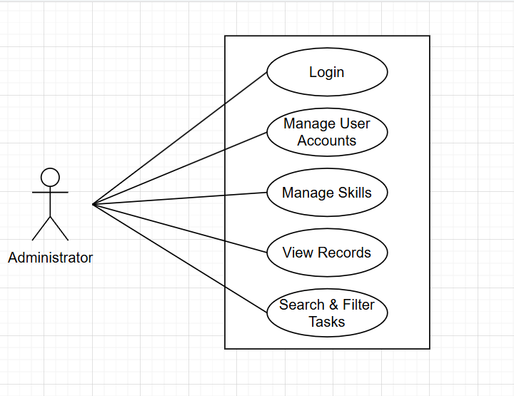

*Fig: Use Case Diagram for Admin*

1. In Admin use case diagram Admin is the Actor.

2. Admin can handle following use cases:

1. Login
2. Mange User Accounts
3. Manage Skills
4. View Records
5. Search & Filter Tasks

**2.4.2 Vendor:**

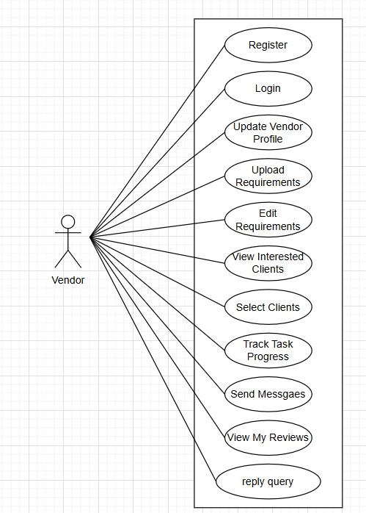

*Fig: Use Case Diagram for Vendor*

1. In Vendor use case diagram Vendor is the Actor.

2. Vendor can handle following use case:

1. Register
2. Login
3. Update Vendor Profile
4. Upload Requirements
5. Edit Requirements
6. Selected Clients
7. Track Task Progress
8. Send Messages
9. View My Reviews
10. Reply Query

**2.4.3 Client:**

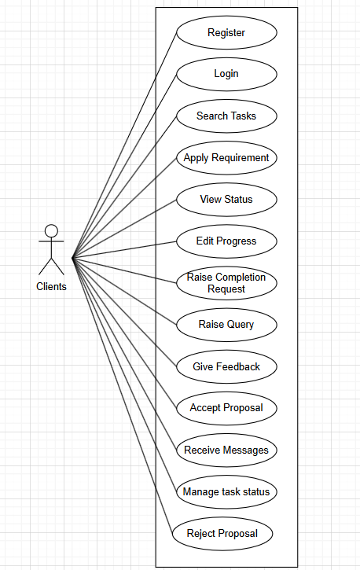

*Fig: Use Case Diagram for Client*

1. In Client use case diagram Client is the Actor.

2. Client can handle following use case:

1. Register
2. Login
3. Search Tasks
4. Apply Requirement
5. View Status
6. Edit Progress
7. Raise Completion
8. Raise Query
9. Give Feedback
10. Accept Proposal
11. Receive Messages
12. Manage Tasks Status
13. Reject Proposal