**Input form**

**Build a dynamic form that adds and removes input fields based on user input.**

To build a dynamic form that allows users to add and remove input fields dynamically, you can achieve this using HTML, JavaScript (or a framework like React, and CSS to manage the layout. Below is a high-level description of how it works, followed by a simple implementation example.

**How It Works:**

1. **Add New Input Fields:**
   * A user can click a button labeled "Add Field" to append a new input field to the form. Each click on the button will generate a new form input dynamically using JavaScript.
2. **Remove Input Fields:**
   * Each dynamically created input field comes with an associated "Remove" button that allows the user to remove the specific field from the form. Clicking this button will remove the corresponding field.
3. **Form Submission:**
   * Once the user is satisfied with the added fields, they can submit the form, and all the input values will be collected and sent as part of the form submission process.

**Output Screenshot**

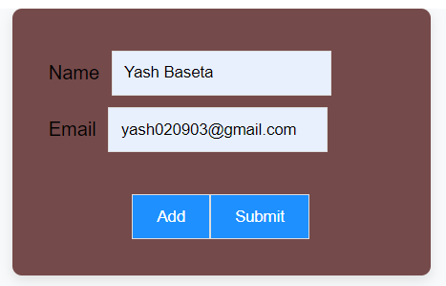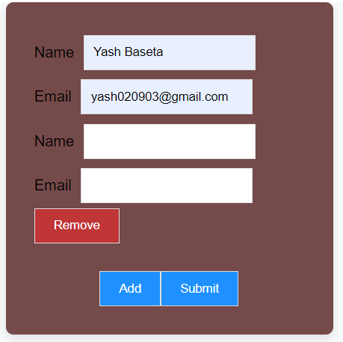

**Widget Used In Task**

* **Add Button Widgets:** Use to add User
* **Submit Button Widgets** Use to submit Form
* **Remove Button Widgets:** Use to remove User
* **Text Widgets:** Use to take Input from user