**Shared input component**

**Create a common shared component that can handle common input like input text area checkbox radio and use this component in one form**

The shared input component should be able to render different types of form elements based on the props passed to it. The key is to ensure flexibility so that the component can handle any type of input, including:

* **Text input**: For single-line text fields.
* **Textarea**: For multi-line text input.
* **Checkbox**: For boolean selections.
* **Radio**: For selecting one option from a group of options.

**Output Screenshot**

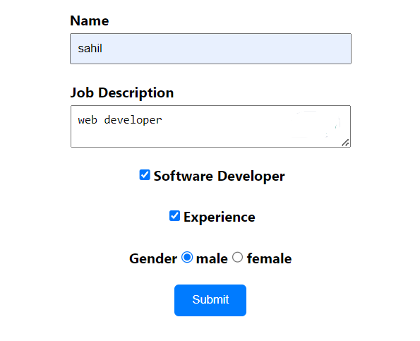

**Widget Used In Task**

* Text View is used to take input from the user.
* checkbox for selecting more options
* Radio button for selecting one of them
* Button Widget Used for submit.
* Text View Used to display Winner.